IPRPS OS Session Master Training Manual
Learn to prepare, run and wrap up great games with IPRPS OS · Version 1.0 · November 2026
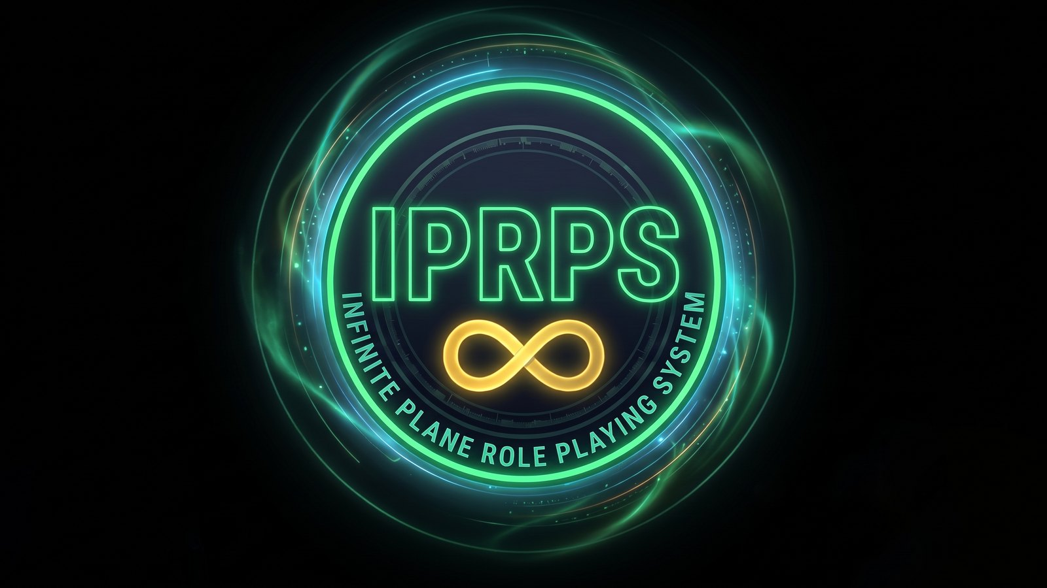
IPRPS OS wallpaper artwork
How to use this manual
This manual teaches you to run games with IPRPS OS. You will learn the tools one at a time. Each chapter ends with a walkthrough: a short exercise you do on your own computer, step by step.
All the examples use one campaign, Iron City Blues. It is a noir mystery on the Infinite Plane, with rain, gas lamps and a harbor full of secrets. Four players are at the table:
Player | Character | Who they are
Dana | Brenna Holt | Wolffolk tracker who used to work for the Night Watch
Marcus | Tobin Fairweather | Human insurance investigator
Priya | Mira Quickstep | Catfolk cat burglar
Leo | Dr. Oro Kessel | Gemp harbor doctor

If you have run the walkthrough adventure Fog on Pier Nine, you already know these people. That's fine if you haven't.
How to read the steps:
- Words in bold are buttons, menus or labels you will see on the screen.
- An arrow (→) means "then choose". IPRPS → IPRPS Welcome means: open the IPRPS menu, then choose IPRPS Welcome.
- Boxes that start with Try it are short practice tasks.
- Boxes that start with Tip share a shortcut or a good habit.
What you need: a computer running IPRPS OS (any edition), and a Wi-Fi network. For the Table chapters, borrow one or two phones, or use a tablet or laptop. The IPRPS Oracle chapter needs the Medium or Advanced edition.
Chapter | You will learn to | Time
1. What makes IPRPS OS different | Know when IPRPS OS is the right tool | 10 minutes
2. Get set up | Create your campaign and choose your apps | 15 minutes
3. Prepare a session | Collect characters, notes, pictures and sound | 20 minutes
4. Open the IPRPS Table | Get players connected on their phones | 15 minutes
5. Roll the IPRPS way | Read checks, bands and BTN | 15 minutes
6. Run a fight | Track initiative, HP, AR and conditions | 20 minutes
7. Set the mood | Use the Soundboard and the Table's sound | 10 minutes
8. Ask the IPRPS Oracle | Improvise NPCs and scenes with private AI | 15 minutes
9. Wrap up the night | Write the recap and track XP | 10 minutes
10. Keep it running | Install updates and invite remote players | 10 minutes

Chapter 1: What makes IPRPS OS different
Most digital tools for tabletop games are websites. You and your players sign in, and the game lives on the company's computers. IPRPS OS is different. It is a whole computer system made for the Session Master. It runs on your own PC, and your game lives there too.
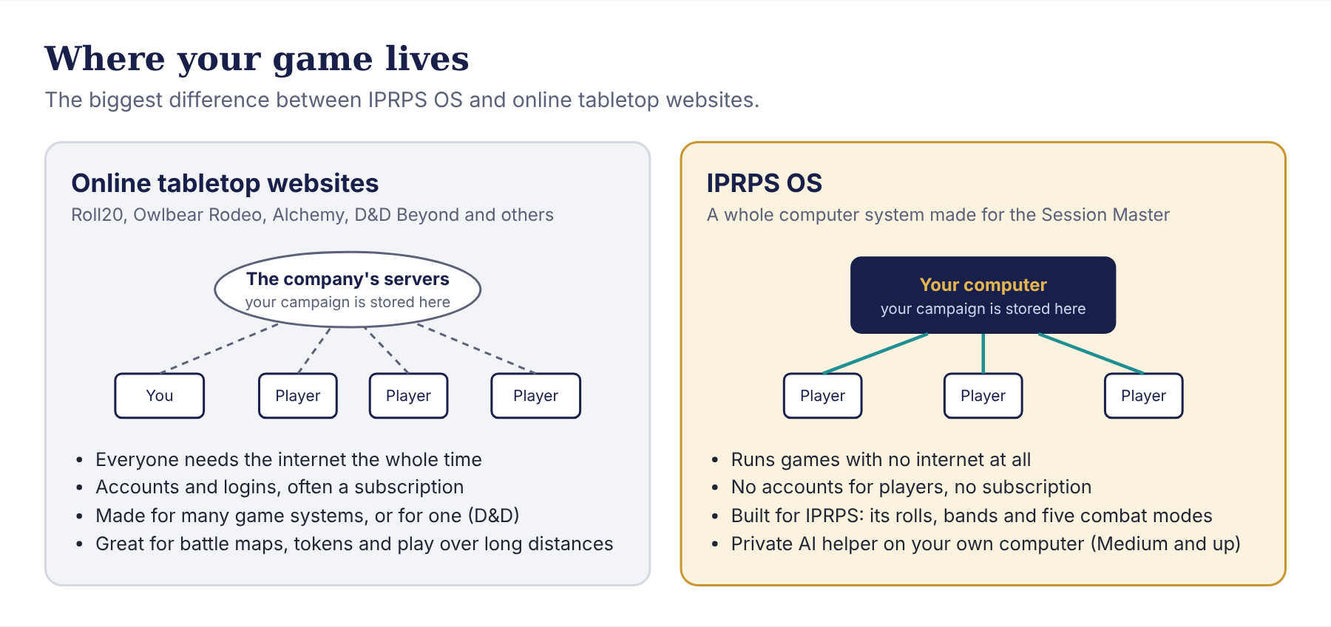
Where your game lives: online tabletop websites keep your campaign on the company's servers, and everyone needs the internet; IPRPS OS keeps it on your computer, and players join over your Wi-Fi

Five things that set IPRPS OS apart
1. It works with no internet at all. Your players join from their own phones, tablets or laptops over your home Wi-Fi. They don't need an account, an app or a password. They scan a QR code, type a six-letter join code, and they are in. If the internet goes down on game night, nothing stops.
2. It speaks IPRPS. Other tools are made for many game systems, or for one other system. IPRPS OS is made for the Infinite Plane Role Playing System. The dice know the success bands, the BTN (Base Target Number), Skill Shift and Attribute Shift. The combat tracker subtracts AR (Armor Rating) from damage and supports all five IPRPS combat modes. The Character Creator counts Development Points for you.
3. It has a private AI helper. In the Medium and Advanced editions, the IPRPS Oracle runs on your own computer. It can invent an NPC, a place or a read-aloud description for you. It reads your campaign, so its ideas fit your story. Its own model keeps everything on your computer, with no account or fee. If you want faster answers, you can switch it to Claude, an online AI, with your own key.
4. Every tool is connected. The dice roller and the combat tracker write into the session log as you play. After the game, the log turns into a recap with one click. Character sheets you import show up in the combat tracker, the Table and the Oracle. One click on Session Master Mode opens everything you need for game night.
5. Your game is yours. Your campaigns, notes, sheets and recordings stay on your computer. There is no subscription to keep paying, and no company can close your account or lose your campaign.

How it compares with popular online tools
Here is a short, fair comparison with five well-known tools. These tools are good at many things, and many groups use them happily. The details below are a summary as of November 2026; check each website for current features and prices.
Tool | What it is | What it does best | How it differs from IPRPS OS
Roll20 | A virtual tabletop website for many game systems | Battle maps and tokens, character sheets for many systems, a big store of official adventures, voice and video chat | Runs on Roll20's servers and needs the internet. Some features, like dynamic lighting and more storage, need a paid subscription
Owlbear Rodeo | A simple map-and-token website | Quick, clean battle maps with very little setup, plus add-on extensions | Online only. Focused on maps, so rules, notes and campaign records happen somewhere else. Paid plans add storage
Alchemy RPG | A "cinematic" virtual tabletop website | Mood: animated scenes, music and a story-first, theater-of-mind feel | Online only, with free and paid plans. Built for other publishers' games, not for IPRPS rolls
Fantasy Grounds | A desktop program for many game systems | Deep rules automation for supported systems, and a large content library | The base program is free, but most official content is sold. It is a program on top of your computer, not a whole system with prep, writing and AI tools
D&D Beyond | The official online toolset for Dungeons & Dragons | D&D character building, rules lookup and its own maps tool | Made only for D&D, and needs an account and the internet. Custom maps need a paid tier

When another tool is a better fit. IPRPS OS 1.0 doesn't have battle maps with movable tokens, fog of war, or built-in voice and video chat. If your group plays mostly online, every week, with a battle grid, a website tool may suit you better for that part. You can still use one: open it in the web browser on IPRPS OS, and keep using the IPRPS tools for dice, combat, notes and recaps.
When IPRPS OS shines. IPRPS OS is at its best when your group meets in person, with phones and tablets around the table. It is also the best fit when you play IPRPS, when the internet is slow or missing, and when you want your campaign kept private.
TIP A player in another city can still join your IPRPS Table. Chapter 10 shows how.

Chapter 2: Get set up

Your first login
The first time you log in, IPRPS Welcome opens. It is a short tour that takes about five minutes. You can skip any step and come back later from IPRPS → IPRPS Welcome.
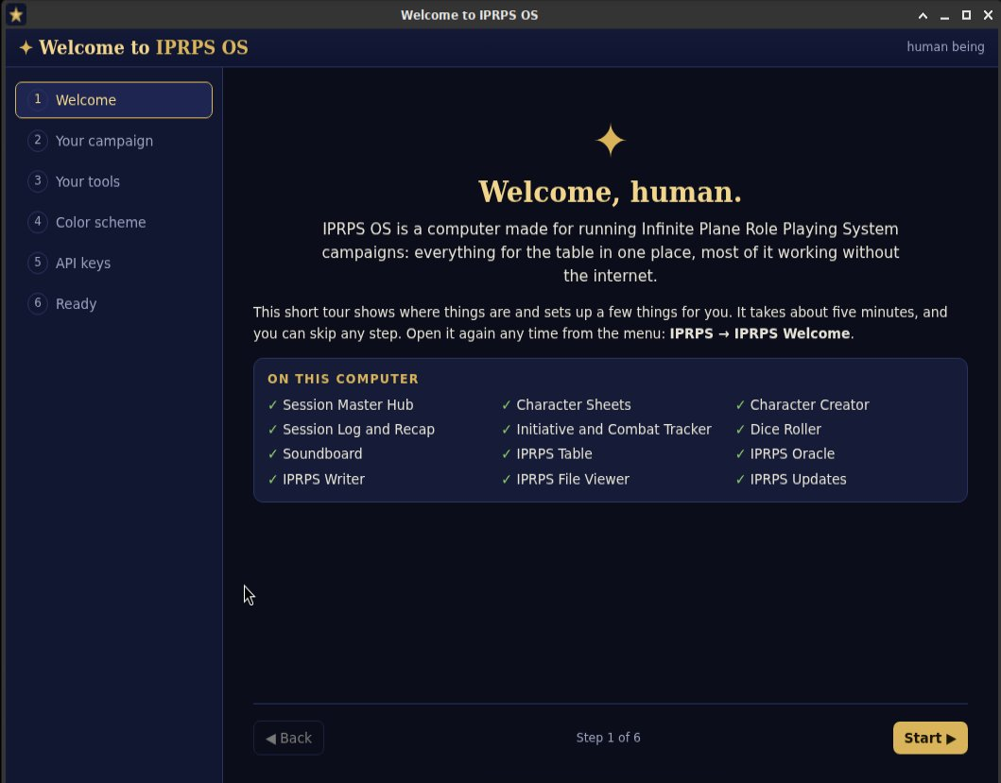
IPRPS Welcome lists the IPRPS apps on this computer
The tour has five parts:
- On this computer: which edition you have and which IPRPS apps are installed.
- Your campaign: create your first campaign.
- Your tools: every IPRPS app, with a short description and an Open button.
- Color scheme: how the session tools look. Choose Night, Parchment, Forest or High contrast.
- API keys for online AI apps: only needed for the two online AI apps. The offline tools never need keys.

Campaigns hold everything
A campaign is the folder for your whole story. Sessions, the session log, fights, character sheets, NPCs and quests all belong to a campaign. The Oracle reads it too. So create your campaign first.

The Session Master Hub
The Session Master Hub is your home page. Each tile opens an app. Open it from the panel at the top of the screen or from the IPRPS menu. The first time, it asks you to sign in. That one sign-in covers every IPRPS app on the computer.
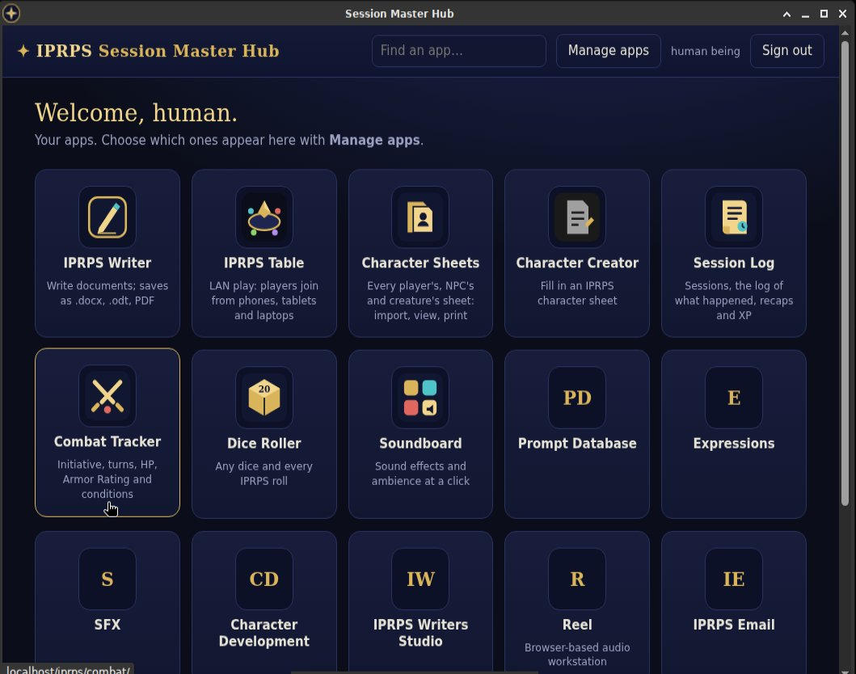
The Session Master Hub: your apps as tiles
You decide which tiles appear. Choose Manage apps, switch apps on or off, and choose Save. Each Session Master on the computer keeps their own choice. Reset to defaults brings back the standard set.
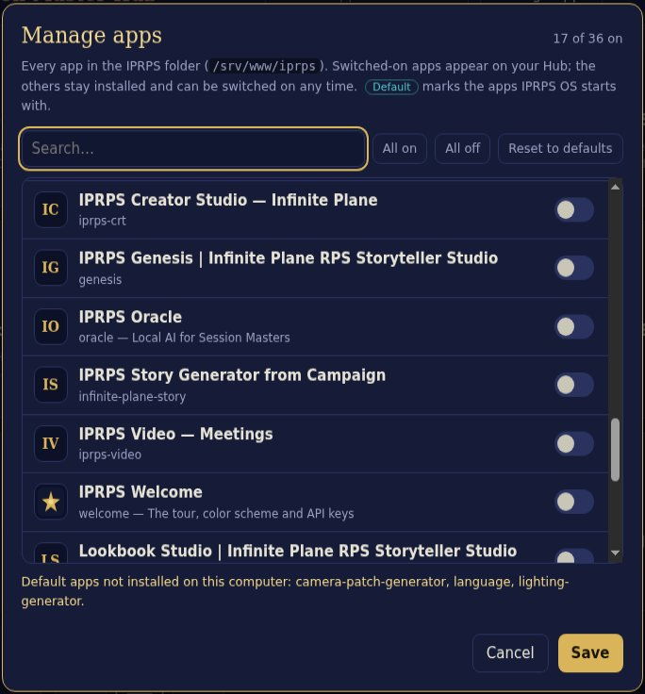
Manage apps: switch each app on or off for your Hub
WALKTHROUGH 1 Set up Iron City Blues
1. Open IPRPS → IPRPS Welcome and go to the Your campaign step.
2. Type the Name: Iron City Blues. Type the Setting: Iron City, the Infinite Plane. Under What it's about, type one sentence: A noir mystery in a rain-soaked harbor where the Guild rules the docks.
3. Choose Create campaign.
4. Go to the Color scheme step and pick the one that's easiest for you to read.
5. Choose Open the Session Master Hub.
6. Choose Manage apps. Make sure these are on: IPRPS Table, Character Sheets, Character Creator, Combat Tracker, Dice Roller, Session Log, Soundboard and IPRPS Writer. Choose Save.
Check: the Hub shows your apps as tiles. In the Combat Tracker, the Campaign menu at the top now lists Iron City Blues.

TIP You can add more campaigns later from any session tool. Open the Campaign menu at the top and choose + New campaign…, or choose the ✎ button next to it to edit one.

Chapter 3: Prepare a session
Good prep makes game night smooth. IPRPS OS gives you a place for each kind of material.

Your campaign folders
Your home folder has a Campaigns folder with three folders inside it:
Folder | Put this inside | Used by
Campaigns/Handouts | Letters, clues, portraits of NPCs | The IPRPS Table (Add media…)
Campaigns/Maps | Maps of cities, buildings and dungeons | The IPRPS Table and the player display
Campaigns/Audio | Music and background sound (MP3, OGG, WAV, M4A) | Session Master Mode plays it as looping ambience

Use pictures and sounds that you made yourself, or that you have the right to use.

Notes in IPRPS Writer
IPRPS Writer is a word processor. Use it for scene notes, NPC lists and read-aloud text. It saves by itself as you type. Save as makes a Word file (.docx), an OpenDocument file (.odt), plain text or a web page. Ctrl+P prints, or saves a PDF.
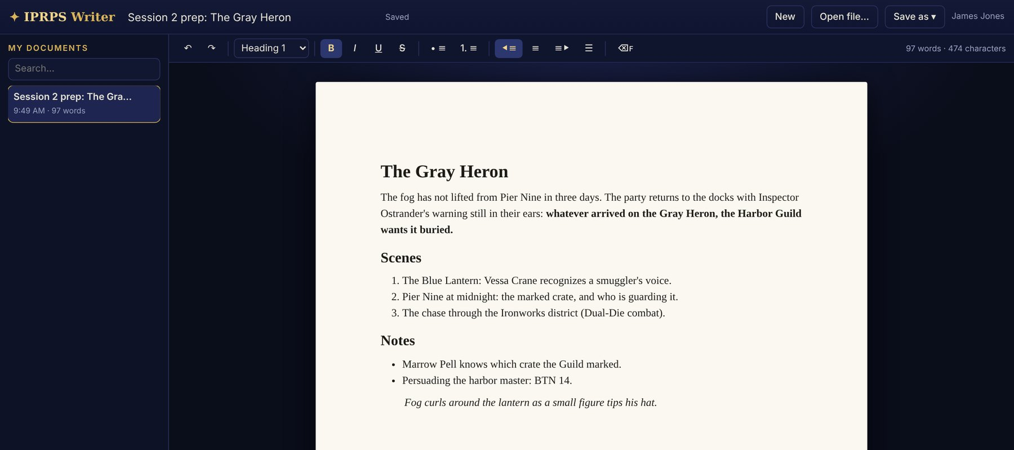
IPRPS Writer with session notes

Character sheets
IPRPS OS has two character sheet apps that work together:
- Character Creator is the IPRPS character sheet. It tracks attributes, skills, advantages, spells and a portrait. It also counts the Development Points you spend, so players can't overspend by mistake.
- Character Sheets is your library. It keeps every player character, NPC and creature, sorted by campaign.
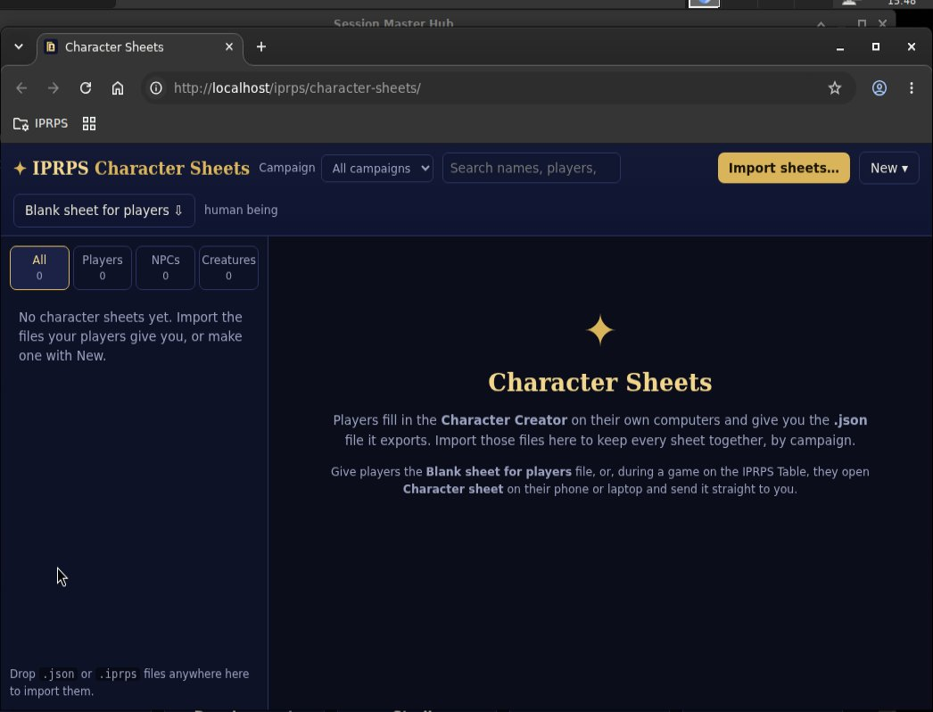
Character Sheets: your library of player, NPC and creature sheets
There are two ways to get your players' characters:
- Before the game. In Character Sheets, choose Blank sheet for players. This saves the Character Creator as one file. Give it to your players by USB stick, email or a shared folder. They open it in any web browser, make their character, and send you the .json file it saves. You choose Import sheets…, or simply drop the files onto the Character Sheets window.
- At the table. Players open 📜 Sheet on their phone or laptop in the IPRPS Table and fill it in there. When they send it, it appears in your Table console under 📜 Character sheets, and you choose Import to Character Sheets.
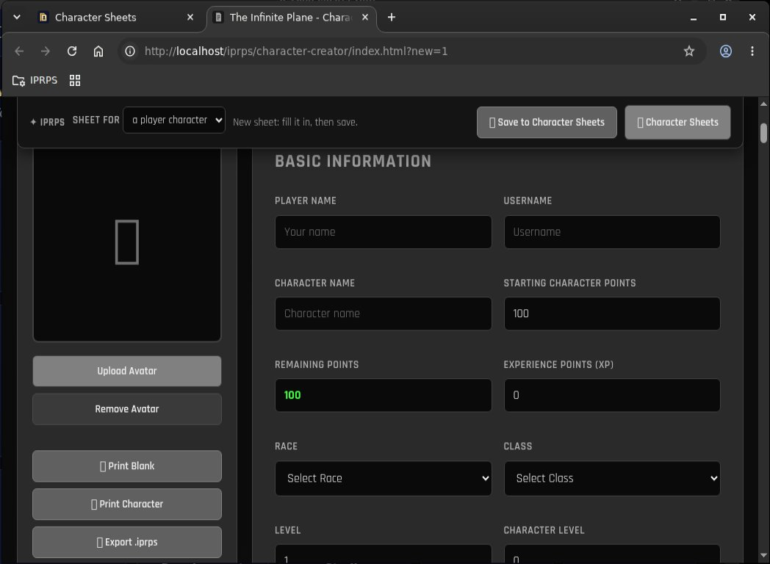
The Character Creator counts Development Points as players build
WALKTHROUGH 2 Get the characters in
1. Open Character Sheets from the Hub. Set Campaign to Iron City Blues.
2. Choose Blank sheet for players and save the file. Open it yourself to see what players will see.
3. In the file, make Brenna Holt: Wolffolk, STR 14, DEX 12, CON 14, WIS 14, and the skills Tracking 30, Brawling 20 and Intimidation 20. Watch the Development Points change as you go. Save it as a .json file.
4. Back in Character Sheets, drop the .json file onto the window, or choose Import sheets…. Choose Import.
5. Now make an NPC: choose New ▾ → NPC sheet and create Inspector Hale Ostrander, a gruff Wolffolk detective.
Check: the list shows Brenna under Players and Ostrander under NPCs. Both will show up in the Combat Tracker's From sheets list.

Chapter 4: Open the IPRPS Table
The IPRPS Table is the heart of in-person play. Your players join from their own devices. They can chat, roll IPRPS dice, see pictures and hear sound you send, and fill in their character sheets. You control everything from the console on your computer.
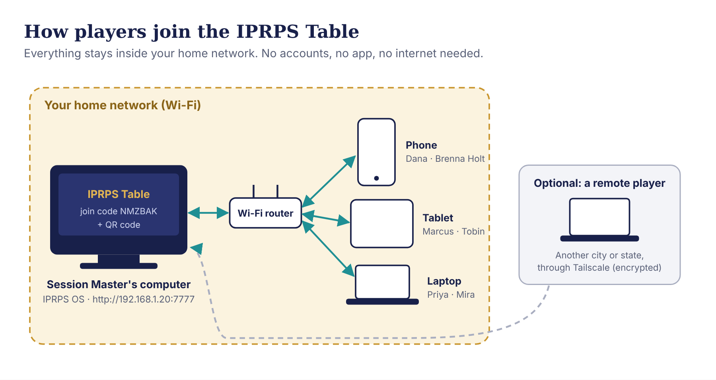
How players join: your computer, your Wi-Fi router, and each player's device. A remote player can join too, through an encrypted link

Session Master Mode: game night in one click
About fifteen minutes before players arrive, choose Session Master Mode on the panel. With one click, it:
- opens the Session Master Hub;
- plays your Campaigns/Audio folder as shuffled, looping background sound, in a small window with play, pause and volume buttons;
- with a second screen (TV, projector or monitor), opens the full-screen player display there; with one screen, it opens the IPRPS Table console instead;
- in Medium and Advanced, warms up the IPRPS Oracle, so its first answer comes quickly.
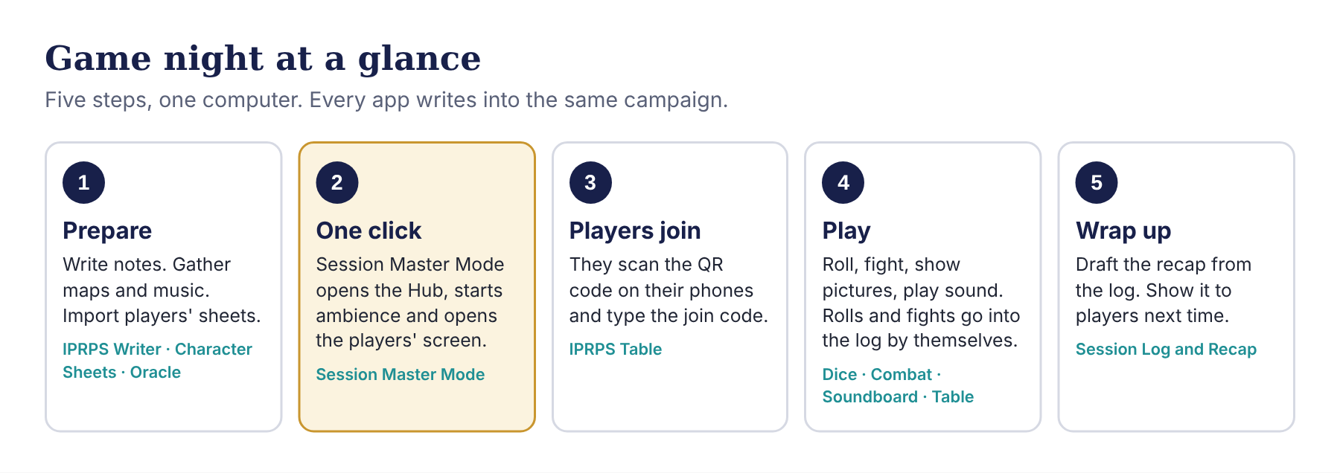
Game night at a glance: prepare, one click, players join, play, wrap up

Opening the table
The table starts Closed. Nobody can join until you open it.
- In the console, click the name at the top and type the campaign name. Players see it.
- Choose Open the table. The status changes to Open.
- The Players join here box shows the join code, the computer's address and a QR code.
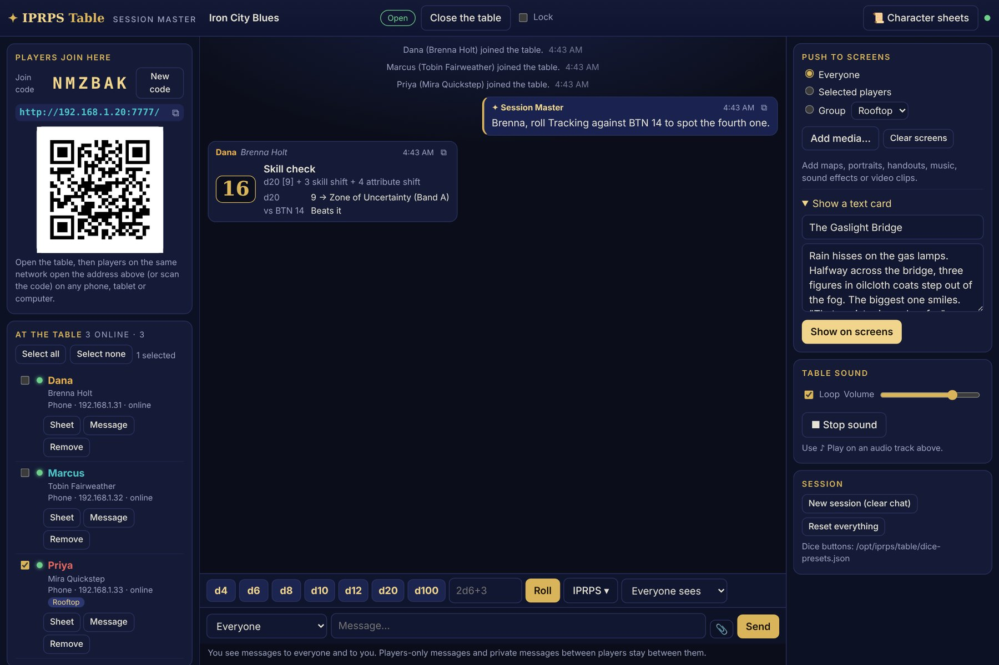
The IPRPS Table console: the join code, address and QR code on the left, chat and rolls in the middle, and the tools for pictures, text cards and sound on the right

How players join
Each player, on a device connected to the same Wi-Fi:
- scans the QR code with the camera (this fills in the code), or opens the address in any web browser;
- types their name and, if they like, their character's name;
- taps Join the table.
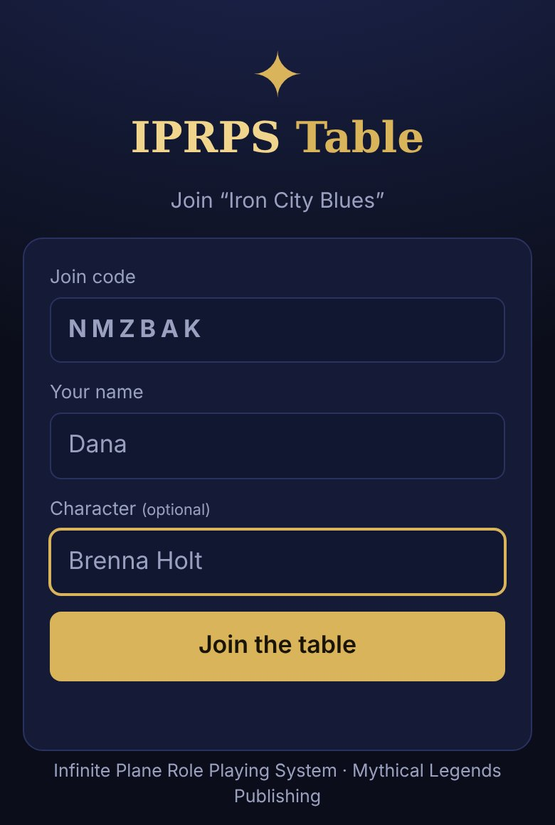
The join screen on a player's phone
Each player appears under At the table with a green dot when they are online. When everyone is in, tick Lock so nobody else can join.

What you can do from the console
You want to | Do this
Talk to everyone | Type in the message box with Everyone selected, then Send
Whisper to one player | Choose their name in the To menu, or choose Message under their name
Talk to part of the party | Tick the players, type a name under Groups, choose Make from selected
Show a picture or video | Under Push to screens, choose who sees it, then Add media… and Show
Read a scene aloud | Open Show a text card, type a title and the text, then Show on screens
Play music or sound on their devices | Choose ♪ Play on an audio file in your media list; tick Loop to repeat it
Clear the players' screens | Clear screens
Roll in secret | Set the dice menu to Secret (only me)
Start fresh next time | Session → New session (clear chat)

Your players see what you send at the top of their screens. The dice bar is at the bottom.
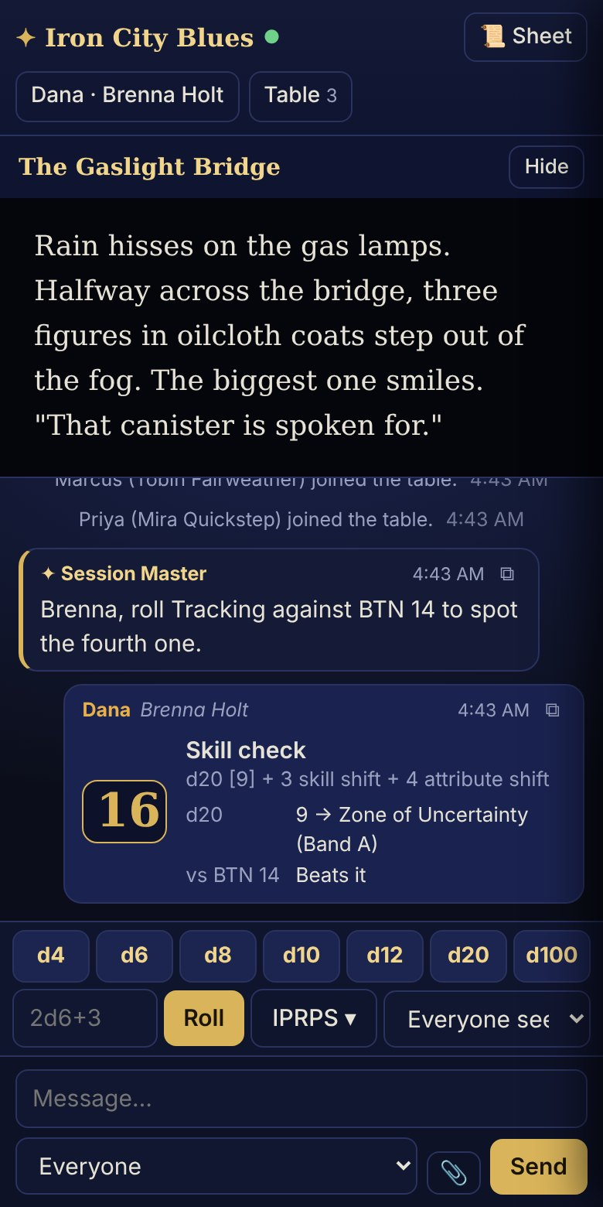
A player's phone: a text card from the Session Master at the top, then the chat, a skill check and the dice bar
Privacy at the table. You see messages sent to everyone and to you. Messages that players send only to other players stay between them. Every roll is made on your computer, so nobody can fake a roll.
TIP Phones stay silent until the player touches the page once. If you start a sound and someone hasn't, they will see 🔊 Tap to turn on the table sound.

WALKTHROUGH 3 Get your players in
1. Choose Session Master Mode on the panel. If you have one screen, the Table console opens. If not, open IPRPS Table from the Hub.
2. Rename the table Iron City Blues and choose Open the table.
3. On a phone on the same Wi-Fi, scan the QR code. Type Dana as the name and Brenna Holt as the character. Tap Join the table.
4. Join from a second device as Priya, playing Mira Quickstep.
5. In the console, tick Priya, type Rooftop under Groups, and choose Make from selected.
6. Open Show a text card. Title: The Gaslight Bridge. Text: Rain hisses on the gas lamps. Three figures in oilcloth coats step out of the fog. Choose Show on screens.
7. Tick Lock.
Check: both devices show the text card at the top. Priya has a Rooftop tag under her name. A third device can't join while the table is locked.

Chapter 5: Roll the IPRPS way
IPRPS uses a d20 for skill checks. The roll has two parts, and IPRPS OS shows both every time.
The total. Roll 1d20, then add the Skill Shift (the skill divided by 10, rounded down) and the Attribute Shift (the attribute minus 10). Compare the total with the BTN (Base Target Number) that you set for the task.
The band. The d20 by itself also falls in a band. Band A answers "yes or no?". Band B answers "how well?".
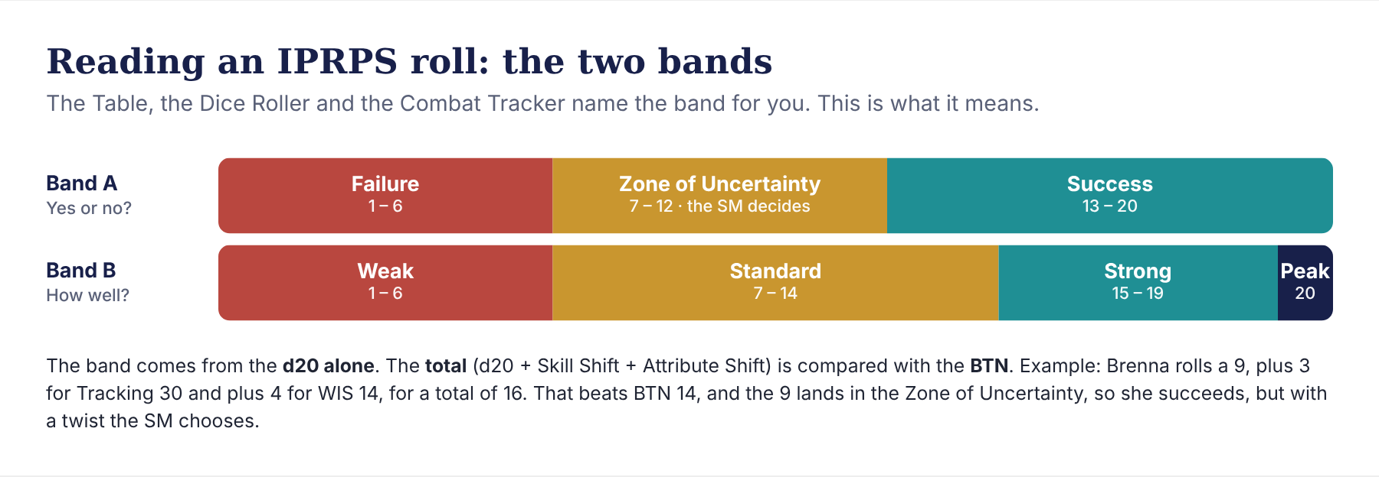
The two IPRPS bands. Band A: Failure 1–6, Zone of Uncertainty 7–12, Success 13–20. Band B: Weak 1–6, Standard 7–14, Strong 15–19, Peak 20
An example. Brenna tracks the smugglers. Her player rolls a 9 on the d20. Tracking 30 gives a Skill Shift of +3, and WIS 14 gives an Attribute Shift of +4. The total is 16, which beats BTN 14. But the 9 lands in the Zone of Uncertainty, so you, the Session Master, decide the twist. Maybe she finds the trail, but the smugglers hear her coming.
You never have to do this math. The Table, the Dice Roller and the Combat Tracker do it, and they name the band for you.

Three places to roll
1. On the IPRPS Table. Players open IPRPS ▾ on the dice bar and pick a roll: Skill check, Initiative, Reaction, Trinity Hand, Dual-Die attack, Infinite Convergence, RPS stance, or a weapon's damage. They type their numbers and roll. They choose who sees it: Everyone sees, Only the SM sees or Only I see.
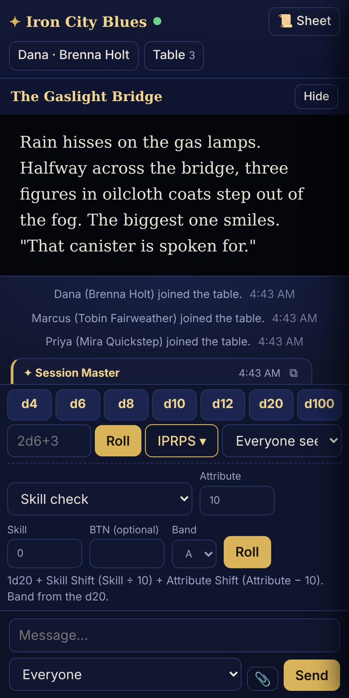
On a phone: the IPRPS rolls menu with a Skill check ready to roll
2. In the Dice Roller on your computer. It has every die, any dice formula (such as 2d6+3), and the same IPRPS rolls. Under After each roll you choose what happens next: Add it to the session log, Show it on the player display, Show it on the IPRPS Table, or Secret roll (only you see it). The History keeps every roll.
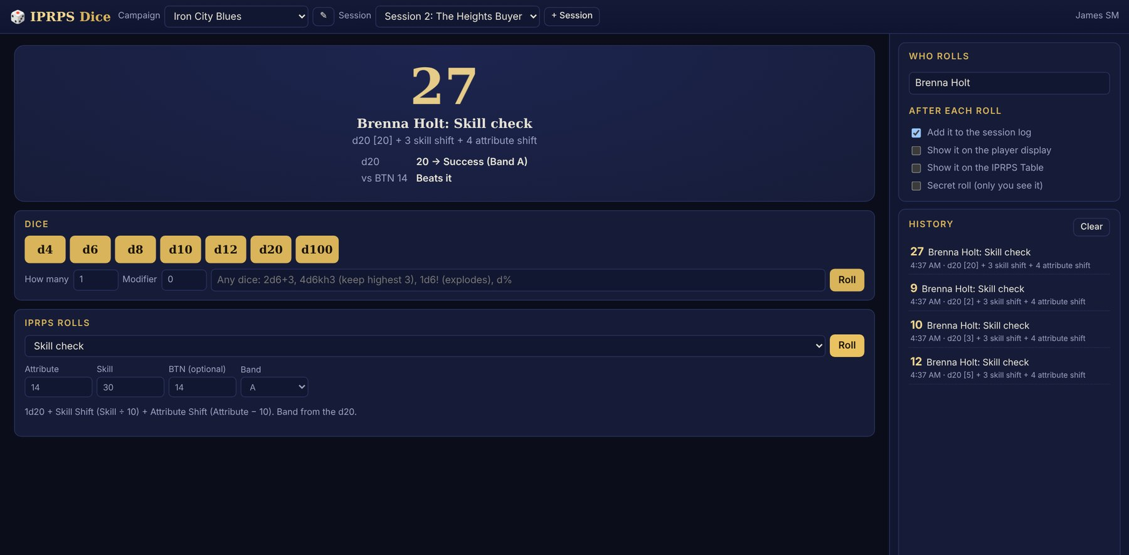
The Dice Roller: a Skill check for Brenna, with its band and BTN result
3. In the Combat Tracker during fights (Chapter 6), with Quick roll.
WALKTHROUGH 4 A skill check, start to finish
1. With your players at the Table, send everyone a message: Brenna, roll Tracking against BTN 14.
2. On Dana's phone: IPRPS ▾ → Skill check. Attribute 14, Skill 30, BTN 14, Band A. Tap Roll.
3. Read the result in the console's chat. It shows the d20, the shifts, the total, the band, and Beats it or Falls short.
4. Now roll a secret one yourself. In the Dice Roller, type Ostrander under Who rolls, pick Reaction, tick Secret roll (only you see it), and roll.
5. Untick Secret roll and tick Add it to the session log. Roll a Skill check for Brenna.
Check: the players saw Brenna's roll but not Ostrander's reaction. The Session Log (Chapter 9) shows Brenna's second roll.

Chapter 6: Run a fight
The Initiative and Combat Tracker keeps a fight moving. It tracks turn order, rounds, HP, Armor Rating and conditions for every fighter. Fights are saved by session, so you can stop and pick up later.
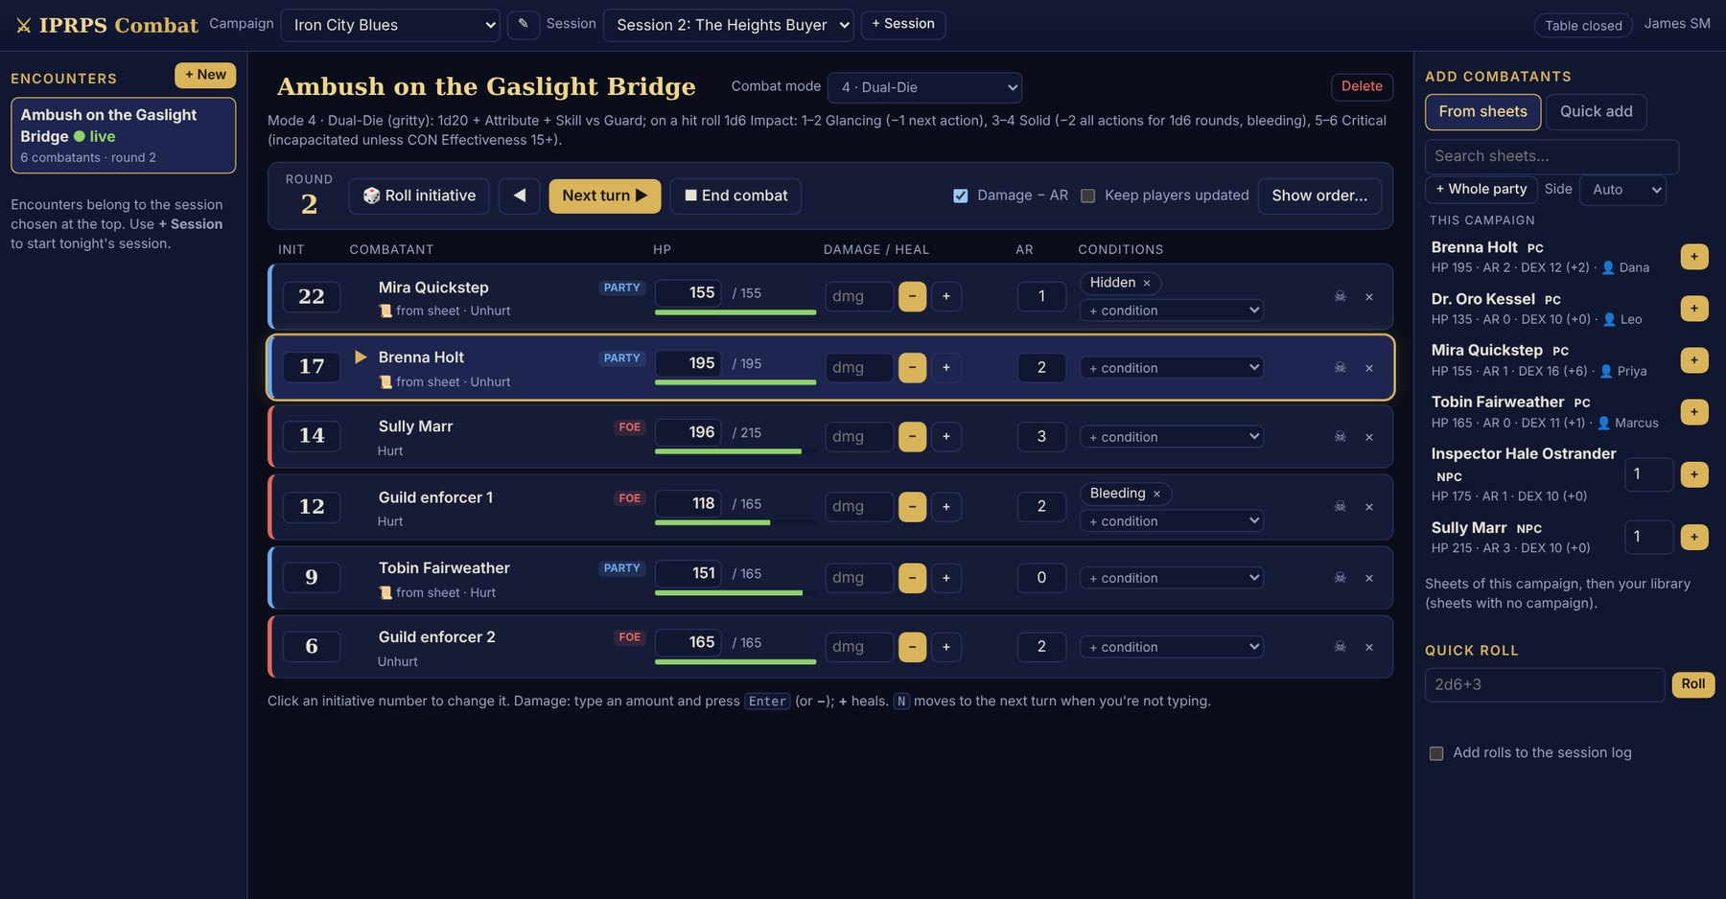
The Combat Tracker in round 2: turn order on the left, HP bars, AR and conditions for each fighter, and sheets to add on the right

The five IPRPS combat modes
Pick the mode in the Combat mode menu. The tracker shows a short reminder of how that mode works.
Mode | Best for | In one line
1 · Standard | Most fights | Initiative 1d20 + DEX modifier. Attack 1d20 + Skill Shift + Attribute Shift against Guard. Damage − AR
2 · Trinity Hand | Bosses, hordes, player-versus-player | Everyone rolls 1d3 Velocity, 1d20 Impact and 1d12 Guard at once. Bosses roll extra Impact dice (Hydra Hand)
3 · Rock-Paper-Scissors | Quick story skirmishes | Rock beats Scissors, Scissors beats Paper, Paper beats Rock
4 · Dual-Die | Gritty, dangerous fights | On a hit, roll 1d6 Impact: Glancing, Solid or Critical wounds
5 · Infinite Convergence | One big, decisive clash | Each fighter picks a Blur level: more dice for speed, or bigger dice for precision. Top results explode

The main controls
Control | What it does
+ New | Makes a new encounter in tonight's session
From sheets | Adds characters from Character Sheets. + Whole party adds every player character at once
Quick add | Adds fighters by hand: name, how many, HP, AR and initiative modifier
🎲 Roll initiative | Rolls for every fighter who doesn't have a number yet
▶ Start combat / Next turn ▶ | Starts the fight and moves to the next fighter. The N key does the same
Damage box | Type the damage and press Enter. With Damage − AR ticked, the tracker subtracts the target's AR for you. + heals
+ condition | Adds a condition such as Bleeding or Hidden
Keep players updated | Shows the turn order to players after each turn
■ End combat | Ends the fight and records it in the session log

WALKTHROUGH 5 Ambush on the Gaslight Bridge
The smugglers spring a trap on the party in the rain. Use Dual-Die, the gritty mode.
1. Open the Combat Tracker. Set Campaign to Iron City Blues. Choose + Session to start tonight's session.
2. Under Encounters, choose + New. Name it Ambush on the Gaslight Bridge. Set Combat mode to 4 · Dual-Die.
3. Under Add combatants → From sheets, choose + Whole party. Your player characters join with their HP and AR.
4. Choose Quick add. Name Guild enforcer, How many 2, HP 165, AR 2, Side Foe. Choose + Add. Add Sully Marr, HP 215, AR 3, the same way.
5. Choose 🎲 Roll initiative, then ▶ Start combat.
6. Mira hits an enforcer for 12. Type 12 in his damage box and press Enter. His HP drops by 10, because his AR of 2 is taken off.
7. The hit was a Solid wound. Choose + condition and add Bleeding.
8. Press N to move to the next fighter. Tick Keep players updated so the players see whose turn it is.
9. When Sully flees, choose ■ End combat.
Check: the fight shows the round number and each fighter's HP bar. The Session Log has a combat entry for the ambush.

TIP Click any initiative number to change it, for example when a player delays their turn.

Chapter 7: Set the mood
Sound turns a description into a scene. IPRPS OS gives you three ways to play it.
Sound | Where it plays | How
Ambience playlist | Your computer's speakers | Session Master Mode plays your Campaigns/Audio folder
Soundboard pads | Your speakers, and players' devices if you choose | Click a pad, or press its key
Table sound | Players' phones and laptops | ♪ Play in the Table console

The Soundboard
The Soundboard puts sounds on big buttons called pads. The built-in sounds are made by the computer as they play, so they need no files and no internet.
- ∞ pads loop until you click them again: rain, storm, wind, campfire, ocean, river, cave drips, night crickets, a dungeon drone and a tavern hum. Several can play together.
- Effect pads play once: thunder, a sword clash, an arrow, a spell, a gong, a war horn, level up and more.
- Keys 1–0 and Q–P play the first twenty pads. Esc fades everything out.
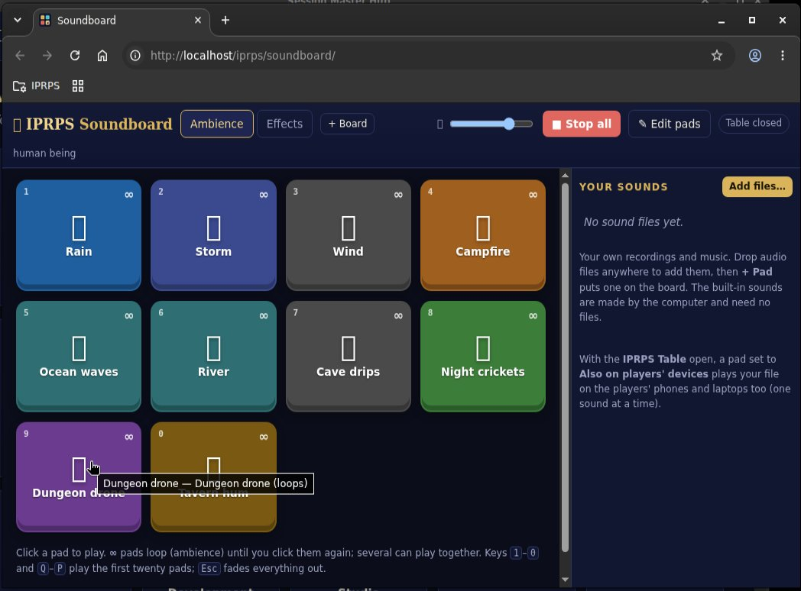
The Soundboard's ambience board, with your own sounds on the right
Add your own music and recordings with Add files…, or drop them on the window. Choose + Pad to put one on a board. Make a new board, such as Tavern or Battle, with + Board. To change a pad, choose ✎ Edit pads and click it. A pad set to Also on players' devices plays your file on the players' phones too, while the Table is open.
TRY IT Make a board called Iron City. Put Rain and Tavern hum on it, plus Thunder as an effect. Start the rain, then press the thunder pad's key during the ambush.

Chapter 8: Ask the IPRPS Oracle (Medium and Advanced)
Players often go somewhere you didn't plan. The IPRPS Oracle helps you keep up. It is a storyteller AI. Its model, Llama 3.2 3B, runs entirely on your computer. It needs no internet, no account and no API key, and nothing you type leaves the machine. Built with Llama.
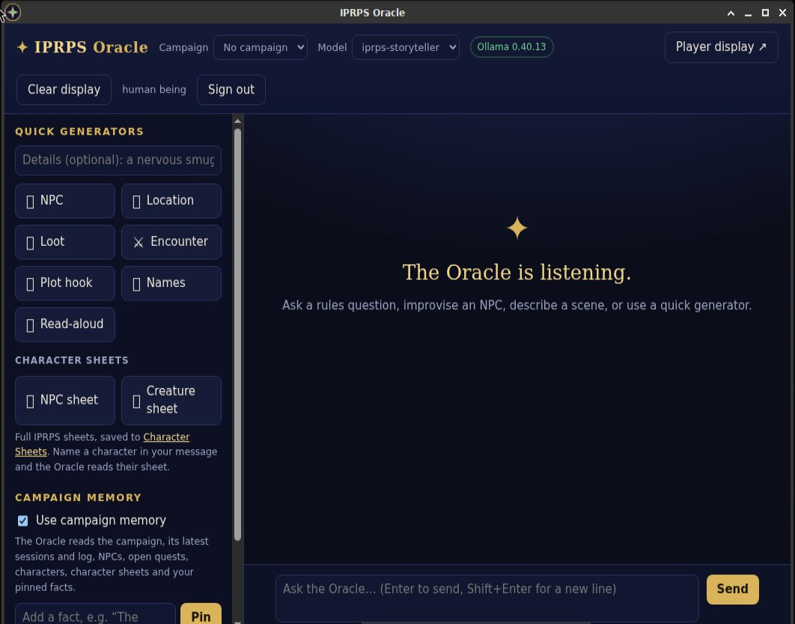
The IPRPS Oracle: quick generators, character sheets and campaign memory on the left, the conversation on the right
What it can do:
- Quick generators: NPC, Location, Loot, Encounter, Plot hook, Names and Read-aloud. Type a few words, such as a nervous dockhand, then choose a generator.
- Character sheets: NPC sheet and Creature sheet write complete IPRPS sheets and save them to Character Sheets.
- Campaign memory: it reads your campaign, its latest sessions and log, NPCs, open quests and character sheets. Pin facts it must always respect.
- Share it: under each answer, Show players puts it on the player display, Pin to memory saves it as a fact, and Save NPC keeps a character for later.
Good habits:
- Set the Campaign menu at the top before you ask, so the Oracle knows your story.
- Pin the facts that matter, like who is secretly working for whom.
- Treat answers as ideas. You are the Session Master, so change anything you like.
- The first answer of the day is slower while the AI loads. Session Master Mode warms it up for you.
- On an older computer, a long answer can take a minute or more. Clear this chat between scenes, and untick Use campaign memory for Names and Loot. Both make answers start sooner.
WALKTHROUGH 6 When the players go off script
Tobin decides to visit a pawnshop you never planned.
1. Open the IPRPS Oracle. Set Campaign to Iron City Blues.
2. Under Campaign memory, type The Harbor Guild pays the Night Watch to look away on Thursdays. Choose Pin.
3. In the Details box above the generators, type a pawnbroker near the docks who hears everything. Choose NPC.
4. Read the answer. If you like the character, choose Save NPC.
5. In the Details box, type the pawnshop at night, in the rain and choose Read-aloud. Choose Show players to put it on the player display, or copy it into a Table text card.
6. Need stats in a hurry? Type a short description of the pawnbroker in Details and choose NPC sheet. It takes a minute or two with the local model.
Check: the new sheet appears in Character Sheets under NPCs, ready to add to a fight.

Optional: Claude, the online AI
The local model is free and private, but it can be slow on older computers. If you have internet, the Oracle can use Claude, an AI made by Anthropic, instead. Claude usually answers in seconds and writes richer scenes. You need your own Anthropic API key, and Anthropic charges your account a small amount for each answer.
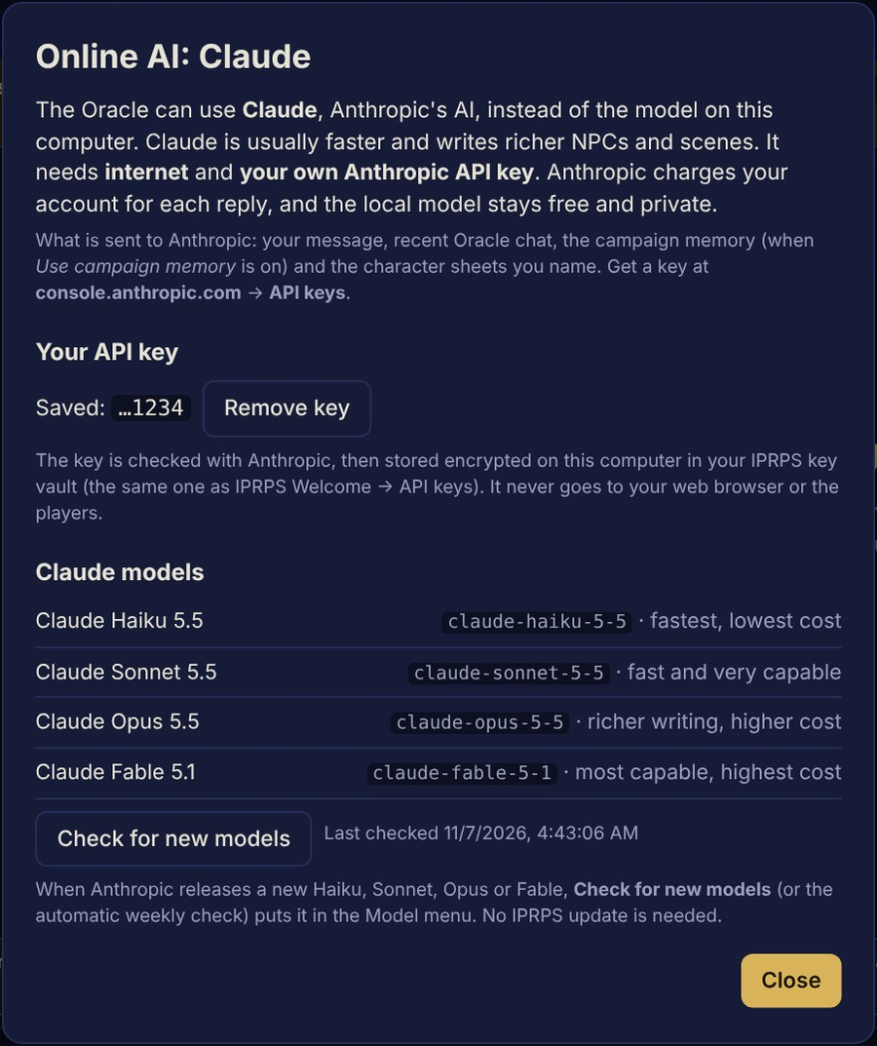
The Online AI window: your saved key, the four Claude models, and Check for new models
Set it up once:
- Get a key at console.anthropic.com, under API keys. It starts with sk-ant-.
- In the Oracle, choose Online AI… next to the Model menu.
- Paste the key and choose Check and save. The Oracle tests the key first. Then it stores it, locked with encryption, on your computer.
Choose a model in the Model menu, under Online: Claude:
Model | Good for
Claude Haiku | The fastest and cheapest. Quick NPCs and names at the table
Claude Sonnet | Fast and very capable. A good everyday choice
Claude Opus | Richer writing, at a higher cost. Prep work between sessions
Claude Fable | Anthropic's most capable model, at the highest cost

What changes when Claude is on:
- The top bar turns teal and says Online. A notice above the message box reminds you that your message, the campaign memory and any character sheets you name go to Anthropic.
- Recaps (✦ Draft with the Oracle) and NPC sheet use Claude too.
- To go back, choose iprps-storyteller under On this computer. Remove key deletes your key.
New Claude models. When Anthropic releases a new model, choose Check for new models in Online AI…. The Oracle also checks once a week by itself. The new model shows up in the menu. You don't need an IPRPS update.
TIP Use the local model when your campaign holds secrets you'd rather keep at home. Use Claude when speed matters most, like a busy game night.

Chapter 9: Wrap up the night
The Session Log and Recap keeps a record of every game night. Notes, events, rolls, fights, loot and XP go in as you play. The Dice Roller, the Combat Tracker and the Oracle add their own entries, so your log fills up by itself.
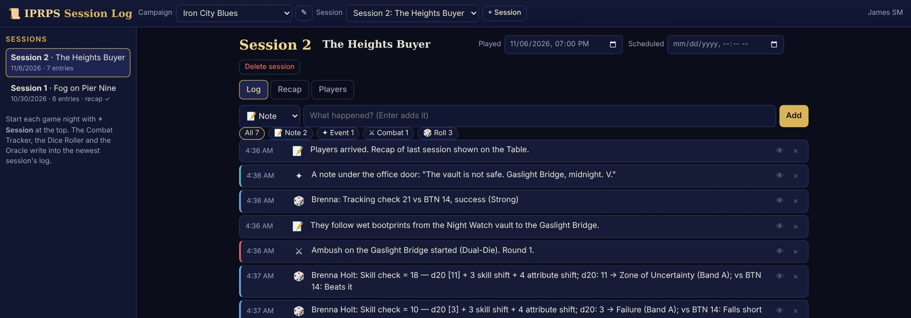
The Session Log for tonight: notes, an event, a roll and a fight, with filters by type

During the game
Start each game night with + Session at the top. Then add your own entries as you go. Pick the type (📝 Note, ✦ Event, ⚔ Combat, 🎲 Roll, 💰 Loot or ⭐ XP), type what happened, and press Enter.

After the game
Open the Recap tab:
- Draft from the log writes a first draft of the recap from tonight's entries. In Medium and Advanced, ✦ Draft with the Oracle writes it as a short story instead.
- Edit the draft. It's for the players, so keep secrets out of it.
- Put your secrets in Session Master notes. Players never see them, but the Oracle reads them.
- Copy, Download .md and Print let you share the recap outside IPRPS OS.
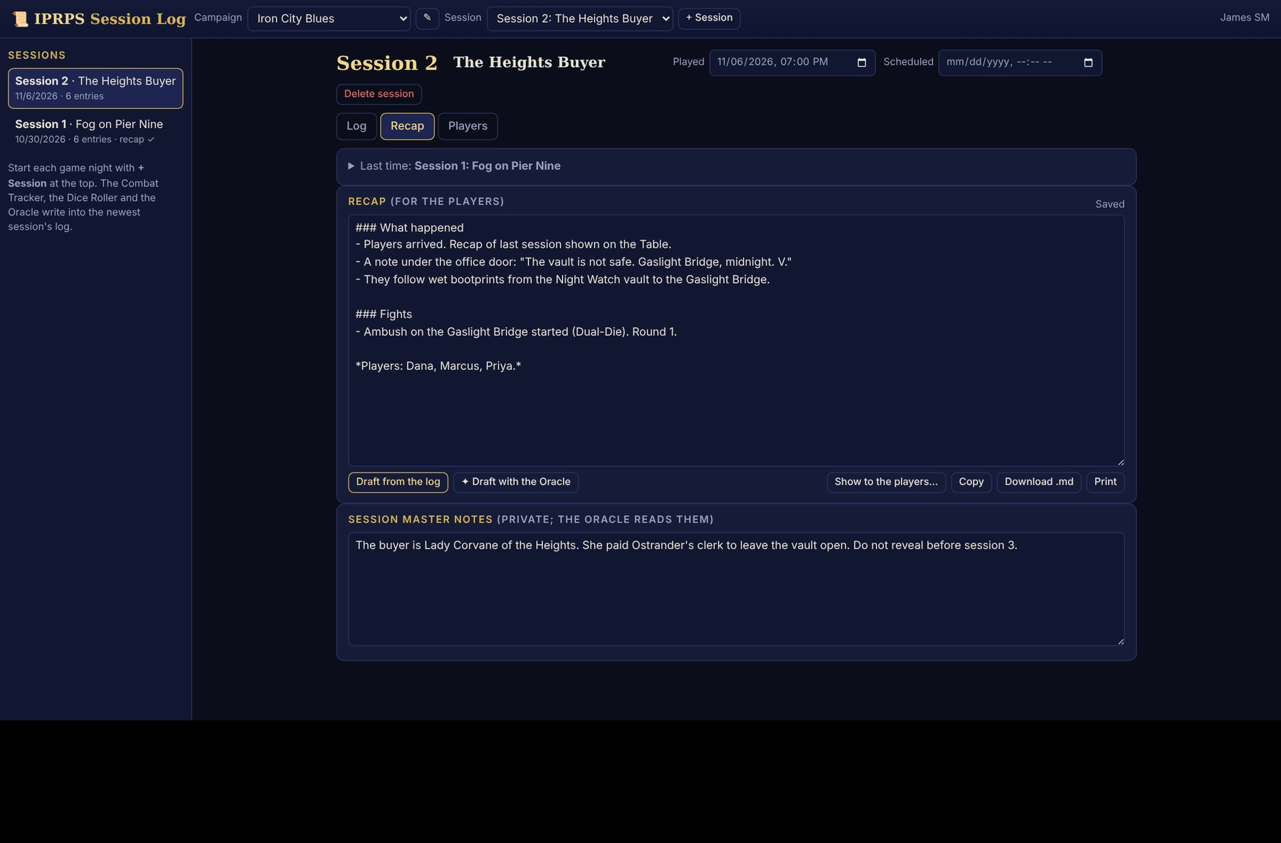
The Recap tab: a recap drafted from the log, and private Session Master notes below
Use the Players tab to record who came and the XP each player earned. XP here is a record. Update each character's XP on their sheet too.
WALKTHROUGH 7 Close out the night
1. In the Session Log, check that tonight's session is selected. Add a 💰 Loot entry: A brass key from Sully's coat.
2. Open the Recap tab and choose Draft from the log. Shorten it to a few sentences.
3. In Session Master notes, type the secret: The buyer is Lady Corvane of the Heights.
4. Open the Players tab. Mark who played, and enter the XP you awarded.
5. In the Table console, choose Close the table. Everyone is disconnected, but the chat and media are kept for next time.
6. Next game night, start the new session with + Session. On its Recap tab, open Last time and choose Show “last time” to the players… to begin with last session's recap.
Check: the session list on the left shows "recap ✓" next to tonight's session.

Chapter 10: Keep it running

IPRPS Updates
IPRPS OS updates itself without reinstalling. About 10 minutes after you start the computer, and every 6 hours while you're online, it checks for updates. When some are ready, a notice appears on the desktop and on the Hub's IPRPS Updates tile.
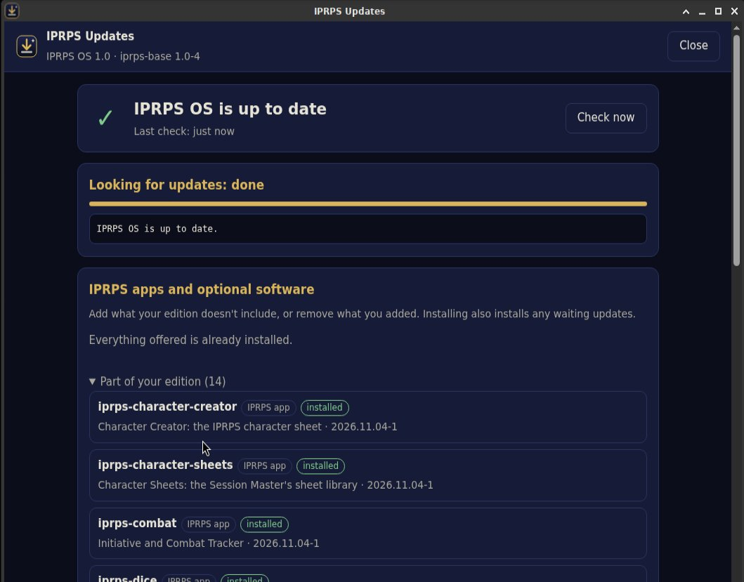
IPRPS Updates
To install them, open IPRPS → IPRPS Updates, type your password, and choose Install updates. Your campaigns, sheets, settings and files are kept. The same window lists extra IPRPS apps and optional software you can add with Install.
TIP Install updates the day before game night, not an hour before.

Remote players
A friend who moved away can still join your IPRPS Table. Both computers install Tailscale, a free app that links them over the internet with strong encryption. Your friend then joins exactly like a player on your Wi-Fi, at an address your Table console lists. IPRPS OS itself doesn't change.
In short:
- On your computer, run the iprps-remote-play.sh script from the IPRPS OS repository, and sign in to Tailscale.
- In Tailscale's admin page, share your IPRPS computer with your friend, and add the rule that lets players reach only the Table.
- Your friend installs the Tailscale app, accepts your invite, and opens the http://100.x.y.z:7777/ address with the join code.
Full steps are in docs/REMOTE-PLAYERS.md and in Appendix G of the build guide. Test it with a phone on mobile data first. Pictures and video you show come from your home internet's upload speed, so short clips work best.

Quick reference: game night
Moment | Tool | Where
Open everything for game night | Session Master Mode | Panel at the top of the screen
Let players in | Open the table, then Lock | Table console, top
Show a map or handout | Push to screens → Add media… → Show | Table console, right
Read a scene aloud | Show a text card → Show on screens | Table console, right
Music on players' devices | ♪ Play, Loop, ■ Stop sound | Table console, right
Whisper to one player | To menu → their name | Table console, message box
Talk to a split party | Make from selected, then To → the group | Table console, left
Secret roll | Secret (only me), or Secret roll in the Dice Roller | Dice bar / Dice Roller
An IPRPS check | IPRPS ▾ → Skill check | Dice bar on any device
Start a fight | + New, + Whole party, Roll initiative | Combat Tracker
Next turn | Next turn ▶ or the N key | Combat Tracker
Thunder! | Click the pad, or press its key | Soundboard
A quick NPC or place | NPC, Location | IPRPS Oracle (Medium and up)
A faster Oracle | Model menu → a Claude model (online, your key) | IPRPS Oracle, Online AI…
End of the night | Draft from the log, then Close the table | Session Log, Table console

Troubleshooting at the table
Problem | What to do
A player can't open the Table address | Their device must be on the same Wi-Fi as your computer. Guest Wi-Fi networks often block devices from seeing each other, so use your main network. Check that the table says Open
"The table is closed" | Choose Open the table in the console. After a restart, the table always starts closed
A player can't join | You may have ticked Lock. Untick it, let them in, then lock again
A phone plays no sound | The player must tap the page once. Look for 🔊 Tap to turn on the table sound
Someone saw the join code who shouldn't have | Choose New code. Players already at the table stay connected
The Combat Tracker says to choose a session | Choose + Session at the top to start tonight's session
A character isn't in the From sheets list | Import their sheet into Character Sheets, and set its campaign to this one
The Oracle is slow | The first answer of the day takes longest, so start Session Master Mode early. Clear this chat between scenes. The local model needs a fairly recent processor and plenty of memory (16 GB is best). For answers in seconds, choose a Claude model (Chapter 8)
The Oracle says A new local model is ready | An update brought a new local model. Open a terminal and type sudo iprps-ai-model upgrade once (it downloads 3.4 GB). The old model keeps working until then
Claude: refused the API key, or out of credit | Copy the key again from console.anthropic.com, or add credit to your Anthropic account. The local model always works
The players see an old picture | Choose Clear screens, then show the new one

Glossary
Term | Meaning
AR (Armor Rating) | Armor's protection. It is subtracted from damage: Damage − AR
Band A / Band B | How to read the d20. Band A: Failure, Zone of Uncertainty, Success. Band B: Weak, Standard, Strong, Peak
BTN (Base Target Number) | The number a check's total must reach
Campaign | Your whole story. Sessions, sheets, fights and notes belong to it
Console | The Session Master's screen of the IPRPS Table
Development Points (DP) | The points players spend to build characters
IPRPS | The Infinite Plane Role Playing System, by Mythical Legends Publishing
IPRPS Oracle | The storyteller AI (Medium and Advanced). Llama 3.2 runs on your computer; Claude is an optional online choice
API key | A secret code from a company like Anthropic that lets an app use its online AI and charges your account
IPRPS Table | Lets players join from their own devices to chat, roll and see what you share
Join code | The six-character code players type to join an open table
Player display | A full-screen window for players on a second screen
Session | One game night. Its log, fights and recap belong to it
Session Master (SM) | The person who runs the game
Session Master Mode | One click that opens the Hub, ambience and the players' screen
Skill Shift / Attribute Shift | What a check adds to the d20: skill ÷ 10, and attribute − 10
Zone of Uncertainty | A d20 of 7 to 12 in Band A. The SM decides what happens, often success with a cost

IPRPS OS and the Infinite Plane Role Playing System are by Mythical Legends Publishing, LLC (infiniteplane.space). The IPRPS Oracle's local model is Built with Llama: Llama 3.2 is licensed under the Llama 3.2 Community License, Copyright © Meta Platforms, Inc. All Rights Reserved. Claude is a product of Anthropic. Screenshots show IPRPS OS 1.0 with example data. Roll20, Owlbear Rodeo, Alchemy RPG, Fantasy Grounds and D&D Beyond are trademarks of their owners and are named only for comparison. Their features and prices change; check their websites for current details.

