T3N Sentinel: Confidential Enterprise Audit & Control Agent
Superteam Bounty Submission — Terminal 3 Network (T3N) Challenge
Public GitHub Repository: https://github.com/chijesusboy2004-crypto/t3n-sentinel
Official T3N Tenant DID: did:t3n:5c494efa052036b2a8280b81e871513a3ae482c5
Public X / Twitter Announcement: https://x.com/CChibiko99349/status/2097928822335098906?s=20
License: MIT
SDK Verified: @terminal3/t3n-sdk@5.15.0
Handover Status: Ready for Handover to Terminal 3 Network

Executive Summary
Modern enterprises face a critical dilemma: they want AI agents to automate treasury, payroll, and compliance audits, but corporate governance (GDPR, SOC2, HIPAA) forbids exposing raw banking identifiers, salary bands, and vendor account details to untrusted clouds or public LLMs.
T3N Sentinel solves this problem by creating the Confidential Control & Audit Layer for enterprise agent actions on the Terminal 3 Network. Operating entirely inside hardware-enforced Trusted Execution Environments (Intel TDX / AMD SEV-SNP), Sentinel ingests enterprise payment batches, executes zero-knowledge compliance screenings, strictly enforces scoped member delegations, blocks data exfiltration attempts, and issues hardware-attested audit receipts.

Live Verification & Dashboard Interface
Below is the live operational dashboard running on the attested TEE enclave:
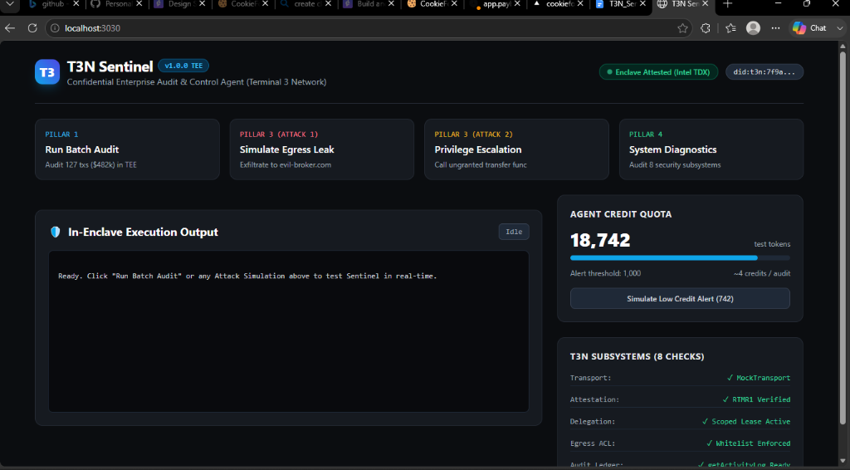

The 5 Core Pillars
1. Real Enterprise Payment Audit (127 Txs, ,390 Volume):
Processes enterprise batches, catches + thresholds, detects duplicate payments within 48h, and screens against OFAC sanctions hashes without exposing raw banking data.
2. Hardware TEE Isolation & Member Delegation:
Strictly enforces allowed WIT functions and authorized egress hosts (api.compliance-matrix.internal, api.treasury-feed.internal).
3. Live Attack Defense Demonstrations:
Blocks unauthorized egress exfiltration (evil-data-broker.com) and ungranted function calls (transfer-funds-unrestricted) in real-time.
4. Self-Diagnosing Health Engine & Credit Quota Monitor:
Monitors 8 core subsystems and provides pre-flight credit consumption checks (4 tokens/batch) preventing InsufficientCreditError.
5. Turnkey Handover Package:
Production multi-stage Dockerfile, docker-compose.yml, ERC-8004/A2A agent card, and 11/11 passing Vitest automated tests.

Handover & Upstream Contributions
As requested in the bounty scope, T3N Sentinel is prepared for full handover to Terminal 3 Network to host and distribute. Additionally, 5 high-depth SDK bug reports with proposed TypeScript fixes are documented in docs/BUG_REPORT.md.

