IS 604 Assignment 6

David Stern

November 12, 2015

1) At a driver’s license facility, applicants arrive at a rate of approximately 10/hour. At check-in, a single clerk checks the applicant’s driving history (if any) and gives the applicant the initial paperwork. Check-in takes approximately 5 minutes. The written exam is administered by one of two exam clerks. When an applicant arrives, s/he waits for an available clerk and, once one is available, takes the exam with the clerk. The exam requires approximately 8.8 minutes. At checkout, the applicant completes the process using one of two check-out computers and receives his/her temporary license. Check-out takes approximately 9 minutes.

a. How many ‘source’, ‘server’, ‘sink’ do we need to develop this model, what do those objects stand for in the real system?

For this mode, we require one source, three servers, and one sink. The three servers represent the three processes in the licensure process: check in, exam administration, and check out.

b. Develop your model in Simio. Show your screenshots including the parameters used in the model (e.g., interarrival time, capacity of the server, etc.)

For the parameters in the model, I set the interarrival time of the source as a constant of 6 minutes (as suggested in the Nov. 5 meet-up) and the capacities of the Check In, Exam, and Check Out servers, respectively, at 1, 2, 2, respectively, and the processing times as 5, 8.8, 9.

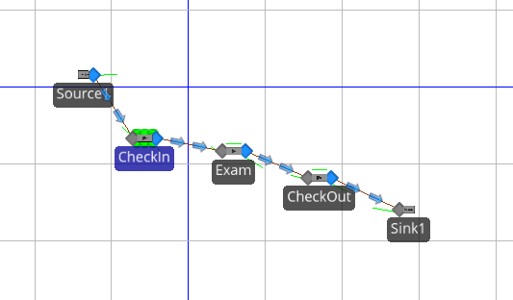

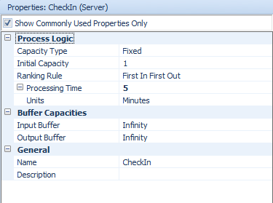 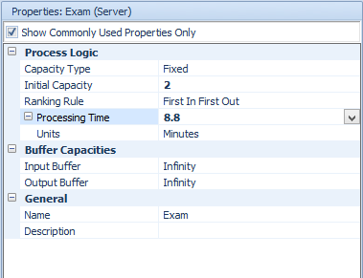. 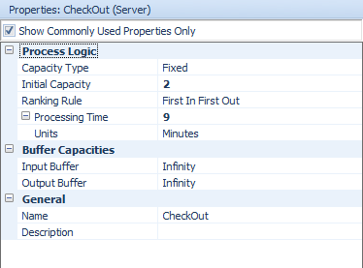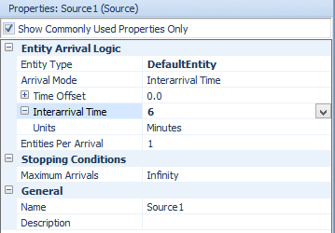

c. Run the model and obtain the performance measures: Server Utilizations, Time in System, and Number in System. Determine the model run time and provide your supporting reason.

Server Utilizations:

Check In: 83.3333%

Check Out: 74.2046%

Exam: 72.9952%

Time in System:

Average: 0.3824 hours (22.944 minutes)

Maximum: 0.3824 hours (22.944 minutes)

Minimum: 0.3824 hours (22.944 minutes)

Number in System:

Average: 3.8017

Maximum: 4

Model Run Time:

I set the model to run for 24 hours. The run time could also be approximated by taking the product of the average time in the system (0.3824 hours) and the number of observations that exited the sink (237) and divide it by average number in the system (3.8017). This gives us a run-time of 23.839 hours. We must remember, however, that the number of objects in the system when the clock stops will be around the average number in the system (3.8017). We can see this as the number that enter the system at the source after we run the simulation is 240 and the number that exited the sink is 237. If the simulation would have run until all 240 objects exited the system, the run time, would have been 24.141 hours. If we average the two run times, we get 23.99 hours.

d. The facility is considering to add an optional “computerized exam kiosk” to replace one of the two clerks. Applicants would have a choice between the exam administered by a human clerk and the computerized exam. The computer kiosk will support two exam-takers at a time. How would you modify the current Simio model? Show your related screenshots. (You do not have to run the model for this question)

I would modify the model by adding a server to represent the computer kiosk and have it run parallel to the server that represents the human clerk. There would then be two pathways exiting the check-in server – one to each of the exam servers. The exam servers would each have their own path to the check-out server. The computer kiosk would have a fixed capacity of two, and we would have to modify the capacity of the clerked exam server to one.

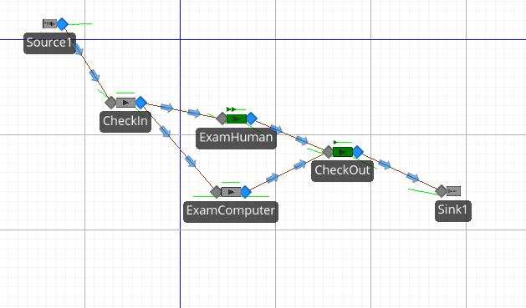

2) Use both Simio and your own developed queuing simulation program to conduct a simulation study for a M/M/1 queue where the mean inter-arrival time equals to 10 minutes and the mean service time is about 7 minutes. Compare the following performance measures: system utilization rate (ρ), expected number of customers in the queue (LQ), expected system time (W) obtained from the above simulators to the analytical solution and make your comments.

$$λ=6 per hour$$

$$μ=8.57 per hour$$

$$System Utilization rate, ρ=\frac{6}{8.57}=0.7$$

$$Expected Number in Queue, LQ=\frac{{0.7}^{2}}{1-0.7}=1.63$$

$$Expected System Time W=\frac{1}{8.57-6}= 0.389$$

I built a fairly simple model in Simio and ran it for 1000 hours. The results I got were fairly close to the analytical values: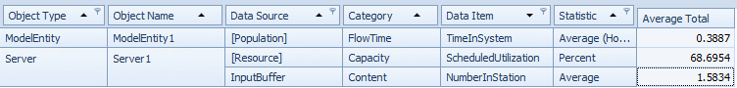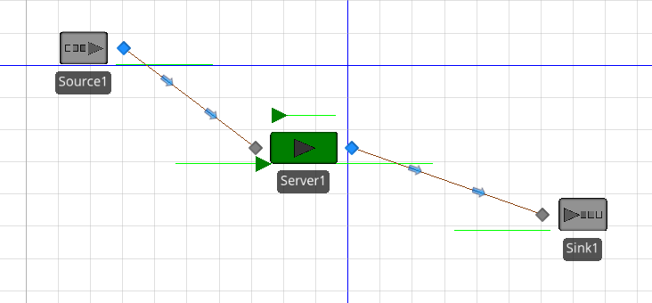

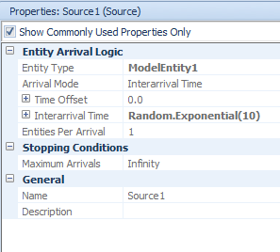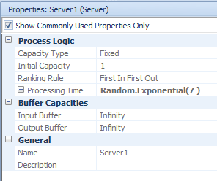

## Using the queuing package in R, we can confirm the analytical values:

library(queueing)

mm1 <- NewInput.MM1(lambda=6, mu=8.57, n=0)

QueueingModel(mm1)$RO

QueueingModel(mm1)$Lq

QueueingModel(mm1)$W

## 6.1) A tool crib has exponential interarrival and service times and servers a very large group of mechanics. The mean time between arrivals is 4 minutes. It takes 3 minutes on the average for a tool-crib attendant to service a mechanic. The attendant is paid $10 per hour and the mechanic is paid $15 per hour. Would it be advisable to have a second tool-crib attendant?

To answer this question, we must compare the costs of each scenario. Hiring the attendants costs $10/hour/server. The costs of the mechanics waiting in line is less straight-forward. With an arrival rate of $\hat{λ}$ mechanics per hour, the average cost per hour is: $15⋅\hat{λ}\hat{w_{Q}}$.

$$λ=15$$

$$μ=20$$

$$ρ=\frac{λ}{μ}=\frac{15}{20}$$

For an $M/M/1$ queue, $\hat{w_{Q}}=\frac{ρ}{μ(1-ρ)}$.

$$\hat{w_{Q}}=\frac{0.75}{20⋅0.25}=0.15$$

The cost per hour of having one server is:

$$Mechanic Cost=15⋅15⋅0.15=33.75$$

$$Attendant Cost=10$$

$$Total Cost=43.75$$

For an $M/M/c$ queue, $\hat{w_{Q}}=w-\frac{1}{μ}$, where:

$$w=\frac{L}{λ}$$

$$L=cρ+\frac{ρP(L(∞)≥c)}{1-ρ}$$

$$P(L(∞)≥c)=\frac{(cp)^{c}P_{0}}{c!(1-ρ)}$$

$$P_{0}=\{[\sum_{n=0}^{c-1}{\frac{(cρ)^{n}}{n!}}]+[(cp)^{c}(\frac{1}{c!})\frac{1}{1-ρ}]\}^{-1}$$

For $c=2$, we can work backwards to get $\hat{w_{Q}}$:

$$P_{0}=[0.75+(2⋅0.75)^{2}(\frac{1}{2!})(\frac{1}{1-0.75})]^{-1}=\frac{4}{21}$$

$$P(L(∞)≥c)=\frac{(2⋅0.75)^{2}⋅\frac{4}{21}}{2!(1-0.75)}=0.4285714$$

$$L=2⋅0.75+\frac{0.75⋅0.4285714}{1-0.75}=2.785714$$

$$w=\frac{2.785714}{15}=0.1857143$$

$$\hat{w_{Q}}=0.1857143-\frac{1}{20}=0.1357143$$

The cost per hour of having two servers is:

$$Mechanic Cost=15⋅15⋅0.1357143=30.54$$

$$Attendant Cost=20$$

$$Total Cost=50.54$$

It appears that the cost of having two servers exceeds the cost of one. It would not be advisable to hire a second tool-crib attendant.

6.2 )A two-runway (one runway for landing, one runway for taking off) airport is being designed for propeller-driven aircraft. The time to land an airplane is known to be exponentially distributed, with a mean of 1.5 minutes. If airplane arrivals are assumed to occur at random, what arrival rate can be tolerated if the average wait in the sky is not to exceed 3 minutes?

For this problem, we are only modeling the landing process, so with one runway, we will use the steady-state parameters of the $M/M/1$ queue. The average wait for this queue is:

$$\hat{w_{Q}}=\frac{λ}{μ(μ-λ)}$$

$$μ=\frac{1}{1.5}=\frac{2}{3}$$

If the average wait is not to exceed three minutes, then we find the maximum $λ$ at $\hat{w_{Q}}=3$.

$$\frac{λ}{\frac{2}{3}(\frac{2}{3}-λ)}=3$$

$$λ=\frac{4}{9}$$

The maximum arrival rate is $lambda=\frac{4}{9}$, or one arrival every 2.25 minutes.