Requirements

Introduction:

quiz is a simple application using c programming language. The quiz is based on basic c language .Any user can take quiz by entering the name of the user. After entering the details like name, the user allowed to take the quiz. The quiz contains total 10 questions .User has to complete all the 10 questions in order to pass the quiz. It is compiled in Visual studio

**Features**

The Key features of quiz are:

1.Participate in quiz

2.View the result

3.Exit

**Language & IDE**

1.C  
2.Visual studio

**SWOT Analysis:**

[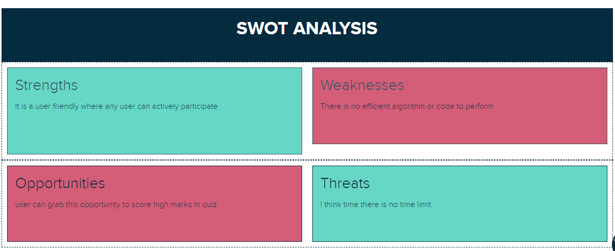](https://user-images.githubusercontent.com/89694095/132469341-64b936b3-d3e4-4520-a745-ed9a70e6cecb.png)

**4W's and 1H**

**Who**

Any user who are intersted can take the quiz and enjoy the quiz.

**What**

The project is main aim is to anyone participate in the quiz.

**When**

Students are actively participate because the quiz is based on c language.

**Why**

The project is mainly about students to get more knowledge on c.

**How**

The user can take the quiz by entering his name