Ado.net (ado.net is activex data object .net )

It is collection of classes ,interface etc for connecting to database software like sqlserver , oracle, access, mysql etc

For doing data base operations like adding records, updating records, deleting records , fetching records

Create new website , add a web form

Place one button and one label

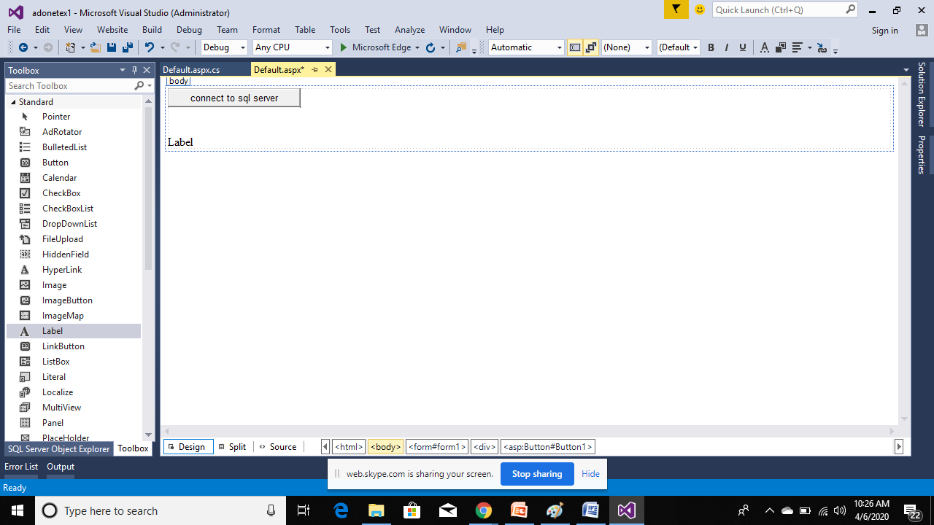

First steps

To connect to sql server database

Double click on web form and go to code window

.net data provider

1. Write at top

using System.Data.SqlClient;

this sqlclient namespace will contain classes and interfaces for connection to sqlserver database.

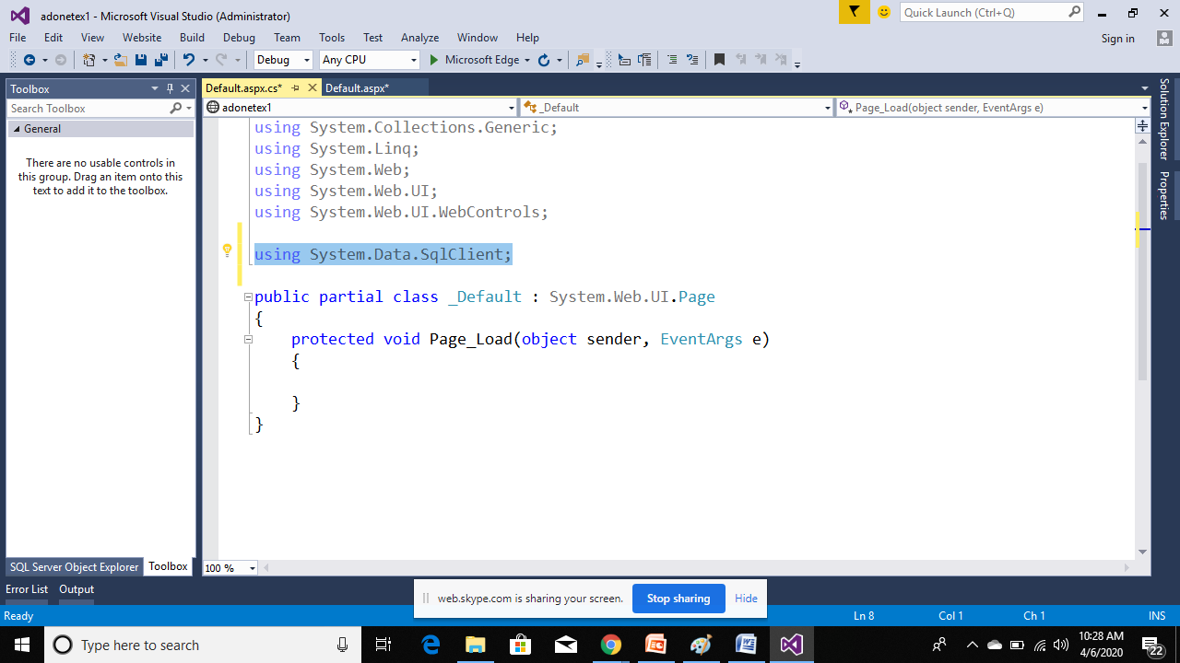

2nd step

Create an object of sqlconnection class and pass the connection string

So how to get connection string

1. Go to sqlserver object explorer window

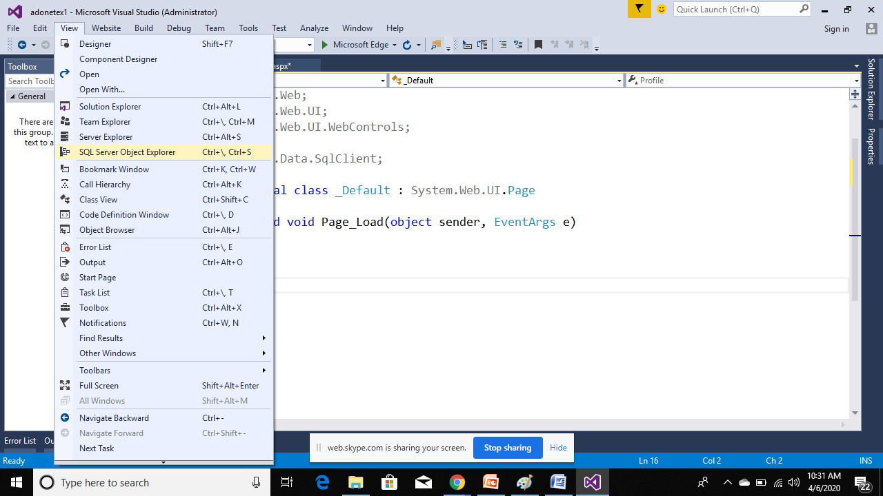

1. Right click on sql server and click on add sqlserver

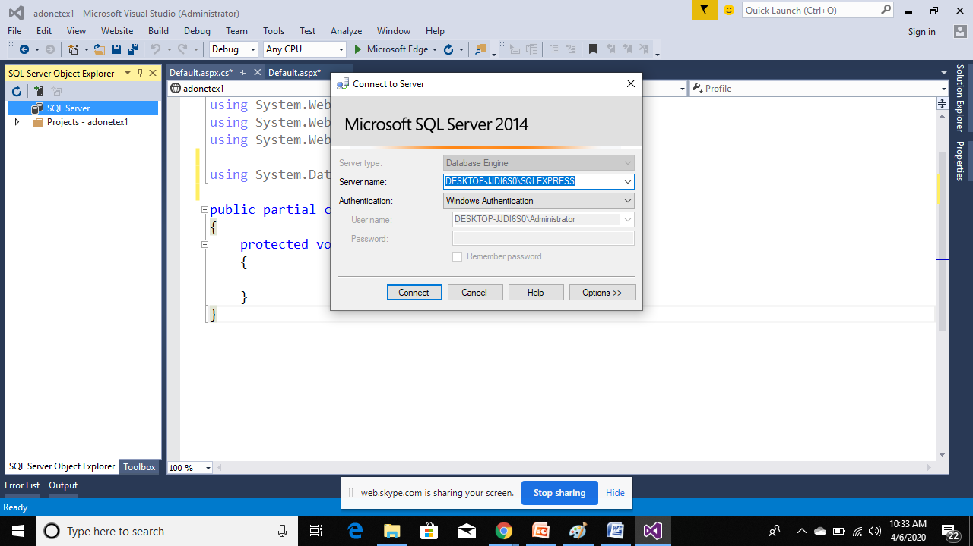

Copy the server name

And paste it some where

Now double click on button and write code in it for connection

protected void Button1_Click(object sender, EventArgs e)

{

//create an object of sqlconnection class for creating

//connection between this web page and sqlserver

string cn = "data source=DESKTOP-JJDI6S0\\SQLEXPRESS;Integrated Security=True;database=mkdatabase";

SqlConnection con = new SqlConnection(cn);

//open the connection using open method of sqlconnection class

try {

con.Open();

Label1.Text = "successfully connected";

}

catch(Exception ee)

{

Label1.Text = ee.ToString();

}

finally

{

con.Close();

}

}

**Sqldataadapter class :**

It acts as a bridge between sqlserver database and dataset .

[ what is dataset – it is in memory cache or in memory database which is used to store data in data tables fetched from sqlserver tables through sqldataadapter ]

it is used for **disconnected environment** means the connection will be opened automatically and after getting or fetching the data from tables the connection will be closed automatically.

1. Create and object of sqldataadapter class

Add a new web form(defualt2.aspx)

Double click on it and write code in page_load event to get data from sqlserver student table

Copy some images inside images folder

So to add some image name inside student table

Go to sqlserver

Rc on student table and select design

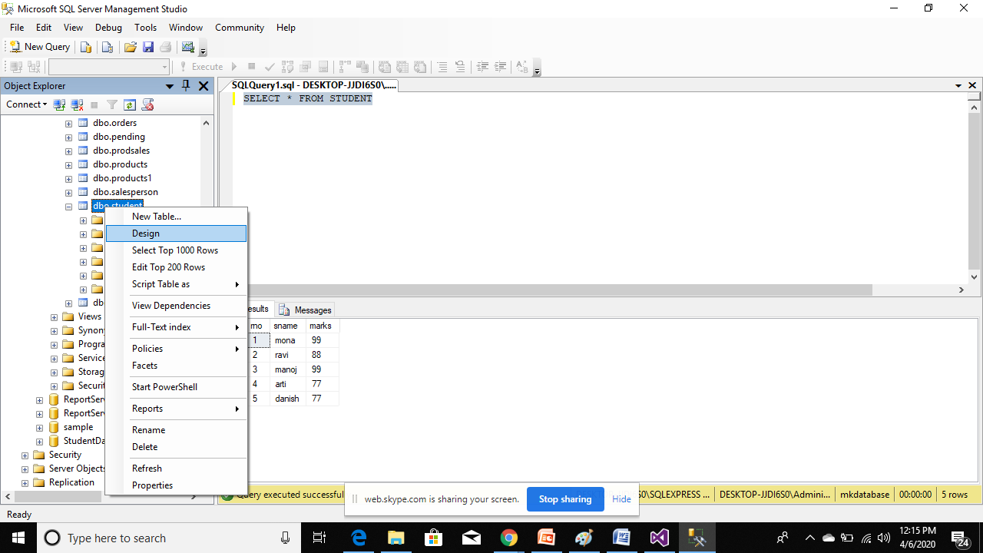

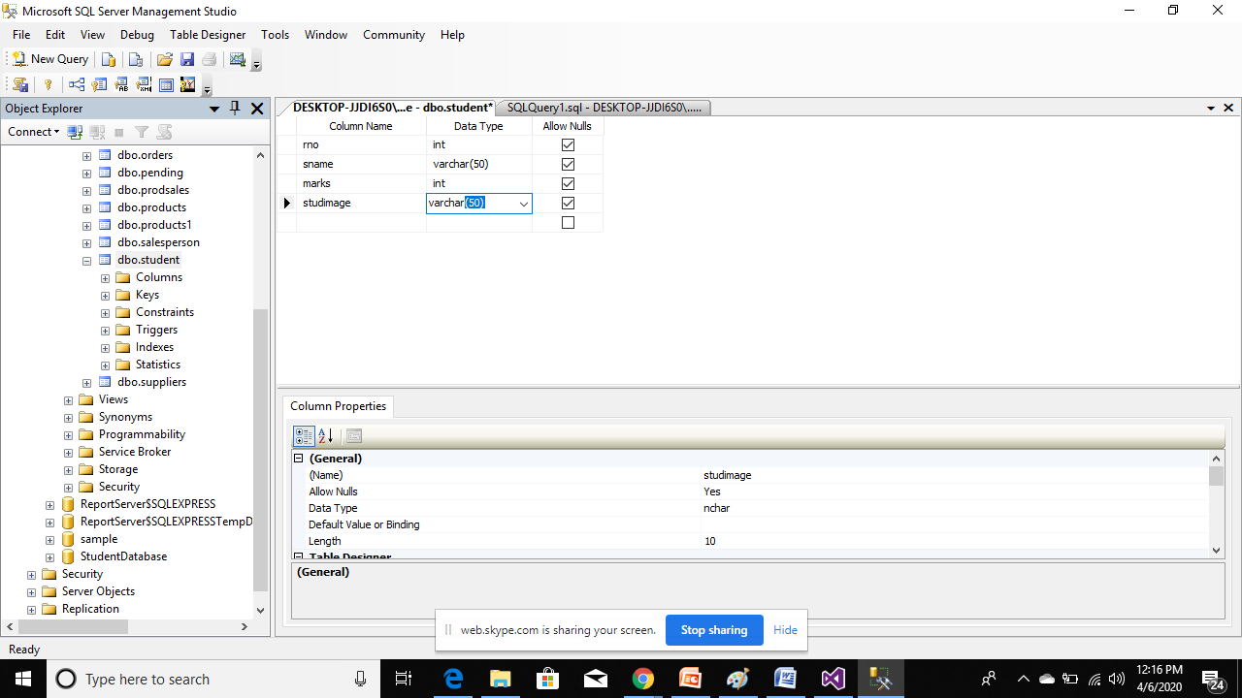

Then click on save button to add this column

Now we will add student image names

Rc on student and select edit top rows

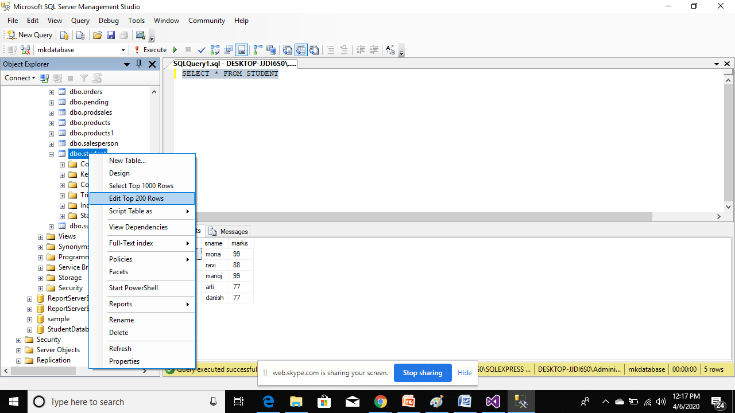

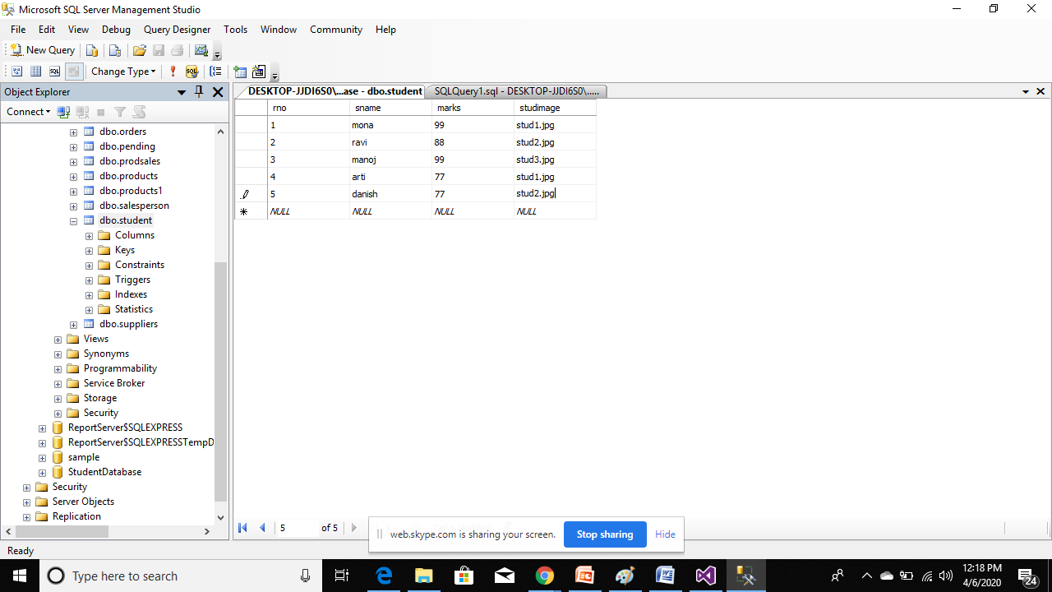

Now add these images inside website

Rc in solution explorer

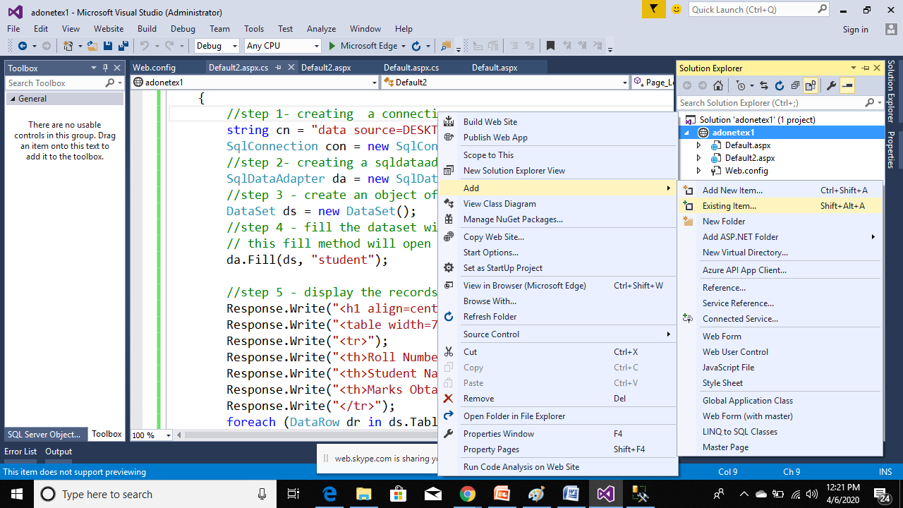

Select existing item

Select images

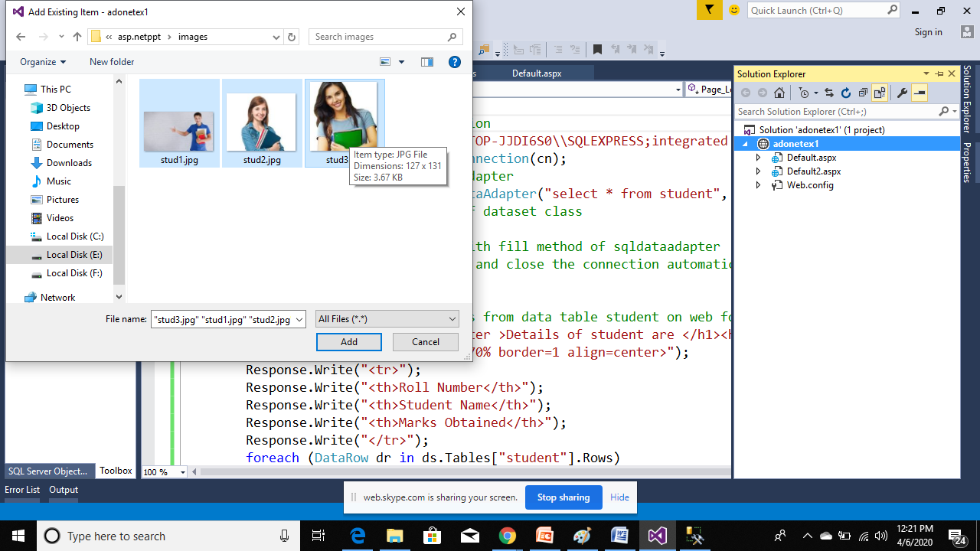

Then click on add button

//complete code to display records from student table

using System.Data.SqlClient;

using System.Data;

public partial class Default2 : System.Web.UI.Page

{

protected void Page_Load(object sender, EventArgs e)

{

//step 1- creating a connection

string cn = "data source=DESKTOP-JJDI6S0\\SQLEXPRESS;integrated security=true;database=mkdatabase";

SqlConnection con = new SqlConnection(cn);

//step 2- creating a sqldataadapter

SqlDataAdapter da = new SqlDataAdapter("select * from student", con);

//step 3 - create an object of dataset class

DataSet ds = new DataSet();

//step 4 - fill the dataset with fill method of sqldataadapter

// this fill method will open and close the connection automatically

da.Fill(ds, "student");

//step 5 - display the records from data table student on web form

Response.Write("<h1 align=center >Details of student are </h1><hr>");

Response.Write("<table width=70% border=1 align=center>");

Response.Write("<tr>");

Response.Write("<th>Student Image </th>");

Response.Write("<th>Roll Number</th>");

Response.Write("<th>Student Name</th>");

Response.Write("<th>Marks Obtained</th>");

Response.Write("</tr>");

foreach (DataRow dr in ds.Tables["student"].Rows)

{

Response.Write("<tr>");

Response.Write("<td>");

string simage = dr["studimage"].ToString();

Response.Write("<center><img src="+simage+" width=100 height=60 /></center>");

Response.Write("</td>");

Response.Write("<td>");

Response.Write(dr["rno"].ToString());

Response.Write("</td>");

Response.Write("<td>");

Response.Write(dr["sname"].ToString());

Response.Write("</td>");

Response.Write("<td>");

Response.Write(dr["marks"].ToString());

Response.Write("</td>");

Response.Write("</tr>");

}

Response.Write("</table>");

}

}

assignment

1. Display the records as shown below
2. 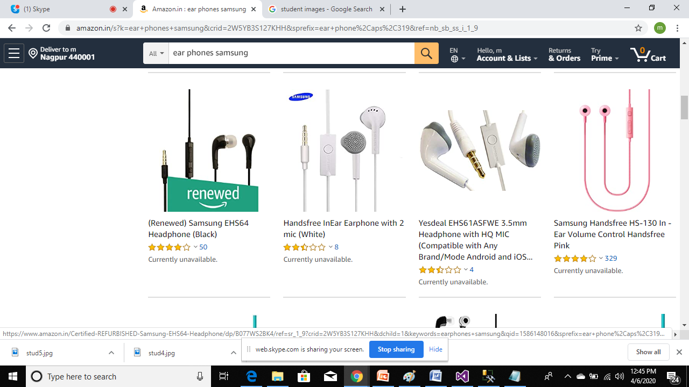

2 -create a table employee having empno empname empdesignation empsalary empimage

and code to display the above 10 employee records in web form