GEOG384 Group 4 Assignment 3

A. Workflow of the Application
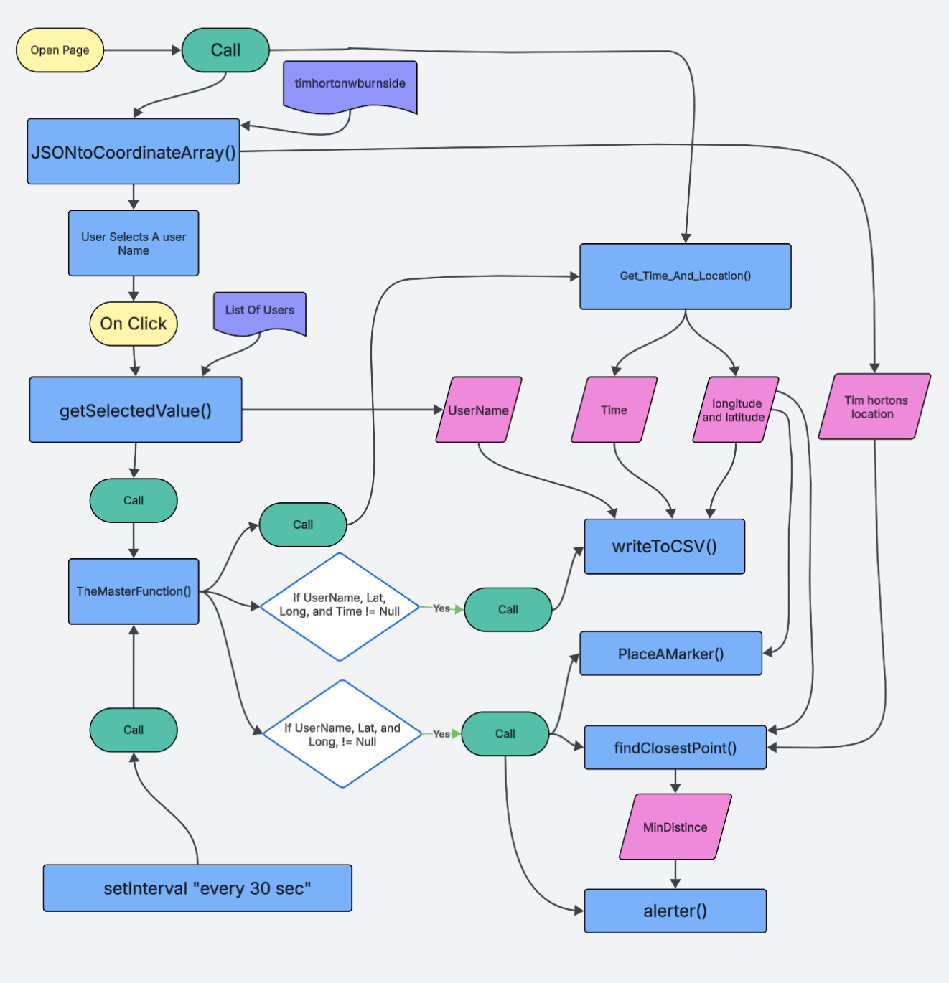
Figure 1. Workflow diagram
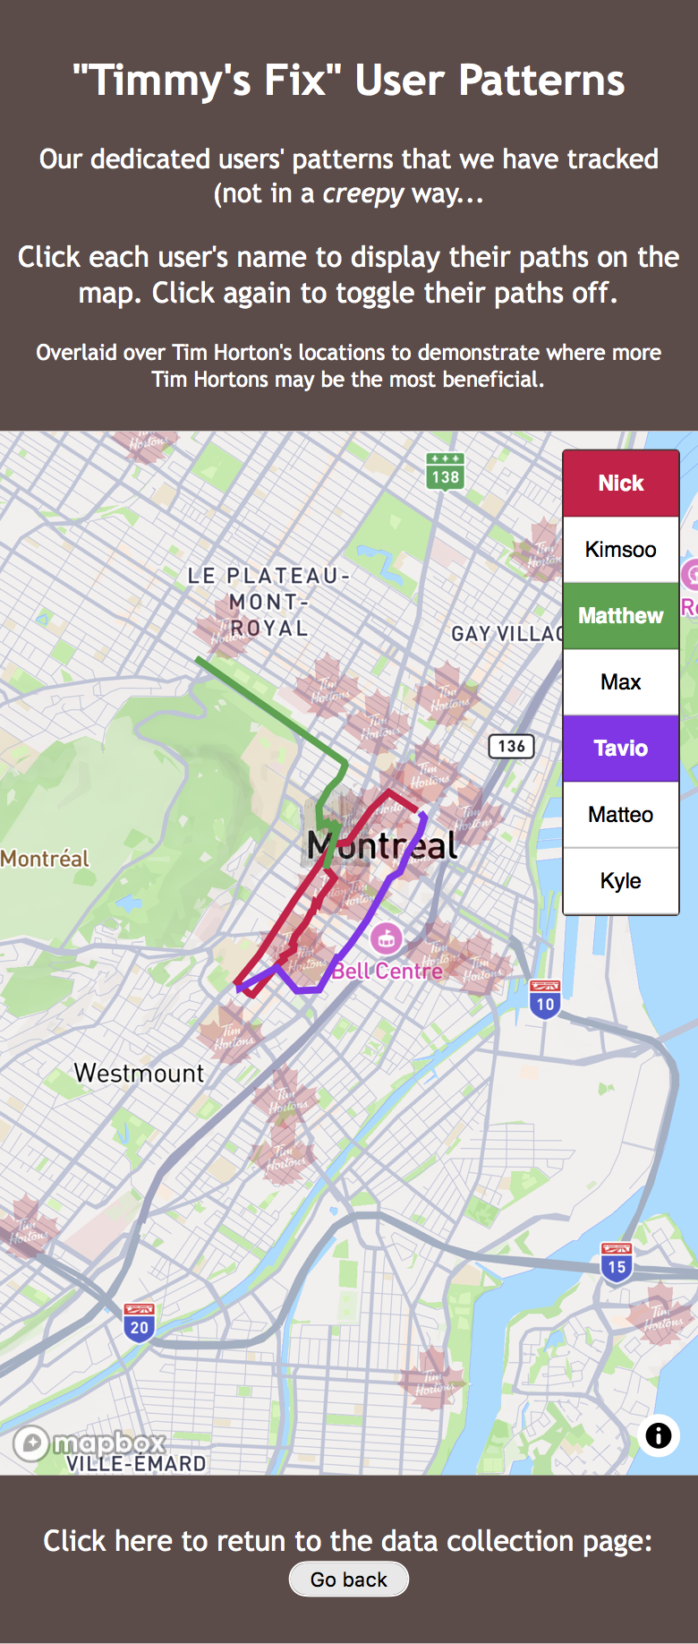
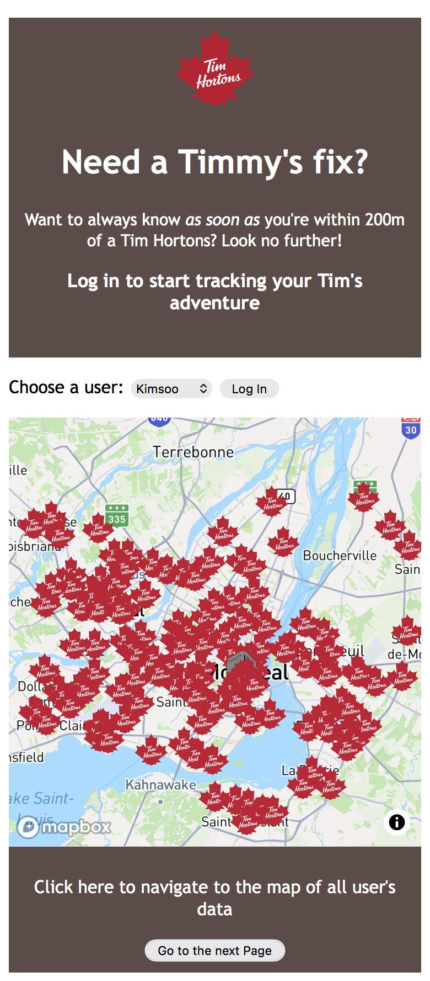
Figure 2. Page 1 of the website Figure 3. Page 2 of the website

When the application is first loaded, two functions are called: Get_Time_And_Location() and JSONtoCoordinateArray(). Get_Time_And_Location() gets the browser to request the user for geolocation permission in order for the app to access the user’s GPS position. This (getCurrentPosition) follows the user and makes it so the user only has to grant location access once per load. The JSONtoCoordinateArray() extracts all Tim Hortons locations from the Mapbox layer called timhortonwburnside and converts them into an array of coordinate objects ({x, y}), preparing them for proximity calculations later in the code.
Once the map loads, the user logs in by selecting their name from a dropdown menu. When the “Log In” button is pressed, the getSelectedValue() function runs. It loops through the predefined users array to find a matching username. The chosen username and its index number are saved in two global variables: userName and UserNumber. These values are used later to assign a marker/line color and determine which data file to read location information from on page 2. When the login process is complete, the function calls TheMasterFunction(), which coordinates the rest of the program.
TheMasterFunction() runs immediately after login and then every 30 seconds using setInterval(). Inside this function, the first call is to Get_Time_And_Location(callback). This retrieves the current date and time and calls navigator.geolocation.getCurrentPosition() to get the user’s latitude and longitude. Since geolocation is asynchronous, it uses a callback function that only executes after the GPS data is ready. The results (dateTime, lon, lat) are assigned to global variables MasterTime, MasterLon, and MasterLat.
An if statement then checks that all necessary variables are defined by comparing each one to null. If any value is still null, the code stops running; otherwise, it calls functions in this order.
The first function to be called is writeToCSV(timestamp_in, userID_in, lat_in, lng_in), which packages the timestamp, username, latitude, and longitude into a request sent to the writetojson.php file on the server. The PHP script stores the data in both CSV and JSON formats so user movement can be logged and reviewed.
Next, PlaceAMarker(lon, lat) runs. If a marker does not exist, it creates one on the map using Mapbox’s Marker object and sets its color based on the user’s profile. If the marker already exists, its position is updated using setLngLat([lon, lat]). The map is then re-centered to the user’s current position with map.flyTo() for smooth animation.
Once the user’s location has been collected, the next step is to run it through the proximity sensor to check if the user is close to one of the Tim Hortons locations. To start, the location points are turned into an array, and a function places only their coordinates into another array for future reference. Then the next function takes in the user’s location and iterates through the array of Tim Hortons coordinates to find which one is closest. The function returns an object, with the first value holding the distance (closestPointResult.md) and the second value the coordinates of the closest location.
The alerter() function is then called; it runs the proximity alert system. It compares closestPointResult.md (the distance in meters) to AlertDistance (set to 200). If the comparison returns true and the variable userHasDismissed equals 0, a dialog opens using alertDialog.showModal(). This dialog informs the user that they are within 200 meters of a Tim Hortons location. If the distance is greater than 200 or the user has dismissed alerts, the dialog remains closed.
Inside the dialog box, “Maybe later” resets the cooldown timer (lastAlertTime), delaying any new alerts for 30 seconds, while “Leave me alone” disables all future alerts by setting userHasDismissed to 1.
This full process repeats every 30 seconds through the setInterval() loop. Each iteration updates the time, location, and nearest Tim Hortons calculation, writes data to the server, moves the map marker, and checks for proximity alerts.
Once location data has been collected, users and instructors can navigate to page2 using the “Go to the next page” button. This second page shows the recorded data of all users. A users array lists all participant profiles, each linked to a .json file and a unique color. The script loops through this array using fetch() to retrieve each JSON file. If a file exists, its contents are added as a GeoJSON source via map.addSource() and drawn as a colored line layer using map.addLayer(). Users without files are skipped to avoid runtime errors. At the bottom of the page, a footer button labeled “Go to the previous page” navigates back to index.html, letting users resume live tracking.

B. How the Team Determined the Workflow
At the beginning of the project, we discussed what the app needed to accomplish. First, we decided that the app would run on a central controlling function named TheMasterFunction(). This function will coordinate location collection, data recording, proximity detection, and marker placement. There was trial and error for the location update function. Our first attempt called the geolocation function directly in a loop, but we discovered that getCurrentPosition() is asynchronous and doesn’t wait for data before continuing. This caused problems and crashed our early tests. To fix this, we created the Get_Time_And_Location(callback) function so that the code would execute only after the callback returned latitude, longitude, and timestamp values. Next, we troubleshoot how to use the writeToCSV() function. This function communicates with the PHP file writetojson.php. Integrating this was very difficult; in order for it to work, this line must be placed in the code: var xmlhttp;We decided that the first page (index.html) would focus on real-time tracking and alerts, while the second page (page2.html) would display all the recorded paths. Each user’s data would be read from their corresponding JSON file and drawn as a colored line using the addLayer() function.
For the proximity sensor, our first issue was to get the array of Tim Hortons locations. We got the JSON from Overpass Turbo (brand=”Tim Hortons” with a bounding box covering the Montreal area, and then also added in the point for MUGS as the Burnside Hall control point, renamed to “Burnside Hall”). Then we figure out that the best way to turn it into an array would be to use queryRenderedFeatures once the map has loaded (from the Mapbox example “Filter features within map view”). Multiple other solutions to get the array were attempted, too numerous and uninteresting to discuss here. Transferring the coordinates to another array was meant as a way to easily access the coordinates without using the original array. The closest point function was a fairly simple function which was adapted from code found on Stack Overflow (from user “obscure” in response to the question”Get nearest point from another one in JavaScript”). We had it return the minimum distance and closest point just in case we wanted to access that particular point later on. We also wanted to store the address from the original JSON file, but not all of the addresses have been updated in a consistent format on OpenStreetMap. We realized the minimum distance was in degrees (since we are using latitude and longitude), so we found a website (Arc2Meters Converter on the site OpenDEM) to convert degrees to meters (for ease of use) at the proper location on the globe. The next step is to call the actual alert. We tried using alerts, but alerts only have one option, so we used an HTML dialog box instead. We found code online for how to run it from javascript (from the MDN reference article “<dialog>: The Dialog element”), and used that to make a decision tree with the options of either pausing or turning off the dialog box “alerts”. We made a decision tree because of the multi-button setup, so that we could easily separate the steps in the process and start from whichever one we wished. We decided to put the option to turn off the alerts in the dialog box itself, because then the user can make the decision when faced with the actual alert. The alert pausing option is meant as a way for the alert to continuously remind the user to get away from one of the locations to avoid, without constantly annoying them (the delay uses the setTimeout function from the “JavaScript Timing Events” page on W3Schools).
To create the map icons, we used the “PNG to SVG” website. The images were obtained from the “Fonts in use” site (for Tim Hortons) and Wikipedia (for Burnside Hall, which was also first processed through paint.net).

C. Process of Collecting and Sending Locations
We used both team members and friends to help collect the data. Nick had brunch with three of his friends, and they all tracked their routes home afterward. This experiment revealed a few interesting things. First, even though two of them walked together for most of the trip, their GPS traces did not align perfectly. Instead of two straight, parallel lines, the points were scattered across the street. This reflects the inaccuracy of phone GPS readings. Second, Nick got home before his friends and realized that he could do live tracking by refreshing Page 2. This showed that live updates were possible while the tracker was running. Third, one of the friends opened the app and logged in while sitting down at brunch, and their GPS position bounced randomly within about a 10 to 15 meter radius. This also makes sense given the GPS accuracy and the fact that some users did not enable high-accuracy tracking on their phones.
An unexpected but useful discovery occurred when one friend accidentally logged in as “Matthew.” Because our system appends new data to each user’s existing JSON file rather than overwriting it, Matthew’s data now begins at the brunch spot. We decided to leave this error in the dataset because it demonstrates how the app stores information across sessions.
Our team collected data using different modes of transportation, including walking, bus, and car trips. This made it interesting to compare route density and spacing between modes. When walking, errors were easier to see, as data points were sometimes not located exactly on the sidewalk. In contrast, car trips created straight lines without bends because a car might make two turns before the map updates the location. Each participant accessed the webpage on their own phone. When the page loaded, the browser requested permission to use GPS. Once permission was granted, the app automatically recorded the current position and timestamp every 30 seconds. Every person who opened the app had to manually enable location services in their preferred browser, meaning most participants were not allowing location tracking by default. One of the biggest challenges was keeping participants’ phones awake and the webpage open during the early winter weather, since cold conditions and screen timeouts often interrupted tracking.
As users moved, the writeToCSV() function sent each new set of coordinates to the server, saving them into the correct user file. The data appeared immediately on the server as .json and .csv files, which could then be visualized on Page 2. During the brunch walk, Kimsoo was editing the CSS and mentioned that she could see the group’s movements in real time, which served as a reminder of the privacy and data security considerations behind the project.
To test the alert system, we initially worked from Burnside Hall, which we had marked as a control point. Because the building is close to a Tim Hortons, the alert kept triggering automatically whenever we logged in. To test it properly, we had to move farther away and temporarily reduce the distance threshold to 30 meters. Once adjusted, the alert worked reliably and displayed the dialog box when users entered the defined radius.
We observed variations in GPS readings of roughly 3 to 20 meters, which occasionally caused early or late alerts. However, using a 200 meter threshold produced consistent and dependable proximity detection results.
D. Browser-Based Location Tracking vs. Mobile App Permissions
Browser-based location tracking is limited to a specific website, while mobile apps can be given varying levels of location permissions. This means that web apps are much more limited in functionality, and also in user experience. They can only collect user locations when they are open and given explicit permission, and must ask each time. This means that they cannot track users who are not actively using them, and are less likely to be used due to the barrier to entry (having a constant reminder you are being tracked and a need to open the page every time discourages casual use). In contrast, mobile apps provide a much more seamless experience for the user and developer. They only ask for location permission once (unless the user sets up some sort of specialized setting), reducing the friction of collecting the user’s location. They can also run in the background, making location data collection quite easy. Additionally, multiple levels of location permission can be given and changed at any time, in contrast to the one-size-fits-all approach of the web app.

E. URLs of the Application and File Structure

Entry URL (main page):
https://www.neogeoweb.ca/group4/assignment3/

Mapping / data view URL:
https://www.neogeoweb.ca/group4/assignment3/nextPage.html
The instructors should use the entry URL to begin the app, select a user, and allow location access. The “Go to the next page” button navigates to the mapping interface for visualizing user data.
File Storage Structure:
All user data files (for example Nick.json, Kimsoo.json, Matthew.json) are stored in the same directory as index.html, page2.html and the The PHP script writetojson.php.
The user data files are automatically created when a user logs in and their position data is updated every 30 seconds.

F. Use of GPT Tools
Yes, our team used ChatGPT in two parts of the code. GPT was used to write two lines of code in the Get_Time_And_Location(callback) function (clearly labeled). It helped determine that the geolocation process was asynchronous and assisted in creating the callback portion of the function and call that allowed the code to run properly. ChatGPT was also used to help get the writeToCSV() function working; it identified that we needed to declare var xmlhttp; outside the function for it to execute correctly. It also helped tidy up the code and debug things.

Step 7: Report

Brief overview of workflow of the app:
Once the user’s location has been collected, the next step is to run it through the proximity sensor to check if the user is close to one of the Tim Hortons locations. To start, the location points are turned into an array, and a function places only their coordinates into another array for future reference. Then the next function takes in the user’s location, and iterates through the array of Tim Hortons coordinates to find which one is closest. The function returns an object, with the first value holding the distance, and the second value the coordinates of the closest location. Then a function checks if the distance is under 200 meters, and if it is, it calls another function Alerter() which opens up a dialog telling the user they are close to a Tim Hortons location. One of the buttons on the dialog box gives the option to wait, calling a function which calls the dialog box function again in 5 seconds. The dialog box function does also check to make sure the distance is still within 200 meters, so if the user moves away from the Tim Hortons in those 5 seconds, it will not bring up another dialog box. The other button on the dialog box is to turn off the alerts, setting a variable which will disable the dialog box function.

Individual Reflections:

Kimsoo:
For this project, I was responsible for building the base of the code (setting up and organizing the html files), ensuring the usability of the app pages (CSS styling), and viewing the user paths. I spent most of my time working on the user legend and the styling of page 2 of the app. I also worked on the pop-ups for when each path is clicked.
The most challenging part of this assignment was determining when to move on and try something else. I spent too much time trying to make the interactive legend minimizable into a sidebar using various W3 Schools tutorials and GPTs, but the assignment did not ask for that and I had to remind myself to refocus. I also struggled with time management during this assignment due to other projects and midterms, which made it frustrating since I wanted to spend more time on it than I was able to.
I was not particularly surprised, given that so many apps exist based on user location, such as navigation apps and crowdsource apps (iNaturalist), many of which we discussed in class. Since it is so common, it makes sense that there would be tutorials and materials easily accessible online and by GPTs.
The app is a mixture of crowdsourcing and surveillance, but more heavily crowdsourcing. Since users have to first log in and accept location tracking from their device, they are aware they are volunteering their location data. However, as with many VGI based apps, users may not realize the extent as to what they are agreeing to. The dystopian satirical nature of the app is designed as a way for Tim Hortons to attract users by alerting them when they are close to one of their cafes. However, the app collects and stores user’s entire routes, not just when they are near a cafe, which makes the app more surveillance focused.
The tracker does not keep working if the user’s phone screen is off, the browser is closed, or the browser is running in the background. The only way that the app collects location data is if the app is open with the screen in. This ensures that users are aware that they are being tracked, but if they want to help contribute data they have to be overly cognisant of it and not do anything else on their device. This is beneficial since it focuses on respecting the user’s privacy, but problematic if users want to contribute data passively (such as biking home and not constantly on their phone)

Matthew:
The most challenging part of the assignment for me was figuring out how to turn the JSON of the points into an actual array. I spent almost as much time on just that one section as I spent on every other aspect of the coding and writeup. The rest of the code was relatively easy, as I was able to find similar solutions on the forums and documentation which I could adapt to my goals. My other main issue was just making errors in syntax, which were relatively easy to catch by comparing my code to online examples.
I was not surprised at how easy it was to collect a user’s space-time signature. From an optimistic perspective, the entire purpose of cellular phones was to provide users with the ability to use all sorts of convenient apps which need your time and location, like navigation apps and time-based reminders. Pessimistically, this data is also collected so that a user profile can be easily created for you. This data is used to generate both aggregated analytics to improve functionality of software and understand general user behavior, and also personally target users with advertisements. As we talked about in class, this sort of information is very attractive to data brokers. They utilize user data to develop profiles on the population as a whole for ad campaigns, and also individual users to better target them.
Our app was designed as a surveillance app, to track users and give them targeted advertisements based on their locations. This was kind of meant as a satirical take on user tracking/targeting, taking it to an absurd level in which you are constantly bombarded with ads no matter where you go.
The website only works if the browser is open and the phone’s screen is on. This is because everything hinges on gathering the user’s location, which it can only do if the webpage is open. This means that the app is not running unless a user is actively using it. The upside of this is that the user does not need to worry about privacy concerns (as it is only tracking them when they actively use it). However, this makes it harder for the developers, as it makes it much harder to get user data due to the high barrier to use.

Nick
I was responsible for the creation of the Get_Time_And_Location(callback), PlaceAMarker(lon, lat), and TheMasterFunction(). I integrated the findClosestPoint(), getSelectedValue(), and writeToCSV(), and altered the alerter() function to work with TheMasterFunction(). I wrote the code to place the lines on the map of page 2, made the diagram, and wrote most of the paper. I got my friends to collect data for us.
The most challenging part of the assignment was trying to get the get location function to work. It took a long time, as I did not know that the data was asynchronous. I ended up getting ChatGPT to help solve the problem, but that was a last resort after 4 hours of tinkering and many iterations of the function trying to interface with the master function.
I was very surprised at how easy it is to get someone’s location. It was literally one line of code:
if (navigator.geolocation) navigator.geolocation.getCurrentPosition();
This surprised me, as I thought there would be more to it. It's kind of upsetting from a data privacy view, as this app was built by amateur coders and we can get and store your data. I can only imagine the techniques more corporations with profit incentives or governments have for tracking or surveillance. If I can do this, I can only imagine what others can do.
I think that our app is crowd-sourcing, because our app is invite-only and the friends we asked to help knew exactly what we were doing. I thought that our app was a form of crowd-sourced VGI. Now there was a level of surveillance as mentioned; I was able to live monitor the locations of my friends on their walk home. This was not intentional, but I was in effect surveilling them.
Upsettingly, no, the tracker does not keep working if the phone’s screen is off or if the browser tab is closed or in the background. I found this out when attempting to test the app on my walk to brunch with my friends. I tried all the different combinations and the app stops running if you do not have your phone on, browser open, and webpage active. The reason for this is that browsers stop running JavaScript and GPS when a page is not active.
Benefit: This prevents tracking and surveillance from webpages that are not directly open. It probably helps battery life as I noticed my battery drained really quickly when running the app.
Problem: The app stops collecting data and people need to keep their phone open and on our webpage in order to get data for us.

Works Cited:
Amazon Web Services, Inc. (n.d.). Web Apps vs. Native Apps vs. Hybrid Apps - Difference Between Types of Web and Mobile Applications - AWS,. Retrieved from https://aws.amazon.com/compare/the-difference-between-web-apps-native-apps-and-hybrid-apps/.
demo (2019). Get nearest point from another one in JavaScript. Stack Overflow. Forum post. Retrieved from https://stackoverflow.com/q/56306097.
Mapbox (n.d.). Filter features within map view | Mapbox GL JS,. Retrieved from https://docs.mapbox.com//mapbox-gl-js/example/filter-features-within-map-view.
MasaKudamatsu (2021). Day 11: Learning about web app limitations on location services. 100 Days in Kyoto to Create a Web App with Google Maps API. Retrieved from https://medium.com/100-days-in-kyoto-to-create-a-web-app-with-google/day-11-learning-about-web-app-limitations-on-location-services-311ea9891b1d.
Maynard, Maxime (2022). Tim Hortons logo and branding,. Retrieved from https://fontsinuse.com/uses/41476/tim-hortons-logo-and-branding.
MDN Web Docs (2025). <dialog>: The Dialog element - HTML | MDN,. Retrieved from https://developer.mozilla.org/en-US/docs/Web/HTML/Reference/Elements/dialog.
obscure (2019). Answer to “Get nearest point from another one in JavaScript.” Stack Overflow. Retrieved from https://stackoverflow.com/a/56306194.
Wikipédia (2024). Pavillon Burnside.
(N.d.-a). JavaScript Timing Events,. Retrieved from https://www.w3schools.com/js/js_timing.asp.
(N.d.-b). JavaScript Timing Events,. Retrieved from https://www.w3schools.com/js/js_timing.asp.
(N.d.-c). JPG, PNG to SVG Converter - Image to High Quality Color SVG for FREE,. Retrieved from https://www.pngtosvg.com/.
(N.d.-d). Navigator geolocation Property,. Retrieved from https://www.w3schools.com/jsref/prop_nav_geolocation.asp.
(N.d.-e). OpenDEM,. Retrieved from https://www.opendem.info/arc2meters.html.
(N.d.-f). overpass turbo,. Retrieved from https://overpass-turbo.eu/.

