**Statistics Website Report**



**Chiko Gita Satria**

**2215101053**

**UNIVERSITAS PENDIDIKAN GANESHA**

**2023-2024**

**Table of Contents**

Link GitHub: https://github.com/chiknwy/Statisics 3

Crud and Table Data tunggal 3

You can create new data to the table by clicking the “Create New Data” Button in top left. 3

You can also update individual data by clicking the update button. 3

You can also delete individual data using delete button. 3

You can also choose module by clicking a button on the top most left. 4

Table Data Frekuensi 4

Table Deskripsi Data 5

Table Lilliefors 5

Table Chi 6

You can also calculate a number by clicking the button “Hitung”. 6

Import Export as an Excel 7

For example, I want to import scores.xlsx that has this value. 7

**Also, you can export the table as excel too.** 7

just press the “Export Data as Excel” button on “Table Data Tunggal” page 7

Here is the table that being used in Uji T and Bi Serial 8

**Table Uji T** 8

**Table Bi Serial** 8

# Link GitHub: <https://github.com/chiknwy/Statisics>

# **Crud and Table Data tunggal**

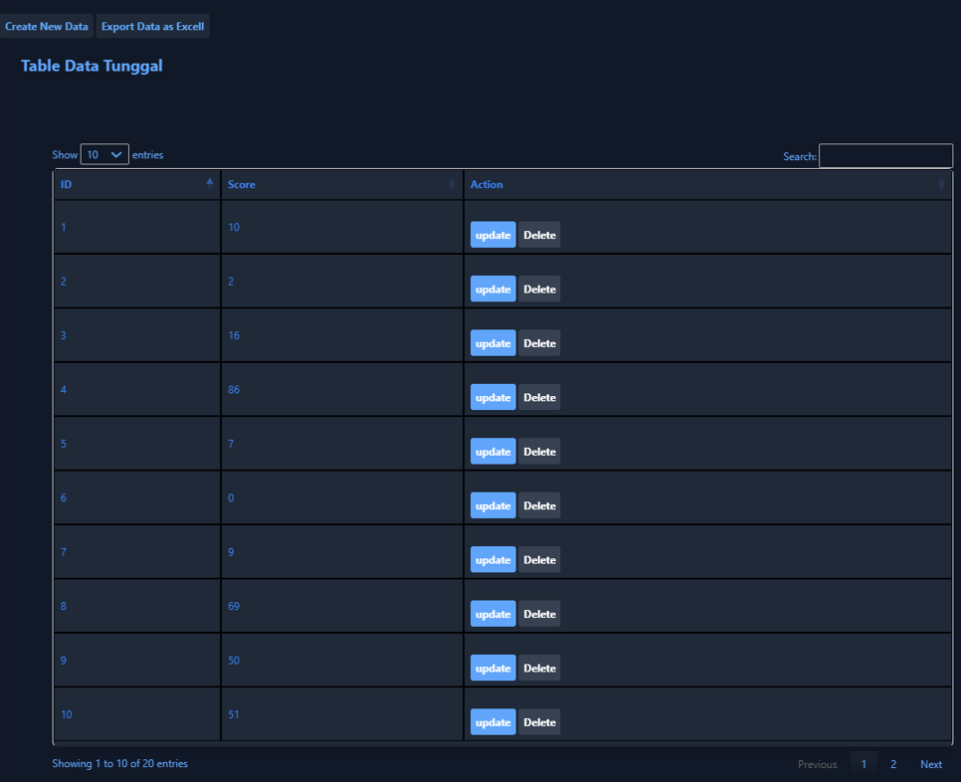

## You can create new data to the table by clicking the “Create New Data” Button in top left.

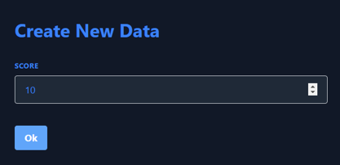

## You can also update individual data by clicking the update button.

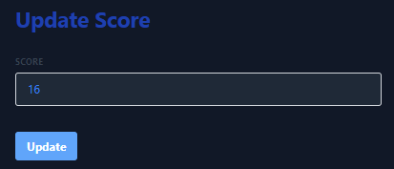

## You can also delete individual data using delete button.

**You can also choose module by clicking a button on the top most left.**  
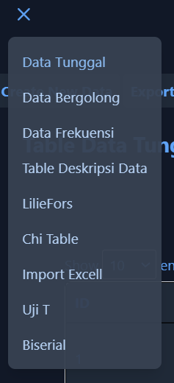  
**Table Data Bergolong**

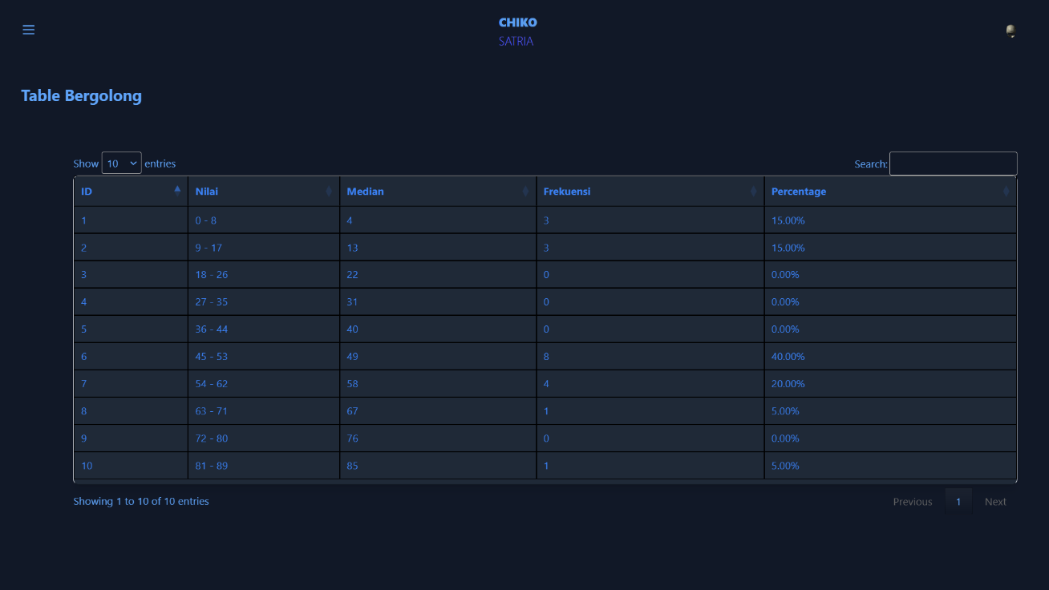

**Table Data Frekuensi**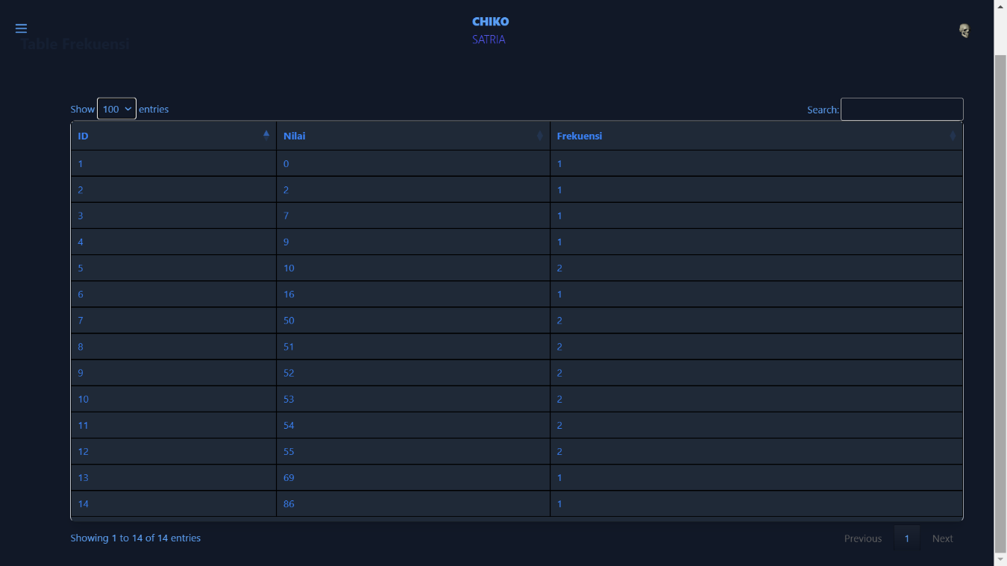

# **Table Deskripsi Data**

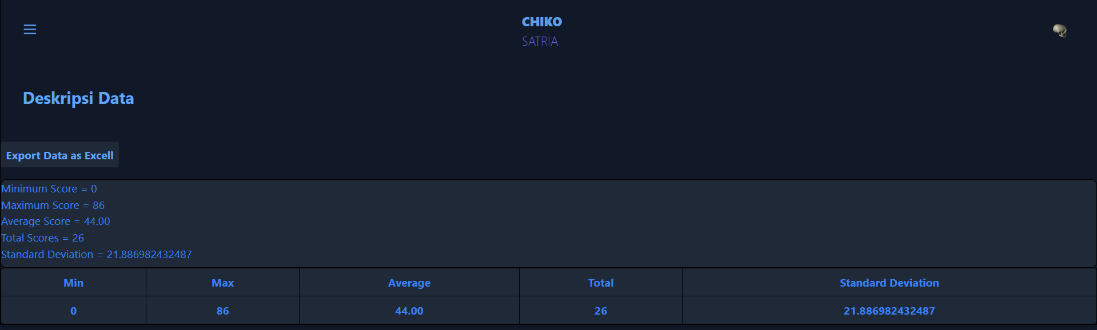

# **Table Lilliefors**

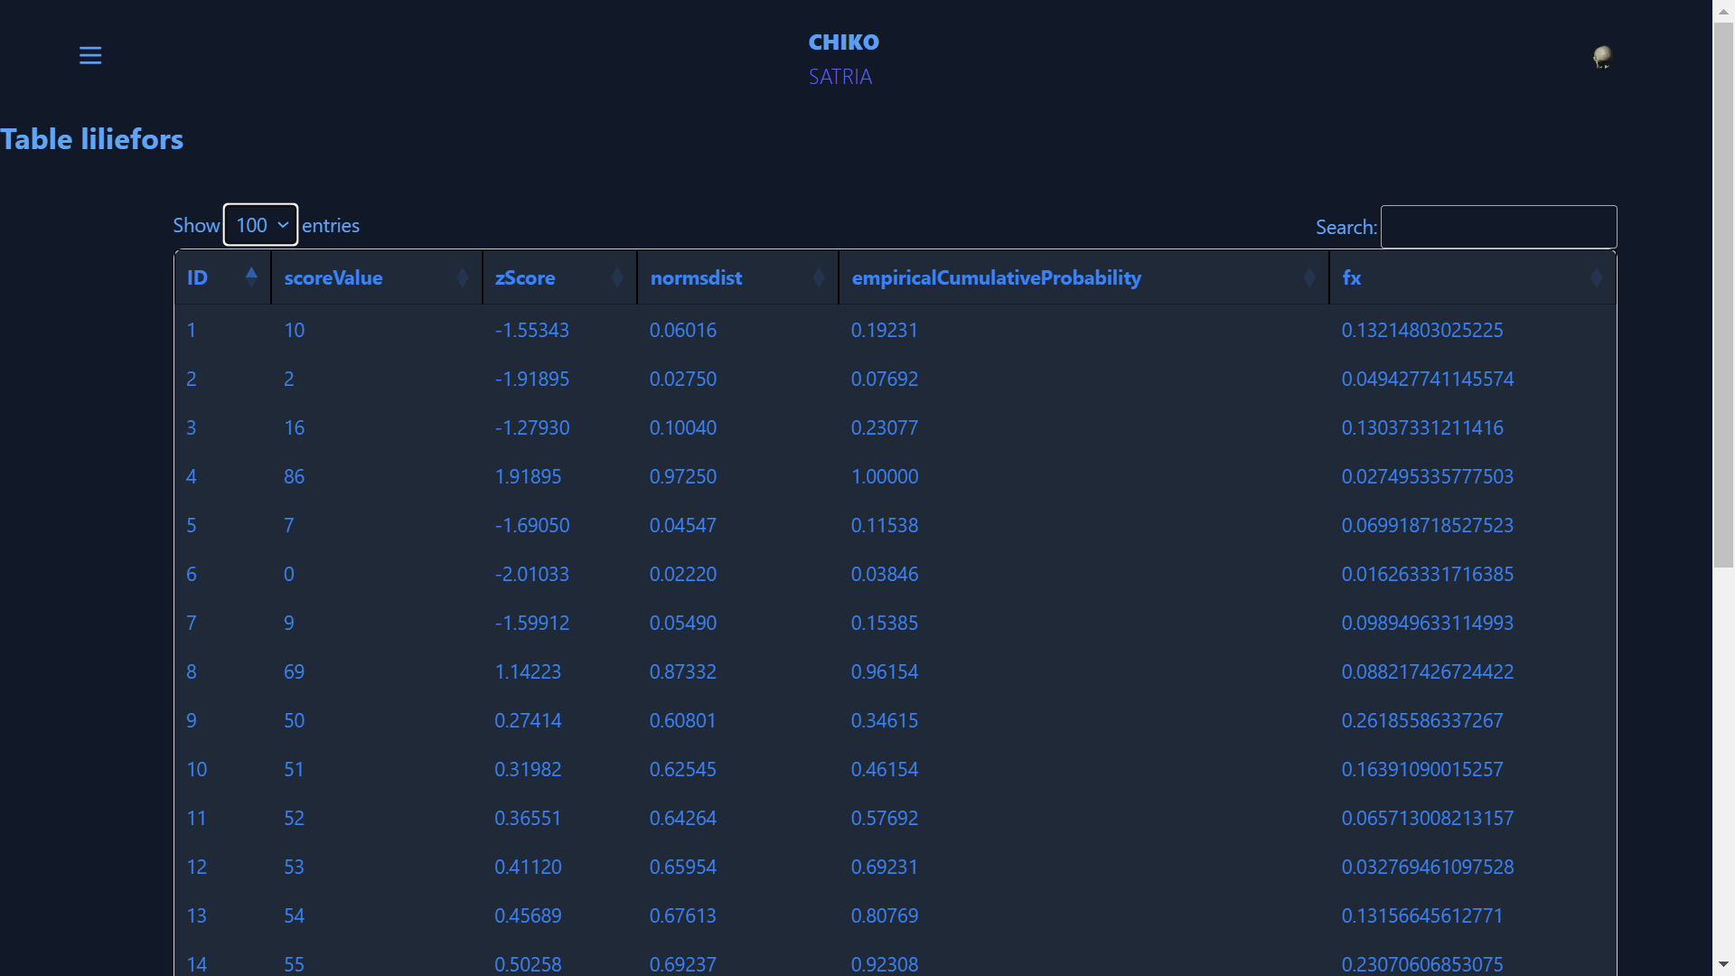

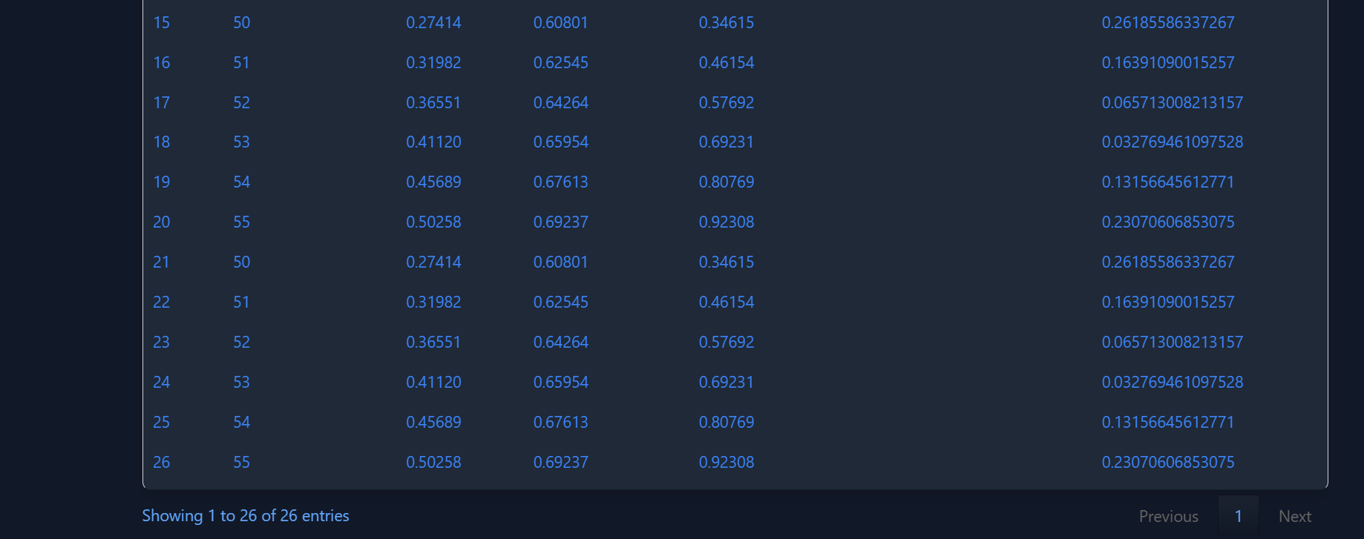

# **Table Chi**

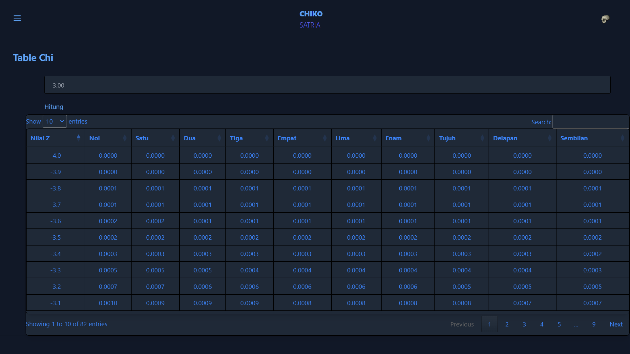

## You can also calculate a number by clicking the button “Hitung”.

For example, in below I want to calculate 1.33 and it outputted 0.8980 just like the table.

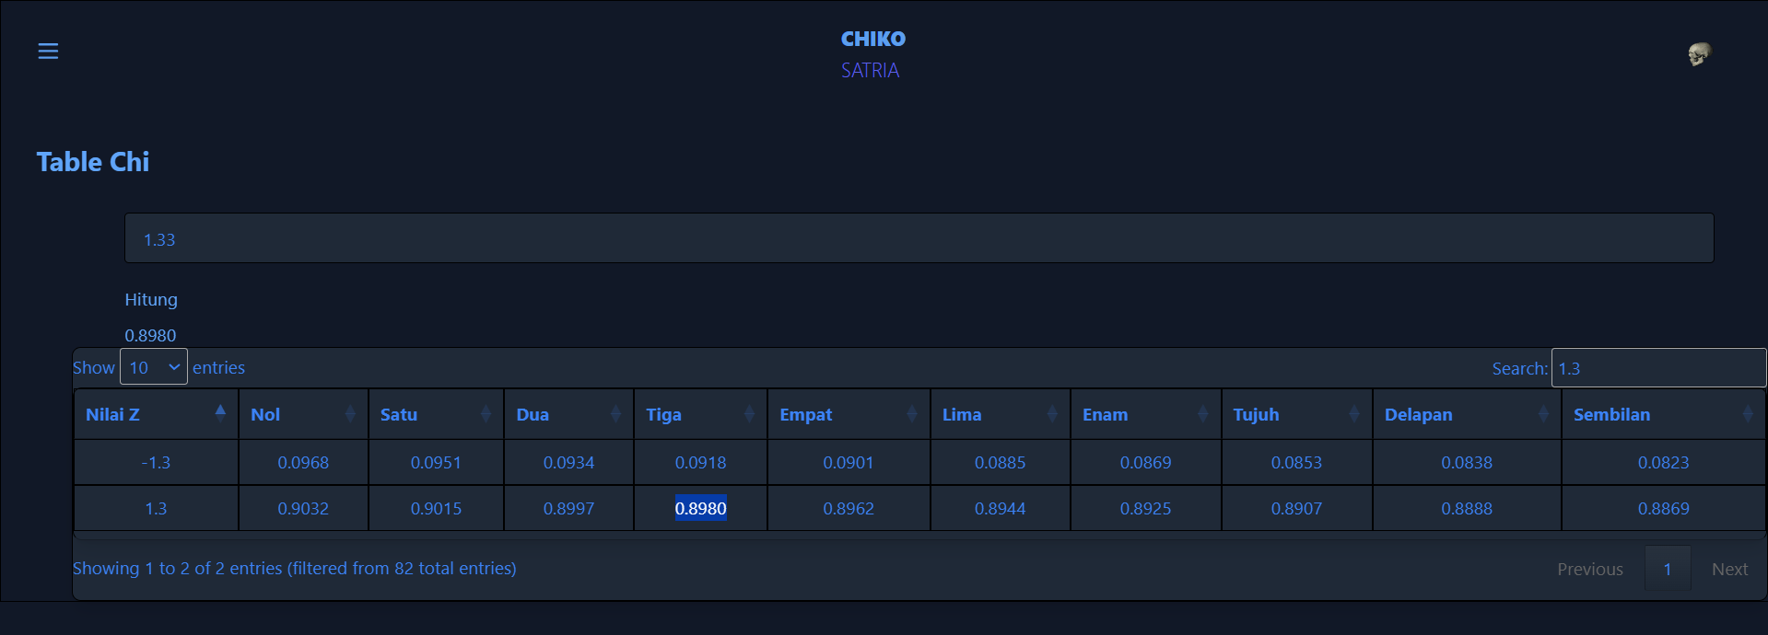

# **Import Export as an Excel**

## For example, I want to import scores.xlsx that has this value.

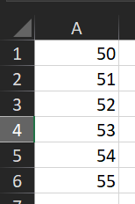

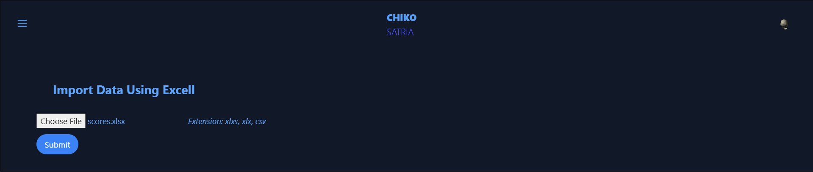

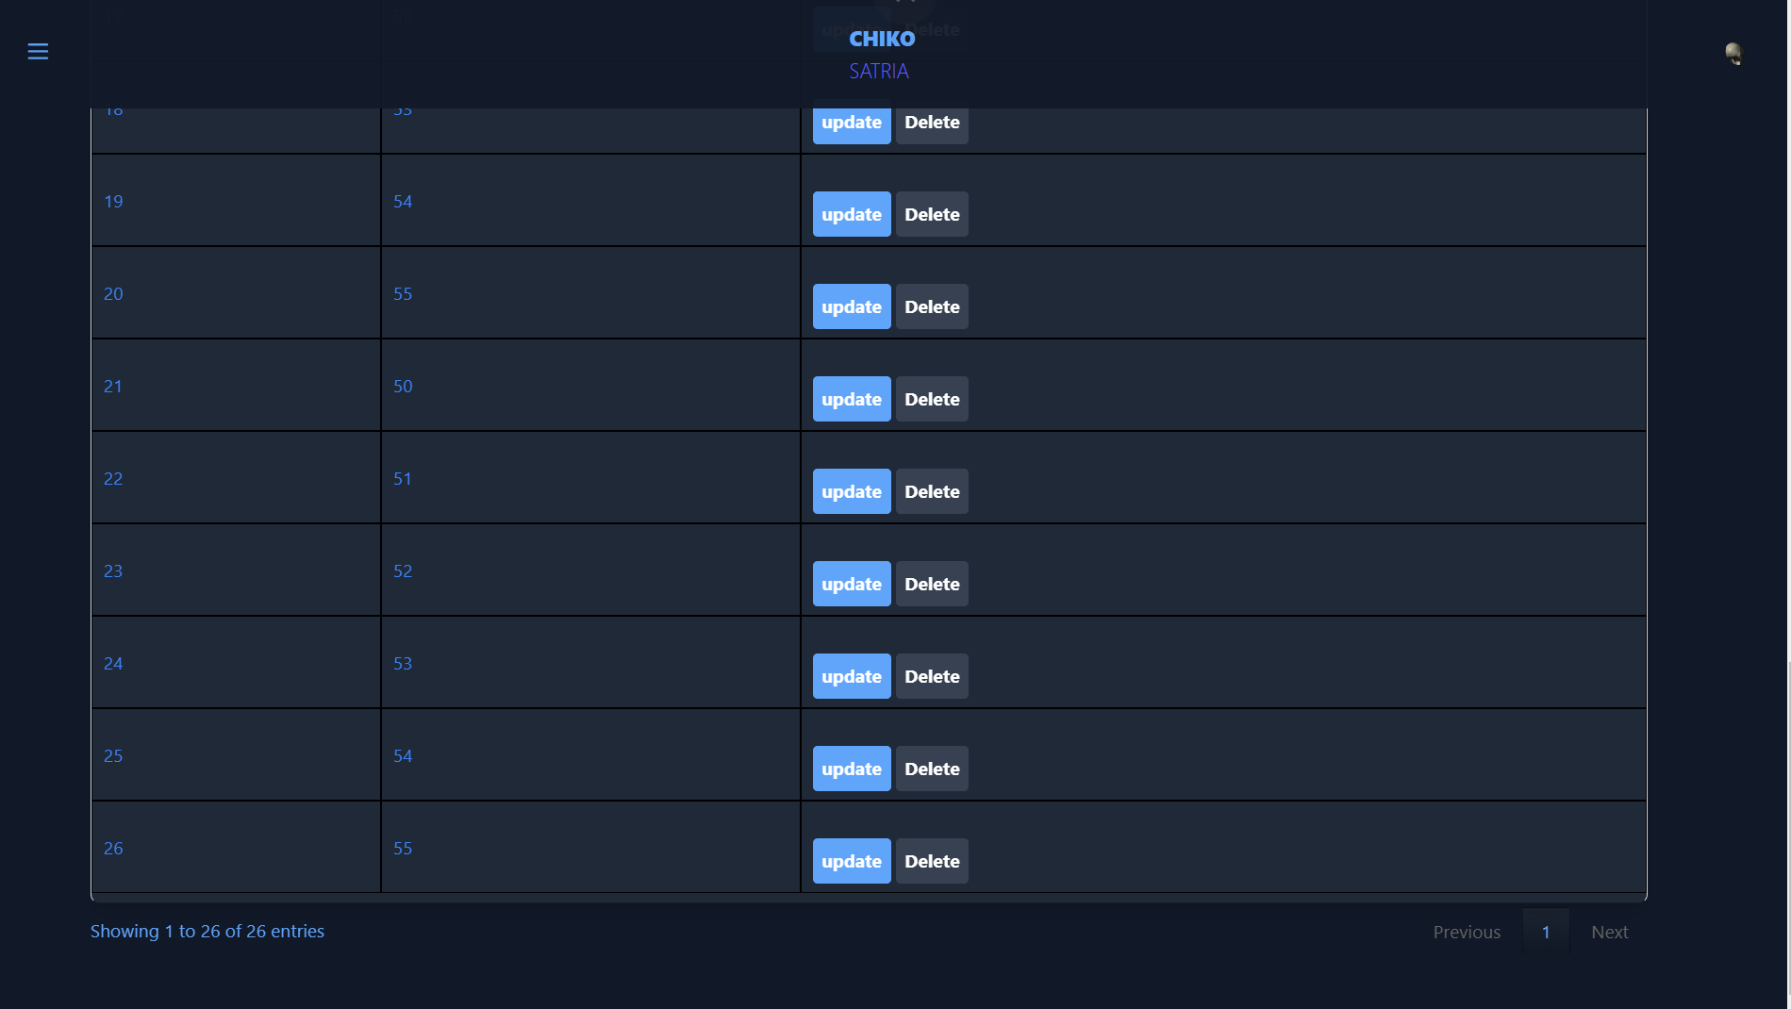

As you can see there are 5 new values being added into the table using import Excel.

**Also, you can export the table as excel too.**

just press the “Export Data as Excel” button on “Table Data Tunggal” page and then save it.

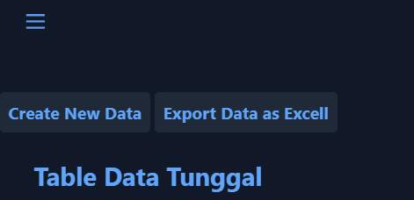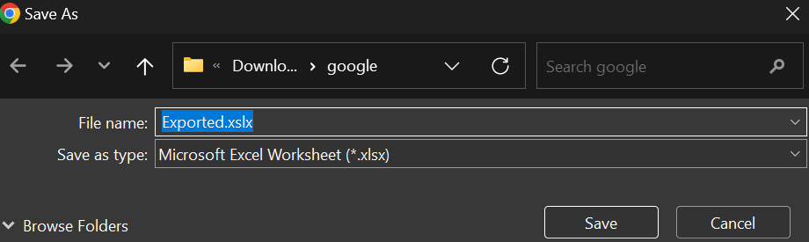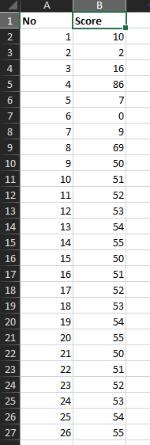

# **Here is the table that being used in Uji T and Bi Serial.**

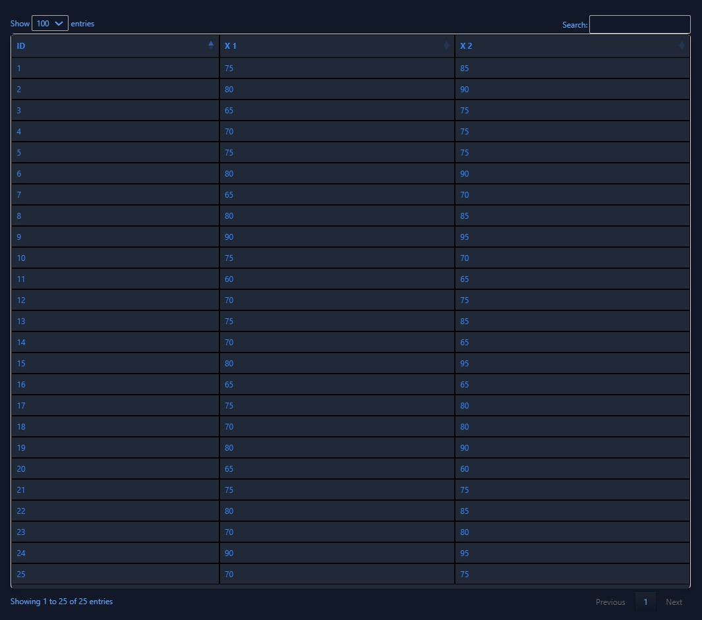

## **Table Uji T**

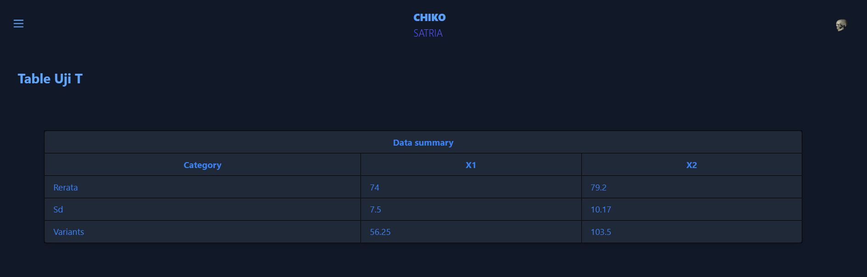

## **Table Bi Serial**

