

**Design of a portable device for rapid and onsite determination of free fatty acids in edible crude oil**

**By**

**Elton M. Chikosha**

**THE DEPARTMENT OF FOOD PROCESSING TECHNOLOGY (FPT)**

The project is to design a protable device to determine the free fatty acids conentration in crude edible oil. The most commonly used method in laboratories in Zimbabwe is titration. However, titrimetric procedures are laborious, time consuming, need large amounts of solvents and chemicals, and substantial glassware is required. In addition, cost of chemicals and environmental issues is also a limitation to these procedures. Accurate detection of endpoints especially for highly coloured crude oil using a colorimetric indicator is a difficult task. Despite all mentioned demerits, unfortunately titration method is still being used in most of the edible oil industries for the determination of FFA.

Innovative techniques have been proposed to this purpose, such as standard method based on the PORIM method, capillary gas chromatography, and to a lesser extent, HPLC and capillary electrophoresis etc (Ali and Abdurrhman, 2013). These approaches, although interesting, are plagued by several problems, such as short lifetime, long response times. Fourier Transform Infrared (FTIR), another technique, although it does not require solvents and short analysis time it was not considered due to the higher cost in the instrumentation involved (Man et al., 1999).

Therefore, building this device will present many benefits to Zimbabwean industries and schools. It is a low cost laboratory equipment that can be implemented and build locally. The new technique is based on the oil’s ability to conduct electricity. According to Grossi (2014), the fatty acids are classified as Bronsted Lowry weak carboxylic acid due to their ability to donate hydrogen ions which essentially contribute to the electrical conductivity.

**Design**

The device is built using Arduino Uno and DFR0300 electrical conductivity sensor which is specially built for arduino.

**Detailed Design**

The Arduino Uno can be powered via the USB connections or with an external power supply. The power source is selected automatically. External (non-USB) power can come from an AC-to-DC adapter (wall-wart) or battery.

**Mode 1:** **Through the USB Port (5V @ 500mA)**

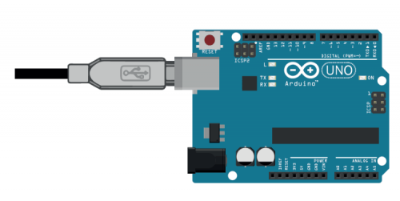

USB powering should only be attempted using a stable 5V supply. It should also be noted that there is a current limit on the USB ports of 500mA, so any current draw greater than this might cause instability. Supplying a voltage to the USB ports essentially dumps that voltage directly to the 5V rail on the Arduino (directly powering the 5V pin). Care should be taken when powering in this manner, as supplying voltage to the USB ports bypasses the 5V regulators, which can damage your board if an incorrect voltage is applied!

Additionally, the Arduino features a resettable polyfuse on the USB ports, with an overcurrent protection of 500mA. This somewhat limits the applications that can be utilised when powering via USB. If anything draws a significant amount of current (or multiple devices draw greater than 500mA combined), the on board polyfuse will likely trip, breaking the connection until the load is removed.

therefore, power required through the USB port = I × V

= **500 × 10-3A × 5V**

**= 2.5watts**

**Mode 2 – DC Barrel Plug 5.5mm/2.1mm (Recommended 9V – 12V @ 2A)**

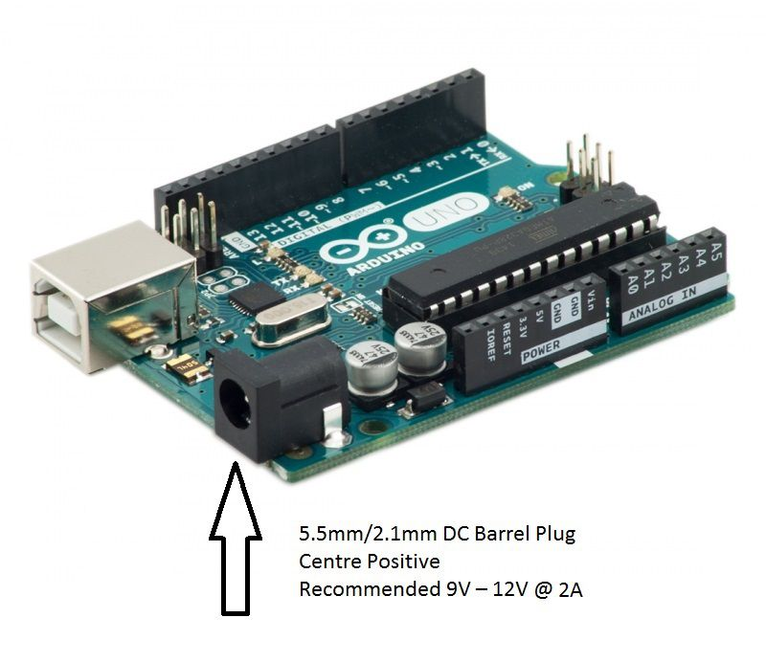

* The Adaptor must be DC (Direct Current) not AC (Alternating Current)
* The barrel plug must be centre positive (The middle pin of the plug must be positive)
* The barrel plug must have an inside diameter (ID) of 2.1mm
* The barrel plug must have an outside diameter (OD) of 5.5mm or less.
* The operating voltage is recommended to be between 9V and 12V
* The operating current is recommended to be 2A.
* Barrel connector length of 9.5mm or greater is sufficient.

The adapter can be connected by plugging a 2.1 mm centre positive plug into the boards power jack. Leads from a battery can be inserted in the Gnd and Vin pin headers of the power connector.

Powermin = I × V

**= 9V × 2A**

**= 18W**

Powermax = I × V

**= 12V × 2A**

**= 24W**

**Operating Voltage**

The Arduino can operate on a supply through this port of 6 to 20V. If the board is supplied with less than 7V, the unit’s performance could become unstable, and the 5V I/O pin may end up supplying less than 5V, which could cause additional circuitry to function incorrectly.

Vice versa, using an over-voltage power supply up to 20V will cause the regulators on the board to run at full-whack, dissipating the extra voltage as heat. This is both inefficient and could cause over-heating of the Arduino.

Therefore, the recommended voltage is 9V to 12V. This is a nice middle ground which enables the board regulators to easily dissipate any unrequired voltage, and additionally supply the correct voltage to the various I/O pins on the Arduino.

It should be noted. The Vin pin on the Power Pins I/O will copy the voltage input supplied through the power jack, and act as an output of that voltage. In this way, you effectively have a customisable output voltage pin on the Arduino which will replicate the input voltage of your power supply.

**Sensor Description**

The suitable conductivity electrode is theAnalog Electrical Conductivity Sensor for Arduino model SKU: DFR0300. The conductivity electrode is designed to optimize the conductivity cell geometry providing the highest accuracy electrode possible. The conductivity cell is designed to allow very shallow immersion depth of 36mm.

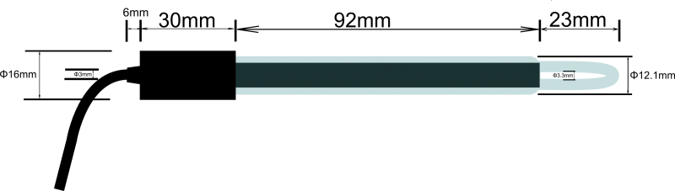

Figure 1: Conductivity Probe DFR0300

**Conductivity Electrode Specifications**

**Accuracy: < ±5% F.S (using Arduino 10 bits ADC)**

Accuracy is a term used to specify the maximum overall error to be expected from a device, such as one that measures a process variable. Accuracy usually is expressed as the degree of inaccuracy. The conductivity cell has an accuracy of ˂± 5% full scale.

**Measuring Range: 0.1ms/cm -- 20ms/cm**

The sensor was chosen because of its high sensitivity in low conductivity samples. According to Hughes (2002), sensitivity is a measure of the change in output of a sensor in response to a change in input. In general, high sensitivity is desirable in a sensor because a large change in output for a small change in input makes it easier to take a measurement.

**DS18B20 Temperature Sensor(Waterproof)**

Conductivity is strongly temperature dependant. As the temperature of the sample increases, the mobility of the ions increases resulting in an increased viscosity. Therefore, we observe the conductivity of the oil sample increases even though the ions concentration may remain constant. In good practices every conductivity result must be specified with a temperature or be temperature compensated usually to the industry standard of 25°C. The conductivity cell has an inbuilt temperature sensor to give the temperature reading of the sample.

**Material use to make the electrode**

The electrode is a platinum plated black electrode. A platinum electrode was chosen because platinum is a very stable, giving the metal excellent [corrosion](https://www.thebalance.com/what-is-corrosion-2339700) resistant properties. Platinum is also a very good conductor of electricity. Platinum is considered a biologically compatible metal because it is non-toxic and stable, so it does not react with, or negatively affect body tissues. Thus, the electrode can be safely used in food applications (Ian, 2004).

**Conductivity Electrode (Electrode Constant K = 1, BNC connector)**

The cell constant is the ratio of the distance the electrode to the area of the electrode in 2 and 4 electrode conductivity sensors. The smaller the cell constant, the more precise the sensor will be in determining changes of the conductivity in the oil. Accuracy conductivity measurements requires an accurate measurement of the cell constant which is determined by calibration. Long term cell constant stability is a result of the conductivity cell’s high-quality abrasion -resistant graphite electrode construction

**Cable Length and diameter of the Electrode: 60cm and 3mm respectively**

The cable length of the conductivity electrode is 60cm and may vary. Additional features mean that the conductivity cell’s measurements are not affected by cable influence. The diameter of the cable is 3mm.

**Operating Voltage: +5.00 V**

The electrode requires the use of an external stable power supply (such as 7.5V DC), and the voltage of MCU (Multi Control Unit) system as close as possible to the +5.00V. More accurate the voltage, higher the accuracy.

**Size of probe**

The length of the probe is 145mm and diameter is 16mm.

**Storage temperature**

The conductivity sensor can be stored at a temperature range of 0 to 50°C thus it can be stored safely at room temperature.

**Life Span**

In solutions of pH 6-8, it can work about one year, and just for reference, if put it in turbid, strongly acid and alkali solution, 25℃, the life span would drop to half a year even less time. The life span depends on your using environment.

**Connections**

The components are connected according to the connecting diagram shown in Fig 1 below. The conductivity electrode is connected to the BNC connector on the EC meter board, and then using the analog connection line, the EC meter board is connected to the analog pin 1 of the Arduino controller. The temperature sensor is connected to the connecting terminal of the terminal sensor adapter. Then should using the digital connection line, the terminal sensor adapter is connected to the digital pin2 of the Arduino controller. When the Arduino controller gets power, the blue LED on board is on

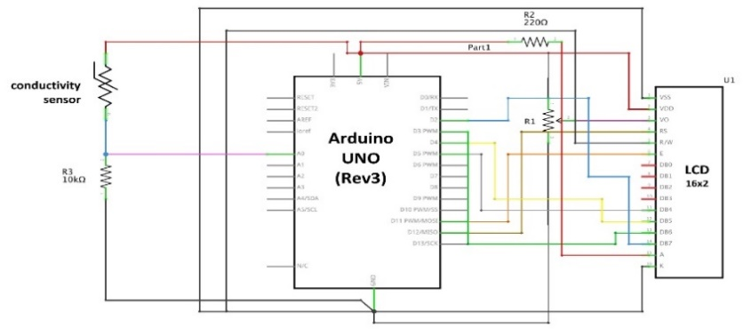

Figure 2 Circuit Schematic

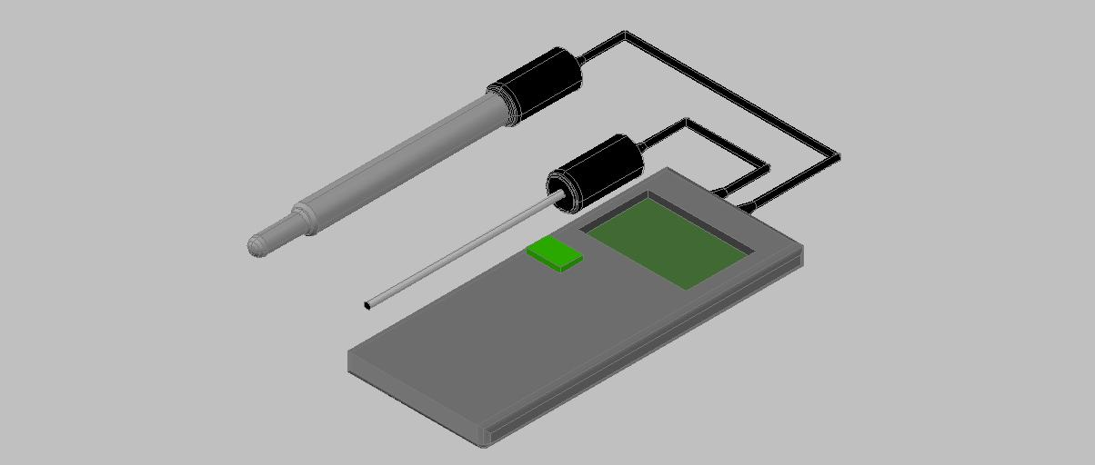

Figure 3: The Prototype

**Budget for the design**

|  |  |  |
| --- | --- | --- |
| Part list | Quantity | Cost |
| Conductivity Electrode (BNC Connector) | 1 |  |
| EC Meter V1.0 and Cable | 1 |
| DS18B20 Temperature Sensor (waterproof) | 1 |
| Pluggable Terminal Adapter V2 and Cable | 1 |
| Conductivity Standard Solution (1413us/cm and 12.88ms/cm) | 4 |
| Cost |  | $124 |
| Covers | 1 | $30 |
| Total Cost |  | $154 |

Direct labour cost: $100

|  |  |
| --- | --- |
| Item | Amount |
| Direct Material Cost | 154 |
| Labour Cost | 100 |
| Total Cost | 254 |

**User Guide**

**How to take a measurement**

Before taking a measurement wash the electrode thoroughly with distilled water. After thoroughly washing the electrode, you immerse the electrode in oil sample, about 50mL in a beaker. The electrode is immersed at least 4 cm deep. The device measures the conductivity and convert it into percentage free fatty acids. Take a reading after the reading on the display has stabilized.

**How to clean the conductivity probe**

Clean with mild liquid detergent and /or dilute nitric acid (1%wt) by dipping or filling the cell with solution and agitating for 1 to 2 minutes. Dilute HCL or H2SO4 may also be used. Wipe the measuring end of the sensor with a clean with a clean soft cloth. Then rinse several times with distilled water or deionised water and recalibrate before use.

**Note:** DO NOT soak the sensor in dilute acid solution for more than 5 minutes.

**How to store the conductivity probe**

Before storing the cell, rinse it carefully in deionised water.

• Short-term storage: in deionised water.

• Long-term storage: in deionised water or store dry.