**Interactive web application for mental well being**

**ABSTRACT**

In the contemporary landscape where mental well-being is paramount, the integration of technology into wellness practices offers innovative solutions to enhance personal health regimes. This project, "Interactive Web Application for Mental Well-Being," aims to develop a comprehensive platform that synergizes personalized yoga practice with an emotion-aware chatbot to promote holistic health. The system comprises two primary modules: Yoga and Chatbot.

The Yoga Module begins by assessing the user’s current emotional state through a selection of 19 predefined moods. Based on this input, the system recommends three tailored yoga poses from a dataset of 77 poses designed to address specific emotional needs. To ensure correct pose execution, the module employs advanced computer vision techniques, utilizing the YOLO (You Only Look Once) model for accurate pose detection and PoseNet for extracting key joint features. An angle heuristic algorithm analyzes the user’s posture, providing real-time corrective feedback to enhance the effectiveness and safety of the practice.

Complementing the Yoga Module, the Chatbot Module engages users by recognizing and responding to 59 distinct emotions. Through an intuitive conversational flow, the chatbot inquires about the reasons behind the user’s emotions, offers empathetic support, and recommends relevant YouTube videos to aid in emotional regulation. Post-interaction, the chatbot gathers feedback to refine its responses, ensuring a personalized and supportive user experience.

By combining personalized physical activity with emotional support, this web application provides a unique and effective tool for individuals seeking to improve their mental and physical well-being. The integration of cutting-edge machine learning and natural language processing technologies ensures that users receive tailored guidance and support, fostering a balanced and healthy lifestyle.

**Keywords**: Personalized yoga, Computer vision, Machine learning, Mood assessment, Emotion recognition, Pose recommendation, YOLO model, PoseNet model, Chatbot, Pose correction, mental well-being.

**OBJECTIVE OF PROJECT:**

The objective of our project is to enhance physical and mental well-being by providing personalized yoga practice and emotional support. Using computer vision, machine learning, and a chatbot, it tailors yoga pose recommendations, and delivers supportive interactions based on user emotions.

**PROBLEM STATEMENT:**

Traditional yoga practice often lacks personalized guidance and correction, leading to potential inefficiencies and injury risks, while emotional support systems are limited. By integrating computer vision, machine learning, and natural language processing, our project aims to provide a solution that analyzes users' mood inputs, recommends suitable yoga poses, offers pose correction, and interacts through a supportive chatbot. This addresses the need for personalized guidance, correction, and emotional support in well-being practices, catering to individual needs and enhancing overall well-being.

**MOTIVATION:**

The motivation behind this project stems from a desire to leverage technology to enhance yoga practice and promote emotional well-being. Traditional yoga methods often lack personalized feedback and guidance, leading to challenges in achieving optimal results and avoiding injuries. Additionally, emotional support is crucial but often not integrated into well-being practices. By combining computer vision, machine learning, and natural language processing, we aim to provide personalized recommendations, real-time feedback, and supportive interactions tailored to individual needs, making yoga practice and emotional support more accessible, effective, and safe for people of all levels.

**SCOPE:**

The scope of our project encompasses the development of a comprehensive system for personalized yoga practice and emotional support, integrating various technologies and methodologies. This includes:

1. Mood Assessment: Implementing a mechanism to assess users' emotional states to tailor yoga recommendations and provide appropriate chatbot interactions.

2. Pose Recommendation: Providing personalized recommendations of yoga poses based on the user's mood input.

3. Pose Detection: Utilizing the YOLO (You Only Look Once) model for accurate detection of yoga poses from user-uploaded images or videos.

4. Key Features Extraction: Employing the PoseNet model to extract key features of the detected yoga poses for further analysis.

5. Pose Correction: Implementing an angle heuristic algorithm to provide real-time feedback and corrective measures for improving the execution of yoga poses.

6. Chatbot Interaction: Developing a chatbot module to interact with users, assess their emotional states, provide supportive responses, and recommend resources such as YouTube videos.

Overall, the project aims to provide a holistic solution for enhancing both physical and mental well-being through advanced technology.

**System Analysis**

**EXISTING METHOD**

Existing methods for personalized yoga practice typically involve manual instruction from yoga teachers or the use of pre-recorded video tutorials, which often lack real-time feedback and personalized guidance. While some online platforms offer algorithm-driven recommendations based on user preferences or skill level, they do not account for the practitioner's emotional state or provide detailed feedback on pose execution. These methods face challenges in accurately assessing users' emotional states, providing precise feedback on pose alignment, and offering tailored recommendations for individual needs. Moreover, the lack of integration across different technologies results in fragmented user experiences.

**DISADVANTAGES**

* Lack of Personalized Feedback: Traditional methods often rely on generic instructions, which may not address the specific needs or limitations of individual practitioners.
* Risk of Injury: Without real-time feedback, practitioners may perform poses incorrectly, leading to potential strain or injury.
* Inability to Address Emotional States: Many methods do not consider the practitioner's emotional state when recommending poses or sequences.
* Lack of Integration with Advanced Technology: Existing solutions may not leverage computer vision and machine learning for real-time feedback and personalized guidance.
* Fragmented User Experience: Users may need to utilize multiple platforms for mood assessment, pose recommendations, and instructional content, resulting in a disjointed experience.

**PROPOSED SYSTEM**

The proposed system for personalized yoga practice and emotional support addresses these limitations by integrating advanced computer vision, machine learning, and natural language processing techniques. The system includes a mood assessment module to tailor yoga recommendations and chatbot interactions based on users' emotional states. It provides personalized yoga pose recommendations using the **YOLO** model for pose detection and **PoseNet** for key features extraction, with an **angle heuristic algorithm** offering real-time feedback and correction. The chatbot module engages users by recognizing and responding to various emotions, offering empathetic support and recommending resources. This unified platform, accessible online and via mobile applications, ensures a streamlined and comprehensive experience, promoting enhanced physical and mental well-being through personalized guidance, real-time feedback, and emotional support.

**ADVANTAGES:**

* Personalized Guidance: The system recommends yoga poses tailored to the user's emotional state, providing a more personalized and effective practice experience.
* Real-Time Feedback: Leveraging computer vision and machine learning, the system provides immediate feedback on pose alignment and execution.
* Reduced Risk of Injury: The pose correction algorithm offers detailed guidance to improve pose execution, minimizing the risk of injury.
* Enhanced User Experience: The seamless integration of various technologies ensures a streamlined and comprehensive solution for personalized yoga practice, enhancing user engagement and satisfaction.

**PROJECT FLOW**

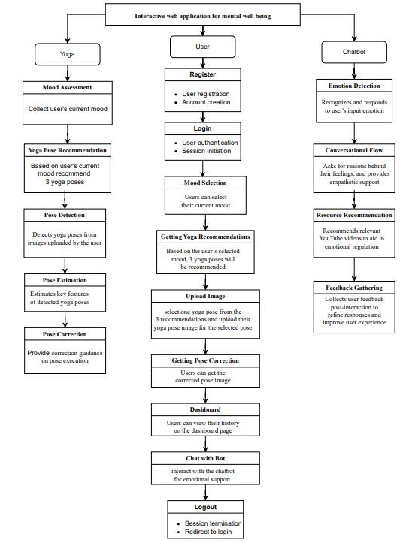

**HARDWARE & SOFTWARE REQUIREMENTS**

**SOFTWARE REQUIREMENS**

Operating System : Windows 7/8/10

Serverside Script : HTML, CSS, Bootstrap & JS

Programming Language : Python

Libraries : Flask, Pandas, numpy

IDE/Workbench : VSCode

Technology : Python 3.6+

Server Deployment : Xampp Server

Database : MySQL

**HARDWARE REQUIREMENTS**

Processor I3/Intel Processor

RAM 8GB (min)

Hard Disk 128 GB

Key Board Standard Windows Keyboard

Mouse Two or Three Button Mouse

Monitor Any

**MODULES**

**1. System:**

* 1. **Yoga system module**
     1. Mood Assessment: Collects user input on their current mood or emotional state.
     2. Yoga Pose Recommendation: Recommends 3 yoga poses based on the user's selected mood.
     3. Pose Detection: Detects yoga poses from images uploaded by the user.
     4. Pose Estimation: Estimates key features of detected yoga poses, such as joint positions and angles.
     5. Pose Correction: Provides real-time feedback and correction guidance on pose execution.
  2. **Chabot Module:**
     1. Emotion Detection: Recognizes and responds to 59 distinct emotions based on user input.
     2. Conversational Flow: Guides the user through their emotions, asks for reasons behind their feelings, and provides empathetic support.
     3. Resource Recommendation: Recommends relevant YouTube videos to aid in emotional regulation.
     4. Feedback Gathering: Collects user feedback post-interaction to refine responses and improve user experience.

**2. User:**

**2.1** Register: Users can register with their credentials such as email and password.

**2.2** Login: Users can log in with their registered credentials.

**2.3** Mood Selection: Users can select their current mood.

**2.4** Getting Yoga Recommendations: Based on the user’s selected mood, 3 yoga poses will be recommended.

**2.5** Upload Image: Users can select one yoga pose from the 3 recommendations and upload their yoga pose image for the selected pose.

**2.6** Getting Pose Correction: The uploaded yoga pose image will be analyzed by the trained model, which provides corrections for the pose. Users can then view the corrected pose image. This information (selected mood, uploaded image, pose-corrected image) will be stored in the database.

**2.7** Dashboard: Users can view their history on the dashboard page. Here they can view their selected mood, uploaded image, and pose-corrected image ordered by date. Users can also retrieve history data by a specific date or period.

**2.8** Chat with Bot: Users can interact with the chatbot for emotional support and recommendations.

**2.9** Logout: After completing their activities, users can log out from the website.