Task:3 Customer Segmentation / Clustering:

Deliverables:

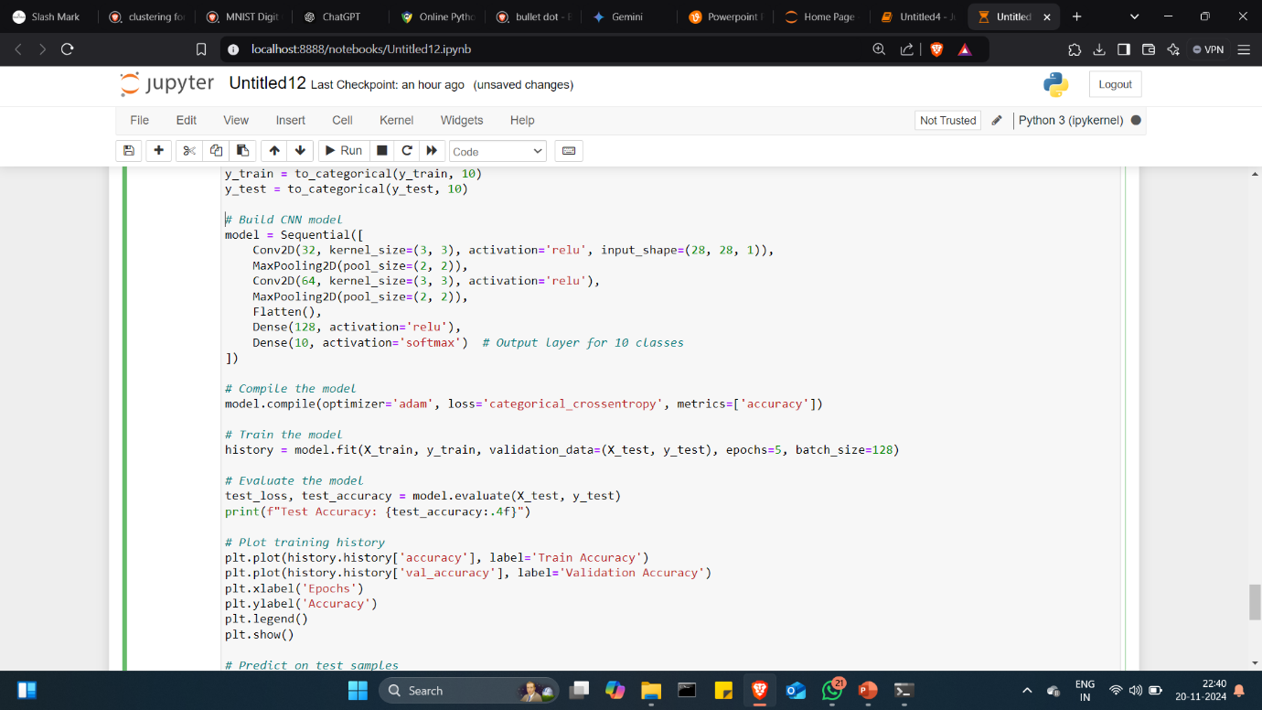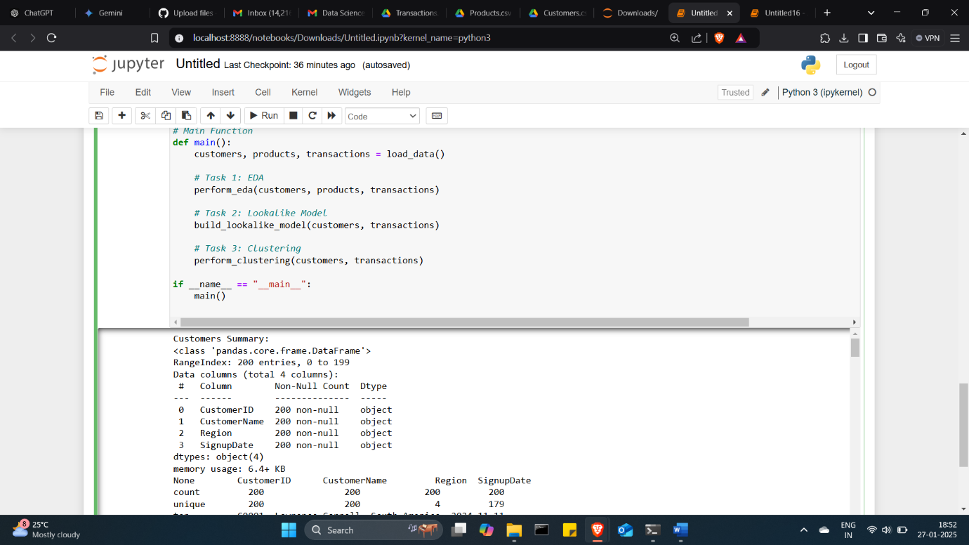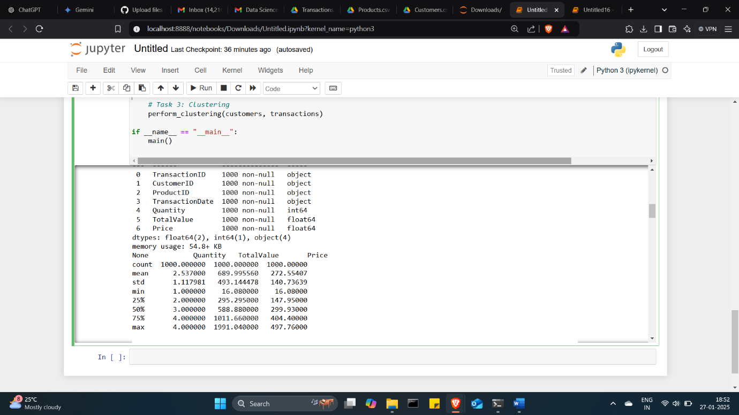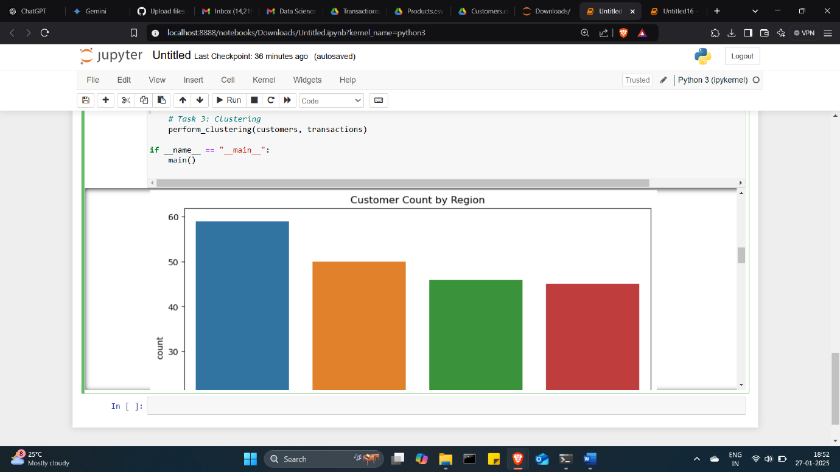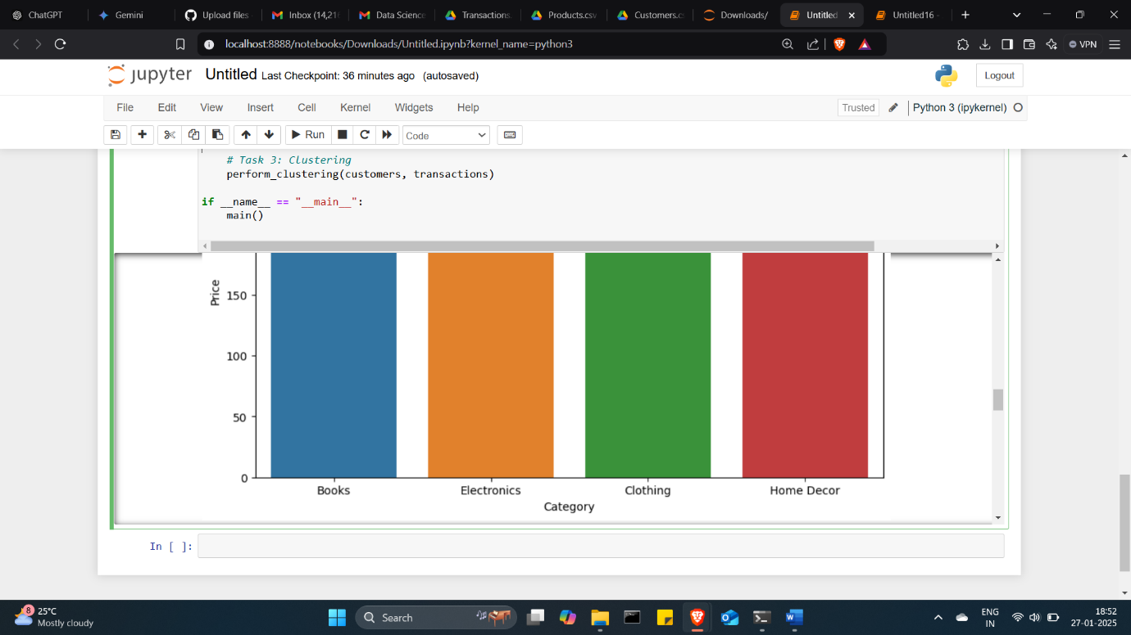**1. Number of Clusters Formed**

* **Algorithm Used:** (e.g., K-Means, Hierarchical Clustering)
* **Optimal Number of Clusters:** (e.g., 4 clusters)
* **Clustering Metrics:**
  + **Davies-Bouldin (DB) Index:** (e.g., 0.82)
  + **Silhouette Score:** (e.g., 0.65)
  + **Inertia:** (if K-Means, e.g., 1,200)

**2. Visualizations**

* **Scatter Plot:**  
  A 2D scatter plot of clusters showing the separation and grouping of customers.
* **Elbow Curve:**  
  An Elbow Curve plot demonstrating the optimal number of clusters based on within-cluster sum of squares.
* **Heatmap (Optional):**  
  Show feature distribution across clusters for detailed analysis.

**3. Observations and Insights**

* Example Clusters:
  + **Cluster 1:** High-value customers with frequent purchases.
  + **Cluster 2:** Low-value, infrequent buyers.
  + **Cluster 3:** New customers with minimal transactions.
  + **Cluster 4:** Moderate-value customers with average transaction frequency.