**Debt Visualization**

**Introduction**

This project was initially inspired by the suspension of the US debt ceiling in 2023 under President Biden's administration. It led me to investigate how the US's debt had changed in the past decade. While I am no expert on politics, it still worries me to see the massive debt that the public is holding now. This project intends to alert the public about the debt accumulation that the US currently holds.

**Research**

Data:

The US total public debt holding data was found easily on the official government website. The dataset is published almost daily, so I obtained a consistent data sample for the past ten years. The data from the official site was presented in a CSV file, which made it easy to work with in processing.

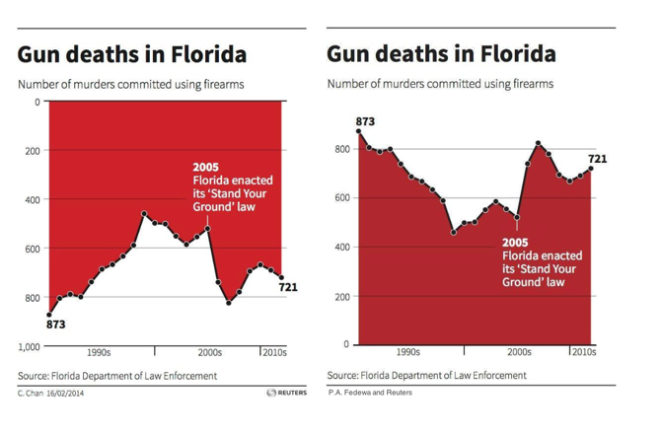Gun Deaths in Florida & Iraq's Bloody Toll:

Figure 1 Florida Gun Deaths example

I liked these two data visualizations presented in class. The design was simple, easy to follow, and had formed an image resembling blood with the data. Although it is said in class that the Florida depiction was misleading, I had no issues reading the data. I will do something quite similar to these two examples given in class.

Visualization of Debt:

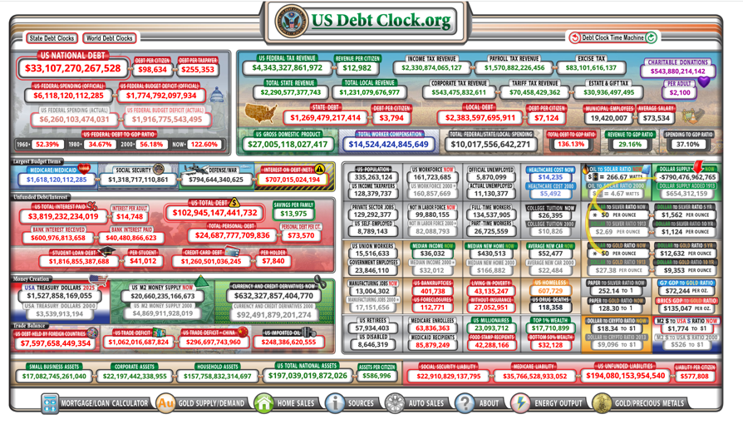I looked at a few ways other people have visualized debt, there were none that I found were creative. I did find a debt clock that displayed the changes in debt every second. I cannot confirm the reliability of the source, but it did make the debt accumulation problem in US seem like an important issue, as the clock essentially shows that the debt is growing every second.

Figure 2 Debt Clock

**Design**

Features of the Visualization:

The first things that come to mind when thinking about debt are burden and accumulation, and naturally, the image of a snowball effect follows. I plan to represent the debt throughout the past decade using a snowball rolling down a hill. The snowball will grow in proportion to how debt changes. I could also represent the debt amount with the shape of the hill. As the debt has increased continuously throughout the past decade, I know that a line graph of "time vs. debt" would have a positive correlation. This can be taken advantage of in creating a hill because turning a positively correlated graph upside down simulates an image of a hill. The y-axis would also have to be modified to be turned upside down.

Data Cleaning:

The data retrieved from the US treasury website contains data recorded almost daily for the last decade. Thus, I have too much data to display, so much so that the canvas size does not have enough pixels to display every data point. I need to delete some data points in each interval to speed up the data-retrieving process and to make the visualization possible on the screen.

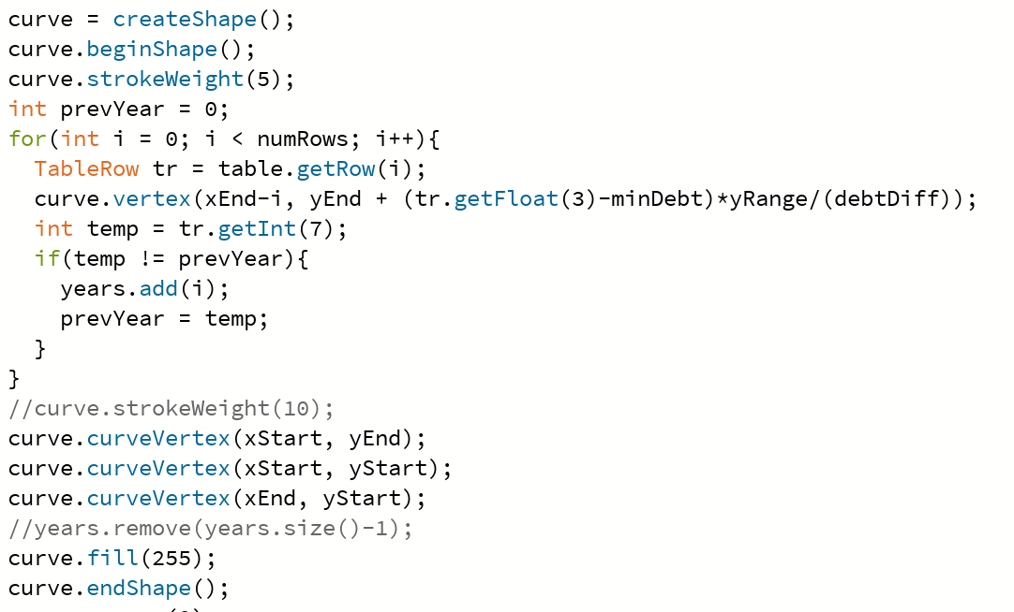Plotting Data:

Figure 3 Curve Creation

I needed to map the ten years' worth of data onto around 800 pixels. As this is an interactive visualization, it would be inefficient to calculate the plot in every "draw()" invocation. My solution was to calculate only once in the setup(), store it in a PShape object, and draw the shape in each iteration instead. The calculation of each data point was introductory algebra involving the size of the canvas and the range of the data distribution. As the data had been cleaned only to contain around 800 entries, the calculation process is relatively fast. As mentioned in the previous section, the y-value needed to be turned upside down; this was done by simply treating the top of the y-axis as the origin (minimum debt value) in the calculation.

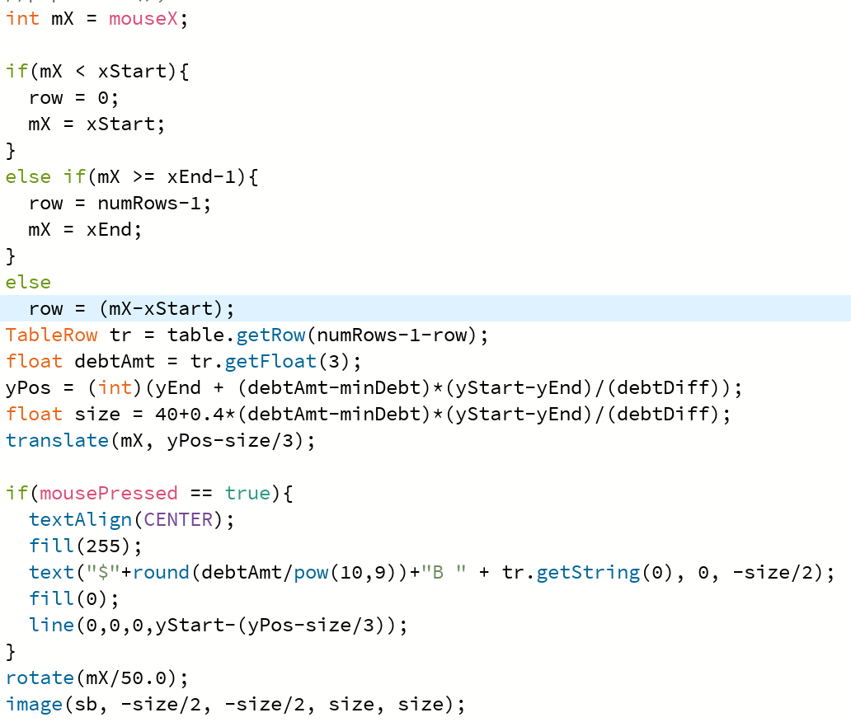Snowball Representation:

Figure 4 Snow Ball Implementation

The snowball is an image found online. Its x position on the canvas and its size change depending on the mouse's x position, while the y position changes based on the y value on the curve created. The value of the debt is retrieved based on the mouse's position, and then through some calculation and mapping, the size of the snowball and the y position is determined. When the user presses the mouse, the total accumulated debt and the data will appear above the snowball; this feature was added to make the data easier to read.

Difficulties

Rotation and Translation:

The rotate function confused me for quite some time at the beginning. I recall from one of the lectures that the translation and rotation are preserved in the program, so I wrote the translation of the snowball on the assumption that the translations previously made were preserved. My understanding was incomplete, and it took quite some time to debug this problem. I later realized that the translation and rotations were not preserved between different method calls and did not require matrix pop and push, which simplified the issue.

Snowball Size and Y Position:

As the snowball grows, its y position could not simply be a constant away from the curve. I needed to make the image of the snowball look like the ball was rolling on the surface of the hill/curve. This solution was to make the y positioning in proportion to the positioning of the curve with a constant added in proportion to the size of the ball. Even then, the problem is not entirely solved; the ball still looks embedded in the hill in some parts of the curve, but luckily, the visualization looks convincing.

**Discussion**

Data Accuracy:

While the current product captures the picture of how accumulated debt has changed over time, it is still important to note that 2/3 of the data was removed for the graph to fit in the canvas. The accuracy of the product could be improved through using a software that allows for a canvas with a more compact placement of pixels such that details and data points do not need to be removed to fit. This would hopefully give people the more accurate representation of US debt holding.

Another approach to this problem is to minimize the issue by averaging or smoothing out the dataset instead of deleting data points. By taking the average in intervals of 3 points, the curve will still consider the entirety of the dataset.

**Final Product**

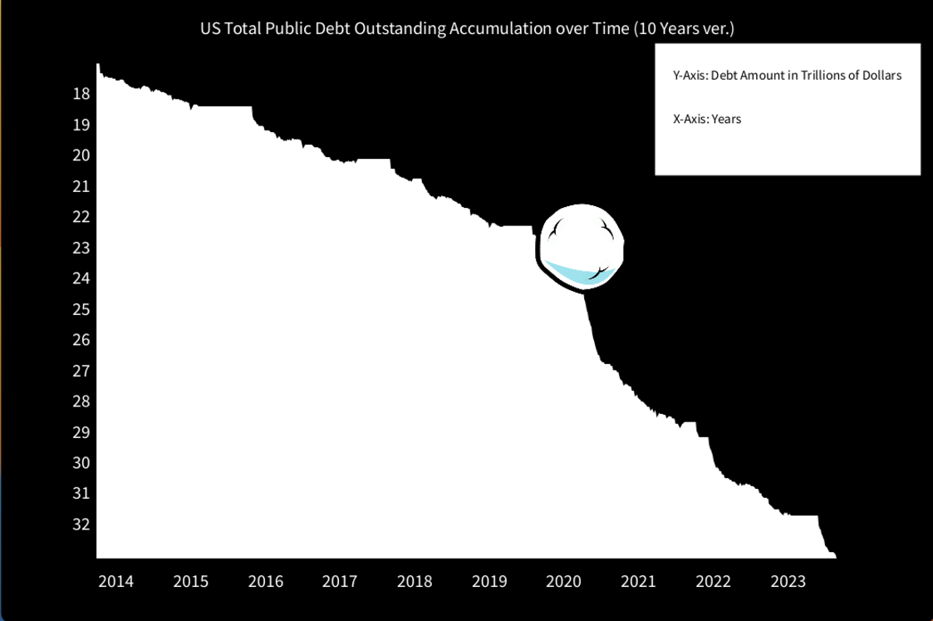

Figure 6 Demo 1

Figure 5 Demo 2

Bibliography

Lallanilla, M. (2014, April 23). *Misleading gun-death chart draws fire*. LiveScience. <https://www.livescience.com/45083-misleading-gun-death-chart.html>

Treasury, U. s. D. O. T. (n.d.). *Debt to the penny*. U.S. Treasury Fiscal Data. <https://fiscaldata.treasury.gov/datasets/debt-to-the-penny/debt-to-the-penny>

U.S. National Debt Clock : Real Time. (n.d.). <https://www.usdebtclock.org/>

Wikimedia Foundation. (2023, September 19). *Fiscal responsibility act of 2023*. Wikipedia. <https://en.wikipedia.org/wiki/Fiscal_Responsibility_Act_of_2023>