|  |
| --- |
| **Final Projecet: Detective Investigation Map** |

Instructions

|  |
| --- |
|  |

# 1. Introduction

The purpose of writing this use note is to realize the functions of the Detective Investigation Map application, so that users can understand the method of use of the platform.

# 2. APP Overview

The detective investigation map is an app that aims to create a digital platform for investigators, journalists, detectives, and of the sorts to record data as they do in investigation walls. This app allows the user to mark events that occurred on a location in the map along with visual and texual data to be attached. It also provides the ability to seek assistance from Google’s Gemini AI for assistance of any sorts.

# 3. System Introduction

The technical characteristics of the software : APP, small program, artificial intelligence software, map/location tracker software

Application Version : v1.00.000

Applicable platform : Android 7.0 above

Required permissions : Microphone ; Camera ; write to the memory card ; Internet ; Media Video ; Fine Location

Other Requirements: Requires Internet Availability, Camera Hardware, VPN connection if in China

Android users : copy the installation files directly to the phone for installation.

# 4. Enter the APP

# 5.1 Map View and its Functions

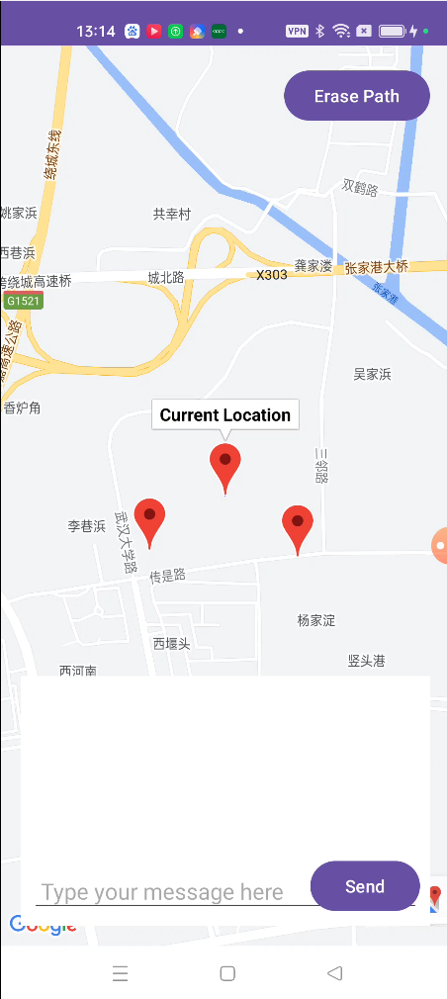After entering the application, users can see the layout of the application, a map. This map view is the main UI thread of the application and displays the current location of the user indicated by the center pin. The erase path button on top right and the chat box at the bottom half of the screen shall be explained in a later section. On this screen, the user is able to scroll in four directions to reposition the screen and monitor the surrounding geographic areas. When the user starts to move away from their current location, a pace is traced by the app to indicate the route that the user is taking. Long pressing on a location on the map creates a “permanent pin” (pp for short) which is saved throughout multiple launches of the app.

## 5.2 Pin Dialog Options

Clicking on the pin brings up a dialog box to the user, which includes the name of the pin and a sequence of options, operations that can be performed on the selected pin. These options include: Rename, Add/View Video, Draw Line to Another Pin, Delete Connected Line, Add/View Text.

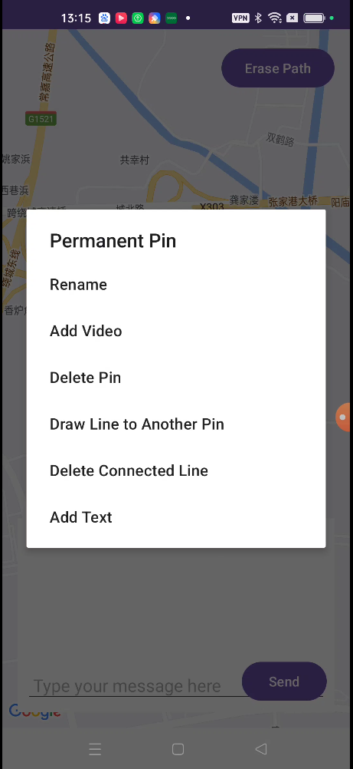

## 5.2.1 Rename

When a pp is created, the default name that is given to it is “Permanent Pin,” this option allows the user to define the name of the selected pp. When the option is clicked on, a text box pops up in front of the user and prompts the user to enter the desired name, after clicking “ok,” the name is then reflected in the app. Names are preserved along with the pp between different app launches.

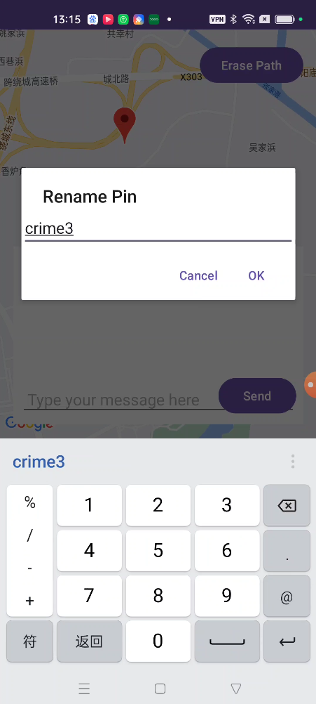

This functionality is useful as it indicates the event/crime scene being referenced in the investigation.

## 5.2.2 Add/View Video

After a pp is created, it is by default without a video, when a pp is without a video assigned, clicking on the pp will include an “add video” option. When this option is selected, the app fires an intent to open the camera view.

The user is prompted to record a video and once confirmed, the recorded video is added to the pp.

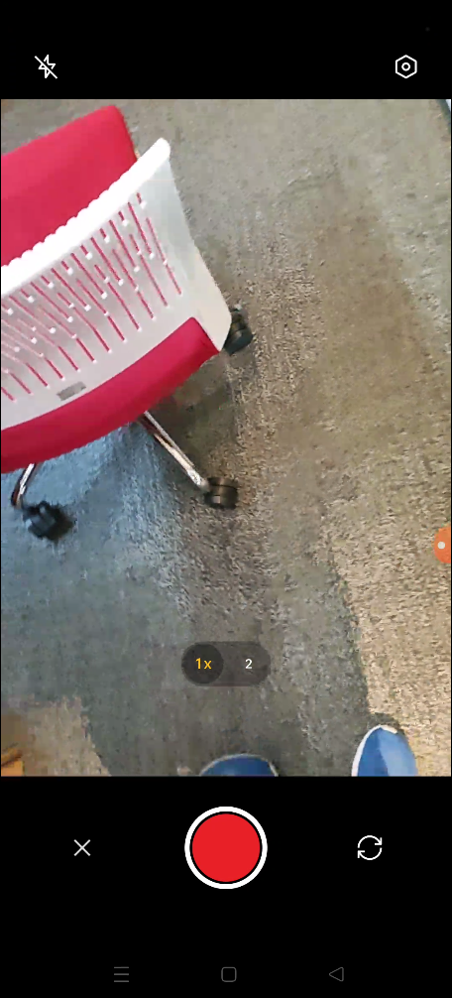

Upon being assigned a video, the next time the user clicks on the pp, the add video option is replaced by a view video option, allowing the user to view the assigned video instead.

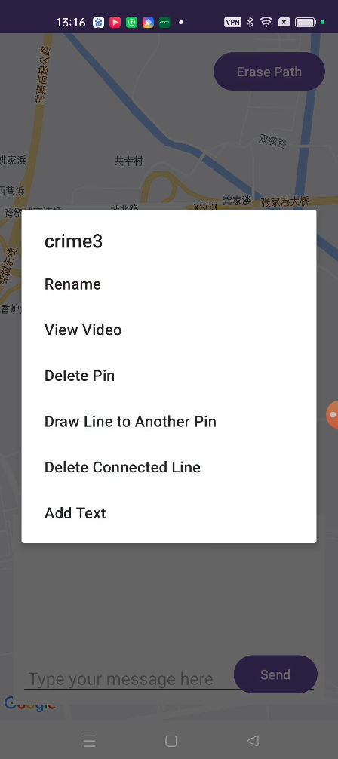

When this option is selected, the video fragment is spawned on the top left corner of the screen as it plays the recorded video. The video can be dragged around the screen implemented using an event listener. This video fragment is played and operated on a separate thread.

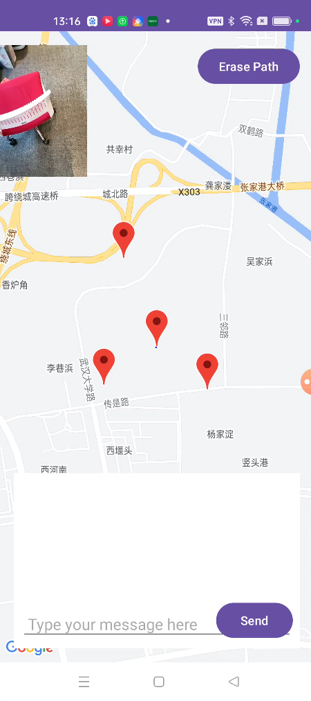

This function allows the user to record visual data and sorts of the crime scene or event.

## 5.2.3 Draw Line to Another Pin and Deleting the Line

Drawing a line between two pps is implemented using the Draw Line to Another Pin option. Upon selection, the app prompts the user to choose the pp that is to be connected with the selected pin, as indicated by the names of the other pps.

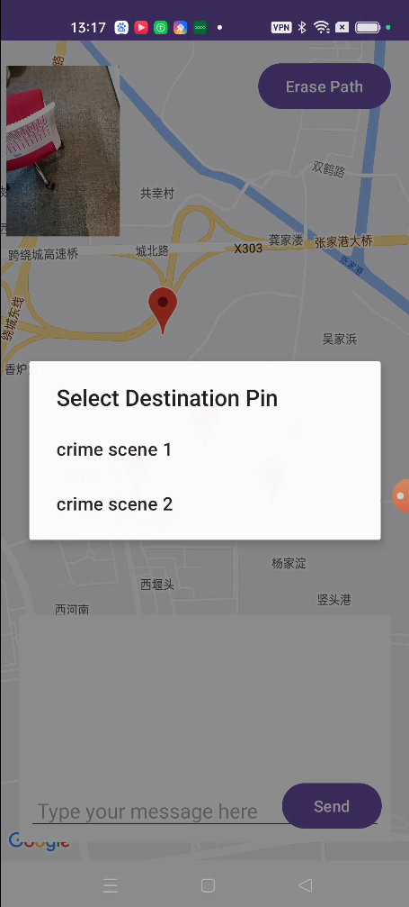

Once selected a pin to be connected, the line between the two selected pin is drawn on the map.

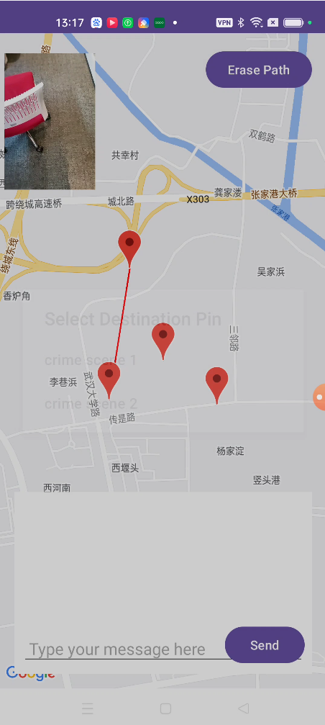

The Delete Connected Line option gives the user the option to delete all connections to a pin. For example, if pp A and B is both connected to pp C, an invocation of Delete Connected Lin on pp C will delete both connections.

This functionality allows the user to record relationships between crime scenes.

## 5.2.4 Add/View Text

The last option in the pps is Add/View Text. Similarly to Add/View Text, this option allows the user to add text information only when no text is attached to the pp.

When clicked, the user is prompted to add text information and it is saved/attached to the pp when the user confirms completion with the “ok” button.

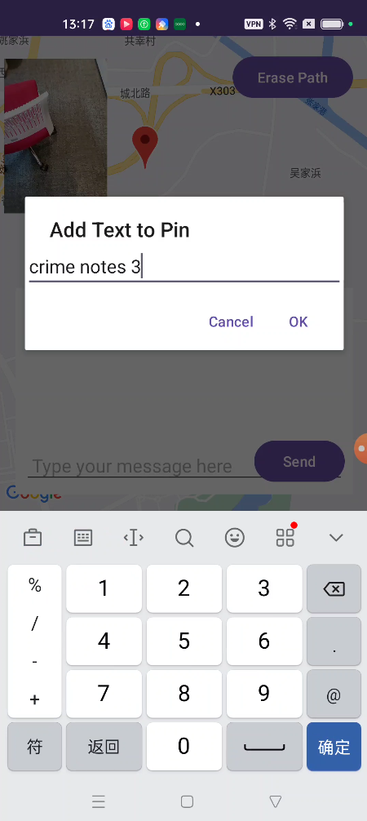

Once text data is attached to a pp, the next click on the pp will replace the previous option to View Text, which allows the user to view the recorded text.

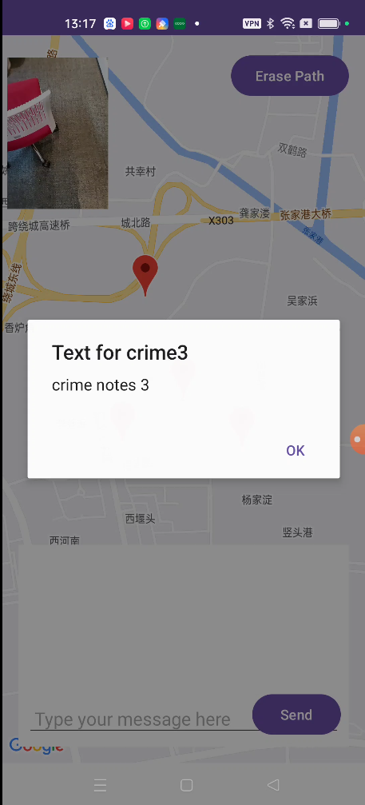

This is a function that allows the user to record textual data on a specific crime scene.

## 5.3 Gemini Chat Function

Entering the application the user is presented with a chat box at the bottom half of the application, it prompts the user to enter a text message.

When the user enters the desired message, the message can be sent with the “send message” button.

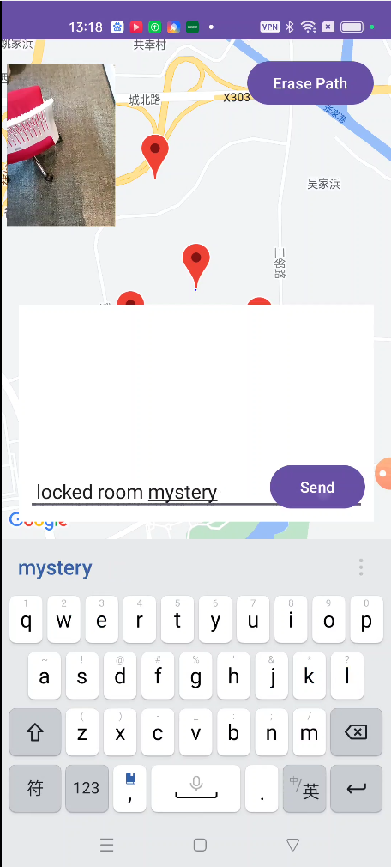

The application will take 3-6 seconds for the server to create a response to be displayed in the chat box. As this function is multithreaded, the user is allowed to perform other functionalities mentioned above. When a response is returned, the user is allowed to scroll through the message if it is too long.

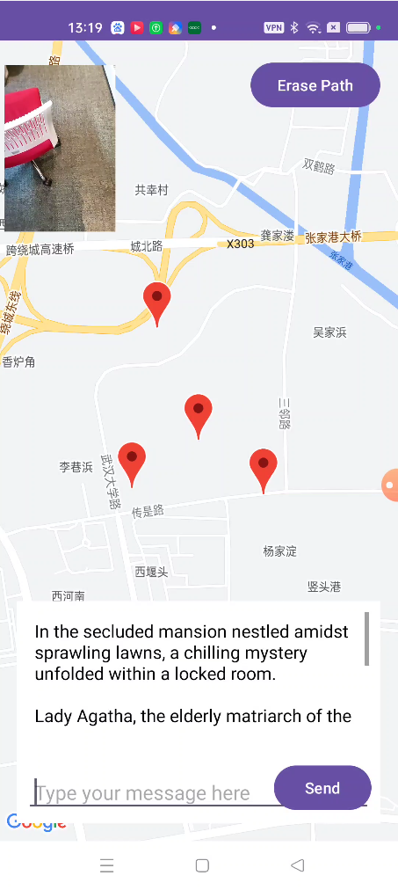

# 6 References

Below lists the links to the resources that have helped in the building of this project.

Alertdialog  :  android developers. Android Developers. (n.d.). <https://developer.android.com/reference/android/app/AlertDialog>

Google. (n.d.). Get started with the gemini API in Android Apps (Client SDK)  |  google AI for developers  |  google for developers. Google. <https://ai.google.dev/gemini-api/docs/get-started/android#multi-turn-conversations-chat>

Google. (n.d.). Google Maps platform documentation  |  maps SDK for Android  |  google for developers. <https://developers.google.com/maps/documentation/android-sdk>

SharedPreferences.editor  :  android developers. Android Developers. (n.d.-b). <https://developer.android.com/reference/android/content/SharedPreferences.Editor>

VideoView  :  android developers. Android Developers. (n.d.-c). https://developer.android.com/reference/android/widget/VideoView <https://www.youtube.com/watch?v=8XACQDbH6gA>