**Electric Force Field**

**Introduction**

Electricity is the foundation of our modern world. It is difficult to imagine living in a world without phones, light, transportation, and other such electronics. For this reason, the topic of electricity is one of the first topics taught in physics. Before electricity, students typically work with kinematics or fluids, which are things we see in our everyday life and is easy to picture each concept. However, electricity is a topic that some students struggle to visualize as it is not as intuitive as the previous topics, even abstract at times. This project therefore aims to create a simulator that demonstrates one of the concepts in electricity: the electric field. It hopefully will show how electric fields change directions under the influence of multiple charged particles. The parameters of this parametric design will be the number of positively charged particle and the number of negatively charged particles, with a minimum of one charged particle on the board.

**Research**

Electric field and electrostatic force equation:

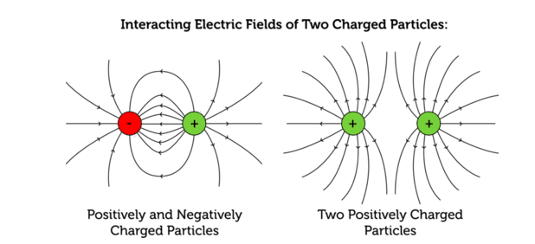Electric Force $F_{e}=\frac{1}{4πε_{0}}\frac{q_{1}q_{2}}{r^{2}}$ where q1 and q2 are the charges of the two charged particles in space and r being the distance between the center of the two particles. The rest is a constant and will be replaced with a constant more suitable for the visual consideration.

Figure 1 Interacting Electric Fields of Two Charged Particles

Electric Field $E= \frac{F_{e}}{q_{2}}$. The Electric field measures the electric force experienced in a position in space, where r measures the distance between the point in space and the charged particle creating the field. The way to account for the forces from multiple charged particles would just be to add up the electric fields in their respective components (x and y axis as I am working only on a 2-dimensional surface).

The direction of the electric field is dependent on the charged particle exerting the force. If the charged particle was positively charged, this would be a repulsing force, whereas with negatively charged forces, this would be an attracting force.

The strength of the field is also dependent on the charge of the particles, to simplify the problem, I will assume that the absolute value of the charges is the same, taking only the positive/negative charges and distance into consideration.

As this is a simulation to benefit the learning of electrostatic forces, I will neglect other properties in real life such as mass and size of the particles.

**Design**

Setting Charges:

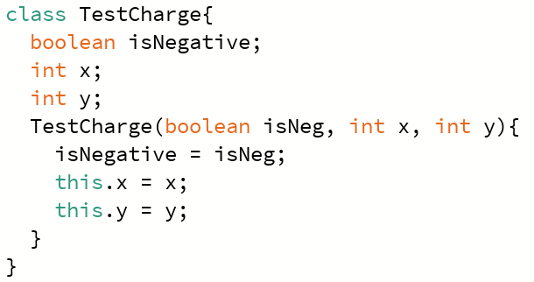I am again working with a board representation of the screen, using a 2D array to manage the elements I want to place on the screen. Two types of elements are placed on the board: charged TestParticles and arbitrary points in space where I will be drawing the electric field.

Figure 2 TestCharge Class

The TestParticles are placed randomly on the board; each particle has essential information, such as the charge (negative or not) and its position, indicated using int members x and y. The rest of the board (those not test charges are labeled so and have the TestParticle field initialized to null.

Calculating Directions:

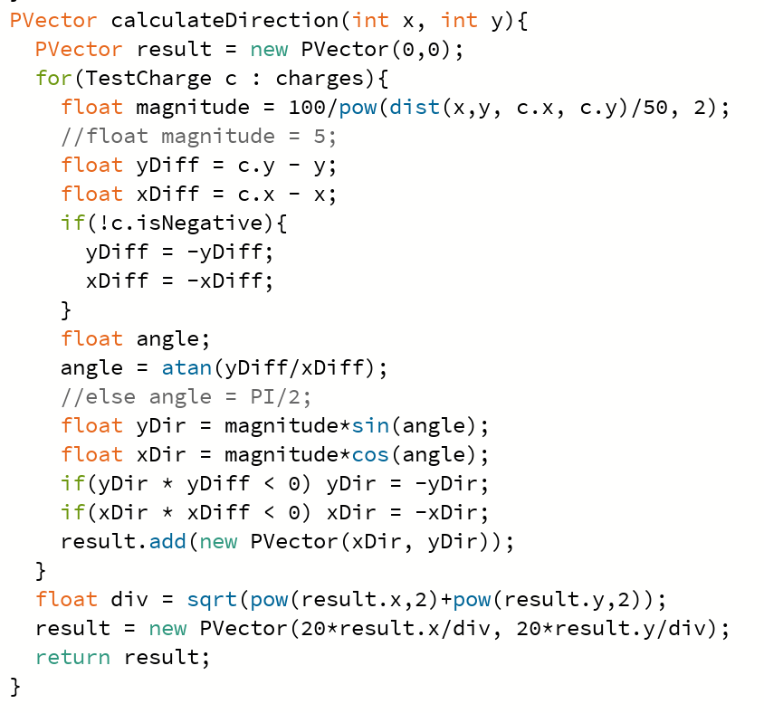As I will be fixing the magnitude, the direction was my only concern. Deciding the direction, in effect, still required calculations involving the magnitude of each force imposed on a point in space. If charge a is further from a point than another charge b, then charge b would have a greater magnitude of force imposed on that point, and therefore, the vector direction will change respectively. As I must calculate the direction of the resultant vector, I would have to iterate through the charges with every point on the board. The process requires determining the slope between the point and the charge and then using trigonometry to figure out the angle to work with. Using the angle, I can calculate the x and y components of the field of each electric field. I would add the x and y components on the resultant vector for each electric field created by the charges on the board. After calculating the resultant vector for a specific point, that vector is stored in the board element and drawn during the drawBoard() stage.

Figure 3 Direction Calculation

Fixing the magnitude:

As explained in the research, this project neglects the relative magnitude of each resultant field at each point on the board. To make the magnitude all equal. I needed to calculate the unit vector for each resultant. This is done by dividing the x and y components by the length of the resultant.

Drawing the Board:

The charged particles will be indicated by large circles colored red or blue. Red circles are positively charged particles, whereas the blue circles will be the negatively charged particles. The rest of the board will be points in spaces to draw the electric field. A small black circle indicates the center of the points in space, and the black line segment reaching out of the circle indicates the direction of the electric field.

**Difficulties**

There were no real difficulties worth mentioning. As this simulation ignores several physical properties of the particles, it turned out to be a simple project. However, it is surprising that calculating the direction of the resultant vector would take so much time to program.

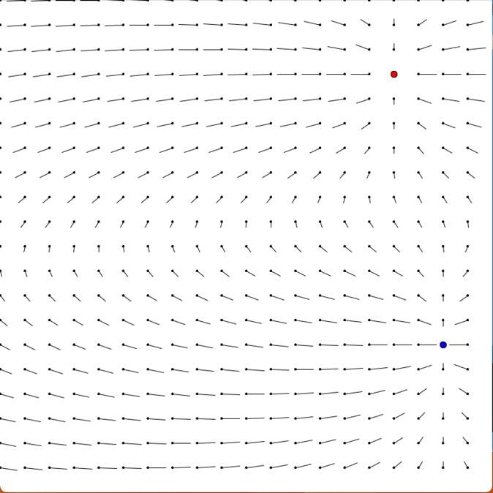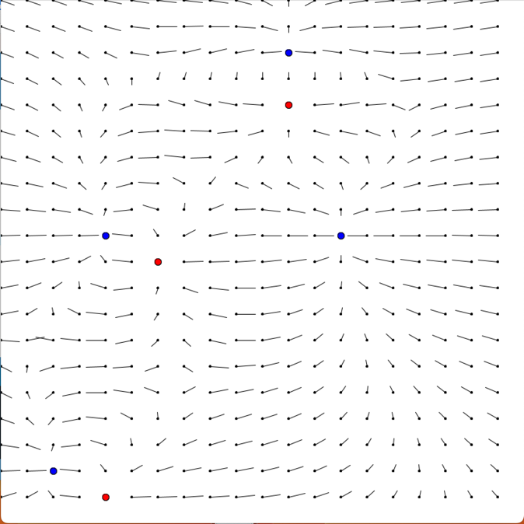**Product**

Figure 4 One Positive and One Negative Example

Figure 5 Three Positive and Four Negative Example

Bibliography

Urone, P. P., & Hinrichs, R. (n.d.). *18.3 electric field - physics*. OpenStax. <https://openstax.org/books/physics/pages/18-3-electric-field>