# **IMF Dashboard Analysis of Global Economic Indicators**

## **1.0 Introduction**

The IMF's viewpoint on various countries' growth is significant because it provides an unbiased evaluation of the prospects in such countries and puts them in a broader context (Area, 2019). Key economic indicators are analyzed in this research utilizing information from the International Monetary Fund's (IMF) Global Economic Outlook, which covers a variety of metrics from 2001 to 2020. This information was used to generate a dashboard that shows national and regional GDP, inflation, unemployment, government debt, and other measures. In order to evaluate economic health, help policymakers make wise decisions, and facilitate cross-economy comparisons, these indicators are crucial. This research examines major influences on economic outcomes, regional variations, and changes in these variables across time.

The Power BI dashboard offers insights into economic metrics such as GDP, inflation, unemployment, government debt, national savings, and total investment across various regions. presents an in-depth analysis of the IMF Global Economic Dashboard, a Power BI tool designed to visualize and interpret global economic indicators

## **2.0 Data Preparation**

Data preparation was critical because it guarantees that the data is correct, consistent, and structured, hence improving the quality of analysis and modeling. Without adequate preparation, data inaccuracies, inconsistencies, or irrelevant information can result in erroneous results or flawed conclusions. Data preparation was critical for this research because it ensured that the data was ready to analyze.

## 2.1 Data Collection

The data was obtained from the International Monetary Fund's (IMF) Global Economic Outlook, which includes a variety of statistics covering the period 2001-2020. It contained the data, metadata, and country groups. These datasets spanned multiple areas and socioeconomic classes, allowing for the collection of high-level indicators required for global and regional research.

## 2.2 Data Cleaning

* Data cleaning is critical for ensuring accuracy and consistency in analysis. The data cleansing method involved:
* Removed rows with null values to prevent problems in computations and visualizations. This guaranteed that only complete records were saved, hence improving data integrity.
* To ensure consistency, numeric columns were standardized as whole numbers or decimals based on the data type. This provided interoperability with Power BI's analytical tools while minimizing computation difficulties.
* Validated data types for each column based on their intended purpose. For example, categorical columns (such as regions and income classes) were set as text fields, and numerical columns (such as GDP and population) were set as numbers.

## 2.3 Data Modeling

Upon cleaning, the data was prepared for analysis by building links among the datasets - nation groups, metadata, and data. Power BI's data modeling enabled the integration of numerous tables, allowing for intricate relationships between datasets.   
The data modeling approach involved several key steps, including:

* Integrated the Country Grouping Dataset: Using the "Country" column, the country grouping dataset was linked to the main economic data table, providing information on regions and income categories. This enabled filtering and grouping based on area and income level.
* Established one-to-many links between the nation table and the main data table, enabling accurate filtering by region, country, and income grouping.

The data modeling method was critical to ensuring that each dataset interacted fluidly, allowing for dynamic filtering and analysis across various economic indicators.

# **3. Dashboard Design and Visualizations**

Using the data provided, the IMF Global Economic Dashboard was created, which includes a variety of visualizations chosen for their efficacy in expressing certain insights.

## 3.1 Cards

The dashboard includes seven Indicator cards, each displaying a critical metric:

* Inflation: A measure of price level changes.
* Population: Total population count of each region or country.
* GDP: Gross Domestic Product, representing economic output.
* Net Debt: Total government debt minus financial assets.
* Unemployment: The percentage of the labor force that is unemployed.
* National Savings: Total savings as a percentage of GDP.
* Total Investment: The total amount invested within a region or country.

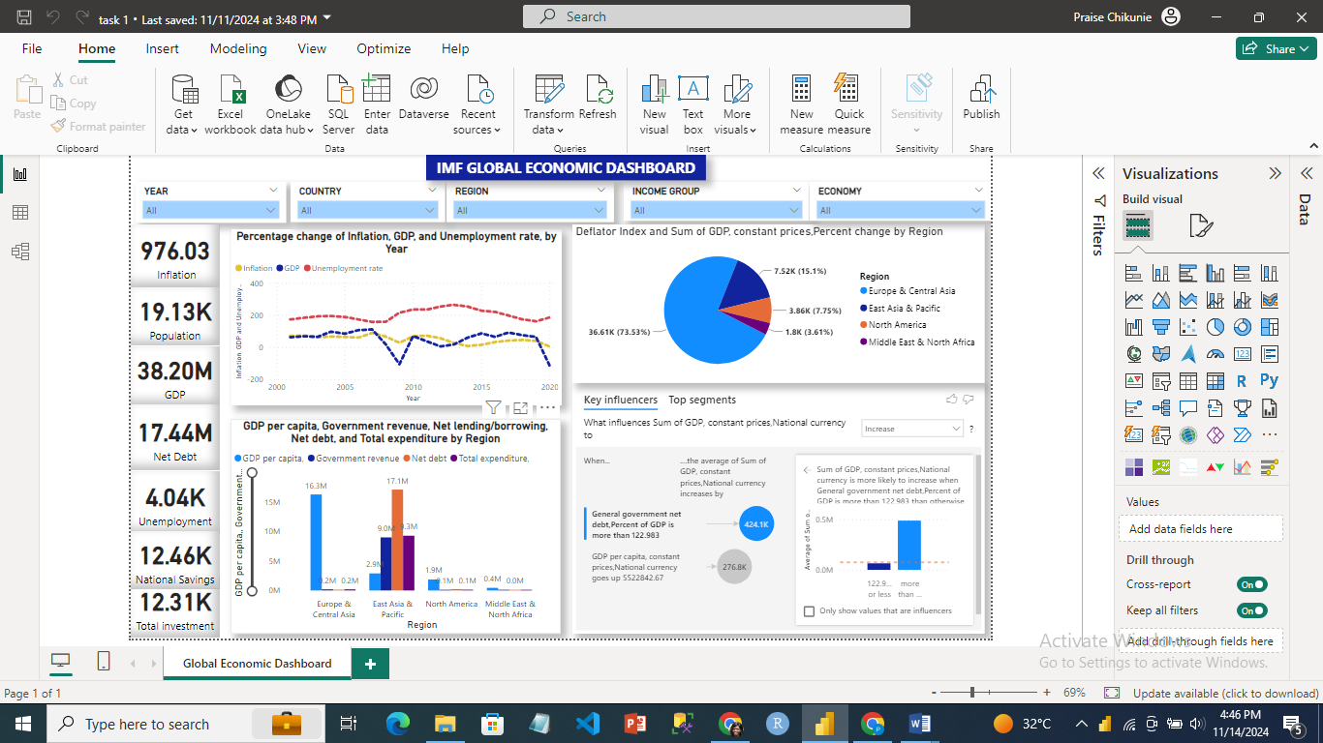

These cards provide a high-level overview, allowing individuals to swiftly analyze the current economic condition. Each card constantly updates based on the filters chosen, providing a quick picture of crucial indicators.

## 3.2 Line Chart: Percentage Change in Inflation, GDP, and Unemployment Rate by Year

The line chart plots inflation, GDP, and unemployment rates across time, making it simpler to identify long-term changes and swings. Data can be filtered by area, income category, year, economy, and nation to investigate specific patterns.   
The goal of this graphic is to examine the behavior of inflation, GDP, and unemployment rates over time, as well as to identify periods of economic expansion or contraction.

* Functionality: By studying the direction and amplitude of the lines, users can deduce economic cycles, such as periods of recession or growth, and examine how different regions are affected.



## 3.3 Bar Chart: GDP per Capita, Government Revenue, Net Debt, and Total Expenditure by Region

This bar chart compares GDP per capita, government revenue, net debt, and total expenditures among regions.

This visualization highlights economic discrepancies and sheds light on fiscal policy across regions.   
**Purpose**: To discover regional disparities in economic output and fiscal health.   
**Functionality**: The chart helps policymakers determine which regions are experiencing fiscal stress and may require measures. The data can be filtered by year and income category to isolate certain subsets.   
There is a slider to make the plot interactive, allowing users to view the study of various regions in terms of GDP per capita, government revenue, net debt, and total expenditure.



## 3.4 Pie Chart: Deflator Index and Sum of GDP Constant Prices, Percent Change by Region

The pie chart shows how GDP deflator changes affect GDP numbers across regions.   
The goal is to show how inflationary pressures affect GDP in different locations.   
Hovering over each segment reveals the percentage change, providing insight into how inflation impacts different parts of the world.



## 3.5 Key Influencers Visual: Determinants of GDP

The Power BI Key Influencers visualization was used to discover factors with a strong impact on GDP. This graph explains which variables have the most impact on economic growth.

* **Purpose**: To illustrate significant elements influencing GDP.
* **Functionality**: Users can interact with the graphic by selecting different factors, such as government debt or national savings, and observing their impact on GDP. This can help policymakers prioritize economic strategies.



## **3.6 Slicers and Filters for Customized Analysis**

Slicers for Year, Country, Region, Economy, and Income Group were added to the dashboard to allow it to be tailored to specific user needs. Slicers enable users to interactively filter data, fine-tuning their understanding of the information provided on each visual.

1. Year Slicer: Select one or more years. Users can examine economic trends across time or drill down to a specific year to better understand the economic picture.
2. Country Slicer: Filters data by certain countries. This allows users to focus on economic variables for a given country, yielding detailed insights.
3. Region Slicer: Filter by region, including Europe and Central Asia, East Asia and Pacific, and North America. This slicer allows for global comparisons, revealing regional economic variations.
4. Economic Slicer: Users can filter by income level (e.g., high or low). This filter is useful for comparing economies in similar economic groups.
5. Income Group Slicer: Filter data by income group (e.g., low-, middle-, or high-income) to compare economic variables across income levels.

* Slicers enable people to easily evaluate data based on their interests. By dynamically modifying the visuals, these filters enable targeted investigation.
* Slicers increase user experience by narrowing the dataset for dashboard graphics, allowing for focused, comparative, and contextual insights.



# **4. Analysis and Insights**

## 4.1 Inflation Trends

The inflation line graph shows notable geographical variations in inflation patterns. Because of their rapid development and supply constraints, emerging economies frequently have higher inflation rates.

* **Insight**: Stronger monetary policies are required to regulate price levels and avert economic instability when persistently high inflation persists in specific areas.

## 4.2 Regional GDP Comparisons

The GDP per capita and government revenue bar chart illustrates regional differences. The GDP per capita of high-income regions is typically substantially higher than that of low-income ones.

* **Insight**: These differences highlight the necessity of policies that support economic expansion in areas with lower incomes, possibly by funding technology, infrastructure, and education.

## 4.3 Government Debt and Fiscal Health

High levels of public debt make a region more susceptible to economic shocks. This realization is especially important for emerging markets, which can find it difficult to pay off debt during recessions.

* **Insight**: To guarantee long-term viability, areas with high debt levels may need to implement fiscal austerity measures or debt restructuring.

## 4.4 Unemployment and Labor Market Health

One important measure of the state of the economy is unemployment. Policies to promote job creation and enhance labor skills may be necessary in areas with high unemployment rates.

* **Insight**: Sector-specific interventions, incentives for business expansion, and workforce training programs are among ways that policymakers could combat unemployment.

## 4.5 Key Influencers on GDP

The Key Influencers chart shows how GDP is greatly impacted by elements like national savings and government revenue. Prioritizing economic strategies that encourage savings and effective revenue collection can be aided by this realization.

* **Insight**: Countries may build a stronger basis for economic growth by concentrating on raising government revenue and promoting national savings.

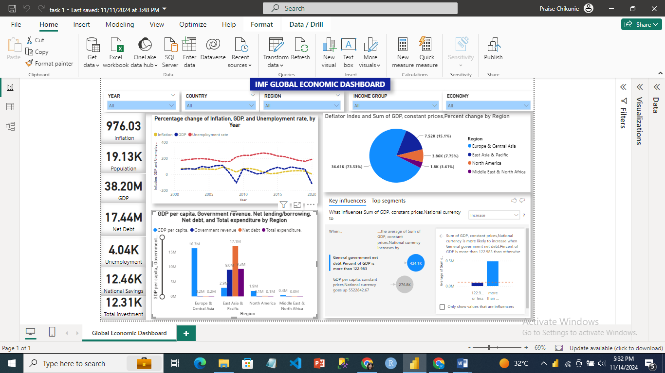

## **5. Key Economic Indicators**

## Gross Domestic Product (GDP)

The GDP gave a sense of the size and performance of the economy over time, measured in both current and constant prices. Current prices provide nominal values, whereas constant prices account for inflation and allow us to observe real growth. The data displays GDP growth trends for various countries, with mature economies generally demonstrating slower but steadier development compared to emerging markets.

* GDP Change Percentage: The GDP change percentage varies by area between 2000 and 2023. More developed economies, such as those in North America and Europe, exhibit steady trends but slower growth rates. On the other hand, emerging markets in Asia and Africa have higher average growth rates but also more volatility.

## Inflation Rate

The rate of inflation quantified the gradual increase in the cost of goods and services. The information reveals trends in inflation that are impacted by international variables like currency rates, monetary policy, and commodity pricing.

* Global Trends: Although inflation has largely remained within a modest range, fundamental economic issues have caused higher inflation rates in portions of Latin America and Africa.

## Unemployment Rate

The state of the labor market and each nation's overall economic health are reflected in unemployment rates.

* Comparing regions: Because to labor market rigidities, unemployment rates were higher in European countries. Economic cycles and reliance on commodity exports were associated with markets that experienced employment instability.

6. Regional Analysis and Comparisons

Europe & Central Asia, East Asia & Pacific, North America, and the Middle East & North Africa are some of the regions by which the dashboard separates the data.

Key findings from these regions are summarized as follows:

* **Europe and Central Asia:** This region exhibits greater debt levels, moderate inflation, and a consistent GDP growth rate. Stable economic performance is impacted by structural problems like aging populations and tight labor markets.
* **East Asia & Pacific**: This region has experienced strong GDP growth and moderate inflation, especially in China and Southeast Asian countries. Nonetheless, debt levels are increasing, especially as a result of higher infrastructure spending.
* **North America**: The US and Canada have stable inflation, large GDPs, and low unemployment rates. Because of the robust economic performance, the debt is sustainable while being somewhat high.
* **Middle East & North Africa:** The GDP and government revenue of this region are highly volatile, and oil prices have a considerable impact. Depending on the stability of oil revenue, unemployment and inflation fluctuate.

## **6.1 Key Influences on Economic Indicators**

The "Key Influencers" portion of the dashboard lists the variables influencing GDP, inflation, and other indicators. The following observations were made:

* **Government Debt**: Because of interest payments and a diminished ability to invest, higher government debt frequently corresponds with slower GDP growth.
* **Inflation and Unemployment:** Because inflationary pressures can lower demand and purchasing power, nations with higher inflation also frequently have higher unemployment rates.
* **GDP and Current Account Balance**: Stable GDP growth is typically observed in nations with positive current account balances. On the other hand, large deficits could be a sign of structural problems in the economy.

# **Conclusion**

The IMF dashboard provides insightful data on global economic trends and regional disparities. Key measures such as GDP, inflation, and unemployment indicate the economic performance of both advanced and emerging economies. Regional study reveals global economic disparities, with established economies showing stable but gradual development and emerging markets demonstrating faster, more variable growth.

These findings highlight the relevance of fiscal and monetary policies that are customized to regional economic situations. Policymakers can use these insights to promote long-term growth, keep inflation under control, and manage debt levels, all of which contribute to economic stability. The dashboard is also a great tool for continuing analysis, allowing stakeholders to monitor economic trends and make data-driven decisions.

# References

Area, E. (2019). IMF: World Economic Outlook. *World*, *2020*, 2021.