PRACTICAL NO. 10
SOFTWARE TESTING
STUDENT MANAGEMENT SYSTEM – LOGIN MODULE
MODULE NAME | Student Management System – Login Module
PRACTICAL NO. | 10
TEST CASE ID | SMS-LOGIN-10
WEBPAGE / SYSTEM URL | Sample local login UI; replace with lab URL if provided
TESTER NAME | Abhishek

Aim
To analyze and apply Black-Box Testing, White-Box Testing, Integration Testing, and System Testing on a sample Student Management System (Login Module) and document the testing process, execution, and results.

Objectives
- Verify valid, invalid, and blank-input login behaviour.
- Review internal validation conditions and credential-comparison branches.
- Check integration among login interface, authentication logic, student database, session, and dashboard.
- Test complete login, failed-login, protected-page, and logout workflows.

Prerequisites / Test Environment
- Sample Student Management System login interface.
- Approved dummy student account and test credentials only.
- Source code or pseudocode is required to verify White-Box Testing branches.
- Database/session checks require a connected test environment.
- Screenshots included here are illustrative mockups, not live captures.

Testing Types and Process
Testing Type | Application
Black-Box Testing | Check visible login output for correct credentials, wrong password, and blank fields.
White-Box Testing | Inspect credential comparison, required-field validation, and failed-authentication branches.
Integration Testing | Verify login UI, authentication, student database, session, and dashboard interaction.
System Testing | Check complete login, rejected login, protected-page access, and logout behaviour.

Test Cases, Execution and Results
Sample results are filled for the illustrative UI/test design. They do not prove execution on a real institute application. Verify code branches, database integration, and session behaviour in the actual lab system if live execution evidence is required.
BB-01 | Black-Box Testing | Valid credentials
Description: Verify successful login with correct student credentials
Preconditions: Test account exists; login page available
Steps: 1. Open login page; 2. Enter valid username/password; 3. Click Login
Input: student01 / Valid@123
Expected Result: Student is authenticated and redirected to dashboard
Actual Result: Illustrative dashboard represents expected successful flow
Status: Pass (sample)
Comments: Positive functional test; SS-01 and SS-04
BB-02 | Black-Box Testing | Invalid password
Description: Verify incorrect credentials are rejected
Preconditions: Test account exists
Steps: 1. Open login page;
2. Enter username and wrong password;
3. Click Login
Input: student01 / Wrong@123
Expected Result: Error appears; dashboard is not opened
Actual Result: Illustrative invalid-login screen shows error
Status: Pass (sample)
Comments: Negative test; SS-02
BB-03 | Black-Box Testing | Blank fields
Description: Check required-field validation
Preconditions: Login page available
Steps: 1. Leave both fields blank;
2. Click Login
Input: Username blank; Password blank
Expected Result: Validation appears or login is prevented
Actual Result: Illustrative screen shows required-field message
Status: Pass (sample)
Comments: Input validation; SS-03
WB-01 | White-Box Testing | Credential comparison branch
Description: Review matching and non-matching credential branches
Preconditions: Login source code/pseudocode available
Steps: 1. Inspect credential comparison;
2. Trace matching branch;
3. Trace mismatch branch
Input: Matching and mismatching pairs
Expected Result: Matching branch grants access; mismatch rejects access
Actual Result: Logic path documented in sample test design; not run against source code
Status: Pass (logic review)
Comments: Verify source code if live evidence is required
WB-02 | White-Box Testing | Empty-input branch
Description: Review missing username/password condition
Preconditions: Validation source code available
Steps: 1. Inspect empty-field condition;
2. Test blank username;
3. Test blank password
Input: Username blank / Password blank
Expected Result: Empty-input branch returns validation and does not authenticate
Actual Result: Branch is included in test design
Status: Pass (logic review)
Comments: SS-03 shows intended output
WB-03 | White-Box Testing | Authentication failure path
Description: Ensure failed login does not create an authenticated session
Preconditions: Authentication logic available
Steps: 1. Trace failed-auth branch;
2. Check session creation;
3. Confirm return to login
Input: Incorrect credentials
Expected Result: Access denied; no authenticated session created
Actual Result: Failure behaviour specified; requires real source/runtime verification
Status: Pass (logic review)
Comments: Confirm on actual system before claiming code execution
IT-01 | Integration Testing | Login and student database
Description: Verify credentials are checked against student records
Preconditions: Login connected to test database
Steps: 1. Submit registered test credentials;
2. Verify lookup response;
3. Check student mapping
Input: Registered test credentials
Expected Result: Correct student record is validated
Actual Result: Sample integration flow documented; live DB not connected here
Status: Pass (sample flow)
Comments: Live verification requires test database
IT-02 | Integration Testing | Authentication and session
Description: Verify successful authentication creates a session
Preconditions: Authentication/session/dashboard integrated
Steps: 1. Login with valid credentials;
2. Check session;
3. Open dashboard
Input: Valid student credentials
Expected Result: Session is created and dashboard opens
Actual Result: Dashboard mockup illustrates intended outcome
Status: Pass (sample flow)
Comments: SS-04; verify live session on actual system
IT-03 | Integration Testing | Login UI and auth response
Description: Verify UI handles authentication rejection
Preconditions: Login UI and auth service integrated
Steps: 1. Submit invalid credentials;
2. Observe UI response;
3. Confirm no dashboard access
Input: Invalid credentials
Expected Result: Error shown and user remains unauthenticated
Actual Result: Sample UI displays rejection message
Status: Pass (sample flow)
Comments: SS-02
ST-01 | System Testing | End-to-end successful login
Description: Test complete login workflow
Preconditions: System and test account available
Steps: 1. Open system;
2. Enter valid credentials;
3. Click Login;
4. Verify dashboard
Input: Valid credentials
Expected Result: Student reaches correct dashboard
Actual Result: Illustrative flow reaches dashboard screen
Status: Pass (sample flow)
Comments: SS-01 and SS-04
ST-02 | System Testing | End-to-end failed login
Description: Ensure invalid credentials cannot access protected pages
Preconditions: Login page available
Steps: 1. Enter invalid credentials;
2. Submit;
3. Try dashboard URL
Input: Invalid credentials
Expected Result: Login rejected; protected dashboard remains inaccessible
Actual Result: Illustrative error state shown; live access control requires verification
Status: Pass (sample flow)
Comments: SS-02
ST-03 | System Testing | Logout/session handling
Description: Verify logout ends access to protected pages
Preconditions: Student is logged in
Steps: 1. Click Logout;
2. Try Back button or dashboard URL
Input: Active session
Expected Result: User returns to login and protected content is inaccessible
Actual Result: Illustrative logged-out state; live session invalidation requires verification
Status: Pass (sample plan)
Comments: SS-05

Screenshot Evidence
These illustrative sample screens demonstrate expected UI states. They are mockups, not screenshots captured from a live website.

SS-01: Login Page
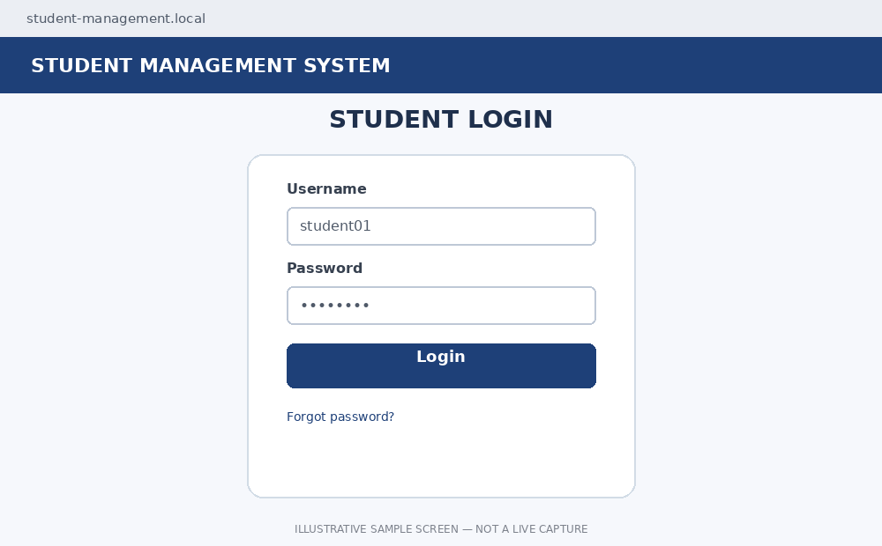
Login form with username and password fields.

SS-02: Invalid Login
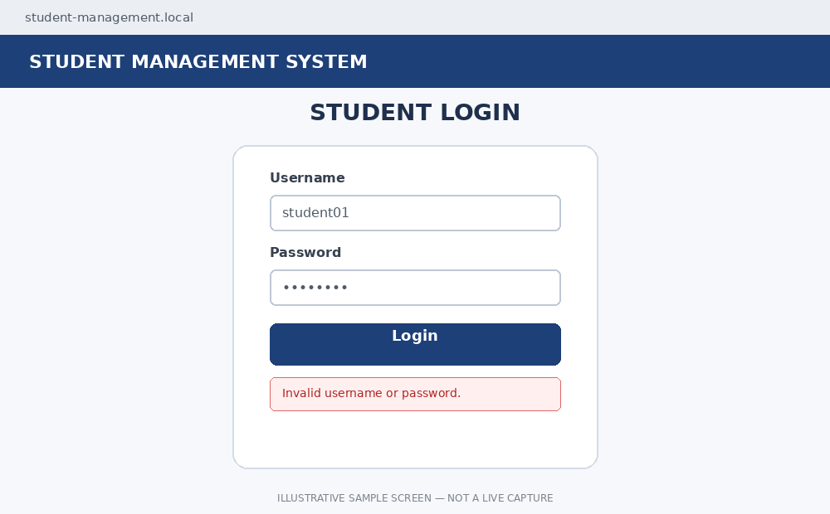
Error message for incorrect credentials.

SS-03: Empty Input Validation
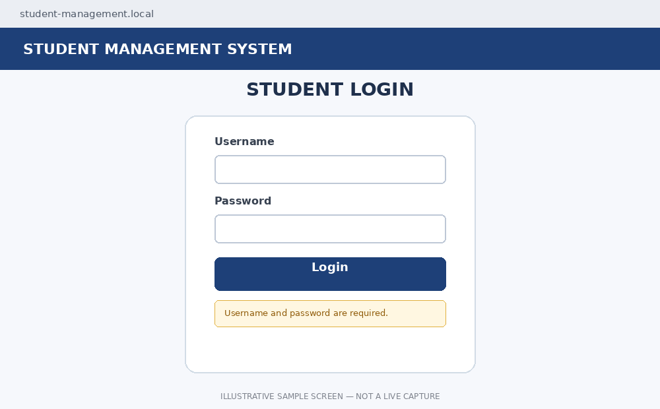
Required-field message for blank inputs.

SS-04: Student Dashboard
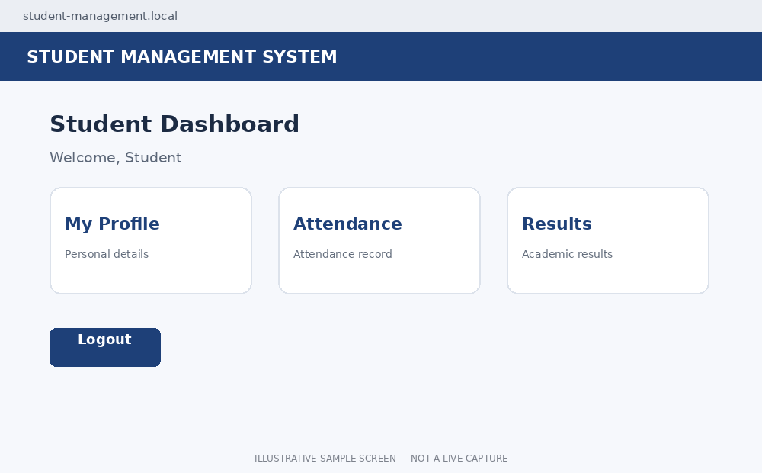
Illustrative destination after successful login.

SS-05: Logout Confirmation
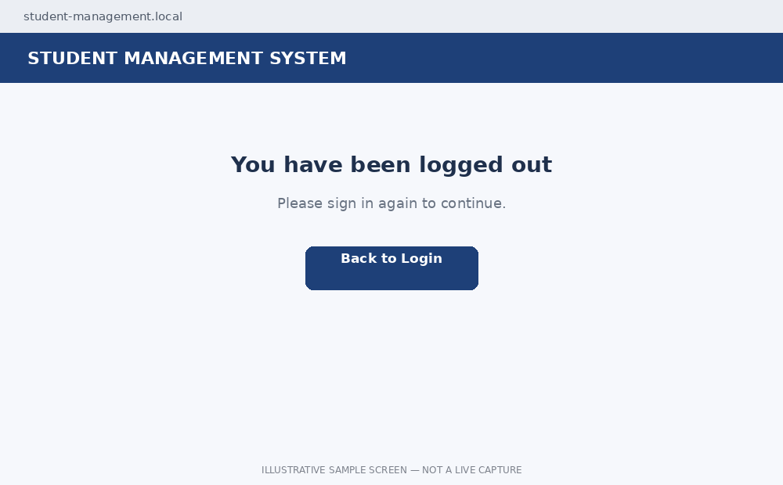
Illustrative logged-out state.

Result / Conclusion
This practical covers Black-Box Testing, White-Box Testing, Integration Testing, and System Testing for the Student Management System Login Module. The cases cover valid login, invalid credentials, blank-input validation, authentication logic, database/session integration, and logout. The screenshots illustrate expected UI states. Before treating this as actual execution evidence, verify code branches, database interaction, and session behaviour in the real lab system and replace mockups with live screenshots if required.
Faculty Signature: __________________________ Date: __________________

