Scenario ID: 1a
Scenario : Search with valid location
Test Steps:
1. Enter URL
2. Open Google Maps
3. Enter valid location
4. Click on Search button
ScreenShort:
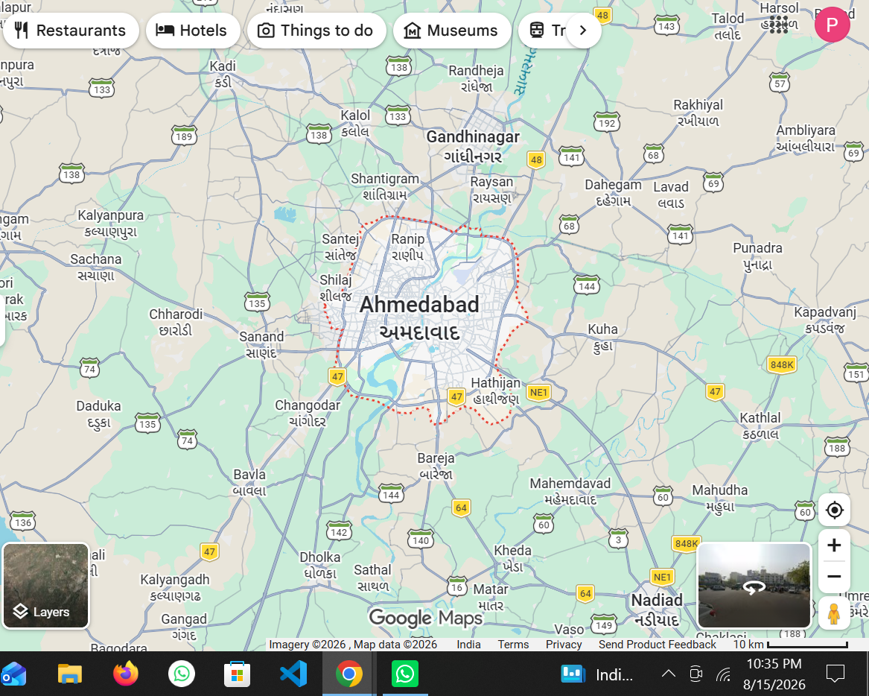

Scenario ID: 1b
Scenario : Search with invalid location
Test Steps:
1. Enter URL
2. Open Google Maps
3. Enter invalid location
4. Click on Search button
ScreenShort:
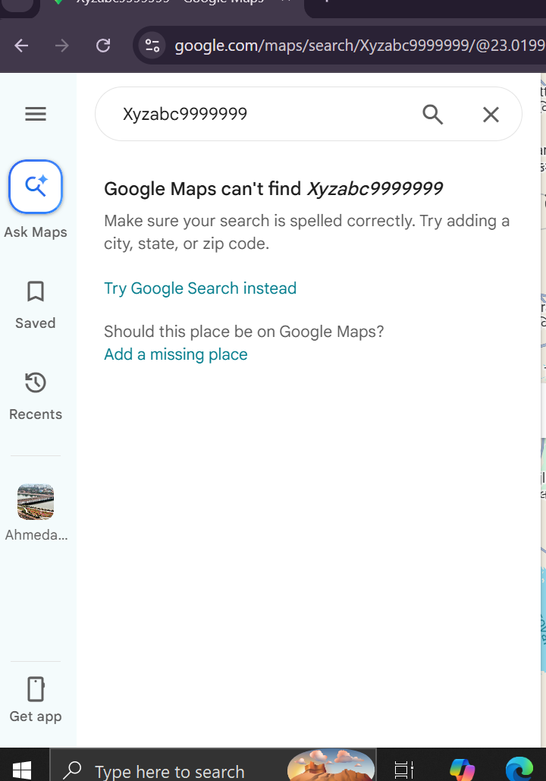
Scenario ID: 1c
Scenario : Search with partial location
Test Steps:
1. Enter URL
2. Open Google Maps
3. Enter partial location
4. Check suggestions
ScreenShort:
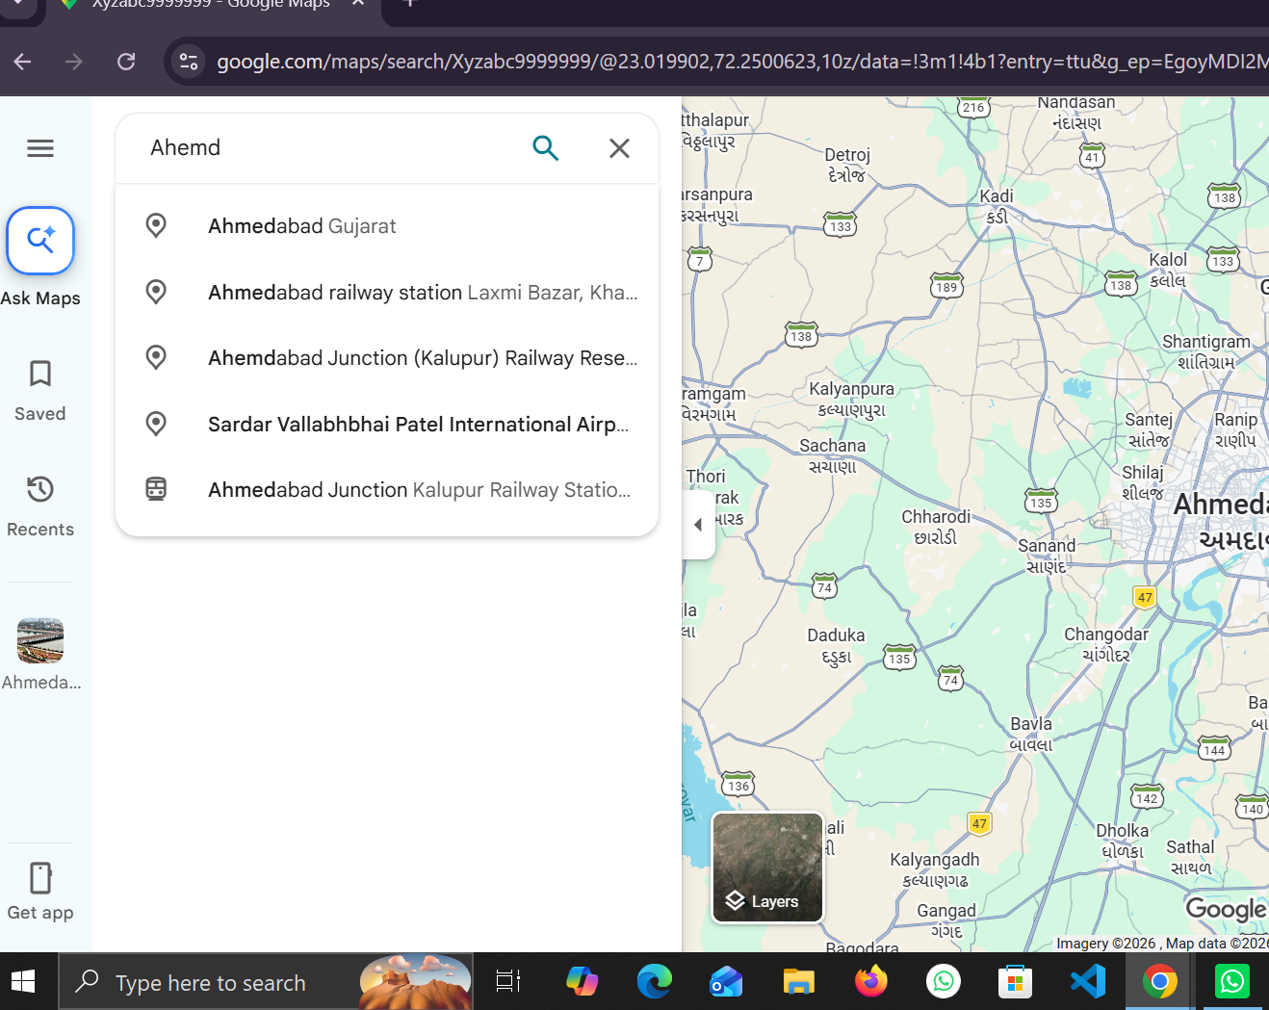

Scenario ID: 1d
Scenario : Search with blank location
Test Steps:
1. Enter URL
2. Open Google Maps
3. Leave search box blank
4. Click on Search button
ScreenShort: