Scenario ID: 1a
Scenario : Search with valid song/artist name
Test Steps:
1. Enter URL
2. Open Spotify
3. Enter valid song or artist name
4. Click on Search
ScreenShort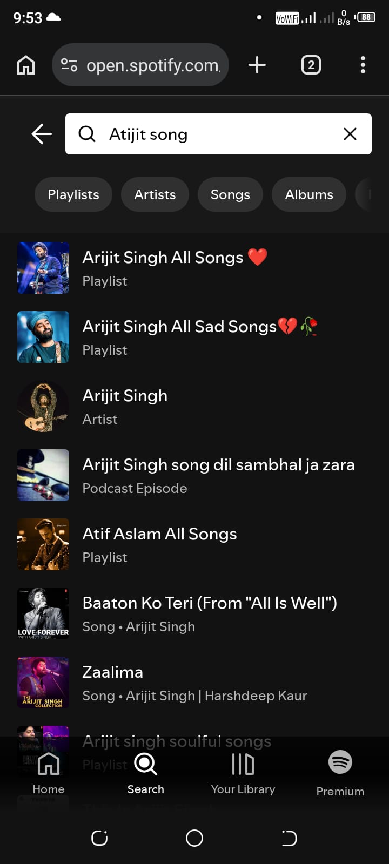

Scenario ID: 1b
Scenario : Search with invalid song/artist name
Test Steps:
1. Enter URL
2. Open Spotify
3. Enter invalid song or artist name
4. Click on Search
ScreenShort:
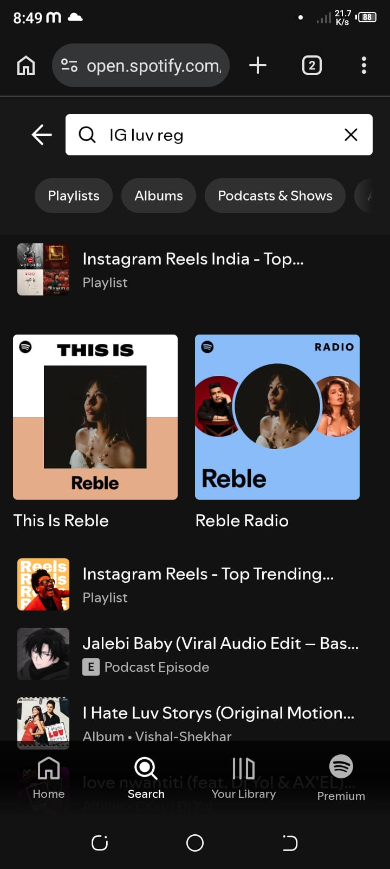
Scenario ID: 1c
Scenario : Search with partial song/artist name
Test Steps:
1. Enter URL
2. Open Spotify
3. Enter partial song or artist name
4. Check suggestions
ScreenShort:
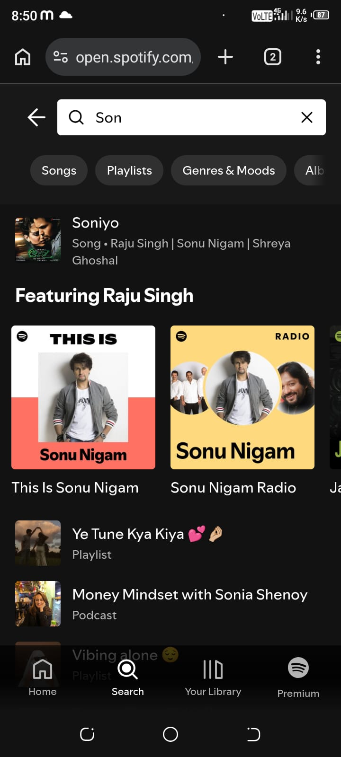

Scenario ID: 1d
Scenario : Search with blank input
Test Steps:
1. Enter URL
2. Open Spotify
3. Leave search box blank
4. Click on Search
ScreenShort: