Module Name: Bugzilla – Bug Tracking Workflow
Test Steps:
1. Open Bugzilla application
2. Observe the Bugzilla home page
3. Verify the main bug-tracking options
4. Verify the user/session information
Screenshots:
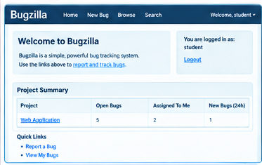
Scenario ID:a2
Scenario: Report a New Bug
Test Steps:
1. Open the New Bug page
2. Select Product, Component and Version
3. Select Severity
4. Enter the bug Summary and Description
5. Submit the bug
Screenshots:
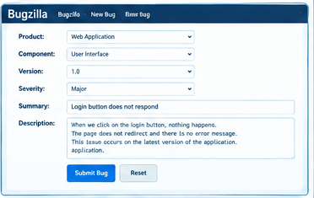
Scenario ID:a3
Scenario: View Reported Bugs
Test Steps:
1. Open the Bugzilla bug list
2. Observe the listed bugs
3. Verify the bug ID and Summary
4. Verify the displayed bug information
Screenshots:
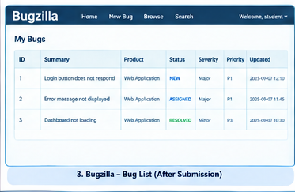

Scenario ID:a4
Scenario: Verify Bug Details
Test Steps:
1. Open the reported bug
2. Verify the bug Summary
3. Verify Status, Product and Component
4. Verify Severity and Priority
5. Verify the Description
Screenshots:
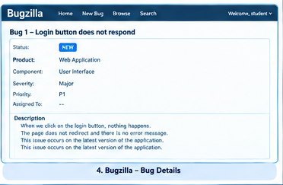

Scenario ID:b1
Scenario: TestLink Project Home
Test Steps:
1. Open TestLink
2. Observe the TestLink home page
3. Verify the Project Tree
4. Select the Web Application project
Screenshots:
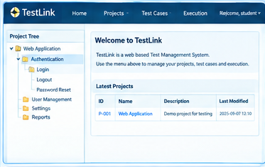
Scenario ID: b2
Scenario: Create Test Case
Test Steps:
1. Open the Web Application project
2. Open the Test Cases section
3. Create a new test case
4. Enter Test Case ID and Summary
5. Enter the required test details
6. Save the test case
Screenshots:
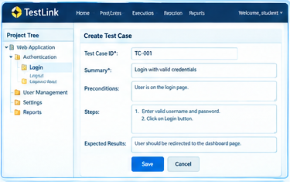

Scenario ID:b3
Scenario: Execute Test Case
Test Steps:
1. Open the Execute Test Case page
2. Select the project/test plan
3. Open the required test case
4. Execute the defined test steps
5. Record the execution result
Screenshots:
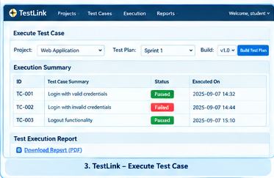

Scenario ID:b4
Scenario:View Execution Report
Test Steps:
1. Open the Execution Report
2. Observe the Execution Summary
3. Verify the total test cases
4. Verify the passed and failed results
5. Verify the individual test case details
Screenshots:
