Scenario ID: 1a
Scenario : Username field with valid value
Test Steps:
1. Open the Instagram-style registration form.
2. Locate the Username field.
3. Enter a valid username within the allowed length (1 to 30 characters).
4. Click on Submit button.
ScreenShot:

Scenario ID: 1b
Scenario : Username field with invalid value below boundary
Test Steps:
1. Open the Instagram-style registration form.
2. Locate the Username field.
3. Leave the Username field empty (0 characters).
4. Click on Submit button and check the validation message.
ScreenShot:
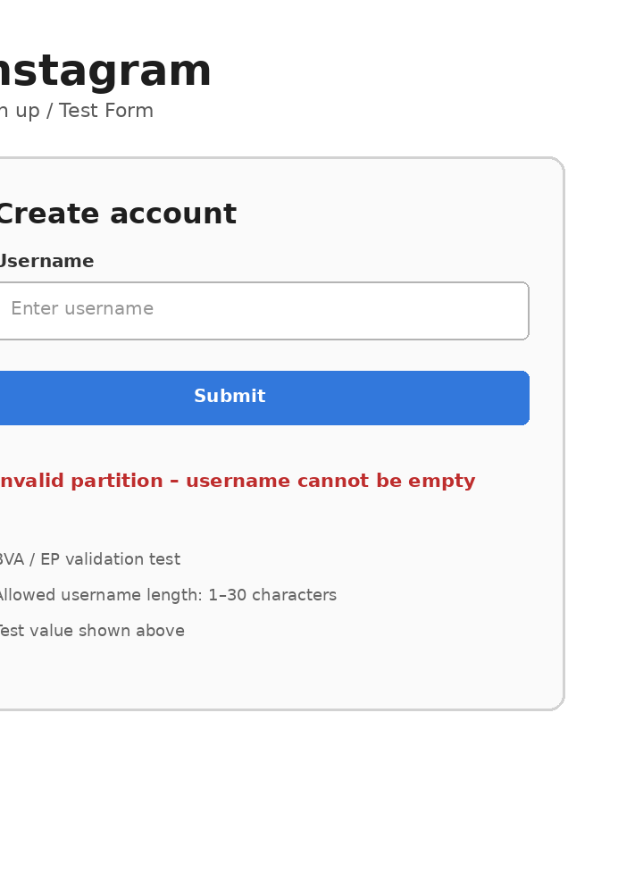
Scenario ID: 1c
Scenario : Username field with minimum boundary value
Test Steps:
1. Open the Instagram-style registration form.
2. Locate the Username field.
3. Enter the minimum boundary value (1 character).
4. Click on Submit button.
ScreenShot:
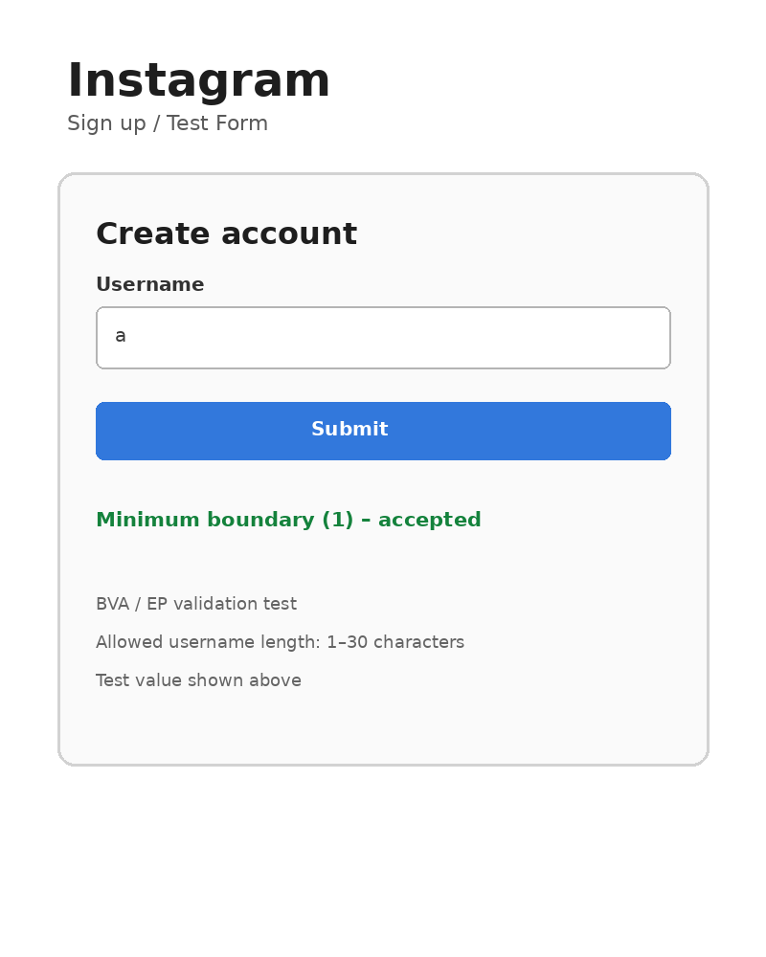

Scenario ID: 1d
Scenario : Username field with maximum boundary value
Test Steps:
1. Open the Instagram-style registration form.
2. Locate the Username field.
3. Enter the maximum boundary value (30 characters).
4. Click on Submit button.
ScreenShot:
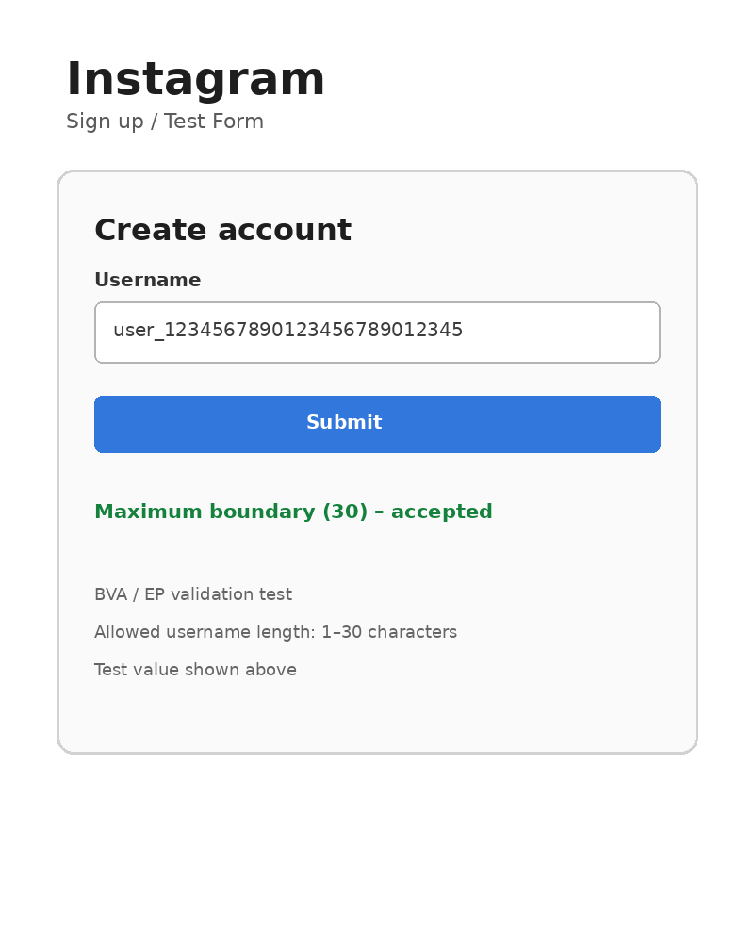

Scenario ID: 1e
Scenario : Username field with value above boundary
Test Steps:
1. Open the Instagram-style registration form.
2. Locate the Username field.
3. Enter a username above the maximum boundary (31 characters).
4. Click on Submit button and check the validation message.
ScreenShot:
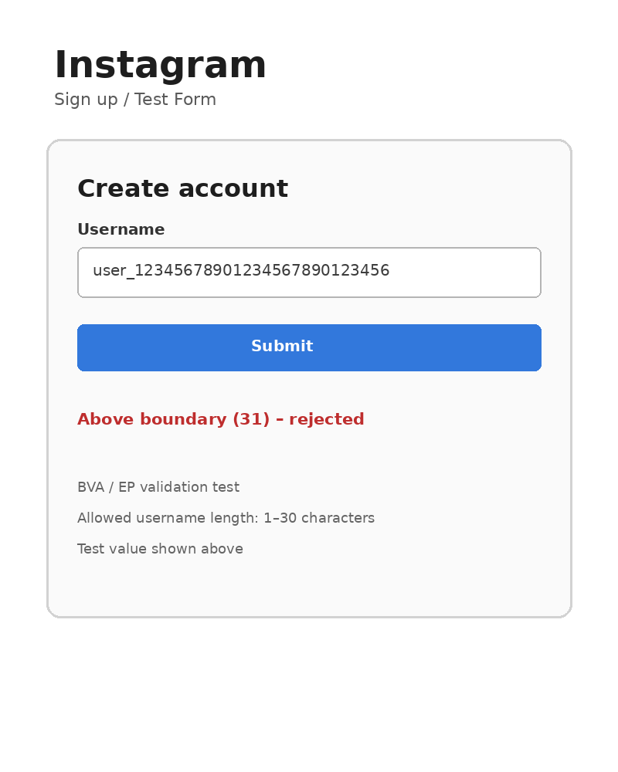

Scenario ID: 1f
Scenario : Instagram login with valid credentials
Test Steps:
1. Open the Instagram login/authentication module.
2. Enter a valid username.
3. Enter the correct password.
4. Click on Login button.
ScreenShot:
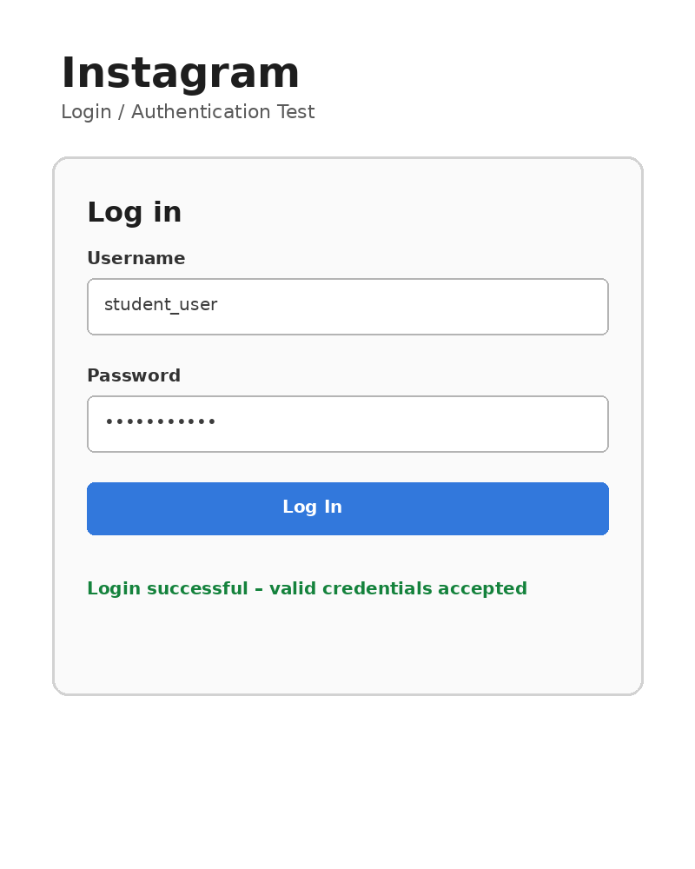

Scenario ID: 1g
Scenario : Instagram login with invalid credentials
Test Steps:
1. Open the Instagram login/authentication module.
2. Enter an invalid username or password.
3. Click on Login button.
4. Check the validation/error message.
ScreenShot:
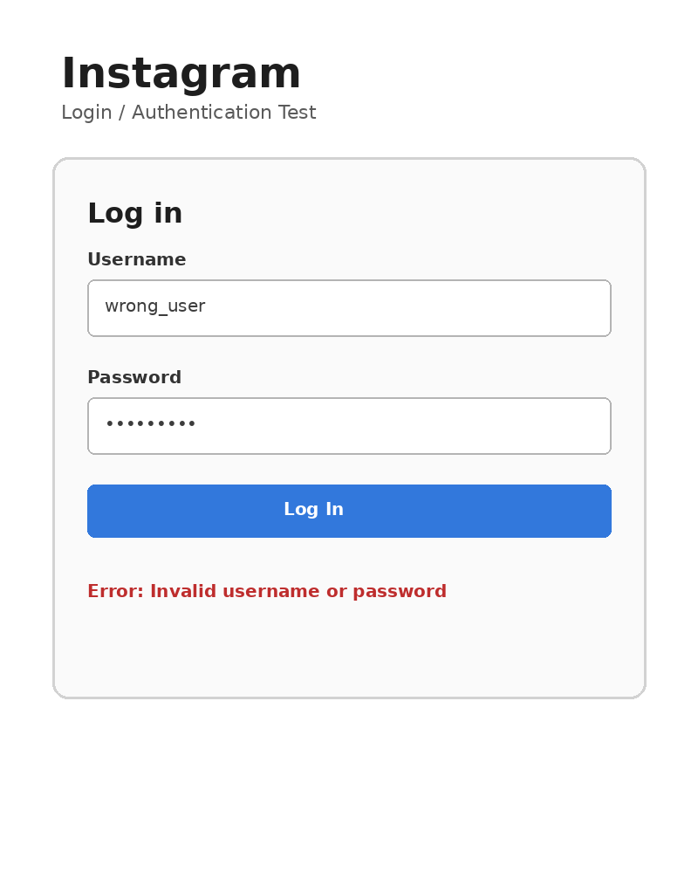

Scenario ID: 1h
Scenario : Instagram login with blank fields
Test Steps:
1. Open the Instagram login/authentication module.
2. Leave username and password fields blank.
3. Click on Login button.
4. Check the validation message.
ScreenShot:
