Slides 6 to 10 Explained
Case Study 4: Healthcare Electrification in Uganda. From priority districts to a costed plan for the Ministry of Health's $1,000,000
Abubakar Chilala · 04-782 Energy Data Analytics, Carnegie Mellon University · November 2026

How to read this document
Slides 1 to 5 showed where the need is greatest. We used Energy Access Explorer (EAE) to rank Uganda's districts and found the top five: Kasese, Isingiro, Tororo, Rukungiri and Kamuli.
Slides 6 to 10 take the next step. They turn that ranking into a plan for spending the Ministry of Health's $1,000,000: what one health centre costs, which ones we fund, why we chose this plan over others, what happens if prices change, and what the Ministry should do next.
For each slide, this document shows the slide, gives its message in one line, then explains in simple steps how we got the numbers and why they matter.
Table 1: What each slide answers
Slide | Question it answers | Assignment question
6. Cost of solar for one health centre | How much does it cost to power one health centre? | Budget allocation: cost per facility and its source
7. Our plan for the $1,000,000 | Which health centres do we fund, and where does the money go? | Budget allocation: maintenance reserve, facilities and people reached
8. Need versus value for money | Why this plan and not another one? | Sensitivity and trade-offs: need vs value for money
9. What if costs go up or down? | Does the plan still work if prices change? | Sensitivity and trade-offs: higher or lower costs
10. What could change our answer, and next steps | How sure are we, and what should the Ministry do now? | Limitations and recommendations

Words used in this document
Table 2: Key words
Word | What it means
kW (kilowatt) | The size of a solar system. More kW means more solar panels.
kWh per day | How much electricity a health centre uses in a day (kilowatt-hours).
HC II, HC III, HC IV | Uganda's health centre levels. An HC II is a small outpatient clinic for a parish. An HC III serves a sub-county and has a maternity ward and a laboratory. An HC IV serves a county and is a small hospital.
Maternity ward | Where babies are delivered. In our plan, only the HC IIIs have one.
High-need district | One of the 14 districts in EAE's top ("High") class on the Assistance Need Index.
People reached | The number of people who live in the area a health centre serves (its catchment). It is not the number of patients.
Cost per person | The cost of powering a health centre divided by the people reached. We use it to compare value for money.
Maintenance reserve | Money kept aside to repair and look after the solar systems for five years.
UEDCL | Uganda Electricity Distribution Company Limited, which runs the local power network.

Slide 6: Cost of solar for one health centre
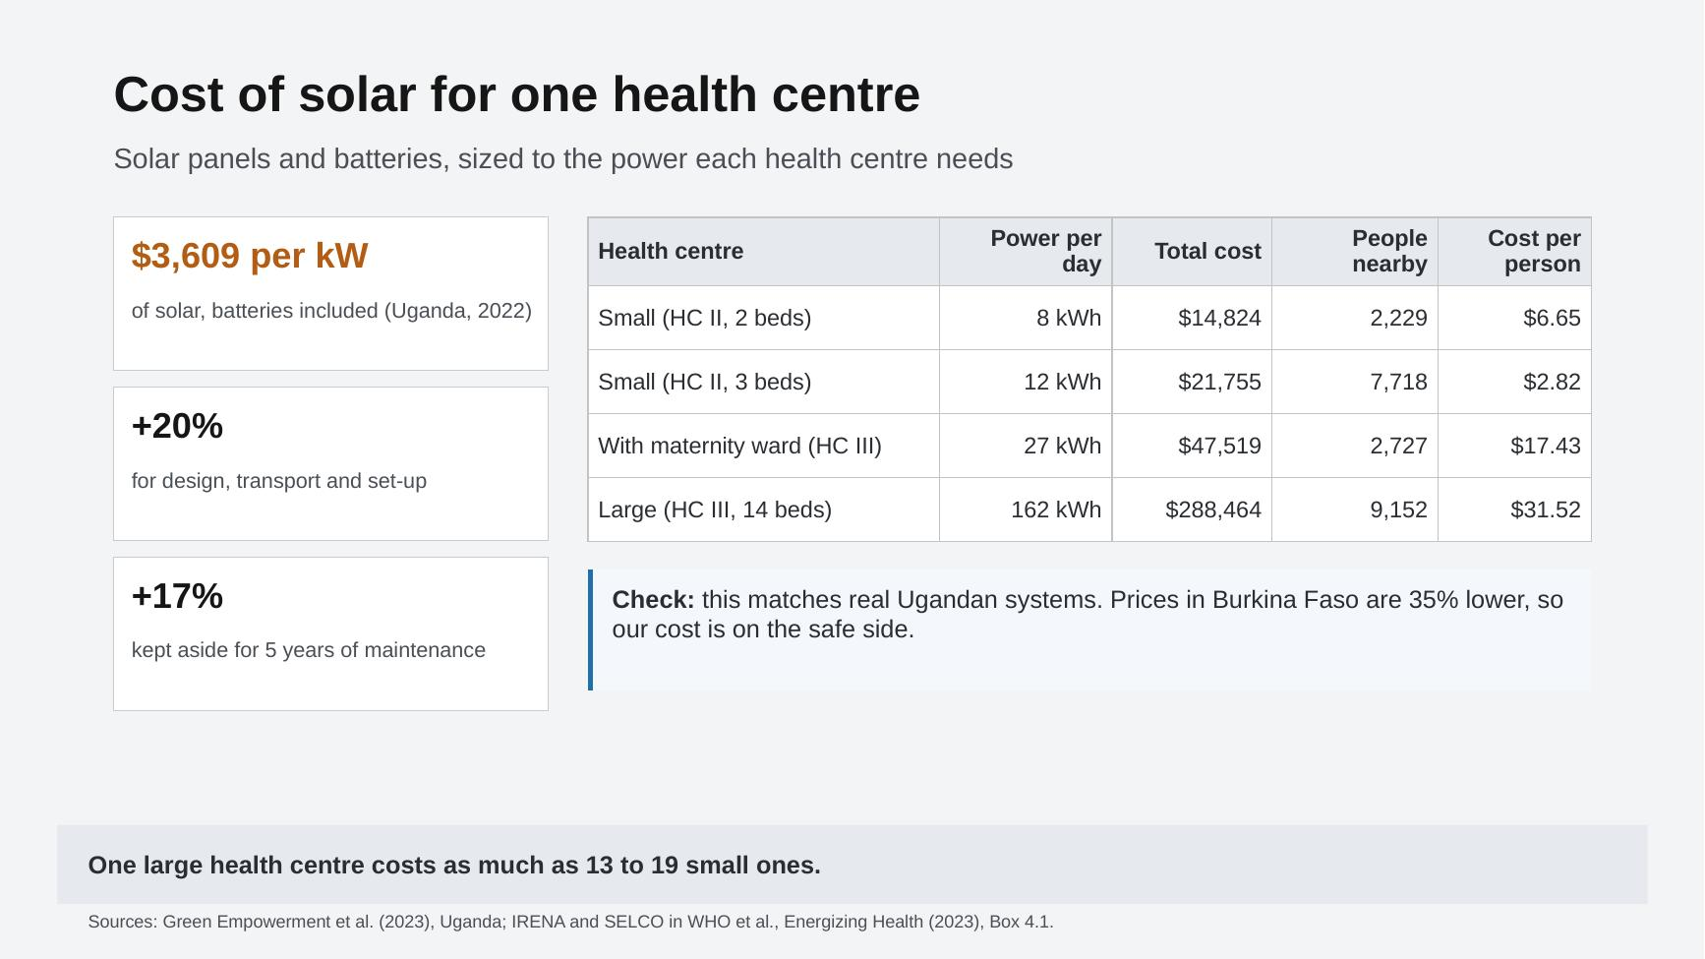
Slide 6 as presented.
In one line: a small health centre costs about $15,000 to $22,000 to power with solar, and one large health centre costs as much as 13 to 19 small ones.

What we did
Before we can spend the money, we need a price for powering each health centre. We priced a solar system with batteries at the health centre itself. It works whether or not a power line is nearby, it can be installed quickly, and there are recent prices from real health centres in Uganda. Where a power line is very close, a grid connection may be cheaper; slide 10 deals with that.

How the cost of one health centre is worked out
We follow the same five steps for every health centre. The example is a small HC II with 3 beds.
- Find how much electricity it needs. The EAE health facility layer gives a daily electricity need for every health centre. WRI estimated it from the centre's level and number of beds (Sinclair-Lecaros et al., 2023). A 3-bed HC II needs about 12.2 kWh per day.
- Work out the size of the solar system. In Uganda, 1 kW of solar panels gives about 2.78 kWh per day after losses (a 3.6 kW system gives 10 kWh a day; Energizing Health, 2023). So the size in kW is the daily need divided by 2.78: 12.21 ÷ 2.78 = 4.4 kW.
- Multiply by the price. Three solar-and-battery systems built at Ugandan health centres in 2022 cost $97,078 in total for 26.9 kW (Green Empowerment et al., 2023). That is $3,609 per kW, with panels, batteries and installation included. 4.4 kW × $3,609 = $15,863.
- Add 20% to deliver it. This pays for design, buying, transport and supervision: $3,173.
- Keep 17% for maintenance. In an example from IRENA and SELCO, looking after a $5,250 system costs $180 a year, which is 3.4% a year. Over five years that is about 17%: $2,719. This money is kept aside, not spent at the start.
Total for a 3-bed HC II: $15,863 + $3,173 + $2,719 = $21,755.
Table 3: The four health centre types on the slide
Health centre | Electricity per day | Solar size | Total cost | People nearby | Cost per person
Small HC II, 2 beds | 8 kWh | 3.0 kW | $14,824 | 2,229 | $6.65
Small HC II, 3 beds | 12 kWh | 4.4 kW | $21,755 | 7,719 | $2.82
HC III with maternity ward, 8 beds | 27 kWh | 9.6 kW | $47,519 | 2,727 | $17.43
Large HC III, 14 beds | 162 kWh | 58.3 kW | $288,464 | 9,153 | $31.52
"People nearby" is the typical (median) number of people living around a health centre of that type. The total cost includes the 20% for delivery and the 17% maintenance reserve.

Is the price sensible?
- It comes from real health centres in Uganda, so it includes local prices, transport and installation.
- Similar systems in Burkina Faso in 2022 cost about 35% less. Our price is on the safe (higher) side, and slide 9 shows what happens if it is lower.

Why this slide matters
A large 14-bed HC III needs about 13 times more electricity than a 3-bed HC II, so it costs $288,464. That is as much as 13 to 19 small health centres. With only $1,000,000, a few large centres would use up most of the money. This is why the plan on slide 7 funds small HC IIs and the smaller 8-bed HC III maternity wards, and leaves the large units for a later phase.

Slide 7: Our plan for the $1,000,000
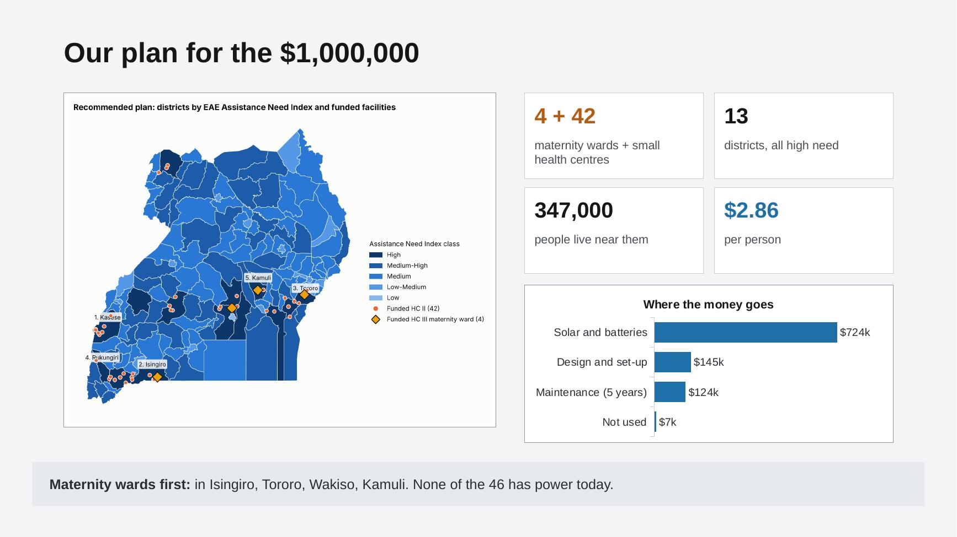
Slide 7 as presented.
In one line: power 46 health centres that have no electricity today (4 maternity wards first, then 42 small health centres) in 13 high-need districts. About 347,000 people live near them, at $2.86 per person.

How we picked the health centres
We applied the same rules to every health centre in Uganda. The computer then went down the list and added health centres until the money ran out.
- Government health centres only. The Ministry pays for its own health centres, so private and NGO ones are left out.
- Only health centres that need power. That means centres with no electricity at all, plus HC IIIs and HC IVs that run on a small off-grid system and need more. In the end, all 46 health centres in the plan have no electricity at all.
- Only high-need districts. We kept the 14 districts in EAE's top class on the Assistance Need Index (slides 3 to 5).
- Maternity wards first. HC IIIs with no power that cost $100,000 or less go to the front of the queue, because power at a maternity ward protects mothers and newborns.
- Then the best value. The other health centres are sorted by cost per person, cheapest first.
- Stop when the money runs out. If a health centre does not fit in the money that is left, we skip it and try the next one.

What the plan buys
Four maternity wards. These are the only HC IIIs with no power in the high-need districts that cost less than $100,000:
Table 4: The four maternity wards in the plan
Health centre | District | Total cost | People nearby
Mbaare HC III | Isingiro | $47,519 | 3,335
Petta HC III | Tororo | $47,519 | 2,787
Nabutiti HC III | Wakiso | $47,519 | 2,209
Busota HC III | Kamuli | $47,519 | 1,755

Then 42 small HC IIs. Together, the plan covers 13 of the 14 high-need districts:
Table 5: Health centres funded in each district
District | Need rank | Health centres | People nearby | Cost
Kasese | 1 | 9 | 47,109 | $147,279
Isingiro | 2 | 5 | 43,589 | $127,608
Tororo | 3 | 3 | 20,961 | $84,098
Rukungiri | 4 | 2 | 19,407 | $43,510
Kamuli | 5 | 2 | 5,943 | $62,343
Luweero | 6 | 1 | 9,185 | $21,755
Mukono | 7 | 1 | 4,670 | $14,824
Mubende | 8 | 4 | 33,800 | $87,020
Ntungamo | 9 | 7 | 87,988 | $152,285
Wakiso | 10 | 3 | 10,499 | $77,167
Yumbe | 11 | 3 | 17,954 | $58,334
Mayuge | 13 | 2 | 10,978 | $36,579
Bugiri | 14 | 4 | 35,258 | $80,089
Total |  | 46 | 347,341 | $992,892

Where the money goes
Table 6: The budget
Item | Amount | Share
Solar panels and batteries (equipment and installation) | $723,984 | 72.4%
Design, buying, transport and supervision (20%) | $144,797 | 14.5%
Maintenance reserve for five years (kept aside) | $124,112 | 12.4%
Not used | $7,108 | 0.7%
Total | $1,000,000 | 100%
The $7,108 left over is too small for another health centre (the cheapest costs $14,824). It could help pay for the site visits on slide 10.

How to read the map
- Darker blue districts have higher need on EAE's Assistance Need Index. The darkest ones are the 14 high-need districts.
- Orange dots are the 42 small HC IIs. Yellow diamonds are the 4 maternity wards.
- The five numbered labels are the top five districts from slide 5.

Why maternity wards first
Uganda still loses 189 mothers for every 100,000 births and 22 of every 1,000 newborns (UBOS, 2023). Many births happen at night. Without power, staff may deliver babies by torchlight, newborns cannot be kept warm and vaccines cannot be kept cold. An HC III is the lowest level with a maternity ward, so powering one helps mothers and babies directly.
Only 4 maternity wards fit the rules. The other HC IIIs with no power in high-need districts are large units. For example, Mayuge (24 beds) would cost about $466,000, almost half the budget on its own. These are left for the next phase (slide 10).

Slide 8: Need versus value for money
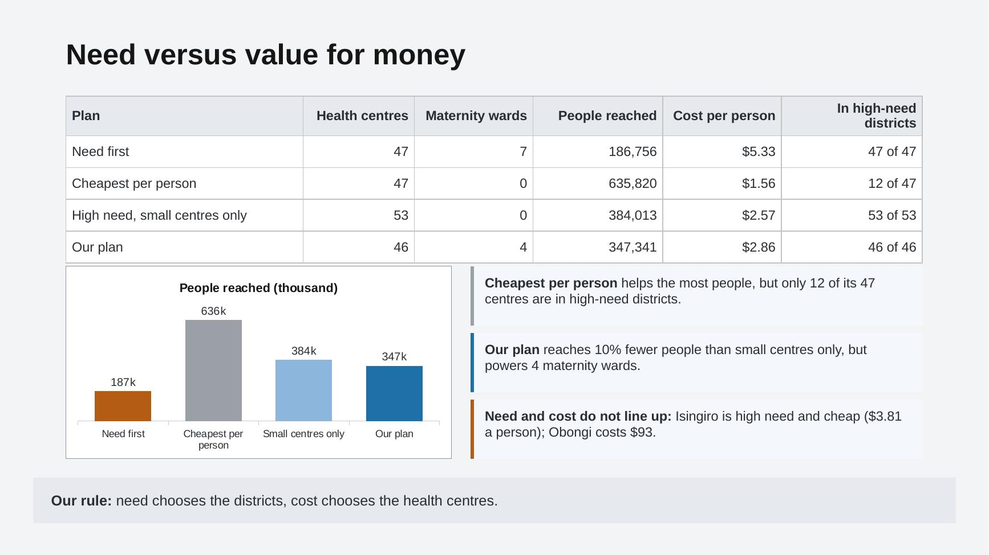
Slide 8 as presented.
In one line: the option that reaches the most people mostly ignores the high-need districts. So we let need choose the districts and cost choose the health centres.

The four options we compared
We spent the same $1,000,000 in four different ways, using the same costs each time:
Table 7: How each option picks health centres
Option | How it picks health centres
Need first | Goes down EAE's district ranking. It funds health centres in the top district, then the next, until the money runs out.
Cheapest per person | Anywhere in Uganda, it funds the health centres with the lowest cost per person first. It ignores the EAE ranking.
Small centres only | Only the high-need districts, cheapest per person first. In practice it picks only small HC IIs. (Slide 9 calls this "High need, small centres only".)
Our plan | Only the high-need districts. Maternity wards first, then cheapest per person.

What each option gives
Table 8: Results of the four options
Option | Health centres | Maternity wards | People reached | Cost per person | In high-need districts | Districts
Need first | 47 | 7 | 186,756 | $5.33 | 47 of 47 | 2
Cheapest per person | 47 | 0 | 635,820 | $1.56 | 12 of 47 | 31
Small centres only | 53 | 0 | 384,013 | $2.57 | 53 of 53 | 13
Our plan | 46 | 4 | 347,341 | $2.86 | 46 of 46 | 13
Need first's 7 maternity wards are HC IIIs that already have a small solar system and get a bigger one. Our plan's 4 maternity wards have no power at all.

What we learned
- Need first puts almost all the money into just 2 districts. It reaches the fewest people (186,756) and costs the most per person ($5.33). Other high-need districts get nothing.
- Cheapest per person reaches the most people (635,820) at only $1.56 each. But only 12 of its 47 health centres are in high-need districts. Most of the money goes to places EAE says are less in need.
- Small centres only stays in the high-need districts and reaches 384,013 people, but it powers no maternity wards.
- Our plan reaches 36,672 fewer people than small centres only (about 10% fewer), but it powers 4 maternity wards. We think this is a fair price, because power in a maternity ward saves lives at birth.

Need and cost do not line up
The cards on the right of the slide show that a high-need district is not always expensive, and a low-need district is not always cheap. The cost below is for powering every health centre in the district that qualifies:
- Isingiro (need rank 2) is high need and cheap: $3.81 per person, because many people live around each health centre.
- Kasese (need rank 1) costs $10.86 per person.
- Obongi (need rank 57) costs $93 per person, because few people live around its health centres.
So the best order is neither "need only" nor "cost only". Our rule is: need chooses the districts, cost chooses the health centres.

Slide 9: What if costs go up or down?
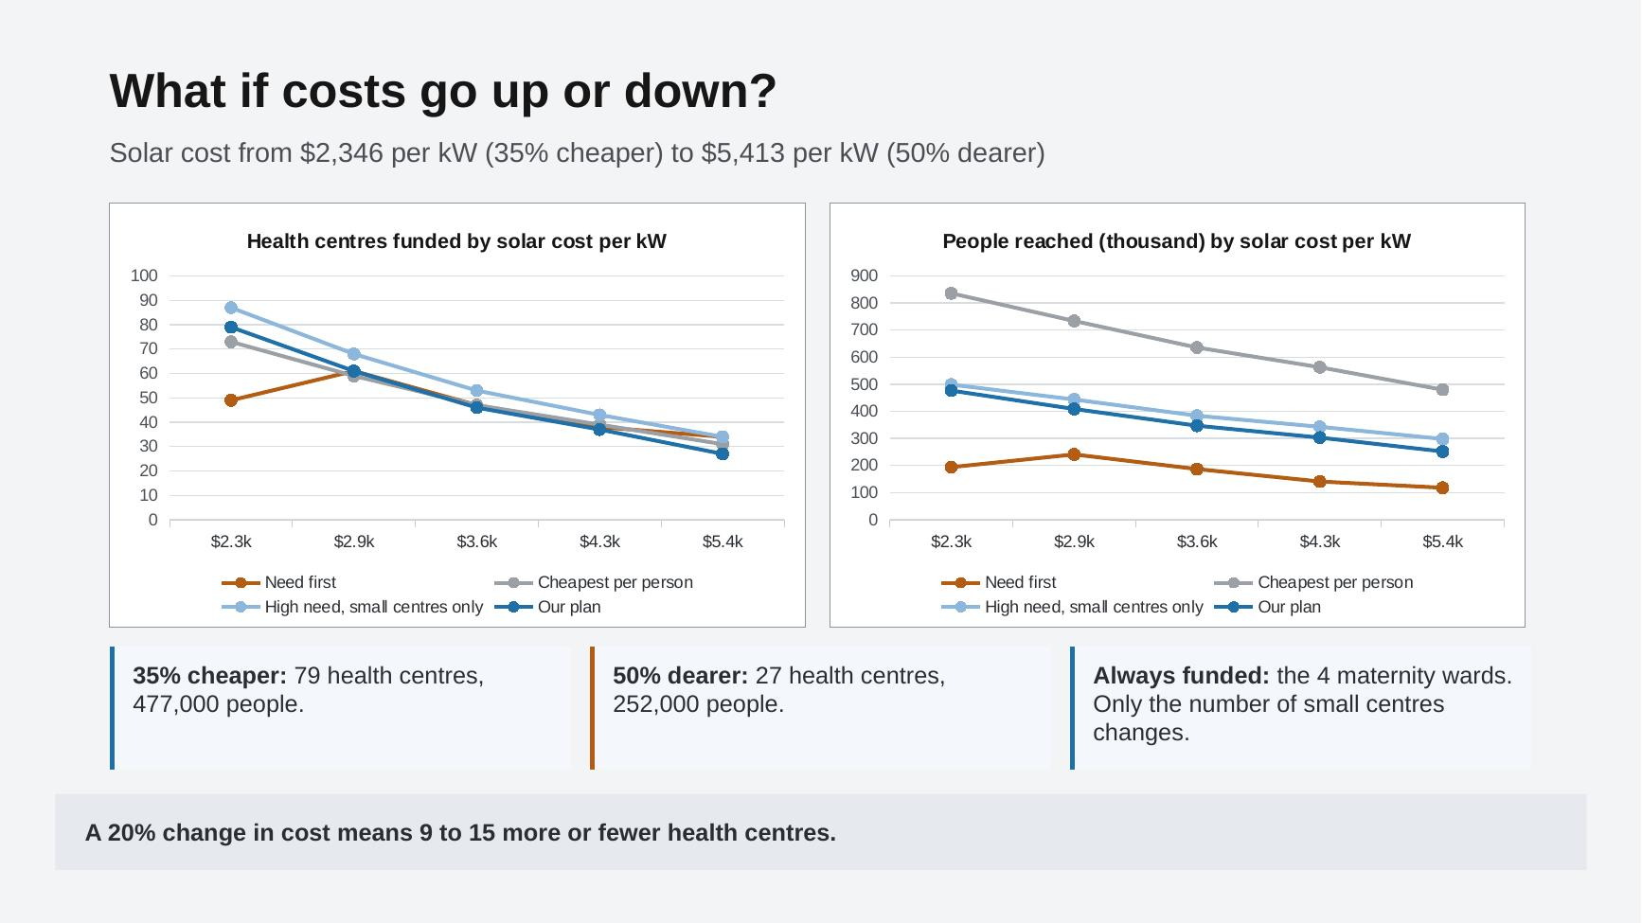
Slide 9 as presented.
In one line: if solar costs 35% less we can power 79 health centres; if it costs 50% more, only 27. The 4 maternity wards are funded every time.

Why we tested this
Our price of $3,609 per kW comes from only a few systems. The real price could be higher (remote sites, lithium batteries, a weaker Uganda shilling) or lower (a large tender that buys many systems at once). We wanted to know if the plan still makes sense when the price is wrong.

What we did
We changed the solar price and ran all four options again. Everything else stayed the same.
Table 9: The prices we tested
Price change | Price per kW | Why we picked it
35% cheaper | $2,346 | About the 2022 price in Burkina Faso
20% cheaper | $2,887 | A good tender price
No change | $3,609 | Our central price (Uganda, 2022)
20% dearer | $4,331 | Higher transport or battery prices
50% dearer | $5,413 | Remote sites with lithium batteries

What happens to our plan
Table 10: Our plan at each price
Price per kW | Health centres | People reached | Cost per person | Maternity wards
$2,346 (35% cheaper) | 79 | 476,534 | $2.10 | 4
$2,887 (20% cheaper) | 61 | 408,665 | $2.42 | 4
$3,609 (no change) | 46 | 347,341 | $2.86 | 4
$4,331 (20% dearer) | 37 | 303,433 | $3.29 | 4
$5,413 (50% dearer) | 27 | 252,446 | $3.94 | 4

What we learned
- A 20% change in price means 9 to 15 more or fewer health centres in our plan (between 37 and 61 instead of 46).
- The 4 maternity wards are always funded, because they are first in the queue. Only the number of small health centres changes.
- The order of the options never changes. Cheapest per person always reaches the most people, and need first always reaches the fewest. So the trade-off on slide 8 holds at any price.
- Need first (the orange line) behaves oddly. When solar is very cheap, it can afford some bigger, more expensive health centres at the top of its list, so it funds fewer centres than at a slightly higher price.

What this means for the Ministry
The plan is safe to approve before the final prices are known. Keep the same ordered list of health centres. If tenders come in cheaper, go further down the list. If they come in dearer, stop earlier. The maternity wards stay in either way.

Slide 10: What could change our answer, and next steps
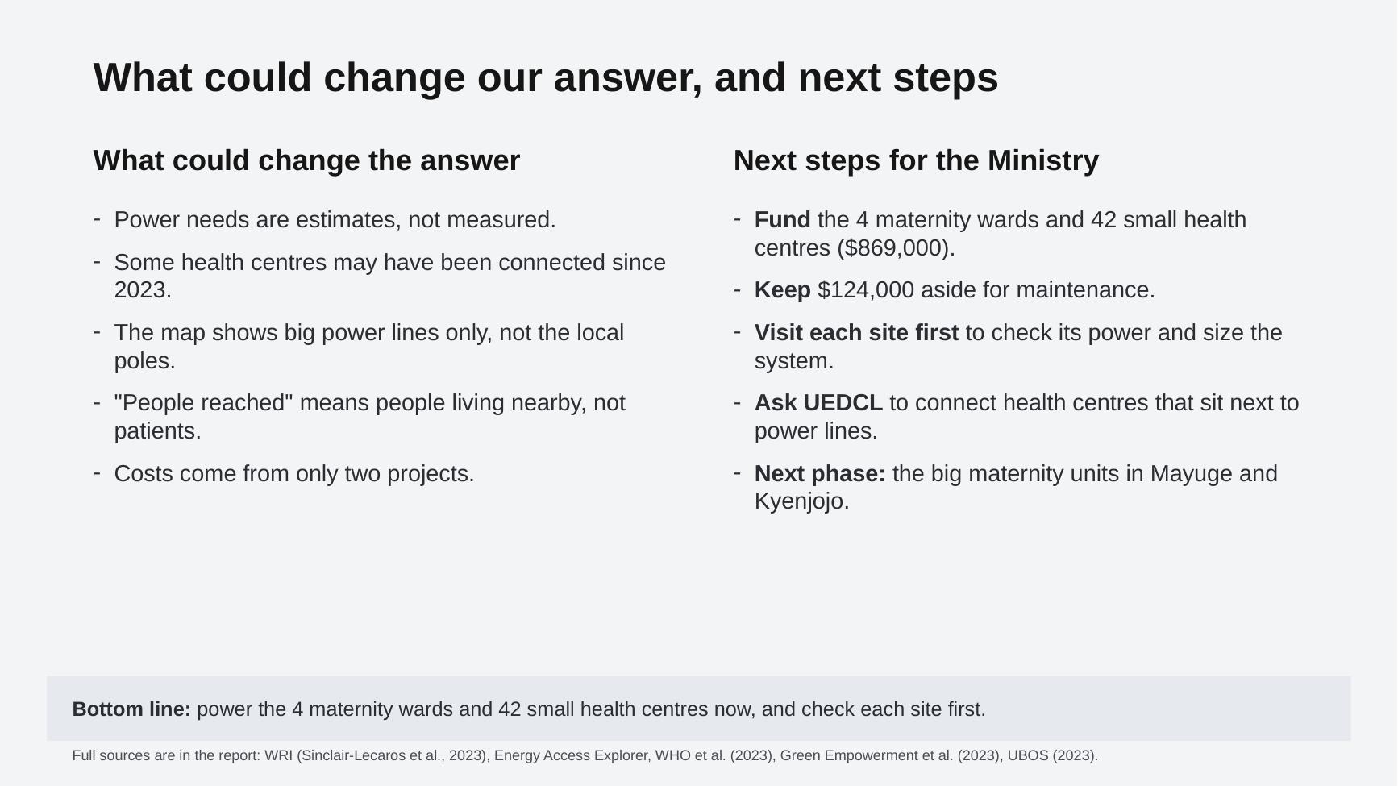
Slide 10 as presented.
In one line: our numbers are estimates, so check each site first. Then fund the plan, keep the maintenance money aside, and ask UEDCL to connect the health centres that sit next to power lines.

What could change the answer
Every analysis rests on data that is not perfect. These are the five main weak points, why they matter and how to deal with them:
Table 11: Limitations
What could be wrong | Why it matters | How to deal with it
Power needs are estimates, not measured | WRI estimated each health centre's need from its level and beds. A real centre may use more or less, so a system could be too big or too small. | Do an energy audit at each site before buying.
Some health centres may have been connected since 2023 | The health centre data is from 2023 and the power line data from 2024. We could pay for solar where the grid has already arrived. | Confirm each centre's power status with the district health office.
The map shows big power lines only | EAE shows 11 kV and 33 kV lines, not the local poles that connect buildings. 35 of our 46 health centres are in the same 1 km square as a big line, so a cheaper grid connection may be possible. | Ask UEDCL which sites can be connected cheaply.
"People reached" is people living nearby, not patients | It shows who could use the health centre, not how many people do. | Collect patient visits and births per month.
Costs come from only two projects | The Ugandan systems from 2022 and one IRENA and SELCO example. The real price could be different. | Slide 9 tests this. Use recent Ugandan tender prices.
One more: batteries usually need replacing after about 10 years. The five-year maintenance reserve does not cover this.

Next steps for the Ministry
- Fund the plan. Power the 4 maternity wards and 42 small health centres: $869,000 for equipment, installation and delivery.
- Keep the maintenance money aside. Ring-fence $124,000 for five years of repairs and upkeep. Use remote monitoring where there is phone signal, so faults are found quickly.
- Visit each site first. Confirm that it still has no power and size the system from an energy audit.
- Ask UEDCL to connect health centres next to power lines. 110 qualifying health centres in high-need districts are in the same 1 km square as a line. If UEDCL connects those, the Ministry's money can go to centres further from the grid: 61 health centres and about 212,000 people. (Fewer people, because centres far from the grid serve fewer people.)
- Plan the next phase for the big maternity units. Mayuge (24 beds, about $466,000, next to a line) and Kyenjojo (20 beds, about $409,000, 6 km from a line) are too big for this budget. Upgrading the 17 HC IIIs in high-need districts that run on small off-grid systems would cost about $0.8 million.
- Budget for new batteries after about 10 years.
- Collect better data: up-to-date power status from district health offices, the local power network, the size of existing solar at off-grid HC IIIs, births per month and recent Ugandan tender prices.
Bottom line: power the 4 maternity wards and 42 small health centres now, and check each site first.

Questions you may be asked
Why solar and not the grid?
Solar works at any site and can be installed quickly. The grid depends on UEDCL building lines and poles. Where a pole is very close, the grid can be cheaper, which is why next step 4 asks UEDCL to connect those sites.
Where does $3,609 per kW come from?
Three solar-and-battery systems at Ugandan health centres in 2022: $97,078 for 26.9 kW in total (Green Empowerment et al., 2023).
Why keep 17% for maintenance?
Solar systems at health centres often stop working because nobody pays for repairs. $180 a year on a $5,250 system is 3.4% a year, and five years of that is about 17% (IRENA and SELCO, in Energizing Health, 2023).
Why not just fund the cheapest per person?
It reaches more people, but only 12 of its 47 health centres are in high-need districts. The Ministry wants to focus where the need is greatest, so we keep the money there.
Why only 4 maternity wards?
They are the only HC IIIs with no power in high-need districts that cost under $100,000. The others are large units that would take almost half the budget each.
What if the price is wrong?
Slide 9 shows it: at 35% cheaper we fund 79 health centres, at 50% dearer we fund 27. The 4 maternity wards are funded every time.

Sources
Energy Access Explorer, World Resources Institute (accessed November 2026). Uganda: health facilities (Ministry of Health and WRI, 2023), distribution lines (Energy Sector GIS Working Group, 2024) and other layers.
Green Empowerment, Medical Teams International and Mandulis Energy (2023). Energizing Healthcare in Uganda: 2023 Impact Report.
Sinclair-Lecaros, S., Mentis, D., Mulepo C.S., E., Falchetta, G. and Stevanato, N. (2023). A GIS-based demand assessment methodology to estimate electricity requirements for health care facilities: a case study for Uganda. World Resources Institute.
Uganda Bureau of Statistics (2023). Uganda Demographic and Health Survey 2022: Key Findings. Kampala: UBOS.
WHO, World Bank, IRENA and SEforALL (2023). Energizing Health: Accelerating Electricity Access in Health-Care Facilities. Geneva: WHO.

