Electrifying Uganda's health facilities: where to spend US$1,000,000
Case Study 4, 04-782 Energy Data Analytics | Abubakar Chilala | November 2026

1. The problem
A health centre without electricity cannot safely deliver a baby at night, run suction or an infant warmer, keep vaccines cold, run lab tests or pump water. Uganda still records 189 maternal deaths per 100,000 live births and 22 newborn deaths per 1,000 (UBOS, 2023). These deaths happen in pregnancy, childbirth and the first weeks of life, when a facility has to work at any hour. Across sub-Saharan Africa more than 1 in 10 facilities have no electricity and about half have an unreliable supply (WHO et al., 2023).
In the Ministry of Health and WRI facility data in Energy Access Explorer (EAE), 582 of Uganda's 4,938 facilities have no electricity and 1,553 rely on off-grid systems, mostly small solar. The 582 serve about 2.5 million people; 547 are HC IIs (outpatient care and emergency deliveries) and 33 are HC IIIs, the level that runs maternity wards. The Ministry's decision is which districts and which facilities to electrify first with US$1,000,000, so that the most people, and the services that matter most for mothers and newborns, get reliable power.

2. Method
I used EAE's Assistance Need Index (ANI) at district level. The ANI rewards high need, poverty and distance from infrastructure, which fits a public grant for facilities the market will not serve. EAE's Demand, Supply and Energy Access Potential indexes were computed for comparison. Table 1 lists the layers, filters and weights.
Side | EAE layer | Filter | Weight | Justification
Demand | Health facilities (proximity) | 0-5 km | 5 | What the programme funds, so the top weight; 5 km is Uganda's access standard.
Demand | Population | 0-1,500 people/km² | 4 | People served. The filter drops towns: 1,102 on-grid facilities sit in denser cells but only 26 unelectrified ones. Without it Kampala ranks 2nd with no unelectrified facility.
Demand | Relative Wealth Index | full range | 4 | Poorer areas cannot pay for power themselves. Same weight as people, so need and equity count equally.
Supply | Distribution lines (11/33 kV) | full range | 3 | Remote areas wait longest for the grid. Lowest weight because 68% of unelectrified facilities are within 1 km of a line.
Table 1: EAE settings (Uganda, Assistance Need Index, district level). Weights run from 1 (low) to 5 (high).
Supply-side choices. I left out solar resource (GHI). It is high almost everywhere (5th to 95th percentile 1,858-2,233 kWh/m²/yr), and in the ANI EAE scores low sunshine as higher need, which is backwards for a solar programme. Adding it at weight 3 leaves the top 10 unchanged. I also did not use the lecture's >2 km grid filter, because it would remove 68% of the facilities with no power. Planned lines, schools, mini-grids and night-time lights are not health-related or barely vary.
Checks. I re-implemented EAE's index in Python from the web tool's own code and then ran the live tool with the same settings (Figure 1). All 146 districts fall in the same class and the top 20 are ranked identically (largest score difference 0.0008).

3. Priority areas
Fourteen districts fall in EAE's High class: Kasese, Isingiro, Tororo, Rukungiri, Kamuli, Luweero, Mukono, Mubende, Ntungamo, Wakiso, Yumbe, Kyenjojo, Mayuge and Bugiri. Table 2 shows the top five and where each places among the 146 districts on every layer.
Rank | District | ANI score | Facilities | People | Poverty | Distance from grid | Facilities with no power (govt)
1 | Kasese | 100% | #2 | #2 | #74 | #52 | 29 (#1)
2 | Isingiro | 93% | #4 | #4 | #72 | #64 | 17 (#5)
3 | Tororo | 91% | #3 | #5 | #98 | #133 | 22 (#3)
4 | Rukungiri | 84% | #1 | #24 | #73 | #129 | 26 (#2)
5 | Kamuli | 82% | #6 | #6 | #91 | #125 | 7 (#23)
Table 2: top five districts and their place among 146 districts on each layer (#1 = highest, poorest or most remote).
What drives the top five is size. They have the most health facilities (1st to 6th) and among the most people (2nd to 24th). On poverty they are mid-table (72nd to 98th) and they are close to the grid, so these layers add about the same to them as to most rural districts. Because EAE's score counts every facility, I checked it against need: Kasese, Rukungiri and Tororo also have the most government facilities with no power in the country, and Isingiro is 5th. Kamuli, with 7, is the weakest of the five. Counting only facilities with no power keeps four of the five; Bugiri replaces Kamuli.
Robustness. Across 500 random weightings (each layer 1-5), Kasese, Isingiro and Tororo are in the top 10 in 100%, 98% and 91% of runs. Equal weights, a 10 km facility range, dropping the wealth layer or adding GHI all keep the top five in the top 10. The objective matters more than the weights: the Demand Index alone points to remote, thinly populated districts (Amudat, Buvuma, Obongi), and without the town filter Wakiso and Kampala come first.

4. Budget allocation
Cost per facility. Each eligible facility gets stand-alone solar PV with batteries, sized from its WRI modelled demand: kWp = kWh per day / 2.78 (WHO et al., 2023, Table 3). The installed cost is $3,609 per kWp, battery included, from three Ugandan health-centre systems built in 2022 ($97,078 for 26.9 kWp; Green Empowerment et al., 2023). I add 20% for design, procurement, transport and supervision, and a maintenance reserve of five years of O&M at 3.4% of capital cost per year (IRENA and SELCO, in WHO et al., 2023, Box 4.1). All-in, an HC II costs $14,824-$21,755, an 8-bed HC III $47,519 and a 14-bed HC III $288,464. The 853 eligible government facilities would cost $64.2 million in total, so the budget covers 1.6% of the need.
Plan. Within the High-class districts I fund first the HC IIIs that have maternity wards and no electricity at all (those under $100,000), then HC IIs with no electricity in order of cost per person. This powers 4 maternity wards (Isingiro, Tororo, Wakiso, Kamuli) and 42 HC IIs in 13 districts: 46 facilities and 347,341 people at $2.86 per person. The budget splits into $723,984 for equipment and installation, $144,797 for delivery, a ring-fenced $124,112 maintenance reserve, and $7,108 unallocated.
Facility type | kWh/day | System | Equipment | +20% delivery | +17% reserve | Total | US$/person
HC II, 2 beds | 8.3 | 3.0 kWp | $10,809 | $2,162 | $1,853 | $14,824 | $6.65
HC II, 3 beds | 12.2 | 4.4 kWp | $15,863 | $3,173 | $2,719 | $21,755 | $2.82
HC III, 8 beds | 26.7 | 9.6 kWp | $34,649 | $6,930 | $5,940 | $47,519 | $17.43
HC III, 14 beds | 161.9 | 58.3 kWp | $210,338 | $42,068 | $36,058 | $288,464 | $31.52
Table 3: cost per facility by type. US$/person uses the median catchment of that type.
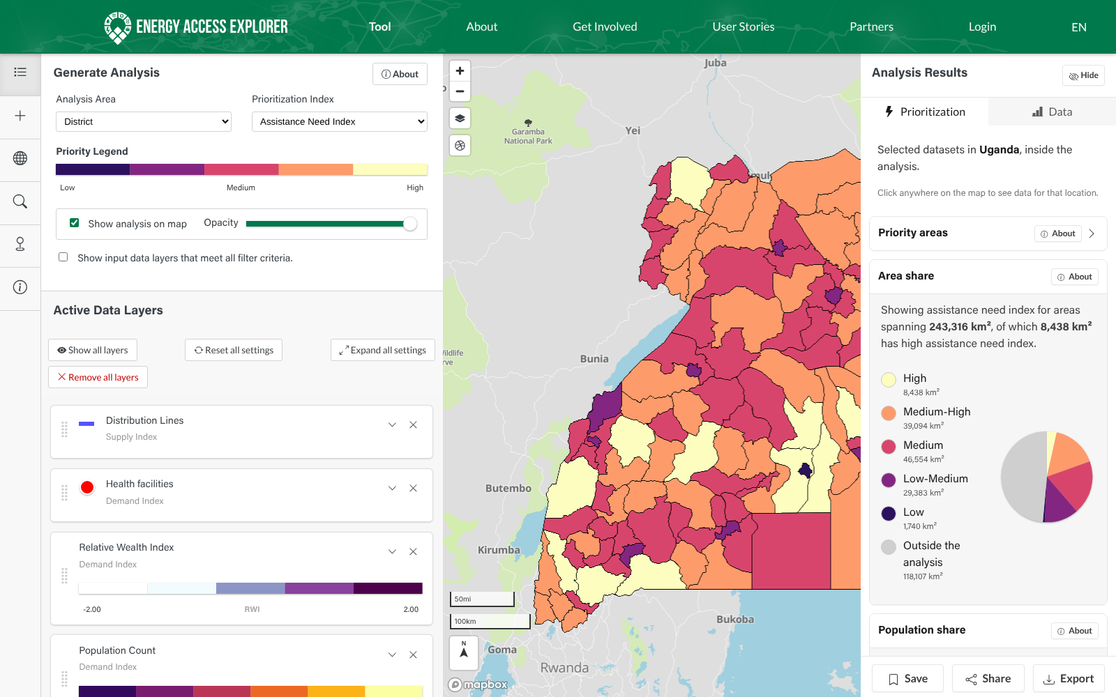  Figure 1: the analysis in the live EAE web tool (Assistance Need Index, district level). | 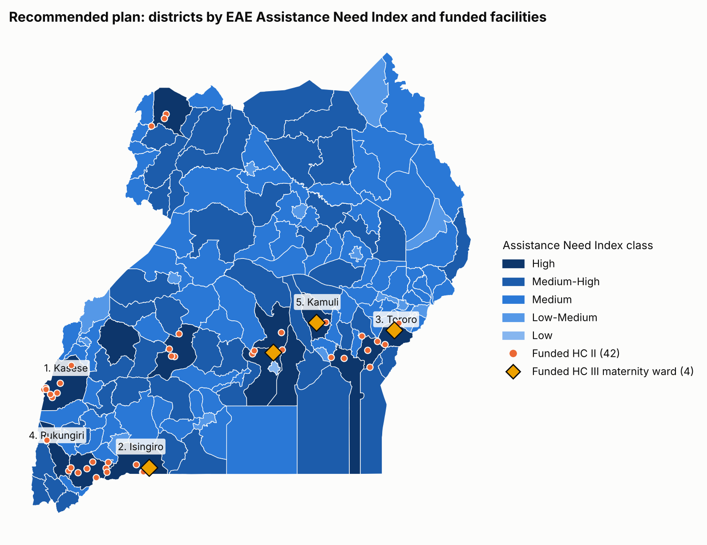  Figure 2: recommended plan. Diamonds are the 4 maternity wards, dots the 42 HC IIs.

5. Sensitivity and trade-offs
Plan | Facilities | Maternity wards with no power | People reached | US$ per person | In High-need districts
Need first (districts in ANI order) | 47 | 0 | 186,756 | $5.33 | 47 of 47
Value for money (cheapest per person) | 47 | 0 | 635,820 | $1.56 | 12 of 47
High-need, cheapest first (HC IIs only) | 53 | 0 | 384,013 | $2.57 | 53 of 53
Recommended (maternity first) | 46 | 4 | 347,341 | $2.86 | 46 of 46
Table 4: four ways to spend the budget. Need first's 7 HC III upgrades already have some power.
Costs. At the Burkina Faso 2022 price ($2,346 per kWp, 35% lower) the plan funds 79 facilities and 477,000 people; at +20% it funds 37 and 303,000; at +50%, 27 and 252,000. A 20% cost change moves the plan by 9 to 15 facilities, but the four maternity wards are funded at every cost level, so cost risk falls only on the number of HC IIs (Figure 3).
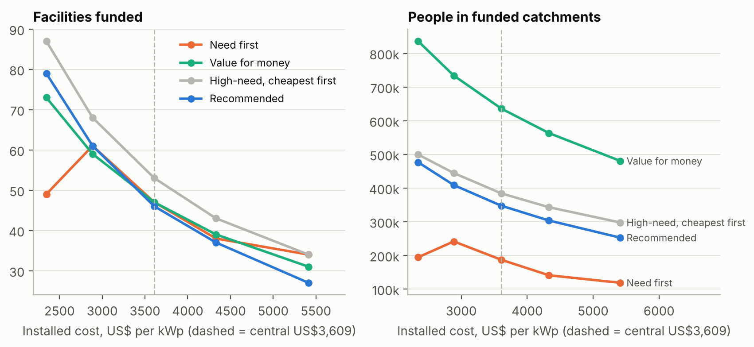
Figure 3: facilities funded and people reached by each plan as the installed cost per kWp changes (dashed line: central $3,609).
Need versus value for money. The value-for-money plan reaches 83% more people than mine, but 35 of its 47 facilities are outside the High-need districts. Across districts, need and cost per person are unrelated (rank correlation -0.04): Isingiro is both high-need and cheap ($3.81 per person against a median of $13.44), Kakumiro is cheap ($2.11) but ranks only 18th, and Obongi costs $93 per person. So I let need choose the districts and cost per person choose the facilities. Within that, putting maternity wards first costs 7 HC IIs and 37,000 people (10%) compared with funding HC IIs only. I accept this because maternity wards serve the deaths that define the problem. A grid option also exists: 110 eligible facilities in High-need districts share a 1 km cell with a line; if UEDCL connected them, the budget could solarise 61 more remote facilities instead.

6. Limitations and recommendations
What could change the answer:
- Modelled demand: WRI's archetype loads are what a facility should use, not what it uses; real systems may be smaller or larger.
- Out-of-date status: the facility data is from 2023 and the lines from 2024; 35 of the 46 funded sites share a 1 km cell with a line and may already be connected.
- Medium voltage only: EAE maps 11/33 kV lines. A cheap UEDCL connection needs a low-voltage pole within about 90 m, which the data does not show.
- People reached is modelled catchment population, not patients or deliveries; EAE's district score rewards size.
- Costs rest on two projects, and the existing solar at 410 off-grid HC IIIs and HC IVs is unknown.
What the Ministry should do next:
- Fund the 4 maternity wards and 42 HC IIs now ($868,781 including delivery) and ring-fence the $124,112 maintenance reserve.
- Before buying, confirm each site's status and size it from an energy audit; refer sites near the low-voltage network to UEDCL's Electricity Access Scale-Up Project.
- Prepare a second phase for maternity: the unpowered maternity units in Mayuge (24 beds, $466,000, next to a line) and Kyenjojo (20 beds, $409,000), and the 17 off-grid 8-bed HC IIIs in High-need districts (about $0.8 million).
- Budget for battery replacement after about 10 years, which the five-year reserve does not cover.
- Collect up-to-date electrification status, deliveries per month, the size of existing systems and recent Ugandan tender prices, and update EAE's health layer.
References
Energy Access Explorer, World Resources Institute (accessed November 2026). Uganda: health facilities (Ministry of Health and WRI, 2023), population (WorldPop), Relative Wealth Index (Meta), distribution lines (Energy Sector GIS Working Group, 2024), GHI (Global Solar Atlas), boundaries (UBOS).
Green Empowerment, Medical Teams International and Mandulis Energy (2023). Energizing Healthcare in Uganda: 2023 Impact Report.
Sinclair-Lecaros, S., Mentis, D., Mulepo C.S., E., Falchetta, G. and Stevanato, N. (2023). A GIS-based demand assessment methodology to estimate electricity requirements for health care facilities: a case study for Uganda. World Resources Institute. doi:10.46830/writn.21.00093
Uganda Bureau of Statistics (2023). Uganda Demographic and Health Survey 2022: Key Findings. Kampala: UBOS.
WHO, World Bank, IRENA and SEforALL (2023). Energizing Health: Accelerating Electricity Access in Health-Care Facilities. Geneva: WHO.

