Case Study 4: Healthcare Electrification in Uganda
What the notebook does, step by step, and what the analysis found
Abubakar Chilala | 04-782 Energy Data Analytics | November 2026

Summary
Uganda's Ministry of Health has US$1,000,000 to bring electricity to health facilities and needs to decide where to spend it. I used Energy Access Explorer (EAE), a free online mapping tool from the World Resources Institute (WRI), to combine data on health needs and electricity supply. The notebook downloads the EAE data, ranks Uganda's 146 districts, works out what a solar system would cost at each facility, and compares three ways of spending the money.
The main findings:
- 582 of Uganda's 4,938 health facilities have no electricity at all. They serve about 2.5 million people. Another 1,553 run on off-grid power, mostly small solar systems.
- 68% of the facilities without electricity are within 1 km of a power line. For most of them the problem is the connection, not distance from the grid.
- On EAE's Assistance Need Index the five highest-priority districts are Kasese, Isingiro, Tororo, Rukungiri and Kamuli. Kasese, Isingiro and Tororo stay in the top 10 in more than 90% of 500 random weightings.
- A solar and battery system for a small health centre (HC II) costs about $15,000 to $22,000, including delivery and five years of maintenance. A large HC III with maternity and a lab costs $240,000 or more.
- Recommended plan: solar for 53 unelectrified HC IIs in 13 High-need districts. This reaches about 384,000 people at $2.57 per person, and $123,000 is kept aside for maintenance.
- Spending only on the lowest cost per person would reach 636,000 people, but only 12 of its 47 facilities would be in High-need districts. This is the main trade-off between need and value for money.

1. The question

1.1 The brief
The Ministry of Health in Uganda has $1,000,000 for a healthcare electrification programme and must decide where to focus it. The task is to use Energy Access Explorer to combine evidence on healthcare needs and electricity supply, identify priority areas, and justify a funding plan. The report has to answer six questions. The table shows where each is answered in the notebook and in this document.
Report question | What it asks | Notebook section | This document
The problem | Why electrifying health facilities matters, and what decision the Ministry faces | 2 | 1.2 and 6
Method | Which EAE layers, filters, weights and index, and why | 3 | 7
Priority areas | Which districts rank highest and what drives the top five | 4 | 8
Budget allocation | Cost per facility with a source, maintenance reserve, facilities and people reached | 5 and 6 | 9 and 10
Sensitivity and trade-offs | What changes if costs change, and where need conflicts with value for money | 7 | 11
Limitations and recommendations | What could change the answer and what the Ministry should do next | 8 | 12 and 13

1.2 Why it matters
Almost every service at a health centre depends on electricity: lighting for deliveries at night, suction and infant warmers, vaccine fridges, lab equipment, phones and computers, and water pumps. Without power these services stop after dark or do not exist at all.
In Uganda, 189 women die for every 100,000 live births and 22 of every 1,000 newborns die in their first month (Uganda Demographic and Health Survey 2022). Many of these deaths happen around birth, which is exactly when a facility needs light and power. Across sub-Saharan Africa more than 1 in 10 health facilities have no electricity and about half have an unreliable supply (WHO, World Bank, IRENA and SEforALL, 2023).

2. Key terms in plain words
Term | Meaning
Energy Access Explorer (EAE) | A free online tool from WRI that puts maps of energy demand and supply together. It also has an open API, so the data can be downloaded by code.
Layer | One map of one thing, for example population, power lines or health facilities.
Raster and 1 km grid | A map split into squares of 1 km by 1 km. Each square holds a number. Uganda's grid has 609 by 637 squares.
Vector data | Points, lines and shapes with exact coordinates, such as facility locations or district borders.
HC II, HC III, HC IV | Levels of Uganda's health centres. HC II: outpatient care and emergency deliveries, 2-3 beds. HC III adds maternity, inpatient care and a lab, 8-24 beds. HC IV adds surgery and blood transfusion, 25-59 beds.
Electrification status | Whether a facility is on the grid (On-grid), has its own system such as solar (Off-grid), has no electricity (No), or is unknown (Data unavailable).
kWh per day | The energy a facility uses in a day. A 3-bed HC II needs about 12 kWh per day.
kW and kWp | kW is power at one moment. kWp (kilowatt-peak) is the size of a solar panel array: the power it gives in full sun.
Catchment population | The people who live closer, in walking time, to this facility than to any other.
Relative Wealth Index (RWI) | Meta's estimate of how rich or poor an area is compared with the rest of the country. Below 0 means poorer than average.
Distribution lines | The 11 kV and 33 kV power lines that carry electricity locally.
Index | One score that combines several layers using weights.
Weight | How important a layer is in the index, from 1 (low) to 5 (high).
Natural breaks (Jenks) | A way to split scores into five classes, Low to High, so that districts in the same class are as similar as possible.
O&M | Operation and maintenance: cleaning panels, checking batteries and repairs.
Cost per person | Total cost of a facility's system divided by its catchment population.

3. How the notebook is organised
The notebook is one Python file that runs from top to bottom in about a minute. It downloads its own data, so anyone can rerun it from scratch. It has ten sections:
Section | What it does
0. Setup and assumptions | Installs missing packages and holds every assumption (EAE settings, costs, eligibility) in one cell.
1. Downloading the EAE layers | Lists all EAE data for Uganda and downloads the layers needed.
2. Health facilities | Counts facilities by level and electrification status and looks at how far they are from the grid.
3. Method | Rebuilds EAE's index calculation, sets the layers and weights, and checks the result against the real web tool.
4. Priority districts | Ranks the districts, explains the top five, and tests how stable the ranking is.
5. Cost per facility | Sizes a solar system for each facility and costs it.
6. Allocating the budget | Spends the $1,000,000 in three different ways and compares them.
7. Sensitivity and trade-offs | Changes the costs, compares need with value for money, and tests a grid option.
8. Limitations | Lists data checks and gaps.
9. Key numbers | Saves the main numbers for the report.

Everything the notebook produces is saved in the outputs folder: 7 figures in outputs/figures and 22 tables in outputs/tables.

4. Step 0: Setup and assumptions
The first cell installs any missing Python packages (geopandas, rasterio, matplotlib and a few others). The second cell holds all the choices the analysis depends on, so they can be changed in one place and the notebook rerun:
Assumption | Value | Where it comes from
Budget | US$1,000,000 | The brief
EAE index | Assistance Need Index | My choice, explained in Section 7
EAE layers and weights | Health facilities 5, Population 4, Relative Wealth Index 4, Distribution lines 3 | My choice, explained in Section 7
Solar cost | $3,609 per kWp, battery included | Three Ugandan health-centre systems, 2022 (Green Empowerment et al., 2023)
Solar output | 2.78 kWh per kWp per day | Energizing Health (2023), Table 3
Delivery overhead | 20% of equipment cost | Based on the Uganda project, which spent 32% on design, O&M and management
Maintenance reserve | 3.4% of equipment cost per year for 5 years | IRENA and SELCO, in Energizing Health (2023), Box 4.1
Cost range tested | x0.65 to x1.5 | x0.65 matches a Burkina Faso 2022 price; x1.5 for remote sites
Eligible owners | Government facilities only | Public money for public facilities
Robustness check | 500 random weightings, seed 42 | So the check gives the same result every run

5. Step 1: Getting the data from EAE
EAE keeps its list of datasets in a public database that can be queried over the internet (an API), and stores each processed layer as a public file on WRI's cloud storage. The notebook asks the API for Uganda and gets back 38 datasets with their sources, dates and licences. This list is saved as eae_uganda_catalogue.csv.
It then downloads only the layers the analysis needs and saves them in data/eae, so they are not downloaded again on the next run:
Layer | What it shows | Source | Date
Health facilities | 4,938 facilities with level, status, modelled demand, catchment | Ministry of Health and WRI | 2023
Population | People per 1 km square | WorldPop | 2022
Relative Wealth Index | How rich or poor each area is | Meta | 2021
Distribution lines | Distance to the nearest 11/33 kV line | Energy Sector GIS Working Group | 2024
Solar resource (GHI) | Sunshine per year, kWh/m2 | Global Solar Atlas | 2024
Night-time lights | Light seen from space at night | Earth Observation Group | 2025
District boundaries | 146 districts | Uganda Bureau of Statistics | 2024
Outline | Uganda's border | Uganda Bureau of Statistics | 2024

Each gridded layer comes in three versions: the value shown on the map, an area-weighted total and an area-weighted average. All layers sit on the same 609 by 637 grid, so square number 1,000 is the same place in every layer. This is how EAE combines layers, and the notebook does the same.
Each facility is placed on the grid the same way EAE does it: its longitude and latitude are converted to web-map coordinates in metres and matched to the nearest square. This gives every facility its distance to the grid, solar resource, wealth index and district.
All layers saved: a separate script, tools/download_eae_layers.py, downloads all 38 Uganda layers and saves CSV versions (facility lists, line lengths and summaries by region, district, county and subcounty) in the eae_data folder.

6. Step 2: The health facilities

6.1 How many facilities, and which have power
Level | On-grid | Off-grid | No electricity | Unknown | Total
HC II | 1,033 | 1,109 | 547 | 82 | 2,771
HC III | 1,012 | 385 | 33 | 11 | 1,441
HC IV | 180 | 25 | 0 | 7 | 212
Hospital | 136 | 5 | 0 | 8 | 149
Regional and national referral hospitals | 14 | 0 | 0 | 1 | 15
Clinic | 288 | 29 | 2 | 21 | 340
Special clinic (SC) | 10 | 0 | 0 | 0 | 10
Total | 2,673 | 1,553 | 582 | 130 | 4,938
Table: facilities by level and electrification status (facilities_by_level_and_status.csv).
Almost all the facilities without electricity are small health centres: 547 of the 582 are HC IIs, and 529 are run by the government. Together they serve about 2.5 million people and would need about 7,150 kWh per day.

6.2 How much electricity each type of facility needs
EAE's health layer includes WRI's estimate of how much electricity each facility would need to run all its services properly. WRI built these estimates by listing the equipment each type of facility should have and simulating how it is used through the day (the RAMP model). They describe what a facility should use, not what it uses today.
Facility type | Beds | Facilities | kWh per day | Peak kW | Median catchment
HC II | 2 | 2,111 | 8.3 | 2.8 | 2,229
HC II | 3 | 660 | 12.2 | 3.6 | 7,719
HC III | 8 | 1,097 | 26.7 | 3.9 | 2,727
HC III | 12 | 120 | 134.0 | 14.7 | 7,269
HC III | 14 | 72 | 161.9 | 18.3 | 9,153
HC III | 16 | 48 | 186.6 | 20.6 | 10,824
HC III | 20 | 80 | 229.3 | 24.2 | 13,596
HC III | 24 | 24 | 261.7 | 28.5 | 18,699
HC IV | 25 | 209 | 295.7 | 34.4 | 3,436
HC IV | 29 | 1 | 324.2 | 39.9 | 21,927
HC IV | 36 | 2 | 411.4 | 49.9 | 36,769
Table: modelled demand by facility type (demand_by_archetype.csv). The standard HC II, HC III and HC IV match the lecture: 12.21, 161.90 and 324.23 kWh per day.
The jump between an 8-bed HC III (27 kWh per day) and a 12-bed HC III (134 kWh per day) matters later: it makes larger HC IIIs much more expensive to power.

6.3 How far facilities are from the grid
Status | Facilities | Within 1 km of a line | 2 km or more | Median distance | Mean wealth index
On-grid | 2,673 | 99% | 1% | 0 km | 0.40
Off-grid | 1,553 | 64% | 36% | 0 km | -0.18
No electricity | 582 | 68% | 32% | 0 km | -0.15
Unknown | 130 | 85% | 15% | 0 km | 0.21
Table: distance to the nearest 11/33 kV line by status (grid_proximity_by_status.csv). 0 km means the facility is in the same 1 km square as a line.
This was the most surprising result. Two out of three facilities without electricity have a power line in the same or the next 1 km square. The grid is close, but they are not connected. Facilities without power are also in poorer areas (wealth index below 0) than on-grid ones.
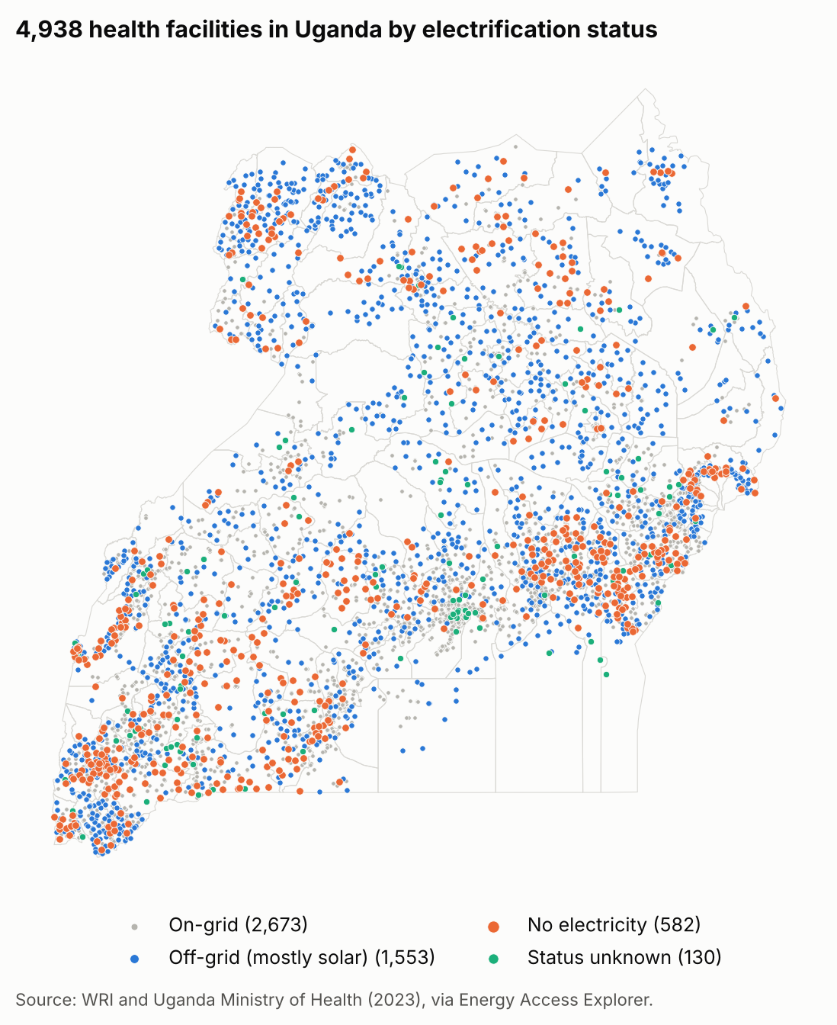
Figure 1: the 4,938 facilities by electrification status. Facilities without electricity (orange) are spread across the country, with clusters in the east and south-west.

7. Step 3: Method

7.1 Choosing the index
EAE offers four ways to combine layers into a score. Each answers a different question (lecture slide 25):
EAE index | Question it answers
Demand Index | Where are energy needs concentrated?
Supply Index | Where are energy resources and infrastructure good?
Energy Access Potential | Where do good demand and supply come together? This is more of a market view.
Assistance Need Index (ANI) | Where is need high, but people are poor and far from infrastructure? This is where public money is needed most.

Because this is public money for facilities that the market will not serve, I used the Assistance Need Index for the ranking. The other three were calculated as well, to show how the answer changes with the objective.

7.2 Layers, filters and weights
Layer | Side | Filter (slider range) | Weight | How it counts in the ANI | Why
Health facilities | Demand | 0-5 km | 5 | Closer to a facility = higher | The programme is about facilities. 5 km is Uganda's access standard.
Population | Demand | 0-1,500 people per km2 | 4 | More people = higher | People served. The filter removes towns, which are already on the grid.
Relative Wealth Index | Demand | Full range | 4 | Poorer = higher | Poor areas cannot pay for electricity themselves.
Distribution lines | Supply | Full range | 3 | Further from a line = higher | Utilities are less likely to reach remote areas soon.
Table: the EAE settings used (eae_settings.csv). These are the exact settings to enter in the EAE web tool.
In the ANI each layer's weight becomes a share of the total: health facilities 31%, population 25%, wealth 25% and distribution lines 19%.

7.3 Why I filtered out towns
My first run used EAE's default population range. It put Wakiso first and Kampala second. Kampala has no unelectrified facility at all. This happens because EAE's district score adds up all the people in a district, so big cities always score high. Limiting population to 0-1,500 people per km2 removes the dense town squares. This is fair because towns are already on the grid: 1,102 on-grid facilities are in squares with more than 1,500 people, but only 26 unelectrified ones are. After the filter, the top 10 districts hold 134 unelectrified facilities instead of 49.

7.4 Layers I did not use
Layer | Reason
Solar resource (GHI) | Sunshine is high almost everywhere in Uganda (5th to 95th percentile 1,858-2,233 kWh/m2 per year), so it barely separates districts. Also, in the ANI EAE scores low sunshine as higher need, which makes no sense for a solar programme. I only used GHI to check the funded sites.
Night-time lights | 96% of squares are dark, so it does not separate rural areas.
Planned distribution lines | Plans can be delayed, and the programme is for facilities that need power now.
Schools, financial services, mini-grids | Not about health; they would dilute the ranking.
Protected areas | The facilities already exist and rooftop systems need no extra land.
The >2 km grid filter from the lecture | 68% of unelectrified facilities are within 1 km of a line, so this filter would remove most of them.

7.5 How EAE turns layers into a score
I rebuilt EAE's calculation in Python by following the web tool's own code. It works in four steps:
- Score each square for each layer. Each layer gives every 1 km square a score from 0 to 1. For health facilities, a square right next to a facility scores 1, a square 5 km away scores 0, and squares further than 5 km are left out. For wealth, the poorest squares score highest. For population, squares are put into classes: under 1 person scores 0, 1-150 scores 0.25, 150-500 scores 0.5, and 500-1,500 scores 0.75. A square with missing data in any layer is left out.
- Combine the layers. Each square's layer scores are multiplied by the weights and added up.
- Rescale. The totals are rescaled so the best square in Uganda is 1 and the lowest is 0.
- Score each district. For each district, the analysed squares are totalled layer by layer: people are added up, facilities are counted, and wealth and grid distance are averaged. Each total is compared across districts (lowest 0, highest 1), weighted, and stretched to a score from 1% to 100%. Districts are then split into five classes with natural breaks.
With these settings the 146 districts fall into: High 14, Medium-High 46, Medium 70, Low-Medium 15 and Low 1.
A limit of the EAE tool: the district score counts every facility in a district, not only the ones without electricity. In the web tool the status checkboxes only hide points on the map; they do not change the analysis. That is why I show the number of unelectrified facilities next to each district's score.

7.6 Checking my version against the real EAE tool
To make sure my Python version matches EAE exactly, I opened the real EAE web tool in an automated browser (tools/eae_check.js), entered the same settings, and saved its district scores. The comparison:
Check | EAE web tool | Notebook
Districts scored | 146 | 146
1 km squares analysed | 125,210 | 125,209
Largest difference in a district score |  | 0.0008
Districts in the same class |  | 100%
Same rank in the top 20 |  | 100%
Table: notebook against the live EAE tool (validation_vs_eae_tool.csv). Two districts tied at 54% swap places at ranks 66 and 67.
So the ranking in this analysis is the same ranking anyone gets in the EAE web tool with these settings.
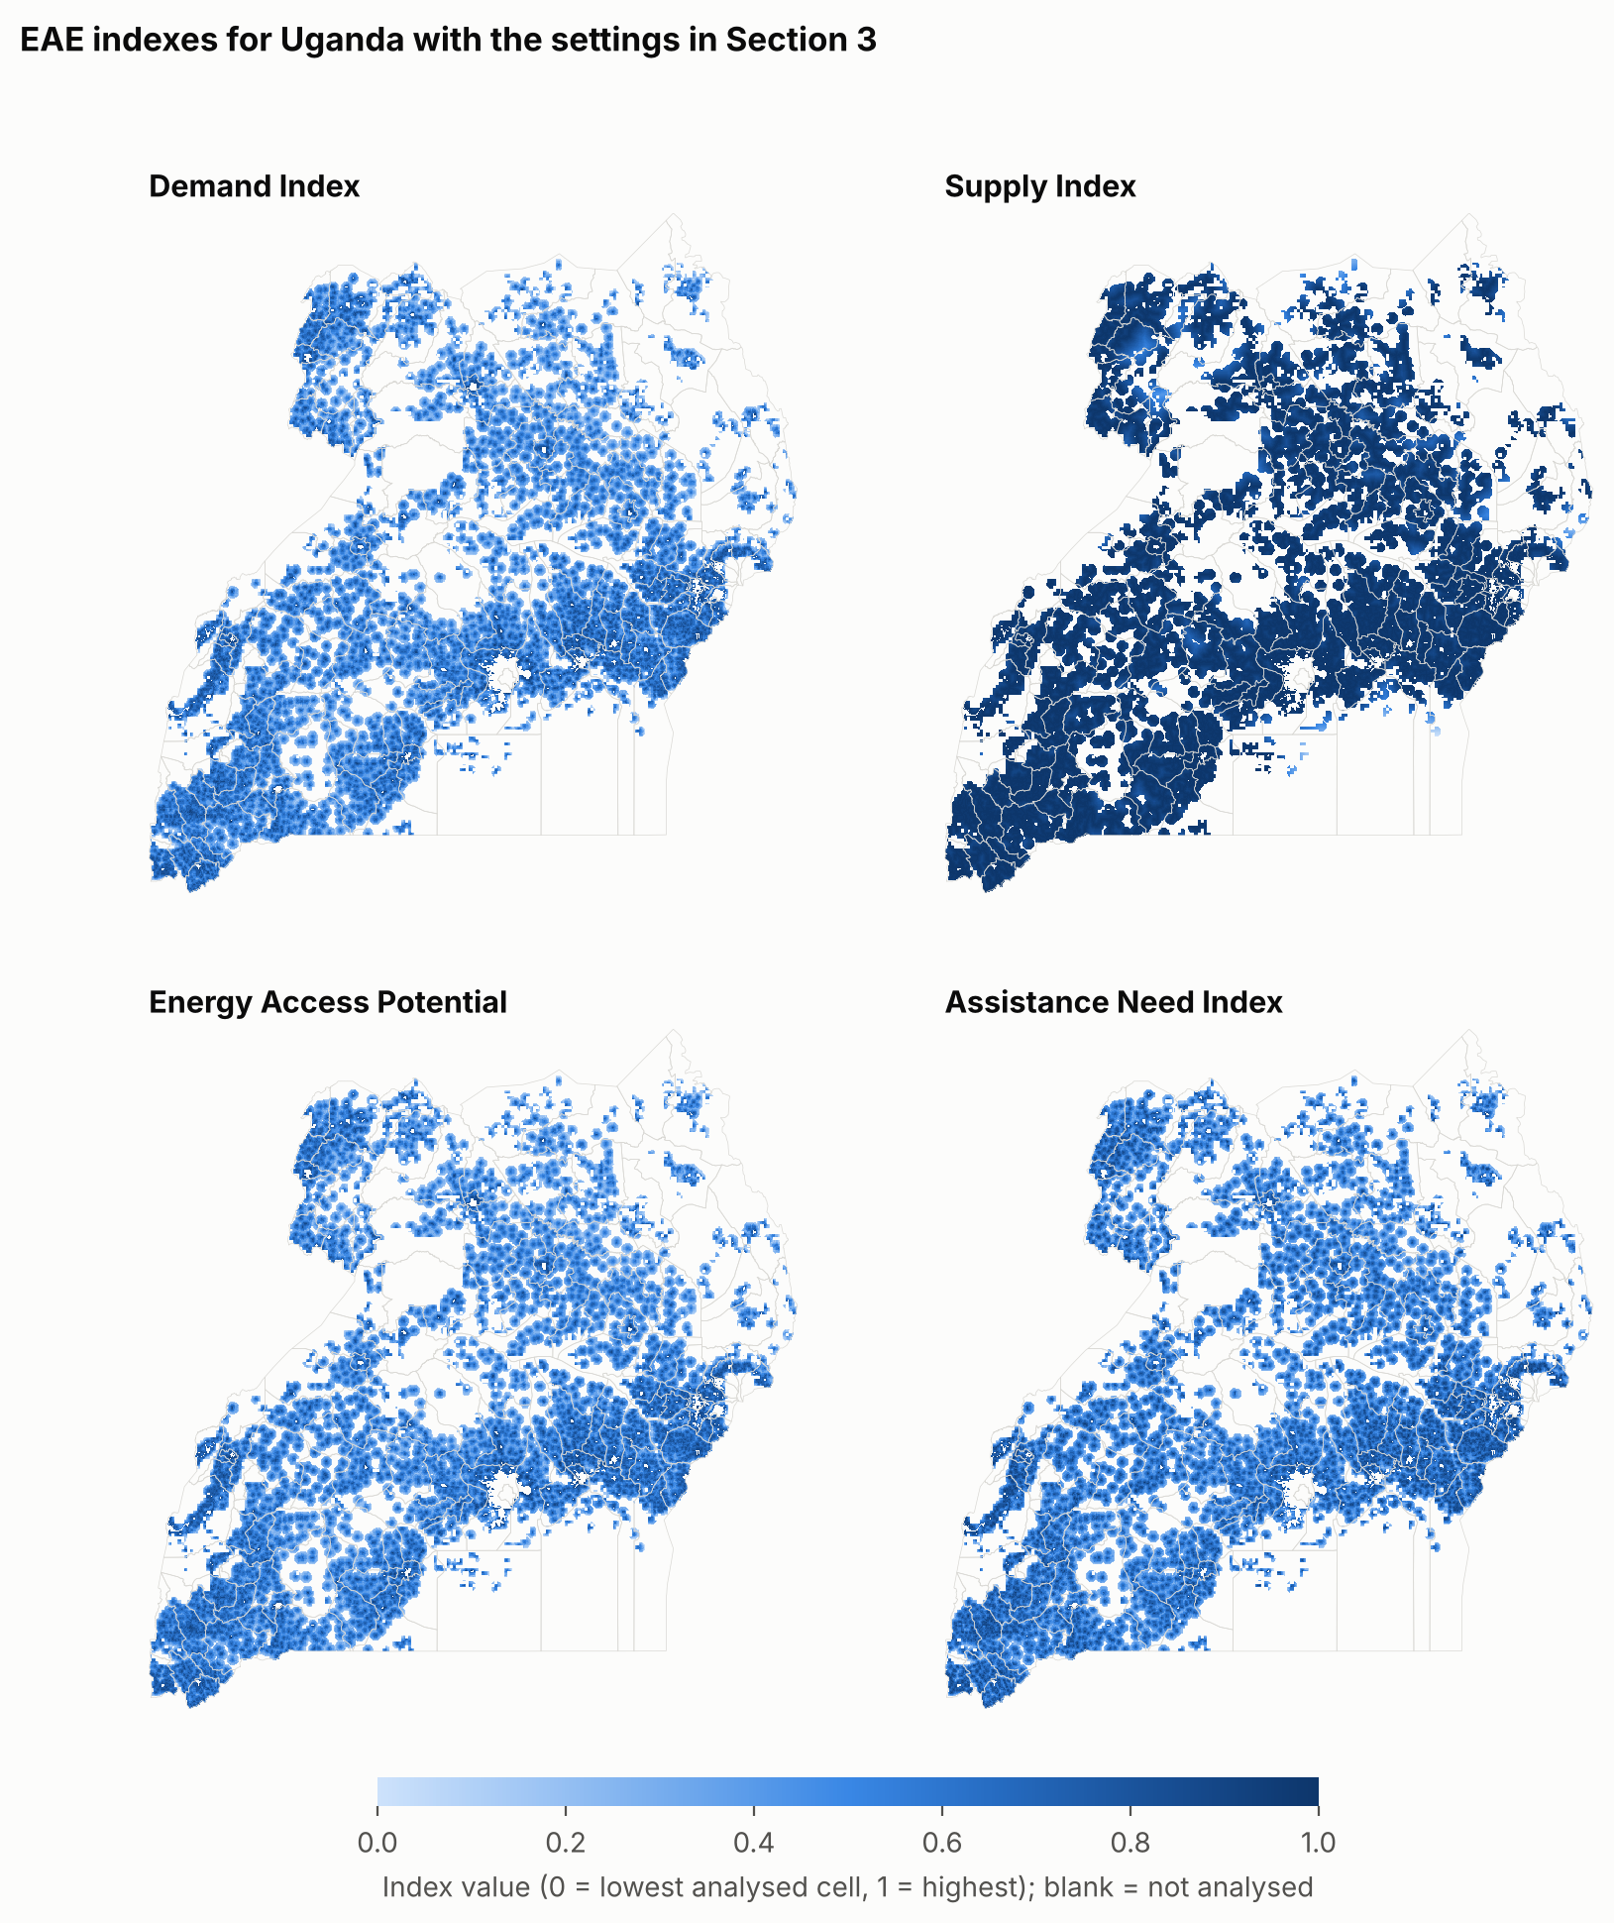
Figure 2: the four EAE indexes with these settings. Darker squares score higher; blank squares are left out (no data, outside the filters, or more than 5 km from a facility).

8. Step 4: Priority districts

8.1 The top 10
Rank | District | ANI score | Main drivers | No electricity (govt) | Off-grid HC III/IV (govt) | Mean wealth | Mean km to line
1 | Kasese | 100% | facility count, people | 29 | 8 | -0.20 | 2.1
2 | Isingiro | 93% | facility count, poverty | 17 | 0 | -0.22 | 1.9
3 | Tororo | 91% | facility count, people | 22 | 2 | -0.13 | 0.8
4 | Rukungiri | 84% | facility count, poverty | 26 | 2 | -0.21 | 0.9
5 | Kamuli | 82% | poverty, people | 7 | 0 | -0.15 | 0.9
6 | Luweero | 82% | poverty, facility count | 1 | 1 | -0.14 | 1.3
7 | Mukono | 79% | people, poverty | 4 | 1 | -0.04 | 2.9
8 | Mubende | 79% | poverty, people | 8 | 1 | -0.29 | 2.1
9 | Ntungamo | 79% | poverty, people | 13 | 1 | -0.11 | 1.2
10 | Wakiso | 76% | people, poverty | 7 | 0 | 0.06 | 1.4
Table: top 10 districts on the Assistance Need Index (district_ranking_ani.csv).

8.2 What drives the top five
- Kasese (100%): the most people and facilities in its analysed area, and 29 government facilities with no electricity, the most of any district.
- Isingiro (93%): many facilities and one of the poorest of the top districts; 17 without electricity.
- Tororo (91%): many facilities and people; 22 without electricity.
- Rukungiri (84%): the highest facility count (79) and poor; 26 without electricity.
- Kamuli (82%): poverty and population; 7 without electricity.
In short, the number of facilities, the number of people and poverty drive the ranking. Distance to the grid adds little, because these districts have lines close by (0.8 to 2.1 km on average).
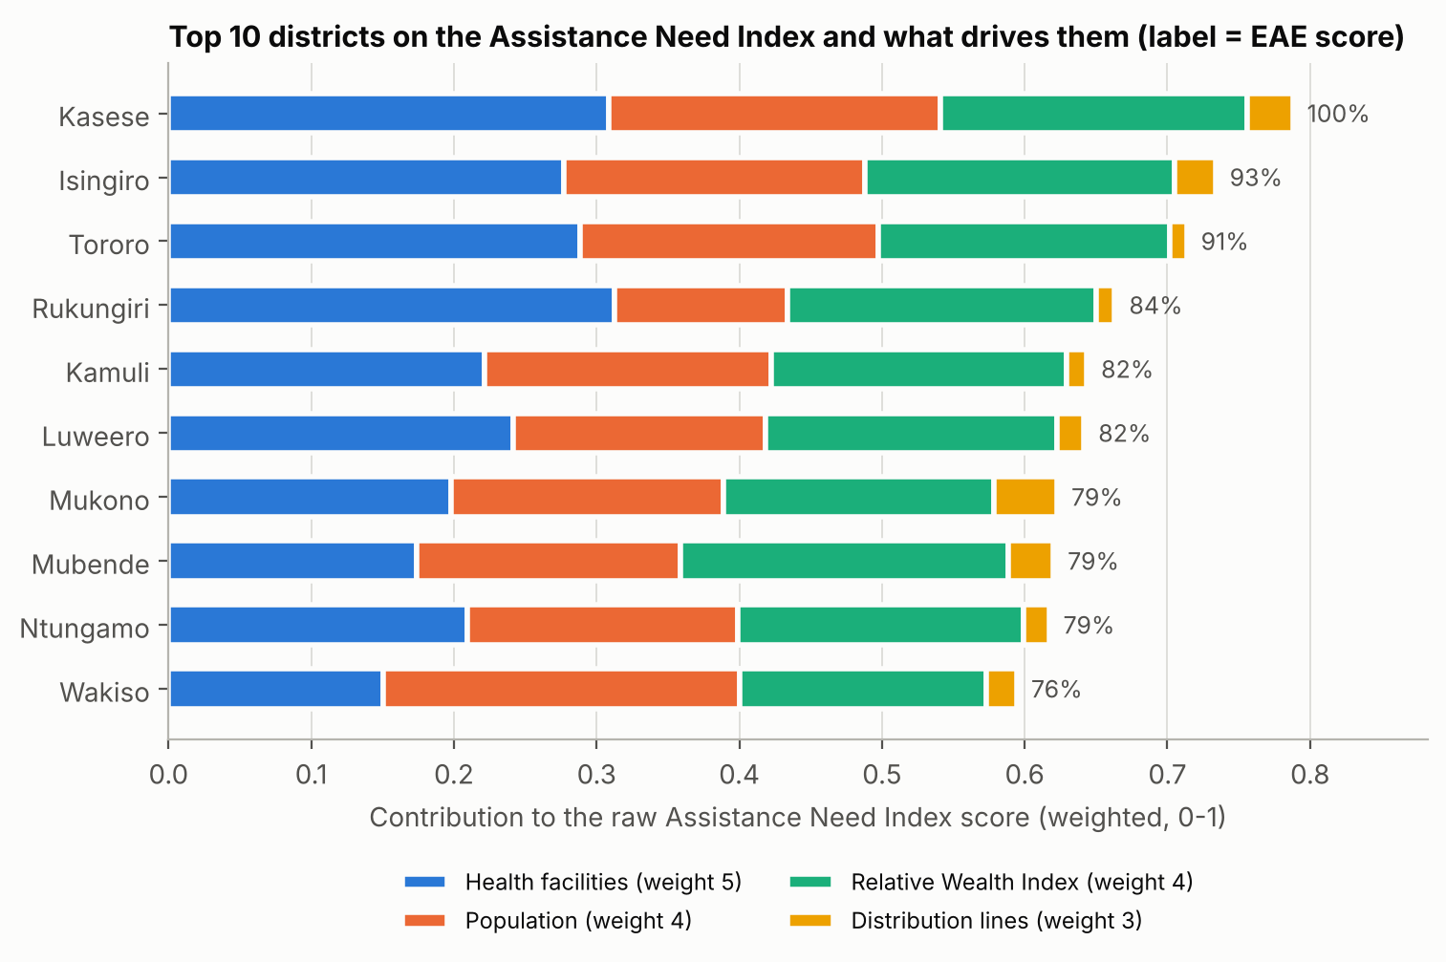
Figure 3: how much each layer adds to the score of the top 10 districts.

8.3 How the answer changes with the objective
Rank | Demand | Supply | Energy Access Potential | Assistance Need
1 | Amudat | Tororo | Tororo | Kasese
2 | Buvuma | Kasese | Kasese | Isingiro
3 | Obongi | Rukungiri | Rukungiri | Tororo
4 | Kasese | Kamuli | Kamuli | Rukungiri
5 | Kalangala | Isingiro | Isingiro | Kamuli
Table: top five districts under each EAE index (index_comparison_top10.csv).
The Demand Index points to remote, thinly populated districts (Amudat, Buvuma, Obongi, Kalangala). The Supply Index and Energy Access Potential share 8 of the ANI's top 10 districts, because districts with many facilities score high on all three. The Demand Index shares only 3.

8.4 Does the ranking hold up?
I tested the ranking in two ways. First, I changed one setting at a time:
Change | New top five | Original top five still in top 10
None (my settings) | Kasese, Isingiro, Tororo, Rukungiri, Kamuli | 5 of 5
EAE default population range (towns kept) | Wakiso, Kampala, Amudat, Buvuma, Lamwo | 1 of 5
Health facilities within 10 km | Kasese, Isingiro, Tororo, Rukungiri, Luweero | 5 of 5
Without the wealth layer | Kasese, Isingiro, Tororo, Mukono, Rukungiri | 5 of 5
Only squares more than 2 km from a line | Kasese, Terego, Isingiro, Buvuma, Adjumani | 2 of 5
All weights equal (3) | Kasese, Isingiro, Tororo, Rukungiri, Kamuli | 5 of 5
Count only facilities with no electricity* | Kasese, Tororo, Rukungiri, Isingiro, Bugiri | 4 of 5
Table: ranking under other settings (robustness_variants.csv). *Not possible in the EAE web tool, only in the notebook.
Second, I gave every layer a random weight from 1 to 5 and repeated the ranking 500 times:
District | Original rank | In the top 5 | In the top 10
Kasese | 1 | 95% | 100%
Isingiro | 2 | 92% | 98%
Tororo | 3 | 82% | 91%
Mukono | 7 | 11% | 82%
Mubende | 8 | 13% | 75%
Kamuli | 5 | 34% | 74%
Luweero | 6 | 21% | 73%
Ntungamo | 9 | 0% | 60%
Rukungiri | 4 | 42% | 59%
Wakiso | 10 | 21% | 54%
Table: share of 500 random weightings in which each district is in the top 5 or top 10 (robustness_weights_montecarlo.csv).
Kasese, Isingiro and Tororo are safe choices whatever the weights. Rukungiri and Kamuli depend more on the weights. The town filter and the 2 km grid filter change the answer the most, which is why I explained both choices above.
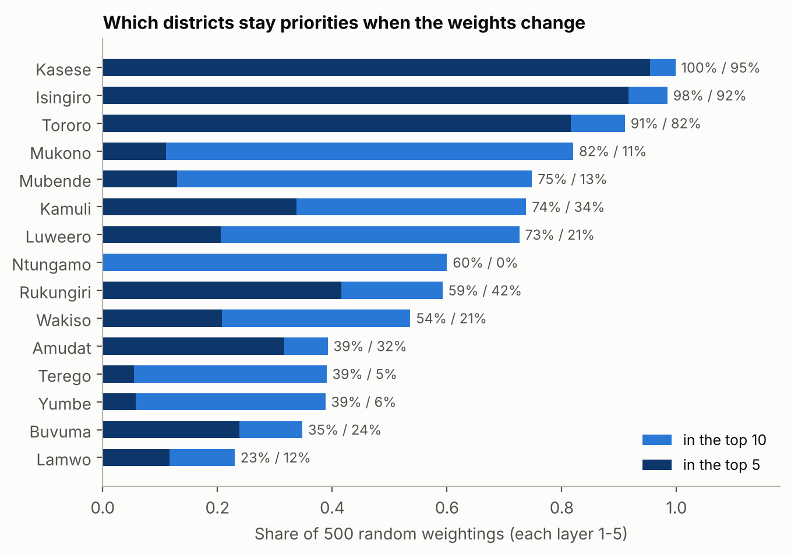
Figure 4: districts that stay priorities when the weights change.

9. Step 5: Cost per facility

9.1 How a system is sized and costed
Each eligible facility gets a stand-alone solar system with batteries, sized to its modelled daily energy. The cost has three parts:
- Equipment and installation: system size (kWp) = energy per day / 2.78, then multiplied by $3,609 per kWp. $3,609 is what three Ugandan health centres paid in 2022: $97,078 for 26.9 kWp of solar with about 19 kWh of batteries each.
- Delivery overhead: 20% on top for design, buying, transport and supervision.
- Maintenance reserve: 3.4% of the equipment cost per year for 5 years, or 17%. This money is kept aside from the same budget so the systems keep working.
Worked example, a 3-bed HC II: it needs 12.21 kWh per day. 12.21 / 2.78 = 4.4 kWp. 4.4 x $3,609 = $15,863 for equipment. Add $3,173 overhead (20%) and $2,719 reserve (17%) for a total of $21,755. Its median catchment is 7,719 people, so the cost is $2.82 per person.
A quick check: an 8-bed HC III needs 26.7 kWh per day, which gives 9.6 kWp. That is the same size as the systems in the Uganda project, so the sizing is realistic.

9.2 Cost by facility type
Facility type | kWh per day | System | Equipment | Overhead | Reserve | Total | Per person
HC II, 2 beds | 8.3 | 3.0 kWp | $10,809 | $2,162 | $1,853 | $14,824 | $6.65
HC II, 3 beds | 12.2 | 4.4 kWp | $15,863 | $3,173 | $2,719 | $21,755 | $2.82
HC III, 8 beds | 26.7 | 9.6 kWp | $34,649 | $6,930 | $5,940 | $47,519 | $17.43
HC III, 12 beds | 134.0 | 48.2 kWp | $174,052 | $34,810 | $29,837 | $238,700 | $32.84
HC III, 14 beds | 161.9 | 58.3 kWp | $210,338 | $42,068 | $36,058 | $288,464 | $31.52
HC III, 24 beds | 261.7 | 94.2 kWp | $339,958 | $67,992 | $58,278 | $466,228 | $24.93
HC IV, 29 beds | 324.2 | 116.7 kWp | $421,235 | $84,247 | $72,212 | $577,693 | $26.35
Table: cost per facility by type (cost_per_facility_by_archetype.csv). Per person uses the median catchment of that facility type.
A small HC II costs about $15,000 all-in. One large HC III costs as much as 13 to 19 HC IIs.

9.3 Which facilities are eligible
A facility is eligible if it is run by the government, has a WRI demand estimate, and either has no electricity or is an off-grid HC III or HC IV. I count the off-grid HC IIIs and HC IVs as under-electrified: they have maternity, inpatient and lab services, which need more power than a basic solar kit gives.
Group | Facilities | Cost to do them all | Median cost each | People served
No electricity | 529 | $11.5 million | $14,824 | 2,272,638
Under-electrified (off-grid HC III/IV) | 324 | $52.7 million | $47,519 | 1,869,617
Total | 853 | $64.2 million
The $1,000,000 budget covers about 9% of the cost of electrifying all the facilities with no power, or 1.6% of everything eligible. So choosing well matters.

10. Step 6: Spending the $1,000,000

10.1 Three ways to fill the budget
Each plan puts the eligible facilities in a different order and funds them one by one until the money runs out. If a facility no longer fits in what is left, it is skipped and the next one is tried.
- Need first: districts in ANI order. Within each district, facilities with no electricity first, then the lowest cost per person.
- Value for money: the lowest cost per person across the whole country, ignoring the district ranking.
- Recommended: the ANI decides where and cost per person decides which. Start with the 14 districts in the High class, fund facilities with no electricity first, then under-electrified ones, cheapest per person first. Money left over moves to the next class.

10.2 Results
 | Need first | Value for money | Recommended
Facilities funded | 47 | 47 | 53
With no electricity / under-electrified | 40 / 7 | 47 / 0 | 53 / 0
HC II / HC III | 40 / 7 | 47 / 0 | 53 / 0
People reached | 186,756 | 635,820 | 384,013
Cost per person | $5.33 | $1.56 | $2.57
Districts reached | 2 | 31 | 13
Facilities in High-need districts | 47 | 12 | 53
Solar installed | 201 kWp | 201 kWp | 199 kWp
Electricity supplied | 558 kWh/day | 558 kWh/day | 554 kWh/day
Equipment and installation | $725,452 | $725,348 | $719,450
Delivery overhead | $145,090 | $145,070 | $143,890
Maintenance reserve | $124,363 | $124,345 | $123,334
Left unspent | $5,094 | $5,237 | $13,326
Table: the three plans compared (scenario_summary.csv).
Need first spends everything in Kasese and Isingiro and buys expensive HC III upgrades early, so it reaches the fewest people. Value for money reaches the most people but spreads across 31 districts, and only 12 of its 47 facilities are in High-need districts. The recommended plan is in between: every facility is in a High-need district and has no electricity today, and it reaches twice as many people as need first.

10.3 The recommended plan in detail
District | ANI rank | Facilities | People reached | Cost
Kasese | 1 | 10 | 50,886 | $162,103
Isingiro | 2 | 7 | 51,520 | $124,561
Tororo | 3 | 5 | 29,426 | $81,051
Rukungiri | 4 | 3 | 23,233 | $58,334
Kamuli | 5 | 2 | 9,895 | $36,579
Luweero | 6 | 1 | 9,185 | $21,755
Mukono | 7 | 1 | 4,670 | $14,824
Mubende | 8 | 4 | 33,800 | $87,020
Ntungamo | 9 | 8 | 93,423 | $174,040
Wakiso | 10 | 2 | 8,290 | $29,648
Yumbe | 11 | 3 | 17,954 | $58,334
Mayuge | 13 | 2 | 10,978 | $36,579
Bugiri | 14 | 5 | 40,753 | $101,844
Total |  | 53 | 384,013 | $986,674
Table: recommended plan by district (recommended_plan_by_district.csv). Costs include overhead and the maintenance reserve.
Budget line | Amount | Share
Solar and batteries, equipment and installation | $719,450 | 72%
Design, buying, transport and supervision (20%) | $143,890 | 14%
Maintenance reserve, 5 years (kept aside) | $123,334 | 12%
Not allocated (too small for another facility) | $13,326 | 1%
Total | $1,000,000 | 100%
Table: how the recommended plan uses the budget (recommended_plan_budget_lines.csv).
All 53 funded facilities are HC IIs. Their sunshine ranges from 1,560 to 2,185 kWh/m2 per year (median 1,925), which is enough for solar. 38 of the 53 are in the same 1 km square as a power line, so their status should be checked before buying anything (Section 12).
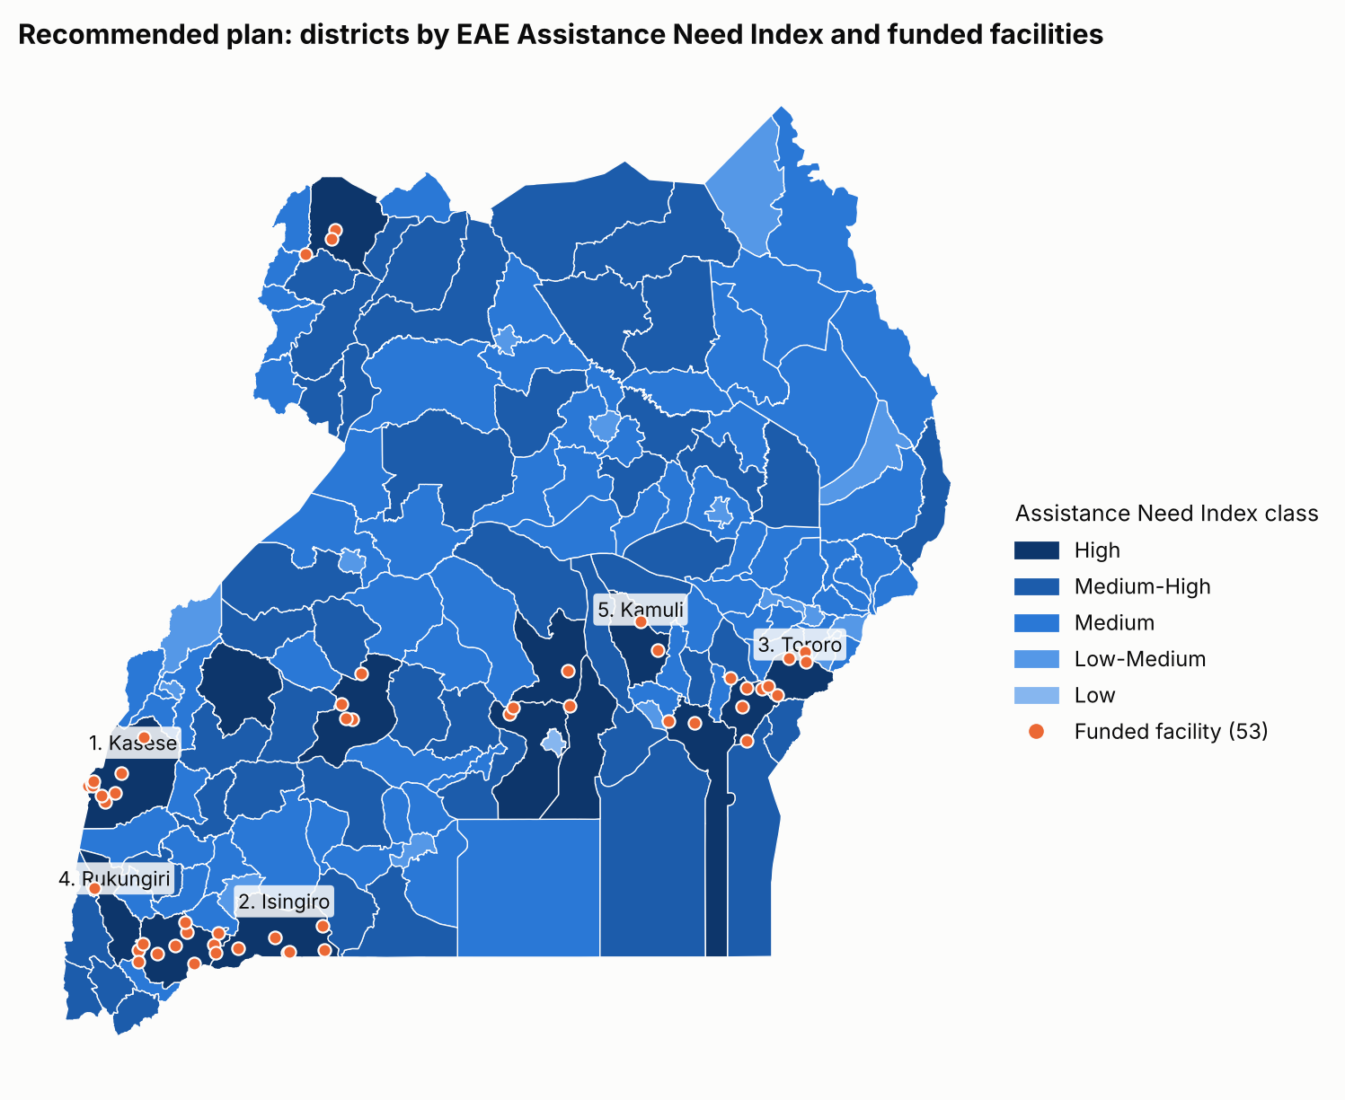
Figure 5: the recommended plan. Districts are shaded by ANI class; orange dots are funded facilities.

11. Step 7: Sensitivity and trade-offs

11.1 What if costs are higher or lower?
I reran all three plans with solar costs from 35% lower (the Burkina Faso 2022 price, $2,346 per kWp) to 50% higher ($5,413 per kWp, for remote sites, insecurity or lithium batteries).
Cost per kWp | Need first | Value for money | Recommended
$2,346 (x0.65) | 49 facilities, 194,318 people | 73 facilities, 836,251 people | 87 facilities, 499,485 people
$2,887 (x0.8) | 61 facilities, 241,294 people | 59 facilities, 733,927 people | 68 facilities, 444,463 people
$3,609 (central) | 47 facilities, 186,756 people | 47 facilities, 635,820 people | 53 facilities, 384,013 people
$4,331 (x1.2) | 38 facilities, 140,790 people | 39 facilities, 563,135 people | 43 facilities, 342,962 people
$5,413 (x1.5) | 34 facilities, 118,484 people | 31 facilities, 480,386 people | 34 facilities, 297,517 people
Table: cost sensitivity (cost_sensitivity.csv).
A 20% change in cost moves the recommended plan by 10 to 15 facilities. The order of the plans does not change: value for money always reaches the most people, and the recommended plan always funds at least as many facilities as the others. The need-first line goes up and then down at lower costs because cheaper systems let it afford a big HC III upgrade early, which then uses money that would have paid for several HC IIs.
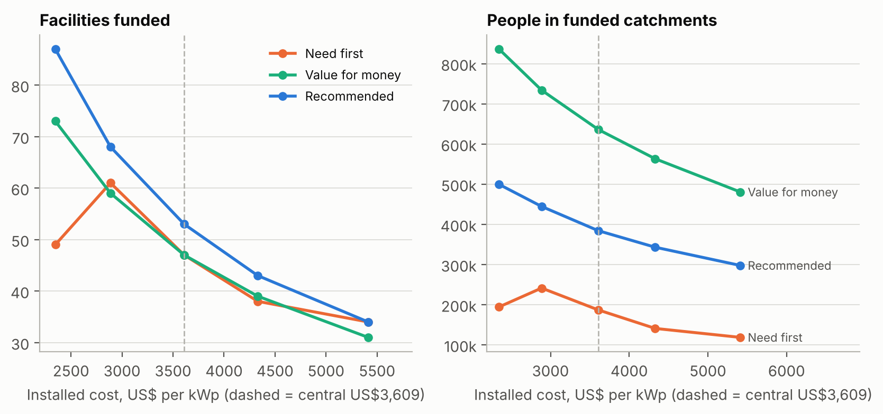
Figure 6: facilities funded and people reached as the cost per kWp changes.

11.2 Where need and value for money disagree
For each district I compared its ANI score with the cost per person of electrifying its eligible facilities. The two are not related (rank correlation -0.04). Some high-need districts are cheap per person, others are expensive:
- Isingiro ranks 2nd and costs $3.81 per person, well below the national median of $13.44. It is good on both counts.
- Kasese ranks 1st but costs $10.86 per person, because it has several expensive HC III upgrades.
- Kakumiro costs only $2.11 per person but ranks 18th. Value for money would fund it; the recommended plan would not.
- Obongi costs $93 per person: its four eligible facilities are expensive HC III upgrades serving only about 7,200 people. Need alone could send money to places like this.
This is why the recommended plan uses need to choose the districts and cost per person to choose the facilities within them.
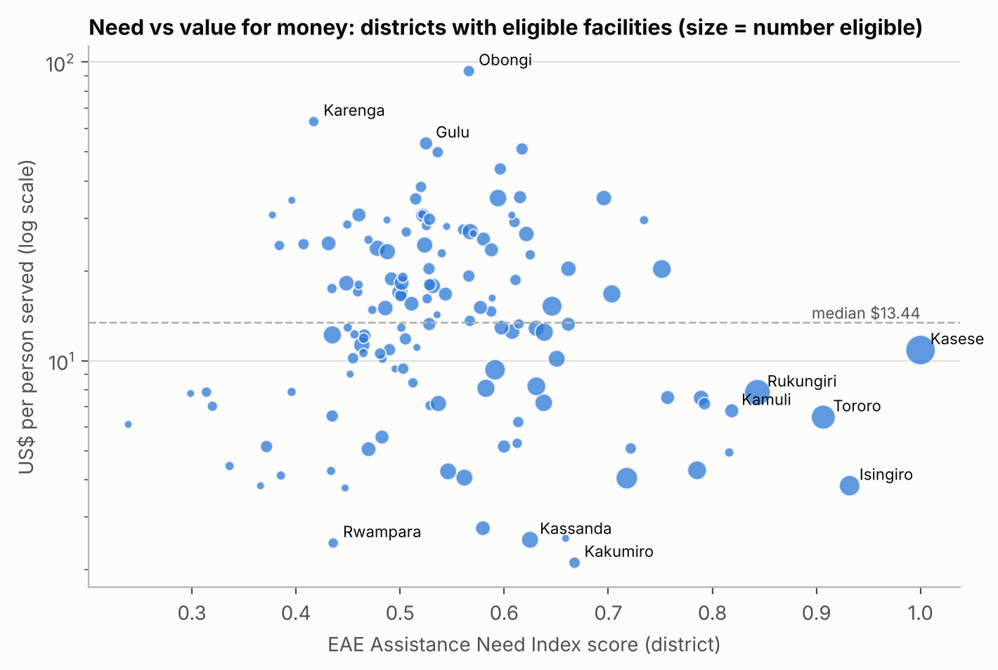
Figure 7: need (ANI score) against cost per person for each district. Bigger circles have more eligible facilities.

11.3 A grid option
480 of the 853 eligible facilities, and 110 of the 189 in High-need districts, are in the same 1 km square as a distribution line. If the national distribution company (UEDCL) connected these through its Electricity Access Scale-Up Project, the Ministry's money could go to facilities further from the grid. The recommended plan would then fund 61 facilities instead of 53, but reach fewer people (about 212,000), because remote facilities serve fewer people. Grid connections are much cheaper than solar where a low-voltage pole is close, so this is worth discussing with UEDCL.

12. Step 8: Limitations and data checks
Check | Result
Facilities with unknown electrification status | 130
Facilities with no WRI demand estimate (hospitals, clinics) | 514
Facility's own district name differs from the EAE district (new districts since) | 15%
Facilities without electricity within 1 km of a line | 68%
Facilities without electricity in squares with no wealth data (left out by EAE) | 23
Eligible facilities counted in their district's EAE score | 92%
Date of facility data / line data | 2023 / 2024
Off-grid HC III/IV where the existing system size is unknown | 410
Lowest sunshine at a funded site | 1,560 kWh/m2 per year
Table: data checks (data_checks.csv).
What these mean for the answer:
- Demand is modelled, not measured. Each site should have an energy audit before systems are bought.
- Status may be out of date. The facility data is older than the line data, and many facilities without power are next to a line. Some may already be connected.
- Only medium-voltage lines are mapped. A cheap UEDCL connection needs a low-voltage pole within about 90 m, which the data does not show.
- Catchments are modelled from walking time and population maps. People reached means people living in the catchment, not patients treated.
- The EAE score counts all facilities, not only those without power (see Section 8.4).
- Costs come from two projects (Uganda and Burkina Faso). A recent Ugandan tender price would make the plan more reliable.
- Battery replacement after about 10 years is not covered by the 5-year reserve.

13. Recommendations
- Fund now: solar and batteries for 53 HC IIs with no electricity in 13 High-need districts, starting with Kasese, Isingiro, Tororo, Rukungiri and Kamuli ($863,000 including delivery).
- Keep systems working: keep $123,000 aside for five years of maintenance.
- Check before buying: confirm every site still has no electricity; 38 of the 53 are in the same 1 km square as a power line.
- Work with UEDCL: ask for grid connections where a line is close; 110 eligible facilities in High-need districts sit next to one.
- Plan a second phase: HC III maternity and lab upgrades ($47,500 to $290,000 each) need a larger budget.
- Plan for batteries: budget for replacement after about 10 years.
- Collect better data: energy audits, up-to-date status from district health offices, the low-voltage network, the size of existing solar at off-grid HC IIIs, and patient numbers.

14. Files and how to rerun
File or folder | What it contains
Uganda_Healthcare_Electrification_EAE.ipynb | The notebook, with all results shown
outputs/figures/ | The 7 figures in this document
outputs/tables/ | 22 result tables as CSV, plus key_numbers.json
outputs/validation/ | District scores from the live EAE tool and the settings used
eae_data/ | All 38 Uganda EAE layers (rasters, vectors), CSV versions and catalogue.csv with sources and licences
data/eae/ | The layers the notebook downloads (a cache)
tools/download_eae_layers.py | Downloads every EAE layer for a country and makes the CSVs
tools/eae_check.js | Runs the live EAE tool with the same settings to check the notebook
presentation/ | The 14-slide presentation

To rerun: install the packages in requirements.txt (pip install -r requirements.txt), then open the notebook and run all cells. It takes about a minute.

15. Sources
- Sinclair-Lecaros, S., Mentis, D., Mulepo C.S., E., Falchetta, G. and Stevanato, N. (2023). A GIS-based demand assessment methodology to estimate electricity requirements for health care facilities: a case study for Uganda. World Resources Institute. doi:10.46830/writn.21.00093
- Energy Access Explorer, World Resources Institute (accessed November 2026): health facilities (Ministry of Health and WRI), population (WorldPop), Relative Wealth Index (Meta), distribution lines (Energy Sector GIS Working Group, 2024), solar resource (Global Solar Atlas), boundaries (Uganda Bureau of Statistics).
- WHO, World Bank, IRENA and SEforALL (2023). Energizing Health: Accelerating Electricity Access in Health-Care Facilities. Table 3 and Box 4.1.
- Green Empowerment, Medical Teams International and Mandulis Energy (2023). Energizing Healthcare in Uganda: 2023 Impact Report.
- Uganda Bureau of Statistics (2023). Uganda Demographic and Health Survey 2022: Key Findings.
- Uganda Electricity Distribution Company Ltd. Electricity Access Scale-Up Project connection terms.
- 04-782 Energy Data Analytics, Lecture 18: Case Study 4, Healthcare Electrification (October 2026).

