Placing Defects in Glass with a Diffusion Model
Team summary: what we have done, what we found, and what comes next
Introduction to Deep Learning course project
College of Engineering, Carnegie Mellon University Africa
Stacy Cheruto, Nicholaus Ladislaus, Abubakar Chilala, Gentille Uwera, Michel Sangwa, Boniface Godwin
Updated 16 October 2026

1. The project in brief
Glass looks smooth and uniform, but at the scale of atoms it contains defects: small spots where atoms are arranged differently from the rest. Defects change how a glass breaks, ages and absorbs light, so scientists want many realistic examples of a given defect to study.
Today there are two ways to get these examples. One is to simulate melting and cooling the glass on a computer and wait until the defect appears by chance, at a place nobody can choose. The other is to build the defect by hand by moving atoms, which often leaves unnatural surroundings.
Our idea: train a deep learning model (a diffusion model) that can be asked “put this type of defect at this exact spot in this glass”, and that fills in natural-looking atoms around it.
Where we are: the model works for two of the three defect types we tried, and it does better than both current methods. The third type cannot be made by any method that only changes a small area, and we found out why. The results are written up as a workshop paper (paper/main.pdf), and we have a plan to move from our simple 2D test glass to real 3D silica glass.

Words used in this document
Word | Meaning
Glass | A solid whose atoms have no repeating pattern (also called an amorphous material).
Defect | A small group of atoms arranged differently from the usual arrangement.
Diffusion model | A model that learns to remove noise from data. Starting from pure noise and removing it step by step, it creates new data, here new atom positions.
Relaxation | Letting all atoms move to the nearest low-energy positions. A real defect must still be there afterwards.
Success rate | The fraction of tries where the requested defect is at the requested spot after relaxation.
Local realism (W1) | How different the energies of atoms near a new defect are from those near natural defects. Lower is better.
Natural floor | The realism score two groups of natural defects get when compared with each other: the best any method can expect.
Guidance weight (w) | A setting used when generating that makes the model follow the request more strongly. We used w = 2 and w = 6.
Training seed | The random starting point of a training run. Training the same model with different seeds shows how much results depend on luck.
GPU-hour | One hour of work on one graphics card, the usual way to count deep learning compute.
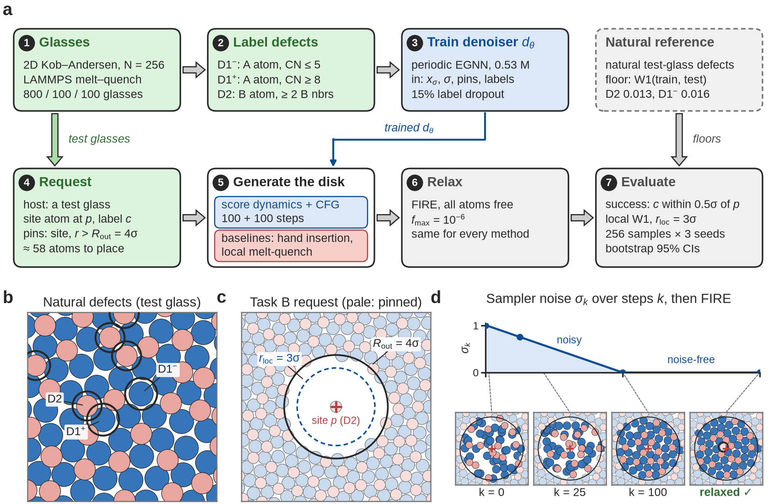
Figure 1 (from the paper). (a) Our workflow, steps 1 to 7. (b) Natural defects (rings) in a test glass. (c) A request: pale atoms stay fixed; atoms inside the solid circle are rebuilt. (d) The model building the region step by step; after relaxation the requested defect sits at the chosen spot.

2. What we have done so far
Step | What it means | Status
Plans | Project plan, data plan and coding plan with tasks for every team member (docs/). | Done
Data | 3,300 simulated 2D glasses made with the LAMMPS simulation program; defects found and labelled; a library of 10,545 natural defects. | Done
Code | The full pipeline: data, physics, neural networks, training, generation, the two comparison methods, scoring and figures. 79 automatic tests check it. | Done
Stage 0 checks | Re-ran the course example notebook (it matches our proposal) and the published DM2 silica model (its structure is right but too disordered). | Done
Training | 11 training runs on free Colab and Kaggle GPUs, about 33 GPU-hours in total. | Done
Experiments | Three rounds of experiments: 146 settings scored, 256 generated samples each. | Done
Reliability checks | Changed every scoring rule to see if conclusions hold; retrained the main models with 3 different seeds. | Done
Paper | Workshop paper of about 8.5 pages with 5 figures, including a workflow diagram and a model diagram, written in plain language. | Draft done
3D silica plan | A 14–16 week plan to repeat the study on real 3D silica glass (docs/SILICA_3D_PLAN.md). | Done
3D silica scripts | Training code for 3D silica: DM2's 24 glasses imported and labelled, our simulation input checked against them, the conditional 3D model, training on Kaggle or the PSC cluster (docs/SILICA_QUICKSTART.md). | Ready to train

3. Data we used
All our data is simulated; there are no lab experiments. We used a standard model glass called the two-dimensional Kob–Andersen glass: a flat sheet of two kinds of atoms, A (large, 65%) and B (small, 35%). Working in two dimensions keeps the computing cheap and the pictures easy to understand, while the material still behaves like a real glass.
Each glass is made by simulating melting at a high temperature, cooling slowly and then letting the atoms settle (energy minimisation). The whole main set took about 14 minutes on 3 CPU cores. Any glass that turned into a crystal was thrown away.
Dataset | Number of glasses | Atoms each | What we used it for
Main set (ka2d_256) | 800 training, 100 validation, 100 test | 256 | Training all main models. The 100 test glasses are the “hosts” where we place defects.
Small set (ka2d_64) | 1,600 / 200 / 200 | 64 | The symmetry test. The plain MLP network only works with a small, fixed number of atoms.
Large set (ka2d_1024) | 100 test | 1,024 | Made for a size test (does a model trained on 256 atoms work on 1,024?). Not used yet.
Slowly cooled set (ka2d_256_slow) | 200 test | 256 | Made for a test on better-settled glass. Not used yet.
Defect library | 10,545 natural defects with their neighbours | 6–11 | The hand-insertion comparison method pastes these into glasses.
DM2 silica data and trained models | 24 published glasses | 3,000 | Checking the DM2 paper (Stage 0); starting point for 3D silica.

The three defect types
An atom's neighbours are the atoms touching or nearly touching it. Each defect type is defined by a simple counting rule, fixed once using the training glasses and never changed:
Name | Plain description | How common
D1− | A large atom with too few neighbours (5 or fewer) | 1.7 per glass
D1+ | A large atom with too many neighbours (8 or more) | 1.4 per glass
D2 | A small atom with two or more small atoms very close to it (a B-rich spot) | 10 per glass

4. Deep learning models and why we chose them

What the network learns
We take a real glass, shift its atoms a little at random (we “add noise”), and train the network to predict how far each atom was pushed. Once trained, the network can start from random positions and remove the noise step by step, building a new and realistic arrangement of atoms. This is how a diffusion model works. We chose this approach because it is the one that recently worked best for generating realistic glass (the DM2 paper, 2026), and because it can fill in a missing region while keeping the rest fixed, like filling a hole in a photo.

How we ask for a defect
- Fixed atoms. The existing glass around the chosen spot is held in place, and only about 58 atoms near the spot are rebuilt.
- Defect label. The atom at the chosen spot carries a label that names the defect we want. All other atoms are labelled “none”.
- Noise level. The network is told how noisy the positions currently are, so it knows how big a correction to make.
- Guidance. During training we hide the label 15% of the time. When generating, we run the network twice, with and without the label, and push the result towards the labelled answer. This trick is called classifier-free guidance; the weight w sets how hard it pushes.

The networks
Network | What it is | Why we used it | What we found
EGNN (our main model) | A graph neural network: every atom exchanges messages with the atoms within 2.5 atom sizes. Built so that shifting, rotating or renumbering the atoms changes the output in the same way. We adapted it to a box that repeats at its edges. 0.53 million parameters, 4 layers. | Atoms in a glass have no fixed order or direction. Building these rules into the network means it does not have to learn them, and it works for any number of atoms. | Best results. Used for every main result.
MPNN (comparison) | The same graph, but it also sees raw x and y directions, so it does not handle rotation correctly. 0.48 million parameters. | To test whether rotation symmetry really matters. | Lower training loss, yet worse glasses.
Flat MLP (comparison) | A plain fully connected network that reads a list of all 64 atom positions. 1.32 million parameters. | The simplest possible model, with no symmetry. The course example uses this kind of model. | Did not learn; 16% of its outputs partly turned into crystal.
DM2's NequIP (published, not trained by us) | A more advanced 3D symmetry-aware network from the DM2 paper, trained on silica glass. | To check the DM2 paper (Stage 0) and as the planned main model for 3D silica. | Correct local structure, but as disordered as glass cooled 100 times faster than its training glass.
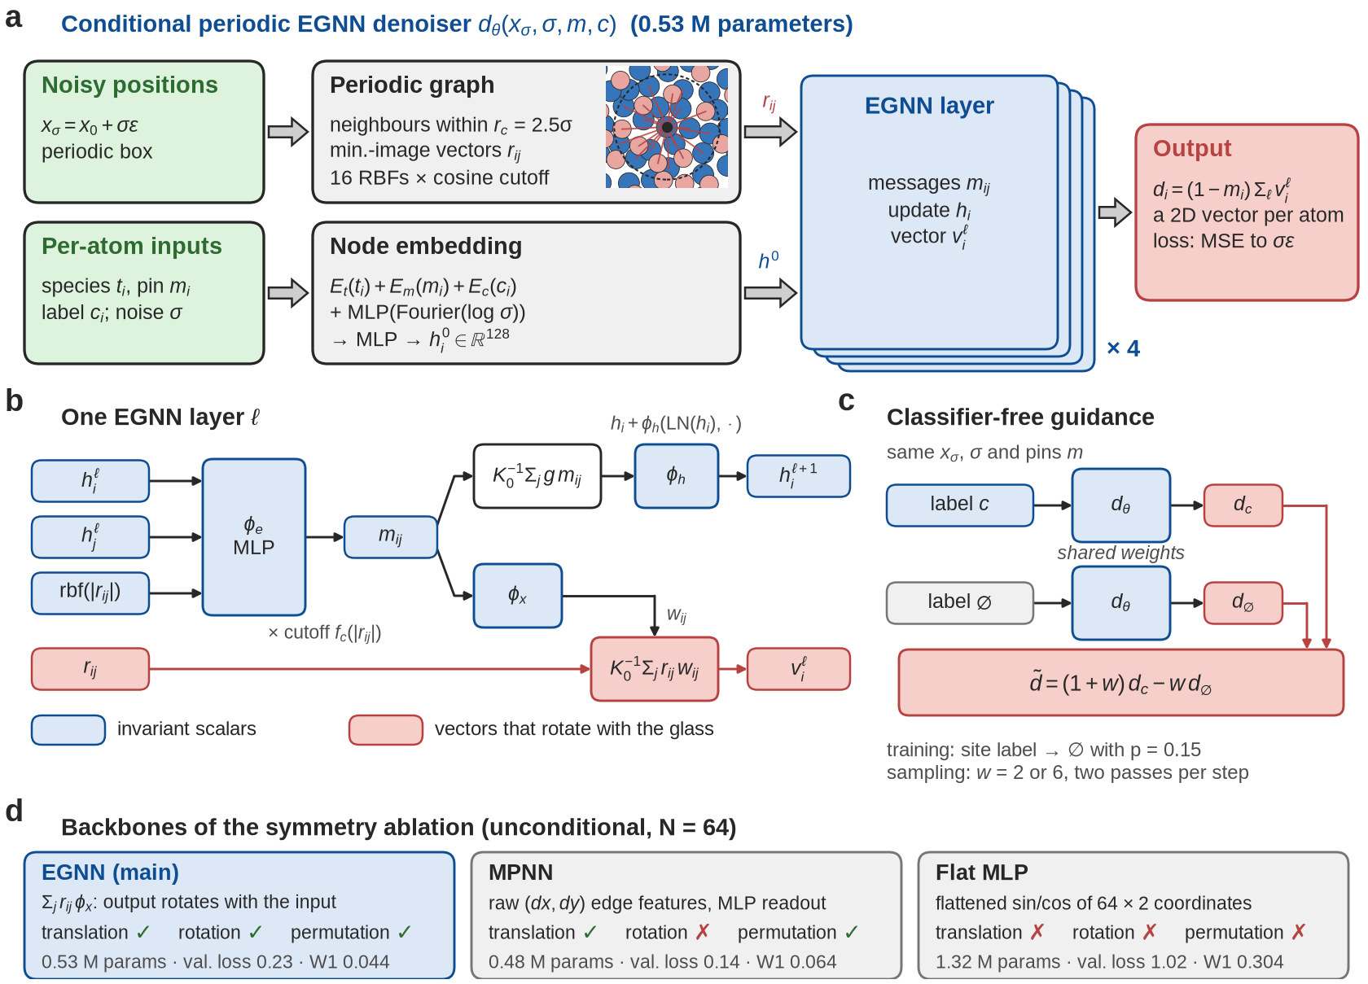
Figure 2 (from the paper). (a) Our main network from input to output. (b) What happens inside one EGNN layer. (c) How guidance runs the same network with and without the label. (d) The three networks compared in the symmetry test.

5. Training runs
All training ran on free cloud GPUs (Google Colab and Kaggle, NVIDIA T4 class). Every run used the AdamW optimiser with a learning rate of 0.0002 and batches of 16 glasses, for 50,000 steps (models with labels) or 40,000 steps (models without labels). “Max noise” is the largest noise level the model saw in training.
# | Run name | Purpose | Max noise | Seed | GPU-hours
1 | egnn_uncond | Main network without labels (needed for whole-glass tests and the Clamp/RePaint comparisons) | 0.5 | 0 | 3.0
2 | egnn_cond | Main network with labels, first recipe (used for D1− and Task A) | 0.5 | 0 | 3.7
3 | egnn_uncond_smax1 | As run 1, with a wider noise range | 1.0 | 0 | 3.2
4 | egnn_cond_smax1 | As run 2, with a wider noise range (used for D2) | 1.0 | 0 | 4.0
5 | egnn_n64 | Symmetry test, 64 atoms | 0.5 | 0 | 0.7
6 | mpnn_n64 | Symmetry test, 64 atoms | 0.5 | 0 | 0.5
7 | mlp_n64 | Symmetry test, 64 atoms | 0.5 | 0 | 0.1
8 | egnn_cond_seed1 | Repeat of run 2 with a new seed | 0.5 | 1 | 5.2
9 | egnn_cond_smax1_seed1 | Repeat of run 4 with a new seed | 1.0 | 1 | 3.8
10 | egnn_cond_seed2 | Repeat of run 2 with a new seed | 0.5 | 2 | 3.8
11 | egnn_cond_smax1_seed2 | Repeat of run 4 with a new seed | 1.0 | 2 | 5.1
 | Total |  |  |  | about 33
After training we generated samples and scored them: 146 settings, 256 samples each, over 36 Colab and Kaggle sessions. Every sample is relaxed before it is scored.

6. What the results say so far
Main task: rebuild the region around a chosen spot inside an existing glass and ask for a defect there. The table gives the success rate after relaxation. For our model, the ± shows the spread over three training runs.
Method | D2 (B-rich) | D1− (too few neighbours) | D1+ (too many)
Chance (no label) | 0.03 | 0.02 | 0.00
Re-melting the region (local melt-quench) | 0.05 | 0.00 | 0.01
Hand insertion (current practice) | 0.30 | 0.06 | 0.02
Our model, w = 2 | 0.45 ± 0.11 | 0.22 ± 0.02 | 0.03
Our model, w = 6 | 0.71 ± 0.08 | 0.21 ± 0.04 | 0.04
For D1+ our model was trained once (seed 0 only).

Main findings
- Better than current methods. Our model places the B-rich defect (D2) 1.5 to 2.4 times as often as hand insertion, with surroundings as natural or more natural. It places the too-few-neighbours defect (D1−) 3.5 times as often, with surroundings close to natural.
- Re-melting does not work. Melting and cooling the region again almost never creates the defect: rare defects stay rare.
- One defect type is impossible locally. No method can make D1+. Even a natural D1+ disappears when it is moved into another glass together with its 47 nearest neighbours, so it depends on atoms further away than any local method changes.
- Guidance is a trade-off. Stronger guidance (w = 6) gives more successes but less natural surroundings than w = 2.
- Train on all the noise you sample with. Our first recipe trained on less noise than generation starts with. Fixing this raised D2 success from 0.54 to 0.79 (seed 0).
- Sampling steps act like a cooling rate. More steps give a more settled glass. 100 steps matched natural glass at 1/15 of the cost of DM2's default 3,000 steps.
- Symmetry matters more than a low loss. The EGNN made the most natural glasses, the MPNN reached a lower training loss but made worse glasses, and the flat MLP did not learn at all.
- Training runs differ. Training the same model three times gave similar results for D1−, but D2 success varied (for example 0.56 and 0.34 at w = 2), even though the training losses were almost equal.
- The results hold up. The ranking of the methods stayed the same when we changed the defect rules, the success radius, the realism window and the size of the rebuilt region.
- Speed. Each success costs our model 1–4 GPU-seconds, about the same as hand insertion and far less than re-melting (65 seconds per D2 success).

Limits to keep in mind
- Our glass is 2D and small (256 atoms). Real materials are 3D.
- Defects are defined by simple counting rules, not by a measured property.
- Whole glasses generated from scratch have too few B–B contacts, so the fill-in task is the one to trust.
- In 2D, simulations are cheap, so saving compute is not yet a strong argument. In 3D silica it will be.

7. What is left to do

7.1 Finish the 2D paper (next 1–2 weeks)
Task | Effort
Choose a venue and its deadline (for example an AI-for-materials workshop) | Team decision
Switch to the venue's official style file and make an anonymous version for review (one switch in main.tex) | About 1 hour
Add an AI-use statement if the venue asks for one | About 30 minutes
Everyone reads the paper and checks each number against the results folder | 1–2 days
Optional: size test on the 1,024-atom glasses (data ready) | A few GPU-hours
Optional: test on the slowly cooled glasses (data ready) | A few GPU-hours
Optional: choose w for each trained model using validation data, to reduce the D2 spread | A few GPU-hours
Optional: train with a range of region sizes, and try a larger region for D1+ | About 10 GPU-hours

7.2 Next step: real 3D silica glass (about 14–16 weeks)
A materials journal (such as npj Computational Materials, where DM2 was published) will want three more things: a real 3D material, defects that matter physically, and proof that generated defects behave like natural ones. Amorphous silica (glass made of silicon and oxygen, as in windows and optical fibres) is the natural choice, because DM2 already provides silica data and a trained model.
The defects we would target are:
- silicon atoms with 3 or 5 oxygen neighbours instead of the normal 4;
- oxygen atoms bonded to only one silicon (non-bridging oxygen), linked to light absorption and radiation damage;
- small rings of three silicon–oxygen units, which show up in Raman measurements used in labs.
These are rare in slowly cooled glass, so a model that can place them on request would save a lot of simulation time. Planned stages:
Weeks | Stage | Check before moving on
1–2 | Setup: get computing time; write and check the silica simulation input against DM2's glasses; measure how long things take | Measured costs fit the budget
2–5 | Data: about 800 silica glasses of 576 atoms; defect detectors; check that natural defects survive noise and relaxation | At least 300 training examples per main defect type
4–8 | Model: 3D code; DM2's NequIP network with our additions (noise level, fixed atoms, labels, cooling rate); first training run; tune the number of sampling steps | Generated glass close to natural glass
7–11 | Main results: success and realism for 3 defect types against all comparison methods, with 3 training seeds and the same reliability checks | The model wins for at least 2 defect types
10–13 | Physics checks: re-relax with an independent machine-learned potential; compare vibrations; optional quantum (DFT) check; one application such as energy barriers | Generated defects behave like natural ones
12–16 | Paper: figures, writing, code and data release | —
Lessons from 2D that we will apply from day one: train on the full noise range, tune the number of sampling steps, use three training seeds, check that each defect type is stable before training, and train with a range of region sizes.

7.3 Decisions the team needs to make
- Which simulation model (potential) to use for silica: DM2's (recommended, so results compare with DM2) or a machine-learned one.
- Glass size: 576 atoms (recommended, cheaper) or larger.
- Which application to show: energy barriers (recommended) or pore surfaces.
- Who applies for computing time in week 1.
- Whether to contact the DM2 authors (UCLA) about working together.
- How to split the five workstreams (data, defect detection and scoring, models, generation experiments, physics checks and writing) among the six of us.

8. Compute required (upper plan)
We estimated compute the way an ACCESS allocation proposal does: for each piece of work, count the model variants we expect to train, the epochs each needs, and the time per epoch.
GPU-hours = number of variants × epochs × epoch time
We use the upper plan: 64 short trial runs for the 3D model, 3,000 sampling steps, the optional quantum (DFT) check at its most expensive, the remaining 2D work included, and 20% extra on top for failed runs and surprises. Credits follow the PSC Explore guide: 200,000 credits buy about 3,700 GPU-hours (54 credits per GPU-hour), and 10,000 credits buy about 1 TB of storage. ACCESS treats one credit as roughly one CPU core-hour; the exact rate for PSC's CPU nodes should be checked in the ACCESS exchange calculator. Scripts and full tables are in docs/compute/.

8.1 Bottom line
Resource | Amount | ACCESS credits
GPU | (522 for 3D + 22 for 2D) × 1.2 = 653 GPU-hours | 35,288
CPU | 1,551 × 1.2 + 5,000 for DFT = 6,861 core-hours | about 6,900
Storage | 1 TB | 10,000
Total |  | about 52,100 (26% of 200K)
Safety check: if every GPU job turns out twice as slow as planned, the total rises to about 87,000 credits, still under half of an Explore allocation.

8.2 By phase
Weeks | Stage | GPU-hours | Core-hours | Credits
1–3 | Finish the 2D paper (optional runs) | 26 | 0 | 1,420
1–2 | Setup: computing time, simulation check, benchmarks | 18 | 0 | 973
2–5 | Data: silica glasses, defect detectors, stability checks | 0 | 882 | 882
4–8 | Model: 64 trial runs, top 6, sampling-step tuning | 156 | 0 | 8,406
7–11 | Main results: full runs, seeds, all sampling, comparison methods | 429 | 799 | 23,990
10–13 | Physics checks, energy barriers, DFT | 24 | 5,180 | 6,477
12–16 | Paper: figures, code and data release | 0 | 0 | 0
 | Total (+ 10,000 for storage) | 653 | 6,861 | 52,148
The busiest stage needs 429 GPU-hours in about five weeks: one GPU running 12 hours a day, or 4 GPUs for under five days. The 882 core-hours of the data stage take about 7 hours on one 128-core PSC node.

8.3 Where the epoch times come from
Quantity | Value | Source
2D training (our EGNN) | 0.27–0.37 s per update; 16 s per epoch | Measured: our 11 runs on Kaggle/Colab T4 GPUs
2D scoring row (256 samples) | 15 minutes | Measured: median of 73 rows
3D training (DM2's NequIP, 576-atom cells, batch 16) | 1.2 s per update on a V100; 45 s per epoch | Our CPU measurement (NequIP is 2.9 times slower than our EGNN per atom) applied to our T4 times: about 1.8–2.4 s on a T4 and 0.9–1.2 s on a V100. We plan with the slow end. (The DM2 paper does not report its training time.)
3D training memory | About 0.5 GB per 576-atom glass | Measured on CPU; 16 glasses fit on a free T4 GPU
3D EGNN (comparison model) | 0.35 s per update; 13 s per epoch | 2D measurement scaled to 3D neighbour counts
Silica simulation (LAMMPS) | 2.9 ms per step for 576 atoms on one core | Measured with a DM2 silica glass
One 3D epoch is one pass over the 600 training glasses (37.5 updates of 16 glasses). A full training run is 50,000 updates, as in 2D: 1,333 epochs, or about 17 GPU-hours for NequIP. Week 1 of the 3D work replaces these planning numbers with timings on the GPUs we are given.

8.4 Training the 3D models
Like the guide's example (many short runs, then fewer longer ones), we first try 64 variants briefly and keep the best. The 64 variants are every combination of two values each for: maximum training noise, training region size, network size, number of layers, learning rate and label dropout.
NequIP stage | Variants | Epochs each | Total epochs | GPU-hours
Short trial runs | 64 | 133 | 8,512 | 106
Top 6 train longer | 6 | 267 | 1,602 | 20
Top 2 train to full length | 2 | 933 | 1,866 | 23
Best variant, 2 more training seeds | 2 | 1,333 | 2,666 | 33
Model without labels (for comparison methods) | 1 | 1,333 | 1,333 | 17
Total |  |  | 15,979 | 200
EGNN-3D: 4 short trial runs | 4 | 133 | 532 | 2
EGNN-3D: best variant, 3 seeds | 3 | 1,333 | 3,999 | 15

8.5 Generating and checking samples
Each row is 256 generated samples. Rows with guidance run the network twice per step. We assume DM2's 3,000 sampling steps; if the tuning experiment picks fewer, sampling drops from 271 to 91 GPU-hours (1,000 steps) or 28 (300 steps).
Item | Rows | GPU-hours
Main results: 3 defect types × 2 guidance weights × 3 seeds | 18 | 121
Guidance sweep: 3 types × 3 more weights | 9 | 61
Region-size sweep: 3 types × 2 more sizes | 6 | 40
Comparison methods without labels (chance, clamp, RePaint) | 9 | 30
EGNN-3D rows: 3 types × 3 seeds | 9 | 18
Sampling-step tuning | 4 | 1
Physics checks (re-relax ~2,300 structures with MACE, vibrations) |  | 20
Setup, benchmarks and debugging |  | 15

8.6 CPU: simulations and comparison methods
Item | Core-hours
Silica glasses: 550 at 10 K/ps (0.58 h each), 200 at 100 K/ps (0.24 h), 50 at 1 K/ps (4 h), 10 large ones; +10% reruns | 735
Re-melting comparison: 3 types × 2 sizes × 256 tries (0.42 h each) | 641
Relaxing generated samples | 25
Hand-built comparison and energy-barrier application | 150
Subtotal × 1.2 | 1,861
Quantum (DFT) check, upper end | 5,000
Total | 6,861

8.7 2D work left
Item | Runs/rows | GPU-hours
Train with a range of region sizes | 2 | 8.9
Size test on 1,024-atom glasses | 5 | 5.0
Slowly cooled host glasses | 5 | 1.2
Choose the guidance weight per model on validation data | 18 | 4.5
Score the region-range models | 6 | 1.5
Larger region for D1+ | 3 | 0.8
Total (fits one week of Kaggle's free quota, or the cluster) |  | 22

8.8 Used so far
About 33 GPU-hours of training plus 36 sessions of sampling and scoring, all on free Colab and Kaggle GPUs; the 2D datasets took under an hour on 3 CPU cores. Nothing has been spent.

9. Where to find things
Everything is in the GitHub repository github.com/chilalaabubakar/IDL-PROJECT.
Folder or file | What is in it
paper/main.pdf, paper/main.tex | The workshop paper and its LaTeX source
paper/make_figures.py | Script that draws all paper figures
results/round3_ANALYSIS.md | Main results and what they mean
results/seeds/README.md | Training seed results
results/sensitivity/README.md | Results with changed scoring rules
results/stage0/ | Checks of the course notebook and of DM2
notebooks/kaggle_*.ipynb | Notebooks to rerun our experiments on Kaggle
docs/PROJECT_PLAN.md, docs/DATASET.md, docs/IMPLEMENTATION_PLAN.md | Project, data and coding plans
docs/SILICA_3D_PLAN.md | The detailed 3D silica plan
docs/SILICA_QUICKSTART.md | How to start 3D silica training (Kaggle and PSC)
docs/compute/ | Compute estimate: tables, budget script and benchmarks
src/glassdiff/, tests/ | The code and its 79 automatic tests

