Finding and Repairing Point Defects in a Model Glass
What we did in the whole study, in plain language: the materials science and the deep learning
Introduction to Deep Learning (11-785) course project
College of Engineering, Carnegie Mellon University Africa
Stacy Cheruto, Nicholaus Ladislaus, Abubakar Chilala, Gentille Uwera, Michel Sangwa; teaching assistant: Boniface Godwin
Updated 13 November 2026. This document goes with the report paper/point_defects_report.pdf and uses the same numbers.

1. The study in brief
Solids are never perfect. Here and there an atom is missing, an extra atom is squeezed in, or two atoms sit in each other's places. These small faults are called point defects. They are tiny, but they decide how atoms move through a material, how it ages and how it stands up to radiation.
In a crystal the atoms sit in a regular pattern, like tiles on a floor. A defect is easy to see there: it is whatever breaks the pattern. A glass has no pattern. Its atoms are packed tightly but without order, like a liquid frozen in place. When a defect is made in a glass, the atoms around it shift and largely hide it.
Our question. Can a deep learning model find a hidden defect in a glass, looking only at where the atoms are and what kind they are? And once the defect is found, can the glass be brought back to exactly what it was before?

What we did, in four steps:
- We made 1,000 small glasses on a computer, where the position of every atom is known exactly.
- We made the four standard point defects in them ourselves and let the atoms settle. Because we made each defect, we always know the right answer.
- We trained one neural network in two stages: first to remove random noise from glasses, so that it learns what normal glass looks like; then to label the atoms that belong to a defect.
- We tested it on defects it had never seen, against three simple methods that involve no learning.
What we found:
- The network finds 69.5% of vacancies, 50% of interstitials, 49% of antisites and 45% of Frenkel pairs. The best method without learning finds 47.5%, 28%, 31.5% and 33%.
- It does this without knowing the forces between the atoms. The strongest classical method needs them.
- Once the defect is found, an ordinary physics step (letting the atoms settle) does the repair. For vacancies, interstitials and antisites, 53.5%, 38% and 30% of the glasses come back exactly as they were. Frenkel pairs stay hard (13%).
- A second network that we trained to do the repair itself was not needed.
- The first training stage, noise removal, is what makes the finder learn quickly. Without it, the same short training finds about half as many defects.
- Checking the physics paid off. We discovered that a quarter of one of our defect types had quietly undone itself, and we corrected every number that depended on it.

2. Words used in this document
Word | Meaning
Crystal | A solid whose atoms sit in a regular repeating pattern.
Glass | A solid whose atoms are frozen in disorder, with no repeating pattern.
Species | The kind of atom. Our glass has two: large A atoms and small B atoms.
Point defect | A fault the size of one atom: an atom missing, extra, moved or swapped.
Interatomic potential | The formula for the forces between atoms. A simulation needs it; a photograph of the atoms does not give it.
Relax (energy minimisation) | Let the atoms shift until the forces on them balance. The structure then rests in a "valley" of the energy.
σ (sigma) | Our unit of length: about one atom diameter.
Neural network | A program with many adjustable numbers (weights) that learns a task from examples.
Training, update | Showing examples to the network and adjusting its weights a little each time. One adjustment is one update.
Graph neural network | A neural network for things that are linked to their neighbours. Here every atom is linked to the atoms close to it.
Denoiser | A network trained to undo random shifts ("noise") of the atoms.
Finder | Our network that gives every atom a label, such as "intact" or "extra atom".
Baseline | A simpler method that we compare against, to see whether the network is really better.
Ablation | An experiment that changes or removes one part of a method to see how much that part matters.
Part A. The materials science

3. Glass, crystals and the four point defects
Scientists describe four standard point defects. They were first defined for crystals, where every atom has a fixed place (a site) in the pattern:
Defect | What it is | How we make it in the glass | Atoms
Vacancy | An atom is missing. | Remove one atom. | 255
Interstitial | An extra atom is squeezed in between the others. | Add one small B atom at the most open spot nearby. | 257
Frenkel pair | An atom has been knocked out of its place into a gap nearby. This is the basic damage that radiation does. | Move one atom to the most open spot 1.2 to 3 atom diameters away. | 256
Antisite | Two atoms of different species have swapped places. | Swap the species of an A atom and its nearest B atom. | 256

A glass has no fixed sites, so we cannot define a defect by comparing with a perfect pattern. Instead we define each defect by the operation that made it. This has a big advantage: because we did the operation ourselves, we know exactly where the defect is and what the glass looked like before. That original glass is the target for the repair.
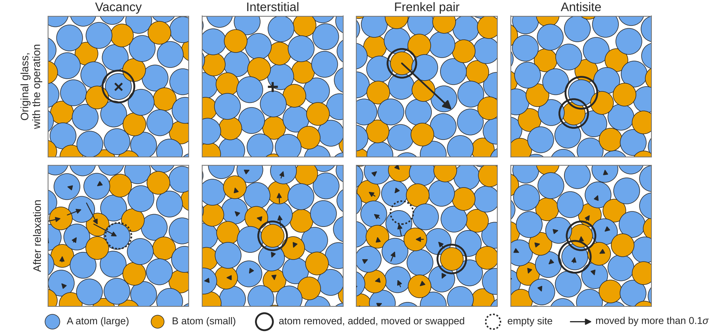
Figure 1. The four point defects in our glass. Top row: the original glass and the operation (× atom removed, + atom added, arrow: atom moved, two rings: species swapped). Bottom row: the same region after the atoms have settled. Blue: large A atoms. Yellow: small B atoms. In the vacancy example the neighbours have moved into the empty place, so the hole is hard to see.

4. The model glass and how we made it
A real piece of glass has far too many atoms, and too complicated forces, for a first study. We used the simplest glass that scientists themselves use to study glasses, called the Kob–Andersen mixture, in two dimensions (the atoms lie in a plane), so that every atom can be drawn and checked.
- Two species of atoms: 65% large A atoms and 35% small B atoms, 256 atoms in each glass.
- Simple forces (the Lennard-Jones formula): two atoms push each other away when they are too close, pull each other a little when slightly further apart, and do not feel each other when far apart.
- Unlike atoms attract most strongly. An A atom and a B atom pull on each other harder than two A atoms or two B atoms. This, and the 65:35 mixture, keep the atoms from arranging into a crystal.
- A box that repeats. The square of glass repeats in every direction: an atom that leaves on one side comes back on the other. This imitates a large sample without edges.
We made each glass the way real glass is made, with the simulation program LAMMPS:
- Melt: heat the atoms until they move freely, like a liquid.
- Cool quickly: the atoms slow down and freeze where they are, without time to form a pattern.
- Relax: let every atom shift until the forces on it balance.
We made 1,000 glasses: 800 for training the networks, 100 for choosing settings (validation) and 100 for the final test. A glass used for testing is never used for training.

5. Making the defects
In every glass we made each of the four defects at random places, one at a time, and then relaxed the glass again, so that the atoms around the defect could settle as they would in a real material. Each example therefore has two versions that we keep: the glass with the settled defect (what the network sees) and the original glass (the right answer).
- Training glasses: 8 defects of each type per glass, about 6,400 examples of each type.
- Validation and test glasses: 2 defects of each type per glass, 200 examples of each type.
- Final test set: 750 real defects (200 vacancies, 200 interstitials, 200 antisites and 150 Frenkel pairs; Section 6 explains why 50 Frenkel pairs were left out).

6. What we learned about the defects themselves
Before trusting any network, we measured what each defect looks like after the glass has relaxed. These are materials-science results in their own right, and they explain why finding defects in a glass is hard.

Vacancies partly close
Right after an atom is removed there is a clear hole. After relaxing, neighbours move in. About 60% of the vacancies still leave a spot that is more open than almost anything in normal glass; the other 40% have handed their empty space to the surroundings and no longer look like a hole. Early simulations of model glasses in 1979 and 1993 found the same.

An interstitial makes room for itself
The neighbours move apart to take the extra atom in. Afterwards the extra atom sits almost as far from its neighbours as a normal atom does. It is only a little more crowded and a little higher in energy.

A quarter of the Frenkel pairs undo themselves
In 50 of our 200 test Frenkel pairs (and 27% of the training ones), the moved atom pushed a neighbour of its own species into the empty place and took that neighbour's place. The result is the original glass with two identical atoms exchanged: no defect at all. Our program had only checked whether the moved atom returned to its own place, so it missed this. We removed these cases from every test and corrected all earlier numbers. In crystals, this kind of self-healing after radiation damage is well known.

An antisite is a fault in who sits next to whom, not in how much room there is
After relaxing, the two swapped atoms have a normal amount of room. What stays wrong is the chemistry: both atoms have fewer neighbours of the other species than is usual (1.8 instead of 2.4 for the A atom, 3.8 instead of 4.4 for the B atom). Because unlike atoms attract most strongly, this is also where energy is lost.

An antisite does not always cost energy
In a stable crystal, swapping two atoms always costs energy. In our glasses, 11% of the swaps made the glass more stable. The reason is that a quickly cooled glass is not in its best possible state, and a swap can help it find a better one.

A defect is spread over many atoms
One defect moves between 14 and 44 other atoms noticeably (the typical number depends on the type). So the mark of a defect is not one odd atom but a faint pattern over a few tens of atoms.
After relaxing | Vacancy | Interstitial | Frenkel pair | Antisite
Real defects in the test | 200 | 200 | 150 | 200
Other atoms moved noticeably (typical) | 14 | 22 | 44 | 29
Energy cost (typical, in units of ε) | – | – | 3.2 | 2.8

7. Three simple ways to look for a defect, without learning
To judge the network fairly we compared it with three measures that need no learning. Each gives every atom a score and points at the atom with the most unusual score.
Measure | What it looks at | Needs the forces formula? | The idea
Cell size | How much room each atom has | No | A missing atom should leave too much room; an extra atom too little.
Unlike neighbours | How many of an atom's neighbours are of the other species | No | Every defect leaves some atoms short of unlike neighbours.
Atom energy | Each atom's share of the total energy | Yes | A defect should raise the energy of the atoms around it. This is the standard tool.

Two things came out of this comparison even before any network was involved:
- All three are weak. A glass is full of atoms that are naturally loosely packed, short of unlike neighbours or high in energy, without being defects. The atom with the highest energy is at the defect only about a third of the time.
- The atom energy is mostly a count of unlike neighbours. In normal glass the two go together almost perfectly. So the expensive measure (which needs the forces) finds about as many defects as simple counting (which does not).
Part B. The deep learning

8. One network, used three ways
All learned parts of the study are one neural network design, a graph neural network (the EGNN design), with about 0.53 million adjustable weights. That is small by today's standards; it trains in one to two and a half hours on a single GPU.

How it sees a glass
- Every atom is a point in a network. It is linked to the atoms within 2.5 atom diameters, about 22 neighbours.
- Every atom carries a list of 128 numbers, its features, which describes its surroundings.
- In each of four layers, every atom receives a message from each neighbour and updates its features. After four layers an atom "knows" about the structure up to ten atom diameters away. This matters, because a defect is spread over many atoms.

What is built in
The network is designed so that its answer cannot depend on things that do not matter physically: shifting the whole glass, turning it, numbering the atoms differently, or where the edge of the repeating box happens to be. It does not have to learn these facts from data.

Two kinds of output
- An arrow for every atom (the vector head): how far and in which direction that atom should move. Used by the denoiser and the repair network.
- A label for every atom (the role head): one of five roles, intact, next to an empty site, extra atom, displaced atom or wrong species. Used by the finder.
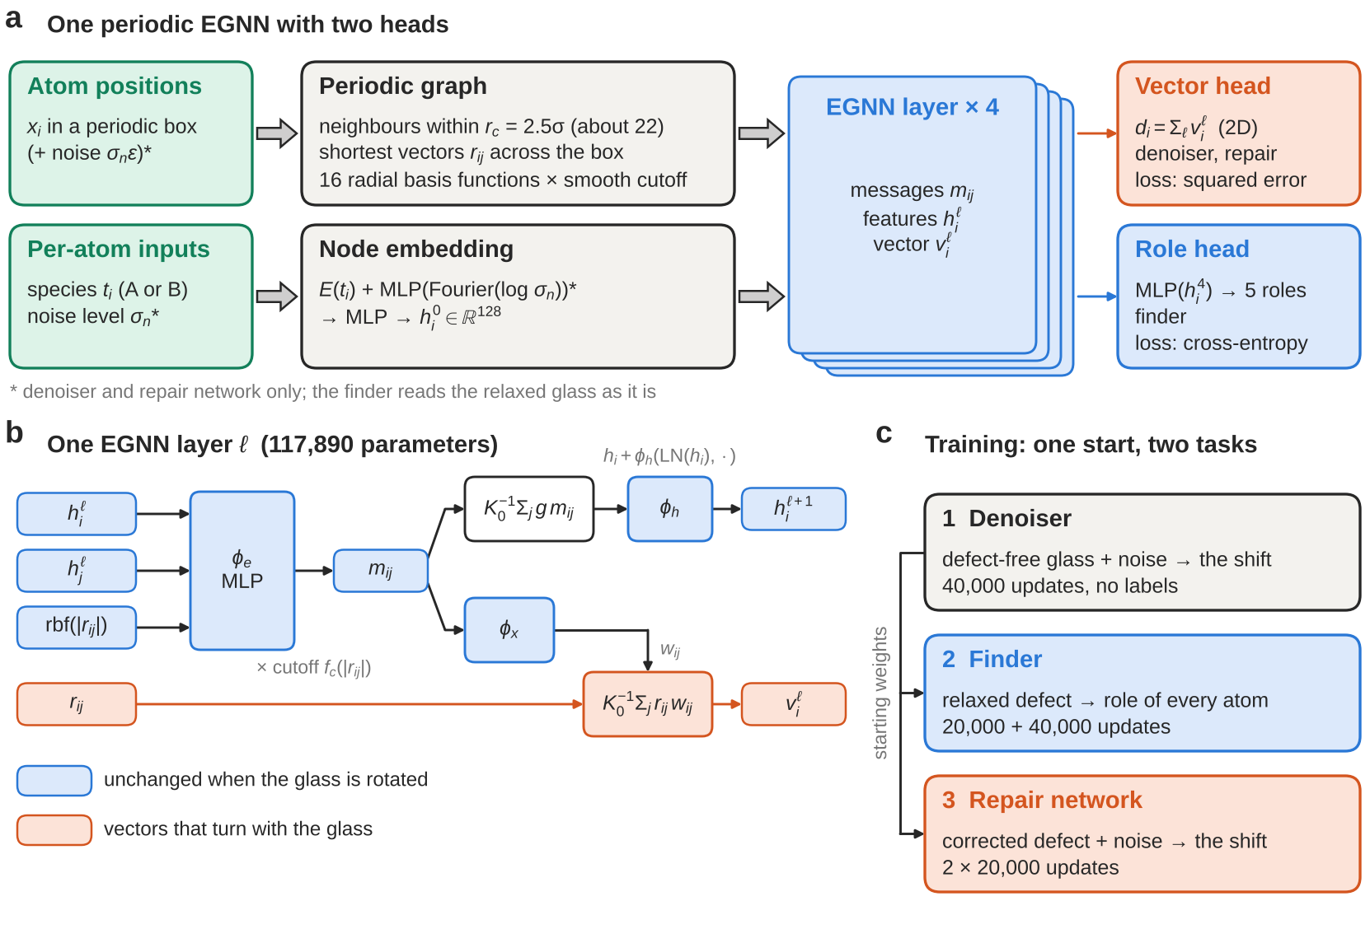
Figure 2. The deep learning model. (a) One network with two outputs. (b) What happens inside one layer. (c) The order of training: the denoiser first, without labels; its weights are the starting point for the finder and the repair network.
Network | What goes in | What comes out | What it learns from | Training
Denoiser | A normal glass with the atoms shaken at random | An arrow per atom: the shake to undo | Defect-free glasses only. No labels. | 40,000 updates
Finder | A relaxed glass with a defect | A label per atom | Glasses with defects, where we know the role of every atom. Starts from the denoiser. | 20,000 + 40,000 updates
Repair network | A glass with a defect (atom count already put right), slightly shaken | An arrow per atom: the move back to the original | Pairs of defected and original glasses. Starts from the denoiser. | 2 × 20,000 updates

9. Stage 1: learning what normal glass looks like
The first network, the denoiser, follows a published method called DM2. We take a defect-free glass, shake every atom by a random amount, and ask the network to predict the shake so that it can be undone. This needs no labels at all: the glass itself is the answer.
What does the network really learn by doing this? To undo a shake it must know where atoms usually sit relative to their neighbours. Mathematics shows that the best possible answer always points towards more likely arrangements of atoms, which is the direction in which the physical forces push. So without ever being shown a force, the network learns something like a restoring force. We checked this directly: the network's corrections point in nearly the same direction as the true forces of the model (agreement 0.81, where 1 would be identical).
Already useful. With no training on defects at all, simply asking "where does the denoiser want to move atoms most?" finds 44% of vacancies. But it finds only 12% of interstitials and 15% of antisites, and it cannot say which species belongs where. This is why a second stage is needed.

10. Stage 2: learning to label defects
The finder starts with the denoiser's weights, so it already knows what normal glass looks like. We add the label output and train it on glasses with relaxed defects. For every atom we know the true role, because we made the defect.

The problem of rare labels
More than 98% of all atoms are intact. A lazy network could be right 98% of the time by calling every atom intact, and learn nothing. We prevent this in two steps:
- Class weights during training: a mistake on a rare role counts 9 to 32 times as much as a mistake on an intact atom.
- Calibration during testing: the weights make the network too eager to call atoms defective, so at test time we take the same weights out of its scores again. This is a standard correction and needs no retraining.

How it was trained
- 20,000 updates, then 40,000 more with smaller steps. One update uses 16 glasses.
- One group of glasses in five contains no defect, so that the network also learns to leave intact glass alone.
- We stopped when the scores on the validation glasses no longer improved.

11. The repair network: tested, and not needed
We expected a network that moves the atoms back to the original glass to be the centre of the study. It was not.
- Version 1 learned the wrong thing. A defect moves only a few tens of the 256 atoms, but the random shake moves all of them. The shake dominated the training, and the network learned to undo the shake but not the defect.
- Version 2 fixed this by making the atoms moved by the defect count 11 times as much. It did learn the defect: one step removes 13–16% of the error on those atoms, against 7–9% for version 1.
- But it does not help. When the physics step (relaxing) follows, the repair network changes nothing: 51.5% of vacancy glasses restored with it and 51% without.
- And alone it does harm. Without the physics step it pushes atoms on top of each other in 20% of the vacancy glasses and 40% of the Frenkel glasses, and in more when it is applied several times. It was trained only on distances to a target and does not know that atoms cannot overlap.
Lesson. Use learning where physics has no tool (finding the defect), and physics where it is already exact (settling the atoms once the right atom has been added, removed or swapped).

12. How we tested
Every method was tested on the same 750 defects from the 100 test glasses, which no network had seen. We asked two questions.

Found: is the defect where the method points?
Each method points at one atom. The defect counts as found if that atom is within 1.5 atom diameters of it, that is, among its nearest neighbours. An atom picked at random would be that close only 3–5% of the time.

Restored: did we get the original glass back?
The repair has two steps. First we put the number or species of atoms right at the atom the method points to: add an atom for a vacancy, remove one for an interstitial, move one back for a Frenkel pair, swap a pair for an antisite. Then we relax the glass. It counts as restored only if every atom is back at its original position. This is a strict test.
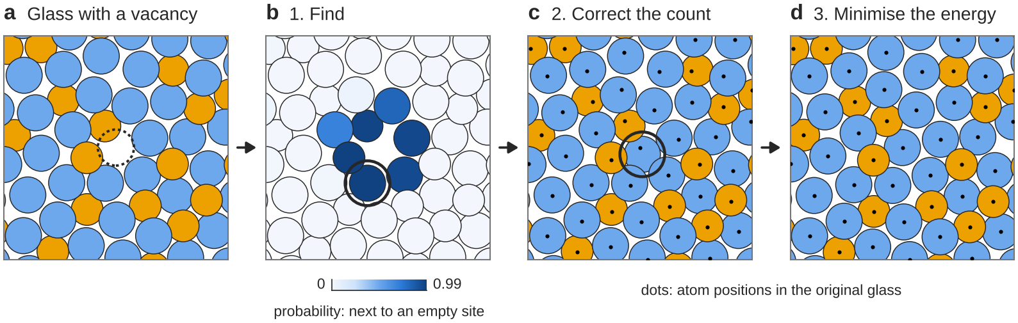
Figure 3. Finding and repairing one vacancy. (a) The relaxed glass; the dotted circle shows where the atom was removed, which the network is not told. (b) The finder's score for every atom; the atom it points to is ringed. (c) An atom is put into the most open spot nearby. (d) After relaxing, every atom is back on its original position (dots).

How sure are the numbers?
With 150–200 defects of each type, each percentage is known to about ±7 points. To compare two methods we looked at the same defects and counted those that only one of the two got right; this tells us whether a lead is real or could be luck. Where we say a difference is "clear", the chance that it is luck is below 5%.

13. Results

Finding the defect (% of test defects found)
Defect | Finder (network) | Cell size | Unlike neighbours | Atom energy | Random atom
Vacancy | 69.5 | 47.5 | 29 | 29.5 | 3
Interstitial | 50 | 15 | 28 | 28 | 3
Antisite | 49 | 16.5 | 31.5 | 29 | 4
Frenkel pair | 45.3 | 26.7 | 27.3 | 32.7 | 5

- The finder is ahead for every defect type, and the lead is clear in every case.
- Cell size is a serious rival only for vacancies, where missing room is exactly what one looks for.
- Only the atom energy needs the forces formula. The finder beats it without that knowledge.

Restoring the original glass (% of test glasses restored)
Defect | Finder (network) | Cell size | Unlike neighbours | Atom energy | True location given
Vacancy | 53.5 | 40.5 | 22 | 26 | 67
Interstitial | 38 | 8.5 | 21.5 | 21 | 80
Antisite | 30 | 1.5 | 7.5 | 8 | 68.5
Frenkel pair | 12.7 | 0 | 1.3 | 7.3 | 42

- Restoring follows finding: the better a method finds, the more glasses it restores.
- For Frenkel pairs every method restores few. Two things must be right there (which atom moved, and where it came from), and the finder's small lead could be luck.
- The last column is the upper limit: if someone tells us where the defect is, relaxing alone restores 42–80%. So what is missing is better finding, not better repair.
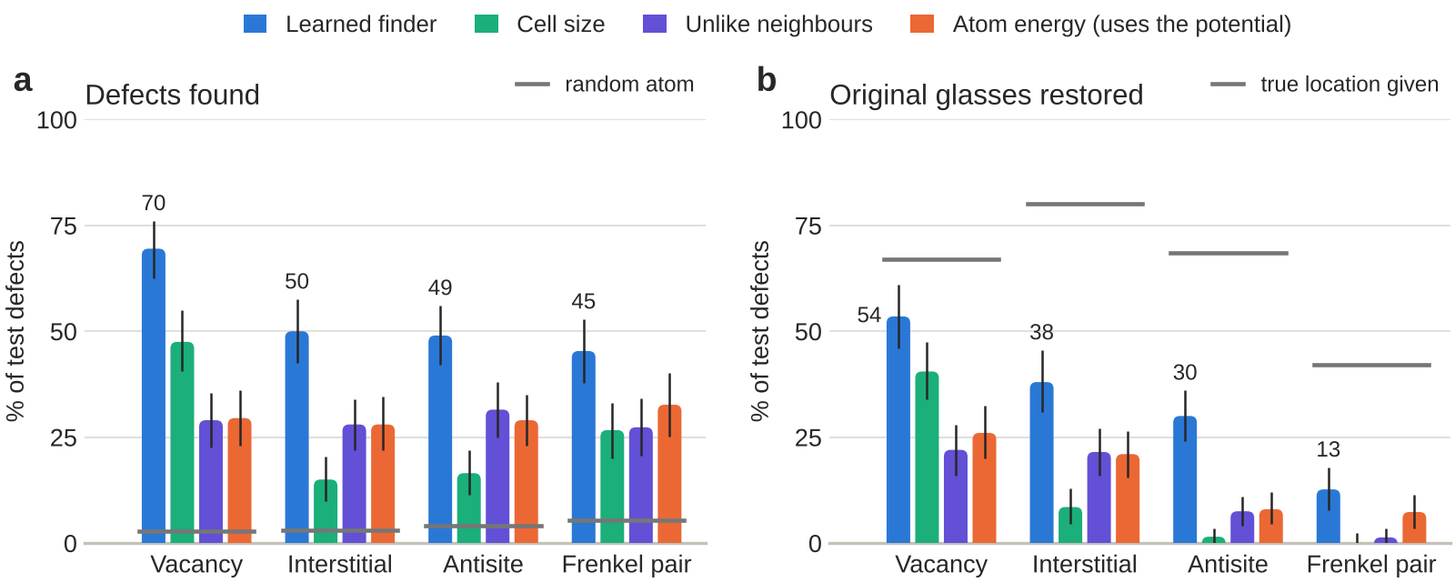
Figure 4. The same results as bars. (a) Defects found; the grey lines show a randomly chosen atom. (b) Glasses restored; the grey lines show the upper limit with the true location given. The thin black lines show how uncertain each number is.

14. Experiments and ablations
Each training run answered one question. The table lists the comparisons we made on the way.
Question | What we compared | Result
Is training on defects needed? | Denoiser alone → trained finder | Found (vacancy / interstitial / antisite): 44 / 12 / 15% → 69.5 / 50 / 49%
Is the finder trained long enough? | 20,000 → 60,000 updates | Found, all defects: 50.3% → 54.0% (clear gain)
Do its probabilities mean anything? | Calibration off → on | Defect-free glasses wrongly flagged: 68% → 2%. Found: 50.7% → 54.0%
Why did the first repair network fail? | Repair version 1 → version 2 | Error removed in one step: 7–9% → 13–16%
Does repeating the repair step help? | 1 step → 10 steps | Glasses with overlapping atoms: 1–40% → 50–73% (worse)
Does the repair network help the physics step? | Without → with | Restored (vacancy / interstitial): 51 / 34.5% → 51.5 / 34% (no change)
Are the labels right? | All 200 → the 150 real Frenkel pairs | Frenkel pairs found / restored: 37 / 18% → 45.3 / 12.7%

Ablations: which parts of the finder matter?
We trained six short versions of the finder, each with one thing changed. Six full runs would have cost too much computing time, so each got only 2,000 updates (the real finder got 60,000). The numbers are therefore lower than in Section 13 and should only be compared with each other.
Version of the finder | Defects found (all 750) | What it tells us
Reference: starts from the denoiser, 4 layers, class weights | 44.7% | The standard recipe.
Starts from random weights (no denoiser stage) | 23.7% | The denoiser stage nearly doubles what the finder finds after the same training.
Random start, 2 layers | 23.1% | Two layers do as well as four in such a short run.
Random start, 1 layer | 17.3% | Clearly worse: the finder has to see beyond the nearest neighbours.
No class weights | 42.9% | Finding is unchanged, but the network then calls nearly every atom intact.
Trained without the Frenkel pairs that undid themselves | 42.1% | No gain. The wrong labels were not what held the finder back.

- The denoiser stage matters most. It helps most for vacancies (17% → 64%), the defect the denoiser alone already found best, and not at all for interstitials.
- An honest surprise. We expected the finder to improve once the wrongly labelled Frenkel pairs were removed from training. It did not, and we say so in the report.
- A caution. There is one run per version. Differences of two or three points can come from the randomness of training.
Part C. Putting it together

15. What the study shows
- Why use deep learning here? Making a defect needs no learning. Finding one in a glass does: the simple measures point at the right place about a third of the time, the network about half to two thirds of the time.
- It works from structure alone. The finder needs only the positions and species of the atoms. It could therefore be used where the forces are unknown, for example on atoms seen in a microscope image.
- Why the network does better. Each simple measure looks at one property of one atom. A relaxed defect is a faint pattern over tens of atoms, in both empty space and chemistry. A network that passes messages between neighbours four times can read such a pattern.
- Physics and learning share the work. Learning finds the place. Physics (relaxing) does the repair, faster and more exactly than a network.
- Checking the physics is part of the method. The Frenkel pairs that undid themselves would have gone unnoticed in the numbers alone.

16. Limits
- A model glass in two dimensions. Its atoms are simple spheres. Real glasses such as silica have directed chemical bonds, and their important defects are of a different kind.
- One defect per glass, in a small box of 256 atoms. Real damage makes many defects that affect each other.
- The type of defect is given. The finder is told whether to look for a vacancy, an interstitial, a Frenkel pair or an antisite; only the place is unknown.
- Is there a defect at all? The finder is good at saying where a defect is, and not yet at saying whether a glass has one.
- "Restored" is strict. It asks for the exact original arrangement. In a glass, other arrangements close by are just as natural.
- Uncertainty. Each percentage is known to about ±7 points, and each ablation was run once.

17. What comes next
- Let the finder name the type of defect by itself, and repeat the training several times to measure how much the results vary from run to run.
- Test whether repaired glasses stay stable when the atoms are set in motion, and study glasses with several defects.
- Move to silica glass (the main ingredient of window glass) in three dimensions. A first step without any network is done: when the place of the defect is given, relaxing restores 76–96% of the glasses, but the standard way of finding defects there finds only 11–29%. Finding is again the bottleneck, which is exactly what our finder is for.

18. Where to find everything
Everything is in the project repository, branch dabo-point-defects.
What | Where
The report (17 pages) | paper/point_defects_report.pdf
Method, in more detail | docs/POINT_DEFECTS.md
The review by Prof. Dabo and our answers | docs/DABO_RECOMMENDATIONS.md
Glasses and defects (data) | data/ka2d_256_point_defects/ ; made by scripts/make_point_defects.py
The network | src/glassdiff/models/egnn_pbc.py
Training | scripts/train_point_defects.py with the settings in configs/train/
Testing | scripts/eval_point_defects.py and scripts/pilots/recheck_real_defects.sh
Final test numbers | results/point_defects_recheck_20261111/README.md
Experiments and ablations | results/point_defects_ablations_20261112/README.md

19. Who did what
Workstream | What it covers | Member
Data and physics | Making the glasses, the forces, relaxing, physical checks of the defects | Nicholaus Ladislaus
Defects and evaluation | Defect operations, tests of success, baselines, statistics | Stacy Cheruto
Models and training | Denoiser, finder and repair network; training runs | Abubakar Chilala
Repair procedure | Correction steps, choice of gap and pair, repair without the forces formula | Gentille Uwera
Baselines and writing | Figures and reports | Michel Sangwa
Supervision | Course teaching assistant; supervised the project | Boniface Godwin

We thank Prof. Ismaila Dabo (Materials Science and Engineering, Carnegie Mellon University), whose review redirected the project from placing defects that we had defined ourselves to finding and repairing the standard ones.

