Flexible top-side load scheduling on a wind-powered offshore oil platform: effects on gas turbine fuel use and CO₂ emissions
Abubakar Juma Chilala^{a,b}
ª College of Engineering, Carnegie Mellon University Africa, Carnegie Mellon University, Pittsburgh, PA, 15213, USA
^{b}
Corresponding author: achilala@andrew.cmu.edu
Abstract. Gas turbines are a major source of CO₂ emissions on offshore oil and gas platforms, and wind power integrated into these off-grid systems saves less fuel than expected, since the turbines must remain online at inefficient part load to provide reserve. Studies usually treat the topside load as fixed. Here, the electric demand of a generic North Sea oil platform was mapped with a steady-state process model, each consumer was classified as must-run, flexible or sheddable, and a mixed-integer linear program scheduled production, water injection, gas turbine commitment, wind use and an optional battery hourly over ten ERA5 weather years, with postponed injection as a virtual storage. For a 20.3 MW platform with a 30 MW wind farm, wind with fixed demand reduces CO₂ emissions by 49 %. Flexible scheduling cuts them by a further 11 % (7.2 kt/yr, 10.5–11.7 % across weather years) without lost production. Of this saving, 58 % comes from avoiding a second running gas turbine and 42 % from catching up injection with otherwise curtailed wind. A 24 h deferral suffices. The benefit roughly doubles, from 4–5 % to 8–12 %, once mean demand exceeds one turbine’s rating minus the reserve, and a persistence wind forecast retains 94 % of it. Operating rules that keep two gas turbines online remove most of the gain, whereas counting injection pumps as trippable reserve captures about 60 % without scheduling. With two turbines online, as the operator assumes, the model matches the CO₂ avoided per MWh of wind expected at Hywind Tampen.
Keywords: offshore oil and gas platform; offshore wind; demand-side flexibility; gas turbine part load; unit commitment; water injection

1. Introduction
The oil and gas extraction sector accounts for about a quarter of the greenhouse gas emissions of Norway (Offshore Norge 2024). Most of these emissions originate from the gas turbines (GTs) that generate power and drive compressors on the offshore installations (Norwegian Ministry of Energy and Norwegian Offshore Directorate n.d.). Power from shore eliminates them where a cable connection is feasible: the electrification projects planned in 2020 had abatement costs below NOK 1,500 per tonne of CO₂ (Norwegian Petroleum Directorate et al. 2020), and the CO₂ cost paid by the operators has since increased from about NOK 860 to NOK 1,860 per tonne (Norwegian Offshore Directorate n.d.b). However, many installations are located too far from shore or are too small to justify a cable, or they depend on onshore grid capacity that is required by other users, and the operators have judged the alternatives to power from shore to be more costly or less effective (Norwegian Offshore Directorate n.d.b). For these installations, the emissions are still determined by the efficiency of the offshore power plant.
The integration of wind power into the platform grid has been studied for more than a decade. He et al. (2010) assessed the potential of integrating wind power with offshore oil and gas platforms, and Marvik et al. (2013) studied the transient stability of a cluster of North Sea installations connected to a wind farm. Riboldi and Nord (2018) optimized an offshore combined-cycle plant integrating a wind farm and found that its economic performance depends on the gas and CO₂ prices. The first large application is Hywind Tampen, an 88 MW floating wind farm that supplies five platforms and has been in operation since 2023; it is expected to cover about 35 % of their electricity demand and to avoid about 200 kt of CO₂ per year (Equinor 2023).
The fuel saved per MWh of wind is, however, smaller on such a platform than in a large grid. Since the wind turbines follow the grid frequency rather than set it, at least one GT must remain online, and the running GTs must hold sufficient spare capacity to cover the loss of the wind farm or of a generator. When wind supplies part of the demand, the GTs therefore operate at part load, where they are least efficient: the electric efficiency of the LEOGO reference turbine decreases from about 35 % at full load to below 20 % near its minimum stable load (Svendsen et al. 2023). Exergy analyses of North Sea platforms attribute 62–65 % of the exergy destroyed on a platform to the gas turbines (Nguyen et al. 2013).
Part of this loss can be recovered by operational optimization. The open-source tool Oogeso optimizes the GT commitment, the wind use and the storage; with a battery providing reserve, one turbine can be switched off and the remaining ones operated at higher load (Svendsen 2022). The LEOGO reference platform provides a common data set for such studies (Svendsen et al. 2023). Zhang et al. (2022) planned investments in offshore energy hubs under emission targets, and Khan et al. (2022) showed that relaxing the GT operating constraints allows a platform grid to absorb more wind power. In all of these studies the platform load is an input. Svendsen (2022) pointed out demand-side flexibility as a means of reducing the need for storage, but left it for future work.
In onshore industry, the shifting of loads in time is an established subject. Zhang and Grossmann (2016) reviewed how energy-intensive production can be scheduled according to electricity prices, and Golmohamadi (2022) reviewed demand-side management in heavy industries such as cement and aluminum production. These studies consider the response to price signals in a large grid. An off-grid platform has no such price signal: the value of moving a load arises only through the platform’s own power plant, and it is strongly non-linear, as it depends on whether the change allows a GT to be stopped or avoids the start of one.
The platform loads are not fixed either. Water injection is one of the largest consumers, and on the platforms studied by Nguyen et al. (2013) only gas compression required more power. Injection can be postponed for hours as long as the cumulative volume meets the requirements of the reservoir, since the reservoir pressure responds slowly. Production can also be reduced, although at a large loss of revenue, whereas utilities and safety systems must run at all times. The share of this flexibility that can actually be used depends on details that a fixed load profile does not capture, such as parallel trains, minimum-flow recycle on compressors and pumps, ramp limits and the need to catch up postponed injection.
Water injection has already been proposed as a controllable load for wind-powered platforms. Sanchez et al. (2017) used variable-speed injection pumps to smooth short-term wind power fluctuations and to damp low-frequency oscillations of the platform grid, and Alves et al. (2019) combined such load management with energy storage to improve power quality. The WIN WIN joint industry project found a stand-alone floating wind turbine that drives water injection directly to be technically feasible (DNV 2016). On the reservoir side, Nilsen et al. (Nilsen et al. 2025b, 2025a) optimized the well controls of a field supplied by offshore wind, so that the power demand follows the wind, and studied the trade-off between profit and emissions. These studies address either the dynamics of the electrical system over seconds to minutes or the response of the reservoir over months to years. The hour-by-hour interaction between deferrable topside loads and the commitment of the gas turbines, which determines how much fuel is actually saved, has not been quantified over full years.
The goal of this study is to quantify this interaction: how much fuel and CO₂ a wind-powered oil platform can save by scheduling its flexible loads, which consumers provide the saving and through which mechanism, and which assumptions determine its magnitude. To the authors’ knowledge, it is the first study that schedules deferrable topside loads together with gas turbine unit commitment over full years at hourly resolution, with consumer power curves derived from a process model. Four main steps were followed in this study:
- development of a demand map of a generic North Sea oil platform with a steady-state process model, giving the power of each consumer as a function of its operating lever, including train switching and minimum-flow recycle;
- classification of the consumers as must-run, flexible (deferrable) or sheddable, with postponed water injection represented as a virtual storage that must be emptied again;
- formulation of a mixed-integer linear program that schedules the flexible consumers together with the GT commitment, the wind use and an optional battery, hour by hour over full years;
- simulation of four cases and ten weather years, with sensitivity analysis, benchmark checks against Hywind Tampen and field data, and economic indicators.
The methodology and the models are described in Section 2. Section 3 reports the results obtained for the four cases, which are discussed in Section 4. Concluding remarks are outlined in Section 5. The code, the input data and all parameters with their sources are openly available (see Data and Code Availability).

2. Methods

2.1 System and cases
The electric power system of a generic oil platform in the northern North Sea (Tampen area, 61.0° N, 2.0° E) was modeled for the year 2023 at hourly resolution (Figure 1), and Cases 1–4 were repeated for the weather years 2014–2022. The platform produces oil with associated gas, exports both and injects water for pressure support. Power is supplied by three GTs and, in the wind cases, by a nearby offshore wind farm of two turbines connected to the AC system of the platform. Four cases were compared:
- GTs only, fixed demand (baseline).
- Wind + GTs, fixed demand: production and water injection at their design and target rates in every hour.
- Wind + GTs, flexible scheduling: production and injection rates are decision variables.
- Case 3 + battery of 4 MW / 4 MWh.
The platform keeps its three GTs in all cases, as a retrofit would; the optimizer decides how many run in each hour. Case 2 corresponds to the usual assumption in platform–wind studies, in which wind displaces GT power but the load is unchanged. The difference between Cases 2 and 3 isolates the value of demand flexibility, and Case 4 tests whether a small battery adds to it.
The base case keeps the existing main turbines, as on the five platforms supplied by Hywind Tampen (Equinor 2023), for two reasons: load flexibility is an operational measure, whereas a new GT is an investment, so a fixed fleet isolates the value of flexibility; and the main turbine is a published reference machine with a documented part-load curve (Svendsen et al. 2023). A smaller unit, an 11.35 MW Solar Turbines Mars 100 (Solar Turbines n.d.), is tested in the sensitivity analysis, replacing one main unit or added to the three. Alone it could not carry the 20 MW platform with 5 MW of reserve in calm periods.
Process behavior is represented by steady-state operating points with ramp limits; transient process dynamics are outside the scope. The model is written in Python with NeqSim for thermodynamics and process simulation (Solbraa n.d.) and Pyomo with the HiGHS solver for optimization (Bynum et al. 2021; Huangfu and Hall 2018). Every parameter is stored in a single configuration file with its unit and source; 31 of 109 parameters are marked as assumptions because no published value could be found (Table S1).
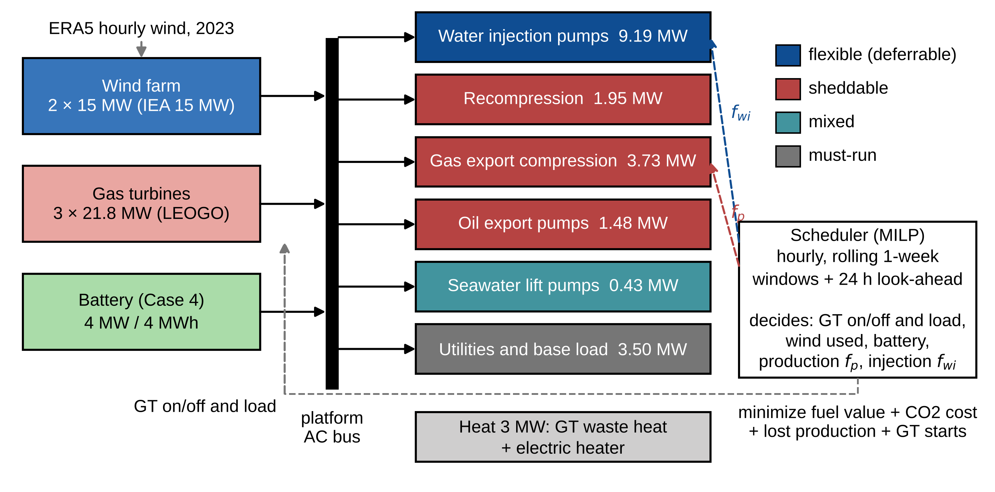
Figure 1. The platform power system. Supply (left) and topside consumers colored by flexibility class (middle) are connected to one AC bus. The scheduler sets the production rate $f_{p}$, the injection rate $f_{wi}$ and the GT commitment every hour.

2.2 Wind farm power
Hourly eastward and northward wind components at 100 m above sea level for 2014–2023 were taken from the ERA5 reanalysis (Hersbach et al. 2020) at the grid point nearest the site. Wind speed was extrapolated to the 150 m hub height with a power law,
 | $$v_{hub}=v_{100}{\left(\frac{z_{hub}}{z_{100}}\right)}^{α}, α=0.11,$$ | (1)
the exponent recommended for near-neutral conditions at sea (Hsu et al. 1994). Turbine power was interpolated on the power curve of the IEA 15 MW offshore reference turbine (Gaertner et al. 2020), with cut-in at 3 m/s, rated power from 10.7 m/s and cut-out at 25 m/s. The base-case farm of two turbines (30 MW) is of the same order as the 32 MW farm of the LEOGO platform (Svendsen et al. 2023). Wake losses (5 %), electrical losses (2 %) and availability (95 %) give a combined factor of 0.884, so the farm delivers at most 26.5 MW. Hourly resolution does not resolve wind variations within the hour; these are covered by the spinning reserve (Section 2.6).

2.3 Gas turbines and emissions
The GTs follow the LEOGO reference turbine (Svendsen et al. 2023): 21.8 MW rated electric power and 3.5 MW minimum stable load (16 % of rating). Fuel input is linear in electric output, a Willans line,
 | $$Q_{g,t}=\frac{P_{rated}}{η_{rated}}\left(a u_{g,t}+\left(1−a\right)\frac{P_{g,t}}{P_{rated}}\right),$$ | (2)
where $u_{g,t}$ is 1 when the unit runs. The rated efficiency $η_{rated}=0.347$ and no-load fuel fraction $a=0.184$ follow from the LEOGO fuel coefficients. A running GT burns 18.4 % of its full-load fuel before it delivers any power, which is why low-load operation is costly: efficiency falls from 34.7 % at full load to 29.3 % at half load and 17.7 % at minimum load, and the CO₂ emitted per MWh of electricity rises from 623 kg to 737 kg and 1,220 kg (Figure S2). A fraction $ϕ=0.5$ of the fuel energy not converted to power is recovered as process heat.
The lower heating value of the fuel gas (38.96 MJ/Sm³) was computed with NeqSim to ISO 6976 (ISO 2016) from a generic North Sea fuel gas composition. CO₂ emissions use the Norwegian standard factor of 2.34 kg/Sm³ (Svendsen et al. 2023). A carbon balance of the assumed composition gives 2.27 kg/Sm³, and the factor reported for the Gullfaks field center lies between 2.32 and 2.40 kg/Sm³ (Section 3.6).

2.4 Process model and demand map
The topside process was modeled in NeqSim with the Peng–Robinson equation of state for hydrocarbons and the CPA equation of state for water. CPA reproduces the density of liquid water, and therefore pump power, more accurately than a cubic equation without association terms. The flowsheet comprises:
- four-stage separation at 70 / 29 / 7.2 / 1.8 bara (Nguyen et al. 2013), with the last stage within the 1.7–2.8 bar found on four real North Sea platforms (Voldsund et al. 2014);
- three recompression stages lifting the gas from each separator to the pressure of the previous one, each followed by a cooler to 30 °C and a scrubber;
- gas export compression from 70 to 180 bara, which agrees with the 179 bar reported for a real platform (Voldsund et al. 2014);
- oil export pumping to 50 bara;
- water injection pumps from 7 to 250 bara;
- seawater lift pumps that supply cooling water (10 K temperature rise) and make-up water for injection, with seawater properties from (Sharqawy et al. 2010);
- a fixed utility load of 3.5 MW and a process heat demand of 3 MW.
Compressor isentropic efficiency (0.75), pump efficiencies, the injection pressure and the utility load follow LEOGO (Svendsen et al. 2023). The design point is 15,000 Sm³/d of oil with a gas–oil ratio of 179 Sm³/Sm³ (2.68 MSm³/d of gas export), a water cut of 40 % (10,000 m³/d of produced water) and 25,000 m³/d of water injection capacity. The resulting electric demand is 20.3 MW at full injection (Table 1). At the injection target of 85 % of capacity (Section 2.5) the demand is 18.8 MW.
Table 1. Electric power at the design point.
Consumer | Class | Trains | Power [MW] | Share
Water injection pumps | flexible | 3 × 33 % | 9.19 | 45 %
Gas export compression | sheddable | 2 × 50 % | 3.73 | 18 %
Utilities and base load | must-run | – | 3.50 | 17 %
Recompression | sheddable | 1 × 100 % | 1.95 | 10 %
Oil export pumps | sheddable | 2 × 50 % | 1.48 | 7 %
Seawater lift pumps | mixed | 3 × 33 % | 0.44 | 2 %
Total |  |  | 20.29
At fixed pressures and efficiencies, steady-state power is proportional to flow, so a simple flow-scaled power curve would make every consumer perfectly flexible. Real equipment is not, so each consumer is represented by $n$ identical parallel trains, of which the smallest number that can carry the flow is running, and by a minimum flow per train, $f_{min}$, below which the train recycles. For a flow fraction $f$ the power is
 | $$P\left(f\right)=P_{design} \frac{n_{run}}{n} max​\left(\frac{f n}{n_{run}}, f_{min}\right), n_{run}=\left\lceil f n\right\rceil ,$$ | (3)
and zero when $f=0$. Recycle represents anti-surge recycle for compressors and minimum-flow recirculation for pumps. The minimum flow is 70 % for compressors and 30 % for pumps. These values are assumptions; anti-surge recycle rates between 4 % and 92 % of compressor flow have been reported on real North Sea platforms (Voldsund et al. 2014), which shows that recycle is common in practice.

2.5 Consumer classes and levers
Each consumer is assigned to one class and one operating lever (Figure 1):
- Must-run: utilities and base load, never reduced.
- Flexible (deferrable): water injection pumps. The lever is the injection rate $f_{wi}$. Postponed injection is not lost but must be caught up.
- Sheddable: recompression, gas export compression and oil export pumps. The lever is the production rate $f_{p}$; any reduction is lost production.
- Mixed: seawater lift pumps, whose cooling part follows $f_{p}$ and make-up part follows $f_{wi}$.
The power of each lever group is the sum of the train curves of its consumers. It is a piecewise-linear function of the lever with steps where a train starts at its minimum flow (Figure 2), and it enters the scheduling model through incremental binary variables, one per segment. Production can be turned down to 50 % of design and changed by at most 10 % of design per hour, which represents the speed at which well chokes and the separation process can be adjusted. Injection can vary between 0 and 100 % of pump capacity, by at most 34 % per hour, about one pump started or stopped.
The average injection must meet a voidage-replacement target, set here to 85 % of capacity. This is modeled as a virtual storage: postponing injection builds a deficit, measured in hours of full-rate injection,
 | $$D_{t}=D_{t−1}+\left(f_{wi}^{target}−f_{wi,t}\right)Δt, 0≤D_{t}≤D_{max},$$ | (4)
with $Δt=1$ h and $D_{max}=72$ h. The lower bound prevents injection from being brought forward, which the reservoir may not tolerate either. The upper bound represents how much injection the reservoir tolerates being postponed. It depends on the reservoir and is uncertain, so it is varied from 0 to 168 h in the sensitivity analysis.

2.6 Scheduling model
The schedule is found with a mixed-integer linear program over each window of hours $T$. The objective minimizes the operating cost in NOK,
 | mint∈T​cgas+cCO2 eCO2g​Qg,tLHV+cprod 1−fp,t+cstartg​sg,t+cpen Ptu+RtuΔt, | (5)
where $c_{gas}=4.19$ NOK/Sm³ is the value of fuel gas, which could otherwise be sold, $c_{CO2}=2.0$ NOK/kg is the Norwegian target for the total CO₂ price in 2030 (Norwegian Ministry of Climate and Environment 2021), $e_{CO2}$ is the emission factor, $c_{prod}$ is the hourly value of design production (oil at 4,190 NOK/Sm³ and gas at the gas price) and $c_{start}=2,000$ NOK per GT start (Svendsen et al. 2023). Unserved energy $P_{t}^{u}$ and missing reserve $R_{t}^{u}$ are allowed only at a penalty $c_{pen}={10}^{6}$ NOK/MWh to keep every window feasible; in all reported runs they are below 0.03 MWh/yr.
The main constraints are:
 | g​Pg,t+Ptw+Ptdis+Ptu=Ptdemfp,t,fwi,t+Pth+Ptch, | (6)
 | $$P_{t}^{w}+P_{t}^{c}=P_{t}^{avail},$$ | (7)
 | ϕg​Qg,t−Pg,t+ηhPth≥H, | (8)
 | $$P_{min} u_{g,t}≤P_{g,t}≤P_{rated} u_{g,t}, s_{g,t}≥u_{g,t}−u_{g,t−1},$$ | (9)
 | g​Prated ug,t−Pg,t+Ptres+Rtu≥R, g​ug,t≥1, | (10)
 | $$E_{t}=E_{t−1}+\left(η_{c}P_{t}^{ch}−P_{t}^{dis}/η_{d}\right)Δt,$$ | (11)
together with the deficit balance of Section 2.5, the ramp limits on $f_{p,t}$ and $f_{wi,t}$, and the piecewise-linear demand $P_{t}^{dem}$ of the lever groups. The first equation is the power balance and the second splits the available wind into used and curtailed power. The heat balance requires recovered exhaust heat plus electric heating, with heater efficiency $η_{h}=0.99$, to cover the heat demand $H=3$ MW. The reserve requirement $R=5$ MW follows LEOGO (Svendsen et al. 2023). A battery contributes reserve $P_{t}^{res}$ only up to its unused discharge power and only if its stored energy can sustain that power for 30 min. The round-trip efficiency of the battery is 0.9. At least one GT must be online because the wind turbines are grid-following and a synchronous machine is needed for frequency and voltage control; this assumption is varied in the sensitivity analysis.
The year is solved as 52 rolling one-week windows, each with an uncommitted 24 h look-ahead, so that each window ends with a realistic state for the next. At the end of each look-ahead horizon the injection deficit may not exceed, and the battery energy may not fall below, their values at the start of the window, which prevents the optimizer from emptying the virtual or real storage at the end of a window. Each window of 192 h has about 6,900 variables, of which 1,344 are binary, and 6,900 constraints, and HiGHS solves it to within 0.5 % of the proven optimum. A full case-year takes 2–3 min on a laptop-class processor.
Because fuel is linear in power, the split of load between identical running GTs does not change total fuel, and the solver’s split between them is arbitrary. GT load is reported instead as shared in proportion to rating, as with droop control in real operation, and an hour counts as a low-load hour for a unit when this shared load is below 50 % of rating.

2.7 Weather years, sensitivity analysis and benchmark checks
To test whether 2023 is representative, Cases 1–4 were also run for each weather year from 2014 to 2022 with ERA5 data at the same grid point and all other inputs unchanged. The injection deficit limit was varied for 2016 and 2017 as well, the years in which the deficit reached its highest values.
For the base year 2023, Cases 2–4 were rerun with one input changed at a time:
- wind farm size (1–4 turbines, 15–60 MW);
- CO₂ price (0.5–3.0 NOK/kg) and gas price (2–8 NOK/Sm³);
- battery size (up to 8 MW / 16 MWh);
- injection deficit limit (0, 24, 72 and 168 h);
- minimum number of GTs online (1 or 0, with an 8 MW / 8 MWh battery that must then provide the reserve);
- GT fleet: three main units; two main units and one small unit, a Solar Turbines Mars 100 rated 11.35 MW with 32.9 % ISO efficiency (Solar Turbines n.d.) and the same relative part-load curve as the main units; or the three main units with one small unit added;
- an operating practice that keeps two GTs online whatever the wind, as some operators require for redundancy;
- GT minimum stable load (16, 30, 40 and 50 % of rating), since dry low-NOx combustors often cannot keep their emissions within limits far below about 40–50 % load;
- a cost per injection pump start (0–20,000 NOK), with the number of running pumps $n_{run}=⌈f_{wi} n⌉$ of Section 2.4 as an integer variable;
- the reserve definition: a requirement that also covers 50 % or 100 % of the wind power used, $R_{t}=R+k P_{t}^{w}$, and running injection pumps counted as reserve because they can be tripped within seconds;
- the solver gap (0.1 % instead of 0.5 %), to check that the small battery effect is not an artefact of the solver tolerance.
To test how far the results carry over to other platforms, Cases 2 and 3 were also run with every electric consumer scaled by 0.6–1.2 (mean demand 11.3–22.6 MW), combined with a spinning reserve of 3, 5, 7 and 9 MW, 28 platforms in total. Finally, the assumption of perfect wind foresight within each window was tested with a schedule that is re-planned every hour over the next 24 h. Only the wind of the current hour is known; every later hour is assumed equal to it (persistence forecast). The same hourly re-planning with the actual wind isolates the effect of the forecast from that of the shorter horizon. Two rules for the injection deficit were compared: each plan must end with no more deficit than it started with, as in the weekly windows, or the deficit left at the end of the plan is valued at 25 % or 50 % of the GT fuel needed to catch it up later, 2,082 Sm³ per hour of full-rate injection. Deficit left at the end of the year is added to the fuel use at the full rate.
The results were compared with independent values:
- platform power: three real North Sea oil platforms (Voldsund et al. 2013, 2014), six modeled platforms (Nguyen et al. 2013), the Johan Castberg development plan (Statoil 2017), and the average demand implied by Hywind Tampen (Equinor 2023);
- wind capacity factor: Hywind Tampen (Equinor 2023; Norwegian Offshore Wind 2025);
- CO₂ avoided per MWh of wind: Hywind Tampen (Equinor 2023);
- water injection specific energy: LEOGO (Svendsen et al. 2023);
- CO₂ intensity: the Norwegian shelf (Offshore Norge 2024) and non-electrified hubs (Westwood Global Energy Group 2022);
- field data for the Gullfaks, Snorre and Statfjord field centers, 2021–2024: CO₂ to air, fuel gas and diesel use from Norskeutslipp (Norwegian Environment Agency n.d.) and net production from the Norwegian Offshore Directorate (n.d.a), summed over the fields processed at each center.
The model components were verified by automated tests against hand calculations and published values (Supplementary material, S5).
The CO₂ avoided per MWh of wind is computed as the difference in annual CO₂ between Case 1 and a wind case, divided by the wind energy used in that case. For the field data, the system boundary was checked by comparing the reported oil volumes of the fields assigned to each center with the center’s processing; they agree within 2 %. A single published value counts as agreeing when the model is within ±20 %, and a published range when the model lies inside it.

2.8 Economic indicators
Two indicators are derived from the annual results, in real NOK. For the wind farm, whose investment can be estimated, the abatement cost is
 | $$c_{abate}=\frac{I CRF\left(r,n\right)+C_{O\&M}−ΔC_{fuel}}{Δm_{CO2}}, CRF\left(r,n\right)=\frac{r}{1−{\left(1+r\right)}^{−n}},$$ | (12)
where $I$ is the investment, $C_{O\&M}$ the annual operation and maintenance cost, $ΔC_{fuel}$ the annual value of the fuel saved and $Δm_{CO2}$ the CO₂ avoided per year. The CO₂ price is not counted as a saving, because the abatement cost is what is compared with the CO₂ price. The investment is scaled from Hywind Tampen, about NOK 7.4 billion for 88 MW before public support (Equinor 2023), which gives 84 MNOK/MW for a first-of-a-kind floating farm. Operation and maintenance cost 35–97 EUR/kW per year, the range between the cheapest and the most expensive repair strategy modeled for floating wind farms (Dighe et al. 2024). The real discount rate is 7 %, with 4 % as an alternative, the two rates used in Norwegian abatement-cost analyses of power from shore (Norwegian Petroleum Directorate n.d.), and the economic life is 20 years. For flexibility, the battery and a small GT, whose investment on an existing platform could not be estimated from published data, the break-even investment is given instead: the present value over 20 years of the annual saving, for the fuel saved alone and for fuel plus CO₂ cost.

3. Results

3.1 Demand map and wind resource
The process model was first used to obtain the electric power of each consumer at the design point (Table 1) and its variation with the lever positions (Fig. 2). Water injection is the largest consumer, with 9.2 MW or 45 % of the design demand, and the only large deferrable one. Stopping injection at full production lowers the demand from 20.3 MW to 10.7 MW, a swing of 9.6 MW that costs no production as long as the injection is caught up. The sheddable consumers tied to production and the must-run base load account for 7.2 MW and 3.5 MW, respectively. Neither lever curve is proportional to the lever position. The power of the injection lever jumps to 0.9 MW as soon as one pump runs, since the pump recycles below 30 % of its flow, and increases linearly from there. The production lever shows a step just above a rate of 50 %, where the second export compressor train must start at its surge limit and adds 0.75 MW. Reducing production from 100 % to 50 % therefore saves only 3.2 MW, about a third of the reduction offered by the injection lever.
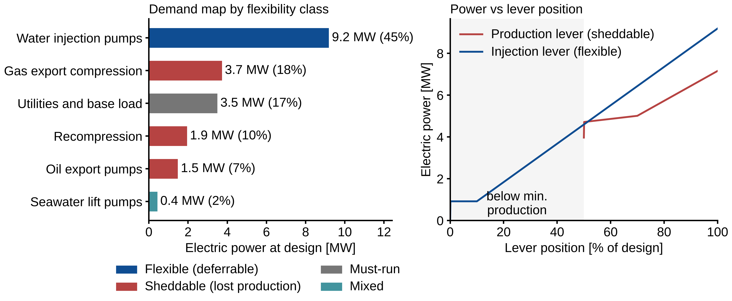
Figure 2. Demand map. Left: electric power at design by consumer, colored by flexibility class. Right: power of the production (sheddable) and injection (flexible) levers against lever position.
The ERA5 data give a mean wind speed of 9.4 m/s at 100 m and 9.8 m/s at hub height, and a capacity factor of 50.9 % for the 30 MW farm in 2023 (Figure S1). The output is seasonal, with monthly capacity factors of 63–68 % in January and February and 36–37 % from June to August. The farm delivers its maximum of 26.5 MW in 40 % of the hours and nothing in 9.6 % of the hours, mainly during calm periods, and the available wind power exceeds the design demand of 20.3 MW in 4,017 h. The farm can thus cover the whole platform demand for long periods, but it also leaves frequent and sometimes long gaps that must be filled by the GTs.

3.2 Comparison of the four cases
Table 2. Annual results for the four cases (2023).
 | 1 GTs only | 2 Wind, fixed | 3 Wind, flexible | 4 Flexible + battery
CO₂ [kt/yr] | 127.7 | 64.7 | 57.5 | 57.2
Reduction vs Case 1 | – | 49.4 % | 55.0 % | 55.2 %
Fuel gas [MSm³/yr] | 54.6 | 27.6 | 24.6 | 24.4
GT running [unit-h/yr] | 17,520 | 10,462 | 8,788 | 8,760
GT below 50 % load [unit-h/yr] | 17,520 | 9,005 | 5,932 | 6,242
GT starts [–/yr] | 0 | 149 | 3 | 0
Wind used [GWh/yr] | 0 | 89.3 | 95.1 | 95.7
Wind curtailed [GWh/yr] | 0 | 44.5 | 38.7 | 38.1
Lost production | 0 | 0 | 0 | 0
Fuel value + CO₂ cost [MNOK/yr] | 484.0 | 245.1 | 217.9 | 216.7
The annual results of the four cases are summarized in Table 2 and Figure 3. With GTs only (Case 1), two turbines run in every hour to carry the average load of 18.8 MW and the 5 MW reserve, each at about 43 % load, so all 17,520 GT unit-hours are low-load hours. Even without wind, the reserve keeps the turbines far from their best efficiency.
A 30 MW wind farm with fixed demand (Case 2) halves the emissions, to 64.7 kt (−49.4 %). Wind covers 54 % of the demand, and one GT is sufficient in 7,058 h. Since the demand cannot follow the wind, 33 % of the available wind energy is curtailed, and a second GT is still required in 1,702 h.
Flexible scheduling (Case 3) reduces the CO₂ emissions by a further 7.2 kt/yr, or 11.1 % relative to Case 2, without any loss of production. The GT running hours fall from 10,462 to 8,788 unit-h, the low-load unit-hours by 34 % and the GT starts from 149 to 3, and the curtailment decreases by 13 %. The combined fuel value and CO₂ cost is reduced by 27 MNOK/yr, of which 12.9 MNOK is the value of the fuel saved.
The 4 MW / 4 MWh battery (Case 4) adds only 0.3 kt (0.6 %). It removes the last starts and hours with a second GT, but with one GT always online it cannot remove the main remaining loss, one turbine idling near minimum load whenever the wind covers the demand.
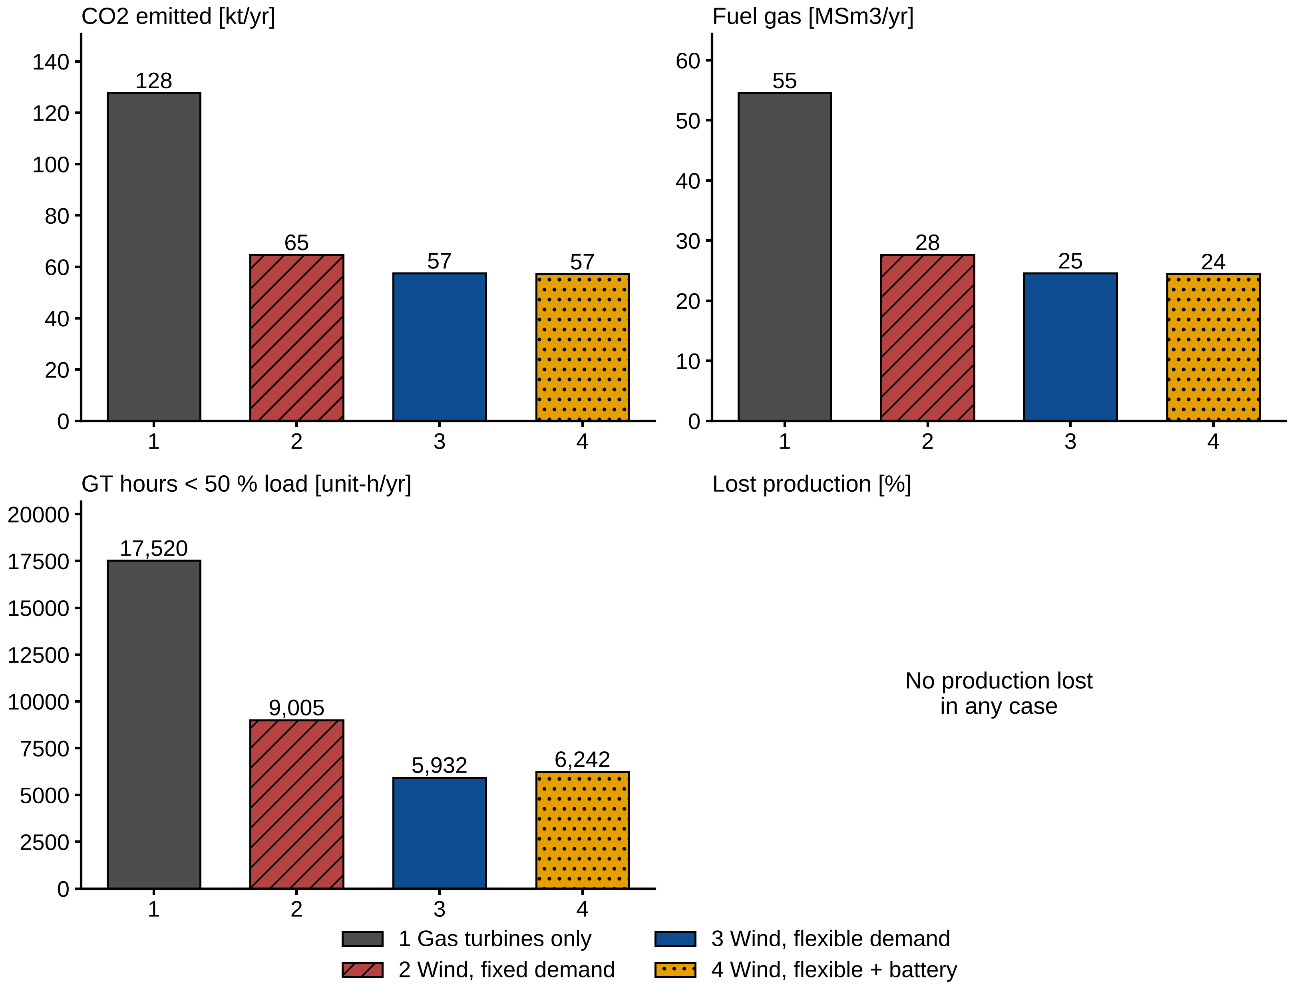
Figure 3. Annual CO₂, fuel gas, GT hours below 50 % load and lost production for Cases 1–4.

3.3 How flexible scheduling saves fuel
The saving is obtained by deferring water injection out of the hours in which a second GT would otherwise be needed. With fixed demand, a second turbine must be started whenever the wind drops and one GT cannot carry the load while holding 5 MW in reserve, i.e. whenever the wind supplies less than about 2 MW at the average demand of 18.8 MW. Each such hour costs the no-load fuel of a whole additional turbine, which amounts to 18.4 % of its full-load fuel. In Case 3 the optimizer postpones water injection in exactly these hours, so that a second GT runs in only 28 h of the year instead of 1,702 h (Figure 4, Figure 5). Since fuel is linear in GT power, the saving splits exactly into two parts (Table 3). The 1,674 avoided GT unit-hours, at a no-load fuel of 1,068 Sm³ per unit-hour, save 1.79 MSm³ (58 % of the 3.07 MSm³ saved). The injection that is moved out of these hours, 5.4 GWh, is caught up in windy hours and absorbs 5.8 GWh of wind that would otherwise be curtailed; at the marginal fuel use of 217 Sm³/MWh this saves the remaining 1.28 MSm³ (42 %). Both parts therefore result from the same deferral of injection: the commitment part from the hours it leaves, and the energy part from the hours it moves to.
Table 3. Split of the fuel saved by flexible scheduling (Case 2 to Case 3, 2023).
Part | Driver | Fuel saved [MSm³/yr] | Share
Commitment | 1,674 GT unit-hours avoided × 1,068 Sm³ no-load fuel | 1.79 | 58 %
Energy shifting | 5.8 GWh more wind used × 217 Sm³/MWh marginal fuel | 1.28 | 42 %
Total |  | 3.07
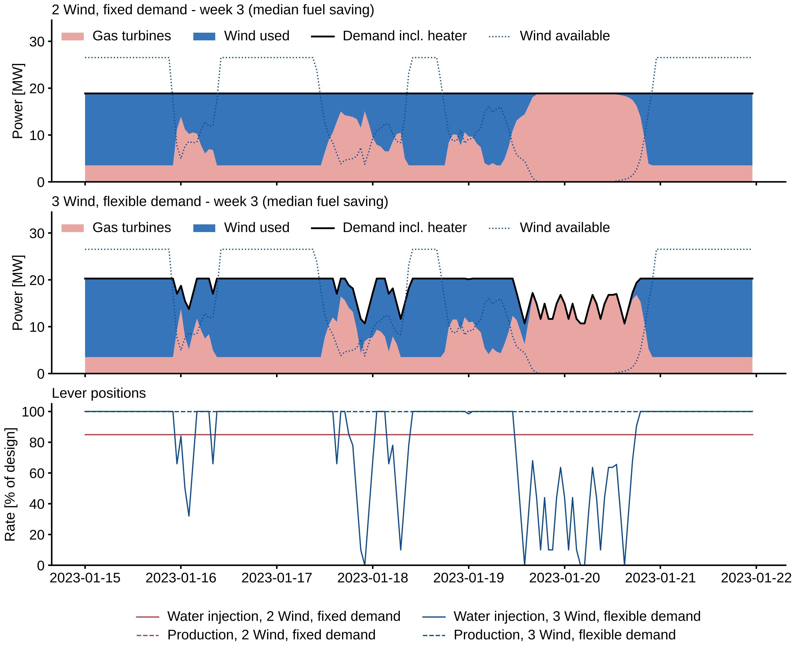
Figure 4. Week 3 (15–21 January 2023), the week with the median fuel saving. Top and middle: power supplied by GTs and wind with fixed (Case 2) and flexible (Case 3) demand. Bottom: production and injection rates.
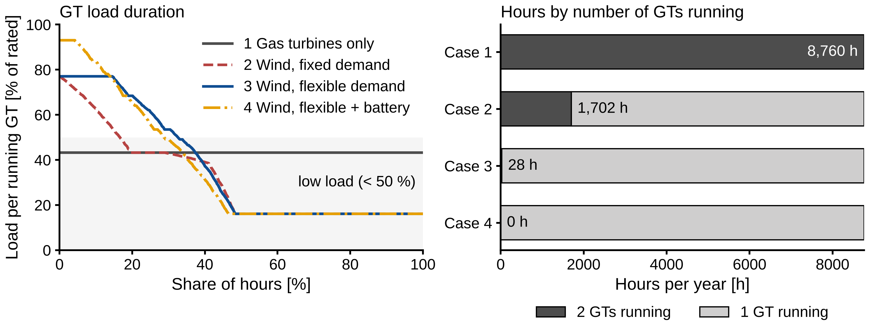
Figure 5. Left: duration curves of GT load per running unit (shaded: below 50 %). Right: hours per year with two and with one GT running.
The pattern is illustrated by the example week in Figure 4, which is the week with the median fuel saving. Whenever the wind drops, injection is reduced, sometimes to zero, so that the demand follows the wind, and when the wind returns, injection runs at full rate in order to catch up. Over the year, the injection rate follows the available wind (Figure 6): its mean increases from 57 % of capacity in the calmest hours to 98–100 % when more than 16 MW of wind power is available, and the correlation coefficient between injection rate and available wind is 0.61. Injection is below its 85 % target in 2,563 h, stopped completely in 187 h and above the target in 6,129 h. Over the year it averages 84.9 % of capacity, and the voidage target is thus met.
The deficit remains small compared with the limit. It averages 9.0 h of full-rate injection, never exceeds 27.5 h and is above 24 h in only 149 h of the year, which is well within the 72 h allowed. At the end of the year, 8.2 h of injection remain to be caught up, corresponding to less than 1 % of the annual saving. The short duration of the deficits is a consequence of the mechanism described above, since the hours in which a second GT would be required occur in spells of a few hours to about a day, between periods of sufficient wind.
Production is not reduced in any of the cases. One hour at a rate of 50 % would lose oil and gas worth about 1.5 MNOK, whereas the fuel and CO₂ saved in that hour are worth a few thousand NOK, and the optimizer therefore always prefers to defer injection. The saving from flexibility is obtained in every month and ranges from 0.43 to 0.77 kt (Figure S3). It is largest in June, December and July, which are the months in which the wind often falls just below the demand.
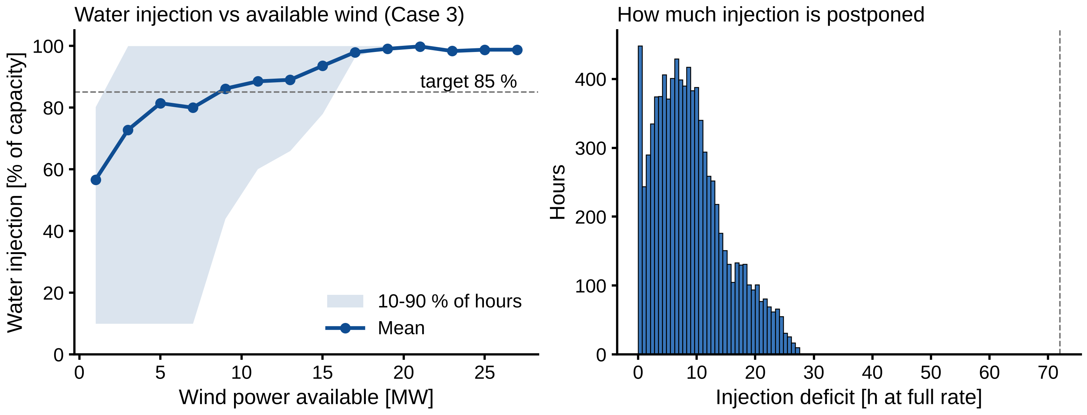
Figure 6. Left: water injection rate against available wind in Case 3 (mean and 10–90 % range of hours). Right: distribution of the injection deficit (dashed: 72 h limit).

3.4 Sensitivity analysis
Table 4. Annual CO₂ with fixed (Case 2) and flexible (Case 3) demand in the sensitivity runs (2023), and the saving from flexibility. Case 2 does not depend on the injection, pump and forecast settings. Forecast runs include the CO₂ of catching up the injection deficit left at the end of the year.
Varied input | Setting | Case 2 [kt/yr] | Case 3 [kt/yr] | Saving [kt/yr] | Saving [%]
Wind farm size | 15 MW | 77.5 | 71.9 | 5.6 | 7.2
 | 30 MW (base) | 64.7 | 57.5 | 7.2 | 11.1
 | 45 MW | 60.2 | 53.4 | 6.8 | 11.3
 | 60 MW | 57.6 | 50.9 | 6.7 | 11.6
Injection deficit limit | 0 h | 64.7 | 64.7 | 0.0 | 0.0
 | 24 h | 64.7 | 57.5 | 7.1 | 11.0
 | 72 h (base) | 64.7 | 57.5 | 7.2 | 11.1
 | 168 h | 64.7 | 57.5 | 7.1 | 11.0
GT fleet | 3 main (base) | 64.7 | 57.5 | 7.2 | 11.1
 | 2 main + 1 small | 53.9 | 47.8 | 6.1 | 11.3
 | 3 main + 1 small | 53.9 | 47.7 | 6.2 | 11.5
GT operating practice | at least 1 GT online (base) | 64.7 | 57.5 | 7.2 | 11.1
 | 2 GTs always online | 90.7 | 87.7 | 3.1 | 3.4
GT minimum load | 16 % (base) | 64.7 | 57.5 | 7.2 | 11.1
 | 30 % | 71.9 | 64.6 | 7.3 | 10.1
 | 40 % | 77.5 | 70.2 | 7.3 | 9.5
 | 50 % | 86.4 | 76.2 | 10.2 | 11.8
Pump start cost | 0 NOK (base) | 64.7 | 57.5 | 7.2 | 11.1
 | 1,000 NOK | 64.7 | 57.6 | 7.1 | 11.0
 | 5,000 NOK | 64.7 | 57.6 | 7.1 | 10.9
 | 20,000 NOK | 64.7 | 57.6 | 7.0 | 10.9
Reserve definition | 5 MW (base) | 64.7 | 57.5 | 7.2 | 11.1
 | 5 MW + 50 % of wind used | 66.2 | 57.7 | 8.5 | 12.8
 | 5 MW + 100 % of wind used | 90.7 | 78.2 | 12.5 | 13.8
 | injection pumps count as reserve | 60.4 | 57.6 | 2.8 | 4.7
Wind forecast (hourly re-planning) | actual wind, deficit repaid in each plan | 64.7 | 59.2 | 5.5 | 8.5
 | persistence, deficit repaid in each plan | 64.7 | 64.2 | 0.5 | 0.7
 | persistence, deficit valued at 25 % | 64.7 | 57.9 | 6.7 | 10.4
 | persistence, deficit valued at 50 % | 64.7 | 58.0 | 6.7 | 10.3
Table 5. Annual CO₂ with a battery added to flexible scheduling (Case 4), against Case 3 without a battery (57.5 kt/yr).
Battery | Min. GTs online | Case 4 [kt/yr] | Saving vs Case 3 [kt/yr] | Saving vs Case 3 [%]
none | 1 | 57.5 | 0.0 | 0.0
2 MW / 2 MWh | 1 | 57.3 | 0.2 | 0.3
4 MW / 4 MWh (base) | 1 | 57.2 | 0.3 | 0.6
8 MW / 8 MWh | 1 | 56.9 | 0.6 | 1.0
8 MW / 16 MWh | 1 | 56.4 | 1.1 | 1.9
8 MW / 8 MWh | 0 | 38.7 | 18.8 | 32.8
The results of the sensitivity runs are given in Tables 4 and 5 and Figure 7. The CO₂ and gas prices have almost no effect: across CO₂ prices of 0.5–3 NOK/kg and gas prices of 2–8 NOK/Sm³, the emissions change by less than 0.1 %. The prices scale the cost of every option alike, so the cheapest schedule remains the cheapest. Deferring injection saves fuel at any price, and shedding production is never profitable, as the lost oil and gas are worth about a hundred times more than the fuel saved.
The deferral capacity required is small. Without deferral, Case 3 equals Case 2 (64.7 kt); a limit of 24 h already gives the full saving, and 168 h changes nothing. The benefit would thus still be captured under a conservative reservoir constraint.
A larger wind farm gives a smaller improvement than its size suggests. Doubling the farm from 30 to 60 MW reduces the Case 3 emissions only from 57.5 to 50.9 kt, while the curtailment increases from 39 to 160 GWh, since one GT must remain online and the platform cannot use more wind in windy hours. The value of flexibility (Case 2 minus Case 3) is highest at the base-case size (7.2 kt). It is 5.6 kt for a 15 MW farm, where the wind seldom covers the demand, and 6.7–6.8 kt for 45–60 MW. Batteries add little as long as one GT must remain online; the largest one tested saves 1.1 kt (2 %, Table 5). The 0.3 kt (0.6 %) of the 4 MW / 4 MWh battery is close to the 0.5 % solver gap, but with a gap of 0.1 % it is 0.4 kt (0.7 %), so it is small but real.
Two assumptions on GT operation have a larger effect than any of these inputs. If an 8 MW / 8 MWh battery could provide reserve and grid stability, so that all GTs may be stopped, the emissions would decrease to 38.7 kt, which is 32 % below the same case with one GT online. The GTs would then run only 3,798 unit-h and start 184 times a year, only 11 GWh of wind would be curtailed, and the electric heater would supply 15 GWh of heat in the hours with no GT running. The opposite rule, with two GTs online whatever the wind, increases the emissions to 90.7 kt in Case 2 and 87.7 kt in Case 3. Flexibility then saves only 3.1 kt, all of it from lower curtailment, since there is no second GT left to avoid.
The composition of the GT fleet also matters. Replacing one main unit by a Solar Mars 100 (11.35 MW) reduces the emissions from 64.7 to 53.9 kt with fixed demand (−17 %) and from 57.5 to 47.8 kt with flexible demand. The small unit runs alone in windy hours; its no-load fuel is about half that of a main unit, and it can carry up to 6.35 MW while holding the 5 MW reserve. Flexibility still saves 6.1 kt (11.3 %) with the small unit installed and reduces the starts of the small unit from 465 to 262 per year. Combined, the small unit and flexibility reduce the emissions by 26 % relative to Case 2. When the small unit is instead added to the three main units, the emissions are 47.7 kt, and the third main unit is never used.
The flexibility benefit is robust to the GT and pump assumptions. A higher GT minimum load raises the emissions of both cases, by 34 % in Case 2 at 50 % minimum load, because the running GT must then produce more power and more wind is curtailed. The saving from flexibility stays between 7.2 and 10.2 kt, or 9.5–11.8 %, and is largest at 50 % minimum load. In the base case the injection pumps start 731 times a year, about twice a day, at no cost. A start cost of only 1,000 NOK reduces this to 163 starts a year and the saving by 0.08 kt; at 20,000 NOK per start, 103 starts remain and 0.14 kt of the 7.2 kt is lost. The optimizer then keeps injection at fixed pump steps for longer and uses the deficit mainly in the spells that avoid a second GT.
The reserve definition has a larger effect. A reserve that must also cover half of the wind power used changes Case 3 only slightly (57.7 kt), but raises Case 2 to 66.2 kt, so that the benefit of flexibility increases to 8.5 kt (12.8 %). If the reserve must cover the loss of all wind used, two GTs run in every hour of Case 2 (90.7 kt), whereas flexible scheduling still avoids the second GT in about 3,600 h and saves 12.5 kt (13.8 %). The opposite assumption, that the running injection pumps count as reserve because they can be tripped within seconds, reduces the emissions of Case 2 to 60.4 kt without any scheduling. This captures about 60 % of the benefit of flexibility, since a second GT is then never needed, and scheduling adds a further 2.8 kt (4.7 %), close to the energy part of the saving. Load shedding as reserve and load scheduling are thus two routes to the same mechanism, and they do not add up: with both, Case 3 emits 57.6 kt, as without tripping.
The weekly windows assume that the wind is known a week ahead. With hourly re-planning over 24 h and the actual wind, the saving falls from 7.2 to 5.5 kt once the 57 h of injection still owed at the end of the year are caught up with GT power; this loss is caused by the shorter horizon, not by the forecast. With a persistence forecast and the rule that every plan must repay its deficit within 24 h, only 0.5 kt is saved. In a calm hour the planner then expects calm for the whole day, sees no chance to catch up, and does not defer injection. If instead the deficit left at the end of the plan is valued at 25–50 % of the GT fuel needed to catch it up, persistence planning saves 6.7 kt, or 94 % of the perfect-foresight saving, including the 44–46 h of injection left at the end of the year. The rule for the deficit thus matters far more than the quality of the forecast: a planner that may carry the deficit over captures nearly all of the benefit with the simplest possible forecast.
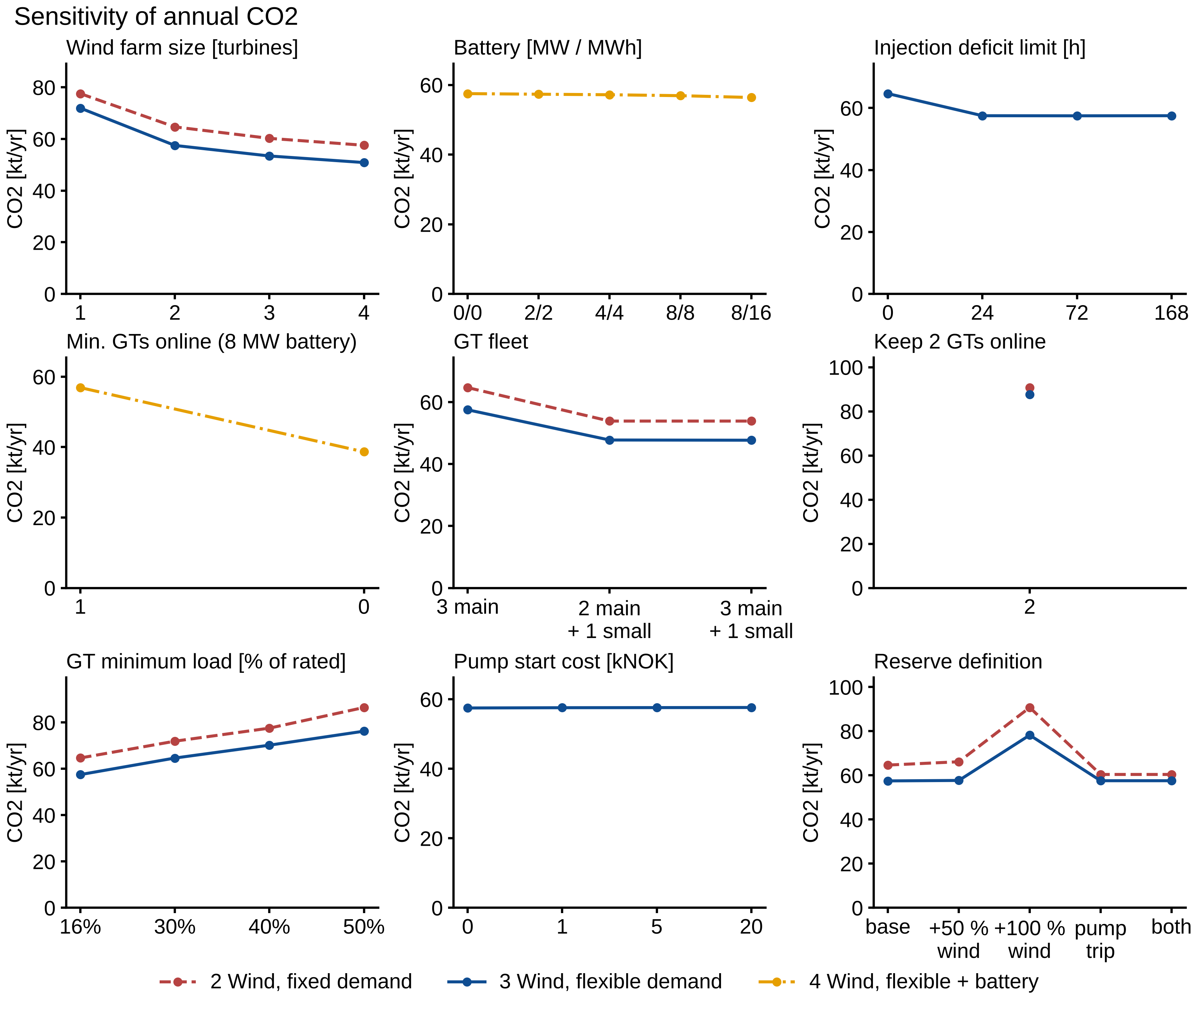
Figure 7. Sensitivity of annual CO₂ emissions to wind farm size, battery size, injection deficit limit, minimum number of GTs online, GT fleet, operating practice, GT minimum load, pump start cost and reserve definition.

3.5 Platform demand and reserve
The base platform has a mean demand of 18.8 MW, just above what one GT can carry while holding the reserve, 21.8 − 5 = 16.8 MW. The demand and reserve map (Figure 8) shows that this margin decides the size of the benefit. When one GT can carry the mean demand plus the reserve (a positive margin), a second GT is rarely needed even with fixed demand, and flexibility saves 4.4–4.8 % of the Case 2 emissions, about the energy part alone. When the mean demand exceeds the rating of one GT minus the reserve, the saving roughly doubles, to 8–12 %, because deferring injection then avoids the second GT in many hours. The transition is sharp and occurs at a margin of about zero for all four reserve sizes, so that the curves of Figure 8 (right) nearly coincide when they are plotted against the margin instead of the demand. Further above the margin, the saving decreases slowly, to 10 % at 22.6 MW, since the deferrable load is then more often too small to keep the second GT off.
The margin of one GT is therefore a simple screening criterion. With the LEOGO turbines and a 30 MW wind farm, a platform whose mean demand lies about 2–8 MW above the rating of one GT minus its reserve can expect about 10–12 % lower emissions from scheduling its deferrable loads, and a platform with a positive margin about 4–5 %.
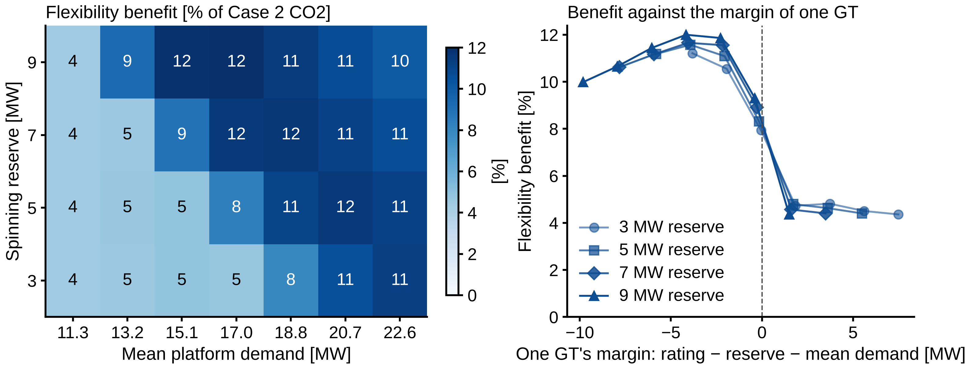
Figure 8. Flexibility benefit (Case 2 − Case 3, % of Case 2 CO₂) for 28 platforms with all electric consumers scaled by 0.6–1.2 and a spinning reserve of 3–9 MW. Left: by mean demand and reserve. Right: the same points against the margin of one GT, its rating minus the reserve minus the mean demand.

3.6 Benchmark checks
Table 6. Model results against published benchmarks.
Benchmark | Model | Published | Status
Platform power, three real oil platforms (Voldsund et al. 2013, 2014) | 20.3 MW | 17–30 MW | within
Platform power, six modeled platforms (Nguyen et al. 2013) | 20.3 MW | 22.6–31.1 MW | below range
Platform power, Johan Castberg (Statoil 2017) | 20.3 MW | 25 MW | within 20 %
Platform power implied by Hywind Tampen (Equinor 2023) | 20.3 MW | 25.1 MW | within 20 %
Wind capacity factor, Hywind Tampen design (Equinor 2023) | 50.9 % | 49.8 % | agrees
Wind capacity factor, Hywind Tampen Q1 2025 (Norwegian Offshore Wind 2025) | 50.9 % | 58.4 % (winter) | within 20 %
CO₂ avoided per MWh wind, two GTs kept online (Equinor 2023) | 0.51 t/MWh | 0.52 t/MWh | agrees
Water injection specific energy (Svendsen et al. 2023) | 8.8 kWh/m³ | 9.0 kWh/m³ | agrees
CO₂ intensity, Norwegian shelf 2023 (Offshore Norge 2024) | 3.1 kg/boe | 7.3 kg/boe | lower
The model results are compared with the published benchmarks in Table 6 and Figure 9. The platform power, the wind resource and the pump energy agree with the published values. The platform power lies within the range of processing-plant power of three real oil platforms and within 20 % of the other references. It is, however, below the range of the six platforms modeled by Nguyen et al. (2013), in which gas compression alone accounts for 42–56 % of a demand of 22.6–31.1 MW, compared with 28 % of 20.3 MW in the present model. The capacity factor obtained with ERA5 is within 2 % of the 49.8 % expected for Hywind Tampen, although that farm uses smaller floating turbines.
The CO₂ avoided per MWh of wind is the most demanding check, as it tests the wind model, the part-load fuel model, the CO₂ factor and the scheduling together. When the model keeps two GTs online and only reduces their load, as assumed in the Hywind Tampen estimate, it avoids 0.51 t/MWh, against the published value of 0.52 t/MWh. When a GT may be stopped in windy hours, as in Case 2, it avoids 0.71 t/MWh, since the no-load fuel of the stopped unit is saved as well. The published value is derived from the expected annual figures of the wind farm, about 200 kt of CO₂ avoided per year (Equinor 2023), and not from measurements, so this comparison is a check of consistency rather than a validation. The model agrees with it only when it is operated as assumed in that estimate; with a GT allowed to stop, as in Case 2, the model value is 36 % higher. The difference shows to what extent the benefit of wind depends on the operating practice rather than on the wind farm itself.
The field data support the fuel and emission model (Figure 9, right). The Gullfaks field center emitted 2.32–2.40 kg CO₂ per Sm³ of fuel gas in 2021–2024, which is consistent with the 2.34 kg/Sm³ used here. After Hywind Tampen started supplying power, the fuel gas use decreased by 30 % at Gullfaks (2021–2023) and by 11 % at Snorre (2021–2024), and the diesel use at Snorre fell from 15.6 kt to about 3 kt, whereas the fuel use was unchanged at Statfjord, which receives no wind power. Since production also declined over the period, not all of the reduction can be attributed to the wind farm. The CO₂ intensity of the model is lower than the shelf average and the field values (9–14 kg/boe at Gullfaks and Snorre, 55–78 kg/boe at the late-life Statfjord), as expected from the system boundary: the model covers only power generation on an efficient platform at plateau rate, whereas the field values include flaring, diesel, gas re-injection compression and the lower production of mature fields. The like-for-like checks, i.e. the fuel gas factor and the CO₂ avoided per MWh, agree, which indicates that the difference originates from the boundary and not from the power system model.
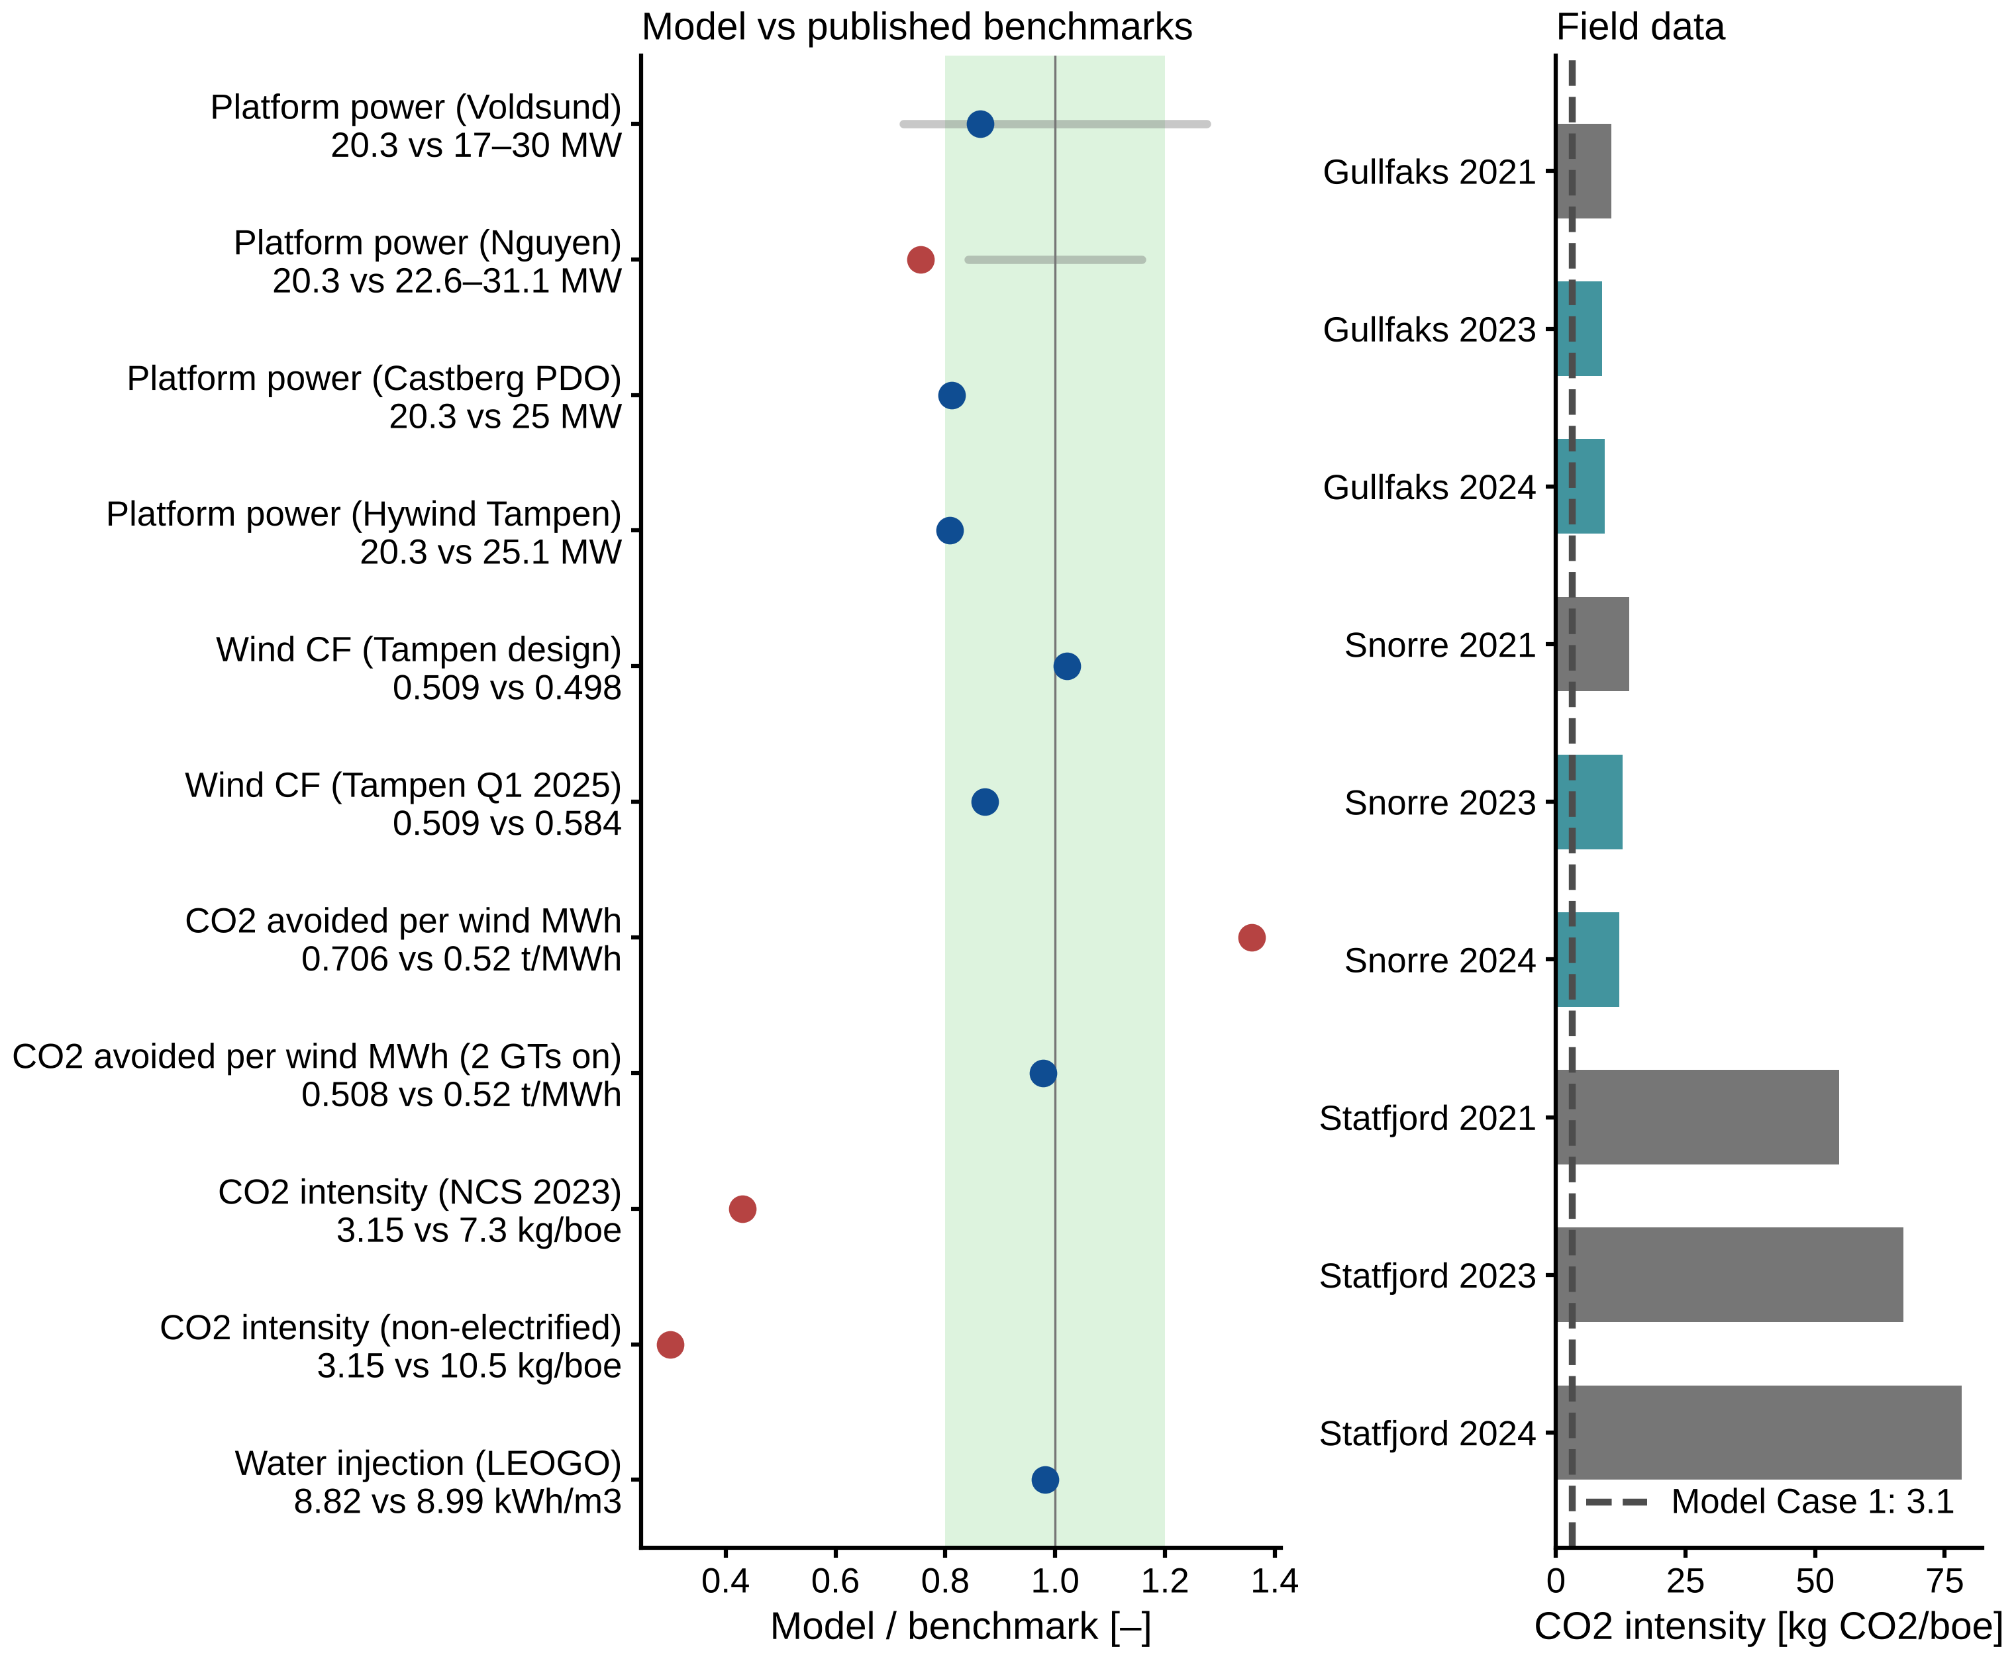
Figure 9. Left: model results divided by published benchmarks (1 = equal; shaded: ±20 %; gray bars: published ranges). Right: CO₂ intensity of the Gullfaks, Snorre and Statfjord field centers (gray: GT-powered; teal: receiving Hywind Tampen power) with the model Case 1 value (dashed).

3.7 Economic indicators
Table 7. Economic indicators (real NOK, 20 years; abatement cost range from the O&M range of floating wind).
Measure | CO₂ avoided [kt/yr] | Fuel value saved [MNOK/yr] | Abatement cost [NOK/t], 7 % / 4 % | Break-even investment [MNOK], fuel / fuel + CO₂
Wind farm, fixed demand (Case 2 vs 1) | 63.0 | 112.8 | 2,180–2,519 / 1,347–1,686 | –
Wind farm with flexibility (Case 3 vs 1) | 70.2 | 125.7 | 1,774–2,078 / 1,026–1,330 | –
Flexibility (Case 3 vs 2) | 7.2 | 12.9 | −1,799 before implementation cost | 137 / 288
Battery 4 MW / 4 MWh (Case 4 vs 3) | 0.3 | 0.5 | −1,562 before battery cost | 5 / 13
Small GT replacing one main GT (flexible) | 9.7 | 17.4 | −1,786 before GT cost | 184 / 391
The economic indicators are given in Table 7. With an investment of 2.5 billion NOK for 30 MW, the wind farm with fixed demand avoids CO₂ at 2,180–2,519 NOK/t at a 7 % discount rate and at 1,347–1,686 NOK/t at 4 %. These values are of the same order as the abatement cost of the power-from-shore projects most recently approved on the Norwegian shelf, just under 2,000 NOK/t (Norwegian Offshore Directorate 2025), and close to the CO₂ price of 2,000 NOK/t targeted for 2030 (Norwegian Ministry of Climate and Environment 2021). Scheduling the flexible loads lowers the abatement cost of the same wind farm by about 400 NOK/t, to 1,774–2,078 NOK/t at 7 %, since 11 % more CO₂ is avoided and 11 % more fuel is saved for the same investment.
Flexibility on its own gives a net saving before any implementation cost, as the fuel saved is worth about 1,800 NOK per tonne of CO₂ avoided. An operator could spend up to 137 MNOK on control systems and process modifications and still break even on the fuel saved alone, or up to 288 MNOK when the avoided CO₂ cost is included. The 4 MW / 4 MWh battery breaks even only at an investment below 5–13 MNOK, which is low for an offshore installation of that size. A small GT replacing one main GT breaks even below 184–391 MNOK, before its additional maintenance and its 262 starts per year are taken into account.

3.8 Weather years
Table 8. Results for ten weather years (ERA5, 2014–2023).
 | Mean | Range | 2023
Wind capacity factor | 54.2 % | 50.3–59.8 % | 50.9 %
CO₂ reduction, Case 2 vs 1 | 51.8 % | 48.5–55.6 % | 49.4 %
CO₂ reduction, Case 3 vs 1 | 57.1 % | 54.5–60.3 % | 55.0 %
Flexibility benefit, Case 2 − 3 | 6.8 kt (11.0 %) | 5.9–7.7 kt (10.5–11.7 %) | 7.2 kt (11.1 %)
Hours with two GTs, Case 2 / Case 3 |  | 1,082–1,889 / 4–66 | 1,702 / 28
Battery benefit, Case 3 − 4 | 0.35 kt | 0.25–0.42 kt | 0.32 kt
Maximum injection deficit |  | 25.8–59.3 h | 27.5 h
The results for the ten weather years are summarized in Table 8 and Figure 10. The weather year affects the benefit of wind more than the benefit of flexibility. Over the ten years, the capacity factor of the wind farm ranges from 50.3 % to 59.8 %, and 2023 is one of the calmer years. The reduction with fixed demand (Case 2) ranges from 48.5 % to 55.6 %, whereas the additional saving from flexibility is remarkably stable at 10.5–11.7 % of the Case 2 emissions, or 5.9–7.7 kt/yr, with a mean of 11.0 %, almost exactly the 2023 value. In absolute terms, the saving is largest in the calm years 2016, 2021 and 2023, in which a second GT is needed most often with fixed demand, and smallest in the windy year 2022. Flexibility removes 96–100 % of the hours with two GTs online in every year, and in no year is production lost or demand left unmet.
The injection deficit varies more between the years than the saving does. Its maximum ranges from 26 to 59 h, which is below the 72 h limit in every year, and up to 28 h remain to be caught up at the end of a year. In 2016 and 2017, the years with the largest deficits, a limit of 24 h still captures 98 % of the saving obtained with 72 h (58.4 against 58.3 kt in 2016 and 52.7 against 52.6 kt in 2017). The conclusion that about one day of deferral is sufficient thus holds for all the weather years tested.
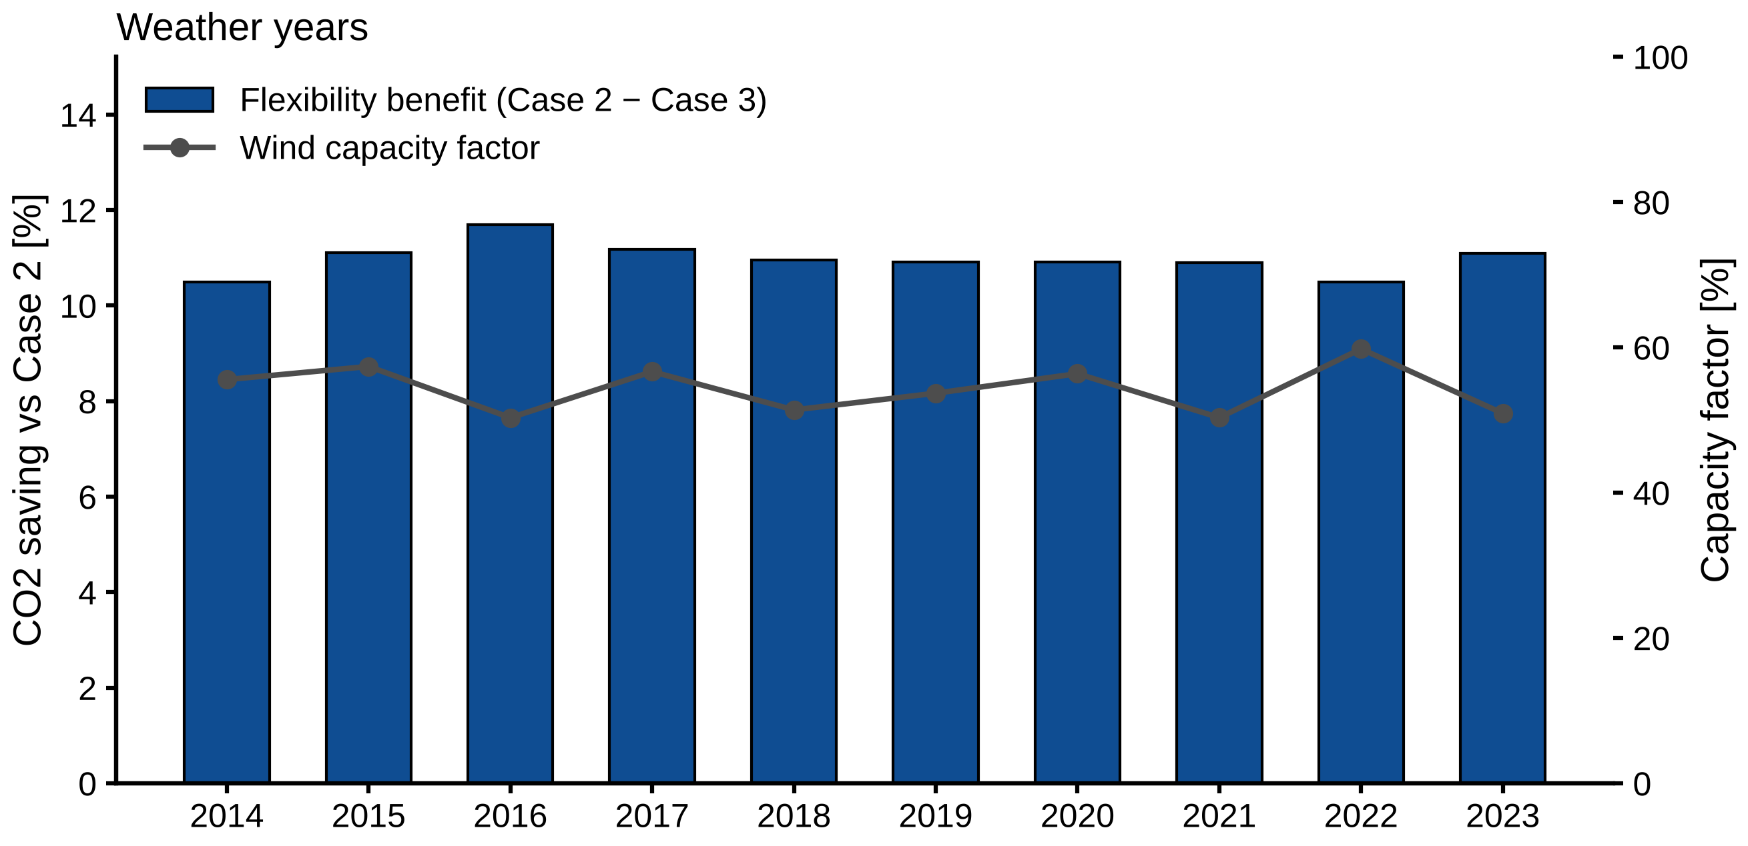
Figure 10. Flexibility benefit (Case 2 − Case 3, bars) and wind capacity factor (line) for the weather years 2014–2023.

4. Discussion
The results presented above show that the benefit of flexible scheduling is obtained through the unit commitment of the GTs. This mechanism is discussed in Section 4.1, and the results are compared with earlier studies in Section 4.2. The practical implementation, the robustness of the conclusions and the limitations of the study are discussed in Sections 4.3–4.5.

4.1 Why load flexibility works
Flexible demand saves fuel through two linked effects. Deferring injection in the hours in which the wind is just too weak for one turbine to carry the load with 5 MW in reserve keeps the second turbine off, which saves its no-load fuel, and the deferred injection then uses wind that would otherwise be curtailed. The commitment effect is the larger one (58 % of the saving), and it explains three of the results of Section 3: almost all of the 1,702 hours with two GTs online are avoided; about one day of deficit capacity is sufficient, since these hours occur in short spells between windy periods; and the saving is reduced to the energy part alone under operating rules that keep two GTs online in any case (3.1 kt instead of 7.2 kt).
The energy-shifting part is limited by the wind that can be absorbed. The curtailment decreases by only 13 %, since one GT must remain online and a 30 MW farm often produces more power than the platform can use, even with injection at full rate. For the same reason, the value of flexibility does not increase with the size of the wind farm: a larger farm covers the demand more often, so that a second GT is needed in fewer hours, and the additional wind in windy hours cannot be absorbed. Flexibility is thus most valuable when the wind farm capacity is of the same order as the platform demand, as in the base case and at Hywind Tampen.
The small effect of the battery in Case 4 has the same cause. With one GT always online, a battery cannot remove the main remaining loss, which is a turbine idling near minimum load. The large saving (38.7 kt, −32 %) is obtained only when the battery, or grid-forming wind turbines, can replace the last running GT. Svendsen (2022) found the same for a battery providing reserve. The present results show in addition that process flexibility gives much of this benefit without new equipment, since both measures reduce the number of GTs that must be online.
A small GT acts on a different part of the loss: it does not reduce the number of running units, but the no-load fuel of the unit that runs. Its saving therefore adds almost fully to that of flexibility (Section 3.4). A retrofit could thus proceed in stages, by first using the flexibility of the existing process at no investment, and then considering the replacement of one main GT by a smaller unit at its next major overhaul, provided that the small unit tolerates about 260 starts a year.

4.2 Comparison with earlier studies
Most studies of wind-powered platforms report the benefit of wind at fixed demand, which corresponds to Case 2 in the present study. This understates the potential of the same wind farm, as the emissions with fixed demand are 12 % higher than when the platform schedules its flexible loads. The CO₂ avoided per MWh of wind, which is the usual metric for wind integration, is 0.71 t/MWh in Case 2, 0.74 t/MWh in Case 3 and 0.51 t/MWh if two GTs are kept online. Values reported for different platforms can therefore only be compared if the GT operating practice behind them is stated.
The economic performance of flexibility also differs from that of wind integration. Riboldi and Nord (2018) found that integrating wind is profitable only with favorable gas and CO₂ prices. Flexibility, in contrast, requires no investment in power generation, its schedule does not depend on prices, and the fuel it saves is worth about 1,800 NOK per tonne of CO₂ avoided at the base-case gas price alone. It is thus profitable without any carbon price, which is relevant in regions where emissions are not priced. The wind farm, by comparison, requires about 1,800–2,500 NOK/t at a 7 % discount rate to break even, which is of the same order as power from shore (Norwegian Petroleum Directorate et al. 2020; Norwegian Offshore Directorate 2025), and flexibility lowers this value by about 400 NOK/t.
The comparison with onshore demand response is less direct than it may appear. Industrial studies consider the response to electricity prices (Zhang and Grossmann 2016; Golmohamadi 2022), whereas on an off-grid platform the value of a load shift arises from discrete decisions of the platform’s own power plant, i.e. whether a GT must be started or can be stopped. This value depends on the state of the system hour by hour, and a model of energy shifting alone, without unit commitment, would not capture most of it.

4.3 Practical implementation
This flexibility already exists on most oil platforms with water injection. Its use requires no new equipment, but it requires a power management system that coordinates the injection with the GTs and a wind forecast, whereas these are usually controlled separately today.
The requirement on the reservoir is modest. A deferral of about 24 h, with an average of 9.0 h, is short compared with the months over which voidage replacement is normally managed. It must nevertheless be confirmed for each field, since a reservoir close to its bubble point, for example, may not accept even short pressure drops.
The schedule also changes the duty of the injection pumps. Without a cost, they start 731 times a year in Case 3, about twice a day. A modest start cost reduces this to 100–160 starts a year at a loss of only 1–2 % of the saving (Section 3.4), so pump wear is not an obstacle; an operator can choose the start frequency it accepts.
Operating practice deserves at least as much attention as hardware. The number of GTs that must be online, and the definition of reserve, affect the emissions more than any price or the battery size. Rules that keep two GTs online for redundancy increase the emissions by 40 % with fixed demand and by 53 % with flexible demand and remove most of the value of flexibility. Such rules exist for good reasons of safety and regularity. Two measures can relax them without new generation. Running injection pumps can serve as reserve, since tripping them is fast and costs no production; this alone captures about 60 % of the benefit of flexibility. Grid-forming batteries that provide reserve and stability without a running GT would go further and are the logical next step after demand flexibility.
The approach should be transferable to other installations. The demand and reserve map (Section 3.5) gives a simple screening rule: a platform gains most, about 10–12 %, when its mean demand exceeds the rating of one GT minus the reserve, and about 4–5 % otherwise, provided it has a large deferrable consumer and a wind supply of the same order as its demand. On other types of installations, gas export compression, electric heating and the regeneration of glycol or other process chemicals could be deferrable, but only where buffer storage such as line pack or tank volume is available.

4.4 Robustness of the conclusions
The saving is determined by the number of hours in which, at fixed demand, the platform runs one GT more than its load requires. The sensitivity runs confirm the expected direction of the main assumptions: a larger reserve, a reserve that covers the wind, a higher GT minimum load and a demand above the margin of one GT all increase the value of flexibility, whereas a wind farm much larger than the demand, or injection pumps that already count as reserve, reduce it.
The assumptions on the flexible load have less effect than might be expected. Since injection is reduced by stopping whole pumps, the assumed minimum pump flow changes the cost of running one pump at low rate but hardly affects the saving. The injection target has a larger effect: a lower target leaves more room for catching up, and at a target of 100 % deferred injection could never be caught up and the flexibility would vanish. The heat balance was never binding in the base cases, since the waste heat of the running GT always covered the heat demand of 3 MW. A platform with a larger heat demand, or one that relies on the heat of the GTs to be stopped, would save less unless its heat demand can be scheduled as well.
The result that production should never be shed is the most robust one, since the lost oil and gas are worth about a hundred times more than the fuel saved, and no plausible change in prices or efficiencies reverses this.

4.5 Limitations and future work
The platform is generic, and the fluid composition, the minimum-flow limits, the injection target and the deficit limit were assumed, although the results are insensitive to the deficit limit, the prices and the battery size. The process is represented by steady states, and the transient compressor behavior, the start-up times of pumps and GTs beyond a start cost, and the reservoir response to deferred injection are not modeled. The GT part-load curve is a Willans line derived from LEOGO, and the curve of a real machine, including its emissions at very low load, may differ.
The weekly schedules assume perfect wind foresight, but hourly re-planning with a persistence forecast retains 94 % of the saving when the injection deficit may be carried over (Section 3.4). The hourly model does not resolve forecast errors within the hour, which decide whether a GT must be started at short notice. The ten weather years cover one site and one platform, without power import or export. The economic indicators are based on the cost of a single first-of-a-kind floating wind farm and exclude the cost of implementing flexibility, the battery or the small GT, for which only break-even values are given. The small GT uses the relative part-load curve of the main units, since its manufacturer publishes only the full-load rating.
Several directions for further work follow from these limitations. A simple reservoir pressure model would test the injection schedule against reservoir limits, and a sub-hourly model of the power system would test the use of injection pumps as fast reserve. Data from a platform with wind supply, such as those served by Hywind Tampen, would allow the model to be calibrated. Finally, combining load flexibility with grid-forming storage and the investment cost of the whole system would show to what extent an off-grid platform can be decarbonized before power from shore is required.

5. Conclusions
The electric demand of a generic North Sea oil platform was mapped with a process model, the consumers were classified according to their flexibility, and the flexible consumers were scheduled together with the gas turbines and a 30 MW wind farm, hour by hour, for ten weather years. Four cases were investigated in order to separate the effect of the wind farm from that of demand flexibility and of a battery, and the model was checked against published data for Hywind Tampen and three North Sea field centers.
With fixed demand, the wind farm halves the CO₂ emissions of the 20 MW platform (−49 %). Scheduling the flexible consumers reduces the emissions by a further 11 % (7.2 kt/yr) without lost production, and the saving remains between 10.5 % and 11.7 % across the ten weather years. All of the useful flexibility is provided by water injection: shedding production is never profitable, and a deferral of about 24 h is sufficient. Deferring injection out of the hours that would need a second GT saves the no-load fuel of that unit (58 % of the saving), and catching it up in windy hours uses wind that would otherwise be curtailed (42 %). Operating rules that keep two GTs online therefore remove most of the saving, whereas counting the injection pumps as trippable reserve captures about 60 % of it without any scheduling.
The benefit depends on one simple quantity, the margin of one GT: it is about 4–5 % when one GT can carry the mean demand plus the reserve, and 8–12 % when the mean demand exceeds its rating minus the reserve. It is robust to the GT minimum load, a reserve that covers the wind, pump start costs and the solver tolerance, and a persistence wind forecast retains 94 % of it when the injection deficit may be carried over from one plan to the next. Prices and battery size alone have little effect. Flexibility pays for itself through fuel savings, breaks even for an implementation cost of up to 137 MNOK and lowers the abatement cost of the wind farm from 2,180–2,519 to 1,774–2,078 NOK/t. Although the exact values would differ from one platform to another, the scheduling of topside loads is a low-cost measure that should be considered together with any integration of wind power on off-grid platforms. Two questions remain open: which limits the reservoir pressure places on the injection schedule, and whether grid-forming storage can safely remove the last running GT.

Nomenclature
Symbol | Description | Unit
Sets and indices
$t∈T$ | hours of a scheduling window | –
$g∈G$ | gas turbines | –
Variables
$f_{p,t}$ | production rate, fraction of design | –
$f_{wi,t}$ | water injection rate, fraction of pump capacity | –
$D_{t}$ | water injection deficit | h of full-rate injection
$u_{g,t}$ | on/off state of gas turbine $g$ | –
$s_{g,t}$ | start-up indicator of gas turbine $g$ | –
$P_{g,t}$ | electric power of gas turbine $g$ | W
$Q_{g,t}$ | fuel energy input of gas turbine $g$ (LHV) | W
$P_{t}^{w}$, $P_{t}^{c}$ | wind power used and curtailed | W
$P_{t}^{h}$ | electric heater power | W
$P_{t}^{ch}$, $P_{t}^{dis}$, $E_{t}$ | battery charge, discharge and stored energy | W, J
$P_{t}^{dem}$ | platform electric demand | W
Parameters
$P_{t}^{avail}$ | available wind farm power | W
$P_{rated}$, $P_{min}$ | rated and minimum stable gas turbine power | W
$η_{rated}$ | gas turbine electric efficiency at rated load | –
$a$ | no-load fuel fraction of the Willans line | –
$ϕ$ | fraction of gas turbine waste heat recovered | –
$f_{wi}^{target}$ | voidage-replacement target for $f_{wi}$ | –
$D_{max}$ | maximum injection deficit | h
$R$ | spinning reserve requirement | W
$H$ | process heat demand | W
$v_{100}$, $v_{hub}$ | wind speed at 100 m and at hub height | m/s
$α$ | wind shear exponent | –

List of Acronyms
Acronym | Meaning
GT | gas turbine
LHV | lower heating value
MILP | mixed-integer linear program

Funding
[Funding.]

Acknowledgements
This work contains modified Copernicus Climate Change Service information (2014–2023).

Declaration of generative AI use
During the preparation of this work the author(s) used [tool name] in order to [purpose]. After using this tool, the author(s) reviewed and edited the content as needed and take(s) full responsibility for the content of the published article.

Data and Code Availability
The model code, configuration with all parameters and sources, and the processed results are available at https://github.com/chilalaabubakar/fallresearch. ERA5 data are available from the Copernicus Climate Change Service.

Conflict of interest
The authors declare that they have no known competing financial interests or personal relationships that could have appeared to influence the work reported in this paper.

CRediT authorship contribution statement
[Author 1]: Conceptualization, Methodology, Software, Formal analysis, Writing – original draft. [Author 2]: Supervision, Writing – review & editing.

References
Alves EF, Sanchez S, Brandão DI, Tedeschi E (2019) Smart load management with energy storage for power quality enhancement in wind-powered oil and gas applications. Energies 12(15):2985. https://doi.org/10.3390/en12152985.
Bynum ML, Hackebeil GA, Hart WE, Laird CD, Nicholson BL, Siirola JD, et al. (2021) Pyomo – optimization modeling in Python. 3rd ed. Cham: Springer.
Dighe VV, Huang L-J, Hernandez Montfort J, Serraris J-J (2024) Improving O&M simulations by integrating vessel motions for floating wind farms. J Mar Sci Eng 12(11):1948. https://doi.org/10.3390/jmse12111948.
DNV GL (2016) WIN WIN – wind-powered water injection: joint industry project, phase 1 results [news release, Offshore Technology Conference].
Equinor (2023) The world’s largest floating offshore wind farm officially opened [press release]. 23 August 2023. https://www.equinor.com/news/20230823-hywind-tampen-officially-opened.
Gaertner E, Rinker J, Sethuraman L, Zahle F, Anderson B, Barter G, et al. (2020) Definition of the IEA 15-megawatt offshore reference wind turbine. Technical Report NREL/TP-5000-75698. Golden, CO: National Renewable Energy Laboratory.
Golmohamadi H (2022) Demand-side management in industrial sector: a review of heavy industries. Renew Sustain Energy Rev 156:111963.
He W, Jacobsen G, Anderson T, Olsen F, Hanson TD, Korpås M, et al. (2010) The potential of integrating wind power with offshore oil and gas platforms. Wind Eng 34(2):125–37.
Hersbach H, Bell B, Berrisford P, Hirahara S, Horányi A, Muñoz-Sabater J, et al. (2020) The ERA5 global reanalysis. Q J R Meteorol Soc 146:1999–2049. https://doi.org/10.1002/qj.3803.
Hsu SA, Meindl EA, Gilhousen DB (1994) Determining the power-law wind-profile exponent under near-neutral stability conditions at sea. J Appl Meteorol 33:757–65.
Huangfu Q, Hall JAJ (2018) Parallelizing the dual revised simplex method. Math Program Comput 10:119–42. https://doi.org/10.1007/s12532-017-0130-5.
ISO 6976:2016 (2016) Natural gas – Calculation of calorific values, density, relative density and Wobbe indices from composition. Geneva: International Organization for Standardization.
Khan KS, Sousa ML, Santos GB, Monaro RM, Salles MBC (2022) Flexibility analysis of O&G platform power system with wind energy integration. J Phys Conf Ser 2362:012021. https://doi.org/10.1088/1742-6596/2362/1/012021.
Marvik JI, Øyslebø EV, Korpås M (2013) Electrification of offshore petroleum installations with offshore wind integration. Renew Energy 50:558–64. https://doi.org/10.1016/j.renene.2012.07.010.
Nguyen T-V, Pierobon L, Elmegaard B, Haglind F, Breuhaus P, Voldsund M (2013) Exergetic assessment of energy systems on North Sea oil and gas platforms. Energy 62:23–36. https://doi.org/10.1016/j.energy.2013.03.011.
Nilsen MM, Lorentzen RJ, Leeuwenburgh O, Stordal AS, Barros E (2025a) Closed-loop workflow for short-term optimization of wind-powered reservoir management. Clean Energy Syst 12:100213.
Nilsen MM, Lorentzen RJ, Stordal AS, Leeuwenburgh O, Barros E (2025b) Wind-powered reservoir management with application to robust multi-objective optimization. Comput Geosci 29:29. https://doi.org/10.1007/s10596-025-10370-w.
Norwegian Environment Agency (n.d.) Norskeutslipp – emissions from Gullfaks, Snorre and Statfjord, 2021–2024. https://www.norskeutslipp.no [accessed DATE].
Norwegian Ministry of Climate and Environment (2021) Meld. St. 13 (2020–2021) Klimaplan for 2021–2030 [Climate plan for 2021–2030]. Oslo.
Norwegian Ministry of Energy, Norwegian Offshore Directorate (n.d.) Emissions to air. Norskpetroleum.no. https://www.norskpetroleum.no/en/environment-and-technology/emissions-to-air/ [accessed DATE].
Norwegian Offshore Directorate (2025) New report about power from shore [news and report]. 2025. https://www.sodir.no/en/whats-new/news/general-news/2025/new-report-about-power-from-shore [accessed DATE].
Norwegian Offshore Directorate (n.d.a) FactPages – field production, yearly. https://factpages.sodir.no [accessed DATE].
Norwegian Offshore Directorate (n.d.b) Power from shore – summary. https://www.sodir.no/en/whats-new/publications/reports/power-from-shore/summary/ [accessed DATE].
Norwegian Offshore Wind (2025) Hywind Tampen capacity factor, first quarter 2025 [news item].
Norwegian Petroleum Directorate (n.d.) Estimating abatement cost curves for power from shore [conference abstract]. International Association for Energy Economics (IAEE) conference proceedings. https://iaee.org/en/publications/proceedingsabstractpdf.aspx?id=12947 [accessed DATE].
Norwegian Petroleum Directorate, Norwegian Water Resources and Energy Directorate, Petroleum Safety Authority Norway, Norwegian Environment Agency (2020) Kraft fra land til norsk sokkel [Power from shore to the Norwegian shelf]. Stavanger.
Offshore Norge (2024) Climate and environmental report 2024. Stavanger: Offshore Norge.
Riboldi L, Nord LO (2018) Offshore power plants integrating a wind farm: design optimisation and techno-economic assessment based on surrogate modelling. Processes 6(12):249. https://doi.org/10.3390/pr6120249.
Sanchez S, Tedeschi E, Silva J, Jafar M, Marichalar A (2017) Smart load management of water injection systems in offshore oil and gas platforms integrating wind power. IET Renew Power Gener 11(9):1153–62. https://doi.org/10.1049/iet-rpg.2016.0989.
Sharqawy MH, Lienhard JH, Zubair SM (2010) Thermophysical properties of seawater: a review of existing correlations and data. Desalin Water Treat 16:354–80. https://doi.org/10.5004/dwt.2010.1079.
Solar Turbines (n.d.) Mars 100 – oil and gas power generation package: ISO rating 11,350 kWe, heat rate 10,935 kJ/kWe-h. https://www.solarturbines.com/en_US/products/oil-and-gas-power-generation-packages/mars-100.html [accessed 27 October 2026].
Solbraa E (n.d.) NeqSim – Non-Equilibrium Simulator, an open-source library for thermodynamic and process calculations. https://github.com/equinor/neqsim.
Statoil (2017) Johan Castberg – plan for utbygging og drift, del II: konsekvensutredning [Plan for development and operation, part II: impact assessment]. Stavanger: Statoil.
Svendsen HG (2022) Optimised operation of low-emission offshore oil and gas platform integrated energy systems. arXiv:2202.05072 [preprint].
Svendsen HG, Vrana TK, Holdyk A, Schümann H (2023) The Low Emission Oil and Gas Open reference platform – an off-grid energy system for renewable integration studies. IET Energy Syst Integr 5(1):66–79. https://doi.org/10.1049/esi2.12085.
Voldsund M, Ertesvåg IS, He W, Kjelstrup S (2013) Exergy analysis of the oil and gas processing on a North Sea oil platform a real production day. Energy 55:716–27. https://doi.org/10.1016/j.energy.2013.02.038.
Voldsund M, Nguyen T-V, Elmegaard B, Ertesvåg IS, Røsjorde A, Jøssang K, et al. (2014) Exergy destruction and losses on four North Sea offshore platforms: a comparative study of the oil and gas processing plants. Energy 74:45–58. https://doi.org/10.1016/j.energy.2014.02.080.
Westwood Global Energy Group (2022) Analysis of electrification and emissions on the Norwegian continental shelf.
Zhang H, Tomasgard A, Knudsen BR, Svendsen HG, Bakker SJ, Grossmann IE (2022) Modelling and analysis of offshore energy hubs. Energy 261:125219.
Zhang Q, Grossmann IE (2016) Enterprise-wide optimization for industrial demand side management: fundamentals, advances, and perspectives. Chem Eng Res Des 116:114–31.

