Supplementary material

Flexible topside load scheduling on a wind-powered offshore oil platform: effects on gas turbine fuel use and CO2 emissions

S1. Wind resource
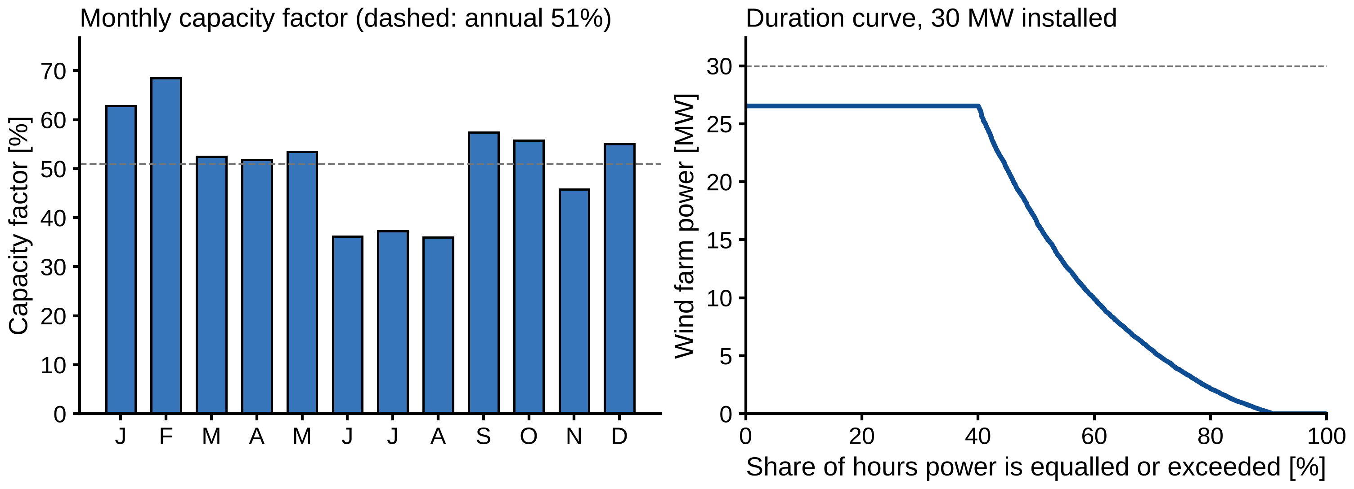
Figure S1. Wind resource at 61° N, 2° E in 2023 (ERA5). Left: monthly capacity factor of the 30 MW wind farm (dashed: annual mean). Right: duration curve of wind farm power.

S2. Gas turbine part-load performance
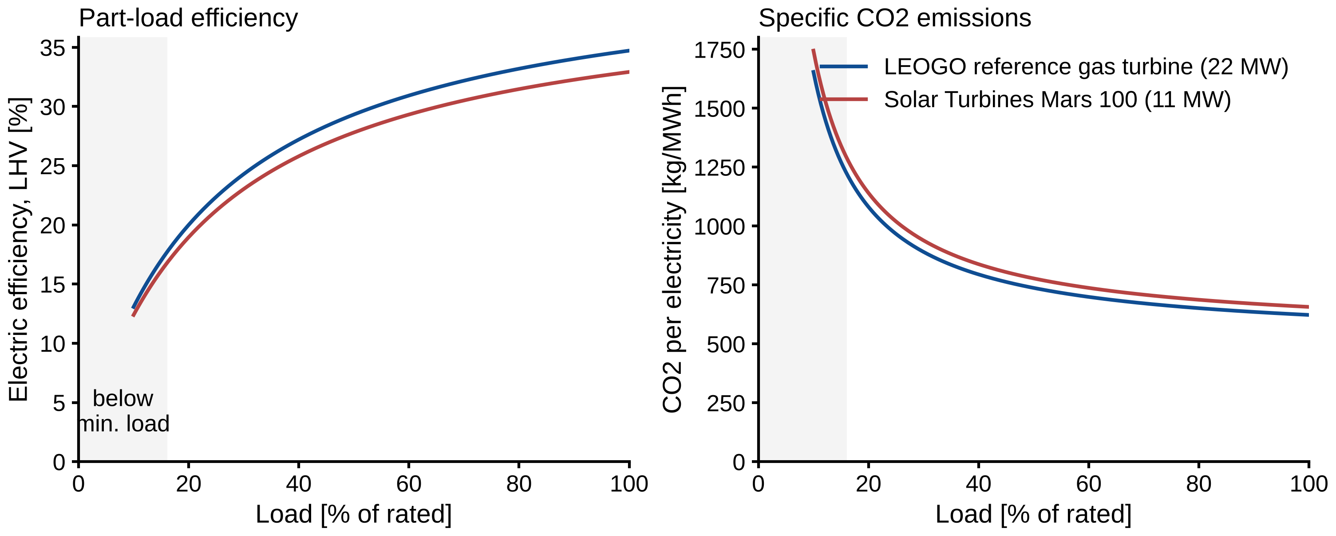
Figure S2. Part-load electric efficiency (left) and specific CO2 emission (right) of the gas turbines. Shaded: below minimum stable load. The main units follow the LEOGO reference turbine. The small unit (Solar Turbines Mars 100, 11.35 MW, 32.9 % ISO efficiency) is used only in the GT fleet sensitivity; its part-load shape is assumed equal to that of the main units.

S3. Seasonal pattern
Monthly emissions follow the wind. With fixed demand (Case 2) they range from 3.8 kt in February to 6.4 kt in June and July. The saving from flexibility (Case 2 − Case 3) is present in every month (0.43–0.77 kt). It is largest in June, December and July, months in which the wind often falls just below the demand and a second GT would otherwise be needed.
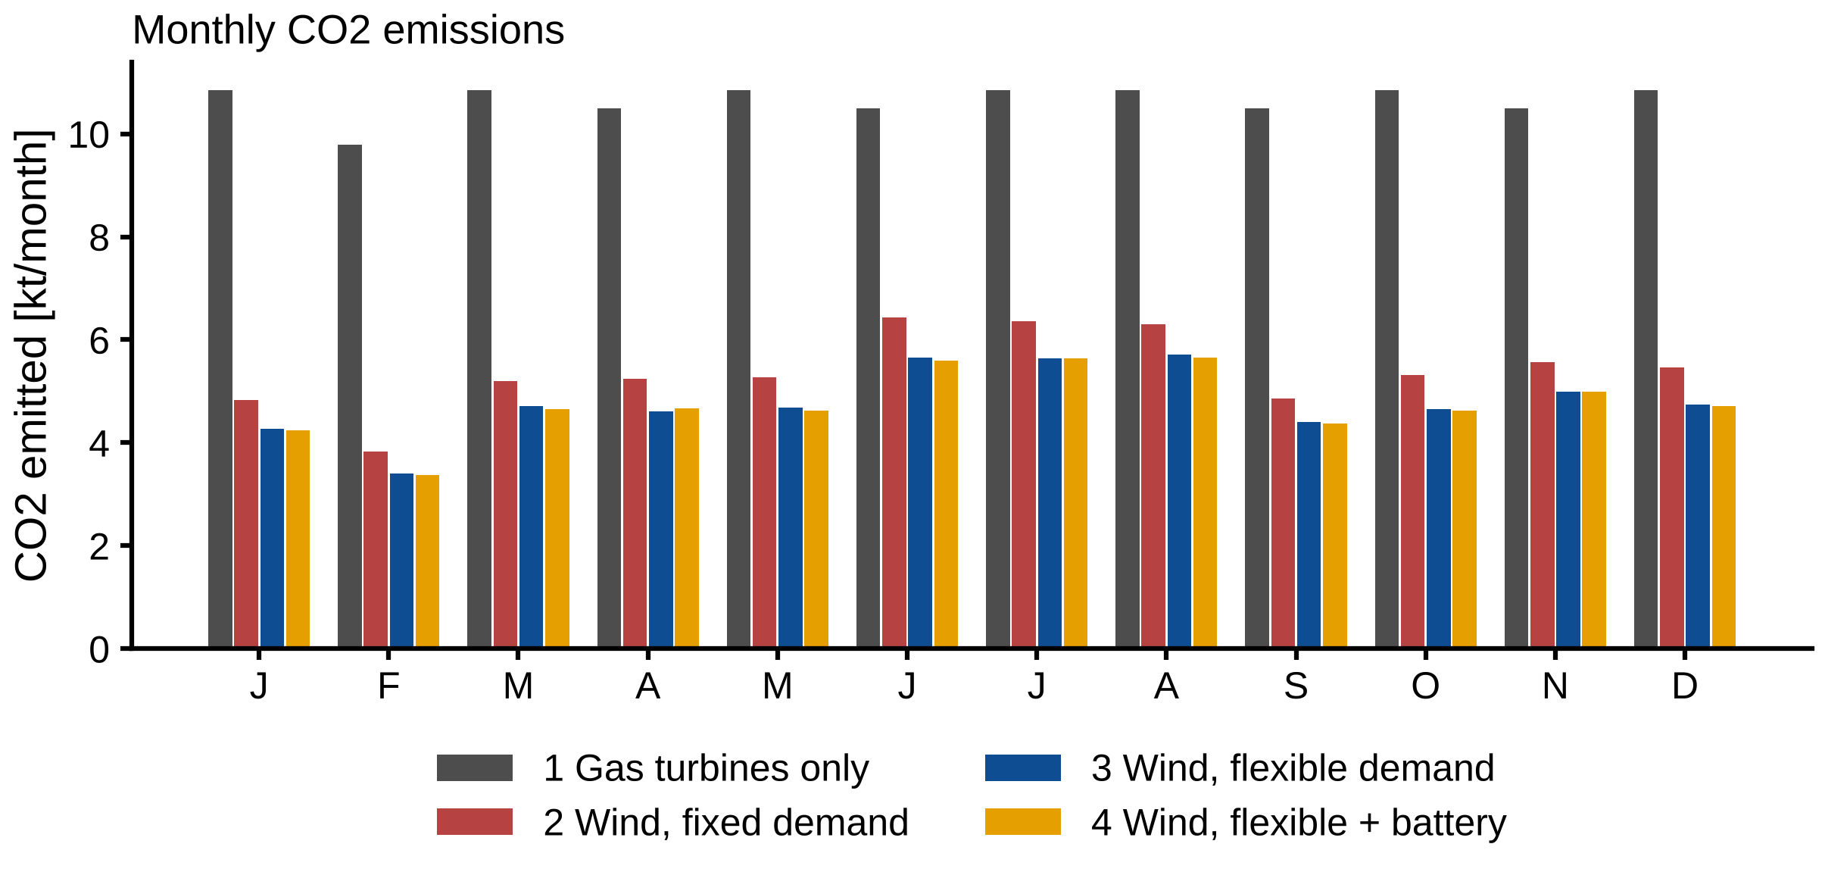
Figure S3. Monthly CO2 emissions for Cases 1–4.

S4. Model parameters
Table S1 lists every model parameter with its value, unit and source, as stored in the configuration file of the model code. Entries whose source begins with “ASSUMPTION” are not verified against a published source.
Table S1. Model parameters.
parameter | value | unit | source
site.latitude | 61.0 | deg_N | Project definition; near Snorre/Gullfaks and Hywind Tampen
site.longitude | 2.0 | deg_E | Project definition
site.year | 2023 | - | Project definition; one full calendar year of hourly data
wind.era5.reference_height | 100.0 | m | ERA5 100 m wind components (Hersbach et al., 2020, QJRMS 146:1999-2049)
wind.height_correction.hub_height | 150.0 | m | IEA-15-240-RWT hub height (Gaertner et al., 2020, NREL/TP-5000-75698)
wind.height_correction.shear_exponent | 0.11 | - | Hsu, Meindl & Gilhousen (1994), J. Appl. Meteorol. 33:757-765, near-neutral conditions at sea
wind.turbine.rated_power | 15.0e6 | W | Gaertner et al. (2020)
wind.turbine.cut_in_speed | 3.0 | m/s | Gaertner et al. (2020)
wind.turbine.cut_out_speed | 25.0 | m/s | Gaertner et al. (2020)
wind.farm.n_turbines | 2 | - | Base case choice: 30 MW installed, same order as the 32 MW wind farm of the LEOGO reference platform (Svendsen et al. (2023), LEOGO reference platform, IET Energy Syst. Integr., doi:10.1049/esi2.12085; dataset Zenodo 7373223 (values read from oogeso/tests/test_data/leogo_reference_platform.yaml)); varied in sensitivity
wind.farm.n_turbines_sensitivity | [1, 2, 3, 4] | - | Sensitivity range, 15-60 MW installed
wind.farm.wake_loss | 0.05 | - | ASSUMPTION: small cluster of 2 turbines; verify against literature
wind.farm.electrical_loss | 0.02 | - | ASSUMPTION: short subsea cable to platform; verify against literature
wind.farm.availability | 0.95 | - | ASSUMPTION: typical offshore availability; verify against literature
fuel_gas.standard_temperature | 288.15 | K | ISO 13443 standard reference conditions (15 degC)
fuel_gas.standard_pressure | 101325.0 | Pa | ISO 13443 standard reference conditions
fuel_gas.composition | {‘nitrogen’: 0.01, ‘CO2’: 0.02, ‘methane’: 0.84, ‘ethane’: 0.07, ‘propane’: 0.035, ‘i-butane’: 0.007, ‘n-butane’: 0.008, ‘i-pentane’: 0.005, ‘n-pentane’: 0.005} | mol/mol | ASSUMPTION: generic lean North Sea fuel gas; gives LHV 39.0 MJ/Sm3 vs 40 MJ/Sm3 used in LEOGO (Svendsen et al., 2023). No public field composition found
fuel_gas.co2_emission_factor | 2.34 | kg_CO2/Sm3 | LEOGO reference platform gas carrier co2_content = 2.34 kg/Sm3, citing Statistics Norway (SSB) 2016 (Svendsen et al. (2023), LEOGO reference platform, IET Energy Syst. Integr., doi:10.1049/esi2.12085; dataset Zenodo 7373223 (values read from oogeso/tests/test_data/leogo_reference_platform.yaml)). Cross-checked in code against the carbon balance of the composition.
gas_turbine.units.main.rated_power | 21800000.0 | W | Svendsen et al. (2023), LEOGO reference platform, IET Energy Syst. Integr., doi:10.1049/esi2.12085; dataset Zenodo 7373223 (values read from oogeso/tests/test_data/leogo_reference_platform.yaml)
gas_turbine.units.main.rated_efficiency | 0.3472 | - | 1/(A+B) with A = 2.35, B = 0.53 from Svendsen et al. (2023), LEOGO reference platform, IET Energy Syst. Integr., doi:10.1049/esi2.12085; dataset Zenodo 7373223 (values read from oogeso/tests/test_data/leogo_reference_platform.yaml)
gas_turbine.units.main.no_load_fuel_fraction | 0.184 | - | B/(A+B) with A = 2.35, B = 0.53 from Svendsen et al. (2023), LEOGO reference platform, IET Energy Syst. Integr., doi:10.1049/esi2.12085; dataset Zenodo 7373223 (values read from oogeso/tests/test_data/leogo_reference_platform.yaml)
gas_turbine.units.main.min_load | 0.161 | - | 3.5 MW minimum of 21.8 MW, Svendsen et al. (2023), LEOGO reference platform, IET Energy Syst. Integr., doi:10.1049/esi2.12085; dataset Zenodo 7373223 (values read from oogeso/tests/test_data/leogo_reference_platform.yaml)
gas_turbine.units.main.n_installed | 3 | - | Svendsen et al. (2023), LEOGO reference platform, IET Energy Syst. Integr., doi:10.1049/esi2.12085; dataset Zenodo 7373223 (values read from oogeso/tests/test_data/leogo_reference_platform.yaml)
gas_turbine.units.main.heat_recovery_efficiency | 0.5 | - | Share of (fuel - electricity) recovered as useful heat, eta_heat in Svendsen et al. (2023), LEOGO reference platform, IET Energy Syst. Integr., doi:10.1049/esi2.12085; dataset Zenodo 7373223 (values read from oogeso/tests/test_data/leogo_reference_platform.yaml)
gas_turbine.units.small.rated_power | 11350000.0 | W | Solar Turbines, Mars 100 oil and gas power generation package: 11,350 kWe at ISO conditions (https://www.solarturbines.com/en_US/products/oil-and-gas-power-generation-packages/mars-100.html, accessed 27 October 2026)
gas_turbine.units.small.rated_efficiency | 0.3292 | - | 3600/10935 from the ISO heat rate of 10,935 kJ/kWe-h (10,365 Btu/kWe-h) at the generator terminals, Solar Turbines Mars 100 product page
gas_turbine.units.small.no_load_fuel_fraction | 0.184 | - | ASSUMPTION: same relative part-load shape as the LEOGO turbine (Svendsen et al., 2023); no OEM part-load curve published
gas_turbine.units.small.min_load | 0.161 | - | ASSUMPTION: same minimum-load fraction as the LEOGO turbine (Svendsen et al., 2023), i.e. 1.8 MW
gas_turbine.units.small.n_installed | 1 | - | Fleet sensitivity: one small unit
gas_turbine.units.small.heat_recovery_efficiency | 0.5 | - | Same as LEOGO turbine (Svendsen et al., 2023)
gas_turbine.low_load_threshold | 0.5 | - | ASSUMPTION: load fraction below which a GT hour is counted as low-load (inefficient)
gas_turbine.min_units_running | 2 | - | ASSUMPTION: N+1 redundancy common on Norwegian platforms; fixed per case later
gas_turbine.spinning_reserve | 5000000.0 | W | el_reserve_margin = 5 MW in Svendsen et al. (2023), LEOGO reference platform, IET Energy Syst. Integr., doi:10.1049/esi2.12085; dataset Zenodo 7373223 (values read from oogeso/tests/test_data/leogo_reference_platform.yaml)
process.reservoir_fluid.components | {‘nitrogen’: 0.5, ‘CO2’: 1.5, ‘methane’: 45.0, ‘ethane’: 6.0, ‘propane’: 4.0, ‘i-butane’: 0.8, ‘n-butane’: 1.8, ‘i-pentane’: 0.7, ‘n-pentane’: 0.9, ‘n-hexane’: 1.0} | mol (relative) | ASSUMPTION: generic North Sea black oil, GOR about 180 Sm3/Sm3; replace with a published field fluid
process.reservoir_fluid.tbp_fractions | {‘C7’: [2.5, 0.0913, 0.746], ‘C8’: [2.5, 0.1041, 0.768], ‘C10’: [4.0, 0.135, 0.79], ‘C15’: [6.0, 0.206, 0.832], ‘C20’: [5.0, 0.282, 0.856], ‘C30’: [6.0, 0.4, 0.88]} | [mol (relative), kg/mol, g/cm3] | ASSUMPTION: generic heavy-end split; replace with a published field fluid
process.design.oil_rate | 15000.0 | Sm3/d | ASSUMPTION: mid-size North Sea platform, plateau rate
process.design.water_cut | 0.4 | - | ASSUMPTION: water fraction of produced liquid at standard conditions
process.design.water_injection_rate | 25000.0 | Sm3/d | ASSUMPTION: roughly voidage replacement
process.design.well_temperature | 70.0 | degC | ASSUMPTION: arrival temperature at the inlet separator
process.pressures.separators | [70.0, 29.0, 7.2, 1.8] | bara | Nguyen et al. (2013), Energy 62:23-36, Table 1: separation train at 7 / 2.9 / 0.72 / 0.18 MPa (generic North Sea platform). Last stage 1.7-2.8 bar on four real North Sea platforms (Voldsund et al. (2014), Energy 74:45-58, Table 2)
process.pressures.gas_export | 180.0 | bara | Voldsund et al. (2014), Energy 74:45-58, Table 2: treated gas at 179 bar on platform D (236, 118 and 184 bar on A-C); Nguyen et al. (2013), Table 1: gas export 18.5 MPa. LEOGO uses 200 bar (sensitivity)
process.pressures.oil_export | 50.0 | bara | 5 MPa oil export pressure, Svendsen et al. (2023), LEOGO reference platform, IET Energy Syst. Integr., doi:10.1049/esi2.12085; dataset Zenodo 7373223 (values read from oogeso/tests/test_data/leogo_reference_platform.yaml)
process.pressures.water_injection | 250.0 | bara | 25 MPa injection pressure, Svendsen et al. (2023), LEOGO reference platform, IET Energy Syst. Integr., doi:10.1049/esi2.12085; dataset Zenodo 7373223 (values read from oogeso/tests/test_data/leogo_reference_platform.yaml)
process.pressures.wi_suction | 7.0 | bara | 0.7 MPa water deck pressure, Svendsen et al. (2023), LEOGO reference platform, IET Energy Syst. Integr., doi:10.1049/esi2.12085; dataset Zenodo 7373223 (values read from oogeso/tests/test_data/leogo_reference_platform.yaml)
process.pressures.seawater_lift | 10.4 | bar | 0.1 -> 1.14 MPa incl. 40 m lift, Svendsen et al. (2023), LEOGO reference platform, IET Energy Syst. Integr., doi:10.1049/esi2.12085; dataset Zenodo 7373223 (values read from oogeso/tests/test_data/leogo_reference_platform.yaml)
process.cooling.gas_cooler_outlet | 30.0 | degC | ASSUMPTION: scrubber inlet temperature
process.cooling.seawater_temperature_rise | 10.0 | K | ASSUMPTION: typical cooling-water design
process.cooling.seawater_cp | 3.99 | kJ/kg/K | Sharqawy, Lienhard & Zubair (2010), Desalin. Water Treat. 16:354-380; salinity 35 g/kg, 10-20 degC
process.cooling.seawater_density | 1026.0 | kg/m3 | Sharqawy, Lienhard & Zubair (2010); salinity 35 g/kg, about 15 degC
process.efficiencies.compressor_isentropic | 0.75 | - | Isentropic efficiency of export and re-compressors, Svendsen et al. (2023), LEOGO reference platform, IET Energy Syst. Integr., doi:10.1049/esi2.12085; dataset Zenodo 7373223 (values read from oogeso/tests/test_data/leogo_reference_platform.yaml)
process.efficiencies.water_pump | 0.75 | - | Water injection and seawater lift pumps, Svendsen et al. (2023), LEOGO reference platform, IET Energy Syst. Integr., doi:10.1049/esi2.12085; dataset Zenodo 7373223 (values read from oogeso/tests/test_data/leogo_reference_platform.yaml)
process.efficiencies.oil_export_pump | 0.6 | - | Oil export pump, Svendsen et al. (2023), LEOGO reference platform, IET Energy Syst. Integr., doi:10.1049/esi2.12085; dataset Zenodo 7373223 (values read from oogeso/tests/test_data/leogo_reference_platform.yaml)
process.efficiencies.motor_and_drive | 1.0 | - | Included in the LEOGO efficiencies above
process.consumers.recompression.min_flow | 0.7 | - | ASSUMPTION: surge margin; no public value found; verify
process.consumers.export_compressor.min_flow | 0.7 | - | ASSUMPTION: surge margin; no public value found; verify
process.consumers.oil_export_pump.min_flow | 0.3 | - | ASSUMPTION: pump minimum continuous flow; no public value found; verify
process.consumers.water_injection_pump.min_flow | 0.3 | - | ASSUMPTION: pump minimum continuous flow; no public value found; verify
process.consumers.seawater_lift_pump.min_flow | 0.3 | - | ASSUMPTION: pump minimum continuous flow; no public value found; verify
process.base_load | 3.5 | MW | 2.5 MW general electric load + 1.0 MW air compressors, Svendsen et al. (2023), LEOGO reference platform, IET Energy Syst. Integr., doi:10.1049/esi2.12085; dataset Zenodo 7373223 (values read from oogeso/tests/test_data/leogo_reference_platform.yaml)
process.heat_demand | 3.0 | MW | Process/utility heat demand (thermal), Svendsen et al. (2023), LEOGO reference platform, IET Energy Syst. Integr., doi:10.1049/esi2.12085; dataset Zenodo 7373223 (values read from oogeso/tests/test_data/leogo_reference_platform.yaml); met by GT waste heat or an electric heater
flexibility.production.min_fraction | 0.5 | - | ASSUMPTION: lowest stable production turndown (separator / well limits); verify
flexibility.production.max_fraction | 1.0 | - | Design rate; no over-production to catch up
flexibility.production.ramp_rate | 0.1 | 1/h | ASSUMPTION: max change in production fraction per hour (well choke / process stability); verify
flexibility.water_injection.min_fraction | 0.0 | - | ASSUMPTION: all injection pumps may stop for short periods
flexibility.water_injection.max_fraction | 1.0 | - | Installed pump capacity (design point)
flexibility.water_injection.target_fraction | 0.85 | - | ASSUMPTION: average injection needed for voidage replacement, as fraction of pump capacity
flexibility.water_injection.ramp_rate | 0.34 | 1/h | ASSUMPTION: about one of three pumps started/stopped per hour
flexibility.water_injection.max_deficit | 72.0 | h | ASSUMPTION: up to 3 days of full-rate injection may be postponed without significant reservoir pressure loss; key sensitivity
economics.oil_price | 4190.0 | NOK/Sm3 | Oil export price in Svendsen et al. (2023), LEOGO reference platform
economics.gas_price | 4.19 | NOK/Sm3 | Gas export price in Svendsen et al. (2023), LEOGO; also the value of fuel gas burned instead of exported
economics.co2_price | 2.0 | NOK/kg_CO2 | NOK 2000/t: Norwegian target total CO2 price (tax + EU ETS) by 2030, Meld. St. 13 (2020-2021) Klimaplan 2021-2030; varied in sensitivity
economics.gt_start_cost | 2000.0 | NOK | penalty_start in Svendsen et al. (2023), LEOGO
economics.unserved_energy_cost | 1000000.0 | NOK/MWh | Modelling choice: feasibility penalty, high enough that the 0.5 % MIP gap cannot leave demand unserved (LEOGO uses 36000 NOK/MWh for load shedding); should never be used
economics.reserve_shortfall_cost | 1000000.0 | NOK/MWh | Modelling choice: same feasibility penalty as unserved energy; should never be used
economics.gas_per_oil_equivalent | 1000.0 | Sm3_gas/Sm3_oe | Norwegian Offshore Directorate (Sodir) convention: 1000 Sm3 gas = 1 Sm3 oil equivalent
investment.discount_rate | 0.07 | - | Real discount rate; 4 % and 7 % are both used in the Norwegian Petroleum Directorate’s abatement-cost curves for power from shore (NPD conference abstract, IAEE); 4 % shown as sensitivity
investment.discount_rate_low | 0.04 | - | Lower real discount rate used in the same NPD abatement-cost curves
investment.lifetime | 20 | yr | ASSUMPTION: economic life of a retrofit wind farm on a producing field (remaining field life)
investment.wind_capex | 84.1 | NOK/W | Hywind Tampen: investment forecast of about NOK 7.4 billion for 88 MW at opening (Equinor, 23 Aug 2023), i.e. 84.1 MNOK/MW before Enova and NOx Fund support; first-of-a-kind floating farm
investment.wind_om_low | 35.0 | EUR/kW/yr | Floating wind O&M with self-hoisting crane strategy, up to 64 % below the tow-to-port cost (Dighe et al., J. Mar. Sci. Eng. 2024, 12(11):1948, Marram Wind and Celtic Sea C case study)
investment.wind_om_high | 97.0 | EUR/kW/yr | Floating wind O&M with tow-to-port repair strategy, 94-97 kEUR/MW/yr (Dighe et al., J. Mar. Sci. Eng. 2024, 12(11):1948)
investment.eur_nok | 11.5 | NOK/EUR | ASSUMPTION: approximate 2024-2025 exchange rate
investment.power_from_shore_abatement_cost | 2000.0 | NOK/t_CO2 | Norwegian Offshore Directorate (2025): operators’ estimated abatement cost of the most recently approved power-from-shore projects (Melkøya, Njord/Draugen) just under NOK 2000 per tonne CO2 (2025-NOK); taken from a search summary, verify in the report. The 2020 report gave below NOK 1500/t for the then-planned projects
scheduler.window_hours | 168 | h | Modelling choice: one week committed per solve
scheduler.lookahead_hours | 24 | h | Modelling choice: extra day solved but not committed, so end-of-week decisions are sensible
scheduler.mip_gap | 0.005 | - | Modelling choice: solver stops within 0.5 % of the proven optimum
scheduler.time_limit | 120 | s | Modelling choice: per weekly solve
scheduler.min_gt_online | 1 | - | ASSUMPTION: wind turbines are grid-following; at least one GT online for frequency/voltage control (as on Hywind Tampen platforms)
scheduler.electric_heater_efficiency | 0.99 | - | ASSUMPTION: resistive electric heater
scheduler.heater_tiebreak_cost | 0.1 | NOK/MWh | Modelling choice: tiny cost so surplus wind is curtailed rather than dumped in the heater; does not change real decisions
scheduler.battery.power | 0.0 | W | Set per case; LEOGO option is 4 MW / 4 MWh (Svendsen et al., 2023)
scheduler.battery.energy | 0.0 | J | Set per case; LEOGO option is 4 MW / 4 MWh (Svendsen et al., 2023)
scheduler.battery.round_trip_efficiency | 0.9 | - | eta = 0.9 in Svendsen et al. (2023), LEOGO
scheduler.battery.reserve_duration | 1800.0 | s | reserve_storage_minutes = 30 in Svendsen et al. (2023), LEOGO: stored energy must sustain the reserve for 30 min
cases.battery_size.power | 4.0 | MW | LEOGO battery option 4 MW / 4 MWh (Svendsen et al., 2023)
cases.battery_size.energy | 4.0 | MWh | LEOGO battery option 4 MW / 4 MWh (Svendsen et al., 2023)
validation.tolerance | 0.2 | - | Modelling choice: +/-20 % counts as agreement for single published values
validation.bbl_per_Sm3 | 6.2898 | bbl/Sm3 | Standard conversion, 1 Sm3 = 6.2898 bbl (Norwegian Offshore Directorate)
validation.benchmarks.platform_power_voldsund | [17.0, 30.0] | MW | Voldsund et al. (2014), Energy 74:45-58, Table 5: power input to the processing plants of three real North Sea oil platforms, 25 / 30 / 17 MW (A, C, D; B is a gas-condensate platform, 5.5 MW). Platform A is the platform of Voldsund et al. (2013), Energy 55:716-727: about 24 MW for processing and about 34 MW for the whole platform
validation.benchmarks.platform_power_nguyen | [22.6, 31.1] | MW | Nguyen et al. (2013), Energy 62:23-36, Table 6 and text: platform power consumption 22.6-31.1 MW over six North Sea reservoir-fluid cases
validation.benchmarks.platform_power_castberg | 25.0 | MW | Johan Castberg PDO part II impact assessment: about 25 MW average, 50 MW peak (via search summary; verify)
validation.benchmarks.platform_power_hywind_tampen | 25.1 | MW | Implied: 384 GWh/yr expected from Hywind Tampen covers about 35 % of the electricity of 5 platforms (Snorre A/B, Gullfaks A/B/C) -> 384/0.35/8760/5 = 25.1 MW per platform (SNL; Equinor)
validation.benchmarks.wind_capacity_factor_tampen_design | 0.498 | - | Hywind Tampen expected 384 GWh/yr from 88 MW (SNL, Hywind Tampen) -> 0.498
validation.benchmarks.wind_capacity_factor_tampen_q1_2025 | 0.584 | - | Equinor via Norwegian Offshore Wind: 58.4 % capacity factor in Q1 2025 (winter quarter)
validation.benchmarks.co2_avoided_per_wind_mwh | 0.52 | t/MWh | Hywind Tampen: about 200 kt CO2/yr avoided (Equinor FID) for 384 GWh/yr expected (SNL) -> 0.52 t/MWh
validation.benchmarks.co2_avoided_per_wind_mwh_2gt | 0.52 | t/MWh | Same Hywind Tampen benchmark (200 kt / 384 GWh), compared with the model run that keeps 2 GTs online (sensitivity gt_operation_practice)
validation.benchmarks.co2_intensity_ncs_2023 | 7.3 | kg/boe | Offshore Norge climate and environmental report 2024: NCS average 7.3 kg CO2/boe in 2023
validation.benchmarks.co2_intensity_non_electrified | 10.5 | kg/boe | Westwood Global Energy (2022 estimate): about 10.5 kg CO2/boe for non-electrified NCS hubs
validation.benchmarks.leogo_water_injection | 8.99 | kWh/m3 | LEOGO: 8.97 MW for 0.277 m3/s at 0.7 -> 25 MPa, eta 0.75 (Svendsen et al., 2023; leogo_resultobject.json in Oogeso)

