Web-SSO between Java webapp CAS-ified and Liferay with CAS
Technical guidelines
Version 1.00 – 28/07/2011

File | 0000.doc
Author | RC | Roger CARHUATOCTO | IN2 Portal Specialist
Reviewer | SP | Sonia PEREZ DIEZ | Project Manager

Version history

Version | Date | Author | Contributors | Change Summary
1.00 | 13/10/2010 | RC |  | Document creation

References

Ref. | Version | Date | File Name
R1 | 1.01 | 01/09/2010 | OHIM-ITD-OHIMPortal-TOAD-v1.01-EN.doc
R2 | 1.00 | 19/10/2010 | OHIM-ITD-OHIMPortal-SAD-1.0-EN_rev3.doc

Table of Contents
1 Overview 4
1.1 Introduction 4
1.2 Objectives 4
2 Use cases when CAS-ifying web applications 5
2.2 Use case: Web-SSO 5
2.3 Use case: Web Single Sign Off or Single Log Out 5
2.4 Use case: Logout 6
3 CAS-ifying Java Web Applications 7
3.1 Overview of installation and deployment process of CAS-ified webapp 7
3.2 Scenario 7
4 Guidelines 9
4.1 Step 4: CAS service manager 9
4.2 Step 5: Develop your Java Webapp and configure Tomcat 10
4.3 Step 6: Connect your Java Webapp to CAS 12

List of Figures
Figure 1 – CAS use case: Authentication of webapp 5
Figure 2 – Overview of installation and development process of CAS-ified webapp 7
Figure 3 – Scenario where we will deploy our CAS-ified webapp. 8
Figure 4 – Task to do with/in webapp 9
Figure 5 – Define URL for CAS-ified webapp 10
Figure 6 – Define URL to filter webapp to do SSO 10
Figure 7 – CAS-client java libraries to be included in webssotest1.war 14
Figure 8 – First login: Liferay 15
Figure 9 – Successfully authentication in Liferay 15
Figure 10 – Successfully Web-SSO in CAS-ified webapp (webssotest1.war) 16

Overview

Introduction
The new OHIM Portal will be the gateway to entry for the vertical business applications. It will replace old MyPage Portal and Authentication and Web-SSO functionalities.
Existing Java webapps will need to be integrated in the new Portal sharing current Authentication and Web-SSO service.
This document explains how to create new java web applications knowing that they will use the AuthN service and will Web-SSO with Liferay.
Although, this document is for new java web applications, existing web applications (based in java, php,. net, ...) can also use it as this document explains the most important steps to perform. This document can be taken as a set of best practices (including source code) when you want to integrate with CAS.

Objectives
The objectives and scope of this document are:
- Learn how to integrate new java web application into CAS.
- Learn how to do Web-SSO between java web application and existing Liferay Portal integrated with CAS.
- Learn what you need to do in CAS for sharing session or implementing Web-SSO.
This document does not say how to do Single Sign Out or logout, but we will include an options for that. We will include some details in next version of document.

Use cases when CAS-ifying web applications

Use case: Authentication
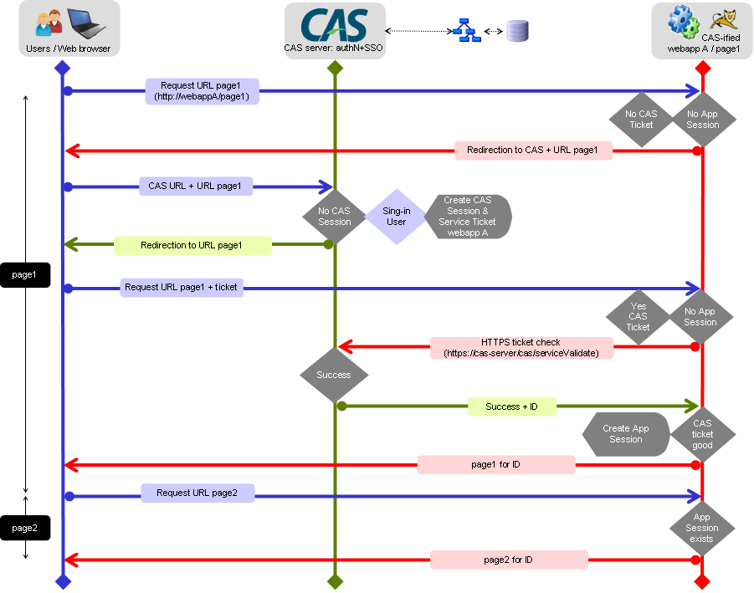
Figure 1 – CAS use case: Authentication of webapp

Use case: Web-SSO
To perform Web-SSO, we will need 2 webapps, the first one is Liferay, and the second one is webappA. Both should be authenticated with CAS-server.
The main difference between authentication and web-sso processes is that CAS shares authenticated session through CAS Service Manager.

Use case: Web Single Sign Off or Single Log Out
Single Sign Out or Single Log Out mean that CAS-server contacts each webapp and notifies them that you have logged out. Then you should invalidate or delete all cookies stored in your web browser.
This protocol is implemented in Java CAS client library only.

Use case: Logout
To perform a logout means (involves) to close authenticated session in CAS-server side. Afterwards, you will need to make sure that the cookie does not exist in your web browser.

CAS-ifying Java Web Applications

Overview of installation and deployment process of CAS-ified webapp
When you install and deploy any web application in an environment where Web-SSO is enabled, you should to following steps.
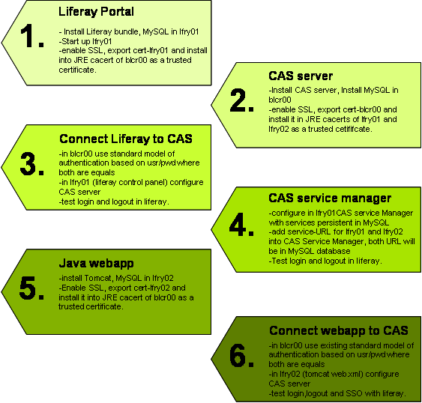
Figure 2 – Overview of installation and development process of CAS-ified webapp

Scenario
We define typical scenario where will deploy our CAS-ified webapp, in this case, we will deploy into lfry02 with Apache Tomcat as Java Web Server.
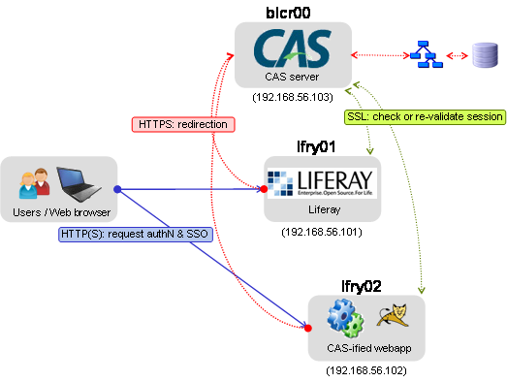
Figure 3 – Scenario where we will deploy our CAS-ified webapp.
These recommendations are applied on the following environment where we will have 3 Servers:
- lfry01, “the Liferay Portal server” :
- Bundle of Liferay 6.0.5 CE with Apache Tomcat 6.0.26
- JRE 1.6.0_21 is included into Liferay-Tomcat bundle but no JDK. JRE is enough in this scenario.
- MySQL 5.1.41 Community Server
- lfry02, “the new java web application”:
- Tomcat 6.0.26.
- CAS client for java 3.1.12
- The Java Web application included in this document.
- blcr00, “CAS server”:
- Tomcat 6.0.26
- CAS server 3.4.3 bundle
- MySQL 5.1.41 Community Server

Guidelines
The points 1, 2, 3 and 4 of Figure 2 have already been made (see Figure 2) and it is only pending to explain how to configure CAS-client, the webapp.

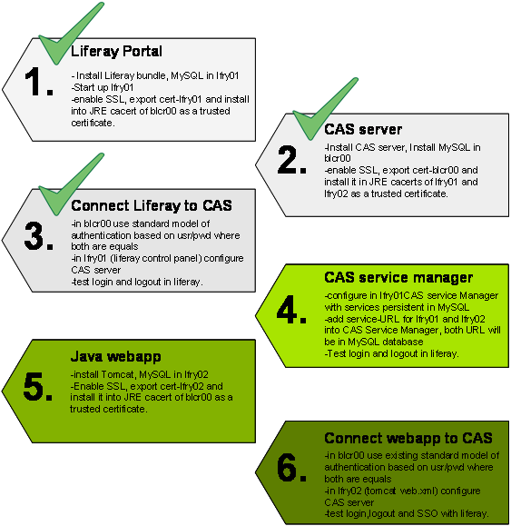
Figure 4 – Task to do with/in webapp

Follow the next steps:

Step 4: CAS service manager
- Define an URL for the new web application. The “URL Service”:
- Identify the CAS-ified webapp trying to authenticate in CAS-server. In almost all cases, this will be the URL of the web application.
- In a successfully login process is used to redirect web browser to URL specified.
- It is used as filter for CAS Services Management in Web-SSO process allowing to do SSO between webapps registered.
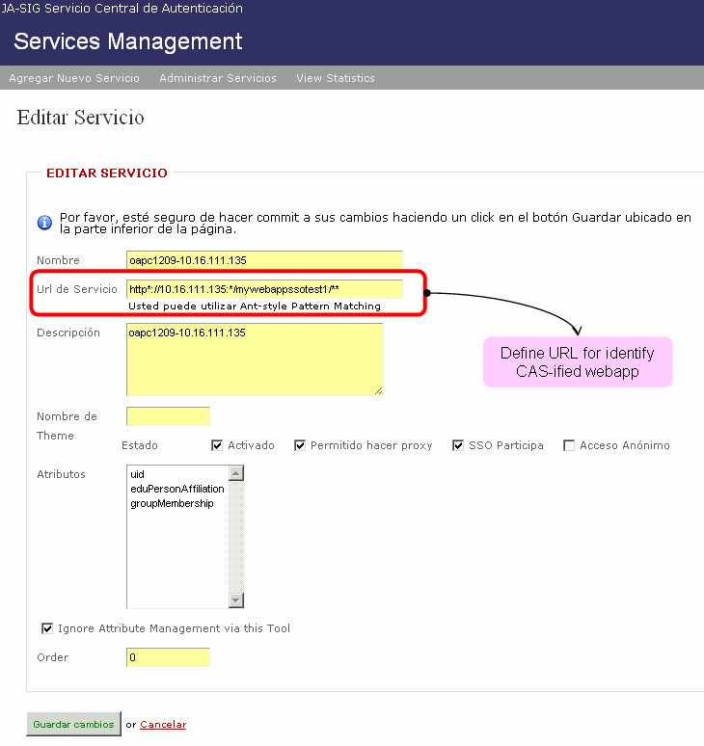
Figure 5 – Define URL for CAS-ified webapp

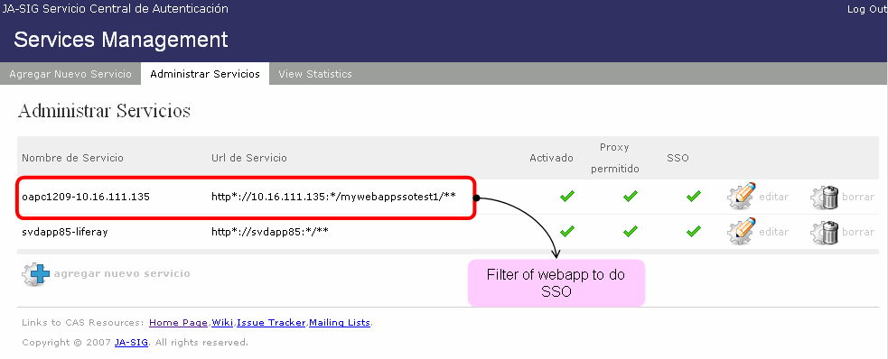
Figure 6 – Define URL to filter webapp to perform SSO

Step 5: Develop your Java Webapp and configure Tomcat
- Install Tomcat, enable SSL (lfry02) using server.xml sample:

<?xml version='1.0' encoding='utf-8'?>
<Server port="8005" shutdown="SHUTDOWN">
<Listener className="org.apache.catalina.core.AprLifecycleListener" SSLEngine="on" />
<Listener className="org.apache.catalina.core.JasperListener" />
<Listener className="org.apache.catalina.core.JreMemoryLeakPreventionListener" />
<Listener className="org.apache.catalina.mbeans.ServerLifecycleListener" />
<Listener className="org.apache.catalina.mbeans.GlobalResourcesLifecycleListener" />
<GlobalNamingResources>
<Resource name="UserDatabase" auth="Container"
type="org.apache.catalina.UserDatabase"
description="User database that can be updated and saved"
factory="org.apache.catalina.users.MemoryUserDatabaseFactory"
pathname="conf/tomcat-users.xml" />
</GlobalNamingResources>
<Service name="Catalina">
<Connector port="8080" protocol="HTTP/1.1"
connectionTimeout="20000"
redirectPort="8443" />
<Connector protocol="org.apache.coyote.http11.Http11NioProtocol"
port="8443" maxHttpHeaderSize="8192" SSLEnabled="true"
maxThreads="150"
enableLookups="false" disableUploadTimeout="true"
acceptCount="100" scheme="https" secure="true"
clientAuth="false" sslProtocol="TLS"
keystoreFile="D:\devel\usr-dev\apache-tomcat-6.0.29\webapps\mywebappssotest1.jks"
keystorePass="changeit"
truststoreFile="D:\devel\usr-dev\jdk_6u21\Java\lib\security\cacerts" />
<!-- My CAS URL service = https://localhost:8443/webssotest1/protected/ -->
<Connector port="8009" protocol="AJP/1.3" redirectPort="8443" />
<Engine name="Catalina" defaultHost="localhost">
<Realm className="org.apache.catalina.realm.UserDatabaseRealm"
resourceName="UserDatabase"/>
<Host name="localhost" appBase="webapps"
unpackWARs="true" autoDeploy="true"
xmlValidation="false" xmlNamespaceAware="false">
</Host>
</Engine>
</Service>
</Server>

- Generate key pair and export certificate SSL of this Tomcat (lfry02).
- Install CAS root certificate (blcr00) as trusted cert into JVM cacert repository of Tomcat (lfry02).
- Use this Java webapp (webssotest1.war), deploy this webapp into Java Web Server (lfry02).
- Test this web application in HTTP and HTTPS mode.

Step 6: Connect your Java Webapp to CAS
We have created a basic sample of java web application based in JSP (webssptest1.war). We recommend that you try to deploy and configure this web application before trying something more complex.

- In blcr00 use existing standard model of authentication based on usr/pwd where both are equals. If Liferay has already used this model, this webapp should follow too.
- In lfry02 (tomcat web.xml) configure CAS server, to use this sample file:

<?xml version="1.0" encoding="UTF-8"?>
<web-app id="webssotest1"
version="2.4"
xmlns="http://java.sun.com/xml/ns/j2ee"
xmlns:xsi="http://www.w3.org/2001/XMLSchema-instance"
xsi:schemaLocation="http://java.sun.com/xml/ns/j2ee http://java.sun.com/xml/ns/j2ee/web-app_2_4.xsd">
<display-name>webssotest1</display-name>
<description>
WebSSO sample, how to use CAS Java Client 3.x.
In this sample exists a public area (/)
and a private area (/protected/*).
</description>

<filter>
<filter-name>CAS Authentication Filter</filter-name>
<filter-class>org.jasig.cas.client.authentication.AuthenticationFilter</filter-class>
<init-param>
<param-name>casServerLoginUrl</param-name>
<param-value>https://svdapp85:6443/cas-server-webapp-3.3.5/login</param-value>
</init-param>
<init-param>
<param-name>serverName</param-name>
<param-value>https://10.16.111.135:8443</param-value>
</init-param>
<init-param>
<param-name>renew</param-name>
<param-value>false</param-value>
</init-param>
<init-param>
<param-name>gateway</param-name>
<param-value>false</param-value>
</init-param>
</filter>
<filter>
<filter-name>CAS Validation Filter</filter-name>
<filter-class>org.jasig.cas.client.validation.Cas20ProxyReceivingTicketValidationFilter</filter-class>
<init-param>
<param-name>casServerUrlPrefix</param-name>
<param-value>https://svdapp85:6443/cas-server-webapp-3.3.5/</param-value>
</init-param>
<init-param>
<param-name>serverName</param-name>
<param-value>https://10.16.111.135:8443</param-value>
</init-param>
<init-param>
<param-name>proxyCallbackUrl</param-name>
<param-value>https://svdapp85:6443/cas-server-webapp-3.3.5/proxyCallback</param-value>
</init-param>
<init-param>
<param-name>proxyReceptorUrl</param-name>
<param-value>/mywebappssotest1/proxyCallback</param-value>
</init-param>
</filter>
<filter>
<filter-name>CAS HttpServletRequest Wrapper Filter</filter-name>
<filter-class>org.jasig.cas.client.util.HttpServletRequestWrapperFilter</filter-class>
</filter>
<filter>
<filter-name>CAS Assertion Thread Local Filter</filter-name>
<filter-class>org.jasig.cas.client.util.AssertionThreadLocalFilter</filter-class>
</filter>
<filter-mapping>
<filter-name>CAS Authentication Filter</filter-name>
<url-pattern>/protected/*</url-pattern>
</filter-mapping>
<filter-mapping>
<filter-name>CAS Validation Filter</filter-name>
<url-pattern>/*</url-pattern>
</filter-mapping>
<filter-mapping>
<filter-name>CAS HttpServletRequest Wrapper Filter</filter-name>
<url-pattern>/*</url-pattern>
</filter-mapping>
<filter-mapping>
<filter-name>CAS Assertion Thread Local Filter</filter-name>
<url-pattern>/*</url-pattern>
</filter-mapping>
<filter-mapping>
<filter-name>CAS Validation Filter</filter-name>
<url-pattern>/proxyCallback</url-pattern>
</filter-mapping>

<welcome-file-list>
<welcome-file>index.jsp</welcome-file>
</welcome-file-list>
</web-app>

- Make sure that exists CAS-client java libraries into WEB-INF/lib directory, as follow:

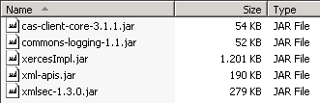
Figure 7 – CAS-client java libraries to be included in webssotest1.war

- Test login and SSO with liferay.

Login to Liferay (lfry01), go to follow URL, for example: http://svdapp85:6060/en/group/ohim/home
To entry an user/password valid in CAS-server.

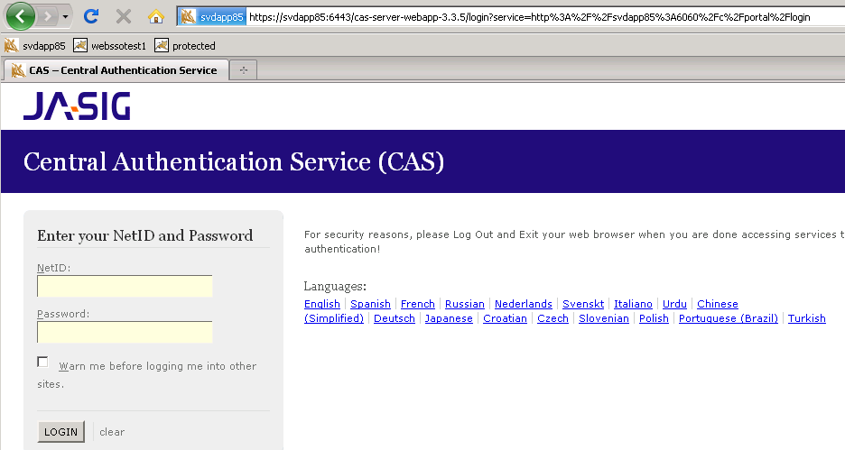
Figure 8 – First login: Liferay

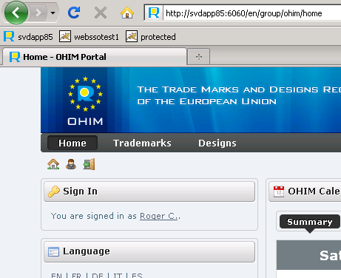
Figure 9 – Successfully authentication in Liferay

Now, from same opened browser, switch to the CAS-ified webapp. Open following protected URL: http://10.16.111.135:8080/webssotest1/protected/
Then you can see URL without user/pwd prompted.
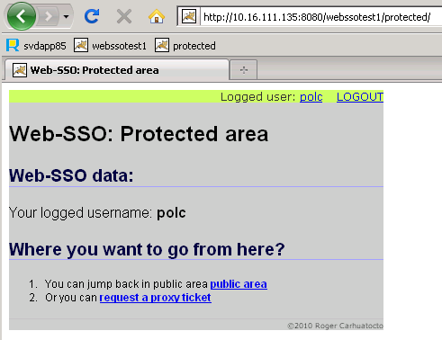
Figure 10 – Successfully Web-SSO in CAS-ified webapp (webssotest1.war)
The same applies if you do log into webssotest1.war first and then go to liferay.
The CAS login form is the first page displayed when trying to login from any application. This form is shared by any web application you want to do Web-SSO.

