STANDARDIZED TESTING, INTERVIEW AND QUESTIONNAIRE RESULTS
This report provides a summary of the following tests, questionnaires, and clinical interviews that were administered during participation in the study. Areas assessed include general cognitive ability, academic achievement, language, fine motor coordination and executive functioning. Clinical interviews and questionnaires were used to assess social, emotional and behavioral functioning. Please reference Appendix A for a full description of the measures administered in the Healthy Brain Network research protocol.
Wechsler Intelligence Scale for Children, 5th Edition (WISC-V)-
Vocabulary, Similarities, Block Design, Visual Puzzles, Matrix Reasoning, Figure Weights, Digit Span, Picture Memory, Coding, Symbol Search
Administered on: {{WISC_V_ADMINISTER_DATE}}
Wechsler Individual Achievement Test, 4th Edition (WIAT-4)-
Word Reading, Reading Comprehension, Pseudoword Decoding, Listening Comprehension, Spelling, Numerical Operations, Math Problem Solving, Math Fluency Subtests
Administered on: {{WIAT_4_MAIN_ADMINISTER_DATE}}
Wechsler Individual Achievement Test, 4th Edition (WIAT-4)-
Sentence Composition, Essay Composition
Administered on: {{WIAT_4_ESSAY_ADMINISTER_DATE}}
Test of Word Reading Efficiency-2nd Edition (TOWRE-2)
Administered on: {{TOWRE_2_ADMINISTER_DATE}}
Clinical Evaluation of Language Fundamentals - 5th Edition Screener (CELF-5 Screener)
Administered on: {{CELF_5_ADMINISTER_DATE}}
Comprehensive Test of Phonological Processing - 2nd Edition (CTOPP-2)
Administered on: {{CTOPP_2_ADMINISTER_DATE}}
Kiddie Schedule for Affective Disorders and Schizophrenia (K-SADS) -
Child Behavior Checklist - Parent Report Form (CBCL)
Extended Strengths and Weaknesses of ADHD Symptoms and Normal Behavior Scale (ESWAN)
Conners 3 Child Self-Report Assessment Form
Social Responsiveness Scale - 2 (SRS)
Mood and Feelings Questionnaire (MFQ) -
Child and Parent Report Forms
Screen for Child Anxiety and Related Disorders (SCARED) -
Child and Parent Report Forms

What do the scores represent?
Standard scores, T scores, and percentile ranks can indicate {{FIRST_NAME_POSSESSIVE}} performance compared to other children in the same age or same grade (see Figure below). A standard score of 100 is the mean of the normative sample (individuals in the same age or same grade), and a standard score within the range of 90-109 indicates that an individual’s performance or rating is within the average or typical range. A T score of 50 is the mean of the normative sample, and a T score within the range of 43-57 indicates that an individual’s performance or ratings is within the average range. A percentile rank of 50 is the median of the normative sample, meaning that an individual’s performance equals or exceeds 50% of the same-age peers. A percentile rank within the range of 25-75 indicates that an individual’s performance or rating is within the average.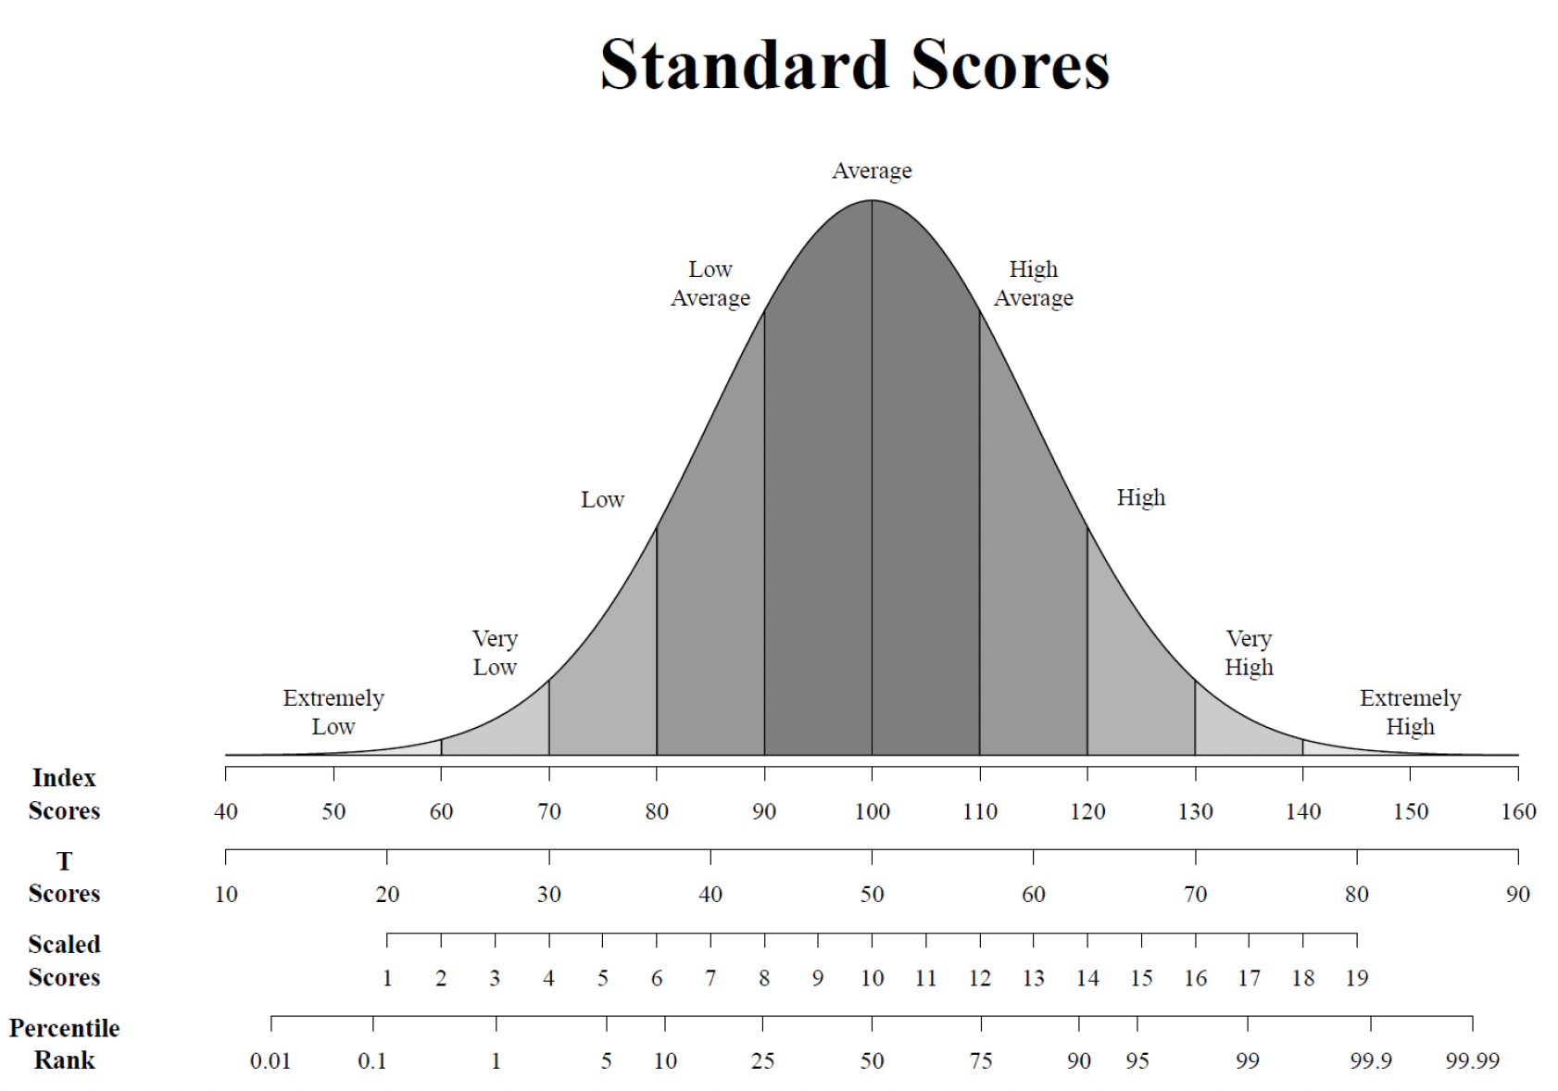

Appendix A. Instruments administered in Healthy Brain Network

Child Behavior Checklist (CBCL)
The CBCL is a questionnaire on which parents rate a child's problem behaviors and competencies. The CBCL also obtains parents’ reports of the amount and quality of their child’s participation in sports, hobbies, games, activities, organizations, jobs and chores, friendships, how well the child gets along with others and plays and works by himself, and school functioning.
Reference: Achenbach, T. M. (1991). Integrative Guide to the CBCL/4-18, YSR, and TRF Profiles. Burlington, VT: University of Vermont, Department of Psychology.

Clinical Evaluation of Language Fundamentals - Fifth Edition Screener (CELF- 5)
The CELF-5 screener is a brief measure of basic aspects of language, including morphology, syntax, semantics, and pragmatics.
Reference: Semel, E., Wiig, E. H., & Secord, W. A. (2013). Clinical Evaluation of Language Fundamentals: Screening Test (5th ed.) Bloomington, MN: Pearson.

Comprehensive Test of Phonological Processing - Second Edition (CTOPP -2)
The CTOPP - 2 is an assessment of reading related phonological processing skills including fluency.
Reference: Wagner, R. K., Torgessen, J. K., Rashotte, C. A., & Pearson, N. (2013). The

Conners’ ADHD Rating Scale (Conners)
The Conners is a questionnaire that uses child and adolescent self-report ratings to assess symptoms of attention deficit/hyperactivity disorder (ADHD) and evaluate problem behavior in children and adolescents.
Reference: Conners, C. K. (2001). Conners’ Rating Scales-Revised. North Tonawanda, NY: Multi-Health Systems, Inc.

Kiddie Schedule for Affective Disorders and Schizophrenia-Present and Lifetime Version (K-SADS-PL)
The K-SADS is a semi-structured diagnostic interview designed to assess current and past episodes of psychopathology in children and adolescents according to DSM-5 criteria.
Reference: Kaufman, J., et al. (1997). Schedule for affective disorders and schizophrenia for school-age children-present and lifetime version (K-SADS-PL): Initial reliability and validity data. Journal of the American Academy of Child & Adolescent Psychiatry, 36(7), 980-988.

Mood and Feelings Questionnaire (MFQ)
The MFQ consists of a series of descriptive phrases for children and their parents to report on mood and depressive symptoms currently and in the past.
Reference: Angold, A., Costello, E. J., Messer, S. C., Pickles, A., Winder, F., & Silver, D. (1995) The development of a short questionnaire for use in epidemiological studies of depression in children and adolescents. International Journal of Methods in Psychiatric Research, 5, 237 - 249.

Screen for Child Anxiety Related Disorders (SCARED)
The SCARED is a self- and parent-report measure of symptoms of anxiety-related disorders among children and adolescents, including general anxiety disorder, separation anxiety disorder, panic disorder, and social phobia. In addition, the SCARED assesses symptoms related to school phobias.
Reference: Birmaher, B., et al. (1999). Psychometric properties of the Screen for Child Anxiety Related Emotional Disorders (SCARED): a replication study. Journal of the American Academy of Child and Adolescent Psychiatry, 38(10), 1230-1236.

Social Responsiveness Scale-2 (SRS-2)
The SRS-2 is a parent-report measure of the various dimensions of interpersonal behavior, communication, and repetitive/stereotypic behavior characteristic of autism spectrum disorders.
Reference: Constantino, J. N. & Gruber, C. P. (2012). The Social Responsiveness Scale Manual, Second Edition (SRS-2). Los Angeles, CA: Western Psychological Services.

Extended Strengths and Weaknesses of Attention-Deficit/Hyperactivity Disorder Symptoms and Normal Behavior Scale (ESWAN)
The ESWAN is parent-report questionnaire that assesses symptoms of attention deficit/hyperactivity disorder (ADHD) and evaluates problem behavior in children and adolescents.
Reference: Swanson, J. M., et al. (2006). Categorical and dimensional definitions and evaluations of symptoms of ADHD: The SNAP and SWAN Rating Scales. Available from http://www.ADHD.net.

Test of Word Reading Efficiency - Second Edition (TOWRE - 2)
The TOWRE - 2 efficiently assesses two important components of the reading process: sight word reading and phonetic decoding.
Reference: Torgesen, J. K., Wagner, R. K., & Rashotte, C. A. (2012). Test of Word Reading Efficiency

Wechsler Individual Achievement Test - 4th Edition (WIAT - 4)
The WIAT -4 is a clinician-administered measurement tool useful for academic achievement skills assessment, learning disability diagnosis, special education placement, and clinical appraisal.
Reference: NCS Pearson. (2020). Wechsler Individual Achievement Test, 4th Ed. Bloomington: Author.

Wechsler Intelligence Scale for Children - V (WISC - V)
The WISC-V is a measure of general intellectual ability for children age 6 to 16 years. Seven subtests are used to calculate a Full Scale IQ, and ten subtests are used to calculate indices of verbal reasoning (VCI), non-verbal reasoning (VSI, FRI), working memory (WMI), and processing speed (PSI).
Reference: Wechsler, D. (2014). Wechsler Intelligence Scale for Children-Fifth Edition (WISC-V). San Antonio, TX: NCS Pearson.

Results Appendix

