Adam Klein and Veronica Child

Visualization 1: % Poverty to Median Income Bar Chart

We chose to use US census data on poverty to construct this visualization. Specifically, we used data collected on the total percentage of people in poverty and the median income in each county in 2015. The data was edited to remove commas from numerals, though in the future it would probably be best to deal with that inside of the JavaScript file using functions like parseInt().

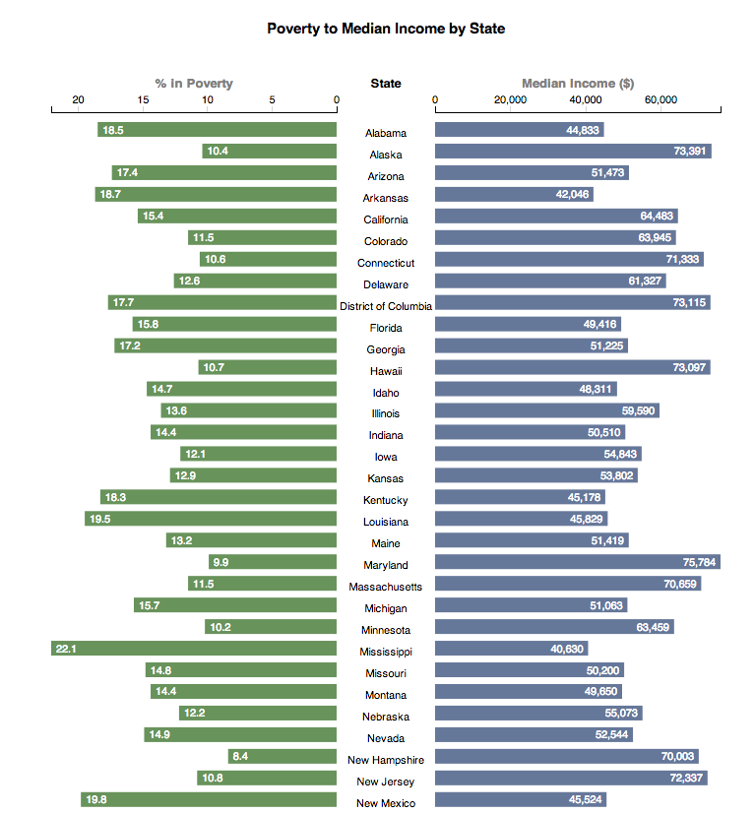 We downloaded the census data from the following url: [<https://www.ers.usda.gov/data-products/county-level-data-sets/county-level-data-sets-download-data/>](%3Chttps://www.ers.usda.gov/data-products/county-level-data-sets/county-level-data-sets-download-data/%3E)

This visualization consists of two bar graphs and a column of state names. The bar graphs line up with the state names such that the name on the same vertical position as a bar acts as a label for that bar. The two bar graphs represent the percent of the state’s population that is in poverty (left) and the median income of that state (right).

Our visualization examined the question of what relationship exists between poverty and average income. We found data for both attributes in data from the US census, and displayed it with our visualization. In order to make the visualization easier to read, we decided to show only data for states rather than attempt to represent every county.

We encode each state’s information on a single horizontal plane – at the center is the name of the state, and to the left and right are bars whose heights represent the percentage of people in poverty and the median income of that state, respectively. This method of encoding is useful in that data is grouped in a way that is easy to understand. By scanning at a vertical section of the graph one can scan a single attribute of all items, while scanning horizontally shows you all the attributes of a single item.

This method of encoding makes comparisons between items easy, but makes it more difficult to look up a specific value of a bar. To help readers get the best use out of the strength of the encoding in the field of comparisons, we made the visualization sortable so that data could be displayed in order of either percent in poverty or median income. The ability to sort the data also allows enhances the explorative attributes of our visualization. To shore up the encoding’s shortcomings when it comes to looking up values, we also added a redundant encoding of the exact value represented by each bar as text at the end of the bar.

Visualization 2: Proportion of the impoverished under 17

For our second visualization, we used the same data sheet as the first (US census data on poverty in the US). We used the state name and location data based on data from the D3 Maps and Color Introduction lab.

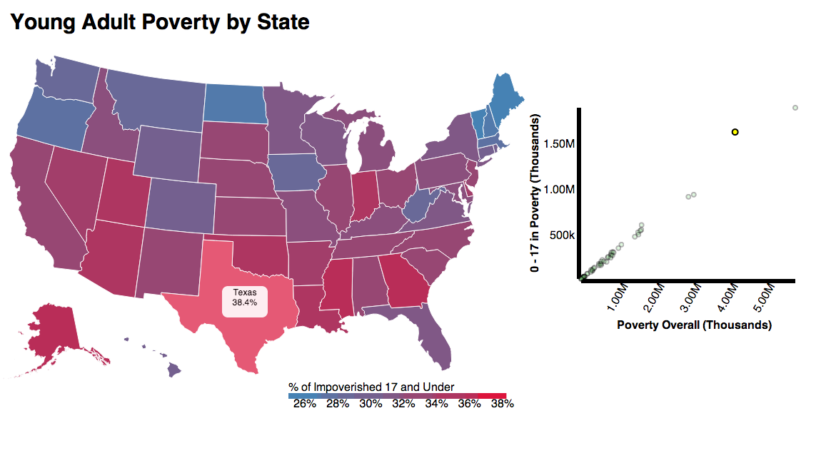We also used two attributes from the original data, total number of people under 17 in poverty and total number in poverty, in order to find the proportion of the impoverished who are under 17 (calculated by dividing the former by the latter).

Each state is displayed on a map of the US, allowing readers to identify trends based on location. For each state, the proportion of the impoverished under 17 is encoded in two ways: first, as color on a scaled hue between two colors, and also as a percentage displayed upon mouseover of a state.

Our visualization uses a two value color scale to represent the percent of young adults (aged 0-17) that make up the impoverished. Each state on a map of the US is colored based on this scale, shown below the map. To the right of the map is a scatter plot which plots the total poverty and number of young adults in poverty for each state.

Our visualization examined which states had a disproportionately high ratio of young people (under 17) among the impoverished.

The two-value color scale was chosen because readers might not only be interested in high values, but also low values, and having a scale of two hues makes both extremes immediately apparent. However, the color does not encode anything other than the proportion itself. This means that states with high or low total poverty can show up as the same color are indistinguishable if the relative number of young people in poverty is the same. While this information is not needed for the immediate goal (examining only the proportion) of the visualization, including it would provide additional context to let readers explore the data and draw conclusions about questions on the periphery of the main focus of our visualization.

In order to add value lookup functionality to our graph, we have added a scatter plot in addition to our map.