**DFPGL25G_50G Dev. Kit**

**FPGA Development User Guide V1.0**

**-Alientek Dev. Kit Tutorial**

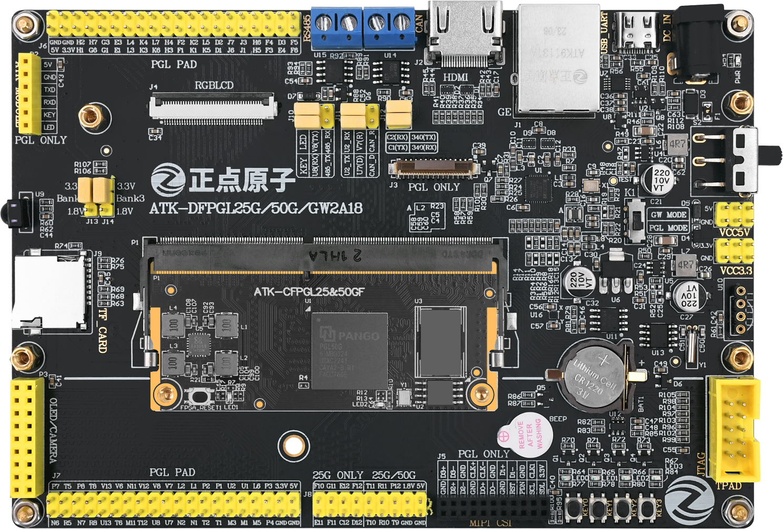

### **Development Kit Overview**

### 

### **Hardware Resource Description**

TBD

### **Software Resource Description**

Above, we briefly introduced the hardware resources of the DFPGL25/50G development kit. Next, we will provide a brief overview of the software resources available for the DFPGL25/50G development kit.

The DFPGL25/50G development kit offers up to 52 standard Verilog example projects. All these examples are original, independently developed, with very detailed comments, consistent code style, and a progressive difficulty level, making them very suitable for beginners. In contrast, example projects by other vendors either have fewer comments or inconsistent project file management, which can make it difficult for beginners to get started.

The list of Verilog example projects for the DFPGL25/50G development kit is shown in the table below:

Table 2.2.1 Verilog Example Projects for DFPGL25/50G Development Kit

|  |  |  |  |
| --- | --- | --- | --- |
| Num | Experiment Name | Num | Experiment Name |
| 1 | LED Blinking Experiment | 2 | Button Controlled LED Experiment |
| 3 | Button Controlled Buzzer Experiment | 4 | Touch Button Controlled LED Experiment |
| 5 | Breathing LED Experiment | 6 | IP Core: PLL Experiment |
| 7 | IP Core: Single-Port RAM Experiment | 8 | IP Core: Dual-Port RAM Experiment |
| 9 | IP Core: FIFO Experiment | 10 | UART Communication Experiment |
| 11 | RS485 Serial Communication Experiment | 12 | RGB TFT-LCD Color Bar Display Experiment |
| 13 | RGB TFT-LCD Character and Image Display Experiment | 14 | HDMI Color Bar Display Experiment |
| 15 | HDMI Block Movement Experiment | 16 | MIPI DSI Color Bar Display Experiment |
| 17 | Infrared Remote Control Experiment | 18 | DS18B20 Digital Temperature Sensor Experiment |
| 19 | DHT11 Digital Temperature and Humidity Sensor Experiment | 20 | EEPROM Read/Write Test Experiment |
| 21 | RTC Real-Time Clock LCD Display Experiment | 22 | Frequency Meter Experiment |
| 23 | RGB-LCD Touch Screen Experiment | 24 | High-Speed AD/DA Experiment |
| 25 | DDS Signal Generator Experiment | 26 | Voltmeter Experiment |
| 27 | Dual-Channel High-Speed DA Experiment | 28 | Dual-Channel High-Speed AD Experiment |
| 29 | I/O Expansion Module Experiment | 30 | Traffic Light Experiment |
| 31 | DDR3 Read/Write Test Experiment | 32 | OV5640 Camera RGB-LCD Display Experiment |
| 33 | OV5640 Camera HDMI Display Experiment | 34 | OV7725 Camera RGB-LCD Display Experiment |
| 35 | OV7725 Camera HDMI Display Experiment | 36 | FLASH Read/Write Test Experiment |
| 37 | SD Card Read/Write Test Experiment | 38 | SD Card Read BMP Image LCD Display Experiment |
| 39 | SD Card Read BMP Image HDMI Display Experiment | 40 | MDIO Read/Write Test Experiment |
| 41 | Ethernet ARP Test Experiment | 42 | Ethernet ICMP Test Experiment |
| 43 | Ethernet UDP Test Experiment | 44 | Ethernet Image Transmission (LCD Display) Experiment |
| 45 | OV5640 HDMI Grayscale Display Experiment | 46 | OV5640 LCD Grayscale Display Experiment |
| 47 | OV5640 Median Filtering Display Experiment | 48 | OV5640 Binarization Display Experiment |
| 49 | OV5640 Edge Detection Display Experiment | 50 | Dual OV5640 HDMI Display Experiment |
| 51 | Digital Recognition Display Experiment | 52 | OV5640 Camera Ethernet Video Transmission Experiment |

As can be seen from the table above, the DFPGL25/50G development kit offers a very rich set of example projects, including many valuable extensions. The difficulty of each example progresses step by step, starting from the most basic LED blinking experiment and gradually moving to more complex projects. This progression from simple to complex is beneficial for learning and mastery, making the DFPGL25/50G development kit very suitable for beginners. Of course, for those who want to delve deeper into FPGA development, the DFPGL25/50G development board is also an excellent choice.