Community Volunteer Connect

Project Documentation

NAME : CHILIVERI AKHIL

Introduction:
The community volunteer connect is an web application in which the volunteers and organizations will connect through the web. The organization will post an activity that helps citizens . The volunteers who are intresred in the activity posted by organization will register through the web service and perform action in the activity which is conducted by organization

1. Project Objective and Scope
Design, develop, and implement a functional, database-driven web application to connect local volunteers with non-profit organisations. This project will provide hands-on experience in the complete lifecycle of a database system, from conceptual data modelling and normalisation to implementing a secure, multiuser application that performs complex queries and transactions.

The system enables volunteers to manage profiles, browse and apply for opportunities, and track applications, while organizations can post, manage, and review opportunities. Featuring secure authentication, REST APIs, robust database design, and a responsive UI for seamless, real-time interaction.

2. Project Structure & Files
Folder/File | Purpose
backend/ | Holds backend source code and database interaction
backend/db.js | Database connection and query utility
templates/ | Static frontend assets (HTML, CSS, JS)
home.html | Homepage
Organization login.html | Login page for organizations
Volunteers login.html | Login page for volunteers
Volunteer signup.html | Registration page for volunteers
Organization signup.html | Registration page for organization
styles.css | Application style definitions
script.js | Frontend JavaScript logic and API interaction
schema.sql | SQL schema for setting up MySQL database structure
README.md | Project description, setup instructions, and notes

2.1 Folder Structure:

community_volunteer_connect/
│
├── requirements.txt
├── config.py
├── main.py Backend python flask code
├── README.md
│
├── venv/ Virtual environment (Venv config)
│
├── schema.sql Database structure
│
├── static/
│ ├── css/
│ │ ├── home.css
│ │ ├──volunteer register.css
│ │ ├── organization register .css
│ │ ├── volunteer login.css
│ │ ├── organization login.css
│ │ ├── volunteer post activity.css
│ │ ├── volunteer myactivities.css
│ │ ├── organization posted .css
│ │ ├── organization myactivities .css
│ │ ├── organization request .css
│ │
│ ├── js/
│ │ ├── home.js
│ │ ├──volunteer register.js
│ │ ├── organization register .js
│ │ ├── volunteer login.js
│ │ ├── organization login.js
│ │ ├── volunteer post activity.js
│ │ ├── volunteer myactivities.js
│ │ ├── organization posted .js
│ │ ├── organization myactivities .js
│ │ ├── organization request .js
│ │
├── templates/
│ ├── home.html
│ ├── organization_signup.html
│ ├── organization_login.html
│ ├── volunteer_register.html
│ ├── volunteer_login.html
│ ├── organization_post.html
│ ├── organization_myactivities.html
│ ├── organization_requests.html
│ ├── volunteer_activities.html
│ ├── volunteer_myactivities.html
│ └── error.html
│
└── .env # Environment variables (DB, secret key, etc.)

3. Database Design and Setup
3.1 ER Diagram and Entities

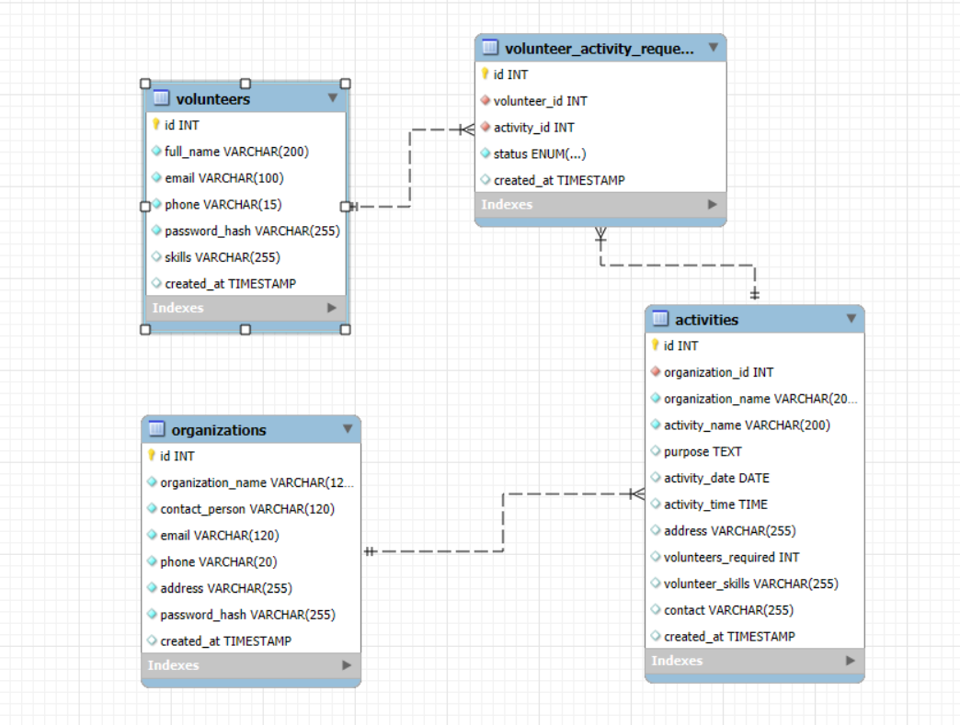

Figure : Entity Relationship Diagram of the Community Volunteer Connect System
The schema implements the following main entities:
- Volunteers
- Organizations
- Activities
- Volunteer activity request

3.2 Schema Implementation
- Defined in your schema.sql file.
- Includes tables with primary and foreign keys, indexes, and constraints.
- Example table declaration for volunteers:

SQL ( Structured Query Language) :

CREATE DATABASE community_volunteer_connect;
USE community_volunteer_connect;

CREATE TABLE volunteers (
id INT AUTO_INCREMENT PRIMARY KEY,
full_name VARCHAR(200) NOT NULL,
email VARCHAR(100) NOT NULL UNIQUE,
phone VARCHAR(15) NOT NULL UNIQUE,
password_hash VARCHAR(255) NOT NULL,
skills VARCHAR(255),
created_at TIMESTAMP DEFAULT CURRENT_TIMESTAMP
);

CREATE TABLE organizations (
id INT AUTO_INCREMENT PRIMARY KEY,
organization_name VARCHAR(120) NOT NULL,
contact_person VARCHAR(120) NOT NULL,
email VARCHAR(120) NOT NULL UNIQUE,
phone VARCHAR(20) NOT NULL UNIQUE,
address VARCHAR(255) NOT NULL,
password_hash VARCHAR(255) NOT NULL,
created_at TIMESTAMP DEFAULT CURRENT_TIMESTAMP
);

CREATE TABLE activities (
id INT AUTO_INCREMENT PRIMARY KEY,
organization_id INT NOT NULL,
organization_name VARCHAR(200) NOT NULL,
activity_name VARCHAR(200) NOT NULL,
purpose TEXT,
activity_date DATE,
activity_time TIME,
address VARCHAR(255),
volunteers_required INT,
volunteer_skills VARCHAR(255),
contact VARCHAR(255),
created_at TIMESTAMP DEFAULT CURRENT_TIMESTAMP,
FOREIGN KEY (organization_id) REFERENCES organizations(id) ON DELETE CASCADE
);

CREATE TABLE volunteer_activity_requests (
id INT AUTO_INCREMENT PRIMARY KEY,
volunteer_id INT NOT NULL,
activity_id INT NOT NULL,
status ENUM('pending','accepted','rejected') not null DEFAULT 'pending',
created_at TIMESTAMP DEFAULT CURRENT_TIMESTAMP,
FOREIGN KEY (volunteer_id) REFERENCES volunteers(id) ON DELETE CASCADE,
FOREIGN KEY (activity_id) REFERENCES activities(id) ON DELETE CASCADE
);

ALTER TABLE volunteer_activity_requests
MODIFY status ENUM('pending','approved','rejected') NOT NULL DEFAULT 'pending';

4. Backend Implementation:
4.1 Environment Set-Up
- Python with Flask framework (in backend).
- MySQL database interaction implemented using mysql2 package and asynchronous queries (connection in db).
4.2 Crud Operations
- Volunteer APIs:
Register, login, profile retrieval, skill assignment.
- Organization APIs:
Registration, login, activity management.
- Opportunity APIs:
CRUD operations, filter by location.
- Application APIs:
Volunteer applies for opportunity, status updates, listings per volunteer or opportunity.
4.3 Security & Validation
- Passwords hashed securely using bcrypt.
- Input validation before processing.

5. Frontend Implementation
5.1 Pages and Functionality
- home.html: Landing page.
- login.html: Login form linked to backend authentication APIs.
- Volunteer-posted.html: Volunteer interface for browsing and applying to opportunities.
- organization-posted.html: Organization interface for managing posted opportunities and applications.
- All CSS styles in styles.css.
- Client-side JavaScript in script.js handles form submissions, API calls, and dynamic content updates.
5.2 UI/UX
- Responsive design using CSS.
- Clear navigation between key sections.
- User interaction feedback via form validation and status messages.

6. Running the Application
6.1 Database Setup
- Import schema.sql into your MySQL server using MySQL Workbench or CLI:
mysql -u yourusername -p yourdatabase < schema.sql
6.2 Backend
- Install dependencies: flask install
- Run the backend: python main.py
- Backend listens on port 5000 by default.
6.3 Frontend
- Access application via browser at: http://localhost:5000/

7. Testing & Validation
- The system supports all user workflows:
  - Volunteer registration: login, posted activities and myactivities.
  - Organization registration: login, activity postings ,accepting and rejecting, myactivities.
  - Applying for activities.
- Database constraints tested by invalid inputs.
- Password hashing and login authentication verified.

8. Tools & Technologies Used
Category | Technology/Tools
Backend | Python Flask
Database | MySQL
Frontend | HTML, CSS, JavaScript
Development IDE | Visual Studio Code
Database Client | MySQL Workbench

9.Source code
Github Repository Link :
https://github.com/chiliveri96/community_volunteer_connect

10.Conclusion
The TCS Community Volunteer Connect app connects local volunteers with non-profit organizations, making it easy to post, search, and manage volunteering opportunities. With secure authentication, role-based access, and efficient database operations using MySQL, Node.js, Express.js, HTML, CSS, and JavaScript, this project streamlines community engagement and fosters greater participation in social initiatives for all stakeholders involved.

