**WEB SERVICES**

420-511-VA

PROJECT

DELIVERABLE-2-

Team Members: Theodore Tsimiklis(2065694), Jiahui Xia (2044092), Chilka Castro(2030864)

For this deliverable, you need to deliver the following:

Project Plan

* Tasks, or user stories, breakdown (for the development of the web service and client)
* Tasks assignment per team member,
* and Tasks schedule.
* The plan must be logged in a project tracking tool as a Kanban e.g., Trello. [Trello Link](https://trello.com/invite/b/s9iektXd/8cba80e98089712e8204c6ec71125d59/user-story-map-client-part)
* A repository must be created for the code and shared with all team members e.g., GitHub. [GitHub repository](https://github.com/TheodoreTsimiklis/WebServices-Project)

# Design and Architecture Documents

* A database ERD

* A class diagram

* A list of the web service API’s endpoints

For getting a specific user’s appointments

domain/webservice/api/users/{userID}/appointments?api_key=12345

OR

domain/webservice/api/appointments?api_key=12345&userID=10

To add an appointment

domain/webservice/api/appointments

To update or delete an appointment

domain/webservice/api/appointments/10

For list of hospitals or clinics:

domain/webservice/api/hospitals

For list of hospitals or clinics based on a province

domain/webservice/api/hospitals?province=”QC”

* A workflow, or data flow, diagram describing the interaction of the client with the web service and the back-end internal interactions of the web service, possibly with a third party API.

# API Client

* A list of features, or functionalities, that the client will support.
  + Users have access to Home Page and About Us page.
  + User can sign in through Login page.
  + User can register using the Sign-up Page.
  + User’s can choose whether to (1) book an appointment (Book Appointment Page), (2) view all appointment history (Appointment’s History Page), and (3 ) view account (Account Page) in their Dashboard page.
  + User can upload an image of their Donor card in the My Account Page.
  + User can delete/cancel appointment/s as long as they have not passed the date yet.
  + Users can view all appointments in the appointment’s history
    - Users can still modify any incoming appointments that have not passed the date yet.
  + Create appointment
    - Users can view all the available locations of hospitals/clinics that does blood donation .
    - User can specify the province by filtering the hospitals/clinics results by province.
  + Update appointment
    - Users can change the date and time of the appointment in the specific hospital that they made an appointment.
* Wireframes for the client’s user interfaces.
* Home Page

* About Us page – when user is logged out

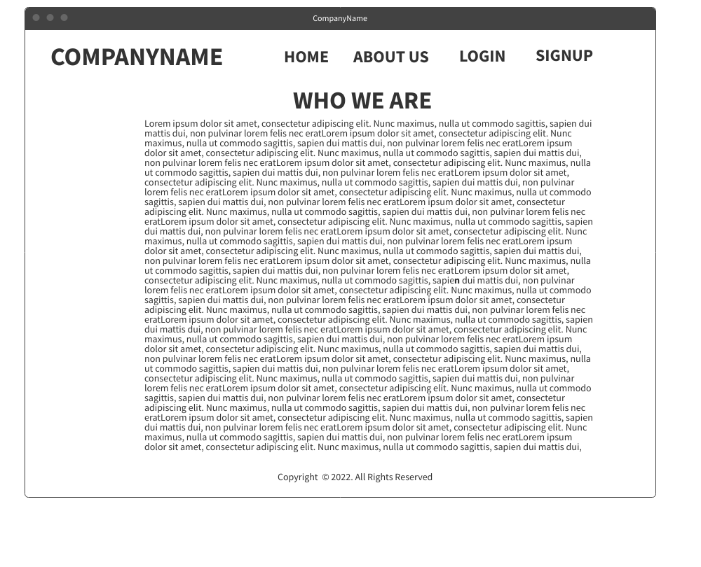

* About Us page – when user is logged in

* Sign Up Page

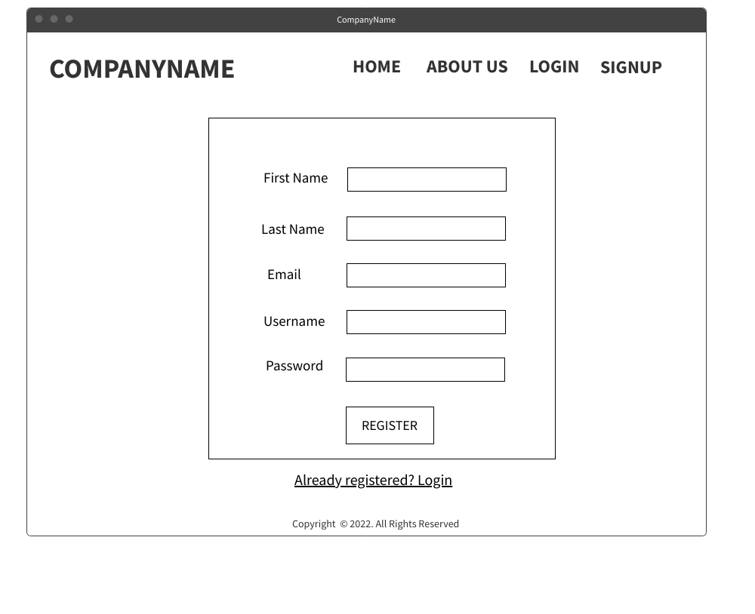

* Login PageGraphical user interface

  Description automatically generated
* Dashboard Page- landing page once user successfully logs in

* When the book an appointment button is clicked in the Dashboard

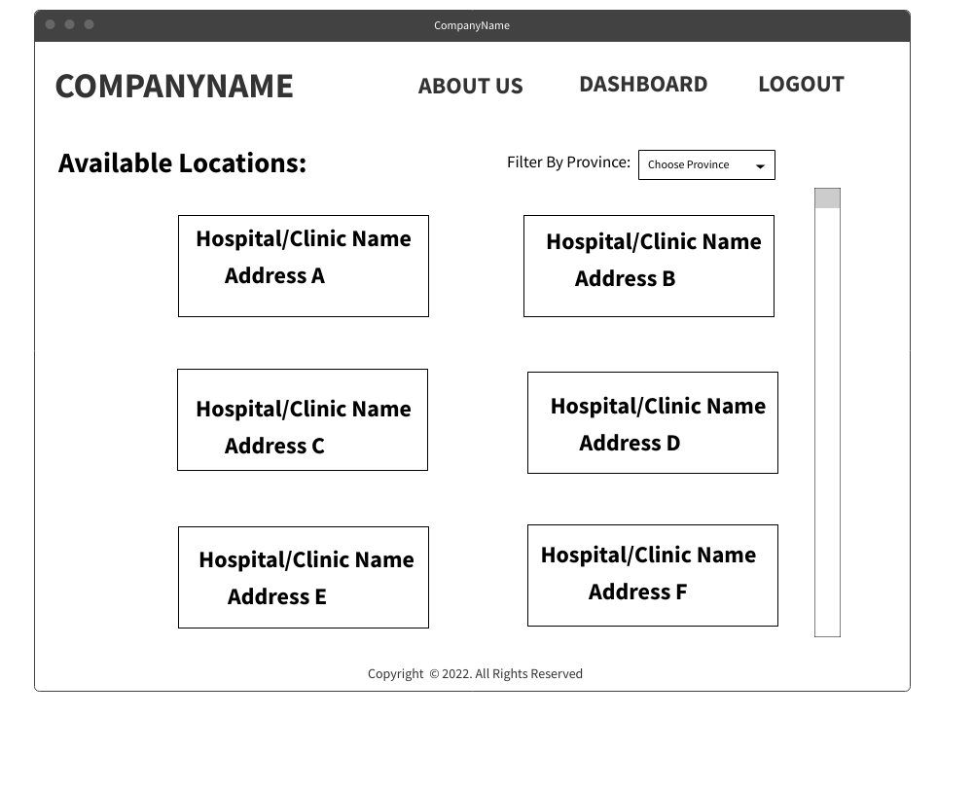

* Book An Appointment page – after choosing a specific hospital/clinic from the list

* Booking Appointment Successful page – after clicking the Book Appointment

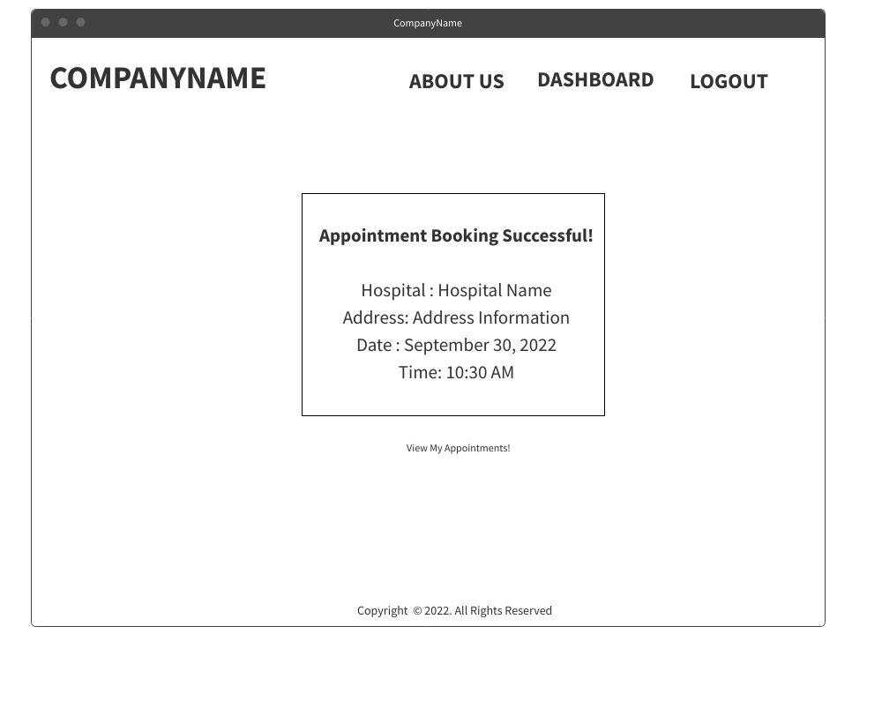

* Appointments History page- shows the incoming appointments and all the past appointments

* Update Appointment page- if Edit is clicked in the Appointments History Page

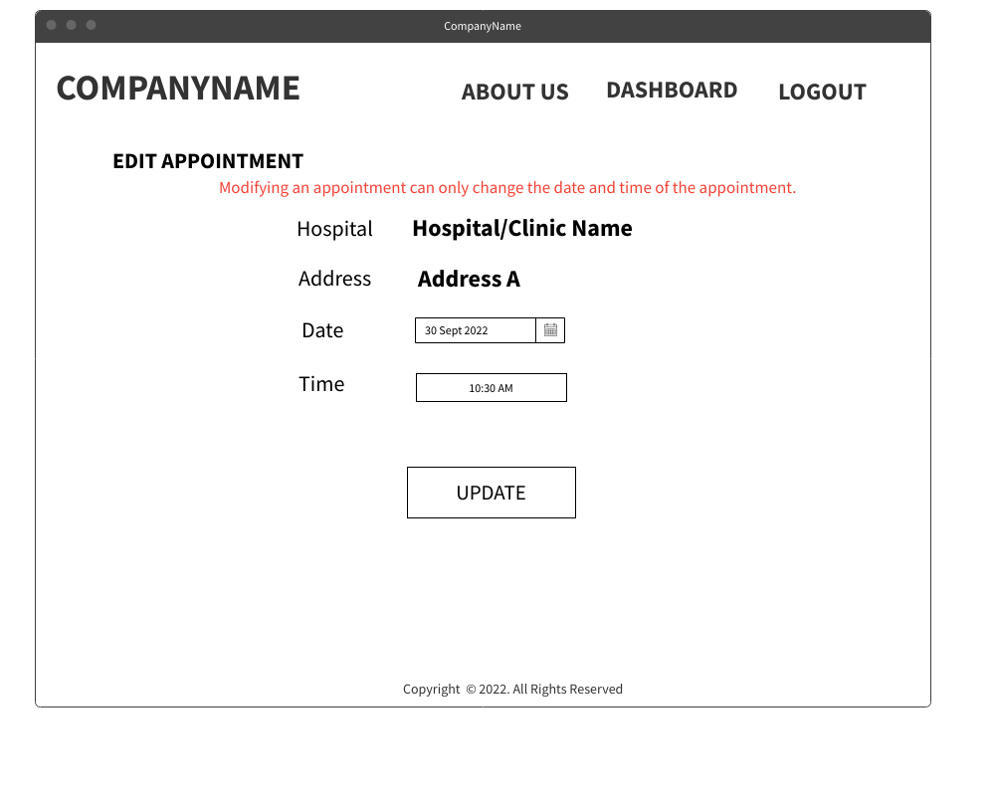

* Update Successful page – after changing the time and date of the appointment

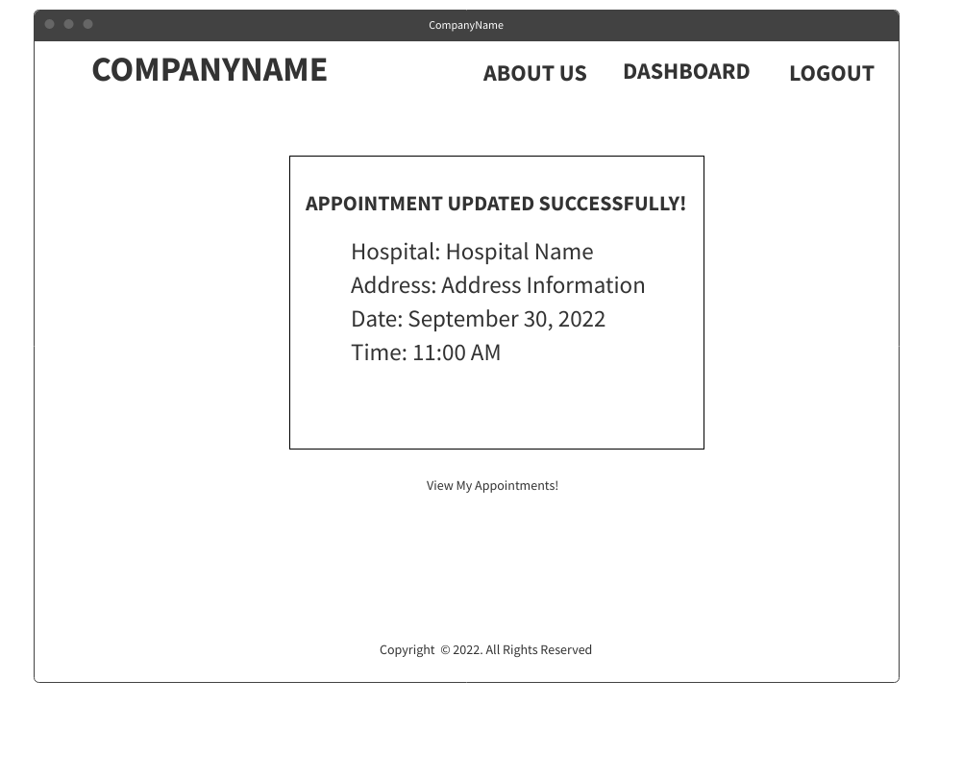

* Cancellation Successful Page – after the Delete is clicked in the Appointments History

* My Account page – where the user can upload an image of the Donor Card.

