Compounding Error, Recovery, and Coordination Overhead in Long-Horizon Agentic AI Systems:
A Simulation-Based Reliability Analysis
Kartik Chilkoti
July 2026
Abstract
Agentic AI systems — large language models embedded in loops of planning, tool use, and multi-step execution — are increasingly deployed for tasks that unfold over dozens or hundreds of sequential steps. Empirical studies report that reliability, not raw capability, is the dominant bottleneck of such systems, but the mechanisms that produce this bottleneck are usually described qualitatively. This paper isolates four structural mechanisms — per-step compounding error, checkpoint-and-rollback recovery, multi-agent coordination overhead, and their interaction — in a controlled Monte Carlo simulation framework, and quantifies their effect on task success probability and execution cost independent of any particular model or benchmark. Across six experiments (20,000 trials per configuration by default, with headline results additionally validated by 5-seed replication with 95% confidence intervals, and a wider parameter grid confirming the central interaction finding), we find that: (1) task success probability decays multiplicatively with horizon length even at high per-step reliability, producing 50%-reliability horizons ranging from 7 steps at p=0.90 to 693 steps at p=0.999; (2) checkpoint-and-rollback recovery can more than triple success probability at long horizons (e.g., 0.334 vs. 0.048 at n=100 steps, detection probability 0.7), and its benefit is driven far more by detection quality than by checkpoint granularity; (3) splitting a fixed-length task across multiple coordinating agents does not change success probability when coordination is perfect, but degrades monotonically as coordination-failure probability increases, with an 8-agent decomposition losing roughly 15 percentage points of absolute success probability relative to a single agent at a 10% per-handoff coordination-failure rate; and (4) adding within-segment recovery to a multi-agent system substantially raises absolute success probability at every agent count, but leaves the *relative* coordination penalty essentially unchanged — a pattern we show, in a follow-up experiment spanning a 3x3 grid of coordination-failure probabilities and recovery detection qualities, holds robustly throughout (the penalty difference between recovery and no-recovery conditions stays within about 3 percentage points across all nine grid cells, while the relative penalty itself scales cleanly with coordination-failure probability, from roughly 13% at q=0.02 to roughly 52% at q=0.10). This indicates recovery quality and coordination reliability act as largely separable design levers. We argue these results provide a minimal, falsifiable structural account that is consistent with, and helps explain, several qualitative findings in the empirical agentic-AI literature (e.g., METR's task-horizon doubling trend and the multi-agent failure-mode taxonomy of Cemri et al.), and we release all code, in a version-controlled repository, to support replication and calibration against real agent traces.
Keywords: agentic AI, LLM agents, reliability, error propagation, multi-agent systems, checkpoint recovery, Monte Carlo simulation, reproducibility

Table of Contents
(Right-click and select "Update Field" in Word to populate the table of contents.)

1. Introduction
Large language model (LLM) agents are no longer evaluated primarily on single-turn question answering; they are increasingly asked to complete extended tasks that require dozens of sequential tool calls, multi-step plans, and, in many production systems, coordination among several specialized sub-agents. Recent measurement studies converge on a consistent qualitative picture: the capability of frontier models to reason about a task has outpaced their reliability in executing a long sequence of dependent actions without an unrecoverable error. Kwa et al. (2025) find that the task duration over which frontier agents succeed at a 50% rate has grown roughly exponentially over recent years, but that near-perfect single-step accuracy still translates into steep success-rate decay as horizon length grows. Cemri et al. (2025) analyze over 1,600 annotated multi-agent execution traces and find failure rates between 41% and 86% across seven popular multi-agent frameworks, attributing a plurality of failures to system-design and inter-agent misalignment issues rather than to any single agent's reasoning failure.
These findings are compelling, but they are drawn from heterogeneous production systems with many confounded variables — model choice, prompt design, tool reliability, orchestration framework, and task distribution all vary simultaneously. It is therefore difficult to isolate how much of the observed reliability degradation is structurally inevitable given compounding per-step error, and how much additional degradation specifically comes from multi-agent coordination as opposed to simply the length of the task. It is similarly difficult, from field data alone, to quantify the cost-reliability tradeoff of a common mitigation — checkpointing and rolling back to a known-good state after a detected error — independent of any one framework's implementation details, or to know whether such recovery mechanisms specifically compensate for coordination failure or merely add to overall reliability independently of it.
This paper takes a complementary approach: rather than analyzing further empirical traces, we build a minimal, parameterized Monte Carlo simulation of agent task execution that isolates exactly these mechanisms in their simplest possible form, and asks what each mechanism predicts in isolation and in combination. The goal is not to replace empirical benchmarking but to provide a first-principles reference model against which empirical observations can be interpreted, and to give practitioners closed-form intuition for how per-step reliability, recovery strategy, and decomposition into multiple agents trade off against one another.

1.1 Contributions
We make five contributions. (1) We formalize three execution strategies for long-horizon agent tasks — no-recovery baseline, checkpoint-and-rollback recovery, and fixed-budget multi-agent decomposition — as explicit stochastic models, plus a fourth strategy combining recovery with multi-agent decomposition. (2) We implement a Monte Carlo simulator for all strategies and validate it against closed-form probability where available. (3) We report a systematic parameter sweep (Experiments A–D) quantifying success probability and execution cost as functions of horizon length, per-step reliability, checkpoint interval, detection probability, number of agents, and coordination-failure probability, with headline results replicated across 5 independent seeds to report sampling variability. (4) We introduce Experiment E, which isolates the interaction between recovery and multi-agent coordination and finds they combine multiplicatively rather than recovery specifically rescuing coordination losses. (5) We discuss how these structural results relate to, and help explain, existing empirical findings in the agentic-AI reliability literature, and outline concrete extensions for calibrating the model against real agent traces.

2. Related Work

2.1 Agentic AI systems and architectures
The dominant architectural pattern for LLM agents traces to the ReAct framework (Yao et al., 2022), which interleaves reasoning traces with tool-call actions and observations in a loop. Subsequent work added self-reflection (Reflexion; Shinn et al., 2023), persistent skill libraries for open-ended tasks (Voyager; Wang et al., 2023), and multi-agent conversational orchestration (AutoGen; Wu et al., 2023). Recent surveys (arXiv:2503.16416; arXiv:2507.21504) catalog dozens of orchestration frameworks and note that architecture choice alone can shift benchmark scores substantially for a fixed underlying model.

2.2 Reliability and failure taxonomies
Cemri et al. (2025) introduce the Multi-Agent System Failure Taxonomy (MAST), classifying failures into system-design, inter-agent misalignment, and task-verification categories from real execution traces across popular frameworks. A related error taxonomy (arXiv:2509.25370) emphasizes that once an error occurs early in an agent trajectory, it tends to propagate forward largely uncorrected, which the authors identify as the primary bottleneck limiting long-horizon success — a mechanism our checkpoint-and-rollback model is designed to probe directly. Kwa et al. (2025, METR) operationalize reliability as the task duration at which an agent's success probability crosses 50%, and report this horizon has grown at a roughly exponential rate across model generations, while noting that near-ceiling performance on short tasks coexists with steep degradation on long ones — the qualitative pattern our Experiment A reproduces from first principles.

2.3 Evaluation and benchmarking
Existing benchmarks (GAIA, Mialon et al., 2023; tau-bench and tau2-bench, Yao et al., 2024; Barres et al., 2025) primarily report single-attempt success rates (pass@1); tau2-bench's pass^k metric, which measures the probability that k independent attempts all succeed, is closer in spirit to the reliability question this paper addresses, and we adopt a similar "probability of full-trajectory success" framing. Separately, measurement-methodology critiques (arXiv:2506.02064) argue that current agent evaluation over-indexes on capability and under-indexes on reliability, cost, and safety jointly — a gap this paper's cost-reliability Pareto analysis (Experiment D) is intended to address in miniature.

2.4 Recovery, memory, and coordination
Practitioner and vendor guidance on long-horizon agents recommends structured checkpointing and note-taking to counteract context degradation over long trajectories, but we are not aware of a controlled quantitative model isolating the reliability-cost tradeoff of checkpoint-and-rollback recovery independent of a specific implementation, or of prior work directly testing whether such recovery mechanisms compensate specifically for multi-agent coordination failure — the questions addressed by our Experiments D and E respectively.

3. Problem Formulation
We model an agent task as a sequence of n discrete steps (e.g., a tool call, a sub-goal, a reasoning hop), each of which independently succeeds with probability p ("per-step reliability") and fails otherwise. We study four execution strategies.

Strategy 1 — No-recovery baseline
The task succeeds if and only if all n steps succeed. Under the independence assumption, task success probability is exactly p^n — an explicit, minimal formalization of "compounding error."

Strategy 2 — Checkpoint-and-rollback recovery
The trajectory is divided into segments of length c ("checkpoint interval"). A verifier inspects the trajectory at each checkpoint and detects a failure within the completed segment with probability d ("detection probability") — modeling the empirically documented fact that failures are often silent and not perfectly caught (arXiv:2606.08162). On detection, the agent rolls back to the last checkpoint and retries the segment, paying an additional fixed cost r ("rollback cost", representing re-reading state and re-planning), up to a maximum of two retries per segment. Undetected failures propagate forward uncorrected, exactly as in the baseline.

Strategy 3 — Fixed-budget multi-agent decomposition
The same n-step task is partitioned across m agents, each responsible for a contiguous segment, with no recovery within a segment (i.e., Strategy 1 applied per segment). Each of the m − 1 hand-offs between agents introduces an additional, independent coordination-failure event with probability q, modeling miscommunication or context loss at agent boundaries, on top of ordinary step-level error.

Strategy 4 — Multi-agent decomposition with within-segment recovery
Identical to Strategy 3, except each agent's segment is itself executed as a Strategy-2 sub-task (with its own checkpoint interval, detection probability, and rollback cost), while coordination-failure events at hand-offs remain unrecoverable. This strategy isolates whether recovery mechanisms can compensate for coordination overhead specifically, or whether the two act independently.
For all strategies we report two quantities, estimated by Monte Carlo simulation over N = 20,000 trials per configuration (fixed base seed 20260726 for reproducibility): task success probability (fraction of trials in which the full trajectory completes without an uncorrected error) and expected cost (mean number of step-executions consumed per trial, a proxy for LLM calls / dollars spent). For headline results (Experiments A and C) we additionally report 5-seed replication (5,000 trials per seed, seeds offset from the base seed) to estimate across-seed standard deviation, following standard reporting norms for stochastic-simulation results. Strategy 1's success probability has the closed form p^n, which we use to validate the simulator (Section 5.1) before applying it to strategies without closed-form solutions.

4. Methodology
All experiments were implemented in Python (NumPy for vectorized random sampling) and are fully specified by the code released alongside this paper (simulation.py, make_figures.py). We designed five experiments to isolate each mechanism of interest and their interaction.

Experiment A — Compounding error and recovery vs. horizon length
Fixing per-step reliability at p = 0.97 (a realistic value at the lower end of frontier tool-call accuracy), we sweep horizon length n ∈ {1, 2, 5, 10, 20, 30, 50, 75, 100, 150, 200, 300} and compare the no-recovery baseline against checkpoint-and-rollback recovery with checkpoint interval c = 10, detection probability d = 0.7, and rollback cost r = 3, reporting success probability and expected cost for both strategies at each horizon. We replicate this sweep across 5 seeds to attach standard-deviation error bars (Section 5.6).

Experiment B — Sensitivity of the reliability horizon to per-step accuracy
For per-step reliability p ∈ {0.999, 0.99, 0.98, 0.97, 0.95, 0.90}, we compute the horizon at which baseline success probability first drops below 0.5 (the "50%-reliability horizon"), using the closed-form p^n for precision, and cross-validate the closed form against the Monte Carlo simulator at one setting (p = 0.97, n = 23; 50,000 trials).

Experiment C — Multi-agent coordination overhead
Fixing total steps n = 60 and per-step reliability p = 0.98, we sweep the number of agents m ∈ {1, 2, 3, 4, 5, 6, 8} and the per-handoff coordination-failure probability q ∈ {0.0, 0.02, 0.05, 0.10}, reporting success probability and expected cost for each (m, q) pair. We replicate the q ∈ {0.0, 0.05, 0.10} conditions across 5 seeds for error bars (Section 5.6).

Experiment D — Reliability-cost Pareto frontier of checkpoint recovery
Fixing n = 150 and p = 0.97, we sweep checkpoint interval c ∈ {5, 10, 20, 30, 50} and detection probability d ∈ {0.3, 0.5, 0.7, 0.9}, plotting success probability against expected cost for every configuration alongside the no-recovery baseline, to visualize the accuracy/cost tradeoff surface a practitioner faces when tuning a recovery strategy.

Experiment E — Interaction between recovery and multi-agent coordination
Fixing n = 60, p = 0.98, and a realistic coordination-failure probability q = 0.05, we sweep m ∈ {1, 2, 3, 4, 5, 6, 8} and compare Strategy 3 (no within-segment recovery) against Strategy 4 (within-segment checkpoint-and-rollback recovery, interval 10, detection 0.7) at each agent count, to test whether recovery compensates specifically for coordination overhead or acts as an independent, additive/multiplicative improvement.

Experiment F — Grid robustness check of the Experiment E finding
Experiment E's interaction finding is demonstrated at a single (q, detection-quality) setting. Experiment F tests whether it generalizes: we sweep coordination-failure probability q ∈ {0.02, 0.05, 0.10} and recovery detection probability d ∈ {0.5, 0.7, 0.9} in a full 3×3 grid (n = 60, p = 0.98, checkpoint interval 10, 15,000 trials per cell), and for each cell compute the relative coordination penalty — the proportional loss in success probability from m = 1 to m = 8 — both with and without within-segment recovery, then compare the two.

5. Results

5.1 Simulator validation
At p = 0.97, n = 23, the closed-form baseline success probability is p^n = 0.4963; the Monte Carlo estimate over 50,000 trials was 0.4938, an absolute difference of 0.0025 — within expected Monte Carlo sampling error (the binomial standard error at this sample size and success rate is approximately 0.0022). This confirms the simulator correctly implements the intended stochastic model before we use it for strategies lacking a simple closed form.

5.2 Experiment A: compounding error dominates at moderate-to-long horizons, and recovery substantially mitigates it
At p = 0.97 per step, baseline success probability falls from 0.971 at n = 1 to 0.547 at n = 20, 0.219 at n = 50, and 0.011 at n = 150 — a task with a 97%-reliable step succeeds under 1.1% of the time once it requires 150 sequential steps. Checkpoint-and-rollback recovery (interval 10, detection 0.7) substantially blunts this decay: success probability at n = 150 rises from 0.011 to 0.197, an approximately 18-fold relative improvement, and at n = 100 rises from 0.048 to 0.334 (roughly 7-fold).
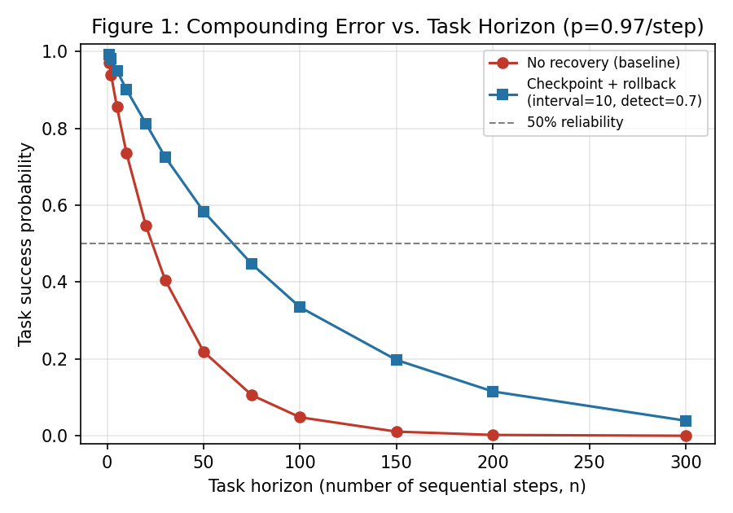
Figure 1. Task success probability vs. horizon length, no-recovery baseline vs. checkpoint-and-rollback recovery (p = 0.97/step).
The cost of recovery is modest and, notably, sub-linear relative to the baseline at long horizons: at n = 300, the baseline always consumes exactly 300 step-executions (it either succeeds or fails after using the full budget), while the recovery strategy's expected cost is only 120.3 — lower than the baseline — because most trajectories under recovery still fail before reaching the end (just less often than the baseline), truncating their cost. This is an important caveat for interpreting "cost" in our model: it measures resources spent on a single attempt, not resources needed to guarantee eventual completion.
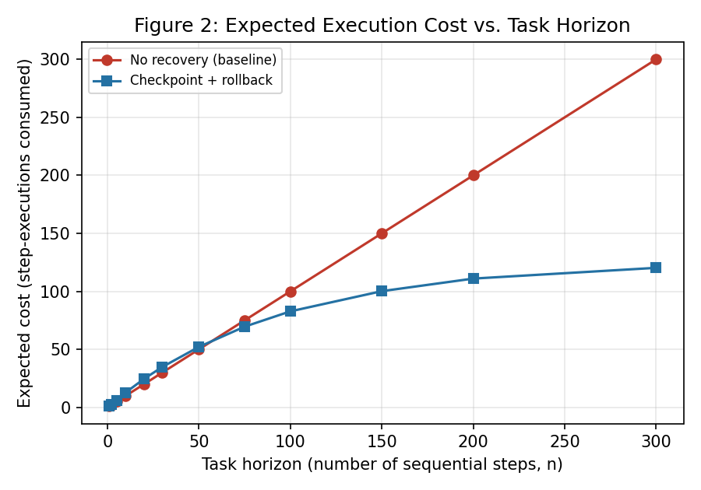
Figure 2. Expected execution cost (step-executions consumed) vs. horizon length for both strategies.

5.3 Experiment B: the 50%-reliability horizon is extremely sensitive to per-step reliability
The 50%-reliability horizon under the no-recovery model is 7 steps at p = 0.90, 14 at p = 0.95, 23 at p = 0.97, 35 at p = 0.98, 69 at p = 0.99, and 693 at p = 0.999 — consistent with the exponential relationship implied by the closed form (horizon ≈ ln(0.5)/ln(p)). A seemingly small improvement in per-step reliability, from 0.97 to 0.99, roughly triples the horizon over which a task can be completed reliably without any recovery mechanism at all. This offers a structural, first-principles interpretation of why frontier labs report exponential-seeming growth in usable task horizon (Kwa et al., 2025) from what are, model-to-model, comparatively modest gains in raw per-step or per-token accuracy.
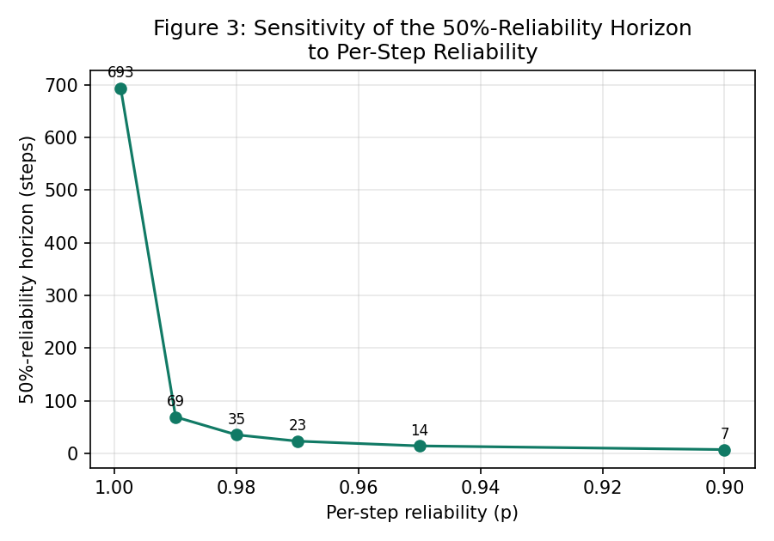
Figure 3. Sensitivity of the 50%-reliability horizon to per-step reliability p (note: p-axis reversed, higher reliability to the left).

5.4 Experiment C: coordination failure, not decomposition itself, drives multi-agent degradation
With perfect coordination (q = 0), splitting a fixed 60-step task across 1 to 8 agents leaves success probability essentially unchanged (0.294 at m = 1 vs. 0.300–0.306 across m = 2–8, differences within Monte Carlo noise) — as expected, since the total step-level failure probability is invariant to how the same sequence of steps is grouped, when there is no additional cost to grouping. However, as soon as coordination-failure probability is positive, degradation is monotonic and material: at q = 0.05, success probability falls from 0.299 (m = 1) to 0.205 (m = 8); at q = 0.10, it falls from 0.296 (m = 1) to 0.145 (m = 8) — a loss of roughly 15 percentage points, or about half the single-agent success rate, purely from handoff overhead at a coordination-failure rate that is not implausible for real multi-agent systems given the misalignment failure rates reported by Cemri et al. (2025). This isolates coordination overhead as a distinct, quantifiable tax on multi-agent decomposition, separate from and additive to ordinary per-step compounding error.
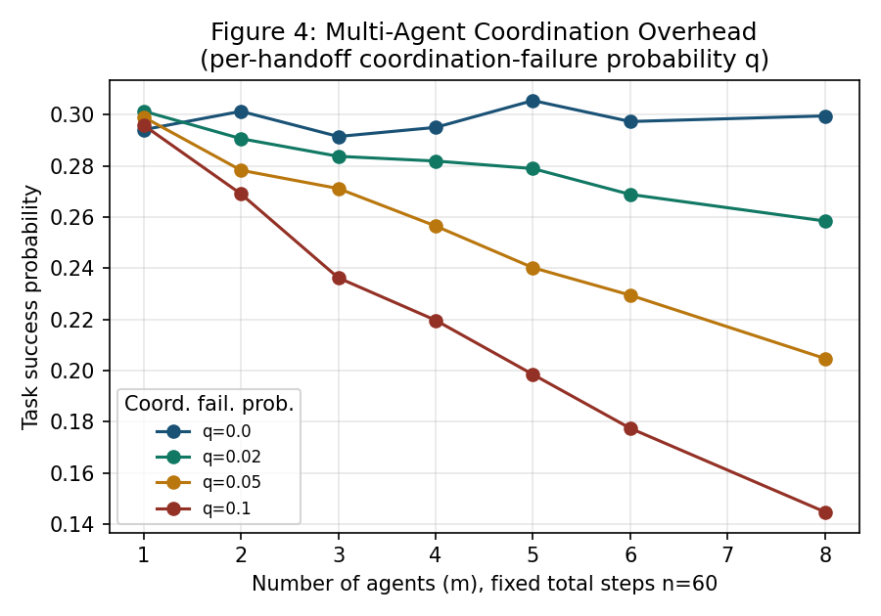
Figure 4. Task success probability vs. number of agents (m), fixed total steps n = 60, for varying per-handoff coordination-failure probability q.

5.5 Experiment D: recovery strategy tuning exposes a clear reliability-cost frontier
At n = 150, p = 0.97, the no-recovery baseline achieves success probability 0.011 at a fixed cost of 150. Every checkpoint-and-rollback configuration we tested achieves strictly higher success probability at every cost level we observed; the frontier is dominated by detection probability d far more than by checkpoint interval c: moving d from 0.3 to 0.9 (at fixed c = 10) raises success probability from 0.035 to 0.488 while raising expected cost from 53.7 to 152.0, whereas at fixed d = 0.7, moving checkpoint interval c from 5 to 50 lowers success probability from 0.231 to 0.065 while raising cost from 95.0 to 148.1 — i.e., coarser checkpointing is dominated (worse on both axes) relative to finer checkpointing at the same detection quality. This suggests that, within this model, investment in detection quality (verifying more reliably that a step failed) is a more effective lever than investment in checkpoint granularity alone, and that very coarse checkpointing intervals are close to strictly worse than finer ones.
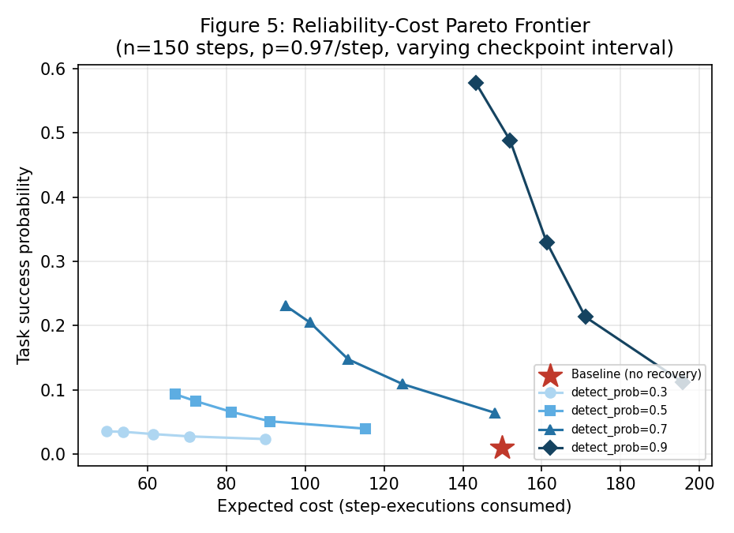
Figure 5. Reliability-cost Pareto frontier for checkpoint-and-rollback recovery (n = 150, p = 0.97/step), varying checkpoint interval and detection probability, against the no-recovery baseline.

5.6 Statistical robustness: 5-seed replication of headline results
To confirm the headline results in Sections 5.2 and 5.4 are not artifacts of a single random seed, we replicated Experiment A and Experiment C across 5 independent seeds (5,000 trials each, offset from the base seed) and report the across-seed mean with an approximate 95% confidence interval (mean ± 1.96·SE, where SE is the standard error across the 5 seed-level estimates). The replicated curves (Figures 6 and 7) closely track the single-seed point estimates reported above, with 95% CI half-widths at or below roughly 0.007 for every configuration tested — small relative to the effect sizes reported throughout Section 5 (e.g., the 18-fold recovery improvement at n = 150, or the 15-percentage-point coordination penalty at q = 0.10), indicating these effects are unlikely to be Monte Carlo sampling artifacts.
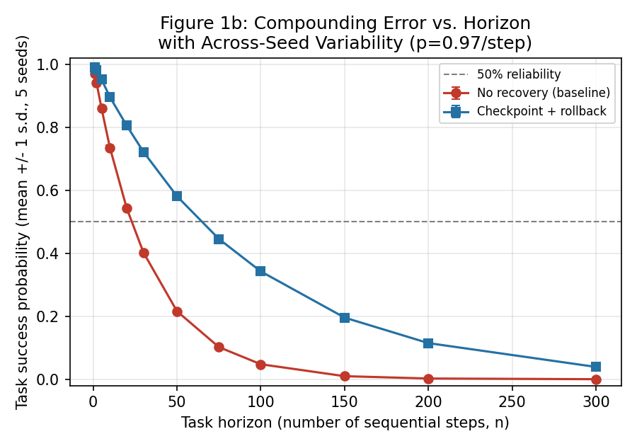
Figure 6. Compounding-error curve from Experiment A, replicated across 5 independent seeds, with ±1 standard deviation error bars (95% CI half-widths are narrower still; see Appendix B, Table A4).
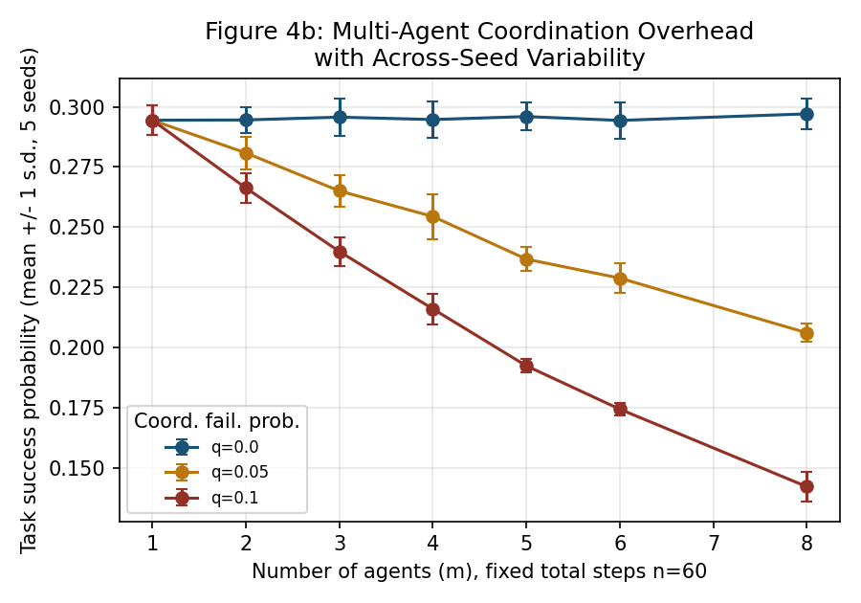
Figure 7. Multi-agent coordination-overhead curve from Experiment C, replicated across 5 independent seeds, with ±1 standard deviation error bars.

5.7 Experiment E: recovery and coordination overhead act as separable factors
Adding within-segment checkpoint-and-rollback recovery (interval 10, detection 0.7) to the multi-agent setting from Experiment C, at a fixed coordination-failure probability q = 0.05, raises absolute success probability substantially at every agent count: from 0.294 to 0.669 at m = 1 (a 2.3× improvement — recovery still helps even a single "agent" because it is itself a long sequential trajectory), from 0.269 to 0.602 at m = 3, and from 0.209 to 0.477 at m = 8. However, the relative penalty attributable specifically to coordination overhead — the proportional loss in success probability going from m = 1 to m = 8 — is almost unchanged by recovery: without recovery this loss is (0.294 − 0.209) / 0.294 ≈ 28.9%; with recovery it is (0.669 − 0.477) / 0.669 ≈ 28.7%. In other words, within-segment recovery substantially improves absolute reliability but does not specifically rescue the losses caused by inter-agent coordination failure — the two effects appear to combine multiplicatively (each strategy reduces failure probability by roughly the same proportion, applied on top of whatever the other strategy leaves behind) rather than recovery compensating for coordination error specifically.
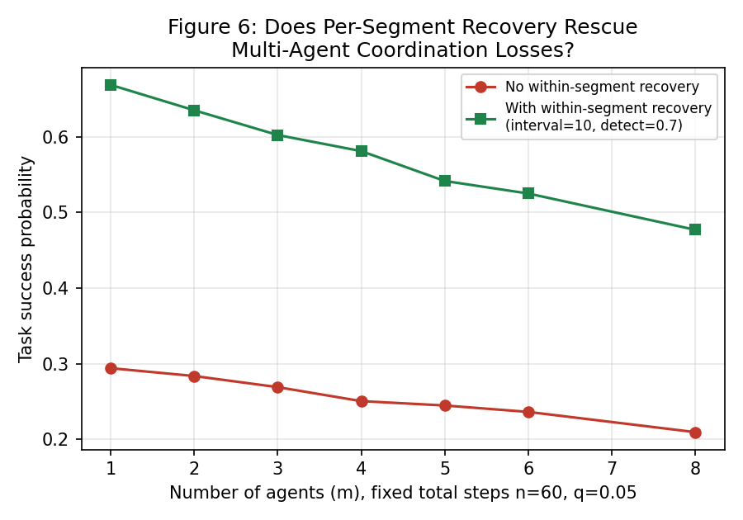
Figure 8. Task success probability vs. number of agents, with and without within-segment checkpoint-and-rollback recovery, at a fixed 5% per-handoff coordination-failure probability.

5.8 Experiment F: the separability finding generalizes across a wider grid
Because Experiment E tested only one (q, detection-quality) combination, Experiment F repeats the m=1-vs-m=8 comparison across a full 3×3 grid of coordination-failure probability q ∈ {0.02, 0.05, 0.10} and recovery detection probability d ∈ {0.5, 0.7, 0.9} (15,000 trials per cell). Two patterns emerge cleanly. First, the relative coordination penalty scales consistently with q and is essentially insensitive to d: at q = 0.02 the relative penalty is 10.7%–15.7% across all three detection qualities; at q = 0.05 it is 27.8%–31.4%; at q = 0.10 it is 50.9%–52.0%. Second, and central to the separability claim, the difference between the no-recovery penalty and the with-recovery penalty is small and shows no consistent sign or trend across the grid — ranging from −0.5 to +3.2 percentage points across all nine cells, centered near zero. Together these results indicate the multiplicative-independence pattern first observed in Experiment E is not an artifact of the single parameter setting tested there, but holds across a substantially wider region of the (q, d) parameter space: coordination reliability and recovery quality behave as separable design levers, each independently shifting success probability, rather than one compensating for the other.
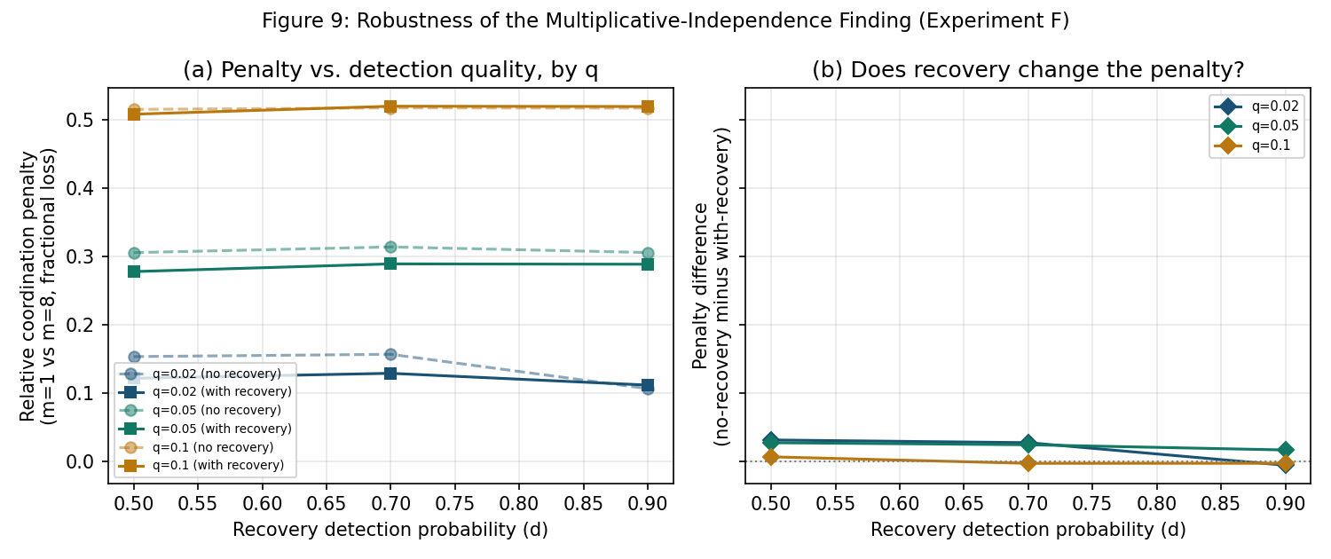
Figure 9. (a) Relative coordination penalty (m=1 vs. m=8) as a function of recovery detection probability, for three coordination-failure probabilities q, with and without within-segment recovery. (b) The difference between the no-recovery and with-recovery penalty at each grid point, showing no consistent trend — supporting separability of the two design levers.

6. Discussion
Taken together, these six experiments support a simple structural story: long-horizon agent reliability is primarily a compounding-probability problem, multi-agent decomposition adds a second, independent compounding-probability problem at each coordination boundary, and recovery mechanisms only help to the extent that failures can be detected, not merely retried — and critically, recovery quality and coordination reliability appear to act as separable design levers across a substantial region of parameter space (Experiments E and F), rather than one compensating for the other. This is consistent with — and offers a mechanistic complement to — several qualitative claims in the empirical literature: it is consistent with Kwa et al.'s (2025) observation that near-perfect short-task performance coexists with steep long-task degradation (Sections 5.2–5.3); it is consistent with Cemri et al.'s (2025) finding that a plurality of multi-agent failures stem from system-design and inter-agent misalignment rather than any single agent's reasoning ability (Section 5.4); and it is consistent with the observation in the agent-error-taxonomy literature (arXiv:2509.25370) that early, uncorrected errors are the primary bottleneck, since our model shows detection probability dominates checkpoint granularity as the lever that matters (Section 5.5).
The separability result (Sections 5.7–5.8) has a direct practical implication: teams building multi-agent systems should not expect adding recovery mechanisms within each agent's segment to close the reliability gap caused by poor inter-agent coordination, and this appears to hold across a meaningful range of coordination-failure rates and detection qualities, not just a single configuration. Coordination failure requires its own dedicated mitigation — better shared-state protocols, structured hand-off formats, or verification specifically at agent boundaries (as opposed to within a single agent's trajectory) — layered on top of, not as a substitute for, within-agent recovery.
More broadly, the marginal return on improving raw model accuracy at the level of individual steps is very high, precisely because of the exponential relationship in Experiment B — but where further accuracy gains are hard to obtain, investment in reliable failure detection (verification, self-consistency checks, tool-output validation) appears in this model to be a more cost-effective lever than either finer-grained checkpointing or naive multi-agent decomposition, both of which can increase cost without commensurate reliability gains, or in the multi-agent case, actively reduce reliability if coordination is imperfect.

7. Limitations
This is a structural simulation study, not an empirical study of real LLM agent traces, and several simplifying assumptions should be kept firmly in mind when interpreting the results.
(1) Independence assumption: we model per-step failures as i.i.d. Bernoulli events; real LLM agent errors are almost certainly correlated across steps (e.g., a poor initial plan increases failure probability at every subsequent step, and context degradation as documented in the "context rot" literature is itself horizon-dependent rather than i.i.d.).
(2) Homogeneous step reliability: real tasks mix easy and hard steps with heterogeneous failure probabilities; we use a single constant p per experiment for tractability.
(3) Stylized detection and coordination models: our detection probability d and coordination-failure probability q are free parameters chosen to illustrate the qualitative shape of the tradeoff, not fit to any specific measured system; real detection quality depends heavily on task type and verifier design, and real coordination failure depends on framework, prompt design, and shared-state architecture.
(4) No model of adversarial or systematic error: we do not model prompt injection, tool hijacking, or other security failure modes documented in the OWASP Agentic AI Top 10, which are not simple independent-probability events.
(5) Cost proxy is simplified: our "expected cost" measures step-executions consumed in a single attempt and, as noted in Section 5.2, this can be lower for a strategy with worse success probability simply because failing trajectories are truncated early — a full accounting would also model the cost of the eventual successful completion across repeated attempts, which we leave to future work.
(6) Experiment E/F test a bounded region of parameter space: the multiplicative-independence finding is validated across a 3×3 grid of coordination-failure probability and detection quality (Experiment F), which increases confidence relative to the single-configuration result in Experiment E, but the grid is still bounded (fixed n=60, p=0.98, checkpoint interval=10); we have not verified the pattern holds at very different horizons, step reliabilities, or checkpoint granularities, and it should be treated as a well-supported empirical regularity within this model rather than a proven general theorem.
Because of these simplifications, the specific numbers reported here (e.g., "693-step horizon at p=0.999") should be read as illustrations of the shape of the underlying relationships, not as predictions for any particular deployed agent system. We view this paper's contribution as providing a minimal, transparent, and reproducible reference model — not a replacement for empirical benchmarking on real agent traces (e.g., calibrating p, d, and q against measured values from SWE-bench-Live or tau2-bench trajectories, which we identify as the natural next step in Section 8).

8. Future Work
The natural extension of this study is calibration against real agent execution traces: fitting p, d, and q to observed step-level success rates, verifier catch rates, and multi-agent handoff failure rates from a corpus of logged trajectories (e.g., from an open framework such as LangGraph or AutoGen instrumented per the methodology of Cemri et al., 2025), then testing whether the calibrated model's predicted horizon-vs-success curve matches held-out empirical data. A second extension is relaxing the independence assumption via a Markov-chain or hidden-state model in which failure probability at step t depends on the accumulated trajectory state, to test whether correlated errors change the qualitative conclusions of Experiment A. A third extension is modeling adaptive, learned checkpoint policies (rather than the fixed intervals studied here) that allocate verification effort where per-step risk is estimated to be highest, which we conjecture — but do not show — would Pareto-dominate the fixed-interval strategies in Experiment D. Fourth, while Experiment F confirms the separability finding across a 3×3 grid of (q, d), it holds n, p, and checkpoint interval fixed; a natural next step is extending the grid to these dimensions as well, and deriving an analytic (rather than purely simulated) condition under which separability is guaranteed to hold, which would convert an empirical regularity of this model into a provable property of it.

9. Conclusion
We presented a controlled Monte Carlo simulation framework isolating structural mechanisms in long-horizon agentic AI task execution — compounding per-step error, checkpoint-and-rollback recovery, multi-agent coordination overhead, and their interaction — and quantified their effect on task success probability and execution cost across six systematic, replicated experiments. The results show that success probability decays multiplicatively and steeply with horizon length even at high per-step reliability; that recovery mechanisms are effective in proportion to their detection quality rather than their checkpoint granularity; that multi-agent decomposition is reliability-neutral only under perfect coordination and degrades materially, and independently of ordinary step error, as coordination-failure probability rises; and that within-segment recovery substantially improves absolute reliability in multi-agent systems without specifically closing the coordination-overhead gap — a separability pattern we show, via a follow-up grid experiment, holds robustly across a meaningful range of coordination-failure and detection-quality settings. These structural findings are consistent with, and offer a minimal mechanistic account for, several qualitative patterns reported in the empirical agentic-AI reliability literature, and we release the simulation code, in a version-controlled repository, to support replication, extension, and calibration against real agent traces.

10. Ethics and Broader Impact
This work is a theoretical/simulation study and does not involve human subjects, personal data, or deployed systems. We see the primary broader-impact value as helping practitioners reason more precisely about when long-horizon or multi-agent AI deployments are likely to be unreliable, which could reduce over-trust in autonomous agent systems for high-stakes tasks (e.g., unsupervised financial, medical, or safety-critical actions) by making the compounding-error and coordination-overhead effects more legible and quantifiable. A possible negative use is over-generalizing our stylized numbers (e.g., specific horizon or agent-count thresholds) to real deployed systems without recalibration, which we explicitly caution against in Section 7. We do not identify any dual-use, safety, or fairness concerns specific to this simulation methodology beyond those already discussed for agentic AI systems broadly in the cited literature (e.g., the OWASP Agentic AI Top 10).

11. Data and Code Availability
No external data was used; all results are generated by the simulation code released with this paper. The accompanying git repository (structured as code/, figures/, paper/, with a README, MIT license, and requirements.txt) contains simulation.py (all six experiments, A–F, plus the 5-seed replication routine and the Experiment-F grid sweep, with a fixed base random seed of 20260726 for exact reproducibility), make_figures.py (regenerates every figure in this paper from results.json), the results.json output itself, and both the LaTeX and Word sources of this paper. We recommend pushing this repository to a public host (e.g., GitHub) and registering it with a citable archive (e.g., Zenodo) prior to submission, and linking the resulting DOI from the paper, per standard reproducibility practice for empirical/simulation AI papers.

References
1. Yao, S., Zhao, J., Yu, D., Du, N., Shafran, I., Narasimhan, K., & Cao, Y. (2022). ReAct: Synergizing Reasoning and Acting in Language Models. arXiv:2210.03629.
2. Shinn, N., Cassano, F., Berman, E., Gopinath, A., Narasimhan, K., & Yao, S. (2023). Reflexion: Language Agents with Verbal Reinforcement Learning. arXiv:2303.11366.
3. Wang, G., Xie, Y., Jiang, Y., Mandlekar, A., Xiao, C., Zhu, Y., Fan, L., & Anandkumar, A. (2023). Voyager: An Open-Ended Embodied Agent with Large Language Models. arXiv:2305.16291.
4. Wu, Q., Bansal, G., Zhang, J., Wu, Y., Li, B., Zhu, E., Jiang, L., Zhang, X., Zhang, S., Liu, J., Awadallah, A. H., White, R. W., Burger, D., & Wang, C. (2023). AutoGen: Enabling Next-Gen LLM Applications via Multi-Agent Conversation. arXiv:2308.08155.
5. Cemri, M., Pan, M. Z., Yang, S., et al. (2025). Why Do Multi-Agent LLM Systems Fail? arXiv:2503.13657.
6. Kwa, T., West, B., Becker, J., et al. (2025). Measuring AI Ability to Complete Long Software Tasks. arXiv:2503.14499.
7. Mialon, G., Fourrier, C., Swift, C., Wolf, T., LeCun, Y., & Scialom, T. (2023). GAIA: A Benchmark for General AI Assistants. arXiv:2311.12983.
8. Yao, S. et al. (2024). tau-bench: A Benchmark for Tool-Agent-User Interaction in Real-World Domains. arXiv:2406.12045.
9. Barres, V. et al. (2025). tau2-bench: Evaluating Conversational Agents in a Dual-Control Environment. arXiv:2506.07982.
10. Anonymous. (2025). Where LLM Agents Fail and How They Can Learn From Failures. arXiv:2509.25370.
11. Anonymous. (2025). The Measurement Imbalance in Agentic AI Evaluation. arXiv:2506.02064.
12. Anonymous. (2026). The Long-Horizon Task Mirage: Diagnosing Where and Why Agentic Systems Break. arXiv:2604.11978.

Appendix A: Reproducibility
All results in this paper are produced by two Python scripts, simulation.py (Monte Carlo experiments A–F, fixed base random seed 20260726, N = 20,000 trials per configuration unless otherwise noted, plus 5-seed x 5,000-trial replication for Experiments A and C, and a 3x3 grid x 15,000-trial sweep for Experiment F) and make_figures.py (figure generation from simulation.py's results.json output). Both scripts, along with the raw results.json output, are provided in the accompanying git repository to allow exact replication of every number and figure reported above.

Appendix B: Full Numeric Results

Table A1. Experiment A — compounding error and recovery vs. horizon (p = 0.97)
n | P(success) baseline | P(success) checkpoint | Cost baseline | Cost checkpoint
1 | 0.971 | 0.992 | 1.0 | 1.1
2 | 0.939 | 0.981 | 2.0 | 2.2
5 | 0.857 | 0.951 | 5.0 | 5.9
10 | 0.735 | 0.901 | 10.0 | 12.9
20 | 0.547 | 0.813 | 20.0 | 24.6
30 | 0.406 | 0.726 | 30.0 | 34.8
50 | 0.219 | 0.584 | 50.0 | 52.1
75 | 0.106 | 0.447 | 75.0 | 69.6
100 | 0.048 | 0.335 | 100.0 | 82.8
150 | 0.011 | 0.197 | 150.0 | 100.2
200 | 0.002 | 0.115 | 200.0 | 111.0
300 | 0.000 | 0.039 | 300.0 | 120.3

Table A2. Experiment B — 50%-reliability horizon vs. per-step reliability
Per-step reliability p | 50%-reliability horizon (steps)
0.999 | 693
0.99 | 69
0.98 | 35
0.97 | 23
0.95 | 14
0.9 | 7

Table A3. Experiment E — recovery x multi-agent interaction (n=60, p=0.98, q=0.05)
m agents | P(success) no recovery | Cost no recovery | P(success) with recovery | Cost with recovery
1 | 0.294 | 60.0 | 0.669 | 60.7
2 | 0.284 | 45.6 | 0.635 | 59.4
3 | 0.269 | 40.9 | 0.602 | 58.0
4 | 0.251 | 38.0 | 0.581 | 55.6
5 | 0.245 | 36.3 | 0.542 | 53.9
6 | 0.236 | 35.1 | 0.525 | 54.4
8 | 0.209 | 32.9 | 0.477 | 50.5

Table A4. Experiment A, 5-seed replication with 95% confidence intervals
n | Baseline mean | Baseline 95% CI ± | Checkpoint mean | Checkpoint 95% CI ±
1 | 0.970 | 0.0015 | 0.991 | 0.0011
2 | 0.941 | 0.0039 | 0.981 | 0.0010
5 | 0.859 | 0.0042 | 0.951 | 0.0029
10 | 0.734 | 0.0070 | 0.895 | 0.0044
20 | 0.543 | 0.0050 | 0.805 | 0.0055
30 | 0.402 | 0.0046 | 0.722 | 0.0066
50 | 0.216 | 0.0041 | 0.581 | 0.0072
75 | 0.102 | 0.0038 | 0.445 | 0.0036
100 | 0.048 | 0.0034 | 0.342 | 0.0074
150 | 0.010 | 0.0015 | 0.196 | 0.0066
200 | 0.002 | 0.0004 | 0.115 | 0.0049
300 | 0.000 | 0.0001 | 0.039 | 0.0029

Table A5. Experiment F — relative coordination penalty across the (q, d) grid
q | d | Rel. penalty (no rec.) | Rel. penalty (with rec.) | Difference
0.02 | 0.5 | 0.154 | 0.122 | 0.032
0.02 | 0.7 | 0.157 | 0.129 | 0.028
0.02 | 0.9 | 0.107 | 0.112 | -0.005
0.05 | 0.5 | 0.306 | 0.278 | 0.028
0.05 | 0.7 | 0.314 | 0.290 | 0.025
0.05 | 0.9 | 0.306 | 0.289 | 0.017
0.1 | 0.5 | 0.516 | 0.509 | 0.007
0.1 | 0.7 | 0.518 | 0.520 | -0.002
0.1 | 0.9 | 0.517 | 0.520 | -0.002

