Survival Based on Fitness

Fight continuously evolving creatures that steadily get smarter as you play.(See a creature with Neuro-Evolution based debugging information below)
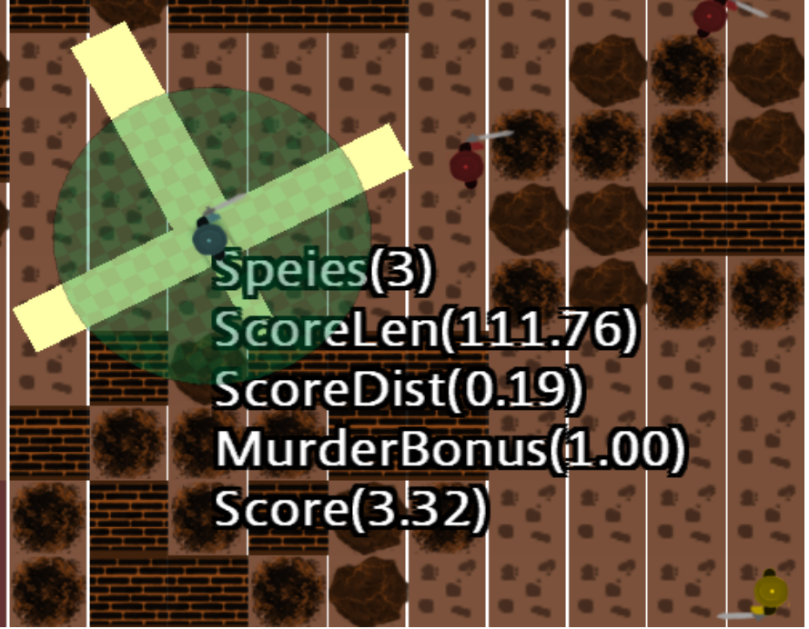
Play through a world where you can see the mythological creatures you know come to life. (See an Elemental creating a purple area below)
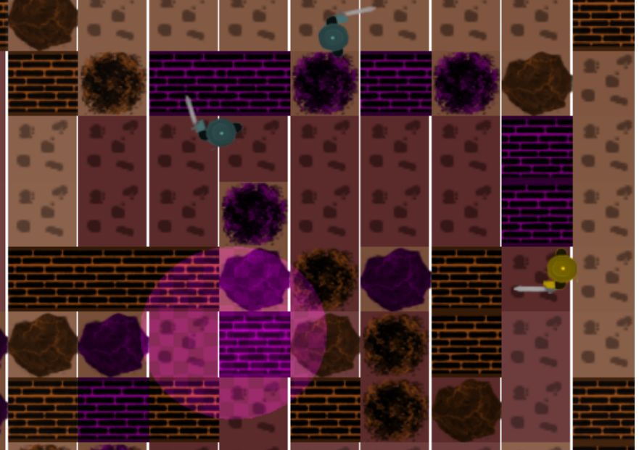
While other games may make a creature an “Elemental” by having them skinned differently or changing stats, we actually have creatures in the world exhibit behavior of that creature.
Elements change the Rocks and Trees around them. Reaper's collected the spirits of ghosts.(See a Reaper collecting the spirit of ghost below)
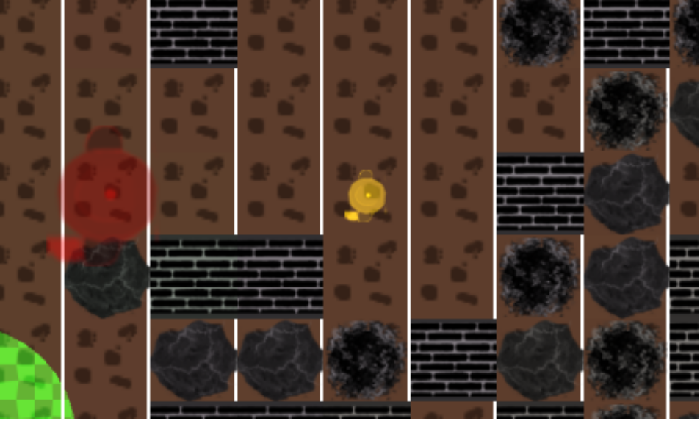

The Evolution of Character's AI creates a world with dynamic behavior. The creatures will change to move and fight through the world better. The Repears's use a dynamic pursuit technique to create a high stacks environment for perma-death.

