How to play the game
You control the gold Knight:
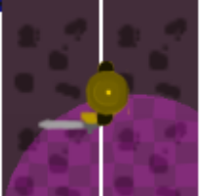
WASD controls the movement of the characters. With W being forward, A being left, S being down, and D being the right. Other knights on the screen can be killed by having your sword touch their body. Careful though, they have swords of their own. When you die you get sent to the Spirit world, where reapers attack you. If they hit you, game over. If you live 10 Sec. You're returned to the life of the living.
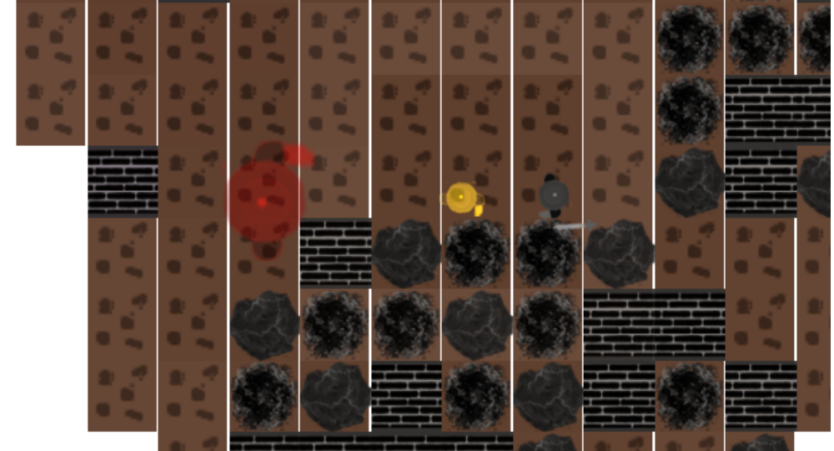

As you kill more knights, you will get to see more of the world around you.
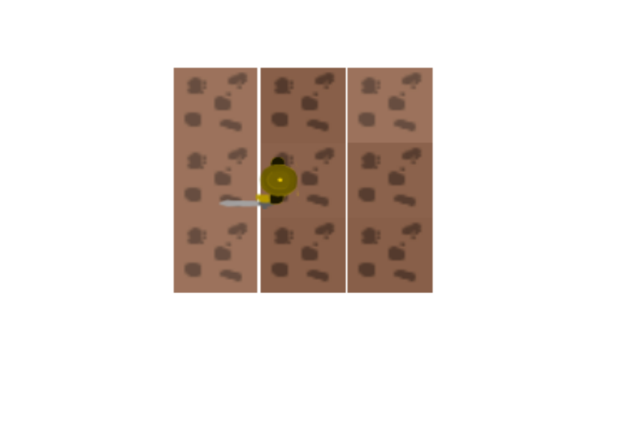
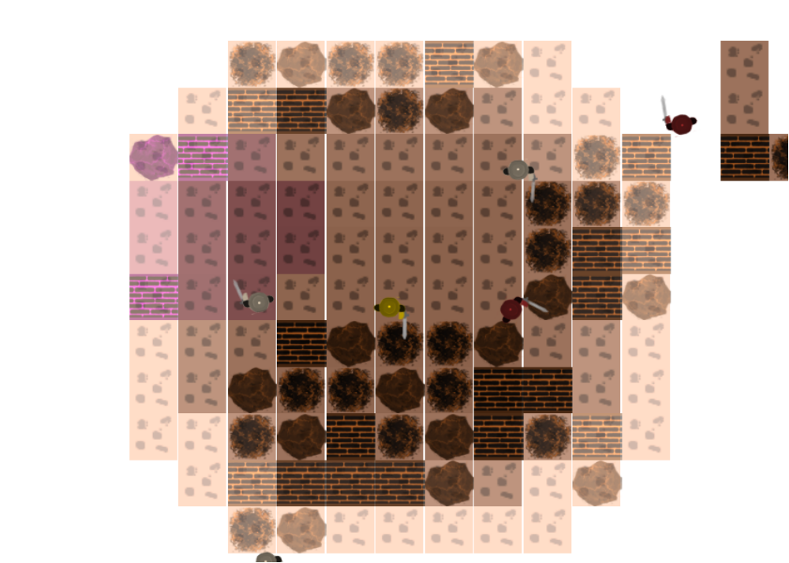
Your objective is to kill 50 other knights, at which point the Reapers will flee from you and you will gain access to the map editing mode.

