Agent creator
By: Christopher Ross

To Play:
1) The map will generate itself before your eyes(See the Map Generation section for more information)

2) Once the map has been generated, click 10 points to define the paths of the agents. Each pair of points defining a starting and ending square for the agents. Gold Squares are the staring points and Red are the ending points.

3) After those 10 points, you may click anywhere on the map to modify the field. Press M to begin the game.

4) Use WASD to move through the map. Press P to pause and M to goto the Map(You can edit the world from here.)

The Generation:
10 Agents will be created at each of the starting points. After X ticks each group is scores based on their distance to their end point and then they are set at another starting point. After each agent has seen each staring point, the path scores are average to create a total score. Then agents with the highest scores get children and the older generation is removed.
This continues until a generation's max scorer gets a score of greater than 29. 30 is the max, 29 was chosen because it represents being, on average, on the ending block.

Ticks Per Generation:
The number of ticks a generation gets goes up as the generation # does. The earlier generations didn't need as much time as the later ones did to differentiate good and bad agents.

Mutation Algorithm:
2 Random rows are selected, then 4 random connections are selected from those rows. The connections are shifted a random amount between -1 and 1.

Idiot Threshold:
To remove easily defined “idiots,” I created a way to take clearly wrong agents and give them a chance before they die sterile. When and agents front facing feeler averages less than .2 I mutate their brain dramatically. I think this extra factor may be responsible for the agents ability to escape local optimums on the map.
Brains:

The agents brains were made of 8 inputs, 1 hidden row with 10 nodes, and 2 outputs. The inputs where 6 different feelers and the normalized X and Y differential between the agents position and the end point. The outputs were the X and Y component of the direction that the agent should face.

Lessons Learned:
Back Prop. Is super difficult. I originally wanted to do that, but my attempts failed dramatically. Local Optimums also tend to be an issue, the idiot threshold helped with that. I was surprised at the variable number of generations it might take to solve the map. Some finished in like 10 generations, others took near 100. the solution tends to pretty specific and can take a long time to generate. In the future I would do a less row based approach and get Back prop. Working.

Run 1:
Remember Gold Squares are the staring points and Red are the ending points. Grided squares are walls, spotted ones are dirt. Attached FilesHW2_1part1 and HW2_1Part2 show the scores of this run.
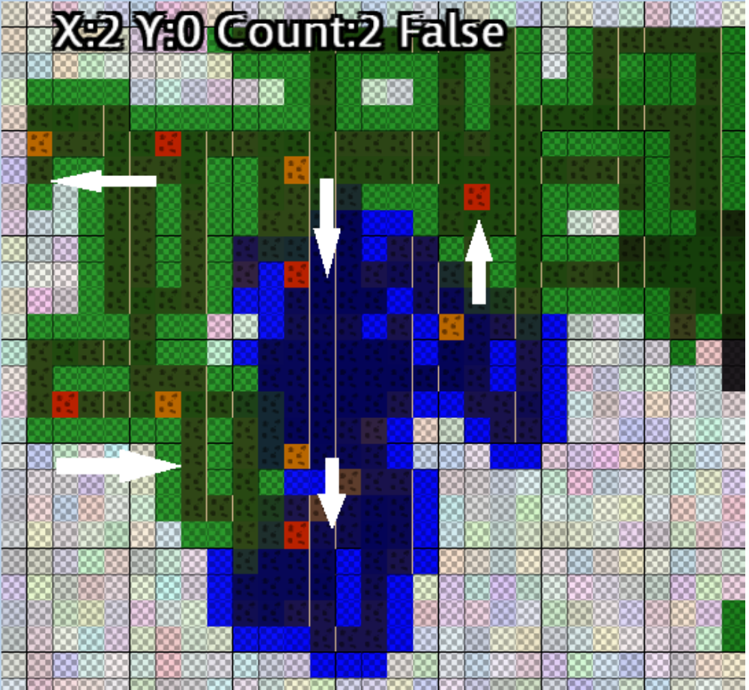

HW2_1Part1 created good results and then the map was modified into the state below:

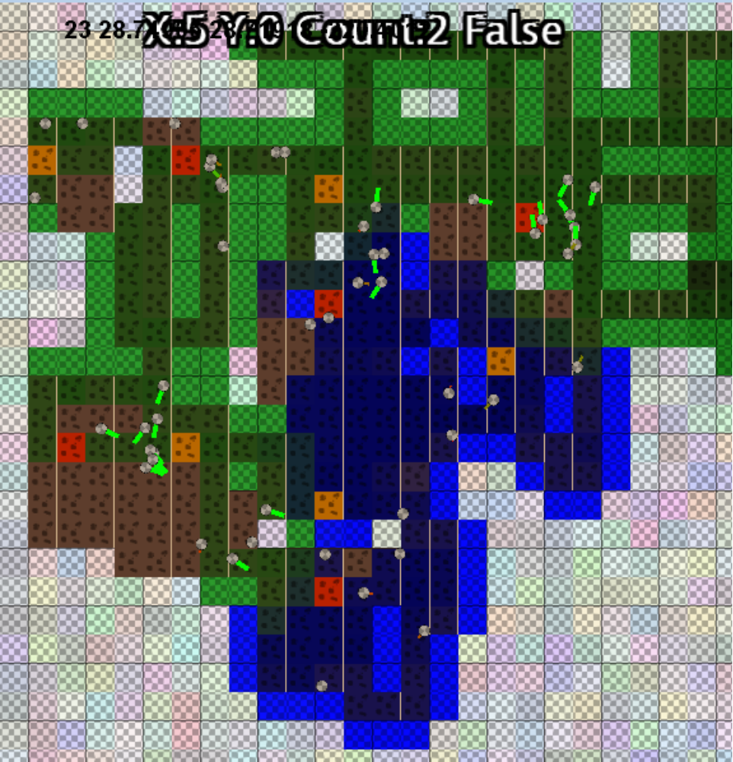

The following three images show the progression of agents in one of the cases from the map above:

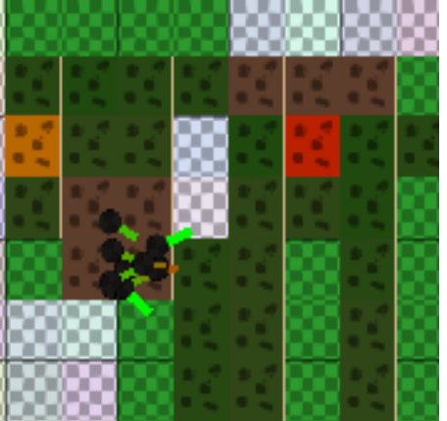

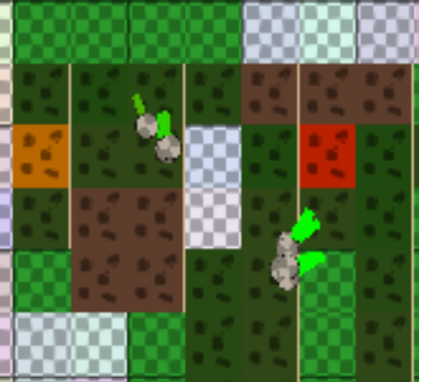

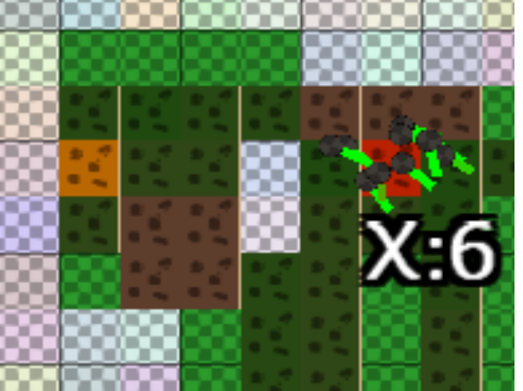

Run 2:
Remember Gold Squares are the staring points and Red are the ending points. Grided squares are walls, spotted ones are dirt. Attached FilesHW2_2part1 and HW2_2Part2 show the scores of this run.

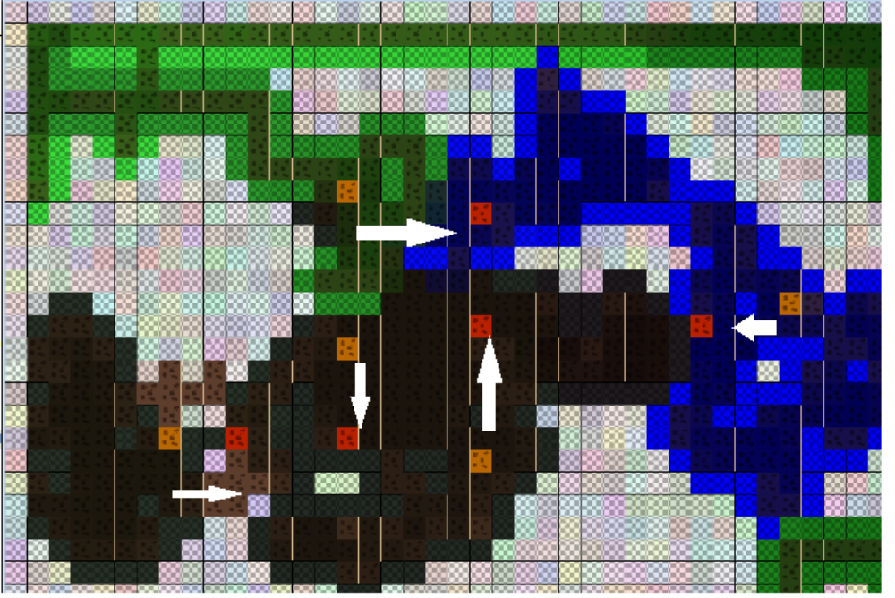

After success I modified the map into the one below, after 86 generations this was found to be to difficult and the map was adjusted.

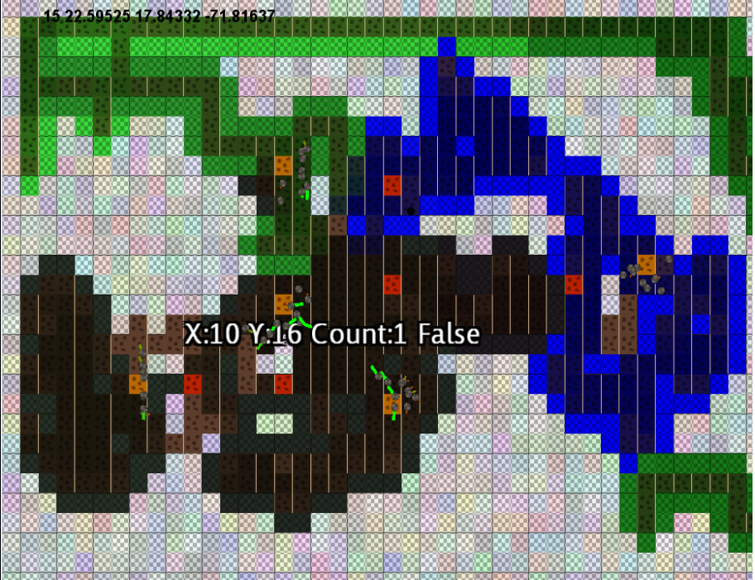
The third version is below, it was solved at generation 5: :

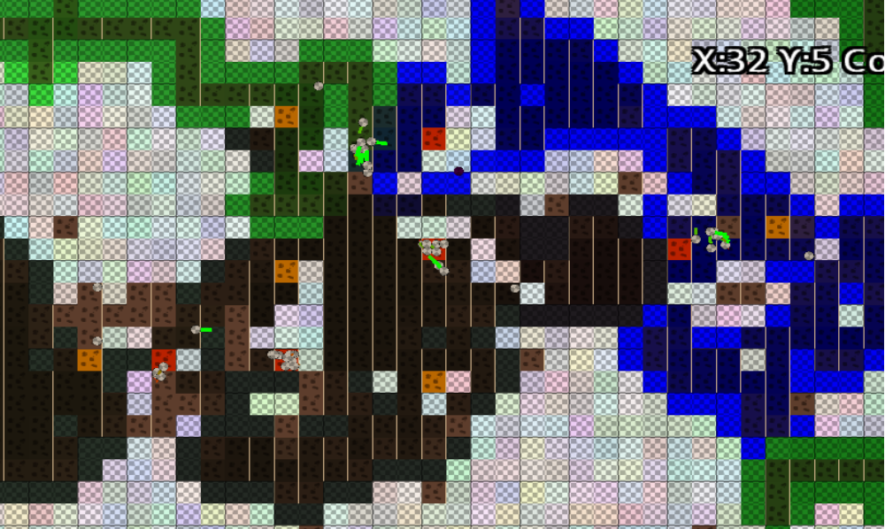

The following three images show the progression of agents in one of the cases from the map above:

