|  |
| --- |
| Software Design Document  for the  **Core Flight System SP0-VxWorks6.9 Platform Support Package – Version 1.5.1.0** |
| Engineering Directorate  Software, Robotics and Simulation Division |
| Availability:  NASA & NASA contractor employees as required  October 2021  Draft      National Aeronautics and  Space Administration  **Lyndon B. Johnson Space Center**  Houston, Texas |

Software Design Document

for the

Core Flight System SP0-VxWorks6.9 Platform Support Package

Version 1.5.1.0

Prepared by:

|  |
| --- |
| ________________________________________________ |
| Tam Ngo/ER6Date |
|  |
|  |

Approved by:

|  |
| --- |
| ________________________________________________ |
| Mark Markovich/NT Date |
| Project S&MA Representative |

|  |
| --- |
| ________________________________________________ |
| Dave Swartwout/ER6Date |
| Project Manager |

Approved for Release by:

|  |
| --- |
| ________________________________________________ |
| Pedro Martinez/ER1Date |
| Division Approval Authority |

**National Aeronautics and Space Administration**

**Lyndon B. Johnson Space Center**

**Houston, Texas**

**Change Record**

|  |  |  |  |
| --- | --- | --- | --- |
| ***Revision*** | ***Date*** | ***Originator*** | ***Description*** |
| N/A | Oct 2021 | Tam Ngo | Initial draft |
|  |  |  |  |
|  |  |  |  |
|  |  |  |  |
|  |  |  |  |

**Table of Contents**

1 Introduction 6

1.1 Scope 6

1.2 Responsibility and Change Authority 6

2 Related Documentation 6

2.1 Applicable Documents 6

2.2 Reference Documents 7

2.3 Order of Precedence 7

3 CSCI-Wide design decisions 7

3.1 Core Flight System 7

3.2 VxWorks6.9/SP0-S Platform Support Package 8

4 CSCI Architectural Design 8

4.1 CSCI Components 8

4.2 Concept of Execution 12

4.3 Interface Design 12

4.3.1 Common APIs 12

4.3.2 Startup APIs 12

4.3.3 CDS in FLASH APIs 12

4.3.4 Exception Storage APIs 12

4.3.5 Memory APIs 12

4.3.6 Memory Scrubbing APIs 12

4.3.7 Module APIs 12

4.3.8 SP0 Info APIs 13

4.3.9 NTP Time Synchronization APIs 13

5 CSCI Detailed Design 13

5.1 Assumptions, Dependencies and Constraints 13

5.1.1 Assumptions 13

5.1.2 Dependencies 13

5.1.3 Constraints 13

5.2 LIMITATIONS AND WARNINGS 14

5.2.1 Limitations 14

5.2.2 Warnings 14

6 Bi-Directional Traceability Matrix 14

6.1 From Requirement to Design Element 14

6.2 From Design Element to Requirement 14

7 Appendices 15

7.1 Abbreviations and Acronyms 15

7.2 Definition of Terms 16

8 notes 16

**List of Tables**

Table 2‑1: Applicable Documents 6

Table 2‑2: Reference Documents 7

Table 4‑1: SP0-VxWorks6.9 PSP Common APIs 12

Table 4‑2: SP0-VxWorks PSP Startup APIs 12

Table 4‑3: SP0-VxWorks PSP CDS-in-FLASH APIs 12

Table 4‑4: SP0-VxWorks6.9 PSP Exception Storage APIs 12

Table 4‑5: SP0-VxWorks6.9 PSP Memory APIs 12

Table 4‑6: SP0-VxWorks6.9 PSP Memory Scrubbing APIs 12

Table 4‑7: SP0-VxWorks6.9 PSP Module APIs 13

Table 4‑8: SP0-VxWorks6.9 PSP SP0 APIs 13

Table 4‑9: SP0-VxWorks6.9 PSP NTP Time Synchronization APIs 13

**List of Figures**

Figure 3‑1: Core Flight System Architectural Layers 8

Figure 4‑1. SP0-VxWorks6.9 PSP File Structure 9

# Introduction

The Software Design Document (SDD) details the Computer Software Units (CSUs), including their identities, attributes, static relationships, dynamic interactions and design requirements. The SDD includes enough structural and behavioral information sufficient to (1) specify the internal and external behavior of the primitive software components, and (2) be translated straightforwardly into the chosen programming language(s). The SDD includes information sufficient to enable sustaining engineering of the software by programmers other than the original developers. This includes the software structure, module definitions and functionality, high-level interface descriptions, threads of control, major data structures, and important algorithms.

This SDD defines the requirements and design of the software for the Core Flight System SP0-VxWorks6.9 Platform Support Package.

## Scope

This Software Design Document (SDD) documents the requirements and design of the Core Flight System SP0-VxWorks6.9 Platform Support Package. This document includes the selected design of the software, including its decomposition into software components, their relationships, and the design of interfaces.

## Responsibility and Change Authority

This document is prepared in accordance with EA-WI-025, “GFE Flight Project Software and Firmware Development”. The responsibility for the development of this document lies with the Spacecraft Software Engineering Branch. Change authority is the Software, Robotics and Simulation Division of the Johnson Space Center.

# Related Documentation

The following documents are referenced in this specification. Unless otherwise specified, the exact issue shown is the applicable version.

## Applicable Documents

The following documents, of the exact issue and revision shown, form a part of this SDD to the extent specified herein.

Table 2‑1: Applicable Documents

| ***Document***  ***Number*** | ***Document Title*** | ***Revision /***  ***Release Date*** |
| --- | --- | --- |
| NPR 7150.2 | NASA Software Engineering Procedural Requirements | Rev C / Aug 2019 |
| EA-WI-025 | GFE Flight Project Software and Firmware Development | Rev D / Sep 2013 |
| GP-10021 | Core Flight Software Certification Software Development Plan | Baseline / May 2020 |

## Reference Documents

The following documents are referenced within this SDD. These documents do not form a part of this SDD and are not controlled by their reference herein.

Table 2‑2: Reference Documents

| ***Document***  ***Number*** | ***Document Title*** | ***Revision /***  ***Release Date*** |
| --- | --- | --- |
| GSFC 582-2007-001 | cFE Application Developer’s Guide | Rel. 5.4 / Sep 2014 |
| GSFC 582-2008-012 | cFS Deployment Guide | Rel. 3.0 / Sep 2014 |
| GSFC 582-2007-00 | OSAL Configuration Guide | Rel. 4.2.1 / Aug 2016 |
| TBD | SP0-VxWorks6.9 PSP Software Developer’s Guide | TBD |

## Order of Precedence

In the event of a conflict between the text of this SDD and an applicable document cited herein, the text of this SDD takes precedence.

# CSCI-Wide design decisions

## Core Flight System

The Core Flight System (cFS) was developed by NASA Goddard Spaceflight Center (GSFC) as a reusable and extendible framework for developing flight software. The cFS framework has been developed over many years and was first used by NASA on the Lunar Reconnaissance Orbiter (LRO) spacecraft mission in 2009. Since then it has been successfully reused for other spacecraft missions, and its reuse has substantially increased across other NASA centers. A key feature of this framework is a layered software architecture proven to be robust and resilient in adapting to new hardware platforms with minimal changes. The cFS framework is composed of software abstraction layers from the underlying hardware and operating system as shown in Figure 3-1. Each layer provides a set of Application Programming Interfaces (APIs) that hides the underlying implementation for various platforms; and the implementation can be changed independently, without affecting the other layers.

Figure 3‑1: Core Flight System Architectural Layers

## VxWorks6.9/SP0-S Platform Support Package

The Platform Support Package (PSP) is the abstraction layer of the processor’s Board Support Package (BSP). A PSP provides a common set of Application Programming Interfaces (APIs) that can be used by the cFE, the OSAL and any cFS application/library.

The SP0-VxWorks6.9 PSP is implemented specifically for the AiTech SP0-S processor running VxWorks v6.9 operating system.

# CSCI Architectural Design

## CSCI Components

The general design of the PSP is structured like a typical C library.

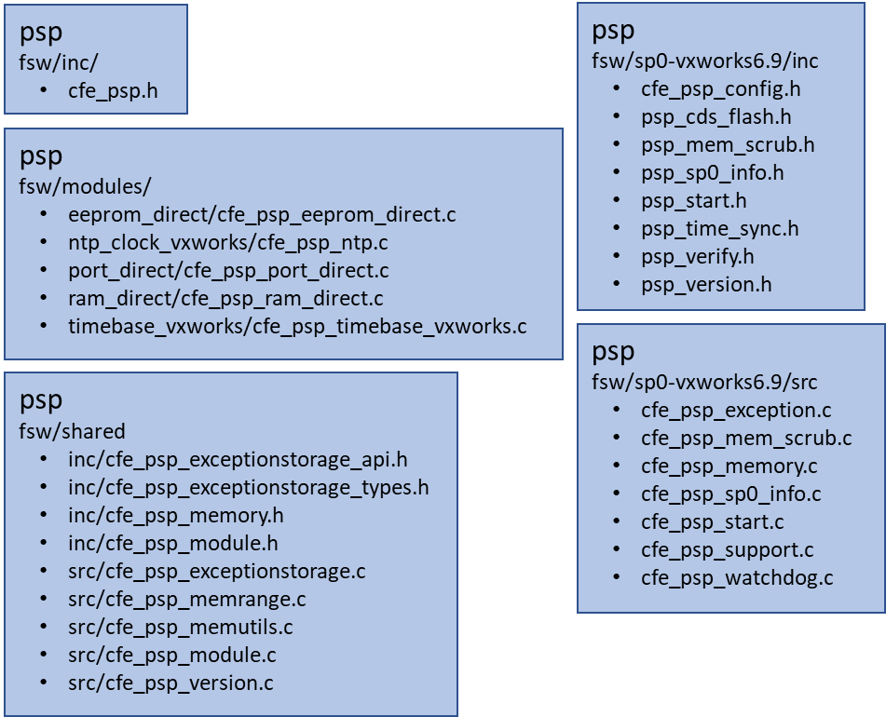

Figure 4‑1. SP0-VxWorks6.9 PSP File Structure

**Figure 4-1** depicts the file directory hierarchy of the PSP code base. The followings list the C source/header files and their purpose.

* psp/fsw/inc/cfe_psp.h

This header file contains the function declarations of the PSP’s public APIs.

* psp/fsw/modules/eeprom_direct/cfe_psp_eeprom_direct.c

This source file defines the function definitions for the EEPROM-related APIs.

* psp/fsw/modules/ntp_clock_vxworks/cfe_psp_ntp.c

This source file defines the function definitions for the NTP time-related APIs.

* psp/fsw/modules/port_direct/cfe_psp_port_direct.c

This source file defines the function definitions for the port-related APIs for systems that can access I/O ports directly via memory-mapped addresses.

* psp/fsw/modules/ram_direct/cfe_psp_ram_direct.c

This source file defines the function definitions for the RAM-related APIs for systems that can access physical memory directly.

* psp/fsw/modules/timebase_vxworks/cfe_psp_timebase_vxworks.c

This source file defines the function definitions for the time-related APIs via the VxWorks vxTimeBaseGet() routine.

* psp/fsw/shared/inc/cfe_psp_exceptionstorage_api.h

This header file defines the function declarations for the exception storage-related APIs. It provides a generic storage buffer ring for exceptions and functions to manipulate it.

* psp/fsw/shared/inc/cfe_psp_exceptionstorage_types.h

This header file contains the definitions of data structures used by the exception storage functions.

* psp/fsw/shared/inc/cfe_psp_memory.h

This header file contains the function declarations for the memory-related supporting functions for the local PSP routines.

* psp/fsw/shared/inc/cfe_psp_module.h

This header file defines the data structures and function declarations for the module-related APIs.

* psp/fsw/shared/src/cfe_psp_exceptionstorage.c

This source file contains the function definitions for the exception storage-related APIs.

* psp/fsw/shared/src/cfe_psp_memrange.c

This source file contains the function definitions for the memory range-related APIs. The memory range is a table of valid memory address ranges maintained by the cFE.

* psp/fsw/shared/src/cfe_psp_memutils.c

This source file contains the function definitions for the utility functions used by the memory-related APIs.

* psp/fsw/shared/src/cfe_psp_module.c

This source file contains the function definitions for the module-related APIs.

* psp/fsw/shared/src/cfe_psp_version.c

This source file contains the function definitions for routines that obtain the values of the various version identifiers.

* psp/fsw/sp0-vxworks6.9/inc/cfe_psp_config.h

This header file defines the PSP configuration and data structure definitions for the SP0-VxWorks6.9 implementation.

* psp/fsw/sp0-vxworks6.9/inc/psp_cds_flash.h

This header file contains the function declarations for the SP0-VxWorks6.9 PSP’s CDS-related APIs. These functions save and restore CDS in FLASH memory.

* psp/fsw/sp0-vxworks6.9/inc/psp_mem_scrub.h

This header file contains the function declarations for the SP0-VxWorks6.9 PSP’s memory scrubbing-related APIs.

* psp/fsw/sp0-vxworks6.9/inc/psp_sp0_info.h

This header file contains the data structure definitions and function declarations for obtaining statistical data on the SP0 processor such as Power-On Self Test (POST) results, processor temperatures, voltages, active boot EEPROM, etc.

* psp/fsw/sp0-vxworks6.9/inc/psp_start.h

This header file contains the function declarations for the SP0-VxWorks6.9 PSP’s startup/reset-related APIs.

* psp/fsw/sp0-vxworks6.9/inc/psp_time_sync.h

This header file contains the function declarations for the SP0-VxWorks6.9 PSP’s NTP time synchronization-related APIs.

* psp/fsw/sp0-vxworks6.9/inc/psp_verify.h

This header file contains the static compile-time checks of the SP0-VxWorks6.9 PSP configurations.

* psp/fsw/sp0-vxworks6.9/inc/psp_version.h

This header file defines the SP0-VxWorks6.9 PSP’s version identifiers.

* psp/fsw/sp0-vxworks6.9/src/cfe_psp_exception.c

This source file contains the function definitions for the SP0-VxWorks6.9 PSP’s exception-related APIs.

* psp/fsw/sp0-vxworks6.9/src/cfe_psp_mem_scrub.c

This source file contains the function definitions for the SP0-VxWorks6.9 PSP’s memory scrubbing-related APIs.

* psp/fsw/sp0-vxworks6.9/src/cfe_psp_memory.c

This source file contains the function definitions for the SP0-VxWorks6.9 PSP’s memory-related APIs.

* psp/fsw/sp0-vxworks6.9/src/cfe_psp_sp0_info.c

This source file contains the functions definitions for obtaining statistical data on the SP0 processor.

* psp/fsw/sp0-vxworks6.9/src/cfe_psp_start.c

This source file contains the function definitions for the SP0-VxWorks6.9 PSP’s startup/reset-related APIs.

* psp/fsw/sp0-vxworks6.9/src/cfe_psp_support.c

This source file contains the function definitions for the SP0-VxWorks6.9 PSP’s “glue” routines between the cFE and the SP0 Board Support Package (BSP).

* psp/fsw/sp0-vxworks6.9/src/cfe_psp_watchdog.c

This source file contains the function definitions for the SP0-VxWorks6.9 PSP’s watchdog-related APIs.

## Concept of Execution

As a library, PSP only provides the public functions that can be used by the cFE, OSAL and any cFS applications/libraries. It cannot be executed as a stand-alone task or application, and hence, has no concept of execution.

## Interface Design

The SP0-VxWorks6.9 PSP’s APIs are grouped into nine categories: common APIs, startup, CDS in FLASH, exception storage, memory, memory scrubbing, module, SP0 info, and NTP time synchronization.

### Common APIs

Table 4.1 lists the SP0-VxWorks6.9 PSP APIs associated with common APIs for a cFE PSP.

Table 4‑1: [SP0-VxWorks6.9 PSP Common APIs](PSP_sp0-vxworks6.9_common.pdf)

### Startup APIs

Table 4.2 lists the SP0-VxWorks6.9 PSP APIs associated with PSP startup.

Table 4‑2: [SP0-VxWorks6.9 PSP Startup APIs](PSP_sp0-vxworks6.9_startup.pdf)

### CDS in FLASH APIs

Table 4.3 lists the SP0-VxWorks6.9 PSP APIs associated with Critical Data Storage (CDS) in FLASH memory.

Table 4‑3: [SP0-VxWorks6.9 PSP CDS-in-FLASH APIs](PSP_sp0-vxworks6.9_cdsflash.pdf)

### Exception Storage APIs

Table 4.4 lists the SP0-VxWorks6.9 PSP’s APIs associated with the exception storage.

Table 4‑4: [SP0-VxWorks6.9 PSP Exception Storage APIs](PSP_sp0-vxworks6.9_exceptionstorage.pdf)

### Memory APIs

Table 4.5 lists the SP0-VxWorks6.9 PSP’s APIs associated with memory.

Table 4‑5: [SP0-VxWorks6.9 PSP Memory APIs](PSP_sp0-vxworks6.9_memory.pdf)

### Memory Scrubbing APIs

Table 4.6 lists the SP0-VxWorks6.9 PSP’s APIs associated with memory scrubbing.

Table 4‑6: [SP0-VxWorks](PSP_sp0-vxworks6.9-memoryscrub.pdf)6.9 PSP Memory [Scrubbing](PSP_sp0-vxworks6.9_memoryscrub.pdf) APIs

### Module APIs

Table 4.7 lists the SP0-VxWorks6.9 PSP’s APIs associated with module.

Table 4‑7: [SP0-VxWorks6.9 PSP Module APIs](PSP_sp0-vxworks6.9_module.pdf)

### SP0 Info APIs

Table 4.8 lists the SP0-VxWorks6.9 PSP’s APIs associated with SP0 statistical data.

Table 4‑8: [SP0-VxWorks6.9 PSP SP0 APIs](PSP_sp0-vxworks6.9_sp0.pdf)

### NTP Time Synchronization APIs

Table 4.9 lists the SP0-VxWorks6.9 PSP’s APIs associated with NTP time synchronization.

Table 4‑9: [SP0-VxWorks6.9 PSP NTP Time Synchronization APIs](PSP_sp0-vxworks6.9_timesync.pdf)

# CSCI Detailed Design

This section of the document is generated from Doxygen comments in the application’s source code. The section contains the declarations of macros, variables and data structures, the function definitions, along with their inputs, outputs and limitations. The generated document also includes the application’s configurable parameters and their values. For more details, see [Section_5](PSP_SP0-VXWORKS6.9_sdd_s5.pdf).

## Assumptions, Dependencies and Constraints

### Assumptions

1. The SP0-VxWorks6.9 PSP contains the implementation of the common PSP APIs, as well as the additional custom APIs that are specific to the SP0 processor. The custom APIs are dictated by the software system’s requirements, and hence, will vary from PSP to PSP.
2. The SP0-VxWorks6.9 PSP’s platform-specific configuration parameters are defined in the header file, ***psp/fsw/sp0-vxworks6.9/inc/cfe_psp_config.h***.
3. DeleteProcessorReservedMemory(), a common PSP API, is not implemented since it is not used for the SP0 processor running VxWorks6.9.
4. Aitech Bootloader seems to delete the Reserved Memory after reboot. Since the Reserved Memory will get erased at each reboot, Critical Data Storage (CDS) is synchronized on FLASH memory.
   * The Reserved Memory on RAM is the Gold copy.
   * The Reserved Memory on FLASH is used for recovery after a soft reboot or a power cycle.
   * The CDS cannot be fully disabled on FLASH memory.

### Dependencies

1. The SP0-VxWorks6.9 PSP is dependent on the Wind River development tools (cross compiler, loader, etc..) for the VxWorks v6.9 operating system for the PowerPC processor family.

### Constraints

1. The SP0-VxWorks6.9 PSP is developed specifically for cFS, and hence, can only be used within the cFS development and run-time environments. For additional information on cFS, see documentation included with the cFE software release.

## LIMITATIONS AND WARNINGS

### Limitations

1. The SP0 exception handling is currently defaulted to the Kernel’s default exception handling.
2. Direct Memory Access (DMA) is not yet supported.
3. When running the SP0-VxWorks6.9 PSP’s unit tests on the SP0 platform, the SPE-based functions are currently stubbed out due to issues with the Wind River’s code coverage tool.

### Warnings

None.

# Bi-Directional Traceability Matrix

This section documents the mapping of the software requirements to the design elements and from the design elements to the software requirements. The SP0-VxWorks6.9 PSP is a library, and therefore, does not have its own requirements. Hence, this section is not applicable to the SP0-VxWorks6.9 PSP.

## From Requirement to Design Element

N/A.

## From Design Element to Requirement

N/A.

# Appendices

## Abbreviations and Acronyms

| **Term** | **Definition** |
| --- | --- |
| AES | Advanced Exploration Systems |
| API | Application Programming Interface |
| CDR | Critical Design Review |
| cFE | Core Flight Executive |
| cFS | Core Flight System |
| CMD | Command |
| CR | Change Request |
| CSC | Computer Software Component |
| CSCI | Computer Software Configuration Item |
| CSU | Computer Software Unit |
| EA | Engineering Directorate Mail Code |
| FSW | Flight Software |
| GFE | Government Furnished Equipment |
| GSFC | Goddard Space Flight Center |
| GUI | Graphical User Interface |
| HK | Housekeeping cFS application |
| ICD | Interface Control Document |
| ISR | Interrupt Service Routine |
| JSC | Johnson Space Center |
| MD | Memory Dwell cFS Application |
| MDT | Message Definition Table (for SCH_TT application) |
| MID | Message Identifier |
| NASA | National Aeronautics and Space Administration |
| NPR | NASA Procedural Requirements |
| OS | Operating System |
| OSAL | Operating System Abstraction Layer |
| PDR | Preliminary Design Phase |
| PMP | Project Management Plan |
| PSP | Platform Support Package |
| PTRS | Project Technical Requirements Specification |
| SCH | Scheduler cFS Application |
| SCH_TT | Time-Triggered Ethernet Scheduler cFS Application |
| SB | cFE Software Bus |
| SBNG | Software Bus Network for Gateway cFS application |
| SDD | Software Design Document |
| SDP | Software Development Plan |
| SDT | Schedule Definition Table (for SCH_TT application) |
| SW, S/W | Software |
| TBD | To Be Determined |
| TBL | Table |
| TDM | Time-Division Multiplexing |
| TLM | Telemetry |
| TTE | Time-Triggered Ethernet |
| TTE_LIB | Time-Triggered Ethernet cFS library |
| TTE_MGR | Time-Triggered Manager cFS application |
| V&V | Verification and Validation |
| V&VD | Verification and Validation Document |
| VDD | Version Description Document |
| WI | Work Instruction |

## Definition of Terms

None.

# notes

None.