

YUVA INTERN | FINAL CAPSTONE PROJ ECT | TASK 6

FINAL CAPSTONE PROJ ECT
NETWORK SECURITY
BEST PRACTICES
Practical Assessment &Technical Report
Submitted by Sai Akul
Programme Yuva Intern – Network Security
Assignment Task 6 – Final Capstone Project
Practical environment Kali Linux and Metasploitable virtual machines
Evidence-based report covering all seven prescribed objectives
Sai Akul • Network Security Best Practices •

YUVA INTERN | FINAL CAPSTONE PROJ ECT | TASK 6

Executive Summary
This report presents a structured review of practical network-security controls and the evidence collected
during a controlled virtual-lab exercise using Kali Linux and a Metasploitable target. The work addresses the
seven Task 6 objectives: security practices, network segmentation, authentication and access control,
firewalls and intrusion detection/prevention, secure configuration, monitoring and logging, and a practical
security checklist.
The strongest hands-on evidence is the Metasploitable authentication log, which records repeated failed
SSH authentication attempts for the test account 'baduser'; the Kali SSH client output showing three
denied password attempts; an Nmap result showing the target's responding ports; an iptables rules listing;
and a tcpdump capture demonstrating that FTP USER/PASS commands can be visible in plaintext. The FTP
password has been redacted in this report.
The lab also revealed configuration issues that are useful findings in themselves: the SSH service-status
command was not successfully executed in the captured session, and the firewall listing did not correspond
to the Nmap result for all listed ports. Therefore, this report does not claim that SSH hardening, complete
segmentation, or effective firewall enforcement was verified. It records observed evidence, explains the
security implications, and recommends corrective controls.
Scope and Lab Setup
Item | Description
Attacker / administration VM | Kali Linux
Target VM | Metasploitable
Target address used | 192.168.56.101
Tools evidenced | SSHclient, grep, /var/log/auth.log, iptables, Nmap, tcpdump
Exercise boundary | Controlled virtual machines on a lab network; no external  systems were tested

Methodology
1. Review the task objectives and identify relevant security controls.
2. Use the Kali VM to initiate controlled SSHauthentication attempts against the Metasploitable VM.
3. Inspect the target authentication log for failed-login records and source addresses.
4. Review firewall rules and use Nmap to observe selected TCP ports on the lab target.
5. Use tcpdump to inspect a controlled FTP exchange and identify the security risk of plaintext
credentials.
6. Compare observed results with recommended security practices and document gaps without
overstating results.
Sai Akul • Network Security Best Practices •

YUVA INTERN | FINAL CAPSTONE PROJ ECT | TASK 6

Objective 1 – Research Commonly Recommended Network
Security Practices
Network security is achieved through multiple complementary controls rather than a single product or
command. A defence-in-depth approach reduces the chance that one configuration failure will expose the
entire environment.
Recommended practice | Purpose and implementation
Asset inventory | Maintain an accurate list of hosts, services, software  versions, owners and data sensitivity.
Least privilege | Give users and services only the permissions required for  their roles; remove unused accounts.
Strong authentication | Use unique passwords, MFA where supported, SSH keys and  account lockout/rate-limiting controls.
Secure protocols | Prefer SSH, HTTPS, SFTP and other encrypted protocols;  disable Telnet and plaintext FTP.
Patch management | Apply supported security updates and remove obsolete or  unnecessary services.
Firewall policy | Allow only required traffic; deny unnecessary inbound  connections and review rules periodically.
Monitoring and response | Centralise logs, synchronise time, alert on suspicious events  and define an incident-response process.
Backups and recovery | Keep protected, tested backups and document recovery  procedures.

Application to the lab
The Nmap scan showed several services responding on the target, including FTP (21/tcp), Telnet (23/tcp)
and 1524/tcp (identified by Nmap as ingresslock). This supports the recommendation to inventory exposed
services and disable or restrict anything not required. The packet capture also demonstrates why plaintext
FTP should be replaced with an encrypted transfer method.
Outcome
The objective is addressed through a documented set of standard controls and their relevance to observed
lab evidence. The report does not claim that every recommended control was deployed in the VM.
Sai Akul • Network Security Best Practices •

YUVA INTERN | FINAL CAPSTONE PROJ ECT | TASK 6

Objective 2 – Understand the Importance of Network
Segmentation
Network segmentation divides a network into smaller security zones using VLANs, subnets, routing policies
and firewall rules. It limits unnecessary communication between systems and helps contain compromise.
Why segmentation matters
● Limits lateral movement: compromise of one workstation does not automatically provide access to
servers or management systems.
● Reduces attack surface: each zone exposes only the services required for its function.
● Supports access control: rules can restrict which source networks may reach specific destinations and
ports.
● Improves monitoring: traffic between zones can be logged and inspected at controlled points.
● Protects sensitive assets: databases, backups and administrative interfaces can be placed in restricted
zones.
Recommended logical design
Security zone | Example systems | Suggested policy
User zone | Student/workstation devices | Permit only approved services to  required internal systems.
Server zone | Application and file servers | Accept connections only from  authorised user or application zones.
Management zone | SSH administration, hypervisor  management | Restrict to designated administrator  devices; require strong authentication.
Monitoring zone | Log collector and monitoring tools | Receive logs/telemetry; restrict  administrative access.

In this exercise, Kali and Metasploitable were used as separate virtual machines. The screenshots show
addresses and traffic associated with the lab, but they do not prove that VLANs, multiple routed subnets, or
inter-zone access-control policies were configured. The recommended design above is therefore a
segmentation plan, not a claim of a completed segmentation test.
Outcome
The objective is explained through a practical security-zone design and the principle of restricting
communication between zones. A follow-up implementation could create separate VirtualBox host-only
networks and verify permitted and denied paths with firewall rules.
Sai Akul • Network Security Best Practices •

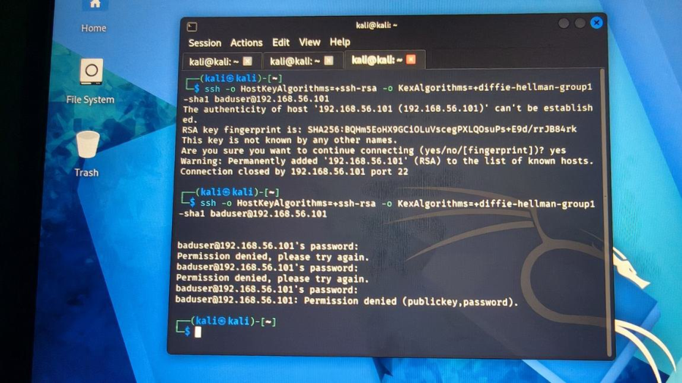
YUVA INTERN | FINAL CAPSTONE PROJ ECT | TASK 6

Objective 3 – Study Secure Authentication and Access-
Control Practices
Authentication verifies an identity; authorisation determines what that identity is allowed to do. Both
controls are essential. A secure design uses unique accounts, strong credentials, least privilege, multi-
factor authentication where available, and auditing of successful and unsuccessful access.
Practical demonstration: failed SSHauthentication
From Kali, an SSH connection was initiated to the Metasploitable host at 192.168.56.101 using the test
username 'baduser'. After the host key was accepted, the client prompted for a password. Three incorrect
password attempts were submitted, and the client ended with 'Permission denied (publickey,password)'.
This is evidence of rejected authentication, not a successful login.
Evidence 1 – Kali SSHauthentication failures
Kali terminal showing repeated 'Permission denied' responses for the test account. The image documents failed authentication
attempts.
Secure authentication recommendations
● Disable password-based SSHauthentication where operationally possible and use managed SSHkeys.
● Disable direct root SSHlogin; use named administrator accounts and controlled privilege escalation.
● Use unique, long passwords and MFA for remote-access systems where supported.
● Limit SSHaccess to the management subnet or approved administrator addresses.
● Apply rate limiting or an intrusion-prevention control to slow repeated login attempts.
● Review dormant accounts and remove default or unnecessary credentials.
The screenshots demonstrate rejected SSH attempts. They do not demonstrate that MFA, key-only login,
account lockout, or an SSHallow-list was configured; these are recommended improvements.
Sai Akul • Network Security Best Practices •

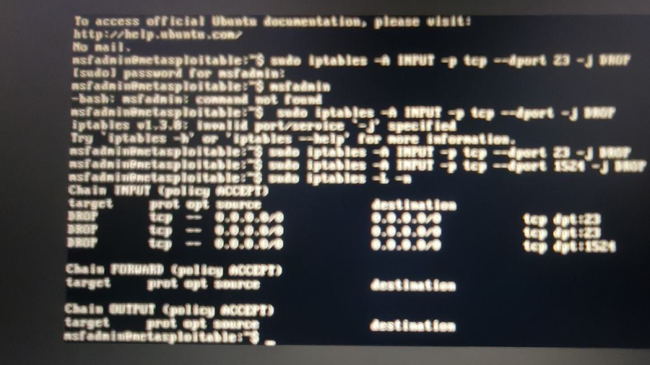
YUVA INTERN | FINAL CAPSTONE PROJ ECT | TASK 6

Objective 4 – Understand Firewall, IDS and IPS Security
Concepts
Firewall
A firewall enforces traffic policy using attributes such as source/destination address, protocol, port and
connection state. A default-deny inbound policy with narrowly defined allow rules is generally safer than
allowing all inbound traffic.
IDS and IPS
Control | Function | Typical response
IDS – Intrusion Detection System | Inspects traffic or host events for  suspicious patterns. | Generates alerts for an analyst or SIEM.
IPS – Intrusion Prevention System | Inspects traffic inline and applies  prevention rules. | Can drop, reject or rate-limit suspicious  traffic.

Lab firewall evidence
Evidence 2 – iptables INPUT chain
Metasploitable iptables listing showing DROP rules for selected TCP destination ports, including 23, 1521 and 1524.
The captured rules listing shows DROP entries for selected TCP ports. However, the separate Nmap scan
reported 23/tcp and 1524/tcp as open. This mismatch means the screenshots do not establish that those
rules effectively blocked the scanned traffic. Possible causes include rule ordering, interface or path
differences, timing, or a rule set that was changed between captures. The correct conclusion is that rules
were inspected, but effective blocking was not conclusively verified.
Sai Akul • Network Security Best Practices •

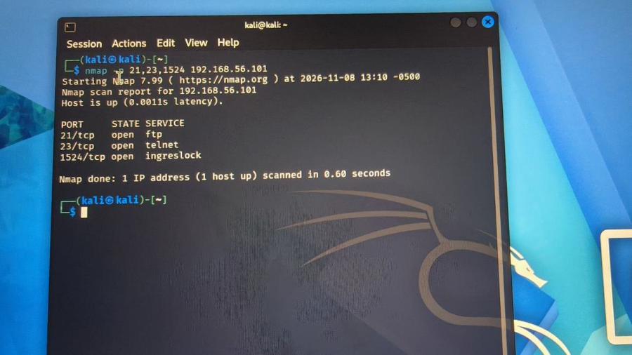
YUVA INTERN | FINAL CAPSTONE PROJ ECT | TASK 6

Nmap service exposure evidence
Evidence 3 – Nmap scan of the lab target
Kali Nmap output reports the target as up and lists 21/tcp FTP, 23/tcp Telnet and 1524/tcp ingresslock as open.
The scan covered only the three specified ports (21, 23 and 1524); it is not a full-port assessment. The
results identify services that should be reviewed, especially Telnet and plaintext FTP. No IDS or IPS alert is
shown in the supplied evidence, so IDS/IPS operation is explained conceptually rather than claimed as a
completed practical deployment.
Sai Akul • Network Security Best Practices •

YUVA INTERN | FINAL CAPSTONE PROJ ECT | TASK 6

Objective 5 – Research Secure Network Configuration
Practices
Secure configuration means reducing unnecessary exposure and ensuring that network services, operating
systems and access paths follow a documented baseline.
Configuration area | Recommended baseline
Services | Inventory listening ports; stop and uninstall unused services;  verify changes with a fresh scan.
Remote administration | Use SSH rather than Telnet; restrict management access to  trusted hosts or a management subnet.
File transfer | Replace FTP with SFTP or FTPS; never transmit credentials in  plaintext.
Firewall | Use explicit allow rules for required traffic, a deny-by-default  inbound stance and periodic rule review.
System maintenance | Patch the OS and applications; remove unsupported software  and default accounts.
Logging | Enable authentication and firewall logs, synchronise time,  protect log files and retain them centrally.
Configuration control | Document changes, back up known-good configurations and  test rollback procedures.

Observed configuration findings
● The target responded on FTP, Telnet and TCP/1524 during the captured Nmap scan; each service should
be confirmed as required.
● The firewall screenshot showed selected DROP rules, but the Nmap result indicates that blocking
effectiveness needs retesting.
● A service-status check was attempted, but the captured terminal returned a command-not-found error;
SSHservice state was therefore not verified by that command.
● The FTP packet capture exposed protocol commands in readable form, illustrating the risk of plaintext
credentials.
These findings are configuration-review observations. They are not evidence that the target was fully
hardened.
Sai Akul • Network Security Best Practices •

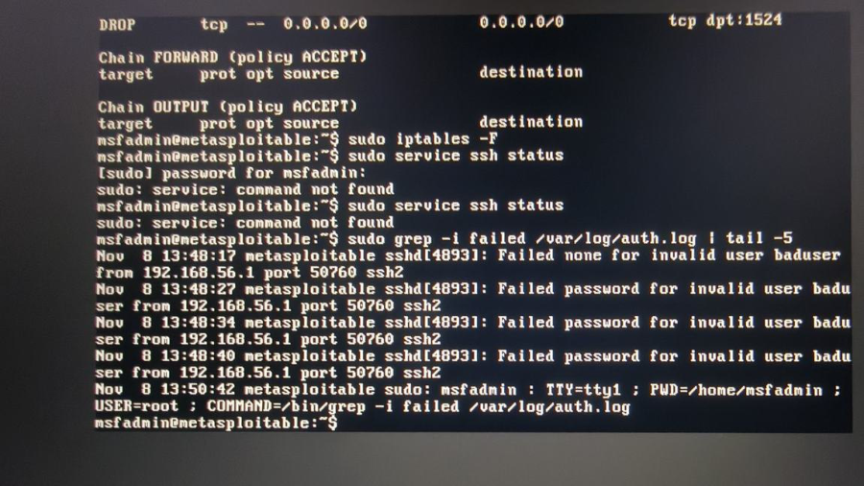
YUVA INTERN | FINAL CAPSTONE PROJ ECT | TASK 6

Objective 6 – Understand the Importance of Monitoring and
Security Logging
Monitoring provides visibility into system and network activity. Logs preserve events for investigation, trend
analysis and incident response. Useful security logs include authentication successes and failures, account
changes, firewall decisions, service events and administrative actions.
Practical demonstration: authentication log review
Evidence 4 – Metasploitable authentication log
Metasploitable /var/log/auth.log output showing repeated failed SSHauthentication for invalid user 'baduser'.
The log records repeated 'Failed none' and 'Failed password' messages for invalid user 'baduser'. The entries
show source address 192.168.56.1 and source port 50760. This is the strongest evidence in the submission
that unsuccessful SSHaccess attempts were recorded on the target.
Packet monitoring with tcpdump
Evidence 5 – tcpdump capture of FTP control traffic
Sai Akul • Network Security Best Practices •

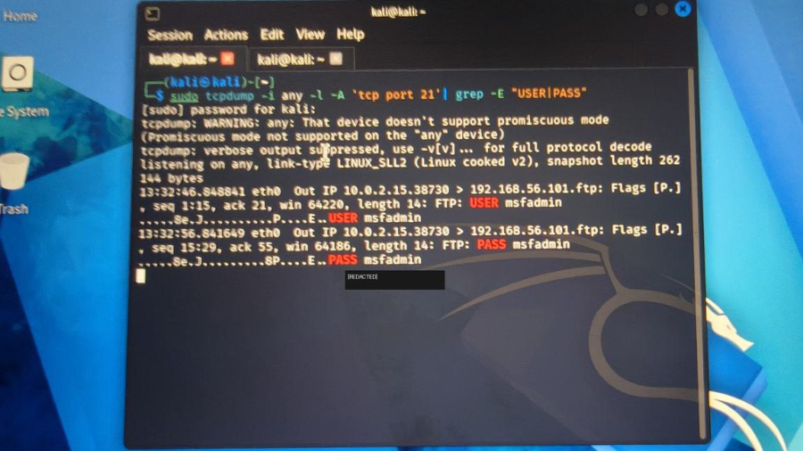
YUVA INTERN | FINAL CAPSTONE PROJ ECT | TASK 6

Kali tcpdump output shows FTP USER and PASS control commands. The password value is redacted in this report.
The capture demonstrates that FTP control traffic can expose authentication commands to a network
observer when transmitted without encryption. This is a security weakness of plaintext FTP and supports
replacing it with SFTP or FTPS. The screenshot shows the capture interface as 'any' and a Kali-side address
of 10.0.2.15, while the SSH authentication log records 192.168.56.1. These addresses belong to different
observed traffic contexts and should not be treated as the same source without further interface and
routing verification.
Monitoring commands used
sudo grep -i failed /var/log/auth.log |tail -5
Displays recent failed-authentication log entries.
sudo tcpdump -i any -l -A 'tcp port 21' |grep -E 'USER|PASS'
Inspects FTP control-channel text in the controlled lab. Use only with authorised traffic; credentials must
be protected.
sudo iptables -L -n -v
Lists firewall chains, rules, counters and numeric addresses/ports.
A separate tcpdump attempt returned zero captured packets. This is a valid negative result for that specific
capture window and filter; it does not prove that the network carried no traffic. The successful FTP capture
is the relevant positive packet-monitoring evidence.
Sai Akul • Network Security Best Practices •

YUVA INTERN | FINAL CAPSTONE PROJ ECT | TASK 6

Objective 7 – Create a Practical Network Security Best-
Practices Checklist
The following checklist can be used during routine network reviews. It is designed to be actionable and
covers prevention, detection and recovery.
Check | Verification item
Asset inventory | Maintain an up-to-date inventory of hosts, services, owners  and criticality.
Segmentation | Separate user, server, management and monitoring systems  into appropriate security zones.
Access control | Apply least privilege; remove unused accounts; review  privileged access.
Authentication | Use strong unique credentials, MFA where available and SSH  keys for administration.
Secure protocols | Disable Telnet and plaintext FTP; use SSH, SFTP, FTPS and  HTTPS.
Firewall | Document inbound/outbound rules; allow only required  traffic; verify rule order and counters.
Vulnerability management | Patch systems and review exposed services and known  vulnerabilities.
Monitoring | Collect authentication, firewall and system logs; synchronise  system clocks.
Alerting | Alert on repeated failed logins, unexpected listening ports  and suspicious traffic.
Incident response | Define escalation, containment, evidence preservation and  recovery procedures.
Backup and recovery | Maintain protected backups and test restoration regularly.
Periodic validation | Repeat authorised scans and configuration reviews after  significant changes.

Priority actions based on this lab
1. Review and disable Telnet (23/tcp) if it is not required.
2. Replace FTP (21/tcp) with SFTP/FTPS and prevent plaintext credential exposure.
3. Reconcile the iptables DROP rules with the Nmap results; retest from the same source and interface.
4. Verify SSH service state and apply key-based authentication, restricted source access and login-rate
controls.
5. Centralise authentication and firewall logs and configure alerts for repeated failed SSHattempts.
Sai Akul • Network Security Best Practices •

YUVA INTERN | FINAL CAPSTONE PROJ ECT | TASK 6

Consolidated Findings and Evidence Matrix
Objective | Evidence / treatment in this report | Status
1. Security practices | Documented defence-in-depth  practices and related lab observations. | Research / analysis
2. Segmentation | Explained security zones and  recommended policy; no VLAN/subnet  implementation shown. | Design / analysis
3. Authentication | Kali shows three denied SSH password  attempts; target log corroborates  failures. | Practical evidence
4. Firewall, IDS, IPS | iptables rules and Nmap scan shown;  IDS/IPS explained; blocking mismatch  noted. | Partial practical + concepts
5. Secure configuration | Configuration baseline and exposed-  service findings documented. | Research / review
6. Monitoring/logging | auth.log and tcpdump evidence  included; plaintext FTP risk identified. | Practical evidence
7. Checklist | Actionable security checklist and lab-  specific priorities supplied. | Deliverable

Key Technical Observations
● Failed SSH authentication was recorded by the target; the log identifies invalid user 'baduser' and
source 192.168.56.1.
● Kali's SSHclient output shows three password rejections and no successful login.
● Nmap found the target up and reported 21/tcp, 23/tcp and 1524/tcp open in the captured scan.
● iptables displayed DROP rules for selected ports, but the separate scan still reported 23/tcp and 1524/
tcp open; rule effectiveness remains unverified.
● tcpdump displayed FTP USER/PASS control commands; the password has been redacted in the report.
Limitations
The supplied screenshots do not show a completed VLAN or subnet segmentation test, a working IDS/IPS
alert, a successful firewall block verification, or an SSH hardening test. The Nmap scan was limited to three
specified ports. The SSH log and FTP packet-capture screenshots show different source addresses and
traffic contexts. These limitations are stated to keep the report technically accurate.
Conclusion
The Task 6 exercise demonstrates why network security requires layered controls. The practical evidence
shows that failed SSH authentication can be logged and investigated, that service discovery can identify
exposed ports, that firewall rules must be validated against observed traffic, and that plaintext FTP can
reveal authentication data. The seven objectives are addressed through practical evidence where available
and clear research, design and checklist material where the screenshots do not establish implementation.
The recommended next steps are to remove insecure services, enforce encrypted administration and file
Sai Akul • Network Security Best Practices •

YUVA INTERN | FINAL CAPSTONE PROJ ECT | TASK 6

transfer, validate firewall policy, strengthen authentication, segment network zones and centralise security
logs.
References
● National Institute of Standards and Technology (NIST), SP 800-41 Rev. 1, Guidelines on Firewalls and
Firewall Policy.
● NIST, SP 800-53 Rev. 5, Security and Privacy Controls for Information Systems and Organizations.
● NIST, SP 800-61 Rev. 2, Computer Security Incident Handling Guide.
● OpenSSHmanual pages: ssh(1), sshd_ config(5).
● Netfilter / iptables documentation and tcpdump manual page.
● Nmap Reference Guide, Port Scanning Basics.
Note: References are provided as authoritative further-reading sources. This report's practical findings are
based on the screenshots supplied for this assignment.
Sai Akul • Network Security Best Practices •

