YUVA INTERN | TASK 5
Security Risk Assessment Report
Security Report & Documentation
Identification, likelihood and impact analysis, and prioritization of security risks in a sample network environment
Prepared by | [Your full name]
Internship task | Task 5 - Security Report & Documentation
Scans performed | 6 November 2026 (as recorded by Nikto)
Report date | 7 November 2026
Environment | Kali Linux (assessment machine) and Metasploitable 2 (target, 192.168.56.101) in an isolated lab
Classification | Educational lab report - authorized testing only

1. Executive Summary
This report presents a security risk assessment of a sample network environment built in an isolated virtual lab: a Kali Linux assessment machine and a Metasploitable 2 target (192.168.56.101). The assessment reviewed the network architecture and security controls, identified weaknesses using Nmap, Nikto, Searchsploit and the National Vulnerability Database (NVD), and rated every finding by likelihood and impact using a 5x5 risk matrix. The findings are supported by the screenshots in Figures 2 to 9.
Result: 16 security risks were identified: 5 Critical, 5 High, 5 Medium and 1 Low. The overall risk posture of the environment is Critical. The target runs backdoored and outdated software, exposes more than 20 services, has no firewall in front of it, and its web server leaks configuration details, so a remote attacker could gain full (root) control without any valid credentials.
Risk level | Count | Findings
Critical | 5 | R1, R2, R3, R4, R5
High | 5 | R6, R7, R8, R9, R10
Medium | 5 | R11, R12, R13, R14, R15
Low | 1 | R16

Top priorities:
- Remove the backdoored services (vsftpd 2.3.4, UnrealIRCd 3.2.8.1) and the root bind shell on port 1524.
- Patch or upgrade Samba, distccd, Apache and PHP, and replace default credentials.
- Add a default-deny firewall, replace Telnet and r-services with SSH, and introduce logging and intrusion detection.
Metasploitable 2 is intentionally vulnerable, so these results are expected. The same method of identifying, rating, prioritizing and mitigating risk applies directly to a real business network.

2. Introduction, Scope and Methodology

2.1 Purpose and scope
The purpose of this assessment is to analyze a sample network environment, identify and evaluate security risks, and prioritize them by likelihood and potential impact, followed by recommended security controls. The scope covers one target host and the network services it exposes. All testing was carried out only on systems owned by the author in an isolated lab, so no third-party systems were affected.

2.2 Test environment
System | Role | Details
Kali Linux | Assessment machine | Host name kali; runs Nmap, Nikto v2.6.0 and Searchsploit; on the 192.168.56.0/24 lab network
Metasploitable 2 | Target server | IP address 192.168.56.101; Ubuntu-based, intentionally vulnerable
Lab network | Virtual network | 192.168.56.0/24, flat network shared by both machines

2.3 Tools used
Tool | Purpose
Nmap | Service and version detection, and the vulnerability scripts (--script vuln) that check for known flaws such as backdoors and weak TLS
Nikto v2.6.0 | Web server scan of port 80 for outdated software, dangerous files and missing security headers
Searchsploit | Offline search of Exploit-DB for public exploits that match the discovered software versions
NVD | Official CVE descriptions and CVSS base scores used to confirm and cross-check the findings

2.4 Approach
- Review the network architecture and the security controls in place.
- Identify services, versions and weaknesses with scanning and research.
- Evaluate likelihood (1-5) of each risk being exploited.
- Assess impact (1-5) on the business and on the technical environment.
- Assign a risk level using Risk = Likelihood x Impact.
- Prioritize by severity and recommend controls and mitigation measures.

2.5 Coverage of task objectives
No. | Objective | Report section
1 | Review the provided network architecture and security controls | Section 3
2 | Identify potential security risks and weaknesses | Section 5
3 | Evaluate the likelihood of each identified risk | Section 6
4 | Assess the potential business and technical impact | Section 7
5 | Assign an appropriate risk level to each finding | Section 8
6 | Prioritize risks based on severity | Section 9
7 | Recommend suitable security controls and mitigation measures | Section 10

3. Network Architecture and Security Controls Review
Objective 1. The environment consists of two virtual machines on the same virtual network. Kali Linux acts as the assessor and Metasploitable 2 as the target. There is no firewall, router ACL or segmentation between them, so every service on the target is directly reachable.
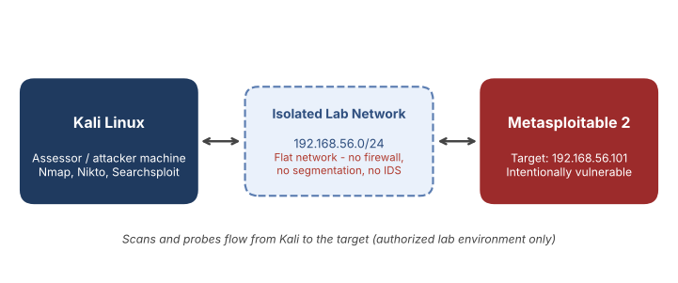
Figure 1: Lab network architecture

3.1 Security controls review
The table compares the security controls expected on a basic network with what the scans showed on the target. The figure numbers point to the evidence in Section 5.
Control area | Status | Observation and evidence
Firewall / packet filtering | Absent | Every Nmap and Nikto probe from Kali reached the target directly; nothing was blocked or filtered (Figs. 2-7).
Network segmentation | Absent | Single flat network; no DMZ or access control between attacker and target (Fig. 1).
Patch management | Absent | Nikto reports Apache 2.2.8 and PHP 5.2.4 as outdated (Fig. 6); backdoored builds of vsftpd and UnrealIRCd are in use (Figs. 3, 8, 9).
Authentication and access control | Weak | phpMyAdmin and Tomcat /admin/ pages are reachable by anyone on the network (Figs. 3, 7); default passwords are likely on management services.
Encryption in transit | Weak | Telnet and r-services send clear text (Fig. 2); the TLS service is vulnerable to POODLE and weak Diffie-Hellman (Fig. 4); HSTS header missing (Fig. 5).
Service hardening | Absent | More than 20 open services, directory listing, phpinfo.php exposed (Figs. 2, 5, 6, 7).
Intrusion detection and monitoring | Absent | Nikto sent 8,242 requests in 340 seconds and finished with no sign of blocking (Fig. 7).
Web application security | Weak | TRACE enabled, security headers missing, session cookies without HttpOnly (Figs. 3, 5, 6).

4. Risk Rating Methodology
Each risk is scored with the formula Risk score = Likelihood x Impact, where both factors use a 1-5 scale. This follows common practice from NIST SP 800-30 and the OWASP Risk Rating Methodology. Likelihood takes into account whether a public exploit exists (checked with Searchsploit), whether login is needed and whether the service is reachable. Impact uses the NVD CVSS score where one is available.

4.1 Likelihood scale
Score | Rating | Meaning
5 | Almost certain | Public exploit or trivial access, no authentication, service exposed
4 | Likely | Easily exploited with common tools and low skill
3 | Possible | Needs some conditions or prior access
2 | Unlikely | Needs special conditions or advanced skill
1 | Rare | Very difficult; no known exploit

4.2 Impact scale
Score | Rating | Meaning
5 | Severe | Full system (root) compromise; major loss of confidentiality, integrity and availability
4 | Major | Code execution or access to sensitive data and credentials
3 | Moderate | Partial data exposure or limited service disruption
2 | Minor | Small information leak with little direct effect
1 | Negligible | Little or no direct effect

4.3 Risk levels
Risk level | Score range | Required response
Critical | 20 - 25 | Fix immediately; the system should not stay exposed
High | 12 - 19 | Fix in the short term (within about 30 days)
Medium | 6 - 11 | Plan and fix within 60-90 days
Low | 1 - 5 | Fix during routine maintenance

5. Identification of Security Risks and Weaknesses
Objective 2. Risks were identified in four steps: service enumeration, Nmap vulnerability scripts, a Nikto web scan and exploit/CVE research. Each screenshot below is followed by a short explanation of what it shows and how it feeds the risk assessment.

5.1 Service enumeration (Nmap)
An Nmap service and OS scan of 192.168.56.101 (nmap -sV -O 192.168.56.101) shows more than 20 open ports. The key services and the risks linked to them are listed below.
Port | Service | Version | Related risk
21/tcp | ftp | vsftpd 2.3.4 | Backdoor (R1)
22/tcp | ssh | OpenSSH 4.7p1 (Debian) | Outdated (R10)
23/tcp | telnet | Linux telnetd | Clear text login (R7)
25/tcp | smtp | Postfix smtpd | Exposed mail service
53/tcp | domain | ISC BIND 9.4.2 | Outdated (R10)
80/tcp | http | Apache httpd 2.2.8 (Ubuntu) DAV/2 | Web findings (R9, R10, R14-R16)
139, 445/tcp | netbios-ssn / microsoft-ds | Samba smbd 3.0.20 | usermap_script RCE (R2)
512-514/tcp | exec / login / shell | netkit-rsh r-services | Clear text, trust-based (R7)
1524/tcp | bindshell | Metasploitable root shell | Backdoor (R3)
3306/tcp | mysql | MySQL 5.0.51a | Default credentials (R6)
3632/tcp | distccd | distccd v1 | Remote command execution (R5)
5432/tcp | postgresql | PostgreSQL 8.3.x | Default credentials (R6)
5900/tcp | vnc | VNC (protocol 3.3) | Weak password (R6)
6000/tcp | X11 | X11 display server | Exposed service (R8)
6667/tcp | irc | UnrealIRCd | Backdoor (R4)
8009/tcp | ajp13 | Apache JServ Protocol 1.3 | Exposed service (R8)
8180/tcp | http | Apache Tomcat / Coyote JSP engine 1.1 | Admin pages (R6, R12)

[Insert screenshot here]
Command: nmap -sV -O 192.168.56.101 (paste your Task 4 service scan screenshot here, or delete this box)
Figure 2: Nmap service and OS detection scan of the target

5.2 Vulnerability scripts (Nmap)
The Nmap vulnerability scripts (nmap --script vuln 192.168.56.101) test each open service for known flaws. Two parts of the output are used as evidence.
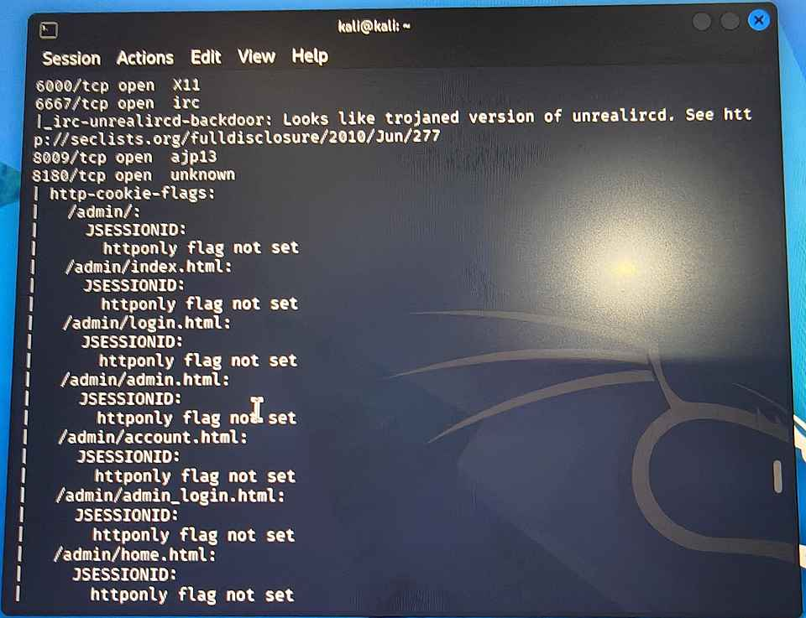
Figure 3: Nmap vulnerability scan: UnrealIRCd backdoor and Tomcat admin pages
What the screenshot shows | What it means for the risk assessment
6667/tcp open irc, with the result irc-unrealircd-backdoor: looks like a trojaned version of UnrealIRCd | The IRC server is a backdoored build, so anyone can send a crafted command and run code on the host. This is risk R4 (Critical).
6000/tcp open X11 and 8009/tcp open ajp13 | A network X11 display service and the Apache JServ Protocol port are reachable. Neither is needed on a server and both widen the attack surface (R8).
8180/tcp open, http-cookie-flags for /admin/, /admin/index.html, /admin/login.html and other admin pages: JSESSIONID httponly flag not set | A Java web admin interface is exposed to the network and its session cookie can be read by scripts, which makes session hijacking easier (R12). It also supports the risk of default credentials on this service (R6).

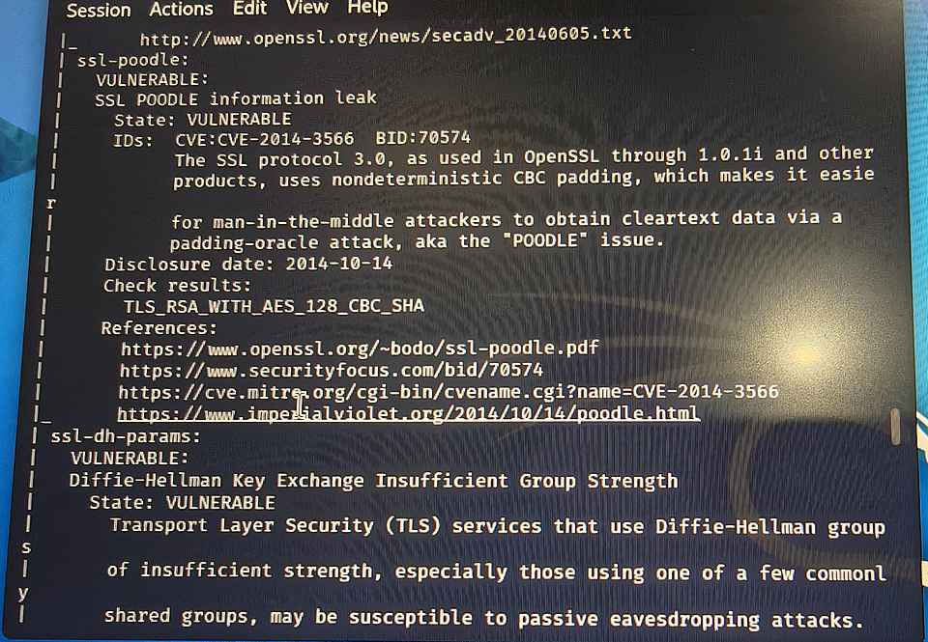
Figure 4: Nmap vulnerability scan: SSL POODLE and weak Diffie-Hellman
What the screenshot shows | What it means for the risk assessment
ssl-poodle: VULNERABLE, SSL POODLE information leak, CVE-2014-3566, check result TLS_RSA_WITH_AES_128_CBC_SHA | The TLS service still supports SSL 3.0 with CBC ciphers. A man-in-the-middle attacker can use a padding-oracle attack to recover clear-text data (R11).
ssl-dh-params: VULNERABLE, Diffie-Hellman key exchange with insufficient group strength | The key exchange uses weak shared groups that may allow passive eavesdropping, so encryption on this service is weaker than it should be (R11).

5.3 Web server scan (Nikto)
Nikto v2.6.0 was run against the web server (nikto -h http://192.168.56.101 -o nikto.txt). It sent 8,242 requests in 340 seconds and reported 30 items, which are grouped into findings R9, R10, R14, R15 and R16. Three screenshots cover the important results.
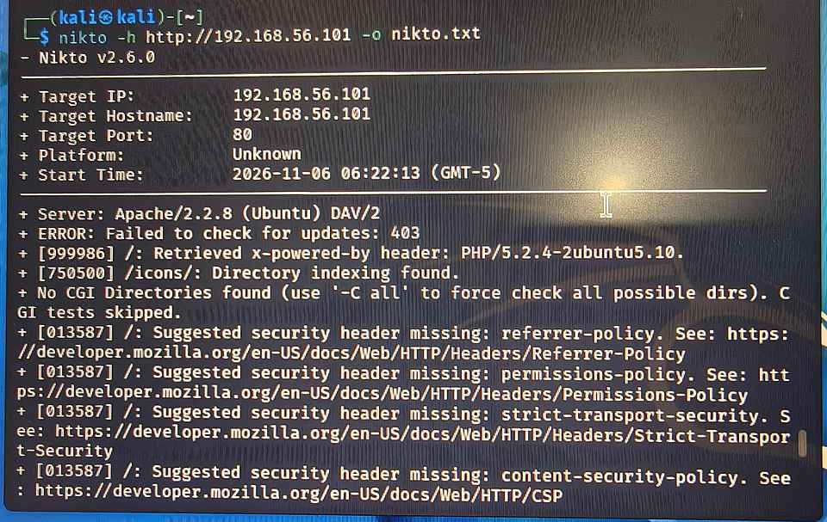
Figure 5: Nikto scan header, server banner and first results
What the screenshot shows | What it means for the risk assessment
Target IP and hostname 192.168.56.101, port 80, Nikto v2.6.0, start time 2026-11-06 06:22:13 (GMT-5) | Confirms what was scanned, with which tool and when. The scan was limited to the web server on port 80.
Server: Apache/2.2.8 (Ubuntu) DAV/2 and x-powered-by header PHP/5.2.4-2ubuntu5.10 | The server reveals its exact software versions to every visitor (R16), and both are very old (R10).
/icons/: directory indexing found | Anyone can browse the contents of this folder, which is an information leak (R9).
Suggested security header missing: referrer-policy, permissions-policy, strict-transport-security, content-security-policy | The browser-side protections these headers provide are not enabled (R14).

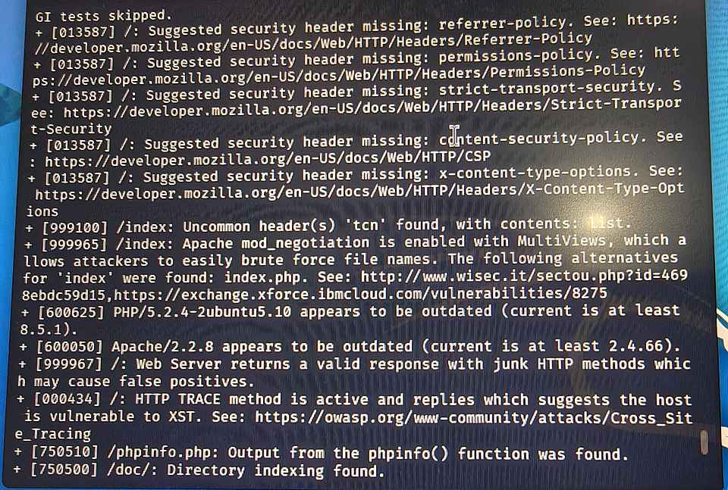
Figure 6: Nikto findings: missing headers, outdated software, TRACE and phpinfo
What the screenshot shows | What it means for the risk assessment
Header missing: x-content-type-options; /index: mod_negotiation enabled with MultiViews (index.php found) | Browsers may guess file types, and MultiViews lets attackers brute-force file names (R14).
PHP/5.2.4-2ubuntu5.10 appears outdated (current is at least 8.5.1); Apache/2.2.8 appears outdated (current is at least 2.4.66) | Both core web components are many versions behind and carry many known vulnerabilities (R10).
HTTP TRACE method is active, which suggests the host is vulnerable to XST (cross-site tracing) | TRACE can be abused to read cookies and headers through scripts (R14).
/phpinfo.php: output from the phpinfo() function was found; /doc/: directory indexing found | phpinfo shows detailed PHP and system configuration, and open directory listings expose files (R9).

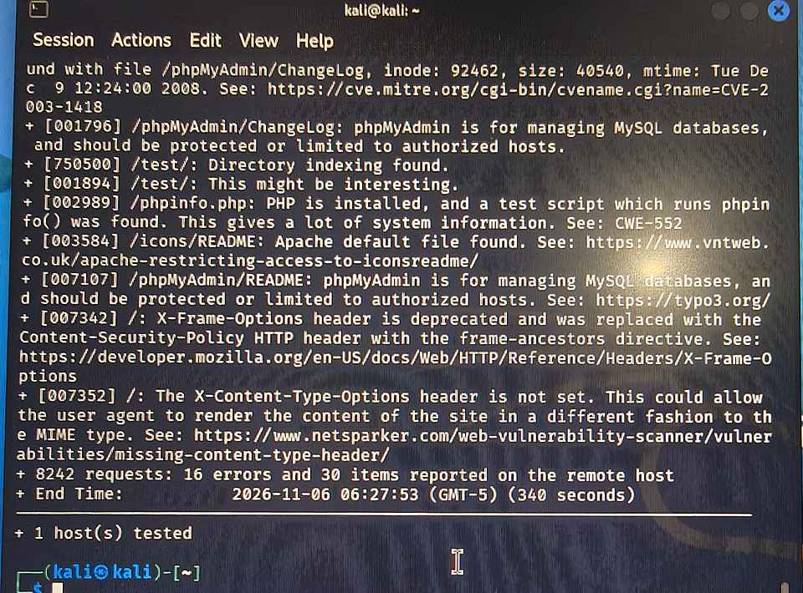
Figure 7: Nikto findings: phpMyAdmin, ETag leak, /test/ and scan summary
What the screenshot shows | What it means for the risk assessment
/phpMyAdmin/ChangeLog: server may leak inodes via ETags (inode 92462), see CVE-2003-1418 | The ETag header reveals internal file-system details (R15). The CVE is checked in the NVD in Section 5.5.
/phpMyAdmin/ChangeLog, README and changelog.php: phpMyAdmin should be protected or limited to authorized hosts | The database admin tool is reachable by anyone on the network and could be attacked or brute-forced (R9).
/test/: directory indexing found; /icons/README: Apache default file found; /phpinfo.php: a lot of system information (CWE-552) | Test content, default files and phpinfo are left on the server and leak information (R9).
X-Content-Type-Options header is not set; X-Frame-Options header is deprecated | More missing or outdated browser protections (R14).
8242 requests: 16 errors and 30 items reported (340 seconds) | The full scan finished normally with no blocking, so nothing detected or stopped the scan (R13).

5.4 Exploit research (Searchsploit)
Searchsploit checks Exploit-DB for public exploits that match the versions found. Commands run: searchsploit vsftpd 2.3.4, searchsploit samba 3.0.20 and searchsploit unrealircd. A public exploit means any attacker can use it without writing code, which raises the likelihood score.
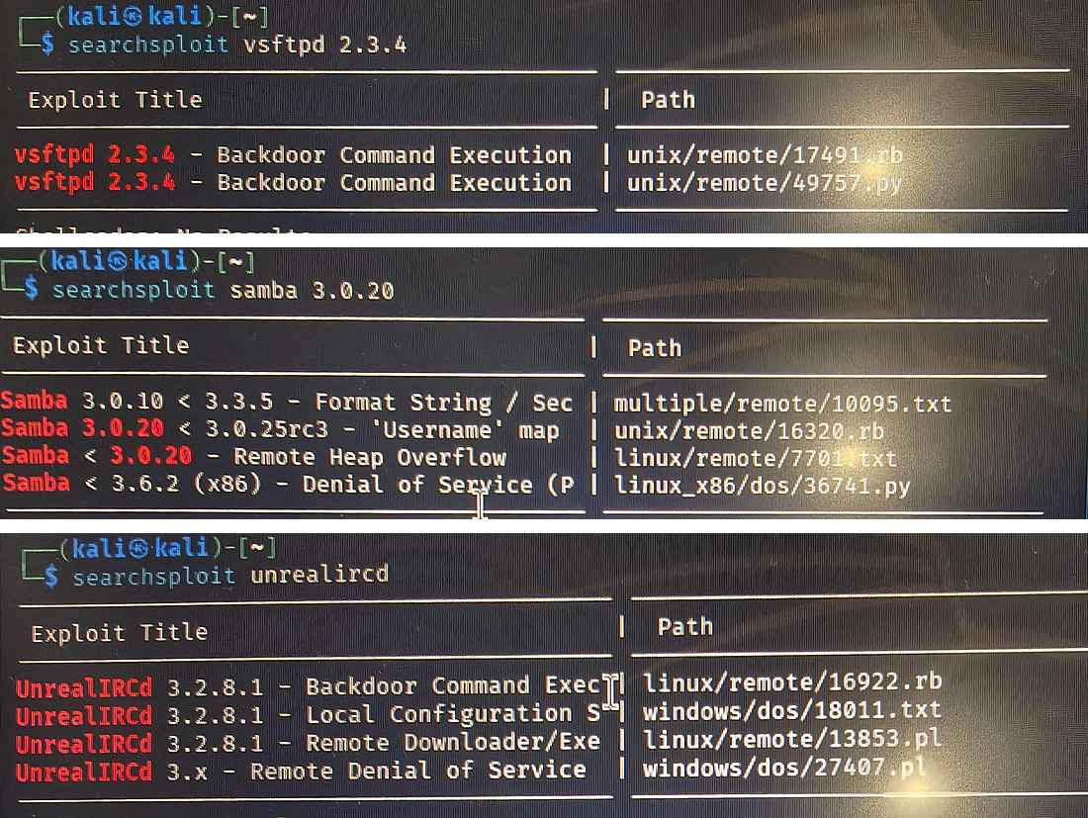
Figure 8: Searchsploit results for vsftpd 2.3.4, Samba 3.0.20 and UnrealIRCd
What the screenshot shows | What it means for the risk assessment
searchsploit vsftpd 2.3.4: two results named Backdoor Command Execution (unix/remote/17491.rb and unix/remote/49757.py) | Two ready-made exploits exist for the exact FTP version in use, so likelihood for R1 is 5.
searchsploit samba 3.0.20: Samba 3.0.20 < 3.0.25rc3 'Username' map script command execution (unix/remote/16320.rb), plus a heap overflow (7701.txt), a format string bug (10095.txt) and a denial of service (36741.py) | Samba 3.0.20 has a remote command execution exploit and several other known flaws, so R2 has likelihood 5 and Samba should be upgraded.
searchsploit unrealircd: UnrealIRCd 3.2.8.1 backdoor command execution (linux/remote/16922.rb), remote downloader/exec (13853.pl), local configuration stack overflow (windows/dos/18011.txt) and a 3.x remote denial of service (windows/dos/27407.pl) | A public backdoor exploit matches the trojaned IRC server found by Nmap (Fig. 3), so R4 has likelihood 5.

5.5 CVE verification (NVD)
Two CVEs were checked on the National Vulnerability Database to confirm what the flaws are and how severe NVD rates them.
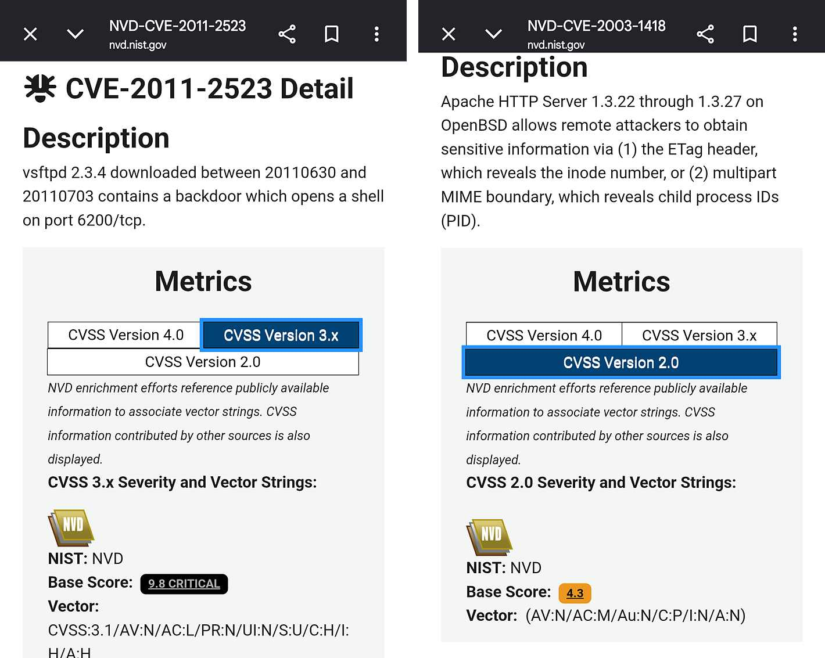
Figure 9: NVD entries for CVE-2011-2523 (left) and CVE-2003-1418 (right)
What the screenshot shows | What it means for the risk assessment
CVE-2011-2523: vsftpd 2.3.4 downloaded between 20110630 and 20110703 contains a backdoor which opens a shell on port 6200/tcp. CVSS 3.1 base score 9.8 CRITICAL, vector AV:N/AC:L/PR:N/UI:N/S:U/C:H/I:H/A:H | The vector reads: attack over the network, low complexity, no privileges, no user interaction, and high impact on confidentiality, integrity and availability. This confirms R1 as Critical.
CVE-2003-1418: Apache HTTP Server 1.3.22 through 1.3.27 on OpenBSD allows attackers to obtain the inode number (ETag header) or child process IDs (multipart MIME boundary). CVSS 2.0 base score 4.3, vector AV:N/AC:M/Au:N/C:P/I:N/A:N | The vector reads: network attack, medium complexity, no authentication and only partial confidentiality impact. This confirms the ETag finding R15 is a Medium-level information leak. NVD lists older Apache 1.3.x on OpenBSD as affected, so on this Apache 2.2.8 server the finding is rated by its observed effect, as reported by Nikto.

5.6 Summary of identified risks
ID | Finding | What was found (evidence) | Port | Reference
R1 | vsftpd 2.3.4 backdoor | The FTP service runs vsftpd 2.3.4. NVD states that copies downloaded between 30 June and 3 July 2011 contain a backdoor that opens a shell on port 6200/tcp. Searchsploit lists two backdoor command execution exploits for this exact version. (Figs. 8, 9) | 21/tcp | CVE-2011-2523
R2 | Samba 3.0.20 username map script command injection | Searchsploit lists a command execution exploit for Samba 3.0.20 < 3.0.25rc3 ('Username' map script) and a format string / security bypass entry for 3.0.10 - 3.3.5. The server runs Samba 3.0.20, which is inside both ranges. (Fig. 8) | 139, 445/tcp | CVE-2007-2447
R3 | Unauthenticated root bind shell (ingreslock) | The Nmap service scan shows a bind shell listening on port 1524. Anyone who connects, for example with netcat, receives a command prompt without any password. (Fig. 2) | 1524/tcp | N/A (backdoor)
R4 | UnrealIRCd 3.2.8.1 backdoor | The Nmap irc-unrealircd-backdoor script reports that the service on port 6667 looks like a trojaned version of UnrealIRCd. Searchsploit lists a 3.2.8.1 backdoor command execution exploit (16922.rb), a remote downloader/exec exploit and a remote denial of service. (Figs. 3, 8) | 6667/tcp | CVE-2010-2075
R5 | distccd remote command execution | The Nmap service scan shows the distributed compiler daemon (distccd) open. It accepts jobs from any host without authentication, so an attacker can submit arbitrary commands to be run on the server. (Fig. 2) | 3632/tcp | CVE-2004-2687
R6 | Likely default or weak credentials on management services | MySQL, PostgreSQL, VNC and a Tomcat web application (port 8180) are exposed to the network. Metasploitable 2 is documented to ship with default or blank passwords on these services. Credential testing was not part of this task, so the risk is rated from the exposed services and the image documentation. (Figs. 2, 3) | 3306, 5432, 5900, 8180 | N/A (misconfiguration)
R7 | Clear-text remote access (Telnet, rlogin, rsh, rexec) | The service scan shows Telnet and the r-services (exec, login, shell) open. They send usernames, passwords and commands unencrypted, and rlogin/rsh can be configured to trust hosts without a password. (Fig. 2) | 23, 512-514/tcp | N/A (insecure protocol)
R8 | Excessive attack surface and no firewall | More than 20 services are open, including X11 (6000), AJP13 (8009) and an HTTP service on 8180. Every Nmap and Nikto probe from Kali reached the target directly, so no firewall or traffic filtering is in place. (Figs. 2, 3) | 20+ open ports | N/A (design weakness)
R9 | Exposed admin and information pages | Nikto found /phpinfo.php (detailed PHP and system information), phpMyAdmin files (README, ChangeLog, changelog.php) that should be limited to authorized hosts, directory listing on /icons/, /doc/ and /test/, and the default /icons/README file. (Figs. 5, 6, 7) | 80/tcp | CWE-552 (Nikto)
R10 | Outdated and end-of-life software | Nikto reports Apache 2.2.8 as outdated (current is at least 2.4.66) and PHP 5.2.4-2ubuntu5.10 as outdated (current is at least 8.5.1). The service scan also shows old OpenSSH 4.7p1, BIND 9.4.2, MySQL 5.0.51a and PostgreSQL 8.3. (Figs. 5, 6) | 80, 22, 53, 3306, 5432 | Multiple CVEs
R11 | Weak TLS configuration (POODLE, weak Diffie-Hellman) | The Nmap vulnerability scan marks a TLS service as VULNERABLE to SSL POODLE (the check result lists TLS_RSA_WITH_AES_128_CBC_SHA) and to Diffie-Hellman key exchange with insufficient group strength. (Fig. 4) | TLS service(s) | CVE-2014-3566
R12 | Tomcat admin pages exposed; session cookies without HttpOnly | Nmap http-cookie-flags shows that the /admin/ pages on port 8180 (index, login, admin, account, home) set a JSESSIONID cookie without the HttpOnly flag. This also shows that a Java admin interface is reachable from the network. (Fig. 3) | 8180/tcp | N/A (misconfiguration)
R13 | No IDS/IPS, logging or monitoring | No intrusion detection, centralized logging or alerting was identified. Nikto sent 8,242 requests in 340 seconds and finished normally, with no sign of being blocked. (Fig. 7) | Host / network | N/A (control gap)
R14 | Web server hardening gaps (TRACE, missing headers, MultiViews) | Nikto reports that HTTP TRACE is active (suggesting cross-site tracing, XST), that the referrer-policy, permissions-policy, strict-transport-security, content-security-policy and x-content-type-options headers are missing, and that mod_negotiation MultiViews is enabled, which lets attackers brute-force file names. (Figs. 5, 6, 7) | 80/tcp | N/A (misconfiguration)
R15 | Apache ETag inode information disclosure | Nikto reports that the server may leak inodes via ETags for /phpMyAdmin/ChangeLog (inode 92462) and links it to CVE-2003-1418. NVD describes this CVE as disclosure of the inode number and child process IDs (CVSS 2.0 base score 4.3). NVD lists Apache 1.3.22 - 1.3.27 on OpenBSD as affected, so on this Apache 2.2.8 server the finding is rated by its observed effect. (Figs. 7, 9) | 80/tcp | CVE-2003-1418
R16 | Service banner and version disclosure | Nikto reads the headers Server: Apache/2.2.8 (Ubuntu) DAV/2 and x-powered-by: PHP/5.2.4-2ubuntu5.10, which give attackers the exact software versions. (Fig. 5) | Multiple | N/A (information leak)

6. Likelihood Evaluation
Objective 3. Likelihood was scored from 1 to 5 using the scale in Section 4.1. The main factors were whether a public exploit exists (Searchsploit, Fig. 8), whether authentication is needed, and whether the service is reachable.
ID | Finding | Likelihood | Justification
R1 | vsftpd 2.3.4 backdoor | 5 (Almost certain) | Two public exploits exist (Ruby and Python); NVD rates it network-reachable, low complexity, no login and no user interaction needed.
R2 | Samba 3.0.20 username map script command injection | 5 (Almost certain) | A ready-made exploit (16320.rb) is listed in Searchsploit; no authentication is needed and the Samba ports are reachable.
R3 | Unauthenticated root bind shell (ingreslock) | 5 (Almost certain) | No exploit is needed; any host on the network can connect and obtain a shell immediately.
R4 | UnrealIRCd 3.2.8.1 backdoor | 5 (Almost certain) | Nmap confirms the trojaned build and a public exploit exists; no authentication is required.
R5 | distccd remote command execution | 5 (Almost certain) | Public exploit available; distccd accepts connections from any host.
R6 | Likely default or weak credentials on management services | 4 (Likely) | The services accept login attempts from any host and default passwords are widely known.
R7 | Clear-text remote access (Telnet, rlogin, rsh, rexec) | 4 (Likely) | Sniffing is simple on a flat network and the services accept clear-text logins.
R8 | Excessive attack surface and no firewall | 5 (Almost certain) | With no filtering, every exposed service can be probed and attacked from anywhere on the network.
R9 | Exposed admin and information pages | 4 (Likely) | The pages are reachable without any restriction and were found by an automated scan in minutes.
R10 | Outdated and end-of-life software | 4 (Likely) | Old versions have many documented flaws, but successful exploitation depends on matching conditions.
R11 | Weak TLS configuration (POODLE, weak Diffie-Hellman) | 3 (Possible) | Exploitation needs an attacker in the network path (man-in-the-middle), so likelihood is moderate.
R12 | Tomcat admin pages exposed; session cookies without HttpOnly | 3 (Possible) | The interface is reachable, but abuse needs a login or a separate script-injection flaw.
R13 | No IDS/IPS, logging or monitoring | 3 (Possible) | The gap does not cause an attack, but it ensures an attack would go unnoticed.
R14 | Web server hardening gaps (TRACE, missing headers, MultiViews) | 4 (Likely) | The issues are visible to any client; exploitation needs a further client-side attack.
R15 | Apache ETag inode information disclosure | 4 (Likely) | The header is returned on every request, but it is only useful together with other attacks.
R16 | Service banner and version disclosure | 5 (Almost certain) | Banners are returned to anyone who connects and tools collect them automatically.

7. Business and Technical Impact Assessment
Objective 4. Impact was scored from 1 to 5 using the scale in Section 4.2, considering both the technical effect on the system (confidentiality, integrity, availability) and the effect on the business.
ID | Finding | Technical impact | Business impact | Impact
R1 | vsftpd 2.3.4 backdoor | Unauthenticated remote command execution; NVD scores confidentiality, integrity and availability impact all as High (CVSS 9.8). | Complete server takeover: data theft, service outage and use of the server as a pivot into other systems. | 5 (Severe)
R2 | Samba 3.0.20 username map script command injection | Unauthenticated remote code execution, typically as root, giving full control of the host. | Compromise of the file server and exposure of all shared data; possible spread to other hosts. | 5 (Severe)
R3 | Unauthenticated root bind shell (ingreslock) | Instant root-level command execution with no authentication. | Total loss of control of the system; evidence of prior compromise must be assumed. | 5 (Severe)
R4 | UnrealIRCd 3.2.8.1 backdoor | Unauthenticated remote command execution in the context of the IRC service account. | Attacker foothold on the server with possible privilege escalation and lateral movement. | 4 (Major)
R5 | distccd remote command execution | Remote command execution as the daemon user; a stepping stone to full compromise. | Foothold on the server and risk to application and build data. | 4 (Major)
R6 | Likely default or weak credentials on management services | Direct authenticated access to databases, the remote desktop and the web management console. | Data breach or tampering and deployment of malicious applications through the management console. | 4 (Major)
R7 | Clear-text remote access (Telnet, rlogin, rsh, rexec) | Credentials can be captured on the network; host-based trust allows unauthorized logins. | Account takeover and loss of confidentiality of administrative access. | 4 (Major)
R8 | Excessive attack surface and no firewall | A large attack surface in which every unnecessary service is another possible entry point. | Higher probability of compromise and more effort needed to monitor and maintain the system. | 3 (Moderate)
R9 | Exposed admin and information pages | Leaks configuration and version details and exposes a database admin tool that can be attacked or brute-forced. | Helps attackers plan targeted attacks; risk of database compromise if phpMyAdmin credentials are weak. | 3 (Moderate)
R10 | Outdated and end-of-life software | Known exploits can lead to information leaks, denial of service or code execution. | Unpatched exposure and failure to meet compliance expectations. | 3 (Moderate)
R11 | Weak TLS configuration (POODLE, weak Diffie-Hellman) | Encrypted traffic can be decrypted with a padding-oracle attack or eavesdropped passively. | Possible exposure of session data or credentials sent over TLS. | 3 (Moderate)
R12 | Tomcat admin pages exposed; session cookies without HttpOnly | Session cookies can be read by injected scripts, enabling session hijacking; the admin console is open to brute force. | Possible takeover of the web management console. | 3 (Moderate)
R13 | No IDS/IPS, logging or monitoring | Attacks and compromise cannot be detected, investigated or traced. | Delayed incident response, longer breach dwell time and poor forensic evidence. | 3 (Moderate)
R14 | Web server hardening gaps (TRACE, missing headers, MultiViews) | Weakens browser protections and enables techniques such as XST and content-type sniffing. | Increases the effect of web attacks on users of the site. | 2 (Minor)
R15 | Apache ETag inode information disclosure | Minor information disclosure that supports reconnaissance. | Low direct impact; helps an attacker profile the system. | 2 (Minor)
R16 | Service banner and version disclosure | Helps an attacker choose matching exploits; no direct compromise. | Reduces attacker effort; indirect risk only. | 1 (Negligible)

8. Risk Level Assignment
Objective 5. The risk score (Likelihood x Impact) and the resulting risk level were calculated for every finding using the levels defined in Section 4.3.
ID | Finding | Port | L | I | Score | Risk level
R1 | vsftpd 2.3.4 backdoor | 21/tcp | 5 | 5 | 25 | Critical
R2 | Samba 3.0.20 username map script command injection | 139, 445/tcp | 5 | 5 | 25 | Critical
R3 | Unauthenticated root bind shell (ingreslock) | 1524/tcp | 5 | 5 | 25 | Critical
R4 | UnrealIRCd 3.2.8.1 backdoor | 6667/tcp | 5 | 4 | 20 | Critical
R5 | distccd remote command execution | 3632/tcp | 5 | 4 | 20 | Critical
R6 | Likely default or weak credentials on management services | 3306, 5432, 5900, 8180 | 4 | 4 | 16 | High
R7 | Clear-text remote access (Telnet, rlogin, rsh, rexec) | 23, 512-514/tcp | 4 | 4 | 16 | High
R8 | Excessive attack surface and no firewall | 20+ open ports | 5 | 3 | 15 | High
R9 | Exposed admin and information pages | 80/tcp | 4 | 3 | 12 | High
R10 | Outdated and end-of-life software | 80, 22, 53, 3306, 5432 | 4 | 3 | 12 | High
R11 | Weak TLS configuration (POODLE, weak Diffie-Hellman) | TLS service(s) | 3 | 3 | 9 | Medium
R12 | Tomcat admin pages exposed; session cookies without HttpOnly | 8180/tcp | 3 | 3 | 9 | Medium
R13 | No IDS/IPS, logging or monitoring | Host / network | 3 | 3 | 9 | Medium
R14 | Web server hardening gaps (TRACE, missing headers, MultiViews) | 80/tcp | 4 | 2 | 8 | Medium
R15 | Apache ETag inode information disclosure | 80/tcp | 4 | 2 | 8 | Medium
R16 | Service banner and version disclosure | Multiple | 5 | 1 | 5 | Low

8.1 Risk matrix (heat map)
Each cell shows the risk score; the finding IDs are placed where their likelihood and impact meet.
Likelihood / Impact | 1 - Negligible | 2 - Minor | 3 - Moderate | 4 - Major | 5 - Severe
5 - Almost certain | 5  R16 | 10 | 15  R8 | 20  R4, R5 | 25  R1, R2, R3
4 - Likely | 4 | 8  R14, R15 | 12  R9, R10 | 16  R6, R7 | 20
3 - Possible | 3 | 6 | 9  R11, R12, R13 | 12 | 15
2 - Unlikely | 2 | 4 | 6 | 8 | 10
1 - Rare | 1 | 2 | 3 | 4 | 5

8.2 Cross-check with NVD scores
Where the NVD screenshots give an official CVSS score, it was compared with the rating from this assessment. Both agree.
Finding | NVD CVSS base score | NVD severity | This assessment | Match
R1 - CVE-2011-2523 | 9.8 (CVSS 3.1) | Critical | 25 - Critical | Yes
R15 - CVE-2003-1418 | 4.3 (CVSS 2.0) | Medium | 8 - Medium | Yes

9. Risk Prioritization
Objective 6. Risks are prioritized by severity (risk score). Where findings share the same score, the ones that give an attacker full control with the least effort are fixed first. Findings R14 and R15 are small configuration changes (TraceEnable Off, security headers, FileETag) and can be done together with Priority 1 work.
Priority | Risks | Timeframe | Rationale
P1 - Critical | R1, R2, R3, R4, R5 | Immediately (0-7 days) | Each risk allows full remote compromise with no login, using a public exploit or a ready-made backdoor.
P2 - High | R6, R7, R8, R9, R10 | Within 30 days | Weak credentials, clear-text access, large attack surface, exposed admin pages and outdated software make a successful attack very likely.
P3 - Medium | R11, R12, R13, R14, R15 | Within 60-90 days | Weak TLS, exposed admin cookies, detection gaps and web hardening issues that support attackers but do not give direct control.
P4 - Low | R16 | Routine maintenance | Reconnaissance help only; fix as part of regular hardening.

10. Recommended Security Controls and Mitigation Measures
Objective 7. The following controls reduce each risk. They are listed in priority order.

10.1 Control recommendations per finding
ID | Recommended control / mitigation | Control type | Timeline
R1 | Upgrade to a current vsftpd from a trusted repository and verify package integrity; replace FTP with SFTP; block port 21 from untrusted hosts. | Preventive / Corrective | Immediate (0-7 days)
R2 | Upgrade to a supported Samba 4.x release; remove the username map script option; restrict ports 139/445 to trusted hosts with a firewall. | Preventive / Corrective | Immediate (0-7 days)
R3 | Identify and stop the listener (ss -tulnp), remove the entry from /etc/inetd.conf, block port 1524 and investigate how it was installed (treat the host as compromised). | Corrective / Preventive | Immediate (0-7 days)
R4 | Remove the service or upgrade to a clean, current release; verify checksums and signatures; run it as an unprivileged user and restrict port 6667. | Preventive / Corrective | Immediate (0-7 days)
R5 | Disable distccd if it is not required; otherwise restrict it with the --allow option to trusted IPs and firewall port 3632. | Preventive | Immediate (0-7 days)
R6 | Change every default password; enforce a strong password policy; bind databases to localhost; remove unused accounts; enable MFA where supported. | Preventive | Short term (within 30 days)
R7 | Disable Telnet and the r-services; use SSH with key-based authentication; remove .rhosts and hosts.equiv trust. | Preventive | Short term (within 30 days)
R8 | Disable unused services (X11 over TCP, AJP13, r-services); enable a host firewall (ufw or iptables) with a default-deny policy; place the server in a segmented zone or DMZ. | Preventive | Short term (within 30 days)
R9 | Delete phpinfo.php and /test/; disable directory indexing (Options -Indexes); restrict phpMyAdmin by IP and authentication or remove it; delete default files such as /icons/README. | Preventive | Short term (within 30 days)
R10 | Create a patch-management process; upgrade Apache and PHP to supported versions; update OpenSSH, BIND, MySQL and PostgreSQL; remove end-of-life software. | Preventive | Short term (within 30 days)
R11 | Disable SSL 3.0 and legacy CBC-only ciphers; enable TLS 1.2/1.3; use Diffie-Hellman groups of 2048 bits or more (or ECDHE); update OpenSSL. | Preventive | Medium term (60-90 days)
R12 | Restrict the Tomcat admin pages by IP or remove them; set the HttpOnly and Secure flags on session cookies; use strong admin credentials. | Preventive | Medium term (60-90 days)
R13 | Deploy IDS/IPS (Snort or Suricata), centralized logging (rsyslog or Wazuh), fail2ban and alerting. | Detective | Medium term (60-90 days)
R14 | Disable TRACE (TraceEnable Off); add the missing security headers; turn off MultiViews (Options -MultiViews). | Preventive | Medium term (60-90 days)
R15 | Set FileETag MTime Size in the Apache configuration and upgrade Apache. | Preventive | Medium term (60-90 days)
R16 | Hide banners (ServerTokens Prod, ServerSignature Off, expose_php = Off) and limit exposure with firewall rules. | Preventive | Planned maintenance

10.2 General defence-in-depth recommendations
- Network security: use a default-deny firewall and segment servers from user and management networks.
- Patch management: keep operating systems and services on supported, regularly updated versions.
- Access control: enforce least privilege, strong unique passwords and MFA, and remove default accounts.
- Secure protocols: use SSH, SFTP and HTTPS (TLS 1.2 or higher) instead of Telnet, FTP and HTTP.
- Monitoring: centralize logs, deploy IDS/IPS and review alerts regularly.
- Continuous assessment: repeat vulnerability scans after changes and on a regular schedule.

10.3 Expected residual risk
After the Priority 1 and Priority 2 actions are completed, the overall risk of the environment is expected to fall from Critical to Medium or lower. A follow-up Nmap and Nikto scan should be run to confirm that the fixes are effective.

11. Conclusion
The assessment identified 16 risks in the sample environment, 5 of them Critical. The most serious problems are backdoored services (vsftpd 2.3.4 and UnrealIRCd 3.2.8.1), a Samba version with a public command execution exploit, and the complete lack of a firewall, all of which allow an unauthenticated attacker to take over the system. The Nikto scan added web-layer weaknesses such as exposed phpinfo and phpMyAdmin pages, outdated Apache and PHP and missing security headers. The two NVD scores that were checked agree with the ratings in this report. By scoring each finding with likelihood and impact, the risks were ranked objectively and a clear action plan was produced. Following the recommended controls, starting with Priority 1, would greatly reduce the exposure. This exercise shows how a structured risk assessment turns raw scan output into decisions that a business can act on.

Appendix A: Commands Used
Command | Purpose
nmap -sV -O 192.168.56.101 | Service version and OS detection
nmap --script vuln 192.168.56.101 | Run Nmap vulnerability scripts
nikto -h http://192.168.56.101 -o nikto.txt | Web server vulnerability scan, saved to nikto.txt
searchsploit vsftpd 2.3.4 | Find public exploits for vsftpd
searchsploit samba 3.0.20 | Find public exploits for Samba
searchsploit unrealircd | Find public exploits for UnrealIRCd

Appendix B: References
- NVD - CVE-2011-2523: https://nvd.nist.gov/vuln/detail/CVE-2011-2523
- NVD - CVE-2003-1418: https://nvd.nist.gov/vuln/detail/CVE-2003-1418
- NVD - CVE-2007-2447: https://nvd.nist.gov/vuln/detail/CVE-2007-2447
- NVD - CVE-2010-2075: https://nvd.nist.gov/vuln/detail/CVE-2010-2075
- NVD - CVE-2004-2687: https://nvd.nist.gov/vuln/detail/CVE-2004-2687
- NVD - CVE-2014-3566: https://nvd.nist.gov/vuln/detail/CVE-2014-3566
- NIST SP 800-30 Rev. 1, Guide for Conducting Risk Assessments
- OWASP Risk Rating Methodology

