COSC343

Meiqi Sun

5926587

**Description:**

The grid size and the turns are using the default numbers as given. Both of these two numbers should be big enough so that the development of the creature is obvious. However, I set number of turns smaller than the default number so that It is more likely for creatures to survive.

**Model**

The reasons why I chose percept format 2 are the following:

First, percept format 2 is consisted with three different sets of information which include monster, food and creature locations and each set is totally independent.

Second, compared with percept format 1, percept format 2 is good at deciding direction based on the information. Instead of making some complex choices for the creatures such as whether to eat or not, what we can do is to tell our creatures which direction to go so that they are able to eat food or run away from the monsters.

**Chromosome**

In myCreature.java, the chromosome is designed to be an array consists of integers. The integers in the array are generated randomly from zero to one.(sometimes the max number is two which depends on the meaning)

The first three elements are decisions related to monster, creature and food. “0” means ignoring the monster/creature/food if creature has detected it; “1” means going toward the monster/creature if creature has detected it, instead if creature has found a strawberry, creature goes the opposite direction. “2” means going to where the food is, or going the opposite direction to avoid a creature or a monster. The bigger the value is, the higher possibility of surviving. The second six elements in chromosome array represent the weights, for monster, food(no matter what color), other creature, eating red food or not, eating green strawberry or not, and the random movement. The bigger the value is , the greater the weight is. The last two elements decide whether to eat strawberry or not when creature has detected it. In this case, “0” means ignoring while “1” means eating.

**Selection, crossover and mutation:**

I chose tournament selection to select “mother” for the next generation. First randomly pick ¼ of the creatures from the old population. Then choose one creature with the highest fitness as the “mother”.

When it comes to the “father”, i decided to randomly pick one survivor from the previous generation. If there is no survivor, then pick the fittest creature to be both the “mother” and the “father”.

As for crossover, I used single point crossover. Pick the cross-point which is defined by a randomly generated integer(same range as the length of the chromosome)and so divide the child chromosome into two parts. The first part comes from the “father” and the second part comes from the “mother”. Each turn the crossover uses a completely new randomly generated number as the cross-point to keep the diversity.

Also define another float number to represent the possibility of mutation which is ten percent. If the number is bigger than the chromosome[i], this chromosome will be replaced by another randomly generated number. With this model, father’s chromosome and mother’s chromosome could sometimes be the same, therefore the possibility of mutation should be big enough to keep the diversity.

**Result and Discussion**

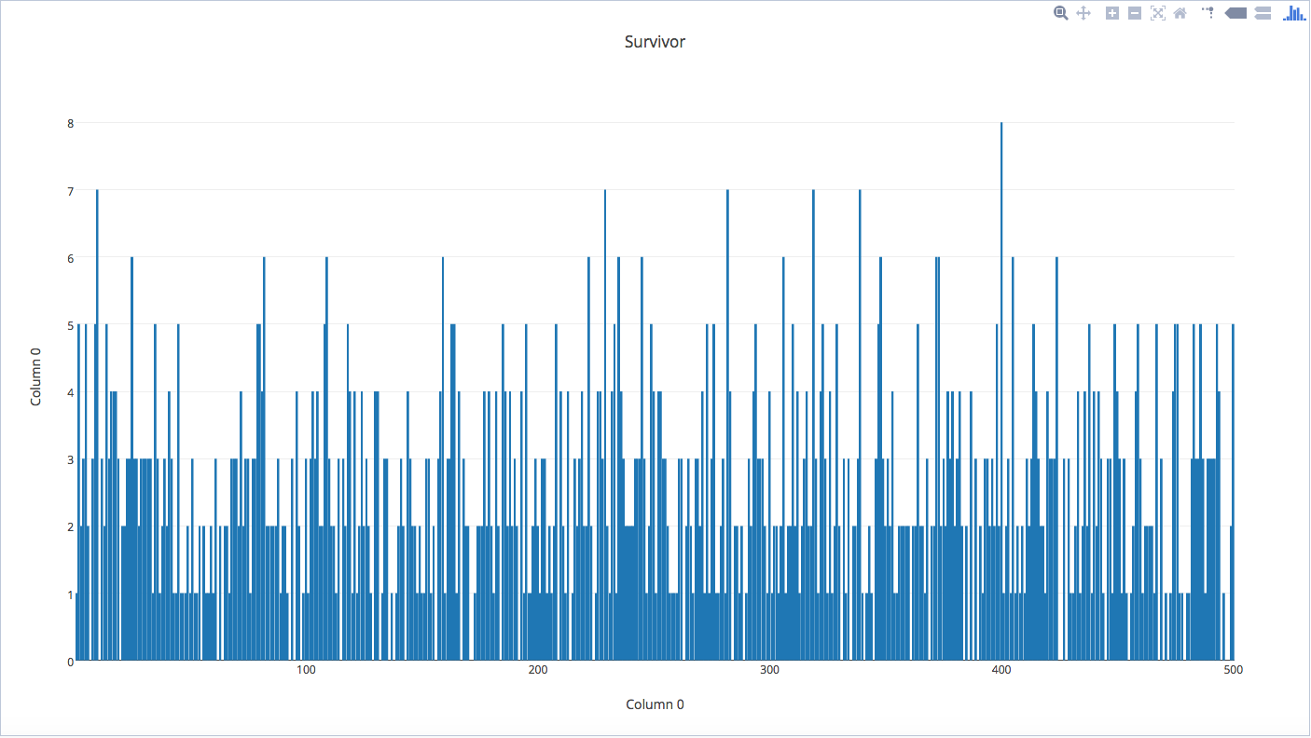

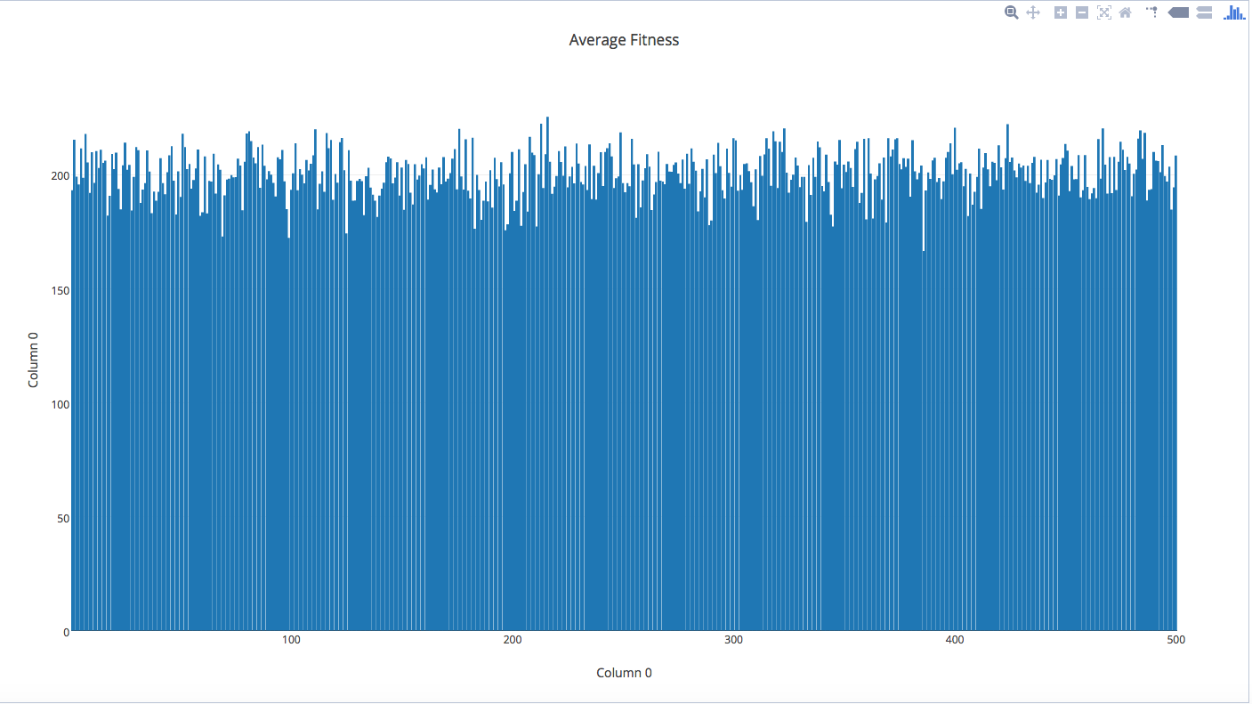

Based on the charts above, the creatures are able to maintain chromosomes which keeps them living longer but during the process of evolution, they sometimes lose the good chromosomes. The rising and falling of the graph shows that creatures are not able to maintain certain chromosome for a long period. Possible reasons could be the following:

First, the way of calculating fitness is not good enough to pick excellent creatures with excellent chromosomes. Many valuable chromosomes got lost during turns of evolutions.

Second, mutation avoids child from maintaining excellent chromosome with parents. Instead of increasing mutation rate, make sure parents’ chromosome are not totally the same before each crossover could also the diversity of chromosome.

Third, the survivors who survived from the last generation died when a new generation is developed. Many valuable chromosomes got lost.

Furthermore, perhaps 500 generations is still not enough for us to observe the changes happened on these creatures;