# Online Resume Builder

* Download the file resume from mail.
* Right click on the file resume and click on extract all from the context.
* Now one new file generates with same name resume and open that file.
* Here we have three files index, script.js and style files.
* Make sure these three files should be on one folder like below snap.

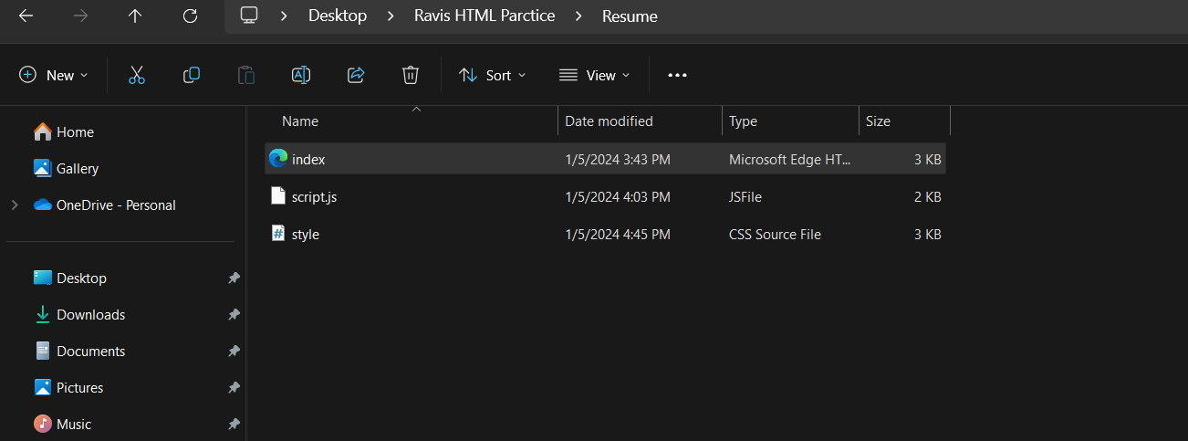

* Double Click on html file and it will open on browser like below screen

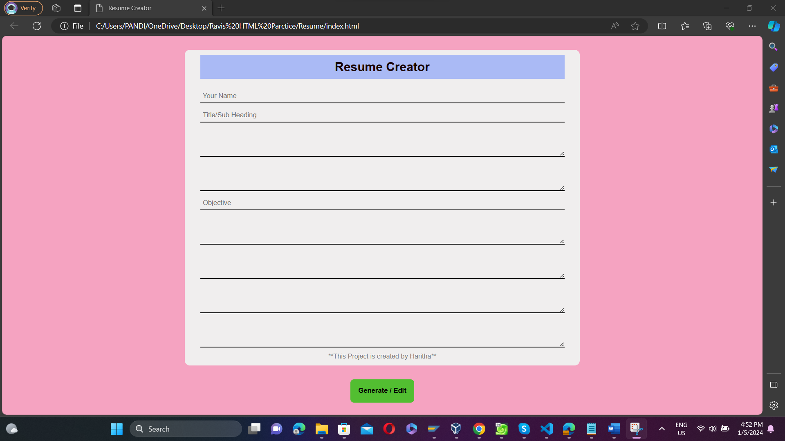

* In the above screen if we place the cursor on the input fields will hover a text labels of input fields.
* Fill up the details required to be in your resume like below snap.

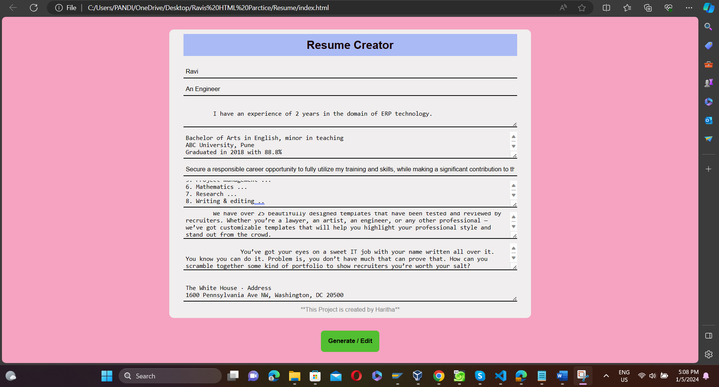

* Click on generate/edit button a resume preview can be seen. If ok click on print or else click on edit option to edit details.

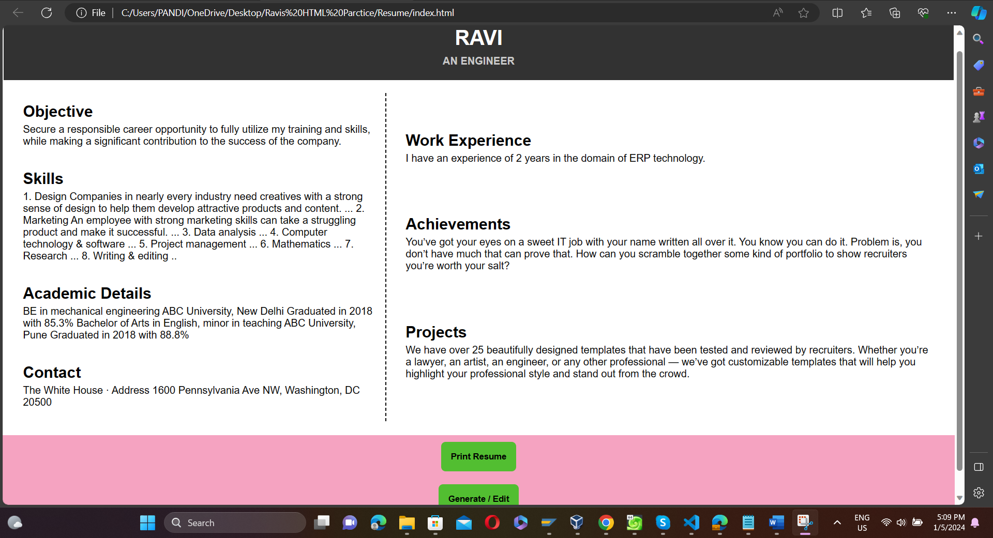

* Click on print resume and it will show like this.

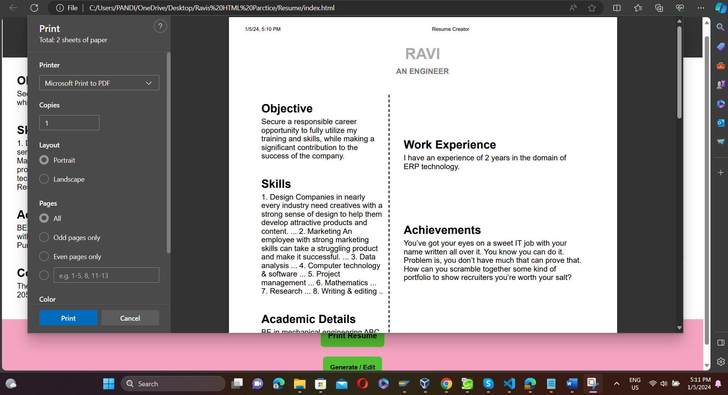

* U can save or print your resume.