Software Requirements Specification

for

PassItOn Books
Version 1.0
Prepared by
Athish Ram Das, Chip Hardy, Stella Luttrell
Mississippi State University
4/30/2026

Introduction
PassItOn Books is a web-based e-commerce platform focused on buying and selling books, while also trying to encourage a sense of community between users. The platform is based on the idea that small actions, like helping the next buyer, can make the overall experience more welcoming and engaging for people using it. Similar ideas can be seen in everyday situations such as paying for the next person’s order in a drive-through, which this platform tries to adapt in a simple and controlled way. This document describes the software requirements needed to support these goals and help develop the system.

Purpose
The purpose of this document is to describe the software requirements for PassItOn Books, which is a web-based e-commerce platform focused on buying and selling books while supporting a connected reading community. The software aims to encourage user participation and repeat usage by introducing small community-based interactions, such as helping support the next buyer on the platform. These goals align with our business objective of increasing user retention and maintaining long-term engagement through a welcoming and trust-based environment.

Document Conventions
The document follows the convention of listing the various features of the product and a high level overview is provided in paragraphs. All items in listed format are given higher priority as they can be seen as a checklist towards the complete development of the product.

Intended Audience and Reading
This document is intended for several types of readers who are involved in the design, development, and evaluation of PassItOn Books. Developers and testers may use this document to understand the functional and non-functional requirements of the system, and project managers can refer to it for planning and tracking progress. Instructors and reviewers can also use this document to evaluate.

The SRS is organized to begin with an overall description of the system and its purpose, followed by sections that describe system features, constraints, and detailed requirements. Readers are recommended to start with the introduction sections to gain a general understanding of the platform before moving on to the sections most relevant to their role. For example, developers and testers may focus more on the functional requirements, while managers may primarily review the overview and constraint sections.

Product Scope
The habit of reading can be best compared to watching a TV show. A user may initially hesitate due to concerns over time investment or the fear of disappointment if the content does not meet their expectations. However, once the consumer becomes engaged, the consumption often continues over time without much effort. PassItOn Books understands this behavior within the reading community and tries to reduce the initial mental barrier by making the first interaction feel lighter and more welcoming. By introducing small community-driven support, such as helping the next reader, the platform encourages users to start reading without overthinking the commitment, which helps support long-term engagement and repeat usage.

Centered around this vision, the major objectives of the product are to bring new users to the platform at a steady rate, retain users through community engagement and by showing the direct impact each user has on the reading community, and improve the trust distributors have in the platform when selling their work of literature.

References
- Google Local Guides – Contribution Program
Google, Local Guides, maps.google.com/localguides. This page describes the Google Local Guides program, where users contribute reviews, photos, and knowledge to improve Google Maps and earn points and badges for their activity, which helps shape content and encourages long-term engagement.
- All documentation related to the implementation of the backend can be referred from https://docs.djangoproject.com/en/6.0/
- All resources related to the implementation of the frontend can be referred from https://react.dev/
- All details regarding hosting servers can be found at https://docs.aws.amazon.com/

Overall Description

Product Perspective
The concept for the product comes from the combination of two ideas. First, a standard e-commerce platform that lets users buy and sell books. Second, the idea of community engagement through paying forward to a future customer. Since the first idea comes from a highly established product family of e-commerce, the overall structure, software frameworks and patterns can be easily adopted for the development of our product. Because of this, we design a novel checkout and redeem mechanism that allows users to contribute toward, and later avail, books on the platform. The overall idea of the product is illustrated in Figure 1.
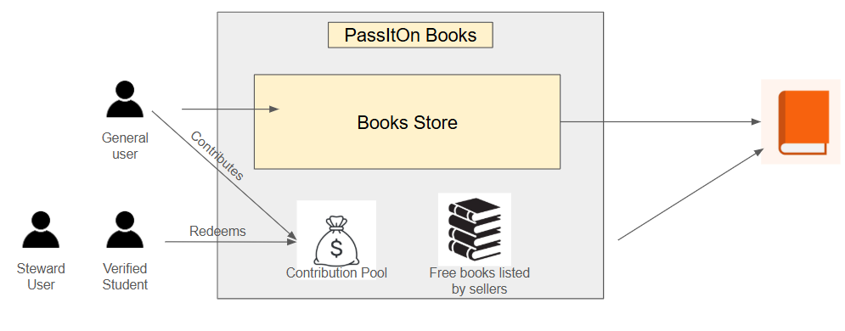
Figure 1: Overview of the product operations

The product is being developed as a website that can be navigated using a desktop browser for the initial version. Further versions might include developing a mobile app. The website contains a backend, frontend and a DBMS package deployed in Amazon Web Service.

Product Functions
The product supports core e-commerce functionality through an implemented Django based system.
The system includes:
- Buyer can browse books, view details, and filter listings
- Buyer can add books to a cart using a session-based system
- Buyer can update quantities and remove items from the cart
- Buyer can proceed to checkout with shipping and payment placeholders
- Buyer can place orders and view order history
- Seller can view incoming orders
- Seller can see order details filtered to their items
- Seller can track revenue per order
- The system allows book inventory tracking
- The system includes order and order item models
- The system includes snapshots of book data at purchased time
- The system uses user authentication and role-based access (buyer/seller/admin)

User Classes and Characteristics
The user classes for this product are classified broadly into 3 categories, Buyer, Seller and Admin. Among the buyers, the vast majority would be people who are avid readers or the ones who are interested in reading books. The minority here would be non readers visiting the website to gift products in the website to the earlier user. Now when it comes to the majority class, the users would be students, faculty members, avid readers and novice readers. The characteristics of different types of buyers are given below.

- Pupils visiting website for gifting: This user group is anticipated to be spending the least amount of time on the website from entering to final checkout. So, it is important for them that the website is highly user friendly.
- Students: This group has the least amount of disposable income but has long term benefits if the user is retained to the habit of reading. Extra features need to be provided to make the website feel welcome to this user group.
- Teachers: Teachers are high income user classes and possibly a major contributor to the pay it forward activity in the website. The teacher also would be a user who can recommend the website to multiple student users in a consistent manner.
- Avid Readers: High income user class with passion for reading. Visit the website in regular intervals. Makes consistent community contributions. Acts of gratitude needs to be added as features for this user group.
- Novice readers: New to the website but thin chance that they would visit again. Needs to make the website minimalistic and user friendly to retain the group.

Now the sellers are categorized into 2 categories. Regular sellers and Generous sellers.

- Regular sellers: as the name indicates, they would be a seller listing the products in the website and aims to sell them.
- Generous sellers: Sellers who would be providing a fixed amount of books as free copies. This user group would be primarily new authors or distributors, or would be large distribution businesses aiming to promote the book. Either way, acts of gratitude should be displayed on the website.

Now admins are responsible for following compliance and maintaining integrity among both sellers and buyers. There are 2 distinct user classes in admin that were identified.
- Authenticator: This admin class has access to all user information who are registered in the platform. It also has read, write and modify access to the user database.
- Financial administrator: This admin class handles all tasks related to payment and talks with external services to handle payments and transactions.
- Moderator: In this version of the app, moderator has access to the user database and will have spam or imposter detection methods integrated.

Operating Environment

The application has a frontend developed in Django templates and a backend developed in Python-Django. The backend will have a Model View Controller software architecture. The current system is hosted locally using Django development server for testing and developmental purposes. The website will be accessible over the internet and supports access through major internet browsers like Google Chrome, Mozilla Firefox, Microsoft Edge and Safari.
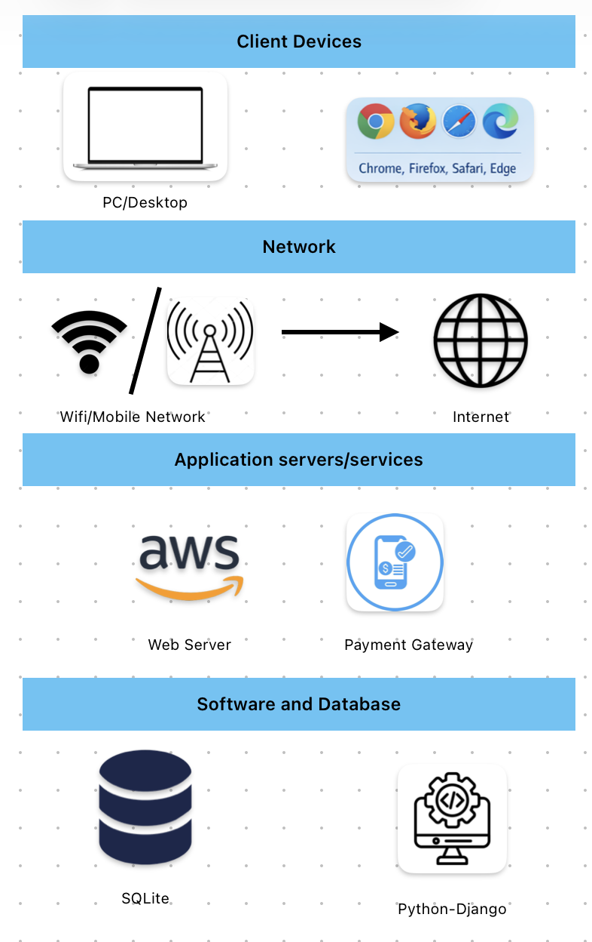
Figure 2: Operating environment for PassItOn Books

Design and Implementation Constraints
The developers will be limited by the constraint of cost in hosting high end servers with AWS. Appropriate server configuration needs to be selected to balance the cost of deployment against the requirement of the website. Implementation of financial transaction portals needs to comply with the IT laws of the country in which the website is operational. User data collection protocols have been designed to be compliant with the product company’s privacy policy, which will be finalized in later stages of development.

System Features

User Account management
3.1.1 Description and Priority
The user has the ability to hold an account on the website. This account should hold information needed by the user to use the website, including email address, payment information, and at least one shipping address. Book wishlist and preferences should also be stored in the user account. The user should be able to login to the account, logout of the account, and edit the information stored in the account. This is a medium priority feature to make it easier for the user to use the website more than once.
3.1.2 Stimulus/Response Sequences
Buyer navigates to the create account page. System prompts the buyer to provide an email address and password. Buyer inputs email address and password and system validates both. If both are valid, the system saves both and creates a new account. Systems prompts buyer to save a payment method or skip. buyer can skip or input a payment method and the system validates the payment method before saving it. System prompts buyer for a shipping address or to skip, buyer can skip or input a shipping address and system validates it before saving.
Seller navigates to create a seller account page. System prompts the seller to provide an email address and password. Seller inputs email address and password and system validates both. If both are valid, the system saves both and creates a new account. System prompts seller for payment or banking information. Seller provides payment/banking information, system validates it and saves if it is valid. System prompts seller for return shipping address (address to send returned books to), seller provides shipping address and system validates it before saving.
User navigates to their account page. …
3.1.3 Functional Requirements
REQ-1: User can create a buyer account
REQ-2: User can create a seller account
REQ-3: User has a valid email address and password
REQ-4: User can change password by entering the old password and a new password
REQ-5: User can send password recovery email to the saved email address which will allow the user to change their password through a link in the email
REQ-6: User can change email address
REQ-7: System sends link to user’s email address to verify email address once user clicks the link in their email
REQ-8: Buyer and seller can save payment information
REQ-9: Buyer and seller can change payment information
REQ-10: Buyer and seller can save shipping address
REQ-11: Buyer can change shipping address
REQ-12: User can login to an existing account
REQ-13: User can logout of their account
REQ-14: User will be logged out after 15 minutes of inactivity

Admin privileges
3.1.1 Description and Priority
Website administrators have the ability to monitor the website to check for spam, prevent abusive and resolve conflicts. Administrators have the ability to reject new buyers or sellers and ban existing ones to prevent abuse. Admins can remove books. Admins can monitor user’s use of the website to prevent users from abusing the steward system.
3.1.2 Stimulus/Response Sequences
After a buyer or seller completes account creation, the system evaluates the registration automatically. If nothing appears suspicious, the account is accepted automatically and the user receives a message that the account was successfully created. If the system detects something unusual, such as weak password strength, suspicious IP address, or other flagged details, it notifies an admin for review. The admin logs in, navigates to the approval page, and reviews the account information. The admin then decides whether to reject the account. If rejected, the user receives a message that the application was not approved.
After a seller adds a new book that does not already exist on the platform, the system automatically evaluates the submission. If the book information appears valid and not suspicious, the book is approved automatically and becomes visible to buyers. The seller receives a confirmation message.

If the system detects any issues, such as incomplete metadata, suspicious ISBN, or mismatched details, the book is marked as pending and the admin is notified for review. The admin logs in, navigates to the approval page, and reviews the book information including title, author, ISBN, description, and any external ISBN reference link if available. The admin then decides whether to reject the submission. If rejected, the seller is notified that the book was not approved.
3.1.3 Functional Requirements
REQ-15: The system shall automatically approve new user applications and notify the admin only for review of flagged or suspicious accounts, which the admin may reject.
REQ-16: The system shall automatically approve new book submissions by sellers and notify the admin only for review of flagged or suspicious listings, which the admin may reject.
REQ-17: Admin can approve new users and remove existing users
REQ-18: Admin can remove books already on market
REQ-19: Admin can promote other existing users to admin
REQ-20: System suggest books similar to ones previously bought by user (same genre or author)
REQ-21: Admin can monitor user’s progress to Steward badge (how fast they get status)
REQ-22: Admin can check for different accounts from the same address
REQ-23: admin can have various privileges related to administrative duties

Book browse
3.1.1 Description and Priority
Buyers can browse for potential books to buy from different categories on their home page, such as previously viewed, related to previous purchases, favorite genres, and previous searches. Buyers also have the ability to browse genre pages which list all of the available books from a specific genre, or author pages which show all available books written by a specific author. An all books page is available that lists every book available on the website and can be filtered by author, genre, price range, and rating or sorted by alphabetical, price, or rating.
3.1.2 Stimulus/Response Sequences
Once the buyer has logged into their account, the system navigates them to their home page. The home page displays multiple categories with the suggested books from each category, categories include: previously viewed books, favorite genres, recommended genres, books related to previous pages, previous search results. Buyer can select a book to view and the system navigates them to the book’s page, or the buyer can pick a specific genre and the system navigates them to the genre’s book list.
Once the buyer navigates to the book’s page, the system displays the book's title, price, rating, ISBN, and description. The book’s page gives the buyer the options to add to a wishlist, add to the compare page, or add to cart.
Buyer can navigate to the all books page from their home page. The all books page contains a list of all books on the website. Buyer can filter by author genre, price range, or rating. Buyer can sort by alphabetically, price, or rating. Buyer can select a book to view its page. Buyer can add book to cart from all books page. Buyer can add a book to compare page from all the books page.
Each genre has a dedicated page to it. The user can navigate to this page from their home page. The page displays a list of books on the website that are in the page’s genre, each book would have the same details as on the all books page. The page would have the same filters as the all books page (except for filter by genre) and the same sorts as the all books page.
Each author will have a dedicated page for them. When the buyer navigates to the author’s page, the page will display all the books where that author is credited, each book would have the same details as on the all books page. The page would have the same filters as the all books page and the same sorts as the all books page.
3.1.3 Functional Requirements
REQ-24: Home page displays books previously viewed by buyer and not purchased
REQ-25: Home page displays books in the same genre as books previously bought by the buyer
REQ-26: Home page displays books related to books previously bought by the buyer
REQ-27: Home page displays books from a previous search or related to that search
REQ-28: All books page that displays all available books on the website
REQ-29: All books page can be sorted alphabetically, by price, or by rating
REQ-30: Each genre present on the site have a page that displays every book listed in the given genre
REQ-31: Each author have a page that displays all books written by that author on the site
REQ-32: User can give a rating to a book from 1 to 5 stars

Book search
3.1.1 Description and Priority
Buyers can use search tools to find a book by using the book’s title, ISBN, author or a keyword within the title, author, ISBN, or description. An ISBN search tool allows to user to search for a specific book using its ISBN and be directed to the page for that book or get an error message informing the buyer the book is not on the site. A search results page shows the results of title or keyword search.
3.1.2 Stimulus/Response Sequences
Buyer can input whole or partial book title, partial ISBN, or one or more keywords. The system displays all books available on the website with a matching pattern within the title. The list has the same features as the all books page (filters, sorts, and book details), except the page only shows the search result.
The buyer can input a whole ISBN. The system will search for a book on the website with a matching ISBN. if a book with that ISBN does not exist, the system will send an error message to the user.
3.1.3 Functional Requirements
REQ-33: Buyer can input book title and system returns all books with matching pattern within the title
REQ-34: Buyer can enter a whole ISBN and system will search for the book with that ISBN; if the book with that ISBN exist and is on the site, system will direct user to the book’s page, if the book with the given ISBN exist and is not on the site system will return an error to the system, if book with the given ISBN is not found system returns an error
REQ-35: Buyer can enter partial ISBN and system will return all books with a matching string within its ISBN
REQ-36: Buyer can enter a keyword and system will return all books with a matching string within either the title, ISBN, or description

Book compare
3.1.1 Description and Priority
Buyers can add 2 or more books to the compare page, which allows the buyers to view the books’ details (title, cover, price, rating, description) in a side-by-side view. Buyers can add books to the compare page from the book’s page, search results page, all books page, or from the compare page itself by searching for the book.
3.1.2 Stimulus/Response Sequences
The user can add a book to the compare page from a book’s details page, the all books page, book page, genre page, author page, or from the compare page itself. Once at least 2 books are added to the compare page, the page displays the details of each book side-by-side.
3.1.3 Functional Requirements
REQ-37: Compare page allows buyer to see 2 or more books details (title, price, genre, rating, and description) side by side
REQ-38: Buyer must have the ability to add a book to the compare page from the book’s details page
REQ-39: Buyer must have the ability add books to the compare page from the browse page
REQ-40: Buyer has the ability to remove books from the compare page
REQ-41: Buyer can use book search on the compare page to add a new book

Book cart
3.1.1 Description and Priority
Buyers can add books to the cart in order to pay for them and check out the books. Buyers can add, remove, or change quantities of books in the cart. Buyers can provide payment information and a shipping address or select saved information if they have previously saved payment information or shipping address on their account. …
3.1.2 Stimulus/Response Sequences
User can add books to their cart. Once a user is ready to checkout (pay for books and submit order), the user can navigate to the cart page from their home page. The cart page displays all of the books in their cart, a subtotal and estimated total price. Buyers can remove books from the cart, or change the quantities of items in their cart. Buyer can input a shipping address or select a saved shipping address if they are logged into an account with a shipping address saved. Buyer can input a payment method or select a saved payment method if they are logged into an account with a payment method saved.
3.1.3 Functional Requirements
REQ-42: Buyer can add book to cart
REQ-43: Buyer can remove a book from their cart
REQ-44: Buyer can update the quantities of a book in their cart
REQ-45: Cart displays subtotal, tax, fees, and total price
REQ-46: Cart displays total number of items, including duplications
REQ-47: Buyer can proceed to the checkout page
REQ-48: Checkout page displays order summary before purchase
REQ-49: Buyer must provide shipping address before completing checkout
REQ-50: Buyer must provide payment method before completing checkout
REQ-51: System creates an Order and Order Item records after checkout
REQ-52: System stores book snapshot data at time of purchase
REQ-53: Buyer can view order history
REQ-54: Buyer can view order details including purchased items
REQ-55: Seller can view orders containing their books only
REQ-56: Seller can see revenue from their items within each order

Seller Inventory
3.1.1 Description and Priority
Sellers can post books to the website that they have available to sell and manage the inventory within the website. Sellers can add new books to sell, change the quantity available to sell, and remove books they can sell. Sellers can view the books they have for sale, the quantities remaining, and how many books have they sold with the income provided from those books.
3.1.2 Stimulus/Response Sequences
Seller can navigate to their seller portal, select to upload a new book. System navigates the user to the uploaded book page and prompts the seller for the book’s information: title, ISBN, description, price, and quantity available to sell.
Seller can navigate to their seller portal. Seller portal displays the total revenue made by the seller (can be set to the monthly, annual or lifetime), and all the books the seller has for sale with the book’s title, ISBN, remaining quantity, items sold, and total revenue from that book.
Seller can view their individual book’s details from the seller portal. Seller can change the quantity available to sell, change the price, change book details (title, author, description, ISBN), or remove the book from sale.
3.1.3 Functional Requirements
REQ-55: Seller can add a new book to sell with the attributes title, author, ISBN, genre, description, and price
REQ-56: Seller can edit details (title, author, ISBN, genre, description, and price) about books available to sell
REQ-57: Seller can set quantity of a specific book available to sell
REQ-58: Seller can view all books they have to sell
REQ-59: Seller can remove a book they have for sell
REQ-60: Seller will receive a notification email when a buyer submits a purchase
REQ-61: Seller can view sales history
REQ-62: Seller can configure and manage an RSS feed from their seller profile to publish updates (e.g., new books, price changes, availability) that can be consumed by external websites or platforms of their choice

Steward System
3.1.1 Description and Priority
All buyers begin as non-stewards. Buyers can make voluntary contributions to the steward pool during checkout. For every dollar contributed, the buyer earns 10 steward points. Once a buyer reaches 100 steward points, the system grants them steward status. Steward users become eligible to claim a free book, but only if they have not claimed a free book within the past 30 days. The checkout page must display the contribution option, and the system must track steward points, steward status, and free book claim eligibility.
3.1.2 Stimulus/Response Sequences
A buyer adds books to their cart and proceeds to checkout. On the checkout page, the system displays an option for the buyer to contribute an amount to the steward pool. If the buyer enters a contribution amount and completes checkout, the system records the contribution and awards steward points at a rate of 10 points per dollar contributed. If the buyer’s total steward points reach 100 or more, the system updates the buyer’s account to steward status.

When a steward user browses the website, the system checks whether the user has claimed a free book within the last 30 days. If the steward has not claimed a free book during that period, the system marks the user as eligible to claim a free book. If the steward has claimed a free book within the last 30 days, the system informs the user that they are currently not eligible and indicates that they must wait until the 30 day period has passed.

When an eligible steward claims a free book, the system records the claim date and updates the user’s eligibility so that another free book cannot be claimed until 30 days have passed.
3.1.3 Functional Requirements
REQ-62: Every buyer account shall begin with non-steward status.
REQ-63: Checkout page shall provide the buyer with an option to contribute to the steward pool.
REQ-64: System shall allow the buyer to enter a contribution amount during checkout.
REQ-65: System shall award 10 steward points for every 1 dollar contributed to the steward pool.
REQ-66: System shall track each buyer’s accumulated steward points.
REQ-67: System shall automatically update a buyer’s status to steward when the buyer reaches at least 100 steward points.
REQ-68: System shall store steward status as part of the buyer’s account information.
REQ-69: A steward user shall be eligible to claim a free book only if they have not claimed a free book in the previous 30 days.
REQ-70: System shall track the date of each steward free book claim.
REQ-71: System shall prevent a steward user from claiming a free book if fewer than 30 days have passed since their last free book claim.
REQ-72: System shall allow an eligible steward user to claim a free book.
REQ-73: System shall update the steward user’s free book eligibility immediately after a free book is claimed.
REQ-74: System shall inform the steward user whether they are currently eligible or ineligible to claim a free book.
REQ-75: System shall display the buyer’s current steward points and steward status on the user account page.

Other Nonfunctional Requirements

Performance Requirements
Customer Requirements:
- Internet Access
  - Browser access
- Devices Available
  - Laptop
  - Desktop
Software Performance:
- Page load time should be under 2-3 seconds under normal conditions
- System should support at least 10-50 concurrent users
- Database queries should be optimized using:
  - Select_related
  - prefetch_related
Software Requirements:
- The software that is being run needs to have reliability management to prevent lag and user frustration
  - The storefront that we have made will be accessible by most devices and will not need many resources to run
- Compatibility with other systems
  - The software will have little disturbance to other systems on the browser
    - The software will require no permissions from the client
- The software requires an active server to be displayed on
  - Any free server or browser provider will suffice

Safety Requirements
Data Safety:
- Admin Passwords
  - To prevent restricted personnel from accessing sensitive data
- Proper Code
  - Proper handling of database functions and database handling to prevent data corruption
    - Loss of database items
    - Skewing of database items during editing
- Proper Git Commits
  - Properly committing changes to the correct branches(specific functions) and using pull request to edit the main branch(live application)
Safeguards:
- Traceability
  - The software should be traceable through the GitHub for review and validation during development.
- Specified Developer Access
  - Only the team creating PassItOn books should have access to the repositories and data for the software
- Limited AI Usage
  - Simply not using AI to write entire blocks of structural code

Security Requirements
Security Requirements:
- Handling user traffic
  - The software’s server (AWS) should be able to handle user traffic from an acceptable amount of current users
    - 1 to 20 users
- Software should be scalable
  - The software should be manageable on a fluctuating scale to encompass the flow of information and data from users
- User Identification
  - User accounts have the function to create passwords
  - Emails can be an option for added personability
- Software Compliance(taken from legal and policy requirements)
  - The system complies with data privacy regulations.
  - The system does not share user data without users consent.
  - The system stores payment information using secure third party services.

Software Quality Attributes
Software Quality Attributes:
- Necessary menus and options for storefront navigation and access
  - All necessary menu items and storefront options for our specific application
    - Home
      - Base menu with tabs and directors to other website functions and services
    - Books
      - Library of purchasable books and free pre-purchased “pass-it-on” books
    - Checkout
      - Cart information
        - Books chosen
        - Purchase amount
        - Checkout button
    - Profile
      - Options
        - Edit Profile
        - Create Profile
        - Login
        - Logout
- Reusability:
  - Software flexibility
    - Coded for revision and editability
      - Proper level of complexity or simplicity for later development(Sprints 3 and 4)
    - Readable code
      - Proper syntax and function calls
  - User satisfaction
    - Avoid frustrating issues:
      - Cluttered UI
        - Unreadable UI that lacks simplicity
      - Broken menus and tabs
        - Lack of page navigation
          - <previous page> or <next page>
  - Portability
    - The software is ported through a browser system to the internet
- Efficiency:
  - Interoperability
    - The development of the software tackles and handle the needed functionality of all systems and applications required for the software’s completion
  - Maintainability
    - The software does not require company level resources for development and runs the simple application PassItOn Books
  - Robustness
    - The software is coded and optimized to cover all necessary requirements for functionality
  - Functionality
    - Optimized functions and code for the software that keeps processing to a minimum
  - Testing
    - Proper testing of functions and database connection
    - Reasonable commit history
      - No random commits with no revisions or changes
      - No arbitrary changes that are redundant to the code or harmful to the project

Other Requirements
5.1 Data Requirements
The system stores user account information such as username, email, status, and payment information.
The system stores book data such as ISBN, author, price, description, and cover image
The system contains role based data access.
The system stores cart data with session-based key value storage.
The system stores order data through order and orderItem models.
The system stores seller specific order breakdowns.
The system ensures each user account is identified by its own unique identifier.

5.2 Legal and Policy Requirements
The system complies with data privacy regulations.
The system does not share user data without users consent.
The system stores payment information using secure third party services.

5.3 Logging and Backup Requirements
The system logs failed login attempts for security purposes.
The system logs admin actions such as user removal and book removal.
The system backs up stored data on a regular basis.
The system holds logs for a set time period.
The system allows recovery in the event of system failure.

5.4 Installation requirements.
The system is usable on a standard web server.
The system does not require special hardware to operate.
The system is deployable using cloud computing services.

5.5 Future Expansion and Reuse Requirements
The system allows additional features to be added in the future.
The system allows module components when possible.
The system allows new user tokens and badges.
The system supports growth to handle increased user traffic.

Appendix A: Glossary
Administrator (Admin):
A user with higher access with the ability to manage the system and other users accounts.

Checkout:
The process a customer goes through to purchase an item.

Community Contribution:
A voluntary contribution made during a purchase, supporting the pay it forward system. Contributions are pooled to help reduce costs and provide free books to eligible users.

Functional Requirements:
A requirement that explains a specific aspect of a system and its function.

Inventory:
An object that holds items available for purchase by the customer.

Pay-It-Forward:
A feature on Pass-It-On Books website that allows buyers to optionally contribute a small additional amount to help others with the future purchase of books.

Payment Gateway:
A secure third party service used to process final transactions on the PassItOn Books website.

SRS:
Software Requirement Specification.

Steward Badge:
An award to users who actively participate in community contributions. Users who earn the steward badge are constantly engaged with the pay it forward system, making them eligible for a free or discounted book.

User:
The person who operates the software product.

Wishlist:
A feature that allows users to save books they are interested in to come back and check out later.

Appendix B: Analysis Models
To be determined in sprint 2
Appendix C: To Be Determined List
TBD 1:
Pay It Forward wishlist requirements

TBD 2:
Buyer feature requirements

TBD 3:
Performance benchmarks

TBD 4:
Admin Privilege Levels

