Customer Retention & Churn Analysis
Future Interns — Data Science Task 2

Executive Summary
Of 7,043 customers in the Telco dataset, 26.5% churned — roughly one in every four. This analysis identifies which customer segments drive that loss, quantifies the financial impact, and uses logistic regression to isolate the independent contribution of each driver.
Two findings dominate the analysis:
- The largest churn driver is fiber-optic internet service. Holding all other factors constant, fiber customers have 3.58 times the churn odds of DSL customers. The premium product has the worst retention.
- The strongest retention factor is a two-year contract. Two-year customers have churn odds 0.26 times as high as month-to-month customers — a roughly 74% reduction in churn odds.
Beyond these headlines, the first year of a customer's tenure is brutal — first-year churn exceeds 47% — but retention climbs sharply for customers who pass that threshold, reaching 98% by year six. Add-on services (online security, tech support) reduce churn odds by roughly 25-30%, offering a low-cost retention lever. Streaming services, surprisingly, do not protect against churn and may slightly increase it.
These findings point to three actionable interventions: convert month-to-month customers to longer contracts, investigate the fiber-optic customer experience, and bundle protective add-on services more aggressively — particularly with new customers in their first year.

Data & Methodology

Dataset
The IBM Telco Customer Churn dataset contains 7,043 customer records and 21 columns covering demographics (gender, senior citizen status, partner, dependents), services (phone, internet, online security, tech support, streaming), account information (tenure, contract type, payment method, billing), charges (monthly and total), and a binary churn label. Each row represents a single customer.

Cleaning
The raw data contained no duplicates and no explicit null values. One subtle data-quality issue was discovered: the TotalCharges column was stored as text rather than numeric. Investigation revealed 11 rows with blank-string values (whitespace, not nulls), all corresponding to brand-new customers with tenure = 0. These were filled with 0 (no billing cycle had yet occurred) and the column was converted to float. No other cleaning was required.

Approach
The analysis followed a three-stage approach:
- Descriptive analysis: compute the overall churn rate, then break it down by segment (contract type, tenure bucket, payment method, internet service, and add-on services).
- Financial overlay: estimate revenue at risk by multiplying monthly charges by churn status, isolating which segments carry the greatest financial exposure.
- Logistic regression: model churn as a function of all features simultaneously to isolate each driver's independent effect, since several descriptive findings (contract, fiber, payment method) describe overlapping customer populations.
The logistic regression was trained on an 80/20 stratified split (5,634 training rows, 1,409 test rows). Categorical variables were one-hot encoded with the first category dropped to serve as the implicit baseline. Test accuracy reached 80.6%, comfortably above the 73.5% naive baseline, with train and test scores matching to indicate the model generalises and is not overfit.

Dashboard
The dashboard below summarises the four most important findings: churn rate by contract type (with the overall 26.5% baseline marked), revenue at risk by contract type, the tenure retention curve from month 0 to month 72, and churn rate by internet service.
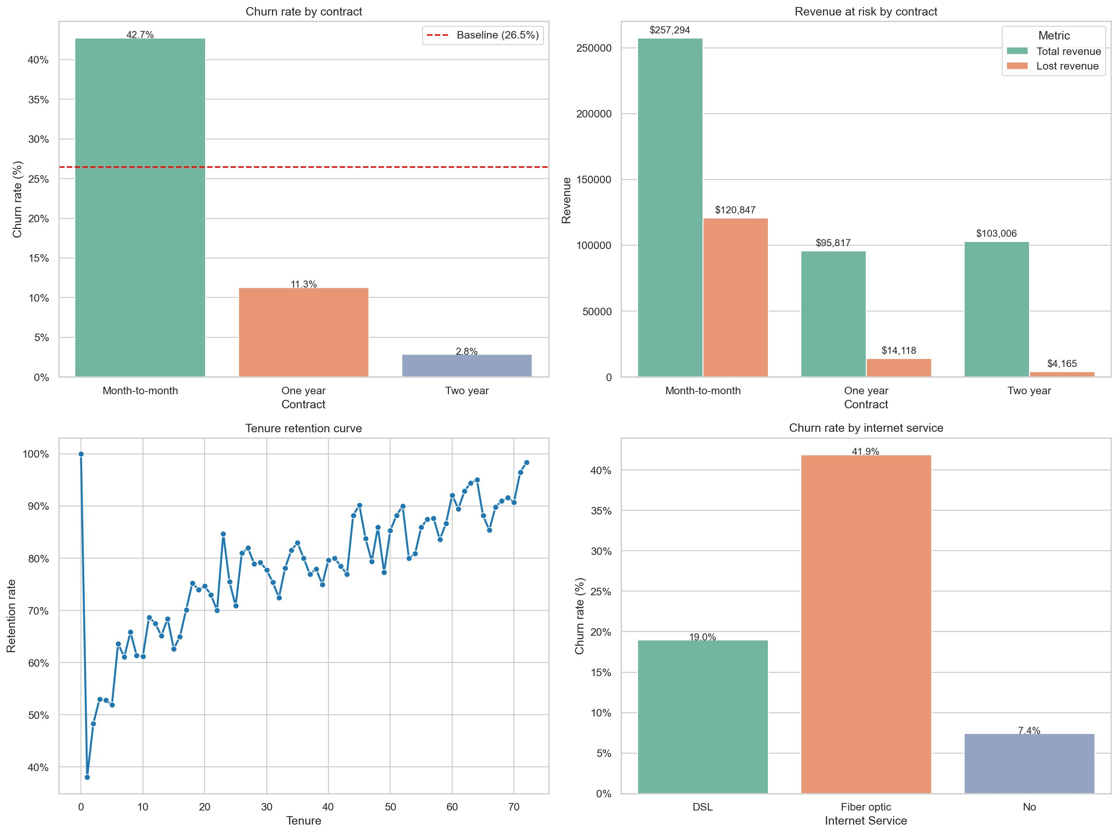

Findings

1. Fiber optic is the largest single churn driver
Customers with fiber-optic internet service churn at 41.9%, more than double the DSL rate of 19.0% and over five times the rate for customers with no internet service (7.4%). The logistic regression confirms this is not merely a correlation with other variables: holding contract type, tenure, payment method, and all other features constant, fiber customers have 3.58 times the churn odds of DSL customers. This is the largest coefficient in the model after contract type itself.
Financially, fiber accounts for the single largest revenue leak in the dataset: $114,300 in monthly recurring revenue is lost to fiber customer churn, a figure comparable to the total monthly revenue lost across all month-to-month contracts combined ($120,847). The premium product has the worst retention.

2. Two-year contracts are the strongest retention factor
Churn rates fall sharply with contract length: 42.7% for month-to-month, 11.3% for one-year, and 2.8% for two-year customers. The regression isolates the independent effect: two-year contracts produce churn odds 0.26 times as high as month-to-month — a roughly 74% reduction. One-year contracts halve the odds.
It is worth noting that this effect is partly causal and partly self-selective: customers willing to commit to a long contract are likely already more loyal. The descriptive gap is therefore an upper bound on what contract conversion alone can achieve, but the effect after controlling for other variables remains the single largest negative coefficient in the model.

3. The first year is brutal; long-tenured customers are sticky
The tenure retention curve shows churn is heavily front-loaded. Among customers in their first month, only 38% are retained. The curve climbs steadily through the first two years, passing 80% by month 25, and reaches 98% by month 72. First-year customers (n = 2,186) churn at 47.4%, accounting for 1,037 of all lost customers.
The implication is that the company does not have a chronic loyalty problem — it has an acquisition-stage problem. Customers who pass the first year become very durable.

4. Add-on services reduce churn; streaming does not
Online security and tech support each reduce churn odds by roughly 25-30% after controlling for everything else (odds ratios 0.72 and 0.76 respectively). These services may serve as indicators of customer engagement or directly improve the experience by reducing technical frustration.
In contrast, streaming TV and streaming movies — which descriptive analysis suggested were churn-neutral — slightly increase churn odds in the regression (1.51× each). One plausible explanation is that streaming customers are more sophisticated users who comparison-shop providers. Streaming should not be relied upon as a retention bundle.

5. Payment method has a modest residual effect
Electronic check payments correlate with the highest churn rate descriptively (45.3%), and the regression preserves a meaningful but smaller independent effect (1.46× odds). Much of the raw descriptive signal is explained by overlap with month-to-month and fiber-optic customers. Even so, electronic check remains a marker of elevated churn risk.

6. Summary of model coefficients
The following table summarises the principal drivers and their effect on churn odds.
Driver | Effect on churn odds | Interpretation
Fiber optic internet | 3.58× higher (vs DSL) | Largest single churn driver
Two-year contract | 0.26× as high (vs month-to-month) | Strongest retention factor
One-year contract | 0.50× as high (vs month-to-month) | Moderate retention factor
Streaming TV / Movies | ~1.51× higher | Modest churn increase (surprising)
Electronic check payment | 1.46× higher | Modest churn driver
Online security add-on | 0.72× as high | Protective factor
Tech support add-on | 0.76× as high | Protective factor
Note: variables not listed (gender, partner status, total charges) had coefficients near zero, indicating no meaningful independent effect on churn.

Recommendations

1. Prioritise contract conversion campaigns
The single highest-leverage intervention is moving month-to-month customers onto one- or two-year contracts. Targeted offers — discounts conditional on signing a longer commitment — should focus on customers who have survived the first six months (and thus shown some stickiness) but have not yet been on a long-term plan. Avoid burning incentive budget on the first-month cohort, where churn is highest and conversion intent is lowest.

2. Investigate the fiber-optic experience
The fiber-optic churn finding warrants a dedicated operational review. This analysis cannot determine whether the cause is pricing, reliability, service quality, or competitive pressure in fiber-eligible markets. Recommended next steps: customer satisfaction survey specifically targeting fiber subscribers, churn reason analysis from cancellation records, and competitive benchmarking on fiber pricing in served regions.

3. Bundle protective add-on services with new accounts
Online security and tech support each independently reduce churn odds by 25-30%. Offering these services free for the first six months — or bundled by default — could materially improve first-year retention, which is the period of greatest customer loss. Streaming services should not be used for this purpose; the data does not support them as a retention lever.

4. Build a churn-risk scoring system
The logistic regression developed in this analysis can be operationalised as a per-customer risk score. Customers in the top decile of predicted churn probability could be flagged for proactive retention outreach. This would shift the company from reactive (responding to cancellation requests) to predictive (intervening before the customer decides to leave).

Limitations
Several limitations should be considered when acting on these findings:
- The dataset is a single snapshot and lacks a time dimension. Cohort analyses by signup date and changes in churn over time cannot be performed.
- Customer behavioural data (support tickets, payment delinquency history, usage patterns) is not present, and would likely improve predictive accuracy beyond 80.6%.
- Several drivers describe overlapping customer populations — for instance, 55% of month-to-month customers have fiber optic — meaning the regression coefficients, while isolating each variable's independent effect, cannot be summed naively into expected outcomes for hypothetical interventions.
- The contract-length effect is partly self-selective: customers willing to sign long contracts are likely already more committed. The model controls for observable variables but cannot account for unobserved loyalty traits.
- No data is available on competitor pricing, marketing campaigns, or regional service quality, all of which likely contribute to churn but are not captured here.
- The model uses unscaled features for interpretability, with logistic regression's iteration limit raised to accommodate convergence. The same predictions could be obtained with feature scaling, which would not change conclusions.

