
LAB-1-3 v6 (autosaved) 

Python [default]
- File
- Edit
- View
- Insert
- Cell
- Kernel
- Widgets
- Help

%matplotlib inline
import torch
import torchvision
import torchvision.transforms as transforms
import torchvision.datasets as datasets
def get_mean_and_std(dataset):
'''Compute the mean and std value of dataset.'''
dataloader = torch.utils.data.DataLoader(dataset, batch_size=1, shuffle=False, num_workers=2)
​
mean = torch.zeros(3)
std = torch.zeros(3)
print('==> Computing mean and std..')
for inputs, targets in dataloader:
for i in range(3):
mean[i] += inputs[:, i, :, :].mean()
std[i] += inputs[:, i, :, :].std()
mean.div_(len(dataset))
std.div_(len(dataset))
return mean, std
#To determine if your system supports CUDA
print("==> Check devices..")
device = 'cuda' if torch.cuda.is_available() else 'cpu'
print("Current device: ",device)
​
#Also can print your current GPU id, and the number of GPUs you can use.
print("Our selected device: ", torch.cuda.current_device())
print(torch.cuda.device_count(), " GPUs is available")
#device = 'cpu'
==> Check devices..
Current device: cuda
Our selected device: 0
1 GPUs is available
print('==> Preparing dataset..')
==> Preparing dataset..
"""1.1"""
#img_size, linear_size, fc1_out = 64, 13, 256
#img_size, linear_size, fc1_out = 128, 29, 256
#img_size, linear_size, fc1_out = 256, 61, 256
img_size, linear_size, fc1_out, fc2_out = 384, 93, 1024, 1024
#img_size, linear_size, fc1_out = 512, 125, 256
#img_size, linear_size, fc1_out = 512, 125, 512
#img_size, linear_size, fc1_out = 1024, 253, 256
​
calculate_mean_std = False
​
if calculate_mean_std == True:
#The transform function for train data
transform_train = transforms.Compose([
transforms.Resize(img_size),
transforms.RandomCrop(img_size, padding=4),
transforms.ToTensor(),
])
​
#The transform function for test data
transform_test = transforms.Compose([
transforms.Resize(img_size),
transforms.RandomCrop(img_size, padding=4),
transforms.ToTensor(),
])
​
#we will calculate mean and std

trainset = torchvision.datasets.ImageFolder(root='./food/training', transform=transform_train)
testset = torchvision.datasets.ImageFolder(root='./food/evaluation', transform=transform_test)

train_mean, train_std = get_mean_and_std(trainset)
print(train_mean, train_std)
test_mean, test_std = get_mean_and_std(testset)
print(test_mean, test_std)
else:
train_mean, train_std = ([0.5551, 0.4478, 0.3366]), ([0.2337, 0.2414, 0.2386])
test_mean, test_std = ([0.5607, 0.4518, 0.3425]), ([0.2333, 0.2415, 0.2385])

"""1.1+"""
#The transform function for train data
transform_train = transforms.Compose([
transforms.Resize(img_size),
transforms.RandomCrop(img_size, padding=4),
transforms.RandomHorizontalFlip(),
transforms.ToTensor(),
transforms.Normalize(train_mean, train_std)
])
​
#The transform function for test data
transform_test = transforms.Compose([
transforms.Resize(img_size),
transforms.RandomCrop(img_size, padding=4),
transforms.ToTensor(),
transforms.Normalize(test_mean, test_std)
])
"""1.2+"""
trainset = torchvision.datasets.ImageFolder(root='./food/training', transform=transform_train)
testset = torchvision.datasets.ImageFolder(root='./food/evaluation', transform=transform_test)
"""1.3"""
​
#Create DataLoader to draw samples from the dataset
#In this case, we define a DataLoader to random sample our dataset.
#For single sampling, we take one batch of data. Each batch consists 4 images
trainloader = torch.utils.data.DataLoader(trainset, batch_size=32,
shuffle=True, num_workers=2)
​
testloader = torch.utils.data.DataLoader(testset, batch_size=32,
shuffle=False, num_workers=2)
classes = ('Bread', 'DairyProduct', 'Dessert', 'Egg', 'Friedfood',
'Meat', 'Noodles-Pasta', 'Rice', 'Seafood', 'Soup', 'Vegetable')
print('==> Building model..')
==> Building model..
import torch.nn as nn
# define your own model
class Net(nn.Module):
​
#define the layers
def __init__(self):
super(Net, self).__init__()
self.conv1 = nn.Conv2d(3, 6, 5)
self.pool = nn.MaxPool2d(2, 2)
self.conv2 = nn.Conv2d(6, 16, 5)
self.fc1 = nn.Linear(16 * linear_size * linear_size, fc1_out)
self.fc2 = nn.Linear(fc1_out, fc2_out)
self.fc3 = nn.Linear(fc2_out, 11)
self.relu = nn.ReLU()

#concatenate these layers
def forward(self, x):
x = self.pool(self.relu(self.conv1(x)))
x = self.pool(self.relu(self.conv2(x)))
x = x.view(-1, 16 * linear_size * linear_size)
x = self.relu(self.fc1(x))
x = self.relu(self.fc2(x))
x = self.fc3(x)
return x
#declare a new model
net = Net()
# change all model tensor into cuda type
# something like weight & bias are the tensor
#net = net.to(device)
print(device)
if device == 'cuda':
net = net.cuda(0)
else:
net = net.cpu()
cuda
########################################################################

3. Define a Loss function and optimize
########################################################################
print('==> Defining loss function and optimize..')
==> Defining loss function and optimize..
import torch.optim as optim
​
#loss function
criterion = nn.CrossEntropyLoss()
#optimization algorithm
optimizer = optim.SGD(net.parameters(), lr=0.1, momentum=0.9, weight_decay=1e-5)
########################################################################

4. Train the network
Before training the model, we need to analysis the tensor variable.
Each variable have many attibute, like: .grad_fn, .require_grad, .data, .grad...etc. The ".grad_fn" attribute of "torch.Tensor" is an entry point into the function that has create this "torch.Tensor" variables. Because of ".grad_fn" flag, we can easily create a computing graph in the form of DAG(directed acyclic graph).
And then, the ".require_grad" attribute allows us to determine whether the backward propagation function is going to calculate the gradient of this "torch.Tensor" variable. If one variable has a false value of require_grad, it represent that you don't want to calculate this variable's gradient, and also its gradient will not be updated.
########################################################################
print('==> Training model..')
==> Training model..
#Set the model in training mode
#because some function like: dropout, batchnorm...etc, will have
#different behaviors in training/evaluation mode
#[document]: https://pytorch.org/docs/stable/nn.html#torch.nn.Module.train
net.train()
scheduler = torch.optim.lr_scheduler.StepLR(optimizer, step_size = 1, gamma=0.9)
​
for epoch in range(5): # loop over the dataset multiple times
#scheduler.step()
running_loss = 0.0
correct = 0
for i, (inputs, labels) in enumerate(trainloader, 0):

#change the type into cuda tensor
if device == 'cuda':
inputs = inputs.cuda(0)
labels = labels.cuda(0)
else:
inputs = inputs.cpu()
labels = labels.cpu()
​
#print(labels)
#print(inputs)

# zero the parameter gradients
optimizer.zero_grad()
​
# forward + backward + optimize
outputs = net(inputs)
# select the class with highest probability
_, pred = outputs.max(1)
# if the model predicts the same results as the true
# label, then the correct counter will plus 1
correct += pred.eq(labels).sum().item()

loss = criterion(outputs, labels)

loss.backward()
optimizer.step()
​
# print statistics
running_loss += loss.item()
# print(i, " ", end="")
​
​
if i % 200 == 199: # print every 200 mini-batches
print('[%d, %5d] loss: %.3f' %
(epoch + 1, i + 1, running_loss / 200))
running_loss = 0.0

print('%d epoch, training accuracy: %.4f' % (epoch+1, 100.*correct/len(trainset)))
print('Finished Training')
[1, 200] loss: 2.719
1 epoch, training accuracy: 14.4334
[2, 200] loss: 2.303
2 epoch, training accuracy: 14.9909
[3, 200] loss: 2.300
3 epoch, training accuracy: 15.3558
[4, 200] loss: 2.297
4 epoch, training accuracy: 15.0922
[5, 200] loss: 2.300
5 epoch, training accuracy: 15.1024
Finished Training
######################
#######LAB 1-1########
"""
To Do Here
You should show the weight distribution of the convolution layer (conv1, conv2)
You should show the bias distribution of the convolution layer (conv1, conv2)
[hint] you can use matplotlib package to show the result in here
"""
######################
import numpy as np
import matplotlib.mlab as mlab
import matplotlib.pyplot as plt
​
x = net.conv1.weight.view(-1,1).cpu().detach().numpy()
n, bins, patches = plt.hist(x, facecolor='green', alpha=0.75)
​
plt.xlabel('conv1-weight')
plt.ylabel('Probability')
plt.title('weight distribution of the convolution layer conv1')
​
plt.grid(True)
plt.show()
​
x = net.conv2.weight.view(-1,1).cpu().detach().numpy()
n, bins, patches = plt.hist(x, facecolor='green', alpha=0.75)
​
plt.xlabel('conv2-weight')
plt.ylabel('Probability')
plt.title('weight distribution of the convolution layer conv2')
​
plt.grid(True)
plt.show()
​
x = net.fc1.weight.view(-1,1).cpu().detach().numpy()
n, bins, patches = plt.hist(x, facecolor='green', alpha=0.75)
​
plt.xlabel('fc1-weight')
plt.ylabel('Probability')
plt.title('weight distribution of the convolution layer fc1')
​
plt.grid(True)
plt.show()
​
x = net.fc2.weight.view(-1,1).cpu().detach().numpy()
n, bins, patches = plt.hist(x, facecolor='green', alpha=0.75)
​
plt.xlabel('fc2-weight')
plt.ylabel('Probability')
plt.title('weight distribution of the convolution layer fc2')
​
plt.grid(True)
plt.show()
​
x = net.fc3.weight.view(-1,1).cpu().detach().numpy()
n, bins, patches = plt.hist(x, facecolor='green', alpha=0.75)
​
plt.xlabel('fc3-weight')
plt.ylabel('Probability')
plt.title('weight distribution of the convolution layer fc3')
​
plt.grid(True)
plt.show()
​
x = net.conv1.bias.view(-1,1).cpu().detach().numpy()
n, bins, patches = plt.hist(x, facecolor='green', alpha=0.75)
​
plt.xlabel('conv1-bias')
plt.ylabel('Probability')
plt.title('bias distribution of the convolution layer conv1')
​
plt.grid(True)
plt.show()
​
x = net.conv2.bias.view(-1,1).cpu().detach().numpy()
n, bins, patches = plt.hist(x, facecolor='green', alpha=0.75)
​
plt.xlabel('conv2-bias')
plt.ylabel('Probability')
plt.title('bias distribution of the convolution layer conv2')
​
plt.grid(True)
plt.show()
​
x = net.fc1.bias.view(-1,1).cpu().detach().numpy()
n, bins, patches = plt.hist(x, facecolor='green', alpha=0.75)
​
plt.xlabel('fc1-bias')
plt.ylabel('Probability')
plt.title('bias distribution of the convolution layer fc1')
​
plt.grid(True)
plt.show()
​
x = net.fc2.bias.view(-1,1).cpu().detach().numpy()
n, bins, patches = plt.hist(x, facecolor='green', alpha=0.75)
​
plt.xlabel('fc2-bias')
plt.ylabel('Probability')
plt.title('bias distribution of the convolution layer fc2')
​
plt.grid(True)
plt.show()
​
x = net.fc3.bias.view(-1,1).cpu().detach().numpy()
n, bins, patches = plt.hist(x, facecolor='green', alpha=0.75)
​
plt.xlabel('fc3-bias')
plt.ylabel('Probability')
plt.title('bias distribution of the convolution layer fc3')
​
plt.grid(True)
plt.show()
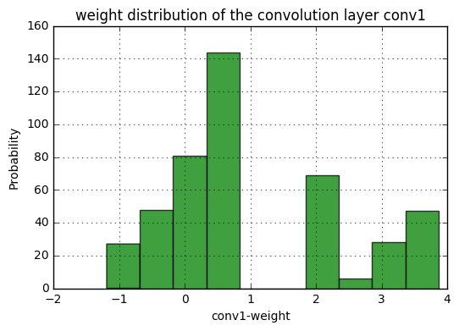
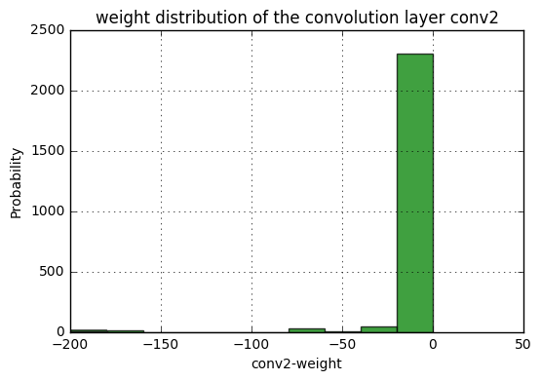
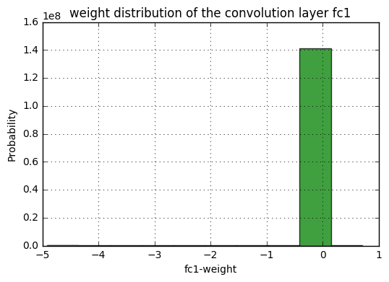
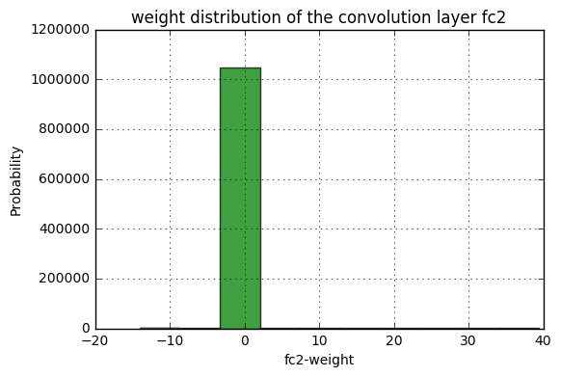
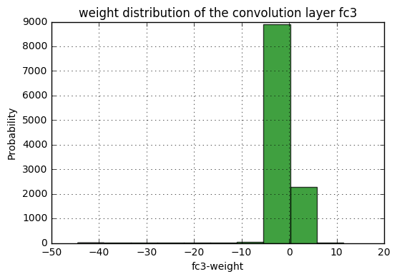
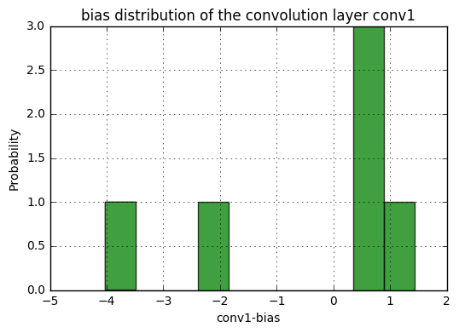
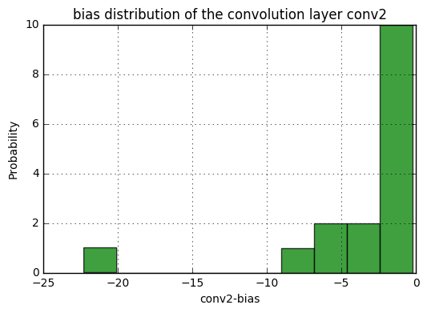
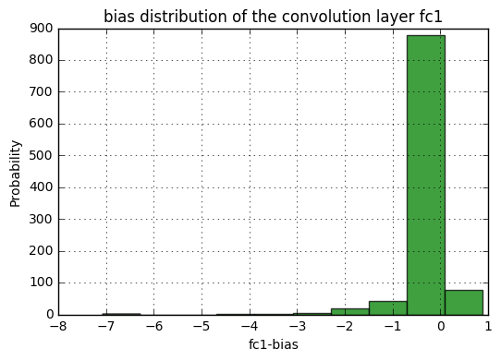
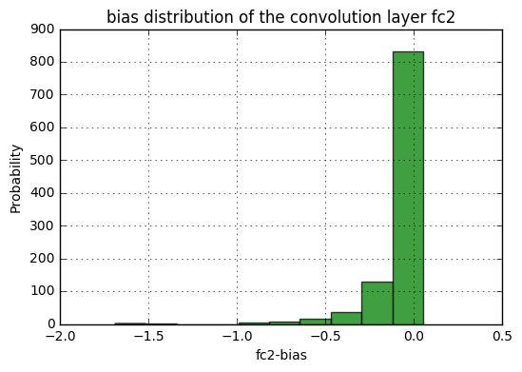
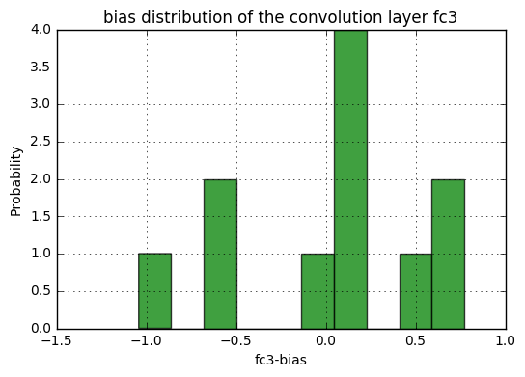
#After training , save the model first
#You can saves only the model parameters or entire model
#Some difference between the two is that entire model
#not only include parameters but also record hwo each
#layer is connected(forward method).
#[document]: https://pytorch.org/docs/master/notes/serialization.html
​
print('==> Saving model..')
​
#only save model parameters
torch.save(net.state_dict(), './checkpoint.t7')
#you also can store some log information
state = {
'net': net.state_dict(),
'acc': 100.*correct/len(trainset),
'epoch': 75
}
torch.save(state, './checkpoint.t7')
​
#save entire model
torch.save(net, './model.pt')
​
print('Finished Saving')
==> Saving model..
/home/ccma/anaconda3/lib/python3.5/site-packages/torch/serialization.py:241: UserWarning: Couldn't retrieve source code for container of type Net. It won't be checked for correctness upon loading.
"type " + obj.__name__ + ". It won't be checked "
Finished Saving
########################################################################

5. Test the network on the test data
########################################################################
#Before testing, we can load the saved model
#Depend on how you save your model, need
#different way to use it
print('==> Loading model..')
#If you just save the model parameters, you
#need to redefine the model architecture, and
#load the parameters into your model net = Net() checkpoint = torch.load('./checkpoint.t7') net.load_state_dict(checkpoint['net'])
#If you save the entire model net = torch.load('./model.pt')
print('Finished Loading')
print('==> Testing model..')
​
#Set the model in evaluation mode
#[document]: https://pytorch.org/docs/stable/nn.html#torch.nn.Module.eval
net.eval()
​
==> Testing model..
Net(
(conv1): Conv2d(3, 6, kernel_size=(5, 5), stride=(1, 1))
(pool): MaxPool2d(kernel_size=2, stride=2, padding=0, dilation=1, ceil_mode=False)
(conv2): Conv2d(6, 16, kernel_size=(5, 5), stride=(1, 1))
(fc1): Linear(in_features=138384, out_features=1024, bias=True)
(fc2): Linear(in_features=1024, out_features=1024, bias=True)
(fc3): Linear(in_features=1024, out_features=11, bias=True)
(relu): ReLU()
)
######################
#######LAB 1-1########
"""
To Do Here
​
You should complete the testing step in LAB 1-1
You should show the total accuracy & loss [10000 cifar10 test cases]
You also need to tell us, how about the accuracy for each class

For example: Total accuracy is: 60.0% and loss is: 0.02
For each class in cifar 10:
Accuracy of plane : 58.0%
Accuracy of car : 22.4%
.
.
.
"""
######################
correct = 0
total = 0
​
class_correct = list(0. for i in range(11))
class_total = list(0. for i in range(11))
​
with torch.no_grad():
test_run = 0
for data in testloader:
images, labels = data
​
if device == 'cuda':
images = images.cuda(0)
labels = labels.cuda(0)
else:
images = images.cpu()
labels = labels.cpu()

#print(test_run, " ", end="")
#test_run = test_run + labels.size(0)

outputs = net(images)
_, predicted = torch.max(outputs, 1)

total += labels.size(0)
correct += (predicted == labels).sum().item()
​
c = (predicted == labels).squeeze()
#print(predicted)
#print(labels.size(0))
#print("(", c, "), ")
for i in range(labels.size(0)):
label = labels[i]
class_correct[label] += c[i].item()
class_total[label] += 1
​
print('Accuracy of the network on the %d test images: %d %%' % (total, 100 * correct / total))
​
for i in range(11):
print('Accuracy of %5s : %2d %%' % (
classes[i], 100 * class_correct[i] / class_total[i]))
Accuracy of the network on the 3347 test images: 14 %
Accuracy of Bread : 0 %
Accuracy of DairyProduct : 0 %
Accuracy of Dessert : 0 %
Accuracy of Egg : 0 %
Accuracy of Friedfood : 0 %
Accuracy of Meat : 0 %
Accuracy of Noodles-Pasta : 0 %
Accuracy of Rice : 0 %
Accuracy of Seafood : 0 %
Accuracy of Soup : 100 %
Accuracy of Vegetable : 0 %
​
​

​

LAB-1-3 v7 (autosaved)

Python [default]
- File
- Edit
- View
- Insert
- Cell
- Kernel
- Widgets
- Help

%matplotlib inline
import torch
import torchvision
import torchvision.transforms as transforms
import torchvision.datasets as datasets
def get_mean_and_std(dataset):
'''Compute the mean and std value of dataset.'''
dataloader = torch.utils.data.DataLoader(dataset, batch_size=1, shuffle=False, num_workers=2)
​
mean = torch.zeros(3)
std = torch.zeros(3)
print('==> Computing mean and std..')
for inputs, targets in dataloader:
for i in range(3):
mean[i] += inputs[:, i, :, :].mean()
std[i] += inputs[:, i, :, :].std()
mean.div_(len(dataset))
std.div_(len(dataset))
return mean, std
#To determine if your system supports CUDA
print("==> Check devices..")
device = 'cuda' if torch.cuda.is_available() else 'cpu'
print("Current device: ",device)
​
#Also can print your current GPU id, and the number of GPUs you can use.
print("Our selected device: ", torch.cuda.current_device())
print(torch.cuda.device_count(), " GPUs is available")
#device = 'cpu'
==> Check devices..
Current device: cuda
Our selected device: 0
1 GPUs is available
print('==> Preparing dataset..')
==> Preparing dataset..
"""1.1"""
img_size, linear_size, fc1_out, fc2_out = 64, 13, 256, 84
#img_size, linear_size, fc1_out = 128, 29, 256
#img_size, linear_size, fc1_out = 256, 61, 256
#img_size, linear_size, fc1_out, fc2_out = 384, 93, 1024, 1024
#img_size, linear_size, fc1_out = 512, 125, 256
#img_size, linear_size, fc1_out = 512, 125, 512
#img_size, linear_size, fc1_out = 1024, 253, 256
​
calculate_mean_std = False
​
if calculate_mean_std == True:
#The transform function for train data
transform_train = transforms.Compose([
transforms.Resize(img_size),
transforms.RandomCrop(img_size, padding=4),
transforms.ToTensor(),
])
​
#The transform function for test data
transform_test = transforms.Compose([
transforms.Resize(img_size),
transforms.RandomCrop(img_size, padding=4),
transforms.ToTensor(),
])
​
#we will calculate mean and std

trainset = torchvision.datasets.ImageFolder(root='./food/training', transform=transform_train)
testset = torchvision.datasets.ImageFolder(root='./food/evaluation', transform=transform_test)

train_mean, train_std = get_mean_and_std(trainset)
print(train_mean, train_std)
test_mean, test_std = get_mean_and_std(testset)
print(test_mean, test_std)
else:
train_mean, train_std = ([0.5551, 0.4478, 0.3366]), ([0.2337, 0.2414, 0.2386])
test_mean, test_std = ([0.5607, 0.4518, 0.3425]), ([0.2333, 0.2415, 0.2385])

"""1.1+"""
#The transform function for train data
transform_train = transforms.Compose([
transforms.Resize(img_size),
transforms.RandomCrop(img_size, padding=4),
transforms.RandomHorizontalFlip(),
transforms.ToTensor(),
transforms.Normalize(train_mean, train_std)
])
​
#The transform function for test data
transform_test = transforms.Compose([
transforms.Resize(img_size),
transforms.RandomCrop(img_size, padding=4),
transforms.ToTensor(),
transforms.Normalize(test_mean, test_std)
])
"""1.2+"""
trainset = torchvision.datasets.ImageFolder(root='./food/training', transform=transform_train)
testset = torchvision.datasets.ImageFolder(root='./food/evaluation', transform=transform_test)
"""1.3"""
​
#Create DataLoader to draw samples from the dataset
#In this case, we define a DataLoader to random sample our dataset.
#For single sampling, we take one batch of data. Each batch consists 4 images
trainloader = torch.utils.data.DataLoader(trainset, batch_size=32,
shuffle=True, num_workers=2)
​
testloader = torch.utils.data.DataLoader(testset, batch_size=32,
shuffle=False, num_workers=2)
classes = ('Bread', 'DairyProduct', 'Dessert', 'Egg', 'Friedfood',
'Meat', 'Noodles-Pasta', 'Rice', 'Seafood', 'Soup', 'Vegetable')
print('==> Building model..')
==> Building model..
import torch.nn as nn
# define your own model
class Net(nn.Module):
​
#define the layers
def __init__(self):
super(Net, self).__init__()
self.conv1 = nn.Conv2d(3, 6, 5)
self.pool = nn.MaxPool2d(2, 2)
self.conv2 = nn.Conv2d(6, 16, 5)
self.fc1 = nn.Linear(16 * linear_size * linear_size, fc1_out)
self.fc2 = nn.Linear(fc1_out, fc2_out)
self.fc3 = nn.Linear(fc2_out, 11)
self.relu = nn.ReLU()

#concatenate these layers
def forward(self, x):
x = self.pool(self.relu(self.conv1(x)))
x = self.pool(self.relu(self.conv2(x)))
x = x.view(-1, 16 * linear_size * linear_size)
x = self.relu(self.fc1(x))
x = self.relu(self.fc2(x))
x = self.fc3(x)
return x
#declare a new model
net = Net()
# change all model tensor into cuda type
# something like weight & bias are the tensor
#net = net.to(device)
print(device)
if device == 'cuda':
net = net.cuda(0)
else:
net = net.cpu()
cuda
########################################################################

3. Define a Loss function and optimize
########################################################################
print('==> Defining loss function and optimize..')
==> Defining loss function and optimize..
import torch.optim as optim
​
#loss function
criterion = nn.CrossEntropyLoss()
#optimization algorithm
optimizer = optim.SGD(net.parameters(), lr=0.1, momentum=0.9, weight_decay=1e-5)
########################################################################

4. Train the network
Before training the model, we need to analysis the tensor variable.
Each variable have many attibute, like: .grad_fn, .require_grad, .data, .grad...etc. The ".grad_fn" attribute of "torch.Tensor" is an entry point into the function that has create this "torch.Tensor" variables. Because of ".grad_fn" flag, we can easily create a computing graph in the form of DAG(directed acyclic graph).
And then, the ".require_grad" attribute allows us to determine whether the backward propagation function is going to calculate the gradient of this "torch.Tensor" variable. If one variable has a false value of require_grad, it represent that you don't want to calculate this variable's gradient, and also its gradient will not be updated.
########################################################################
print('==> Training model..')
==> Training model..
#Set the model in training mode
#because some function like: dropout, batchnorm...etc, will have
#different behaviors in training/evaluation mode
#[document]: https://pytorch.org/docs/stable/nn.html#torch.nn.Module.train
net.train()
scheduler = torch.optim.lr_scheduler.StepLR(optimizer, step_size = 1, gamma=0.9)
​
for epoch in range(5): # loop over the dataset multiple times
#scheduler.step()
running_loss = 0.0
correct = 0
for i, (inputs, labels) in enumerate(trainloader, 0):

#change the type into cuda tensor
if device == 'cuda':
inputs = inputs.cuda(0)
labels = labels.cuda(0)
else:
inputs = inputs.cpu()
labels = labels.cpu()
​
#print(labels)
#print(inputs)

# zero the parameter gradients
optimizer.zero_grad()
​
# forward + backward + optimize
outputs = net(inputs)
# select the class with highest probability
_, pred = outputs.max(1)
# if the model predicts the same results as the true
# label, then the correct counter will plus 1
correct += pred.eq(labels).sum().item()

loss = criterion(outputs, labels)

loss.backward()
optimizer.step()
​
# print statistics
running_loss += loss.item()
# print(i, " ", end="")
​
​
if i % 200 == 199: # print every 200 mini-batches
print('[%d, %5d] loss: %.3f' %
(epoch + 1, i + 1, running_loss / 200))
running_loss = 0.0

print('%d epoch, training accuracy: %.4f' % (epoch+1, 100.*correct/len(trainset)))
print('Finished Training')
[1, 200] loss: 2.296
1 epoch, training accuracy: 16.5822
[2, 200] loss: 2.236
2 epoch, training accuracy: 18.3864
[3, 200] loss: 2.236
3 epoch, training accuracy: 18.4573
[4, 200] loss: 2.228
4 epoch, training accuracy: 18.5587
[5, 200] loss: 2.216
5 epoch, training accuracy: 19.5925
Finished Training
######################
#######LAB 1-1########
"""
To Do Here
You should show the weight distribution of the convolution layer (conv1, conv2)
You should show the bias distribution of the convolution layer (conv1, conv2)
[hint] you can use matplotlib package to show the result in here
"""
######################
import numpy as np
import matplotlib.mlab as mlab
import matplotlib.pyplot as plt
​
x = net.conv1.weight.view(-1,1).cpu().detach().numpy()
n, bins, patches = plt.hist(x, facecolor='green', alpha=0.75)
​
plt.xlabel('conv1-weight')
plt.ylabel('Probability')
plt.title('weight distribution of the convolution layer conv1')
​
plt.grid(True)
plt.show()
​
x = net.conv2.weight.view(-1,1).cpu().detach().numpy()
n, bins, patches = plt.hist(x, facecolor='green', alpha=0.75)
​
plt.xlabel('conv2-weight')
plt.ylabel('Probability')
plt.title('weight distribution of the convolution layer conv2')
​
plt.grid(True)
plt.show()
​
x = net.fc1.weight.view(-1,1).cpu().detach().numpy()
n, bins, patches = plt.hist(x, facecolor='green', alpha=0.75)
​
plt.xlabel('fc1-weight')
plt.ylabel('Probability')
plt.title('weight distribution of the convolution layer fc1')
​
plt.grid(True)
plt.show()
​
x = net.fc2.weight.view(-1,1).cpu().detach().numpy()
n, bins, patches = plt.hist(x, facecolor='green', alpha=0.75)
​
plt.xlabel('fc2-weight')
plt.ylabel('Probability')
plt.title('weight distribution of the convolution layer fc2')
​
plt.grid(True)
plt.show()
​
x = net.fc3.weight.view(-1,1).cpu().detach().numpy()
n, bins, patches = plt.hist(x, facecolor='green', alpha=0.75)
​
plt.xlabel('fc3-weight')
plt.ylabel('Probability')
plt.title('weight distribution of the convolution layer fc3')
​
plt.grid(True)
plt.show()
​
x = net.conv1.bias.view(-1,1).cpu().detach().numpy()
n, bins, patches = plt.hist(x, facecolor='green', alpha=0.75)
​
plt.xlabel('conv1-bias')
plt.ylabel('Probability')
plt.title('bias distribution of the convolution layer conv1')
​
plt.grid(True)
plt.show()
​
x = net.conv2.bias.view(-1,1).cpu().detach().numpy()
n, bins, patches = plt.hist(x, facecolor='green', alpha=0.75)
​
plt.xlabel('conv2-bias')
plt.ylabel('Probability')
plt.title('bias distribution of the convolution layer conv2')
​
plt.grid(True)
plt.show()
​
x = net.fc1.bias.view(-1,1).cpu().detach().numpy()
n, bins, patches = plt.hist(x, facecolor='green', alpha=0.75)
​
plt.xlabel('fc1-bias')
plt.ylabel('Probability')
plt.title('bias distribution of the convolution layer fc1')
​
plt.grid(True)
plt.show()
​
x = net.fc2.bias.view(-1,1).cpu().detach().numpy()
n, bins, patches = plt.hist(x, facecolor='green', alpha=0.75)
​
plt.xlabel('fc2-bias')
plt.ylabel('Probability')
plt.title('bias distribution of the convolution layer fc2')
​
plt.grid(True)
plt.show()
​
x = net.fc3.bias.view(-1,1).cpu().detach().numpy()
n, bins, patches = plt.hist(x, facecolor='green', alpha=0.75)
​
plt.xlabel('fc3-bias')
plt.ylabel('Probability')
plt.title('bias distribution of the convolution layer fc3')
​
plt.grid(True)
plt.show()
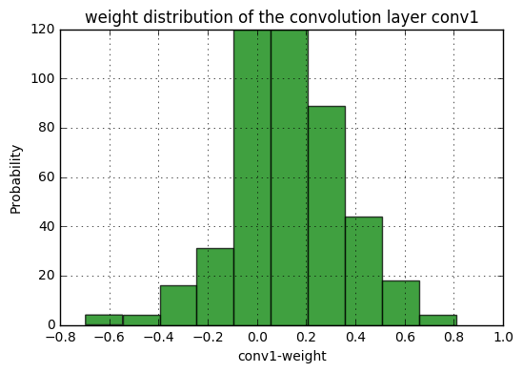
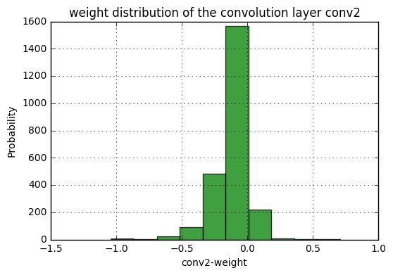
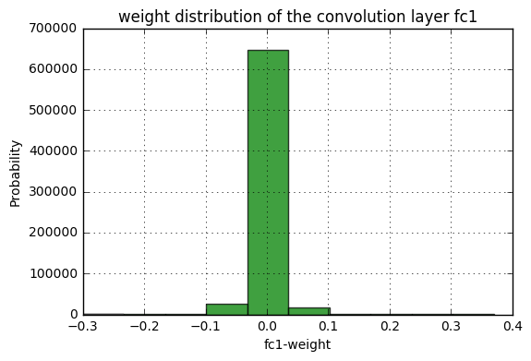
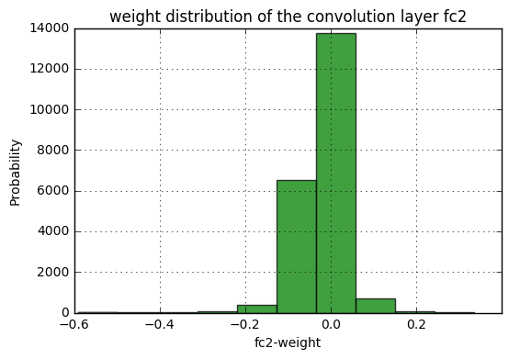
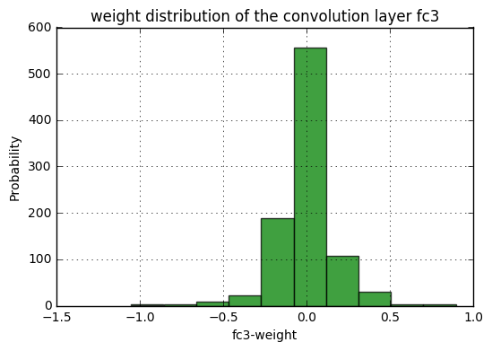
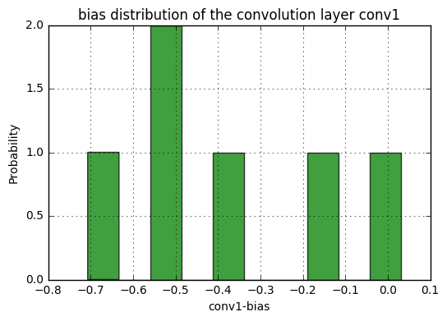
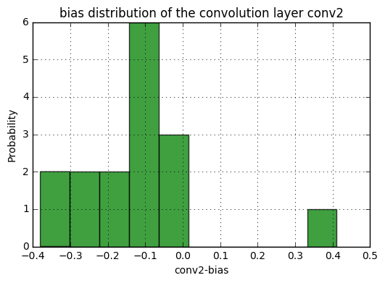
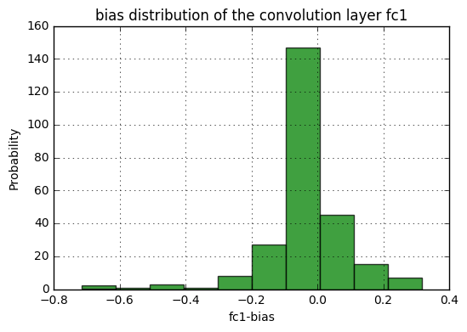
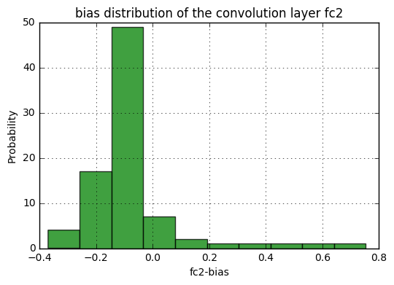
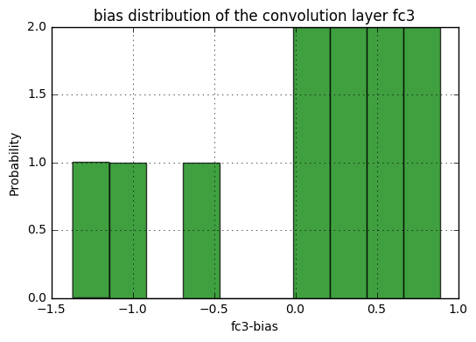
#After training , save the model first
#You can saves only the model parameters or entire model
#Some difference between the two is that entire model
#not only include parameters but also record hwo each
#layer is connected(forward method).
#[document]: https://pytorch.org/docs/master/notes/serialization.html
​
print('==> Saving model..')
​
#only save model parameters
torch.save(net.state_dict(), './checkpoint.t7')
#you also can store some log information
state = {
'net': net.state_dict(),
'acc': 100.*correct/len(trainset),
'epoch': 75
}
torch.save(state, './checkpoint.t7')
​
#save entire model
torch.save(net, './model.pt')
​
print('Finished Saving')
==> Saving model..
Finished Saving
/home/ccma/anaconda3/lib/python3.5/site-packages/torch/serialization.py:241: UserWarning: Couldn't retrieve source code for container of type Net. It won't be checked for correctness upon loading.
"type " + obj.__name__ + ". It won't be checked "
########################################################################

5. Test the network on the test data
########################################################################
#Before testing, we can load the saved model
#Depend on how you save your model, need
#different way to use it
print('==> Loading model..')
#If you just save the model parameters, you
#need to redefine the model architecture, and
#load the parameters into your model net = Net() checkpoint = torch.load('./checkpoint.t7') net.load_state_dict(checkpoint['net'])
#If you save the entire model net = torch.load('./model.pt')
print('Finished Loading')
print('==> Testing model..')
​
#Set the model in evaluation mode
#[document]: https://pytorch.org/docs/stable/nn.html#torch.nn.Module.eval
net.eval()
​
==> Testing model..
Net(
(conv1): Conv2d(3, 6, kernel_size=(5, 5), stride=(1, 1))
(pool): MaxPool2d(kernel_size=2, stride=2, padding=0, dilation=1, ceil_mode=False)
(conv2): Conv2d(6, 16, kernel_size=(5, 5), stride=(1, 1))
(fc1): Linear(in_features=2704, out_features=256, bias=True)
(fc2): Linear(in_features=256, out_features=84, bias=True)
(fc3): Linear(in_features=84, out_features=11, bias=True)
(relu): ReLU()
)
######################
#######LAB 1-1########
"""
To Do Here
​
You should complete the testing step in LAB 1-1
You should show the total accuracy & loss [10000 cifar10 test cases]
You also need to tell us, how about the accuracy for each class

For example: Total accuracy is: 60.0% and loss is: 0.02
For each class in cifar 10:
Accuracy of plane : 58.0%
Accuracy of car : 22.4%
.
.
.
"""
######################
correct = 0
total = 0
​
class_correct = list(0. for i in range(11))
class_total = list(0. for i in range(11))
​
with torch.no_grad():
test_run = 0
for data in testloader:
images, labels = data
​
if device == 'cuda':
images = images.cuda(0)
labels = labels.cuda(0)
else:
images = images.cpu()
labels = labels.cpu()

#print(test_run, " ", end="")
#test_run = test_run + labels.size(0)

outputs = net(images)
_, predicted = torch.max(outputs, 1)

total += labels.size(0)
correct += (predicted == labels).sum().item()
​
c = (predicted == labels).squeeze()
#print(predicted)
#print(labels.size(0))
#print("(", c, "), ")
for i in range(labels.size(0)):
label = labels[i]
class_correct[label] += c[i].item()
class_total[label] += 1
​
print('Accuracy of the network on the %d test images: %d %%' % (total, 100 * correct / total))
​
for i in range(11):
print('Accuracy of %5s : %2d %%' % (
classes[i], 100 * class_correct[i] / class_total[i]))
Accuracy of the network on the 3347 test images: 19 %
Accuracy of Bread : 0 %
Accuracy of DairyProduct : 0 %
Accuracy of Dessert : 50 %
Accuracy of Egg : 0 %
Accuracy of Friedfood : 0 %
Accuracy of Meat : 49 %
Accuracy of Noodles-Pasta : 0 %
Accuracy of Rice : 0 %
Accuracy of Seafood : 0 %
Accuracy of Soup : 34 %
Accuracy of Vegetable : 4 %
​
​

​

LAB-1-3 v8 (autosaved)

Python [default]

- File
- Edit
- View
- Insert
- Cell
- Kernel
- Widgets
- Help

%matplotlib inline
import torch
import torchvision
import torchvision.transforms as transforms
import torchvision.datasets as datasets
def get_mean_and_std(dataset):
'''Compute the mean and std value of dataset.'''
dataloader = torch.utils.data.DataLoader(dataset, batch_size=1, shuffle=False, num_workers=2)
​
mean = torch.zeros(3)
std = torch.zeros(3)
print('==> Computing mean and std..')
for inputs, targets in dataloader:
for i in range(3):
mean[i] += inputs[:, i, :, :].mean()
std[i] += inputs[:, i, :, :].std()
mean.div_(len(dataset))
std.div_(len(dataset))
return mean, std
#To determine if your system supports CUDA
print("==> Check devices..")
device = 'cuda' if torch.cuda.is_available() else 'cpu'
print("Current device: ",device)
​
#Also can print your current GPU id, and the number of GPUs you can use.
print("Our selected device: ", torch.cuda.current_device())
print(torch.cuda.device_count(), " GPUs is available")
#device = 'cpu'
==> Check devices..
Current device: cuda
Our selected device: 0
1 GPUs is available
print('==> Preparing dataset..')
==> Preparing dataset..
"""1.1"""
img_size, linear_size, fc1_out, fc2_out = 64, 13, 256, 84
#img_size, linear_size, fc1_out = 128, 29, 256
#img_size, linear_size, fc1_out = 256, 61, 256
#img_size, linear_size, fc1_out, fc2_out = 384, 93, 1024, 1024
#img_size, linear_size, fc1_out = 512, 125, 256
#img_size, linear_size, fc1_out = 512, 125, 512
#img_size, linear_size, fc1_out = 1024, 253, 256
​
calculate_mean_std = False
​
if calculate_mean_std == True:
#The transform function for train data
transform_train = transforms.Compose([
transforms.Resize(img_size),
transforms.RandomCrop(img_size, padding=4),
transforms.ToTensor(),
])
​
#The transform function for test data
transform_test = transforms.Compose([
transforms.Resize(img_size),
transforms.RandomCrop(img_size, padding=4),
transforms.ToTensor(),
])
​
#we will calculate mean and std

trainset = torchvision.datasets.ImageFolder(root='./food/training', transform=transform_train)
testset = torchvision.datasets.ImageFolder(root='./food/evaluation', transform=transform_test)

train_mean, train_std = get_mean_and_std(trainset)
print(train_mean, train_std)
test_mean, test_std = get_mean_and_std(testset)
print(test_mean, test_std)
else:
train_mean, train_std = ([0.5551, 0.4478, 0.3366]), ([0.2337, 0.2414, 0.2386])
test_mean, test_std = ([0.5607, 0.4518, 0.3425]), ([0.2333, 0.2415, 0.2385])

"""1.1+"""
#The transform function for train data
transform_train = transforms.Compose([
transforms.Resize(img_size),
transforms.RandomCrop(img_size, padding=4),
transforms.RandomHorizontalFlip(),
transforms.ToTensor(),
transforms.Normalize(train_mean, train_std)
])
​
#The transform function for test data
transform_test = transforms.Compose([
transforms.Resize(img_size),
transforms.RandomCrop(img_size, padding=4),
transforms.ToTensor(),
transforms.Normalize(test_mean, test_std)
])
"""1.2+"""
trainset = torchvision.datasets.ImageFolder(root='./food/training', transform=transform_train)
testset = torchvision.datasets.ImageFolder(root='./food/evaluation', transform=transform_test)
"""1.3"""
​
#Create DataLoader to draw samples from the dataset
#In this case, we define a DataLoader to random sample our dataset.
#For single sampling, we take one batch of data. Each batch consists 4 images
trainloader = torch.utils.data.DataLoader(trainset, batch_size=32,
shuffle=True, num_workers=2)
​
testloader = torch.utils.data.DataLoader(testset, batch_size=32,
shuffle=False, num_workers=2)
classes = ('Bread', 'DairyProduct', 'Dessert', 'Egg', 'Friedfood',
'Meat', 'Noodles-Pasta', 'Rice', 'Seafood', 'Soup', 'Vegetable')
print('==> Building model..')
==> Building model..
import torch.nn as nn
# define your own model
class Net(nn.Module):
​
#define the layers
def __init__(self):
super(Net, self).__init__()
self.conv1 = nn.Conv2d(3, 6, 5)
self.pool = nn.MaxPool2d(2, 2)
self.conv2 = nn.Conv2d(6, 16, 5)
self.fc1 = nn.Linear(16 * linear_size * linear_size, fc1_out)
self.fc2 = nn.Linear(fc1_out, fc2_out)
self.fc3 = nn.Linear(fc2_out, 11)
self.relu = nn.ReLU()

#concatenate these layers
def forward(self, x):
x = self.pool(self.relu(self.conv1(x)))
x = self.pool(self.relu(self.conv2(x)))
x = x.view(-1, 16 * linear_size * linear_size)
x = self.relu(self.fc1(x))
x = self.relu(self.fc2(x))
x = self.fc3(x)
return x
#declare a new model
net = Net()
# change all model tensor into cuda type
# something like weight & bias are the tensor
#net = net.to(device)
print(device)
if device == 'cuda':
net = net.cuda(0)
else:
net = net.cpu()
cuda
########################################################################

3. Define a Loss function and optimize
########################################################################
print('==> Defining loss function and optimize..')
==> Defining loss function and optimize..
import torch.optim as optim
​
#loss function
criterion = nn.CrossEntropyLoss()
#optimization algorithm
optimizer = optim.SGD(net.parameters(), lr=0.1, momentum=0.9, weight_decay=1e-5)
########################################################################

4. Train the network
Before training the model, we need to analysis the tensor variable.
Each variable have many attibute, like: .grad_fn, .require_grad, .data, .grad...etc. The ".grad_fn" attribute of "torch.Tensor" is an entry point into the function that has create this "torch.Tensor" variables. Because of ".grad_fn" flag, we can easily create a computing graph in the form of DAG(directed acyclic graph).
And then, the ".require_grad" attribute allows us to determine whether the backward propagation function is going to calculate the gradient of this "torch.Tensor" variable. If one variable has a false value of require_grad, it represent that you don't want to calculate this variable's gradient, and also its gradient will not be updated.
########################################################################
print('==> Training model..')
==> Training model..
#Set the model in training mode
#because some function like: dropout, batchnorm...etc, will have
#different behaviors in training/evaluation mode
#[document]: https://pytorch.org/docs/stable/nn.html#torch.nn.Module.train
net.train()
scheduler = torch.optim.lr_scheduler.StepLR(optimizer, step_size = 1, gamma=0.5)
​
for epoch in range(5): # loop over the dataset multiple times
scheduler.step()
running_loss = 0.0
correct = 0
for i, (inputs, labels) in enumerate(trainloader, 0):

#change the type into cuda tensor
if device == 'cuda':
inputs = inputs.cuda(0)
labels = labels.cuda(0)
else:
inputs = inputs.cpu()
labels = labels.cpu()
​
#print(labels)
#print(inputs)

# zero the parameter gradients
optimizer.zero_grad()
​
# forward + backward + optimize
outputs = net(inputs)
# select the class with highest probability
_, pred = outputs.max(1)
# if the model predicts the same results as the true
# label, then the correct counter will plus 1
correct += pred.eq(labels).sum().item()

loss = criterion(outputs, labels)

loss.backward()
optimizer.step()
​
# print statistics
running_loss += loss.item()
# print(i, " ", end="")
​
​
if i % 200 == 199: # print every 200 mini-batches
print('[%d, %5d] loss: %.3f' %
(epoch + 1, i + 1, running_loss / 200))
running_loss = 0.0

print('%d epoch, training accuracy: %.4f' % (epoch+1, 100.*correct/len(trainset)))
print('Finished Training')
[1, 200] loss: 2.284
1 epoch, training accuracy: 17.0079
[2, 200] loss: 2.201
2 epoch, training accuracy: 21.2548
[3, 200] loss: 2.139
3 epoch, training accuracy: 24.3057
[4, 200] loss: 2.056
4 epoch, training accuracy: 27.7012
[5, 200] loss: 1.988
5 epoch, training accuracy: 30.9447
Finished Training
######################
#######LAB 1-1########
"""
To Do Here
You should show the weight distribution of the convolution layer (conv1, conv2)
You should show the bias distribution of the convolution layer (conv1, conv2)
[hint] you can use matplotlib package to show the result in here
"""
######################
import numpy as np
import matplotlib.mlab as mlab
import matplotlib.pyplot as plt
​
x = net.conv1.weight.view(-1,1).cpu().detach().numpy()
n, bins, patches = plt.hist(x, facecolor='green', alpha=0.75)
​
plt.xlabel('conv1-weight')
plt.ylabel('Probability')
plt.title('weight distribution of the convolution layer conv1')
​
plt.grid(True)
plt.show()
​
x = net.conv2.weight.view(-1,1).cpu().detach().numpy()
n, bins, patches = plt.hist(x, facecolor='green', alpha=0.75)
​
plt.xlabel('conv2-weight')
plt.ylabel('Probability')
plt.title('weight distribution of the convolution layer conv2')
​
plt.grid(True)
plt.show()
​
x = net.fc1.weight.view(-1,1).cpu().detach().numpy()
n, bins, patches = plt.hist(x, facecolor='green', alpha=0.75)
​
plt.xlabel('fc1-weight')
plt.ylabel('Probability')
plt.title('weight distribution of the convolution layer fc1')
​
plt.grid(True)
plt.show()
​
x = net.fc2.weight.view(-1,1).cpu().detach().numpy()
n, bins, patches = plt.hist(x, facecolor='green', alpha=0.75)
​
plt.xlabel('fc2-weight')
plt.ylabel('Probability')
plt.title('weight distribution of the convolution layer fc2')
​
plt.grid(True)
plt.show()
​
x = net.fc3.weight.view(-1,1).cpu().detach().numpy()
n, bins, patches = plt.hist(x, facecolor='green', alpha=0.75)
​
plt.xlabel('fc3-weight')
plt.ylabel('Probability')
plt.title('weight distribution of the convolution layer fc3')
​
plt.grid(True)
plt.show()
​
x = net.conv1.bias.view(-1,1).cpu().detach().numpy()
n, bins, patches = plt.hist(x, facecolor='green', alpha=0.75)
​
plt.xlabel('conv1-bias')
plt.ylabel('Probability')
plt.title('bias distribution of the convolution layer conv1')
​
plt.grid(True)
plt.show()
​
x = net.conv2.bias.view(-1,1).cpu().detach().numpy()
n, bins, patches = plt.hist(x, facecolor='green', alpha=0.75)
​
plt.xlabel('conv2-bias')
plt.ylabel('Probability')
plt.title('bias distribution of the convolution layer conv2')
​
plt.grid(True)
plt.show()
​
x = net.fc1.bias.view(-1,1).cpu().detach().numpy()
n, bins, patches = plt.hist(x, facecolor='green', alpha=0.75)
​
plt.xlabel('fc1-bias')
plt.ylabel('Probability')
plt.title('bias distribution of the convolution layer fc1')
​
plt.grid(True)
plt.show()
​
x = net.fc2.bias.view(-1,1).cpu().detach().numpy()
n, bins, patches = plt.hist(x, facecolor='green', alpha=0.75)
​
plt.xlabel('fc2-bias')
plt.ylabel('Probability')
plt.title('bias distribution of the convolution layer fc2')
​
plt.grid(True)
plt.show()
​
x = net.fc3.bias.view(-1,1).cpu().detach().numpy()
n, bins, patches = plt.hist(x, facecolor='green', alpha=0.75)
​
plt.xlabel('fc3-bias')
plt.ylabel('Probability')
plt.title('bias distribution of the convolution layer fc3')
​
plt.grid(True)
plt.show()
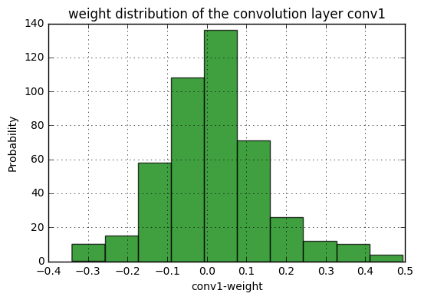
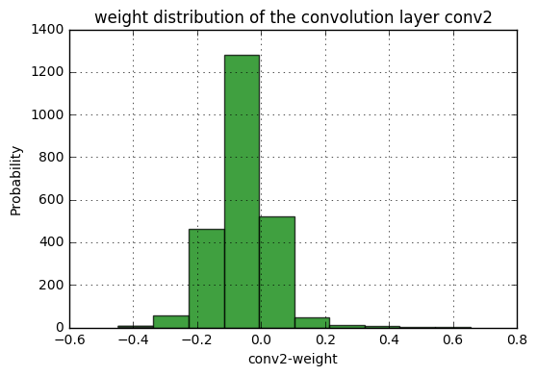
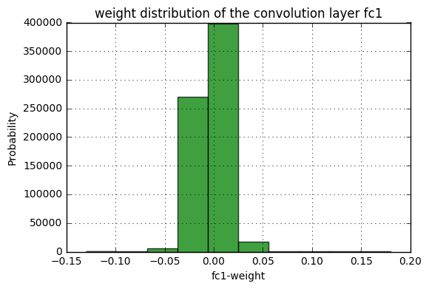
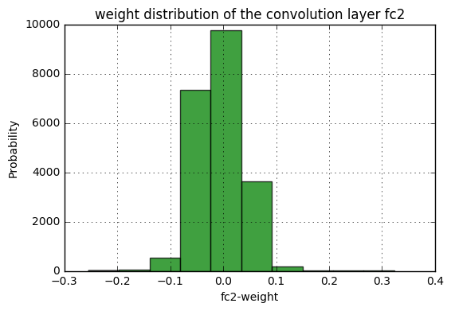
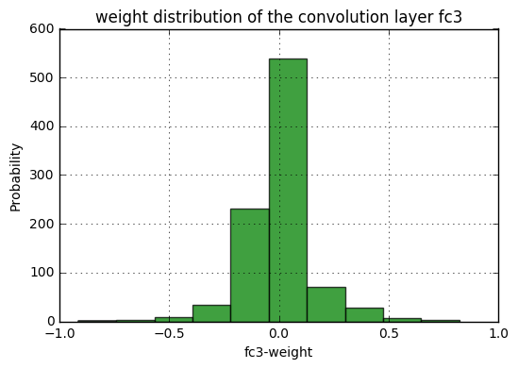
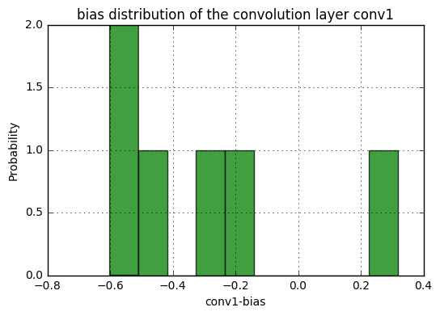
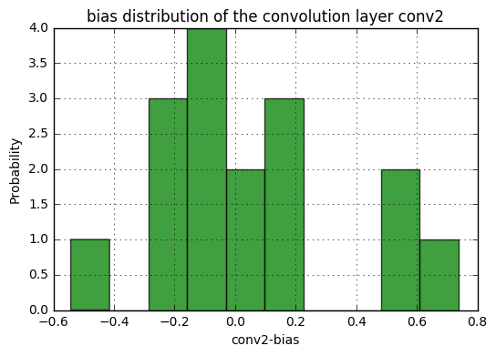
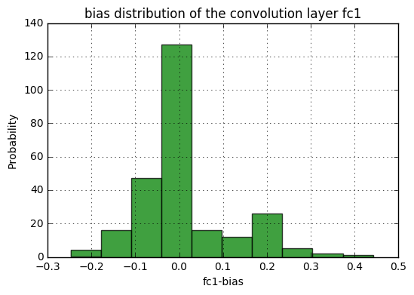
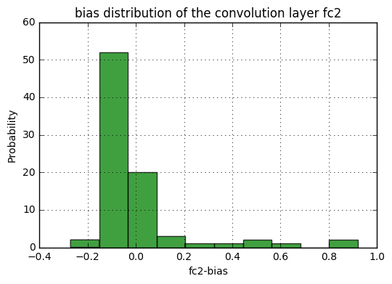
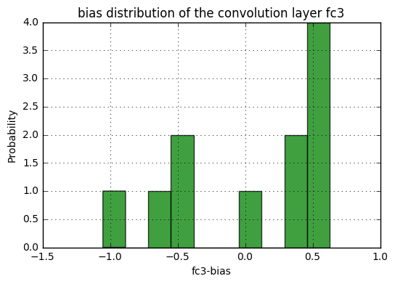
#After training , save the model first
#You can saves only the model parameters or entire model
#Some difference between the two is that entire model
#not only include parameters but also record hwo each
#layer is connected(forward method).
#[document]: https://pytorch.org/docs/master/notes/serialization.html
​
print('==> Saving model..')
​
#only save model parameters
torch.save(net.state_dict(), './checkpoint.t7')
#you also can store some log information
state = {
'net': net.state_dict(),
'acc': 100.*correct/len(trainset),
'epoch': 75
}
torch.save(state, './checkpoint.t7')
​
#save entire model
torch.save(net, './model.pt')
​
print('Finished Saving')
==> Saving model..
Finished Saving
/home/ccma/anaconda3/lib/python3.5/site-packages/torch/serialization.py:241: UserWarning: Couldn't retrieve source code for container of type Net. It won't be checked for correctness upon loading.
"type " + obj.__name__ + ". It won't be checked "
########################################################################

5. Test the network on the test data
########################################################################
#Before testing, we can load the saved model
#Depend on how you save your model, need
#different way to use it
print('==> Loading model..')
#If you just save the model parameters, you
#need to redefine the model architecture, and
#load the parameters into your model net = Net() checkpoint = torch.load('./checkpoint.t7') net.load_state_dict(checkpoint['net'])
#If you save the entire model net = torch.load('./model.pt')
print('Finished Loading')
print('==> Testing model..')
​
#Set the model in evaluation mode
#[document]: https://pytorch.org/docs/stable/nn.html#torch.nn.Module.eval
net.eval()
​
==> Testing model..
Net(
(conv1): Conv2d(3, 6, kernel_size=(5, 5), stride=(1, 1))
(pool): MaxPool2d(kernel_size=2, stride=2, padding=0, dilation=1, ceil_mode=False)
(conv2): Conv2d(6, 16, kernel_size=(5, 5), stride=(1, 1))
(fc1): Linear(in_features=2704, out_features=256, bias=True)
(fc2): Linear(in_features=256, out_features=84, bias=True)
(fc3): Linear(in_features=84, out_features=11, bias=True)
(relu): ReLU()
)
######################
#######LAB 1-1########
"""
To Do Here
​
You should complete the testing step in LAB 1-1
You should show the total accuracy & loss [10000 cifar10 test cases]
You also need to tell us, how about the accuracy for each class

For example: Total accuracy is: 60.0% and loss is: 0.02
For each class in cifar 10:
Accuracy of plane : 58.0%
Accuracy of car : 22.4%
.
.
.
"""
######################
correct = 0
total = 0
​
class_correct = list(0. for i in range(11))
class_total = list(0. for i in range(11))
​
with torch.no_grad():
test_run = 0
for data in testloader:
images, labels = data
​
if device == 'cuda':
images = images.cuda(0)
labels = labels.cuda(0)
else:
images = images.cpu()
labels = labels.cpu()

#print(test_run, " ", end="")
#test_run = test_run + labels.size(0)

outputs = net(images)
_, predicted = torch.max(outputs, 1)

total += labels.size(0)
correct += (predicted == labels).sum().item()
​
c = (predicted == labels).squeeze()
#print(predicted)
#print(labels.size(0))
#print("(", c, "), ")
for i in range(labels.size(0)):
label = labels[i]
class_correct[label] += c[i].item()
class_total[label] += 1
​
print('Accuracy of the network on the %d test images: %d %%' % (total, 100 * correct / total))
​
for i in range(11):
print('Accuracy of %5s : %2d %%' % (
classes[i], 100 * class_correct[i] / class_total[i]))
Accuracy of the network on the 3347 test images: 31 %
Accuracy of Bread : 2 %
Accuracy of DairyProduct : 0 %
Accuracy of Dessert : 31 %
Accuracy of Egg : 29 %
Accuracy of Friedfood : 0 %
Accuracy of Meat : 71 %
Accuracy of Noodles-Pasta : 0 %
Accuracy of Rice : 0 %
Accuracy of Seafood : 26 %
Accuracy of Soup : 54 %
Accuracy of Vegetable : 63 %

​

