class Solution:

def mySqrt(self, x: int) -> int:

if x ==0:

return 0

elif x ==1:

return 1

for i in range(x+1):

if i ** 2 > x:

return i-1

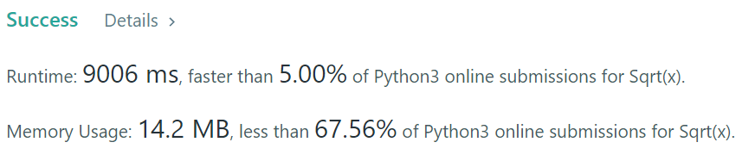

Others:

##### 要用binary search

class Solution:

def mySqrt(self, x):

if x==1: return 1 #deal with exception

l, r = 0, x

while l <= r:

mid = (r+l)//2

if mid * mid <= x < (mid+1)*(mid+1):

return mid

elif x < mid * mid:

r = mid

else:

l = mid

