Unit 1
Syllabus
Computing Paradigms: High performance computing, parallel computing, Distributed computing, cluster computing, Grid computing, cloud computing, Bio computing, Mobile computing, Quantum computing, optical computing, Nano computing

1.High Performance Computing (HPC)
High Performance Computing (HPC) refers to the use of advanced computing techniques to solve complex computational problems that require significant computational power beyond what a typical desktop or workstation can provide. HPC systems typically consist of large clusters of servers or supercomputers interconnected by high-speed networks.

The Need for high-performance computing (HPC):
In the modern world, ground breaking discoveries and inventions can only happen with technology, data and advanced computing. As cutting-edge technologies like artificial intelligence (AI), machine learning (ML) and IoT evolve, they require huge amounts of data. They also need high-performance computing because HPC systems can perform quadrillions of calculations per second, compared to regular laptops or desktops that can perform at most 3 billion calculations per second (with a 3 GHz processor).
- It paves the way for new innovations in science, technology, business and academia.

- It improves processing speeds, which can be critical for many kinds of computing operations, applications and workloads.
- It helps lay the foundation for a reliable, fast IT infrastructure that can store, process and analyse massive amounts of data for various applications.

Features of HPC
High Performance Computing (HPC) has several salient features that distinguish it from standard computing practices:
- Parallel Processing: HPC leverages parallel processing to execute complex computations simultaneously. This involves dividing a large problem into smaller ones that can be solved concurrently, significantly speeding up processing times.
- Advanced Processors: HPC systems often use state-of-the-art, powerful processors. These can include multicore CPUs, GPUs, and specialized accelerators optimized for specific types of computations.
- Scalable Architecture: HPC infrastructure is designed to be scalable, allowing for the integration of additional resources (like nodes in a cluster) to increase computational power as needed.
- High-Speed Networking: HPC systems are equipped with high-speed networking to enable fast data transfer between nodes in a cluster. This is crucial for parallel processing and for handling large datasets.
- Large-Scale Storage: HPC requires substantial storage solutions to manage and process large volumes of data. These storage systems are designed for high performance and often involve a combination of different storage technologies.
- Optimized Software and Algorithms: Software in HPC is specifically optimized for parallel computing. This includes specialized operating systems, middleware, and algorithms designed to distribute and manage tasks efficiently across multiple processors.
- Energy Efficiency: Given the large scale of HPC operations, energy efficiency is a critical aspect. Modern HPC systems are designed to maximize computational power while minimizing energy consumption.
- Reliability and Fault Tolerance: Due to the complexity and importance of tasks handled by HPC, systems are equipped with mechanisms for reliability and fault tolerance to ensure continuous operation.
- Diverse Applications: HPC is used across various fields like scientific research, engineering, financial modeling, and artificial intelligence, showcasing its versatility in solving diverse and complex problems.
- Customization and Specialization: HPC systems can be highly customized and specialized to suit specific computational tasks, making them highly efficient in their domain of application.

These features make HPC a powerful tool for researchers, scientists, and organizations dealing with complex computational tasks that are beyond the capabilities of standard computing systems.

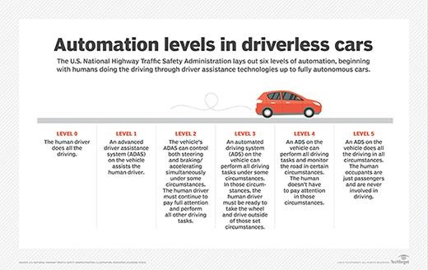

Applications of HPC
- Scientific simulations and research
- Engineering and financial modeling
- Artificial intelligence and machine learning
- Weather forecasting
- Energy and environmental studies
- Healthcare

2.Parallel computing
What is Serial Computing?

- Traditionally, software has been written for serial computation to be run on a single computer having a single Central Processing Unit (CPU)
- A problem is broken into a discrete series of instructions.
- Instructions are executed one after another.
- Only one instruction may execute at any moment in time.
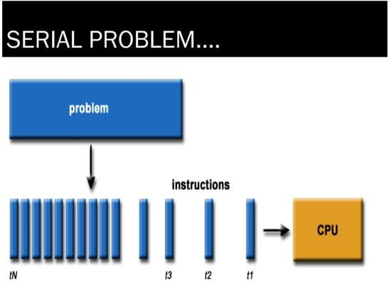

What is Parallel Computing?

- Parallel Computing is a form of computation in which many calculations are carried out simultaneously.
- In the simplest sense, It uses multiple compute resources to solve a computational problem using multiple CPUs
- A problem is broken into discrete parts that can be solved concurrently
- Each part is further broken down to a series of instructions
- Instructions from each part execute simultaneously on different CPU’s.

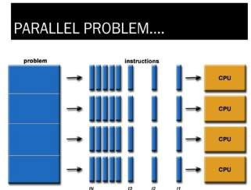

The main features of parallel computing are:

- Hardware: It typically uses multiple CPU cores in a single machine.
  - Problem Division: The problem is split into parts that can be solved in parallel.E.g.: Web Engines/databases Processing millions of transactions per second.
- Memory Access: Generally shares a common memory space for faster data access and communication.
- Use Cases: Ideal for tasks that require heavy computational power, like scientific simulations, complex calculations, or image processing.

Commercial applications are providing an equal or greater driving force in the development of faster computers. These applications require the processing of large amounts of data in sophisticated ways.
Example of Parallel Computing:
In parallel computing, you can divide the arrays into smaller chunks and assign each chunk to a separate processing unit (such as CPU cores or GPU threads). Each processing unit can then simultaneously add the elements of its assigned chunk together. Once all processing units have completed their tasks, the results can be combined to form the final array.
For example:
Array A: [1, 2, 3, 4, 5]
Array B: [6, 7, 8, 9, 10]
Parallel processing would involve dividing these arrays into chunks, like [1, 2] and [6, 7] for the first chunk, [3, 4] and [8, 9] for the second chunk, and so on. Each chunk can then be added together in parallel by separate processing units
Parallel computing allows for faster execution of tasks by distributing the workload across multiple processing units, similar to how walking and talking or eating and talking can happen concurrently in everyday activities.
Limitations of Serial Computing
Limits to serial computing - both physical and practical reasons pose significant constraints to simply building ever faster serial computers.
Transmission speeds - the speed of a serial computer is directly dependent upon how fast data can
move through hardware. Absolute limits are he speed of light (30 cm/nanosecond) and the transmission limit of copper wire (9 cm/nanosecond). Increasing speeds necessitate increasing proximity of processing elements.

Limits to miniaturization - processor technology is allowing an increasing number of transistors to be placed on a chip. However, even with molecular or atomic-level components, a limit will be reached on how small components can be.
Economic limitations - it is increasingly expensive to make a single processor faster. Using a larger number of moderately fast commodity processors to achieve the same (or better) performance is less expensive.
Flynn's Classical Taxonomy
There are different ways to classify parallel computers. One of the more widely used classifications, in use since 1966, is called Flynn's Taxonomy.
Flynn's taxonomy distinguishes multi-processor computer architectures according to how they can be classified along the two independent dimensions of Instruction and Data. Each of these dimensions can have only one of two possible states Single or Multiple.
Single Instruction, Single Data (SISD)
A serial (non-parallel) computer
Single instruction only one instruction stream is being acted on by the CPU during any one clock cycle
Single data only one data stream is being used as input during any one clock cycle Deterministic execution
This is the oldest and until recently, the most prevalent form of computer
Examples most PCs, single CPU workstations and mainframes
Single Instruction, Multiple Data (SIMD)
A type of parallel computer
Single instruction All processing units execute the same instruction at any given clock cycle Multiple data Each processing unit can operate on a different data element
This type of machine typically has an instruction dispatcher, a very high-bandwidth internal network, and a very large array of very small-capacity instruction units.
Best suited for specialized problems characterized by a high degree of regularity,such as image processing.
Synchronous (lockstep) and deterministic execution
Two varieties Processor Arrays and Vector Pipelines
Examples
Processor Arrays Connection Machine CM-2, Maspar MP-1, MP-2 Vector Pipelines IBM 9000, Cray C90, Fujitsu VP,NEC SX-2, Hitachi S820
Multiple Instruction, Single Data (MISD)
A single data stream is fed into multiple processing units.
Each processing unit operates on the data independently via independent instruction streams.
Few actual examples of this class of parallel computer have ever existed. One is the experimental Carnegie-Mellon C.mmp computer (1971).
Some conceivable uses might be multiple frequency filters operating on a single signal stream multiple cryptography algorithms attempting to crack a single coded message.
Multiple Instruction, Multiple Data (MIMD)
Currently, the most common type of parallel computer. Most modern computers fall into this category.
Multiple Instruction every processor may be executing a different instruction stream
Multiple Data every processor may be working with a different data stream
Execution can be synchronous or asynchronous, deterministic or non-deterministic
Examples most current supercomputers, networked parallel computer "grids" and multi- processor SMP computers - including some types of PCs.
Applications include
parallel databases, data mining
oil exploration
web search engines, web-based business services
computer-aided diagnosis in medicine
management of national and multi-national corporations
advanced graphics and virtual reality, particularly in the entertainment industry
weather and climate
chemical and nuclear reactions
biological, human genome
geological, seismic activity
mechanical devices - from prosthetics to spacecraft
electronic circuits
manufacturing processes
3. Distributed Computing
What is distributing Computing
Distributed computing is also a computing system that consists of multiple computers or processor machines connected through a network, which can be homogeneous or heterogeneous, but run as a single system.
The connectivity can be such that the CPUs in a distributed system can be physically close together and connected by a local network, or they can be geographically distant and connected by a wide area network.
The heterogeneity in a distributed system supports any number of possible configurations in the processor machines, such as mainframes, PCs, workstations, and minicomputers. The goal of distributed computing is to make such a network work as a single computer .
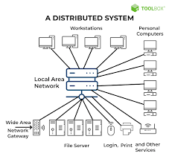

How distributed computing works

In distributed computing, you design applications that can run on several computers instead of on just one computer. You achieve this by designing the software so that different computers perform different functions and communicate to develop the final solution. There are four main types of distributed architecture.

Client-server architecture
Client-server is the most common method of software organization on a distributed system. The functions are separated into two categories: clients and servers.

Clients
Clients have limited information and processing ability. Instead, they make requests to the servers, which manage most of the data and other resources. You can make requests to the client, and it communicates with the server on your behalf.

Servers
Server computers synchronize and manage access to resources. They respond to client requests with data or status information. Typically, one server can handle requests from several machines.

Benefits and limitations
Client-server architecture gives the benefits of security and ease of ongoing management. You have only to focus on securing the server computers. Similarly, any changes to the database systems require changes to the server only.
The limitation of client-server architecture is that servers can cause communication bottlenecks, especially when several machines make requests simultaneously.

Three-tier architecture
In three-tier distributed systems, client machines remain as the first tier you access. Server machines, on the other hand, are further divided into two categories:

Application servers
Application servers act as the middle tier for communication. They contain the application logic or the core functions that you design the distributed system for.

Database servers
Database servers act as the third tier to store and manage the data. They are responsible for data retrieval and data consistency.
By dividing server responsibility, three-tier distributed systems reduce communication bottlenecks and improve distributed computing performance.

N-tier architecture
N-tier models include several different client-server systems communicating with each other to solve the same problem. Most modern distributed systems use an n-tier architecture with different enterprise applications working together as one system behind the scenes.

Peer-to-peer architecture
Peer-to-peer distributed systems assign equal responsibilities to all networked computers. There is no separation between client and server computers, and any computer can perform all responsibilities. Peer- to-peer architecture has become popular for content sharing, file streaming, and blockchain networks.

The characteristics are:

Network of Computers: Utilizes a network connecting multiple computers to work on distributed parts of a problem.
Data Distribution: Data and tasks are distributed across multiple locations.
Communication Overhead: Requires managing communication and data consistency across the network.
Fault Tolerance and Scalability: Often designed to handle failures of individual nodes and can scale by adding more nodes.
Use Cases: Examples include cloud computing, grid computing, and large-scale web applications.

4. Cluster Computing
Cluster computing refers to the use of multiple interconnected computers (nodes) working together as a single system to perform computational tasks. These nodes are often located in close physical proximity and communicate over high-speed networks and are used to handle tasks that require significant computational resources or parallel processing.
Architecture of cluster computing where all nodes in a cluster are typically homogeneous in terms of hardware and software configurations, facilitating easier management and coordination.
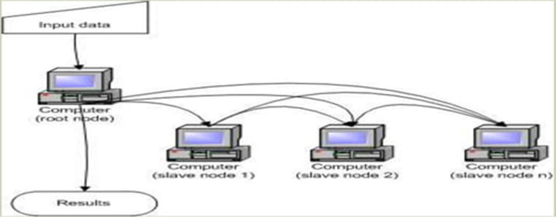
3.1 Key characteristics of cluster computing include:
1. Parallel Processing: Cluster computing allows for parallel execution of tasks across multiple nodes simultaneously, enabling faster computation and improved performance.
2. Scalability: Clusters can easily scale by adding or removing nodes, allowing organizations to adjust the computational resources based on their needs.
3. High Availability: Clusters often incorporate redundancy and failover mechanisms to ensure high availability and reliability of services.
4. Distributed Storage: Data in cluster computing environments is often distributed across multiple nodes, providing fault tolerance and improved data access performance.
3.2 Types of Cluster Computing:
1. High-Performance Computing (HPC) Clusters:
- Description: Specialized clusters designed for high-performance computing tasks, often equipped with high-speed interconnects, accelerators (e.g., GPUs), and specialized software stacks.
- Advantages: Provides maximum computational power and efficiency for demanding scientific and engineering simulations.
- Examples: Supercomputers like IBM Summit, built for research institutions and national laboratories to handle complex simulations in various domains.
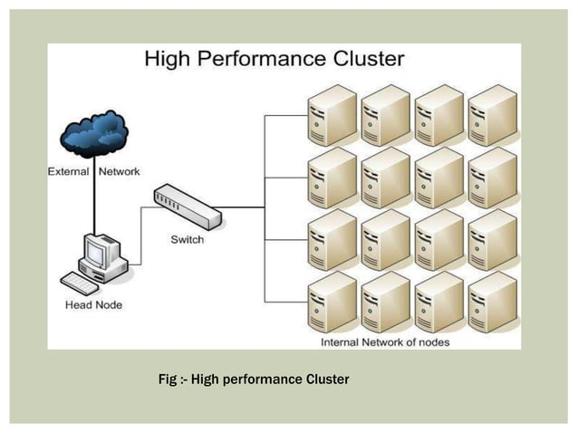
2. Load-Balanced Clusters:
- Description: Distributes workload evenly across cluster nodes to optimize resource utilization and performance.
- Advantages: Prevents overloading of individual nodes, ensures efficient utilization of resources.
- Examples: Web servers, where incoming requests are distributed among multiple servers to handle high traffic and maintain responsiveness.
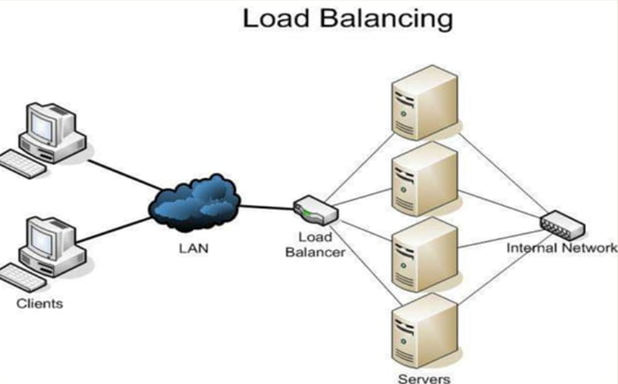

3. High availability cluster or Failover Clusters
- Description: Configured with redundant hardware and software to automatically switch to backup nodes in case of failure.
- Advantages: Ensures continuous operation and data availability, minimizes downtime and data loss.
- Examples: Database servers, where data replication and failover mechanisms are employed to maintain service availability and integrity.
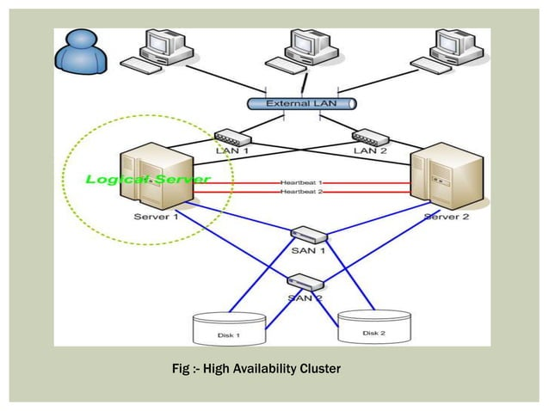
Each type of cluster computing offers distinct advantages and is suitable for different use cases, depending on factors such as workload characteristics, budget constraints, and availability requirements.

Applications of Cluster Computing:
  - Various complex computational problems can be solved.
  - It can be used in the applications of aerodynamics, astrophysics and in data mining.
  - Weather forecasting.
  - Image Rendering.
  - Various e-commerce applications.
  - Earthquake Simulation.
  - Petroleum reservoir simulation.

5. Grid Computing
Grid computing involves the coordination and sharing of computational resources across multiple locations to solve complex problems or perform large-scale computations. It allows organizations to harness the collective processing power of distributed resources, such as computers, storage systems, and networks, to achieve high-performance computing capabilities.
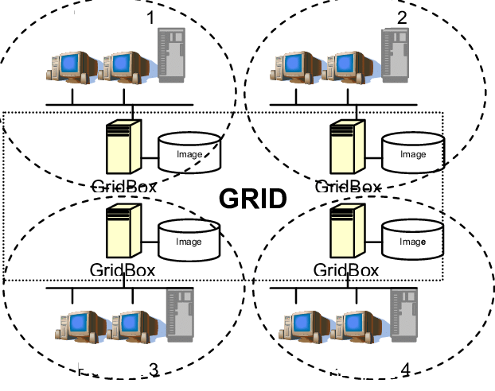
.
- Grid computing network might consist of several distributed computing systems.
- Grid computing is a computing infrastructure that combines computer resources spread over different geographical locations to to accomplish a joint task.
- These tasks are compute-intensive and difficult for a single machine to handle.
- So, Several machines on a network collaborate under a common protocol and work as a single virtual supercomputer to get complex tasks done.
- Mainly used for Technical or Scientific that requires a great number of computer processing cycles or access to large amounts of data.

For example, meteorologists use grid computing for weather modeling. Weather modeling is a computation-intensive problem that requires complex data management and analysis. Processing massive amounts of weather data on a single computer is slow and time consuming. That’s why meteorologists run the analysis over geographically dispersed grid computing infrastructure and combine the results.
Grid computing is more popular due to the following reasons:
- Its ability to make use of unused computing power, and thus, it is a cost-effective solution (reducing investments, only recurring costs)
- As a way to solve problems in line with any HPC-based application
- Enables heterogeneous resources of computers to work cooperatively and collaboratively to solve a
scientific problem.
- Researchers associate the term grid to the way electricity is distributed in municipal areas for the common man.

How does grid computing work?

Grid nodes and middleware work together to perform the grid computing task. In grid operations, the three main types of grid nodes perform three different roles.

User node

A user node is a computer that requests resources shared by other computers in grid computing. When the user node requires additional resources, the request goes through the middleware and is delivered to other nodes on the grid computing system.

Control node/Server

A control node administers the network and manages the allocation of the grid computing resources. The middleware runs on the control node. When the user node requests a resource, the middleware checks for available resources and assigns the task to a specific provider node.

Provider node/Grid node

A provider node is a computer that shares its resources for grid computing. When provider machines receive resource requests, they perform subtasks for the user nodes, such as forecasting stock prices for different markets. At the end of the process, the middleware collects and compiles all the results to obtain a global forecast.

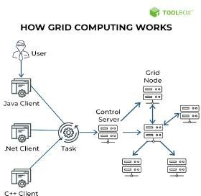

What are the types of grid computing?

Grid computing is generally classified as follows.

Computational grid
A computational grid consists of high-performance computers. It allows researchers to use the combined computing power of the computers. Researchers use computational grid computing to perform resource- intensive tasks, such as mathematical simulations.

Scavenging grid
While similar to computational grids, CPU scavenging grids have many regular computers. The term scavenging describes the process of searching for available computing resources in a network of regular computers. While other network users access the computers for non-grid–related tasks, the grid software uses these nodes when they are free. The scavenging grid is also known as CPU scavenging or cycle scavenging.

Data grid
A data grid is a grid computing network that connects to multiple computers to provide large data storage capacity. You can access the stored data as if on your local machine without having to worry about the physical location of your data on the grid.

Grid computing Benefits
Organizations use grid computing for several reasons.

Efficiency
With grid computing, you can break down an enormous, complex task into multiple subtasks. Multiple computers can work on the subtasks concurrently, making grid computing an efficient computational solution.

Cost
Grid computing works with existing hardware, which means you can reuse existing computers. You can save costs while accessing your excess computational resources. You can also cost-effectively access resources from the cloud.

Flexibility
Grid computing is not constrained to a specific building or location. You can set up a grid computing network that spans several regions. This allows researchers in different countries to work collaboratively with the same supercomputing power.

Use cases of grid computing Gaming
The gaming industry uses grid computing to provide additional computational resources for game developers. The grid computing system splits large tasks, such as creating in-game designs, and allocates them to multiple machines. This results in a faster turnaround for the game developers.

Entertainment
Some movies have complex special effects that require a powerful computer to create. The special effects designers use grid computing to speed up the production timeline. They have grid-supported software that shares computational resources to render the special-effect graphics.

Engineering
Engineers use grid computing to perform simulations, create models, and analyze designs. They run specialized applications concurrently on multiple machines to process massive amounts of data. For example, engineers use grid computing to reduce the duration of a Monte Carlo simulation, a software process that uses past data to make future predictions.

6. Cloud Computing
6.1 Cloud Computing Characteristics
Cloud computing refers to the delivery of computing services—
Including servers, storage, networking, databases, analytics, intelligence, and more—over the internet ("the cloud") to offer faster innovation, flexible resources, and economies of scale.
Instead of owning and maintaining physical data centers and servers, individuals and organizations can access computing resources on-demand from cloud service providers.
There are several key characteristics of cloud computing:
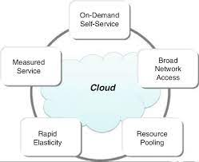
1. On-demand self-service: Users can provision computing resources such as server time and network storage as needed automatically, without human intervention from the service provider.
2. Broad network access: Cloud services are accessible over the internet from a variety of devices including laptops, smartphones, and tablets.
3. Resource pooling: Cloud providers pool computing resources to serve multiple customers, enabling them to dynamically assign and reassign resources based on demand.
4. Rapid elasticity: Cloud resources can be rapidly scaled up or down to accommodate changing workloads, providing flexibility and cost-efficiency.
5. Measured service: Cloud computing resources are metered and users are billed based on their actual usage, allowing for accurate tracking and cost control.
Cloud computing offers several deployment models, including public cloud, private cloud and hybrid cloud each with its own benefits and considerations.
Some of the most prominent cloud service providers include Amazon Web Services (AWS), Microsoft Azure, Google Cloud Platform (GCP), IBM Cloud, and Oracle Cloud.
Common use cases for cloud computing include web and mobile app hosting, data backup and storage, big data analytics, machine learning, Internet of Things (IoT) applications, and software development and testing, among others.
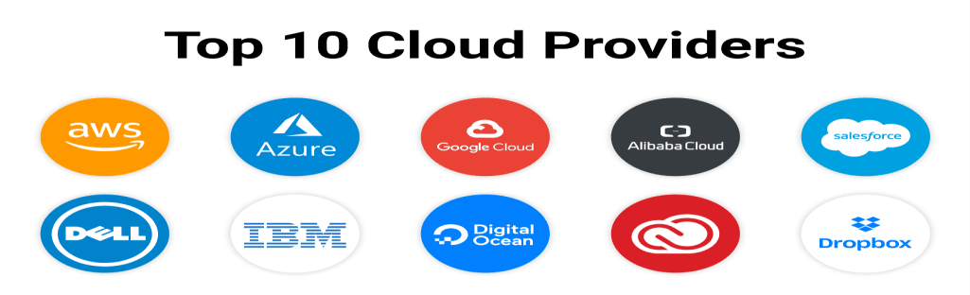
Advantages of cloud computing.
Cloud computing has emerged as a compelling solution for High Performance Computing (HPC) due to several key advantages:

Scalability: Cloud environments can easily scale resources up or down based on computational needs. This flexibility is crucial for HPC applications that may require large amounts of computing power on a temporary basis.
Cost-Effectiveness: Cloud computing allows users to pay only for the resources they use. This is more cost-effective compared to maintaining an in-house HPC infrastructure, which requires significant capital investment and ongoing maintenance costs.
Accessibility: Cloud-based HPC resources are accessible from anywhere, making it easier for researchers and scientists to collaborate and access computing resources remotely.
Reduced Infrastructure Burden: By using cloud services, organizations can avoid the complexities of setting up and maintaining their own HPC infrastructure. This includes the hardware, networking, storage, and cooling systems required for high-performance computing tasks.
➢ Rapid Deployment: Cloud services enable quick setup and deployment of computing resources. This agility allows organizations to start their HPC projects without the delays involved in procuring and setting up physical infrastructure.
Advanced Technologies: Cloud providers often offer access to the latest technologies, including cutting-edge processors, GPUs, and specialized hardware for AI and machine learning tasks, which are essential for many HPC applications.
➢ Customization and Specialization: Cloud platforms provide a range of services and configurations that can be tailored to specific HPC needs, allowing for a more optimized computing environment.
➢ Energy Efficiency: Cloud data centers are designed for high energy efficiency, which is beneficial given the high power consumption of HPC operations.
➢ Data Management and Storage: Cloud providers offer vast data storage options and sophisticated data management tools, which are crucial for HPC applications generating and processing large volumes of data.
➢ Security and Compliance: Reputable cloud providers invest heavily in security measures and compliance certifications, offering a level of security that can be challenging for individual organizations to achieve on their own.

- Disadvantages of Cloud Storage

Internet Connection
Cloud based storage is dependent on having an internet connection. If you are on a slow network you may have issues accessing your storage. In the event you find yourself somewhere without internet, you won't be able to access your files.

Costs
There are additional costs for uploading and downloading files from the cloud. These can quickly add up if you are trying to access lots of files often.

Hard Drives
Cloud storage is supposed to eliminate our dependency on hard drives right? Well some business cloud storage providers require physical hard drives as well.

Support
Support for cloud storage isn't the best, especially if you are using a free version of a cloud provider. Many providers refer you to a knowledge base or FAQs.

Privacy
When you use a cloud provider, your data is no longer on your physical storage. So who is responsible for making sure that data is secure? That's a grey area that is still being figured out.

7. Quantum computing

What Is Quantum Computing?
Quantum computing is an area of computer science that uses the principles of quantum theory. Quantum theory explains the behavior of energy and material on the atomic and subatomic levels.
Quantum computing uses subatomic particles, such as electrons or photons. Quantum bits, or qubits, allow these particles to exist in more than one state (i.e., 1 and 0) at the same time.
Theoretically, linked qubits can "exploit the interference between their wave-like quantum states to perform calculations that might otherwise take millions of years."
Classical computers today employ a stream of electrical impulses (1 and 0) in a binary manner to encode information in bits. This restricts their processing ability, compared to quantum computing.

Understanding Quantum Computing
The field of quantum computing emerged in the 1980s. It was discovered that certain computational problems could be tackled more efficiently with quantum algorithms than with their classical counterparts.
Quantum computing has the capability to sift through huge numbers of possibilities and extract potential solutions to complex problems and challenges. Where classical computers store information as bits with either 0s or 1s, quantum computers use qubits. Qubits carry information in a quantum state that engages 0 and 1 in a multidimensional way.
Such massive computing potential and the projected market size for its use have attracted the attention of some of the most prominent companies. These include IBM, Microsoft, Google, D-
Waves Systems, Alibaba, Nokia, Intel, Airbus, HP, Toshiba, Mitsubishi, SK Telecom, NEC, Raytheon, Lockheed Martin, Rigetti, Biogen, Volkswagen, and Amgen.

Uses and Benefits of Quantum Computing
Quantum computing could contribute greatly to the fields of security, finance, military affairs and intelligence, drug design and discovery, aerospace designing, utilities (nuclear fusion), polymer design, machine learning, artificial intelligence (AI), Big Data search, and digital manufacturing. Quantum computers could be used to improve the secure sharing of information. Or to improve radars and their ability to detect missiles and aircraft. Another area where quantum computing is expected to help is the environment and keeping water clean with chemical sensors.
Here are some potential benefits of quantum computing:
- Financial institutions may be able to use quantum computing to design more effective and efficient investment portfolios for retail and institutional clients. They could focus on creating better trading simulators and improve fraud detection.
- The healthcare industry could use quantum computing to develop new drugs and genetically- targeted medical care. It could also power more advanced DNA research.
- For stronger online security, quantum computing can help design better data encryption and ways to use light signals to detect intruders in the system.
- Quantum computing can be used to design more efficient, safer aircraft and traffic planning systems.

Features of Quantum Computing
Superposition and entanglement are two features of quantum physics on which quantum computing is based. They empower quantum computers to handle operations at speeds exponentially higher than conventional computers and with much less energy consumption.

Superposition
According to IBM, it’s what a qubit can do rather than what it is that's remarkable. A qubit places the quantum information that it contains into a state of superposition. This refers to a combination of all possible configurations of the qubit. "Groups of qubits in superposition can create complex, multidimensional computational spaces. Complex problems can be represented in new ways in these spaces.
Superposition is the ability of a qubit to exist in multiple states (0 and 1) simultaneously until it is measured.

Classical Bits: Can only represent a state of 0 or 1.

Qubits: Can represent 0, 1, or any combination (superposition) of both states at the same time.

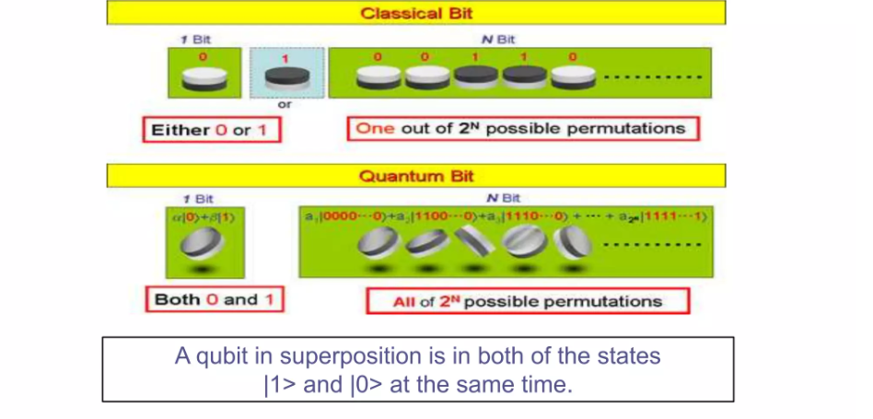

Why it Matters:

Superposition allows quantum computers to perform parallel computations, significantly increasing computational power.

Example:
magine searching for a name in a phone book. A classical computer would check each entry one by one, while a quantum computer, thanks to superposition, could check many entries simultaneously.

Entanglement
Entanglement is integral to quantum computing power. Pairs of qubits can be made to become entangled. This means that the two qubits then exist in a single state. In such a state, changing one qubit directly affects the other in a manner that's predictable.

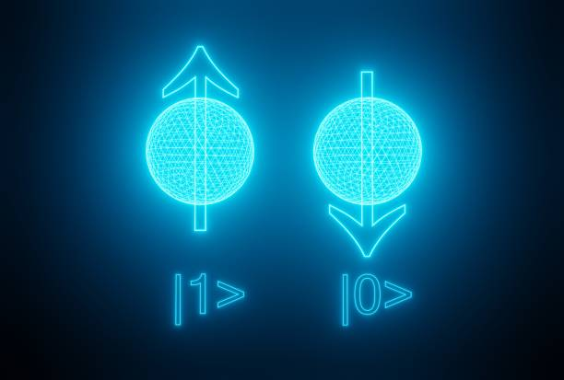

Explanation of Quantum Entanglement

  - Entangling Qubits (Step 1): Imagine you have two magic coins (qubits). You use a "laser spell" to link these coins together. Once linked, they become "entangled."
  - Indeterminate State (Step 2): Before flipping either coin, you don’t know if it will show heads or tails. However, these coins now share a mysterious connection.
  - Separation (Step 3): You take one coin to the North Pole and leave the other at the South Pole. Even though they are miles apart, their magical link remains intact.
  - Instantaneous Change (Step 4): If you flip the coin in the North Pole and it lands on heads, the coin at the South Pole will immediately land on tails — even without anyone touching it.
  - Measurement Ends the Magic (Step 5): Once you observe one coin, both coins "lock in" their states forever (heads or tails). The magical link is broken, and they behave like normal coins.
Quantum algorithms are designed to take advantage of this relationship to solve complex problems. While doubling the number of bits in a classical computer doubles its processing power, adding qubits results in an exponential upswing in computing power and ability.

Quantum Computers in Development

Google
Google is spending billions of dollars to build its quantum computer by 2029. The company opened a campus in California called Google AI to help it meet this goal. Once developed, Google could launch a quantum computing service via the cloud.3

IBM
IBM plans to have a 1,000-qubit quantum computer in place by 2023. For now, IBM allows access to its machines for those research organizations, universities, and laboratories that are part of its Quantum Network.

Microsoft
Microsoft offers companies access to quantum technology via the Azure Quantum platform.

Others
There’s interest in quantum computing and its technology from financial services firms such as JPMorgan Chase and Visa.

What Is Quantum Computing in Simplest Terms?
Quantum computing relates to computing made by a quantum computer. Compared to traditional computing done by a classical computer, a quantum computer should be able to store much more information and operate with more efficient algorithms. This translates to solving extremely complex tasks faster.

How Hard Is It to Build a Quantum Computer?
Building a quantum computer takes a long time and is vastly expensive. Google has been working on building a quantum computer for years and has spent billions of dollars. It expects to have its quantum computer ready by 2029. IBM hopes to have a 1,000-qubit quantum computer in place by 2023.

How Much Does a Quantum Computer Cost?
A quantum computer cost billions to build. However, China-based Shenzhen SpinQ Technology plans to sell a $5,000 desktop quantum computer to consumers for schools and colleges. Last year, it started selling a quantum computer for $50,000.

How Fast Is a Quantum Computer?
A quantum computer is many times faster than a classical computer or a supercomputer. Google’s quantum computer in development, Sycamore, is said to have performed a calculation in 200 seconds, compared to the 10,000 years that one of the world’s fastest computers, IBM's Summit, would take to solve it. IBM disputed Google's claim, saying its supercomputer could solve the calculation in 2.5 days. Even so, that's 1,000 times slower than Google's quantum machine.

Applications of quantum computing
- Healthcare
- Finance
- Climate forecasting
- Travel and transportation
- Privacy/security

Advantages of Quantum computing:
- The main advantage of quantum computing is that it is even classical algorithm calculations. They are also performed easily which is similar to the classical computer.
- If we adding the qubits to the register we increase its storage capacity exponentially.
- In this computing qubit is the conventional superposition state. So there are advantages of exponential speedup to the resulted by handle the number of calculations and method.
- Quantum computing required less power.
- The other advantage of quantum computing is it can execute any task very faster and very accurately compared to a classical computer. Generally, the atom changes very faster in the case of traditional computing whereas in quantum computing it changes even faster.

Disadvantages of Quantum computing:
- The research for this problem is still continuing the effort applied to identify a solution for this problem that has no positive progress.
- Qubits are not digital bits of the day thus they cannot use as conventional error correction.
- The main disadvantage of Quantum computing is the technology required to implement a quantum computer is not available at present days.
- The minimum energy requirement for quantum logical operations is five times that of classical computers.
- Quantum CPU will have efficiency and heating problems of its own.
- When a measurement of any type is made to a quantum system, decoherence is totally broken down and the wave function collapses into a single state.
Limitations of Quantum Computing
Quantum computing offers enormous potential for developments and problem-solving in many industries. However, currently, it has its limitations.
  - Decoherence, or decay, can be caused by the slightest disturbance in the qubit environment. This results in the collapse of computations or errors to them. As noted above, a quantum computer must be protected from all external interference during the computing stage.
  - Error correction during the computing stage hasn't been perfected. That makes computations potentially unreliable. Since qubits aren't digital bits of data, they can't benefit from conventional error correction solutions used by classical computers.
    - Retrieving computational results can corrupt the data. Developments such as a particular database search algorithm that ensures that the act of measurement will cause the quantum state to decohere into the correct answer hold promise.8
    - Security and quantum cryptography is not yet fully developed.
    - A lack of qubits prevents quantum computers from living up to their potential for impactful use. Researchers have yet to produce more than 128.7
According to global energy leader Iberdola, "quantum computers must have almost no atmospheric pressure, an ambient temperature close to absolute zero (-273°C) and insulation from the earth's magnetic field to prevent the atoms from moving, colliding with each other, or interacting with the environment."
"In addition, these systems only operate for very short intervals of time, so that the information becomes damaged and cannot be stored, making it even more difficult to recover the data.

8. Nano computing
Nanotechnology is the use of science, engineering, and technology at the nanoscale, or between 1 and 100 nanometres. Richard Feynman, a physicist, is credited with founding nanotechnology. Nanoscience and nanotechnology, which study and use very small objects, are applicable to all other scientific disciplines, including chemistry, biology, physics, materials science, and engineering. Nanotechnology, or nanotech as it is sometimes abbreviated, is the utilization of matter at the atomic, molecular, and supramolecular scales for commercial applications.
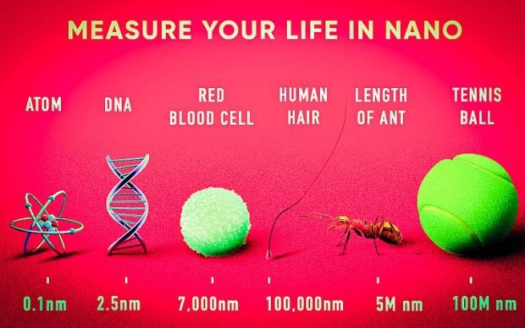

The first, the most popular definition of nanotechnology spoke of the specific technological objective of finely controlling atoms and molecules in order to produce macroscale goods. The National Nanotechnology Initiative went on to describe nanotechnology as the manipulation of matter with at least one dimension scaled from 1 to 100 nanometres, which is a broader definition of the discipline.

Nanotechnology, as defined by size, encompasses a variety of scientific disciplines, including surface science, organic chemistry, molecular biology, semiconductor physics, energy storage, engineering, and molecular engineering.

What are the Types of Nanotechnology?
Top-down or bottom-up processes and dry or wet working environments are used to categorize the many forms of nanotechnology:

- Descending (top-down): Mechanisms and structures are miniaturized at the manometer scale
- from one to 100 manometers - this is the most frequent trend, especially in the electronic field.
- Ascending (bottom-up): By mounting or self-assembling a nanometric structure, you form a larger mechanism than what you started with.
- Dry Nanotechnology: Dry Nanotechnology: It does not require humidity to manufacture structures made from coal, silicon, inorganic materials, metals, and semiconductors.
- Wet Nanotechnology: This technology utilizes biological systems that exist in aqueous environments, including genetic material, membranes, enzymes, and other aspects of the cell.

Nanotechnology Applications:
Various industrial sectors can benefit from nanotechnology and nanomaterials. The following areas are usually where nanomaterials and nanotechnologies are found:

- Nanotechnology in Electronics
- Nanotechnology in Energy
- Nanotechnology in Biomedicine
- Nanotechnology in Environment
- Nanotechnology in Food.
- Nanotechnology in Textile
The other following areas of science employ nanotechnology:
Surface Science, Organic chemistry, Molecular biology, Semiconductor physics, Microfabrication, Molecular engineering, etc.

Advantages
- The use of nanotechnology can create materials that are unique and are stronger, cheaper, and durable.
- Cleaning of pollution utilizes such technology.
- The manufacturing cost of using nanotechnology will be very low.
- Body sculpturing is a great advantage of nanotechnology.
- Nanotechnology leads to the mass production of food and consumables.

Disadvantages
The usage of this technology can cause issues related to health and safety. It can cause severe damage to human bodies. The massive production can lead to the loss of employment in the sectors of farming and manufacturing. The accessing of atomic weapons becomes easier and at the same time can be destructive as well.

9 Optical Computing
Optical Computing is a computing technology that uses light (photons) instead of electricity (electrons) to perform computation, data transmission, and information processing. It relies on optical components such as lasers, lenses, optical fibers, and photonic devices to process data at very high speeds.

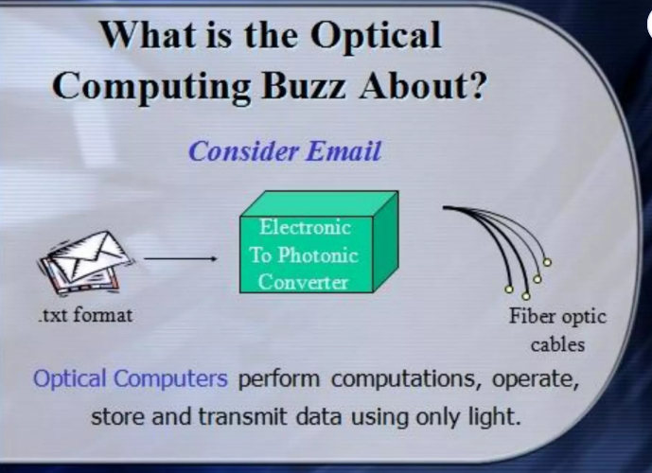

Why Optical Computing is Important

1. Ultra-High Speed
Light travels faster than electric current.
Enables terahertz-level processing speeds.

2. Parallel Processing
Multiple light beams can pass through the same space simultaneously.
Ideal for massively parallel computation.

3. Low Power Consumption
Minimal heat generation compared to electronic circuits.
Reduces cooling and energy costs.

4. High Bandwidth
Supports extremely large data transfer rates.
Essential for future AI, big data, and HPC systems.

5. Overcomes Electronic Limitations
Avoids problems like resistance, capacitance, and electromagnetic interference

How Optical Computing Works
- Data is represented using light signals (different wavelengths, phases, or intensities).
- Optical components manipulate these signals to perform operations.
- Computation happens through light interference, diffraction, and reflection, rather than electrical switching.

Major Components Used in Optical Computers
The following are the primary optical components necessary for computation in an optical computer:

VCSEL (Vertical Cavity Surface Emitting Micro Laser)
The VCSEL is a surface-emitting semiconductor Micro Laser Diode that produces light in a vertical direction. It essentially transforms an electrical signal into an optical signal. It is the ideal illustration of a single-dimensional photonic crystal.

Spatial Light Modulators
Both the optical beam's intensity and phase can be modulated by spatial light modulators. Due to the fact that they convert the data into a laser beam, they are employed in holographic data storage systems.

Optical Logical Gates
In essence, an optical switch that manages light beams is what makes up an optical logic gate. When a gadget transmits light, it is said to be "ON," and when a device blocks light, it is said to be "OFF."

Smart Pixels
High-level electronic signal processing optical systems are assisted by smart pixels.

Advantages:
- Low heating
- Can tackle complex computations very quickly
- Can be scaled to larger networks efficiently.
- Increased computation speed
- Higher bandwidth with very low data loss transmission.
- Free from electrical short circuits.
Disadvantages:
- Components of optical computers would be very costly.
- Size is very bulky.
- Integrating optical gates is complex.
- Interference can be caused by dust or any imperfections.

Applications of Optical Computing
- High-performance computing (HPC)
- Artificial Intelligence & Neural Networks
- Image and signal processing
- Optical neural networks
- Cryptography
- Quantum and photonic computing systems
- High-speed communication networks
10.Bio Computing
What is Bio Computing
Bio Computing (also called Biological Computing or DNA Computing) is a computing paradigm that uses biological molecules such as DNA, RNA, proteins, and enzymes to store information and perform computational operations.
Instead of silicon chips, living or bio-molecular systems are used for processing.
Why Bio Computing is Important
1. Massive Parallelism
- Billions of DNA molecules can compute simultaneously.
- Extremely efficient for solving complex problems.
2. Ultra-High Storage Density
- DNA can store exabytes of data in a few grams.
- Far superior to electronic storage.
3. Energy Efficiency
- Consumes very little power compared to electronic computers.
4. Solving NP-Hard Problems
- Useful for complex optimization problems where traditional computers struggle.
5. Medical & Biological Integration
- Can directly interact with biological systems (cells, tissues).
How Bio Computing Works
- Information is encoded into DNA sequences (A, T, C, G).
- Biological operations such as hybridization, replication, and enzymatic reactions perform computation.
- The result is obtained by analyzing DNA strands (using sequencing or fluorescence).
Major Components Used in Bio Computers
1. DNA Molecules
- Act as data storage units
- Encode information using nucleotide bases.
2. Enzymes
- Act as processing units
- Perform cutting, copying, and joining of DNA.
3. Polymerase Chain Reaction (PCR)
- Used to amplify DNA data.
- Enables massive parallel processing.
4. Biochips
- Lab-on-chip devices that integrate biological reactions with computation.
Advantages of Bio Computing
• Extremely high parallelism
• Very low power consumption
• Massive data storage capacity
• Suitable for complex problem solving
• Highly compatible with medical and biological systems

Disadvantages of Bio Computing
• Very slow compared to electronic processors (reaction time)
• High cost of laboratory setup
• Difficult to program and debug
• Error-prone biological reactions
• Not suitable for general-purpose computing
Applications of Bio Computing
- Drug discovery
- Genetic analysis
- Disease diagnosis
- Optimization problems
- Cryptography
- DNA data storage
- Medical research and bioinformatics
- Mobile Computing
What is Mobile Computing
Mobile Computing refers to a computing environment that allows users to access data, applications, and services wirelessly using portable devices such as smartphones, tablets, laptops, and wearable devices, anytime and anywhere.
Why Mobile Computing is Important
1. Anytime, Anywhere Access
- Enables computing while moving.
- No fixed physical connection required.
2. Wireless Communication
- Uses technologies like Wi-Fi, 4G, 5G, Bluetooth.
3. Portability
- Lightweight and compact devices.
- Improves productivity and convenience.
4. Real-Time Data Access
- Instant access to cloud services and applications.
5. Supports Modern Applications
- Essential for IoT, smart cities, mobile banking, and e-commerce.
How Mobile Computing Works
- Mobile device sends requests through a wireless network.
- Data is transmitted via base stations or access points.
- Backend servers or cloud systems process the request.
- Results are sent back to the mobile device in real time.
Major Components of Mobile Computing
1. Mobile Devices
- Smartphones, tablets, laptops, wearables.
2. Wireless Networks
- Cellular networks (3G, 4G, 5G)
- Wi-Fi and Bluetooth.
3. Mobile Operating Systems
- Android, iOS, Windows Mobile.
4. Middleware
- Enables communication between applications and networks.

Advantages of Mobile Computing
• High portability
• Real-time communication
• Increased productivity
• Easy access to cloud services
• Supports location-based services
Disadvantages of Mobile Computing
• Limited battery life
• Security and privacy issues
• Network dependency
• Limited processing power
• Data loss risk if device is lost
Applications of Mobile Computing
- Mobile banking and payments
- E-commerce and m-commerce
- Location-based services (GPS)
- Telemedicine
- Mobile learning (m-learning)
- Social networking
- IoT and smart devices

