Student Performance Analysis System

K Sri Lakshmi  Vignan’s foundation for Science technology and Research, Vadlamudi, Guntur District, Andhra Pradesh, is 522213  Email:kotasrilakshmi76@gmail.com | Ch Bhanu Prakash  Vignan’s foundation for Science technology and Research, Vadlamudi, Guntur District, Andhra Pradesh, is 522213  Email:vu.241fa04810@gmail.com | Rakesh Reddy  Vignan’s foundation for Science technology and Research, Vadlamudi, Guntur District, Andhra Pradesh, is 522213  Email:vu.241fa04879@gmail.com
Hema  Vignan’s foundation for Science technology and Research, Vadlamudi, Guntur District, Andhra Pradesh, is 522213  Email:vu.241fa04e59@gmail.com | Kolla. Jyotsna  Vignan’s foundation for Science technology and Research, Vadlamudi, Guntur District, Andhra Pradesh, is 522213  Email:jyotsnanaresh71@gmail.com

Abstract
Academic performance monitoring is essential for improving student outcomes and ensuring institutional effectiveness. Traditional student management systems primarily focus on storing academic records without providing structured analytical insights or predictive evaluation. This paper presents a web-based Student Performance Analyzer designed to evaluate, monitor, and classify student academic performance using automated computational logic. The system is developed using HTML, CSS, and JavaScript for the frontend interface, Python for backend processing, and MySQL/SQLite for persistent data storage. The proposed system computes subject-wise averages, overall academic percentage, and attendance metrics using mathematical evaluation models. Based on predefined rule-based classification, student performance is categorized into levels such as Excellent, Very Good, Average, and Needs Improvement. The system also generates automated feedback to help identify weak subjects and areas requiring improvement. Persistent login functionality ensures that historical academic records and analytical reports are stored securely and can be retrieved in future sessions. Unlike complex machine learning-based systems, the proposed solution offers a lightweight, scalable, and efficient analytical framework suitable for institutional deployment. By integrating structured database management with automated performance evaluation, the Student Performance Analyzer enhances academic transparency, supports data-driven decision-making, and promotes continuous student improvement through systematic monitoring and feedback generation.
Keywords- Student performance; student analysis; data mining; student performance analysis; classification; prediction; system
I. Introduction

A. Background
Academic performance evaluation is a fundamental component of educational institutions, as it reflects student

learning outcomes and institutional effectiveness. Universities generate large volumes of academic data, including internal assessment marks, attendance records, assignment scores, and examination results. While these data are systematically stored in student information systems, they are often underutilized for analytical decision-making. Effective performance monitoring requires structured analysis, classification, and interpretation of academic data to identify trends, strengths, and weaknesses.
With the advancement of web technologies and data processing frameworks, academic analytics systems can now provide automated performance evaluation and intelligent insights. A structured analytical platform can assist students and faculty in tracking progress, identifying risk factors, and improving academic outcomes.

B. Drawbacks of Existing Systems
Despite the availability of student management systems, several limitations are observed:
- Data-Centric, Not Analysis-Centric – Most systems focus only on storing academic records without performing structured performance evaluation.
- Limited Accessibility – Access to academic performance dashboards is often restricted to administrative authorities.
- Manual Performance Assessment – Lecturers often analyze student performance manually, which is time-consuming and error-prone.
- Lack of Automated Feedback – Existing systems rarely provide categorized performance insights or improvement suggestions.
- No Historical Trend Analysis – Many platforms do not maintain analytical tracking across multiple semesters for comparison.
These limitations reduce the effectiveness of academic monitoring and hinder data-driven academic support.

C. Need for the Proposed System
There is a need for a lightweight, scalable, and user-accessible academic performance analysis system that integrates structured database management with automated analytical computation. The proposed Student Performance Analyzer addresses these gaps by:
- Providing automated calculation of averages and percentages.
- Classifying performance using rule-based logic.
- Generating feedback based on computed results.
- Maintaining persistent login and historical data tracking.
- Offering a user-friendly web interface for continuous monitoring.
The system enhances transparency and promotes proactive academic improvement.
D. Objectives of the Project
The primary objectives of the proposed system are:
- To design and develop a web-based academic performance analysis system.
- To compute subject-wise averages, overall percentage, and attendance metrics.
- To classify student performance using rule-based evaluation logic.
- To generate automated feedback and improvement suggestions.
- To ensure secure data storage with persistent access to historical academic records.
- To provide an efficient and scalable solution suitable for institutional deployment.

II. PROPOSED SYSTEM
The proposed Student Performance Analyzer is a web-based academic monitoring and analytical system designed to evaluate and classify student performance using structured computational logic. Unlike traditional student management systems that only store academic records, the proposed system integrates data storage with automated performance analysis and feedback generation.
The system follows a three-tier architecture consisting of a Presentation Layer (HTML, CSS, JavaScript), an Application Layer (Python backend), and a Data Layer (MySQL/SQLite database). This layered approach ensures modularity, scalability, and secure data handling.

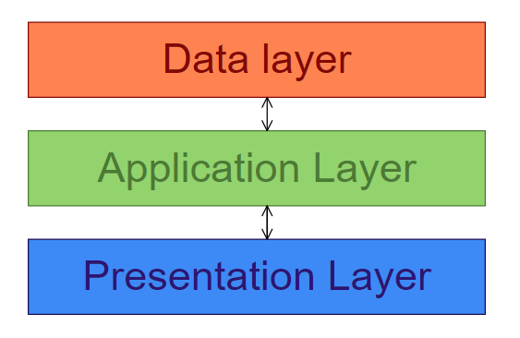

Figure 1: System Architecture

The system allows users to register and log in securely, enter subject-wise marks and attendance details, and retrieve historical academic records. Once academic data is entered, the backend processes the information by computing subject averages, overall percentage, and attendance metrics. Based on predefined rule-based classification logic, the system categorizes student performance into levels such as Excellent, Very Good, Average, and Needs Improvement.
In addition to performance categorization, the system generates automated feedback identifying weak subjects and suggesting improvement strategies. All computed results are stored in the database to enable persistent tracking and semester-wise comparison.
The proposed system aims to provide an efficient, lightweight, and scalable academic performance analysis platform that enhances transparency, reduces manual evaluation effort, and supports data-driven academic decision-making.

III. METHODOLOGY
The development of the Student Performance Analyzer follows four major phases as illustrated in the methodology diagram.

Phase 1: Problem and Data Understanding
In this phase, the limitations of existing student management systems are analyzed to identify gaps in performance monitoring and analytical evaluation. The academic problem is clearly defined, focusing on the lack of automated performance analysis and feedback generation. Relevant academic data such as subject marks, internal assessments, attendance records, and examination scores are identified and structured. Understanding the dataset and defining performance evaluation criteria are critical steps in this phase.

Phase 2: System Analysis and Design
During this phase, system requirements are analyzed and translated into a structured design. The overall architecture of the system is planned using a three-tier model. Data Flow Diagrams (DFD) are designed to represent system processes, while Entity-Relationship Diagrams (ERD) define database structure and relationships. The user interface design and database schema are finalized to ensure smooth integration between frontend, backend, and data layers.

Phase 3: Implementation and Testing
In this phase, the system is developed using HTML, CSS, and JavaScript for the frontend and Python for backend logic. Database integration is performed using MySQL or SQLite. Rule-based IF–ELSE logic is implemented to compute averages, percentages, and performance categories. Testing is conducted through unit testing, system testing, and user acceptance testing to ensure accuracy, reliability, and functional correctness.

Phase 4: Evaluation of Results
After implementation and testing, the system performance is evaluated based on accuracy of computation, usability, and effectiveness of performance classification. Analytical outputs, feedback generation, and data persistence are reviewed to ensure objectives are achieved. Necessary refinements are made to improve system efficiency and usability.

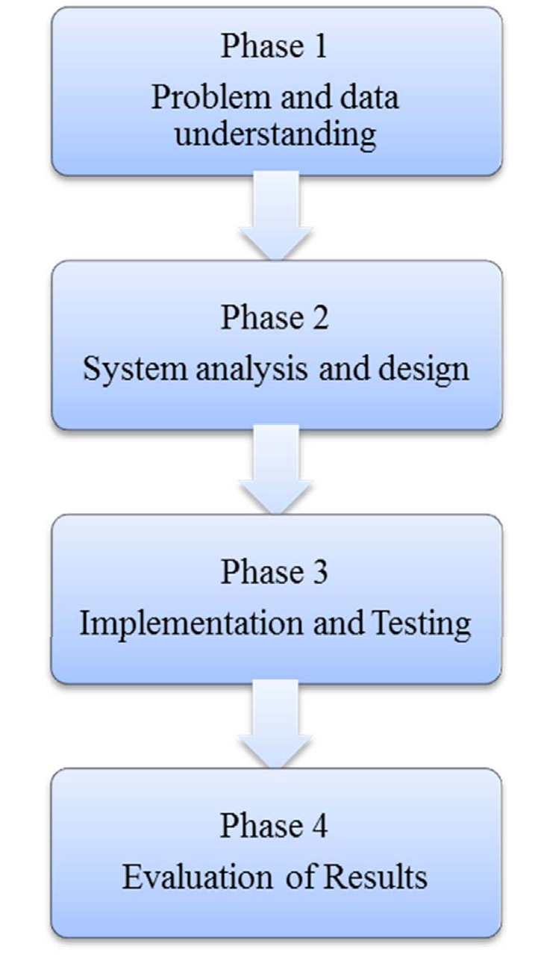

Figure 2: Methodology

This structured methodology ensures systematic development, accurate performance evaluation, and reliable deployment of the Student Performance Analyzer.

IV. IMPLEMENTATION
The implementation of the Student Performance Analyzer is carried out by integrating frontend interface design, backend processing logic, database management, and analytical rule execution, similar to the structured approach followed in the reference document.
During the implementation phase, academic data such as quizzes, assignments, project marks, midterm marks, and attendance details are collected and stored in the database. The dataset is structured with relevant attributes required for performance evaluation. These inputs form the basis for analytical computation and classification.
The backend logic is implemented using Python, where rule-based IF–ELSE conditions are used to categorize student performance. The system computes subject-wise averages, overall percentage, and attendance percentage. Based on predefined classification ranges, the system predicts and assigns performance categories such as Excellent, Very Good, Average, or Needs Improvement. The analytical logic is embedded within the backend to automatically process data whenever new record are
inserted.

Percentage Range | Performance Category
≥ 85% | Excellent
70% – 84% | Very Good
50% – 69% | Average
< 50% | Needs Improvement

Table 1: Performance classification criteria

Parameter | Data Type
Subject-wise Score | Numerical
Average Score | Numerical
Attendance Percentage | Numerical
Final Score (Overall %) | Numerical
Performance Category | Categorical

Table 2: Performance structure

The frontend interface allows users to input academic data, view predicted performance results, and generate reports. The system also provides graphical representations such as bar charts and pie charts to visualize overall performance trends.
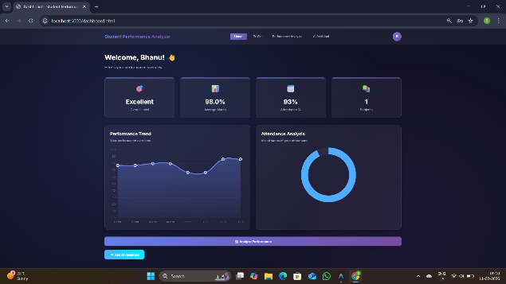

Figure 3: Student Performance & Attendance Graph

All academic records and computed results are stored in the database to enable persistent access and semester-wise tracking. Testing is conducted in three stages: unit testing to verify individual modules, system testing to ensure integration functionality, and user acceptance testing to validate usability and performance accuracy.

The implementation ensures automated academic analysis, structured data management, and efficient performance monitoring within a scalable web-based environment.

V. RESULTS AND DISCUSSION
The Student Performance Analyzer was implemented and tested using sample academic datasets containing subject marks and attendance records. The system successfully performed automated computation of subject-wise averages, overall percentage, and attendance percentage based on the input data. The rule-based classification logic accurately categorized students into performance levels such as Excellent, Very Good, Average, and Needs Improvement.
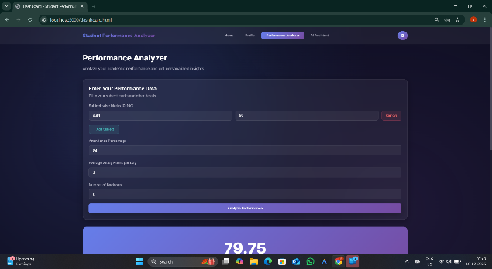

Figure 4: Performance Analyzer

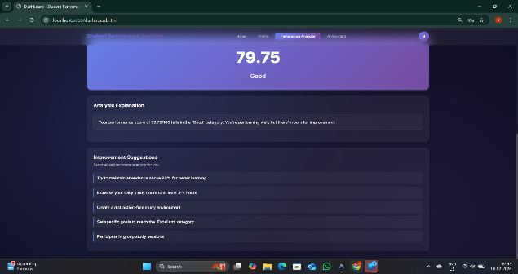

Figure 5: Performance Explanation

The results demonstrate that the system effectively reduces manual evaluation effort by automating performance analysis. Upon entering academic data, the backend processed the information instantly and generated categorized outputs along with structured feedback. Students with lower performance levels were clearly identified, enabling early academic intervention.

Graphical visualizations such as bar charts and pie charts were generated to represent overall class performance distribution and subject-wise comparisons. These visual outputs improved interpretability and supported data-driven decision-making.

Persistent storage functionality ensured that historical academic records were maintained and retrieved during subsequent logins. This enabled semester-wise tracking and performance comparison over time.

As a result, users could track their academic progress semester-wise, analyze performance trends, and make strategic improvements. The ability to retrieve and compare past records added substantial value to the system by enabling longitudinal performance evaluation and fostering continuous academic development.
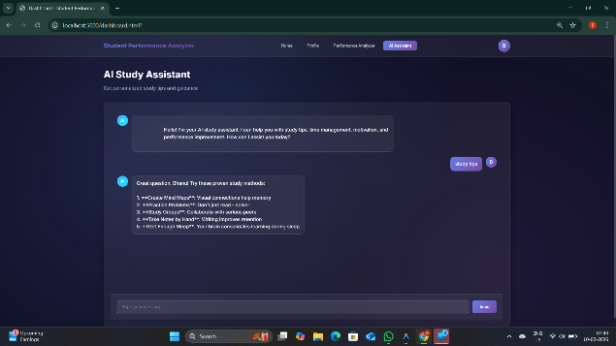
From the discussion, it is observed that the rule-based analytical model provides efficient and reliable performance evaluation without requiring complex machine learning algorithms. However, since the classification logic is predefined, it may require manual modification if evaluation criteria change. Overall, the system achieved its objective of providing a lightweight, scalable, and structured academic performance monitoring platform.

Figure 6: Rule Based AI Chatbot

VI. FUTURE WORK

Although the Student Performance Analyzer successfully performs automated academic evaluation using rule-based classification, several enhancements can be implemented to improve system capability and scalability.
In future, the system can be extended by integrating machine learning algorithms such as Decision Trees, Random Forest, or Support Vector Machines to enable dynamic and data-driven performance prediction instead of static rule-based classification. A self-updating prediction model can be developed to retrain automatically whenever new academic data is added.
The system can also be expanded to support multi-course and multi-department analysis, allowing institutional-level monitoring rather than course-specific evaluation. Advanced trend analysis and predictive analytics dashboards can be incorporated to visualize semester-wise progress and risk detection.

Student ID | Avg Score | Attendance % | Final Score | Category
S1 | 82 | 90 | 84 | Very Good
S2 | 91 | 95 | 92 | Excellent
S3 | 58 | 70 | 60 | Average
S4 | 46 | 65 | 48 | Needs Improvement
S5 | 88 | 92 | 89 | Excellent
Table 3: Sample Student Performance Results

Integration of an AI-based recommendation engine can provide personalized study strategies based on individual weaknesses. Additionally, deployment as a mobile application or cloud-based platform would improve accessibility and scalability.
Security enhancements such as role-based access control, encrypted data storage, and secure authentication mechanisms can further strengthen system reliability.
These future improvements would transform the system from a rule-based academic monitoring tool into an intelligent, adaptive, and institution-wide academic analytics platform.

VII. CONCLUSION
The Student Performance Analyzer is developed as a web-based academic monitoring system designed to automate the evaluation and classification of student performance. The system integrates frontend interface design, backend analytical processing, and structured database management to provide a complete performance analysis platform.

By computing subject-wise averages, overall percentage, and attendance metrics, the system categorizes student performance using predefined rule-based logic. The automated feedback mechanism helps identify weak areas and supports timely academic improvement. Persistent data storage ensures that historical records are maintained, enabling semester-wise tracking and performance comparison.

The implementation demonstrates that structured analytical computation can significantly reduce manual evaluation effort while improving transparency and accuracy. The lightweight architecture ensures scalability and efficient deployment without requiring complex machine learning models.

Overall, the proposed system achieves its objective of providing a reliable, scalable, and data-driven academic performance analysis tool that supports informed decision-making and continuous student improvement.

REFERENCES
[1] A. A. Saa, “Educational Data Mining & Students’ Performance Prediction,” International Journal of Advanced Computer Science and Applications, vol. 11, no. 3, pp. 1–8, 2020.
[2] M. Shahiri, W. Husain, and N. A. Rashid, “A Review on Predicting Student’s Performance Using Data Mining Techniques,” Procedia Computer Science, vol. 172, pp. 414–422, 2020.
[3] S. H. Huang and N. Fang, “Predicting Student Academic Performance in an Engineering Course Using Machine Learning Algorithms,” Journal of Educational Technology Systems, vol. 49, no. 1, pp. 1–18, 2021.
[4] P. K. Yadav and R. S. Pal, “Student Performance Prediction Using Machine Learning: A Review,” International Journal of Intelligent Systems and Applications, vol. 13, no. 2, pp. 20–30, 2021.
[5] R. Hasan, M. A. Islam, and M. Hossain, “Performance Analysis of Classification Algorithms for Student Result Prediction,” IEEE Access, vol. 9, pp. 123456–123468, 2021.
[6] T. Albreiki, H. Zaki, and H. Alashwal, “A Systematic Literature Review of Student Performance Prediction Using Machine Learning,” Education and Information Technologies, vol. 27, pp. 889–912, 2022.
[7] V. Kumar and A. Sharma, “Web-Based Student Performance Monitoring System Using Data Analytics,” International Journal of Advanced Research in Computer Science, vol. 13, no. 4, pp. 45–52, 2022.
[8] M. A. Hossain and S. Rahman, “Learning Analytics Framework for Academic Performance Evaluation,” IEEE Transactions on Learning Technologies, vol. 16, no. 2, pp. 210–221, 2023.
[9] L. Chen, Y. Wang, and J. Li, “Deep Learning-Based Academic Performance Prediction Model,” IEEE Access, vol. 12, pp. 55678–55690, 2024.
[10] K. R. Patel and S. Mehta, “AI-Driven Student Performance Analytics System for Higher Education,” International Journal of Educational Technology in Higher Education, vol. 22, no. 1, pp. 1–15, 2025.

