HouseHunt – Home Rental Platform
College: Seshadri Rao Gudlavalleru Engineering College
Department: Information Technology
Submission Date: 15 July 2026

Team Members
- Jyothika Chimata
- Renuka Sirolu
- Murala Lakshmi Laalasa

1. Introduction
HouseHunt is a MERN-stack web application that helps users browse rental properties, view details, and manage listings through a responsive interface.

2. Project Overview
Purpose: To simplify house rental search and property management.
Features: Registration/Login, property listings, filters, property details, CRUD operations, responsive UI.

3. Architecture
Frontend: React
Backend: Node.js & Express.js
Database: MongoDB using Mongoose.

4. Setup Instructions
Prerequisites: Node.js, npm, MongoDB, Git.
Clone: https://github.com/renukasirolu/househunt.git
Install: npm install in frontend and backend.
Run frontend: npm run dev
Run backend: npm start

5. Folder Structure
frontend/
backend/
.gitignore

6. API Documentation
Authentication: /api/auth/register, /api/auth/login
Properties: GET/POST/PUT/DELETE /api/properties

7. Authentication
JWT-based authentication is used to secure protected routes.

8. User Interface
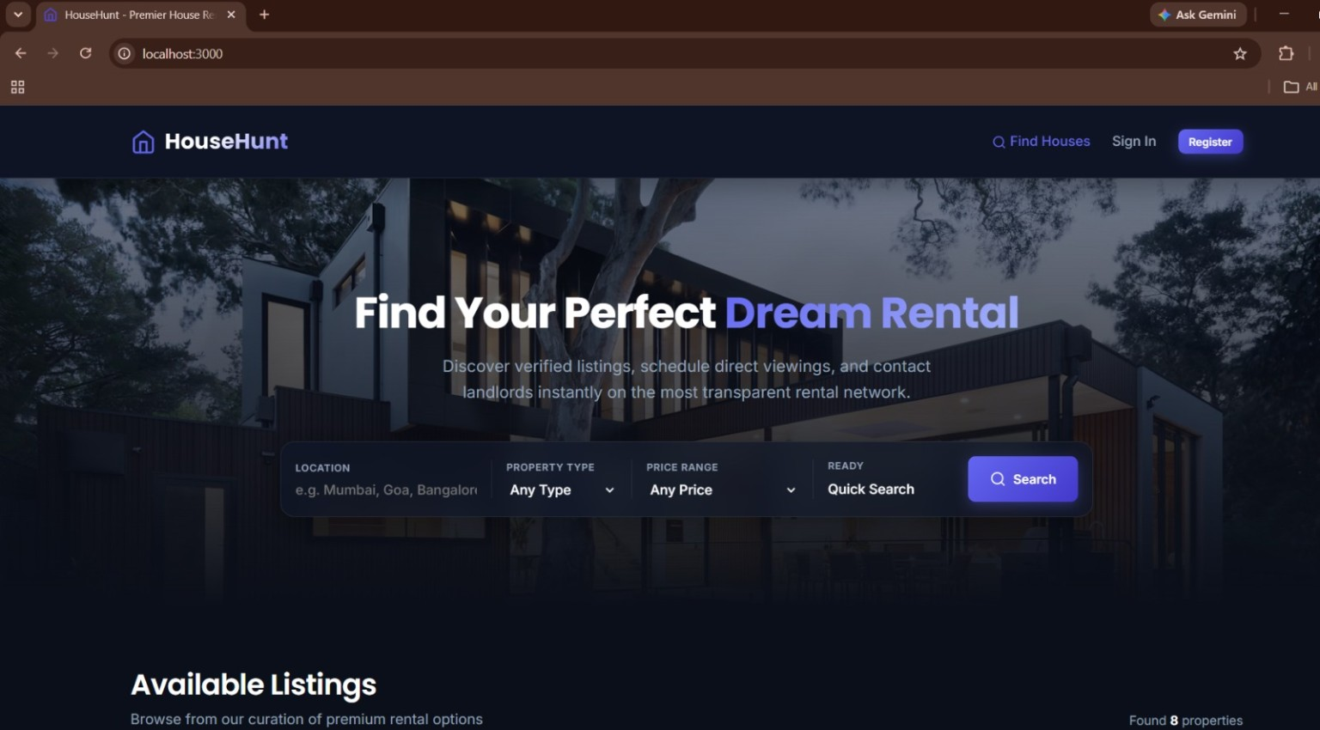
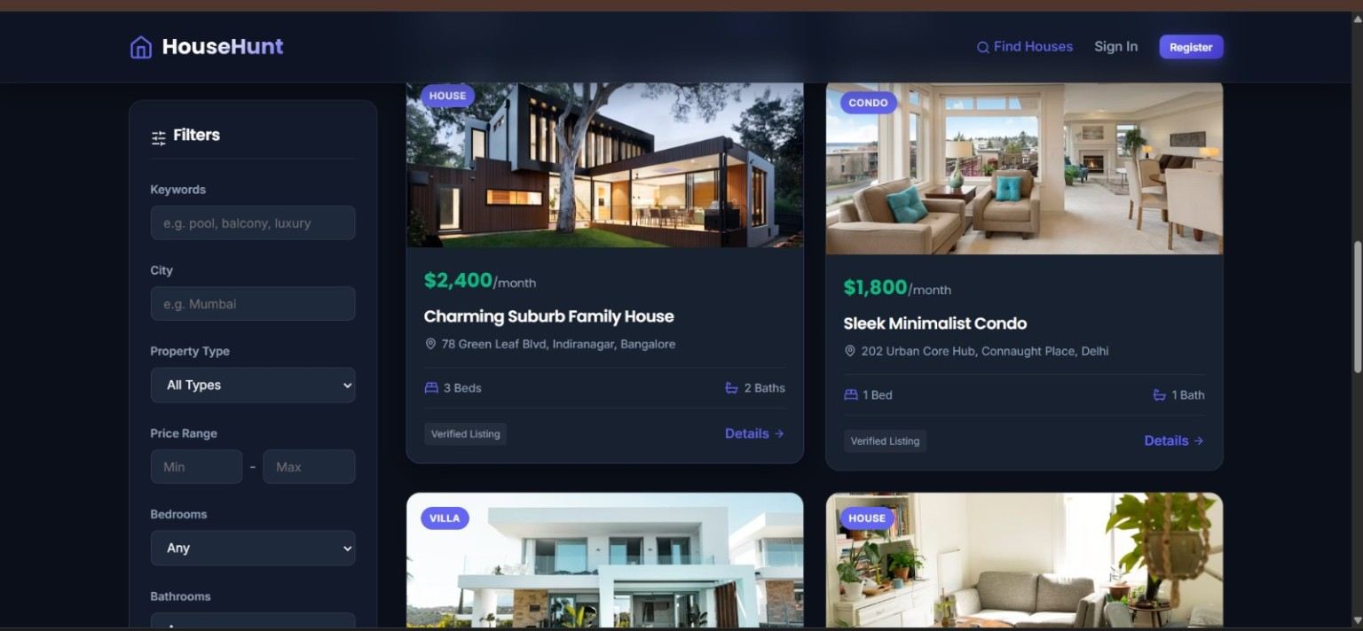
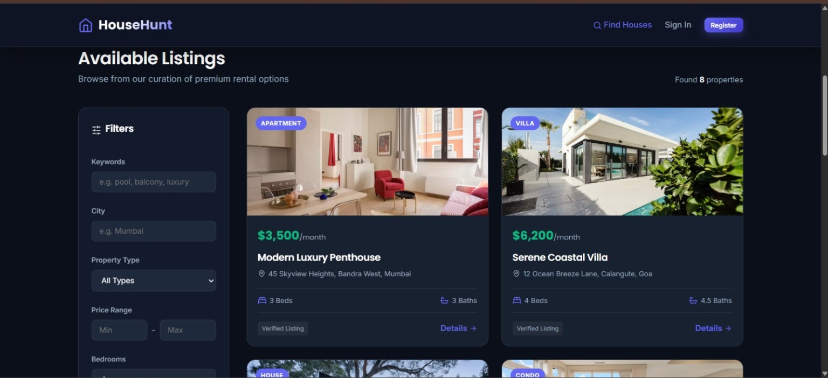

9. Demo & Repository
Demo: https://drive.google.com/file/d/1wScAhC5v-bXByyWo7AyH4ec3cjx9ciVn/view?usp=drive_link
GitHub: https://github.com/chimatajyothika-gif/HouseHunt

10. Testing
Functional testing, API testing, UI responsiveness and CRUD verification were performed.

11. Known Issues
Limited advanced filtering and deployment enhancements can be improved.

12. Future Enhancements
AI recommendations, maps integration, online payments, chat, notifications and mobile application.

