🌍 TravelGuideAI

Explore with AI:
Intelligent Custom Itineraries for the Modern Traveler

Team ID : LTVIP2026TMIDS60563
NAME : CHIMATA RAGHURAM
BRANCH :CSE-AIML
ROLLNO :24X45A4202
COLLEGE NAME : SRK INSTITUTION OF TECHNOLOGIES

GITHUBLINK :

https://github.com/chimataraghuram/Explore-With-Ai-Custom-Itineraries-For-Your-Next-Journey.git

Category: Cloud Application Development
Core Technologies: Machine Learning, NLP, Recommendation Systems, Cloud Deployment
Development Stack: Python (FastAPI), React.js, MongoDB, AWS/Azure

1️⃣ Executive Overview

trip duration, travel style, and budget constraints to generate optimized, structured, and context-aware travel plans.
TravelGuideAI is a cloud-based AI-powered application designed to automate the generation of personalized travel itineraries. The system analyzes user preferences,
The platform leverages:
- Natural Language Processing (NLP)
- Hybrid Recommendation Systems
- Intelligent Scheduling Algorithms
- Cloud-Native Deployment Architecture
It serves three major user segments:
- Individual travelers
- Travel agencies
- Travel websites & content platforms

2️⃣ Problem Statement

Traditional itinerary planning is:
- Time-consuming
- Research-intensive
- Difficult to personalize
- Hard to scale for agencies
Travelers face information overload, while travel agencies struggle with repetitive manual customization.
There is a need for a scalable AI-driven system capable of generating structured, optimized itineraries automatically.

3️⃣ Proposed Solution

TravelGuideAI provides:
- AI-based personalization
- Day-wise structured itinerary generation
- Budget-aware recommendations
- Time-optimized activity planning
- Cloud scalability for high demand
The system transforms minimal user input into a comprehensive travel experience plan.

4️⃣ System Architecture

High-Level Flow
User Interface → Backend API → ML Engine → Recommendation Engine → Database → Cloud Deployment

🔹 Architecture Components
1. Frontend Layer
- Responsive user input form
- Interactive itinerary display
- PDF export option
Technologies:
- React.js
- REST API integration

2. Backend Layer
- Input validation
- Request handling
- Communication with ML modules
Technologies:
- FastAPI (Python)
- JWT Authentication

3. Machine Learning Layer
A. NLP Preference Analyzer
Extracts user interests and travel intent.
B. Hybrid Recommendation System
Combines:
- Content-Based Filtering
- Collaborative Filtering
- Rule-Based Filtering
C. Smart Itinerary Structuring
- Activity clustering by proximity
- Time slot allocation
- Budget constraint filtering
- Travel distance optimization

4. Database Layer
Stores:
- User inputs
- Generated itineraries
- Destination metadata
- Feedback data
Technology:
- MongoDB (Cloud hosted)

5. Cloud Deployment
Deployment Features:
- Docker containerization
- Hosted on AWS EC2 / Azure App Service
- Auto-scaling configuration
- CI/CD pipeline using GitHub Actions

- Reduces planning time by 60–70%
- Increases service scalability
- Enhances client satisfaction

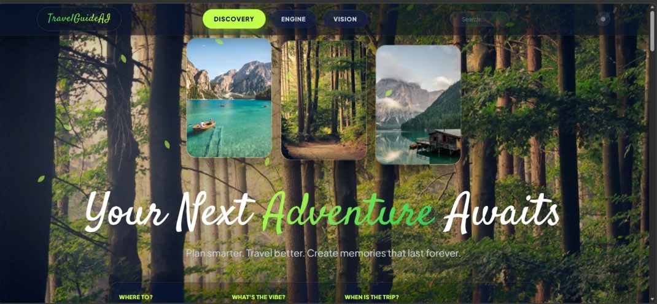
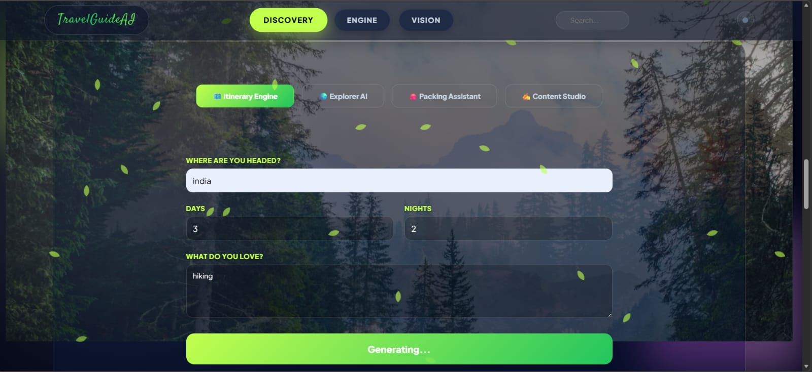

6️⃣ Machine Learning Methodology
Step 1: Data Collection
- Public travel datasets
- Travel APIs
- User behavior data
Step 2: Data Preprocessing
- Tokenization
- Feature extraction
- Text normalization
Step 3: Model Implementation
- Preference classification model
- Hybrid recommendation algorithm
- Ranking optimization
Step 4: Evaluation Metrics
- Precision & Recall
- User Satisfaction Score
- Response Time
- Engagement Rate

7️⃣ Performance & Scalability

- Average response time < 5 seconds
- Horizontal scaling supported
- API caching for performance
- Load balancer integration

8️⃣ Security Measures

HTTPS encrypted communication
Secure cloud hosting
-based access control
Token-based authentication

9️⃣ Future Enhancements

- Real-time flight & hotel integration
- AI travel chatbot
- Voice input itinerary generation
- Multi-language support
- Mobile application version

🔟 Expected Outcomes

- 70% reduction in planning time
- Increased personalization accuracy
- Improved agency efficiency
- Scalable AI-based cloud system

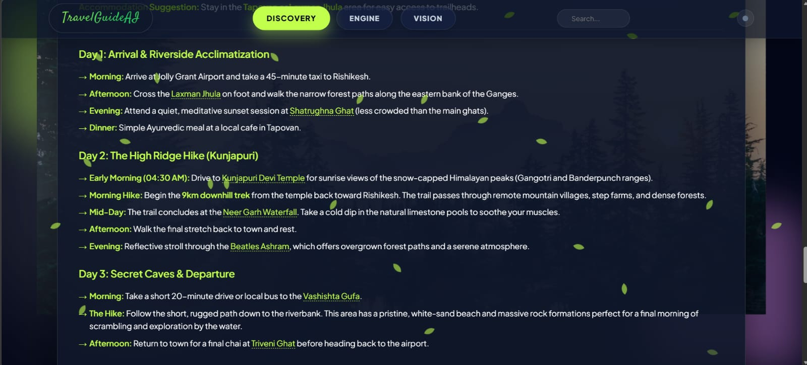

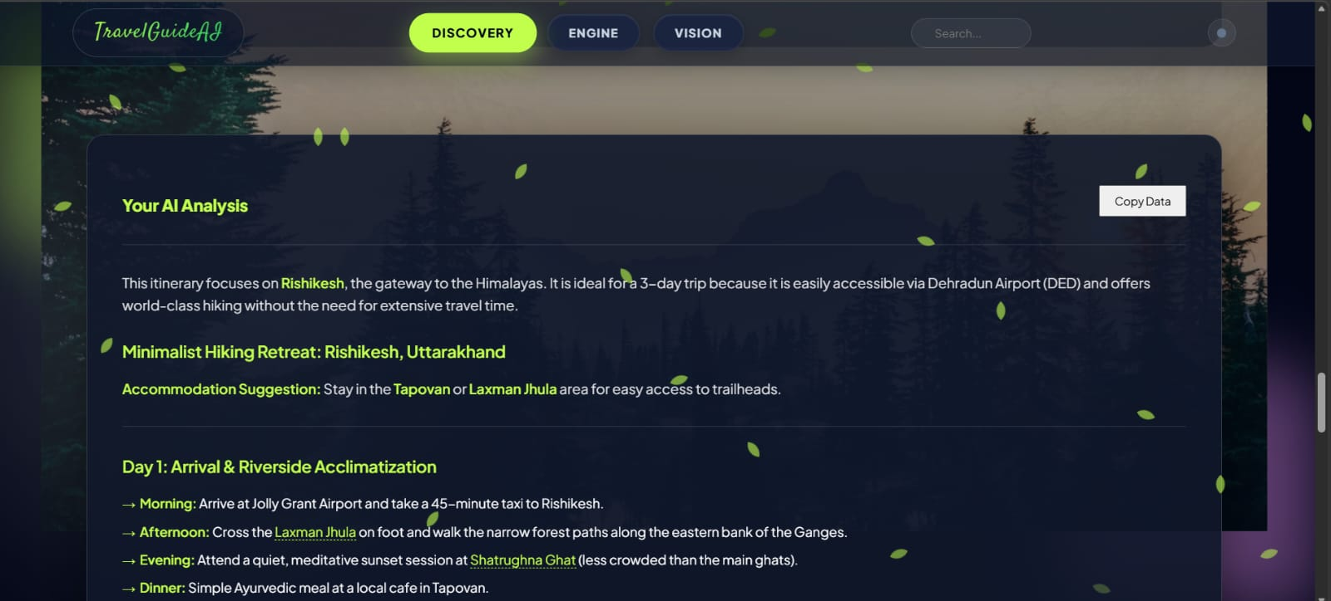

GITHUB LINK:

https://github.com/chimataraghuram/Explore-With-Ai-Custom-Itineraries-For-Your-Next-Journey.git

