**CPPND: TCP Video Streaming application**

This is the captone project for [Udacity C++ Nanodegree Program](https://www.udacity.com/course/c-plus-plus-nanodegree--nd213): TCP Video Streaming application

**Application Structure**

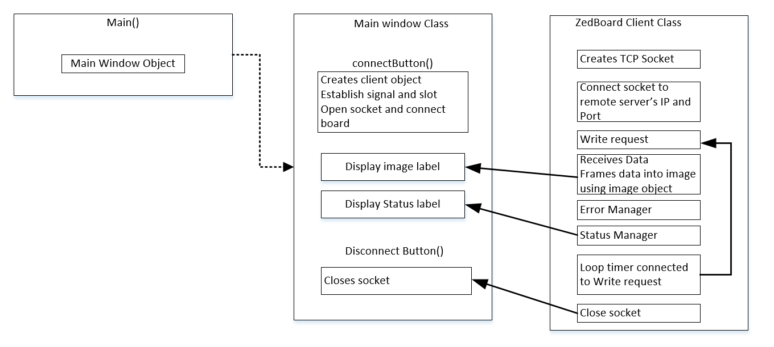

The main class initiates the application by creating an object of the Main window class. The main window class manages the user interface and data flow from the client. Its function is to display the status of the data received from the client. The client is a TCP socket application which connects to a remote device using the TCP protocol. The received data is processed into an image class using a built class of QT creator and the displayed through the user interface (main window class).

**Application Output**

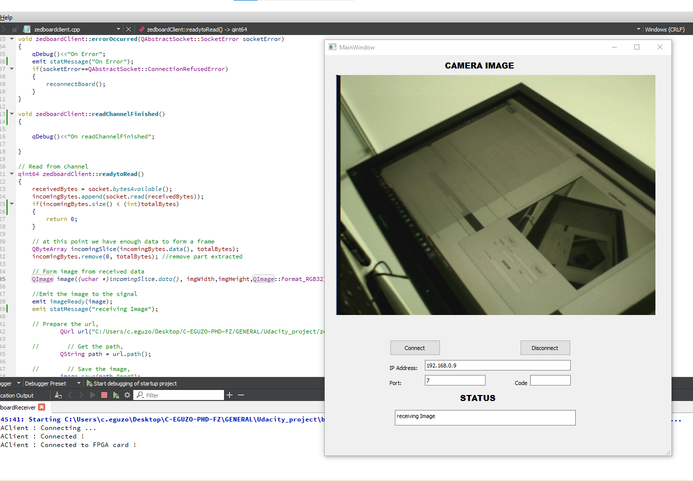

The TCP Video streaming application creates a client manager which connects to a remote Zedboard FPGA integrated with an 0V7670 camera. The client application displays the received image packet through a Graphic User Interface (GUI). The remote Zedboard FPGA is locally connected to the streaming client through IP: 192.168.0.9 and Port: 7.

The main goal of the application is to continuously listen to the specified port for data streaming, structure data into a 2D array for imaging, and display the image on a GUI. The project was developed with QT creator 5.

**Rubrics Addressed**

The project addressed the following project rubrics

**Object Oriented Programming**

The program was developed in three distinct classes namely Main.cpp, Main Window.cpp, and Zedboard client .cpp along with their header file.

Main.cpp is the main program that initiates the application to start.

Mainwindow.cpp creates a user interface to interact with the application. Its function includes reading data from the zedboard class and displaying the status of the data read from the zedboard class.

The zedboard Client creates an interface to establish a TCP socket connection with the remote FPGA integrated with a camera. The FPGA serves as a webserver while the zedboard client is the client. The data from zedboard is routed through a local network connected to ip 192.168.0.9 on port 7.

For data management between the classes, signal and slot feature of QT creator was used. This connection method allows a class to read data from another class only when there is data available to be read.

**Loops, Functions, I/O**

The project has a number of methods with different functions. These include the socket connect/disconnect functions, write functions for sending a request to the socket and readready function for reading data received from the TCP socket.

A file I/O functions is implemented to store the last frame received from the camera on a local directory also a data stream method is implemented for reading data from the socket into an array.

A timed loop method is implemented to enable continues reception of data from the socket as long as the socket is readable without error.

**Memory Management**

Class constructors and destructors was used to prevent segmentation faults.

**Basic Build Instructions**

1. Install QT creator 4 and above.
2. Clone the repo to your local drive
3. Build and Run it
4. Enter the IP address and Port number
5. Click connect to start streaming
6. Click disconnect to end streaming
7. The zedboard server must be on the same subnet with the client otherwise an error will be displayed on the status display label